Attachment C:

FNS-843- Report of Disqualification from Participation: Institution and Responsible Principals/Individuals

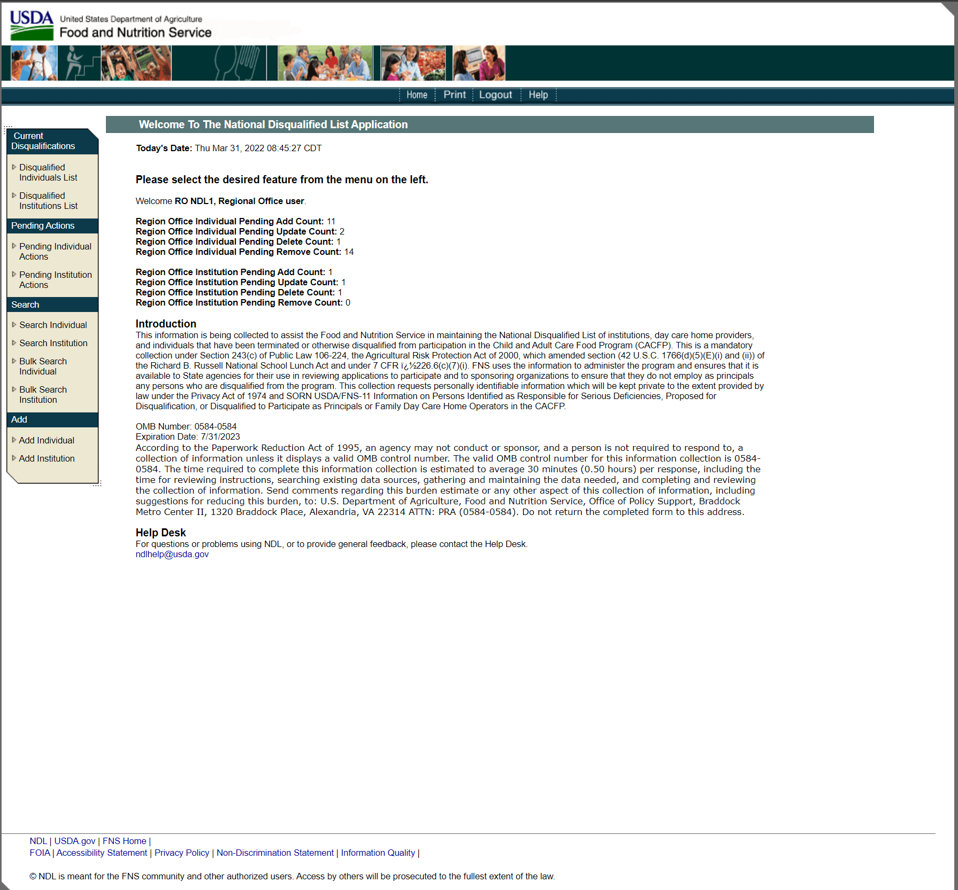

Attachment C

FNS-843- Report of Disqualification from Participation: Institution and Responsible Principals/Individuals

