Attachment A – ACS-16(L) Russian, Front

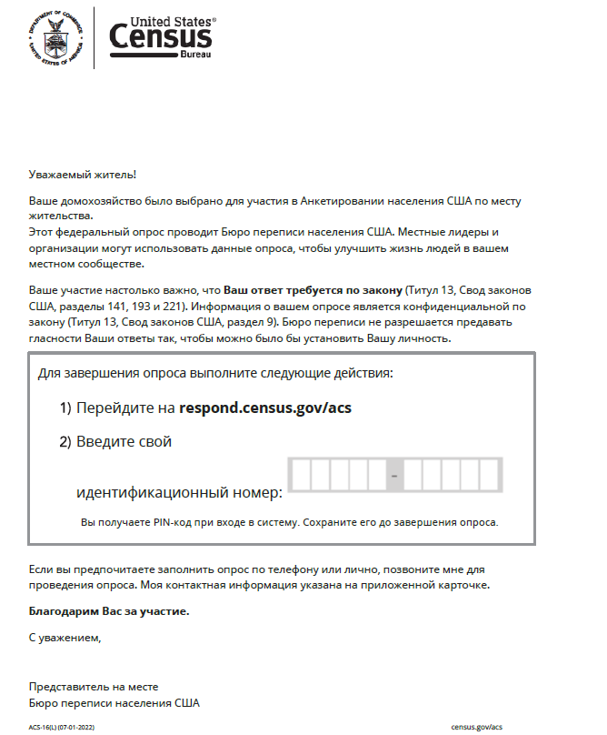

Attachment A – ACS-16(L) Russian, Back

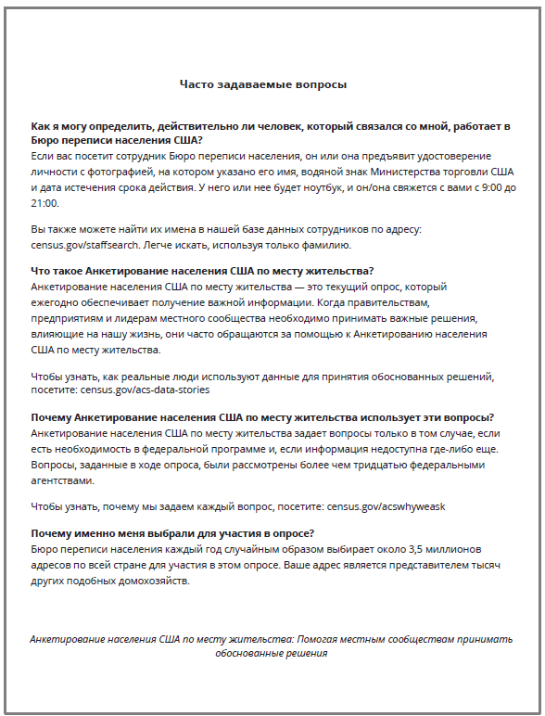

Attachment B – ACS-16(L) Vietnamese, Front

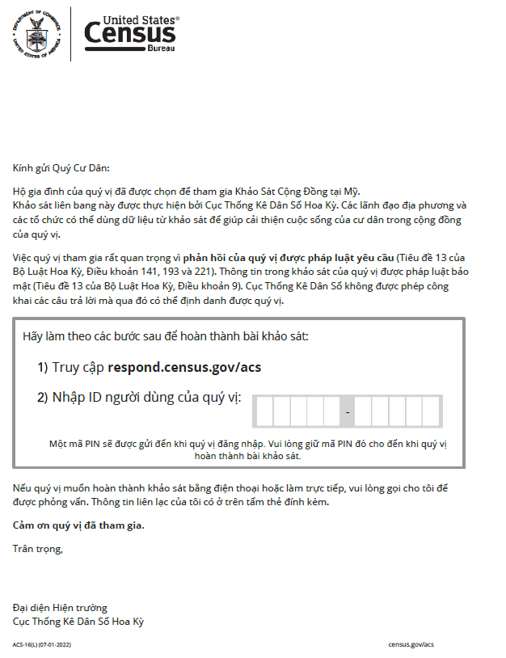

Attachment B – ACS-16(L) Vietnamese, Back

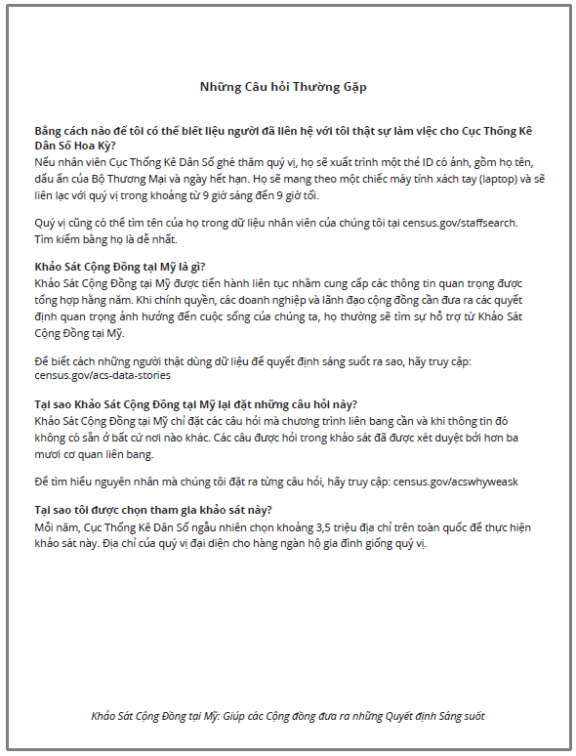

Attachment C – ACS-16(L) Simplified Chinese, Front

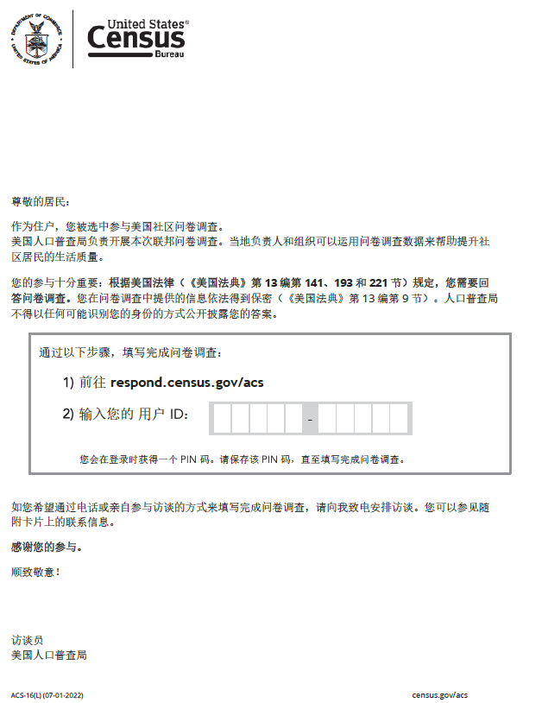

Attachment C – ACS-16(L) Simplified Chinese, Back

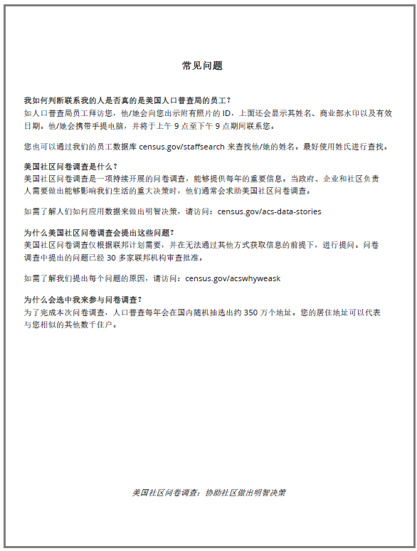

Attachment D – ACS-16(L) Korean, Front

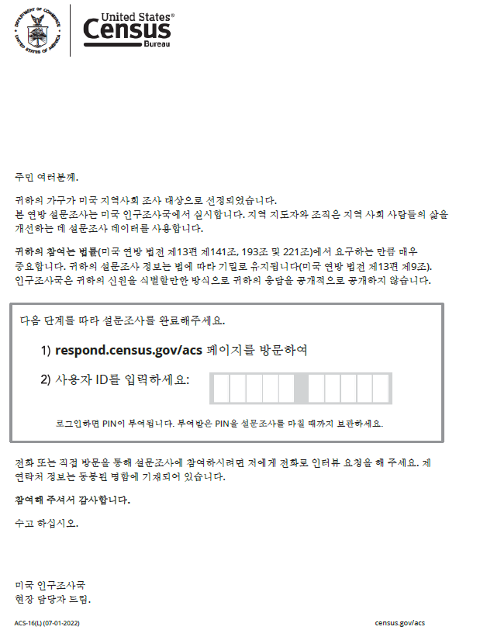

Attachment D – ACS-16(L) Korean, Back

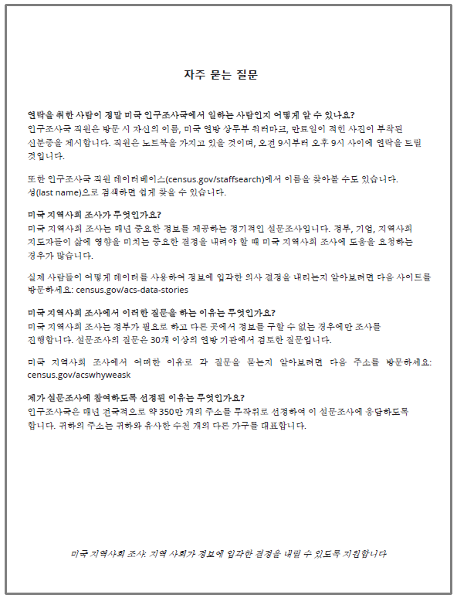

Attachment E – ACS-16(L) Arabic, Front

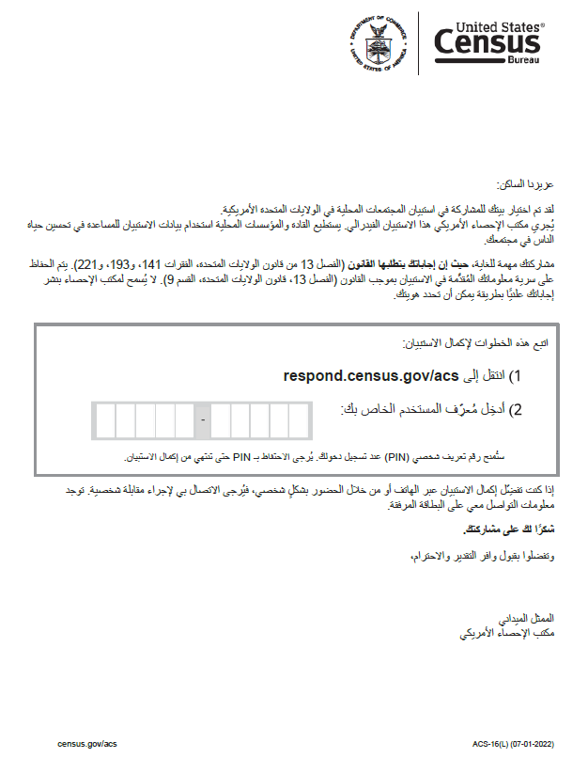
Attachment E – ACS-16(L) Arabic, Back

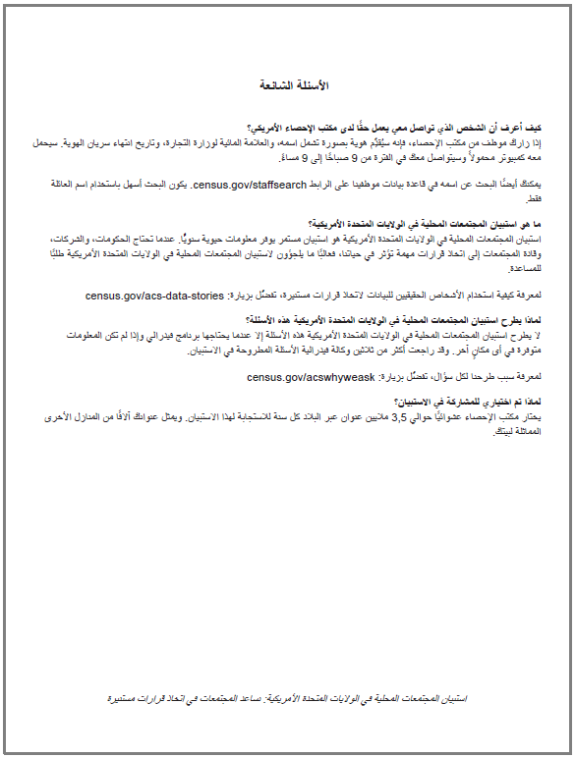

Attachment F – ACS-16(L) French, Front

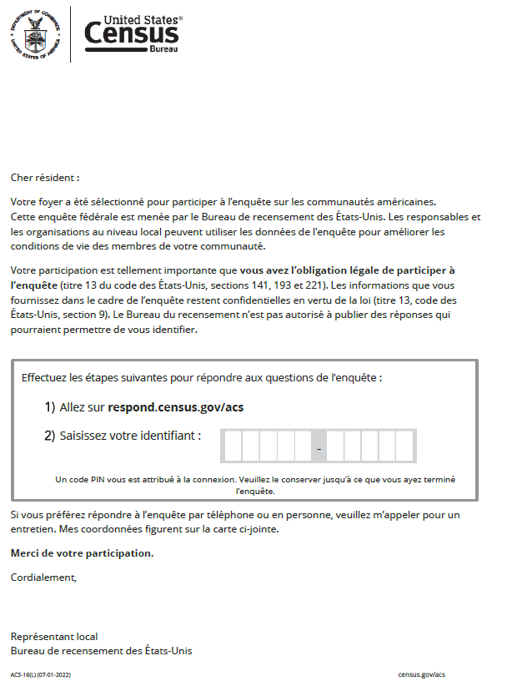

Attachment F – ACS-16(L) French, Back

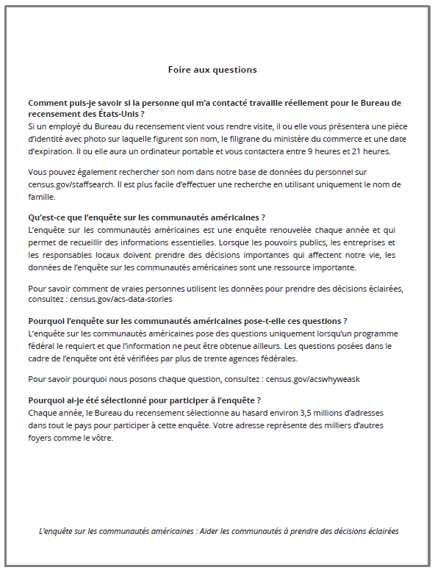

Attachment G – ACS-16(L) Haitian Creole, Front

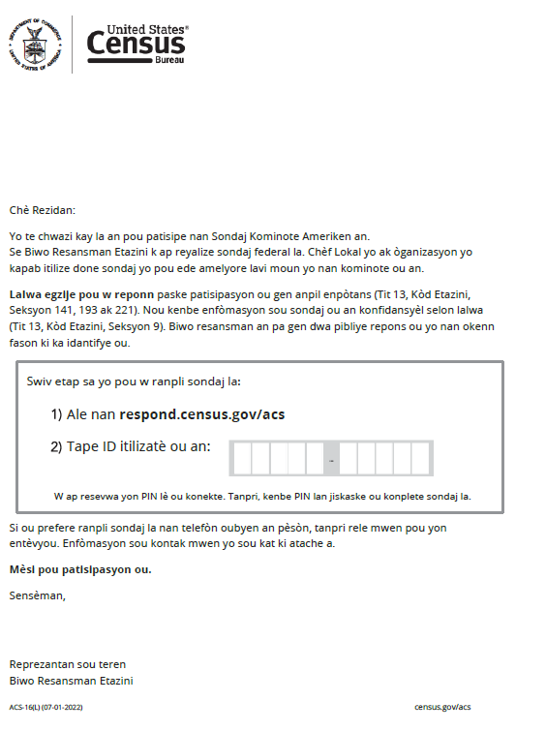
Attachment G – ACS-16(L) Haitian Creole, Back

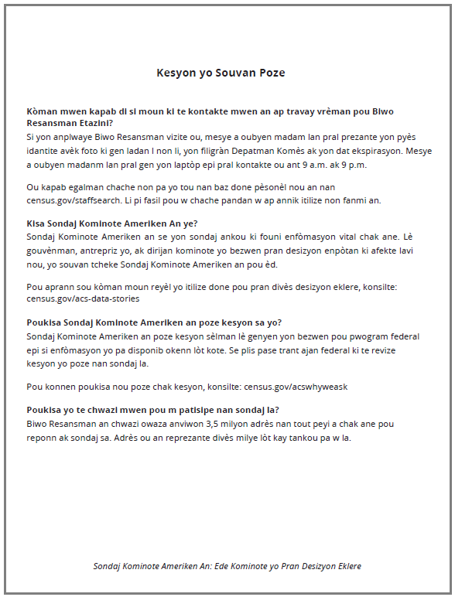

Attachment H – ACS-16(L) Portuguese, Front

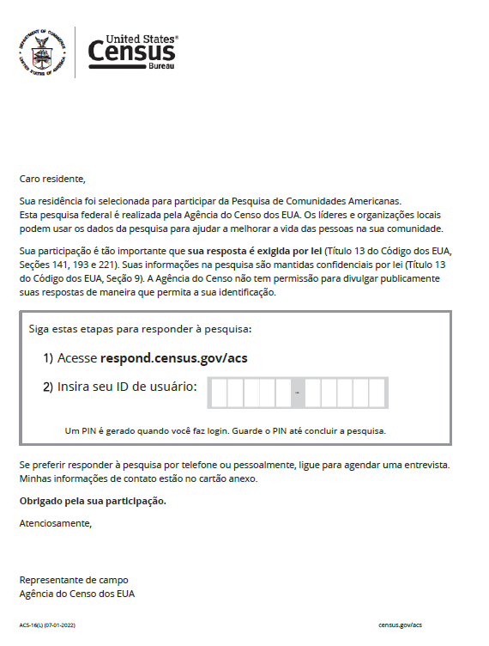

Attachment H – ACS-16(L) Portuguese, Back

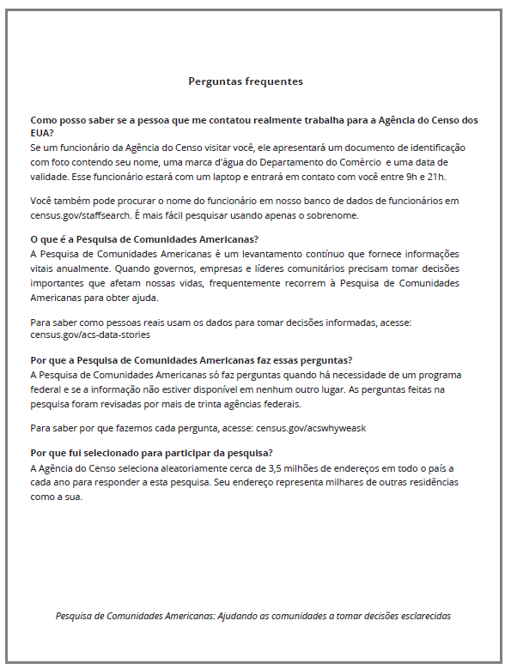
Attachment I – ACS-16(L) Polish, Front

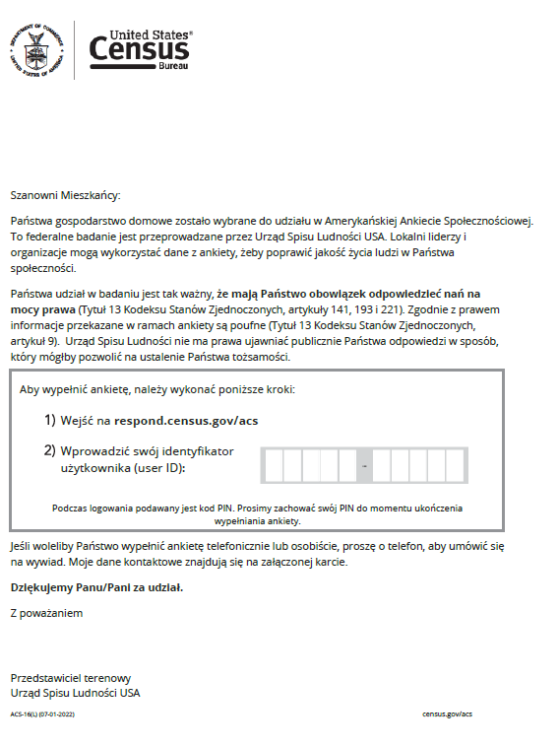
Attachment I – ACS-16(L) Polish, Back

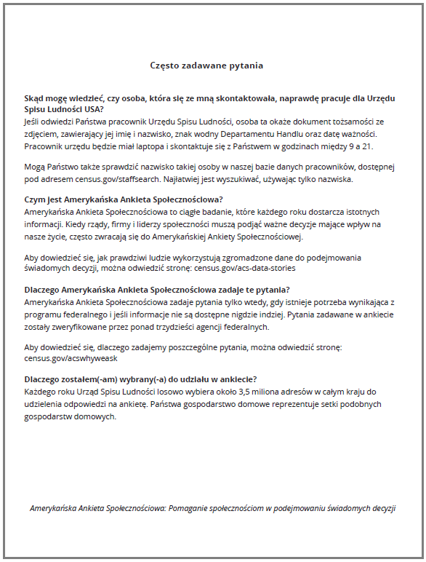
Attachment J – ACS-26(B) Russian, Front

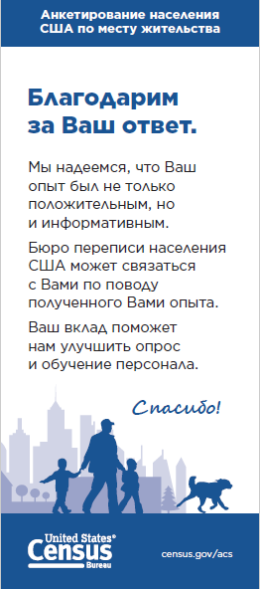

Attachment J – ACS-26(B) Russian, Back

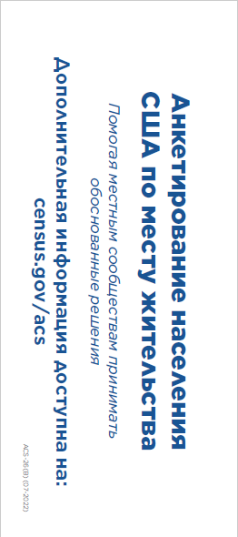

Attachment K – ACS-26(B) Vietnamese, Front

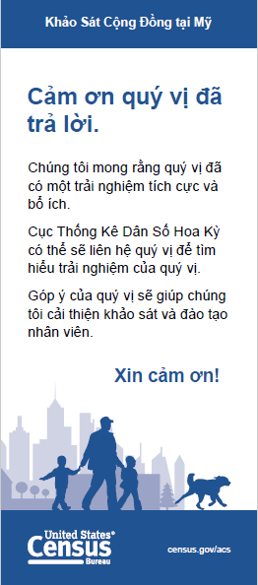

Attachment K – ACS-26(B) Vietnamese, Back

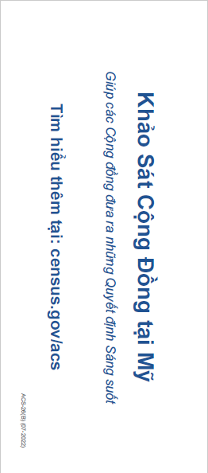

Attachment L – ACS-26(B) Simplified Chinese, Front

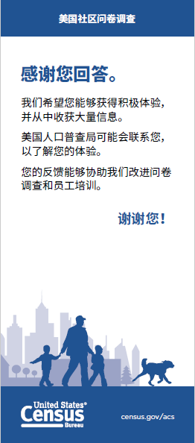

Attachment L – ACS-26(B) Simplified Chinese, Back

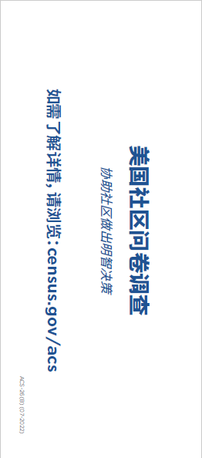

Attachment M – ACS-26(B) Korean, Front

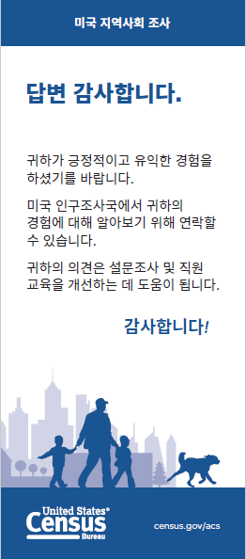

Attachment M – ACS-26(B) Korean, Back

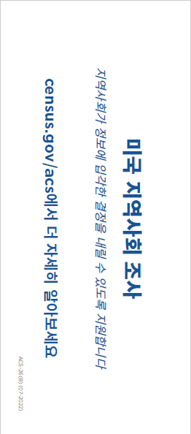

Attachment N – ACS-26(B) Arabic, Front

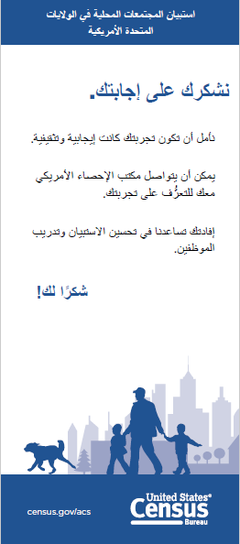

Attachment N – ACS-26(B) Arabic, Back

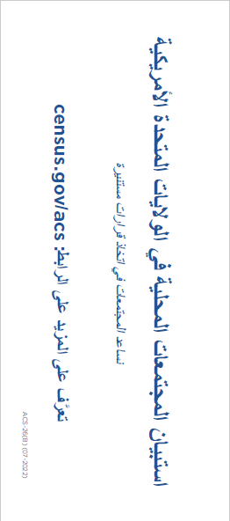

Attachment O – ACS-26(B) French, Front



Attachment O – ACS-26(B) French, Back

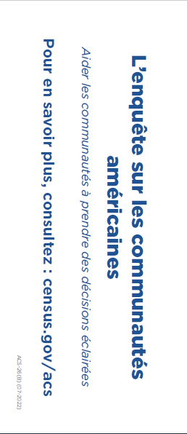

Attachment P – ACS-26(B) Haitian Creole, Front

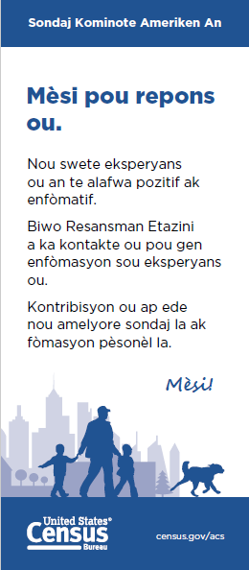

Attachment P – ACS-26(B) Haitian Creole, Back

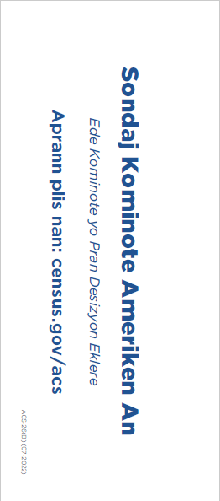

Attachment Q – ACS-26(B) Portuguese, Front

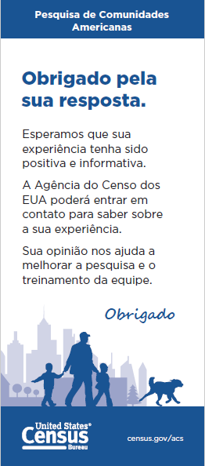

Attachment Q – ACS-26(B) Portuguese, Back

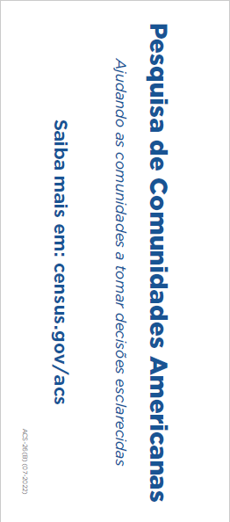

Attachment R – ACS-26(B) Polish, Front

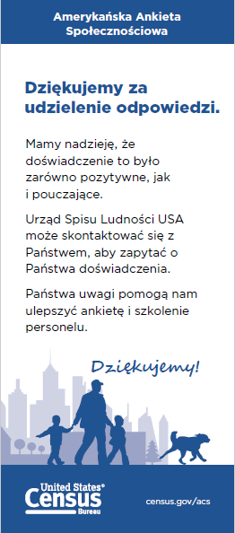

Attachment R – ACS-26(B) Polish, Back

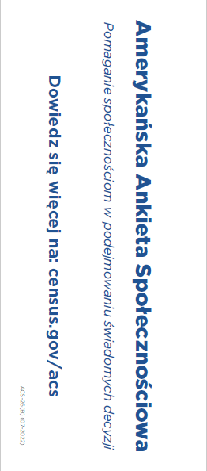

Attachment S – ACS-50(HU) Russian, Front

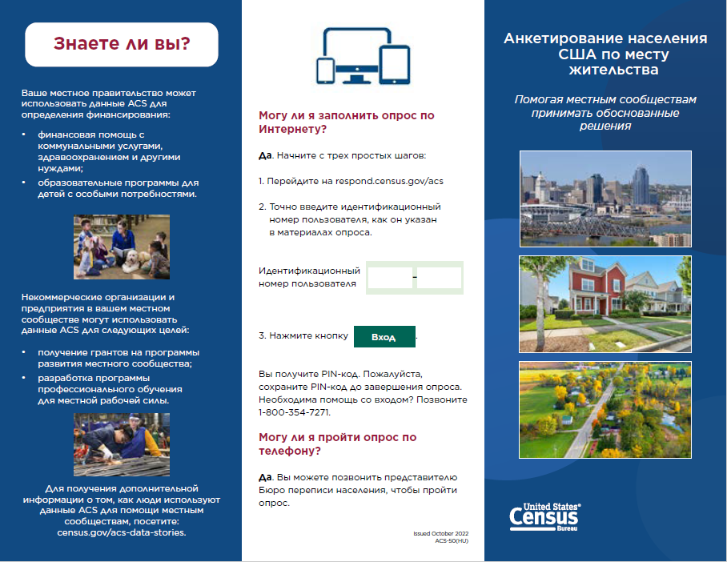

Attachment S – ACS-50(HU) Russian, Back

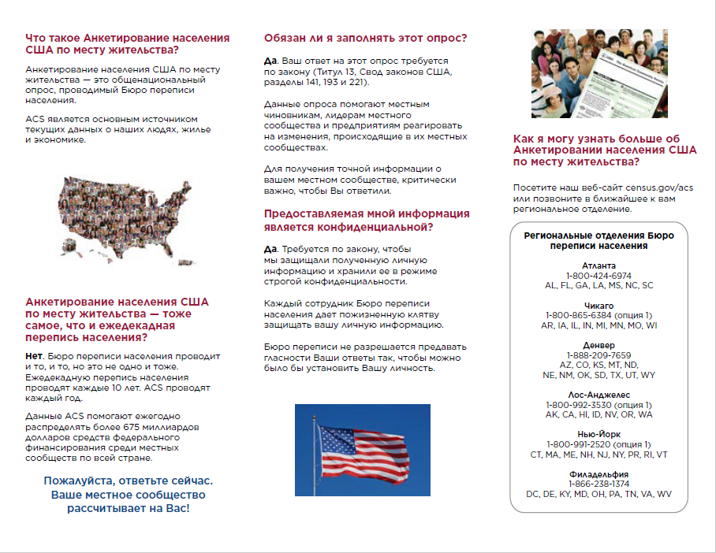

Attachment T – ACS-50(HU) Vietnamese, Front

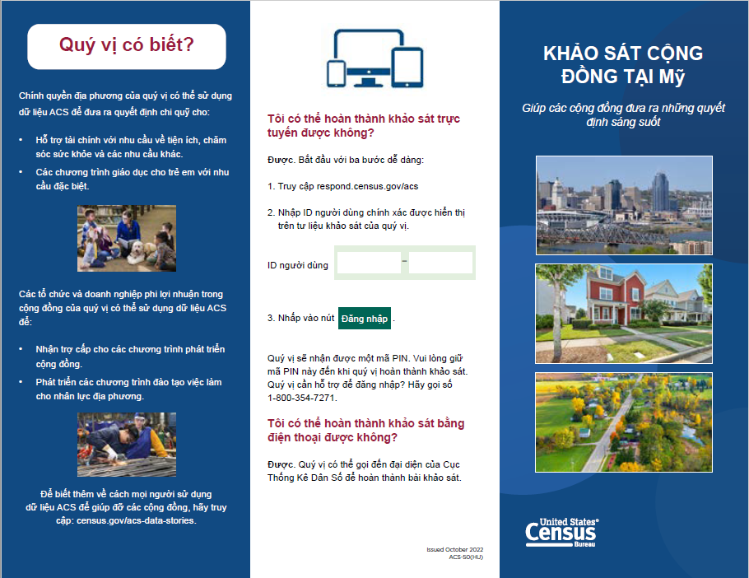

Attachment T – ACS-50(HU) Vietnamese, Back

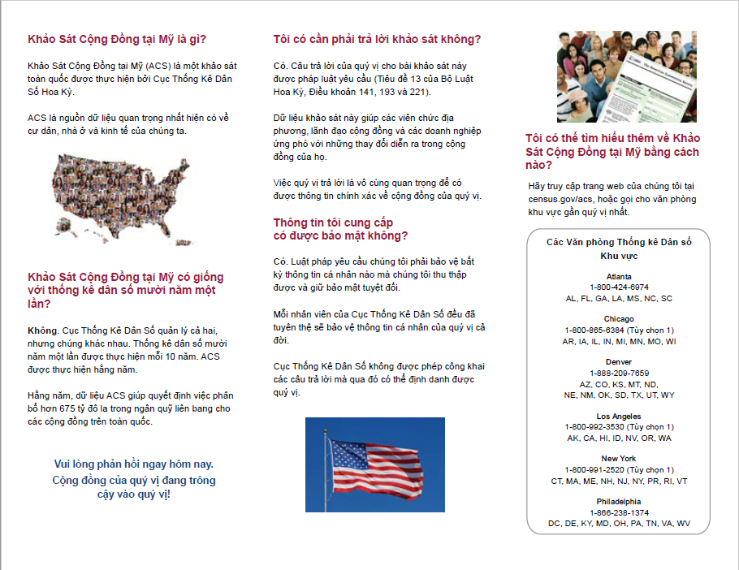

Attachment U – ACS-50(HU) Simplified Chinese, Front

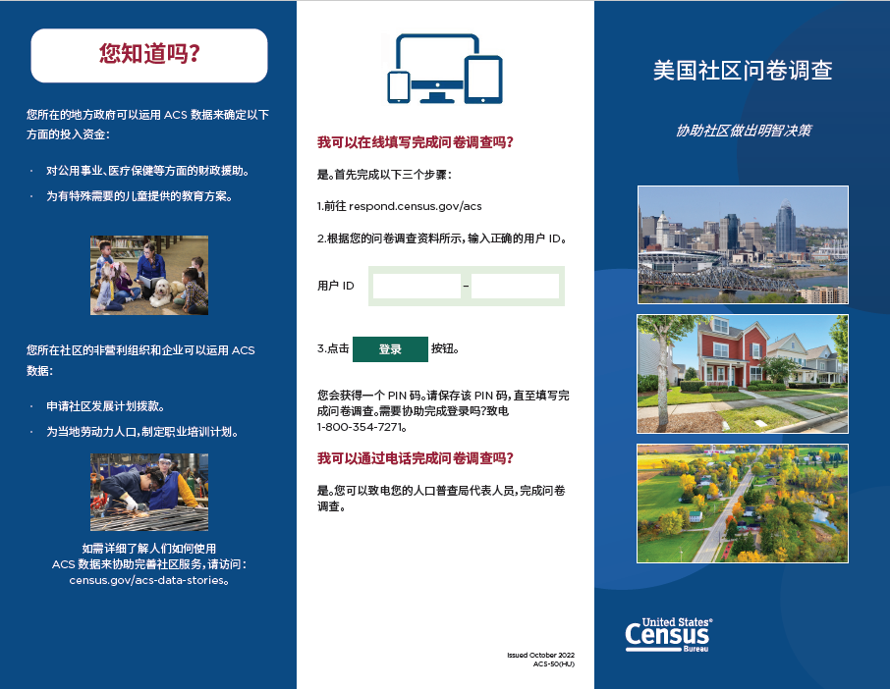

Attachment U – ACS-50(HU) Simplified Chinese, Back

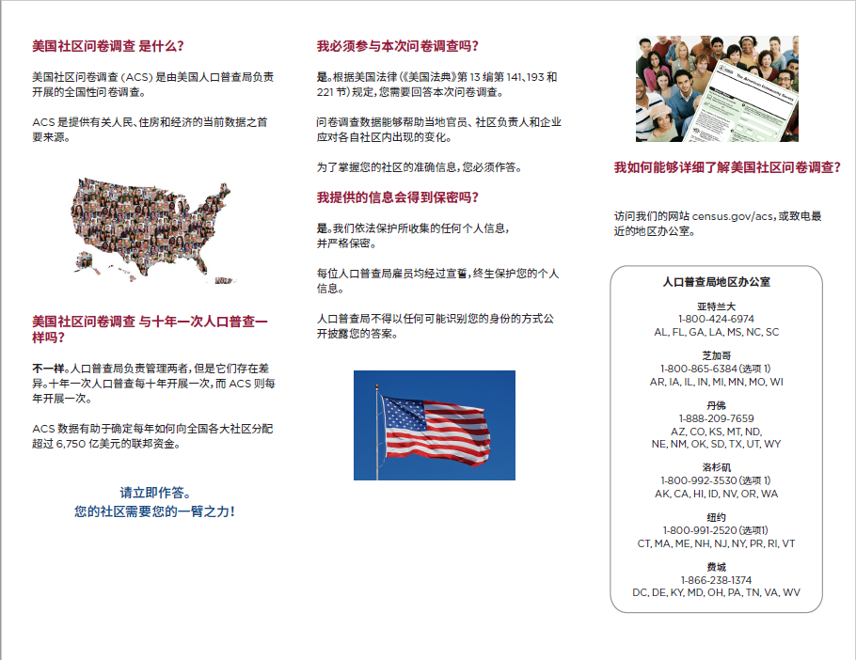

Attachment V – ACS-50(HU) Korean, Front

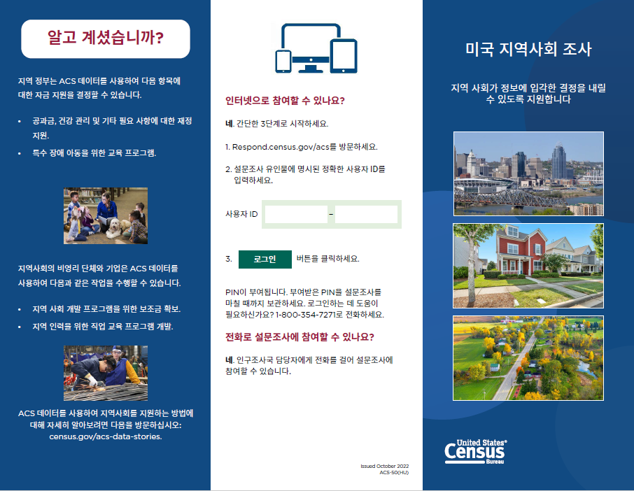

Attachment V – ACS-50(HU) Korean, Back

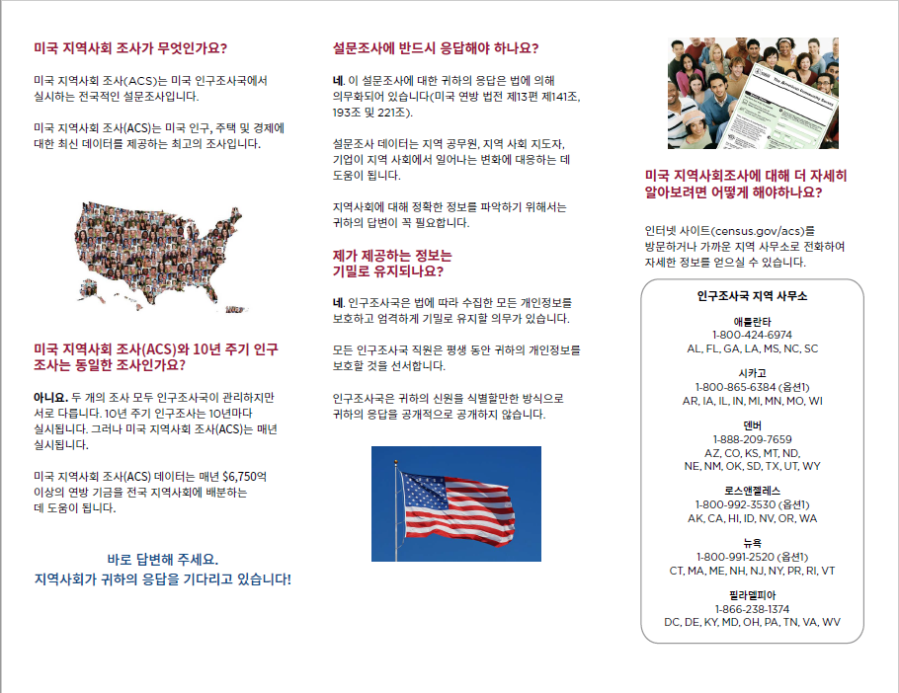

Attachment W – ACS-50(HU) Arabic, Front

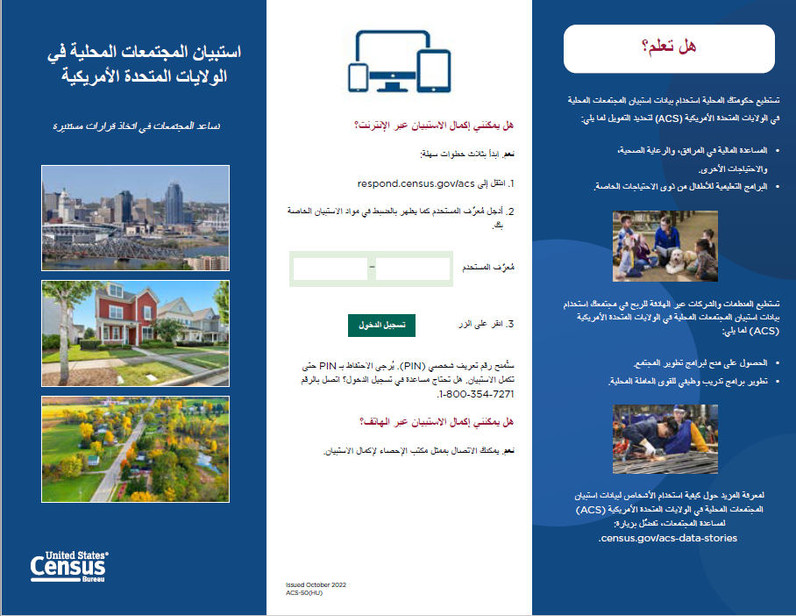

Attachment W – ACS-50(HU) Arabic, Back

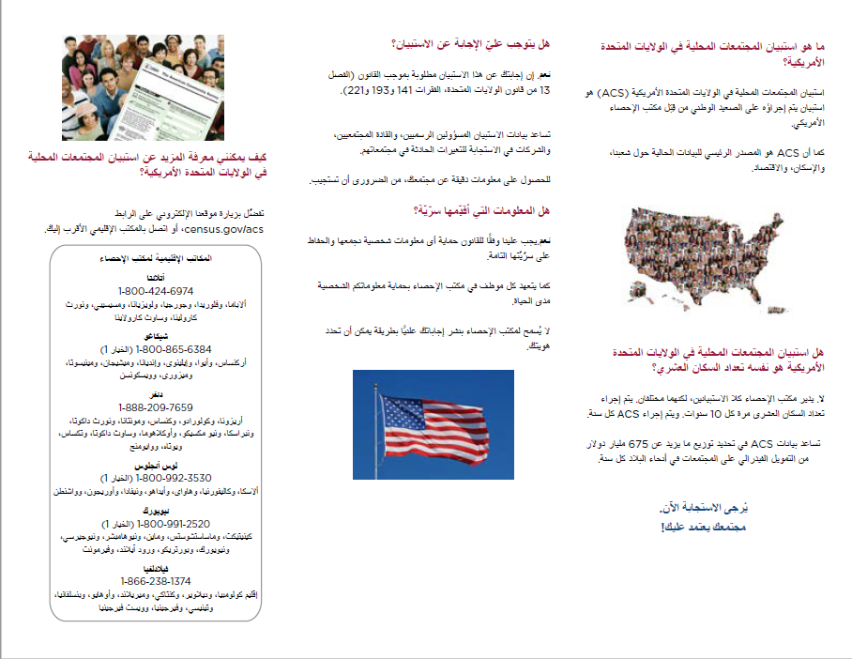

Attachment X – ACS-50(HU) French, Front

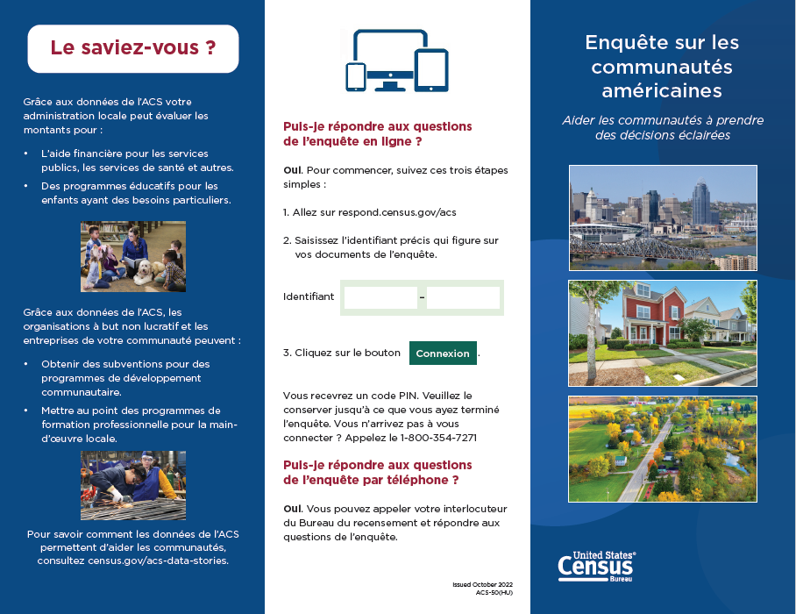

Attachment X – ACS-50(HU) French, Back

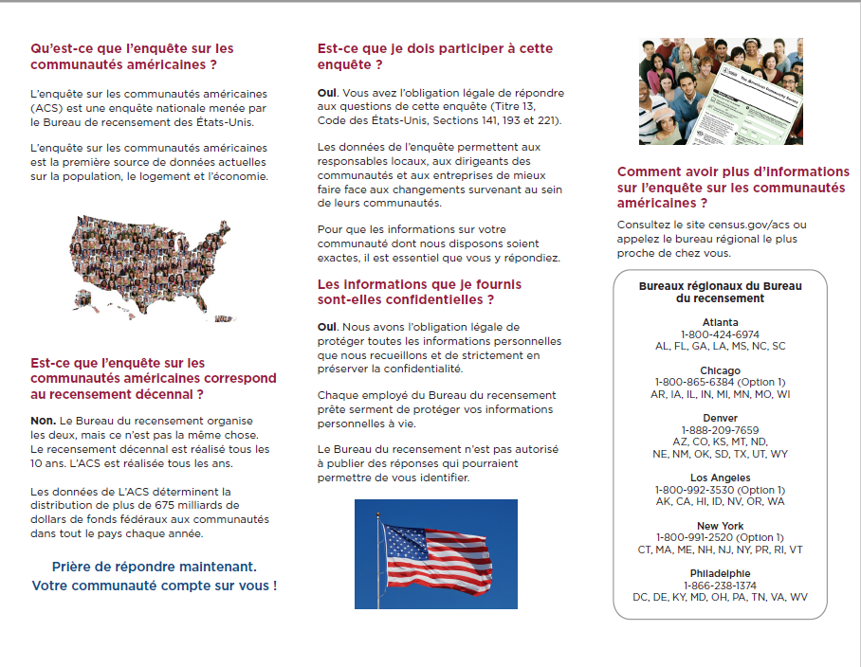

Attachment Y – ACS-50(HU) Haitian Creole, Front

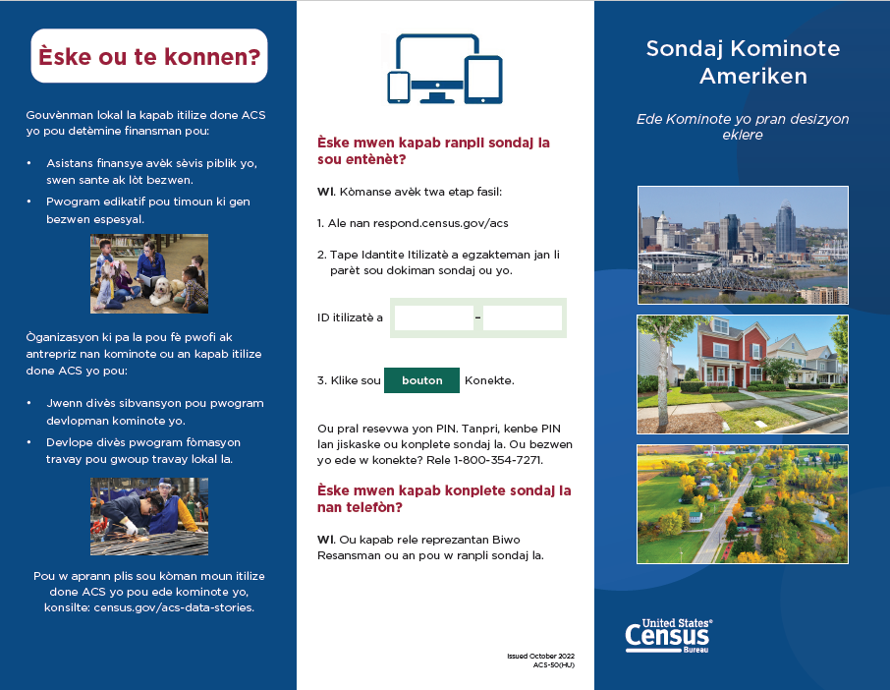

Attachment Y – ACS-50(HU) Haitian Creole, Back

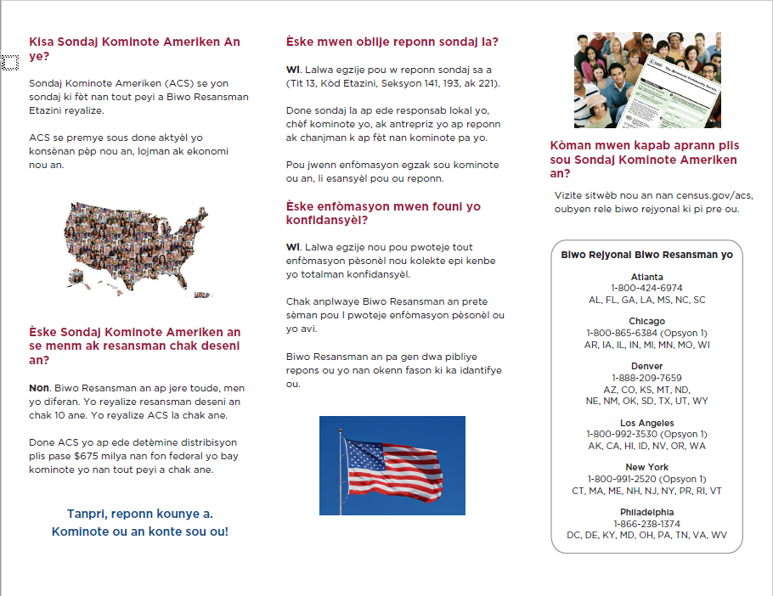

Attachment Z – ACS-50(HU) Portuguese, Front

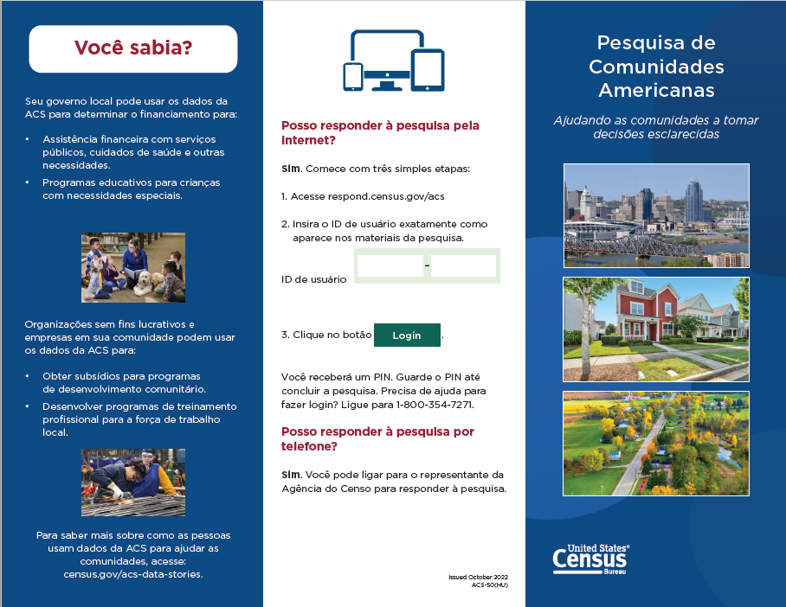

Attachment Z – ACS-50(HU) Portuguese, Back

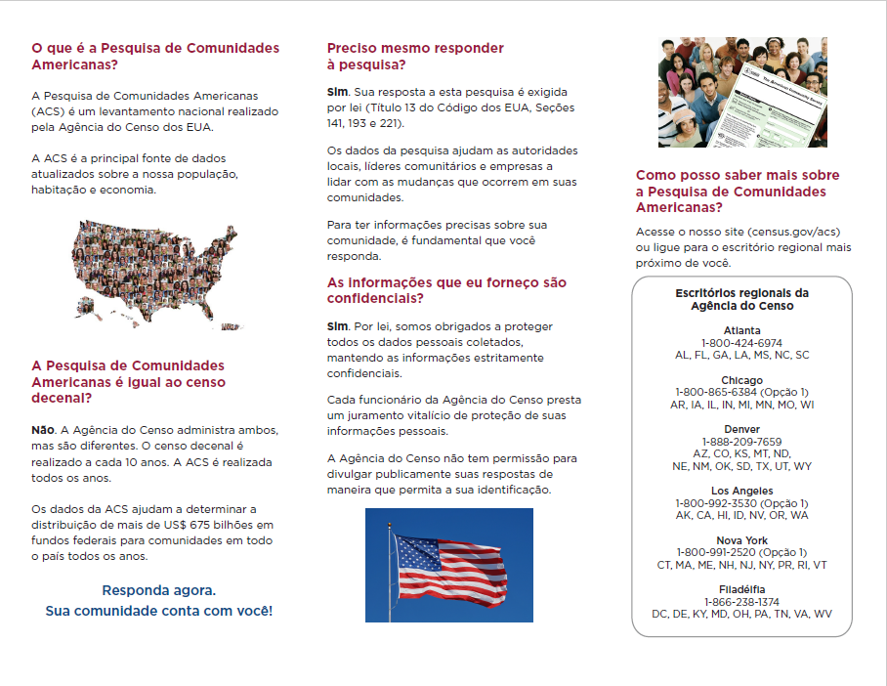

Attachment AA – ACS-50(HU) Polish, Front

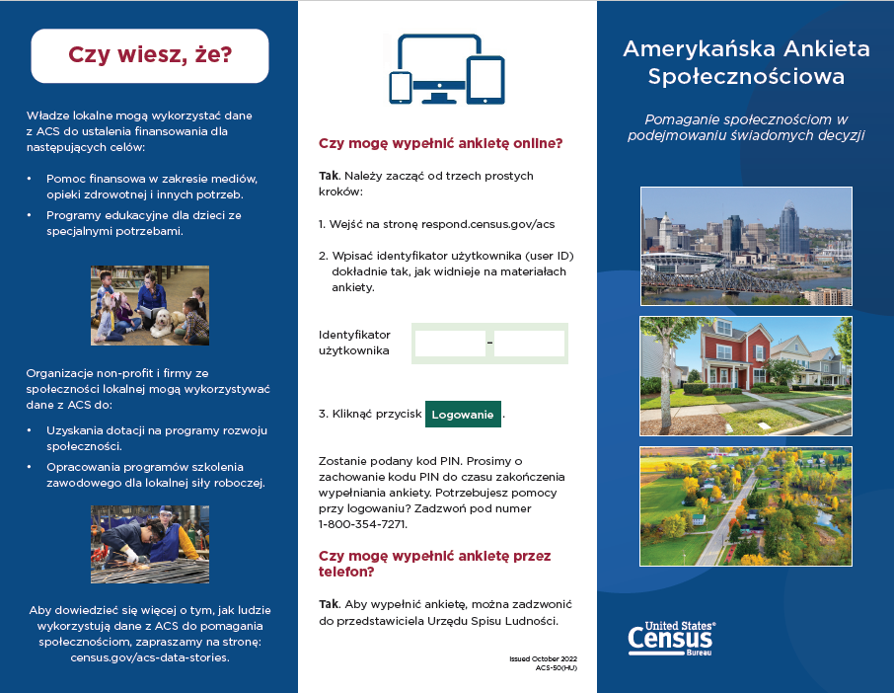

Attachment AA – ACS-50(HU) Polish, Back

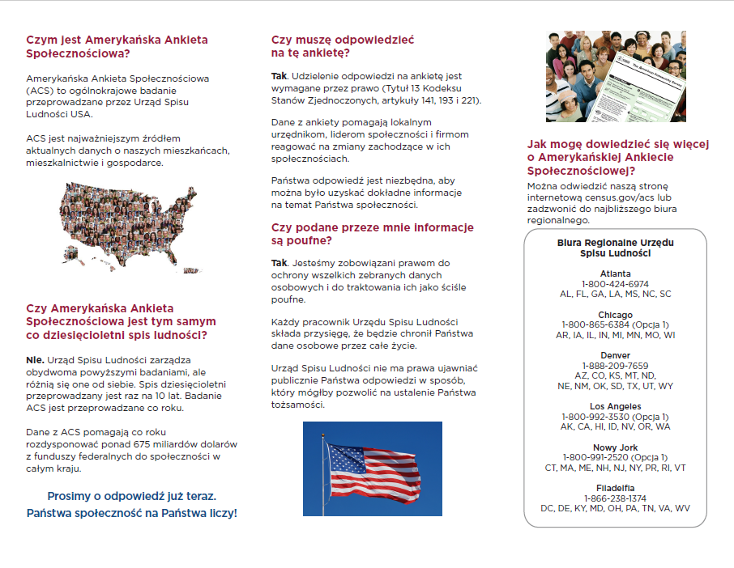

Attachment AB – ACS-51(HU) Russian, Page 1-Front



Attachment AB – ACS-51(HU) Russian, Page 1-Back

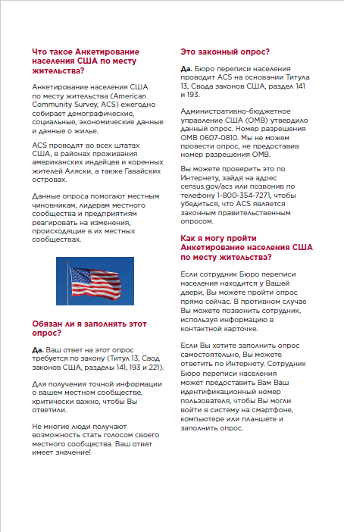

Attachment AB – ACS-51(HU) Russian, Page 2-Front

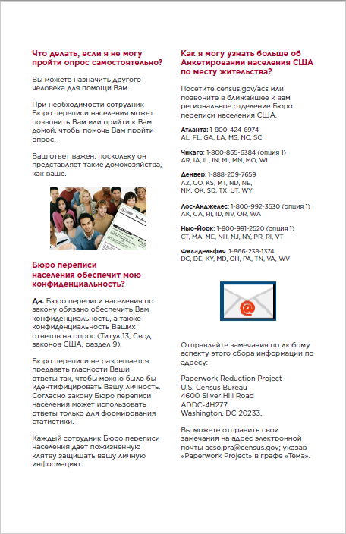

Attachment AB – ACS-51(HU) Russian, Page 2-Back

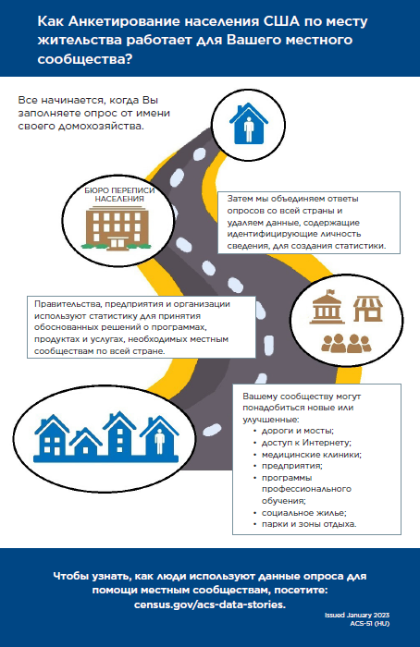

Attachment AC – ACS-51(HU) Vietnamese, Page 1-Front



Attachment AC – ACS-51(HU) Vietnamese, Page 1-Back,

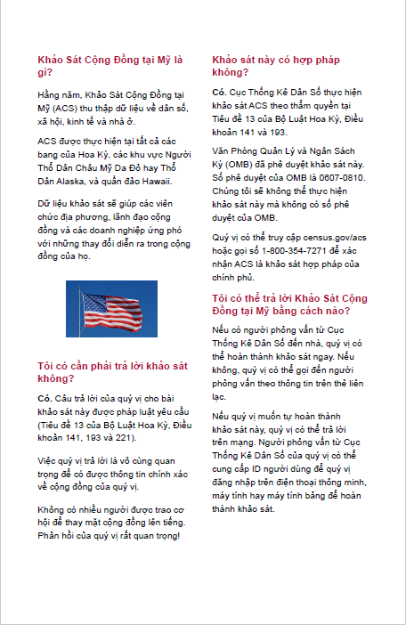

Attachment AC – ACS-51(HU) Vietnamese, Page 2-Front

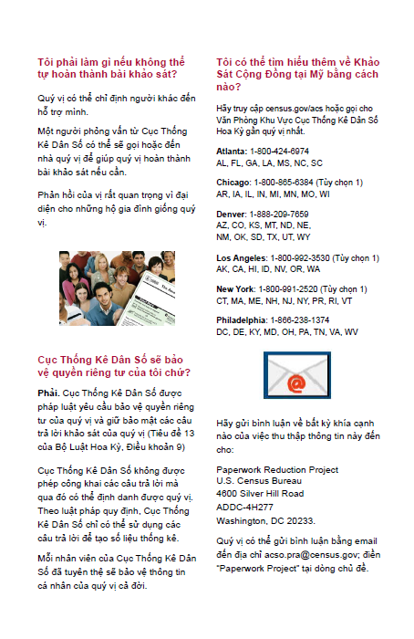

Attachment AC – ACS-51(HU) Vietnamese, Page 2-Back

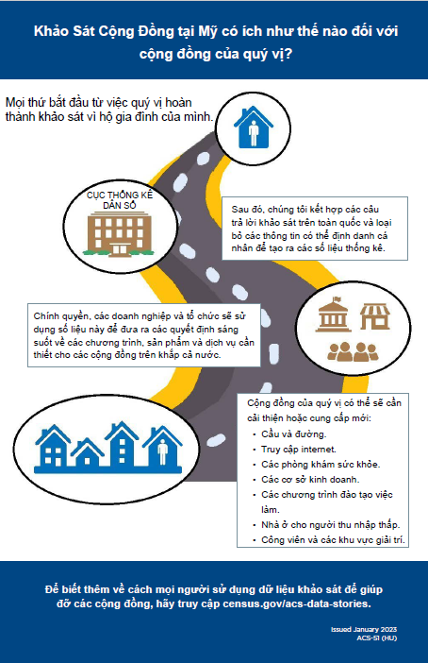

Attachment AD – ACS-51(HU) Simplified Chinese, Page 1-Front



Attachment AD – ACS-51(HU) Simplified Chinese, Page 1-Back

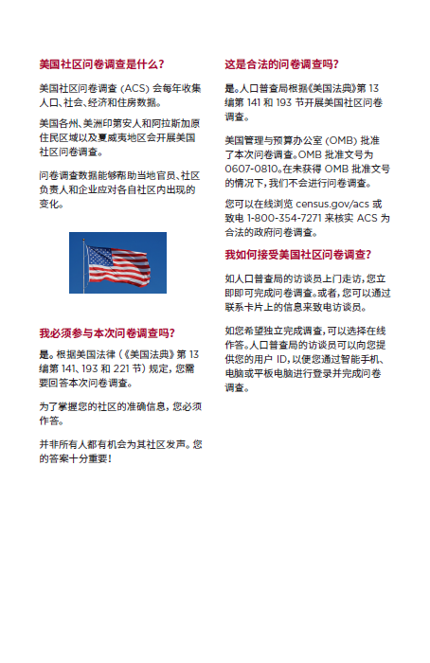
Attachment AD – ACS-51(HU) Simplified Chinese, Page 2-Front

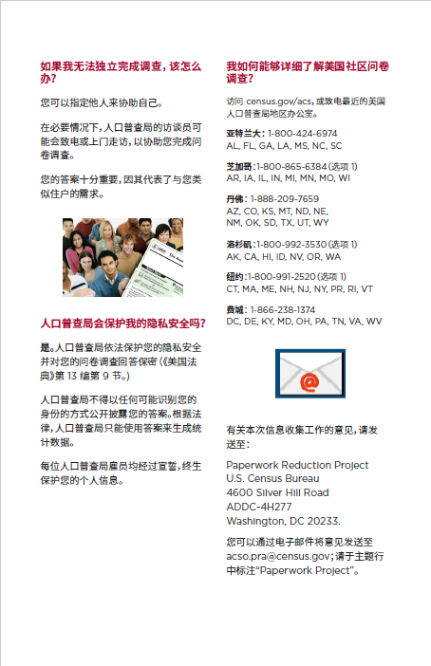

Attachment AD – ACS-51(HU) Simplified Chinese, Page 2-Back

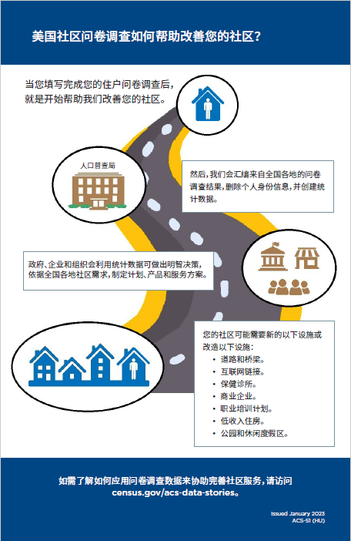

Attachment AE – ACS-51(HU) Korean, Page 1-Front



Attachment AE – ACS-51(HU) Korean, Page 1-Back

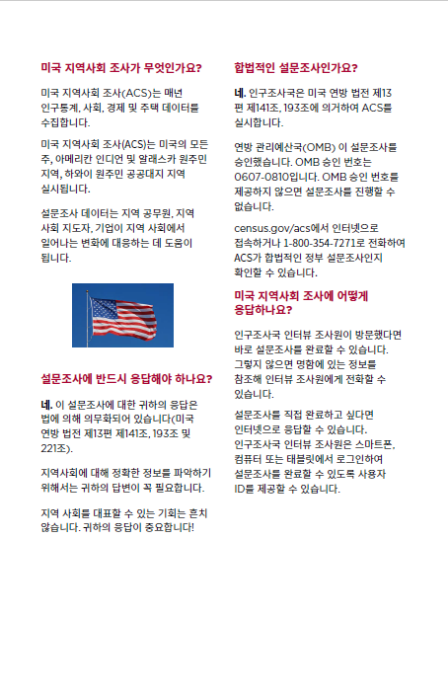

Attachment AE – ACS-51(HU) Korean, Page 2-Front

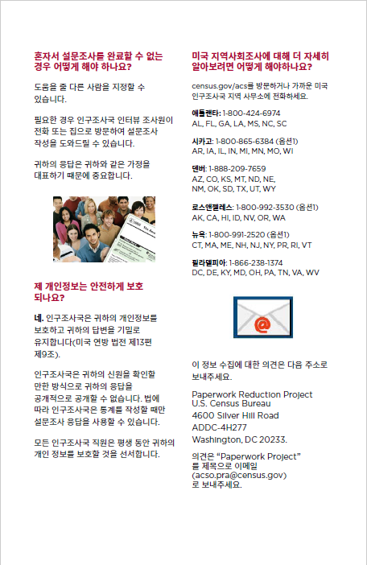

Attachment AE – ACS-51(HU) Korean, Page 2-Back

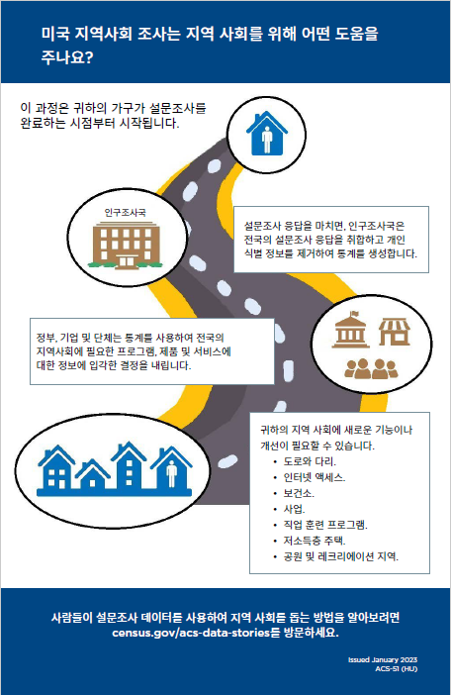

Attachment AF – ACS-51(HU) Arabic, Page 1-Front



Attachment AF – ACS-51(HU) Arabic, Page 1-Back

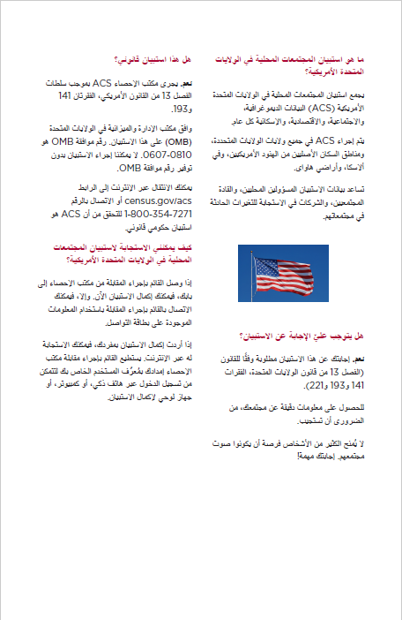

Attachment AF – ACS-51(HU) Arabic, Page 2-Front

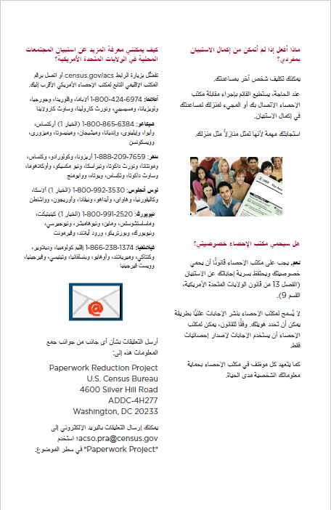

Attachment AF – ACS-51(HU) Arabic, Page 2-Back

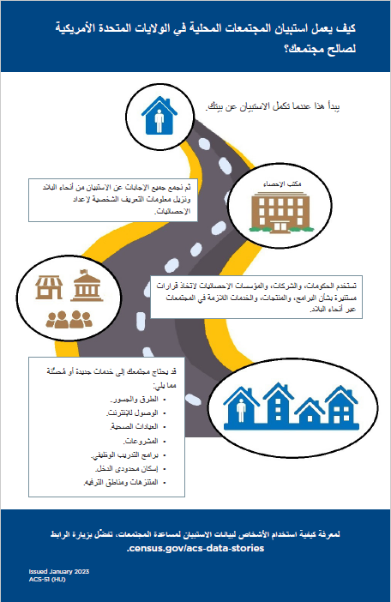

Attachment AG – ACS-51(HU) French, Page 1-Front



Attachment AG – ACS-51(HU) French, Page 1-Back

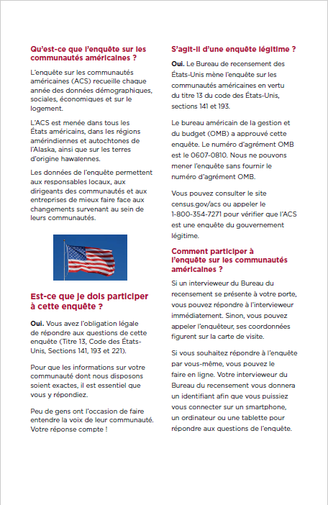

Attachment AG – ACS-51(HU) French, Page 2-Front



Attachment AG – ACS-51(HU) French, Page 2-Back

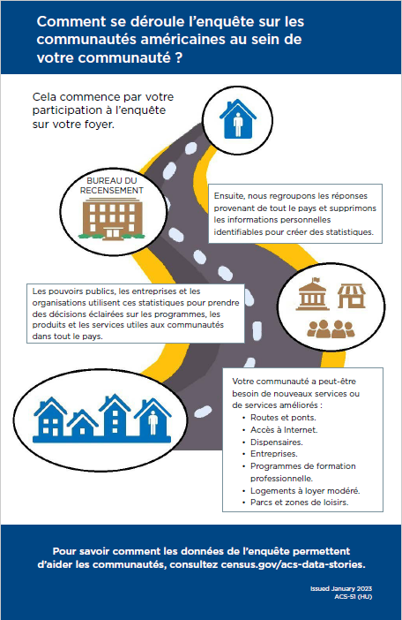

Attachment AH – ACS-51(HU) Haitian Creole, Page 1-Front



Attachment AH – ACS-51(HU) Haitian Creole, Page 1-Back

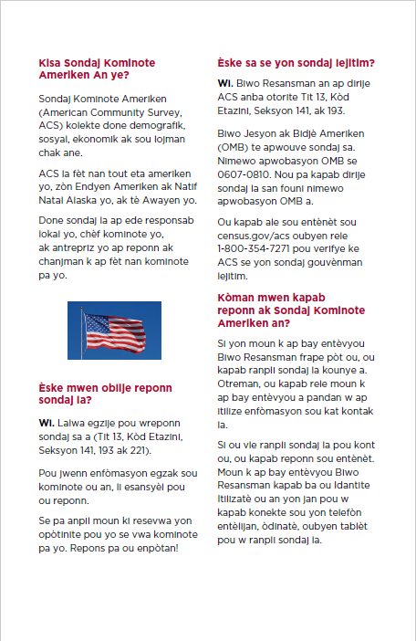

Attachment AH – ACS-51(HU) Haitian Creole, Page 2-Front

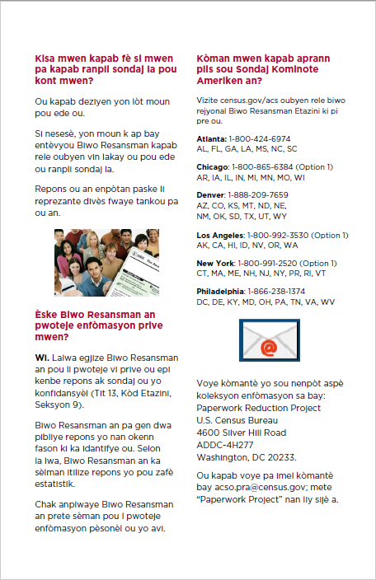

Attachment AH – ACS-51(HU) Haitian Creole, Page 2-Back

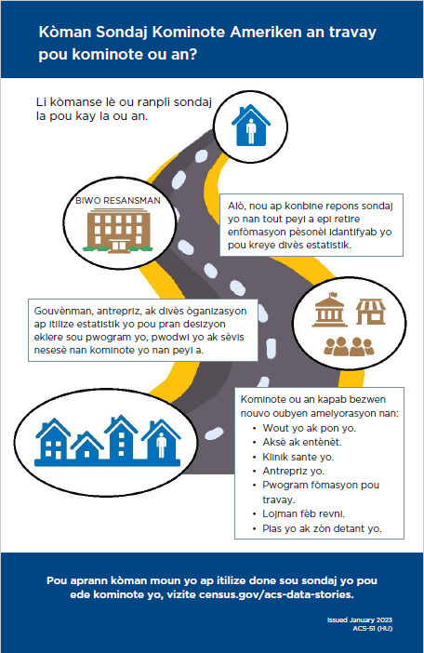

Attachment AI – ACS-51(HU) Portuguese, Page 1-Front



Attachment AI – ACS-51(HU) Portuguese, Page 1-Back

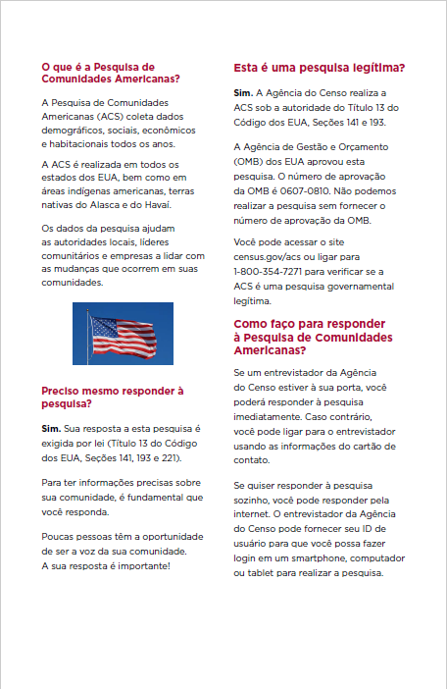

Attachment AI – ACS-51(HU) Portuguese, Page 2-Front

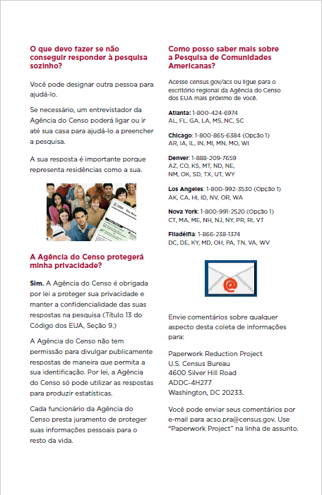

Attachment AI – ACS-51(HU) Portuguese, Page 2-Back

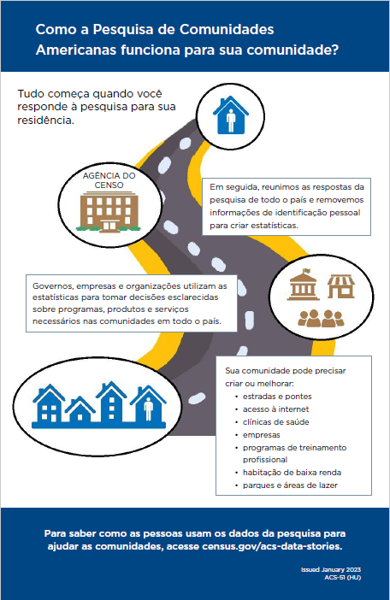

Attachment AJ – ACS-51(HU) Polish, Page 1-Front



Attachment AJ – ACS-51(HU) Polish, Page 1-Back

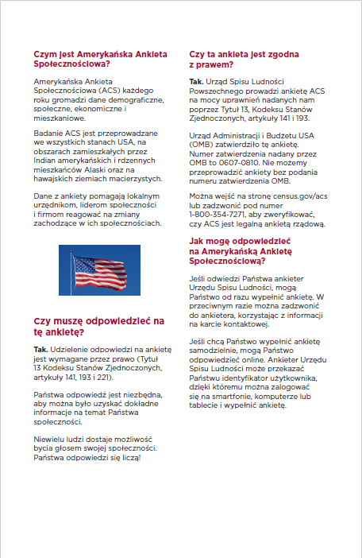

Attachment AJ – ACS-51(HU) Polish, Page 2-Front

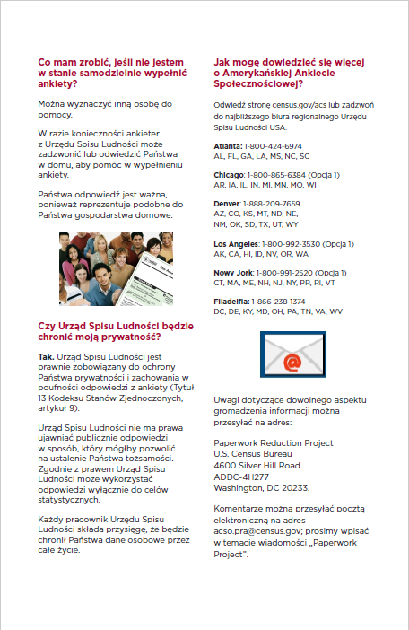

Attachment AJ – ACS-51(HU) Polish, Page 2-Back

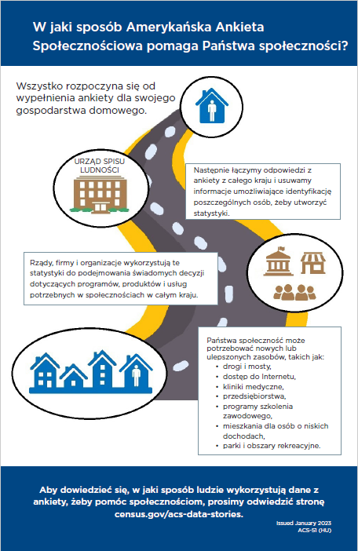

ROSCO Letter’s: Better Understanding (BUL), No One Home (NOH), and Refusal

Attachment AK – Better Understanding (BUL) Simplified Chinese, Page 1

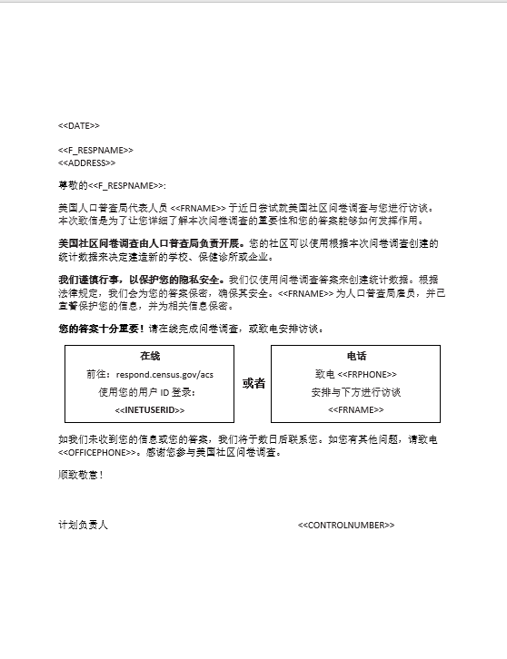

Attachment AK – Better Understanding (BUL) Simplified Chinese, Page 2

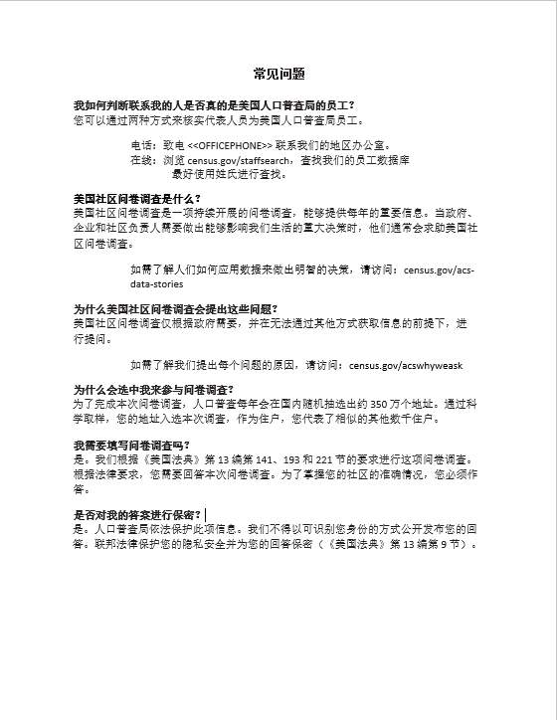

Attachment AL – Better Understanding (BUL) Korean, Page 1

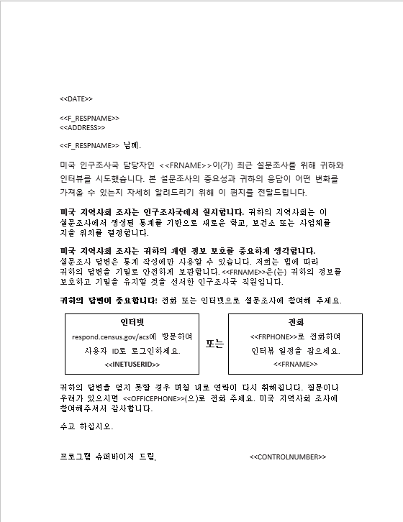

Attachment AL – Better Understanding (BUL) Korean, Page 2

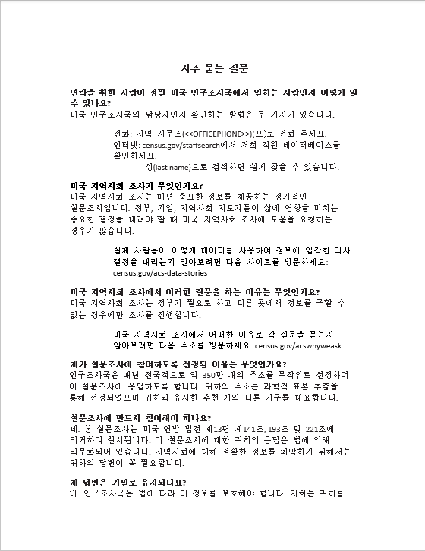

Attachment AL – Better Understanding (BUL) Korean, Page 3

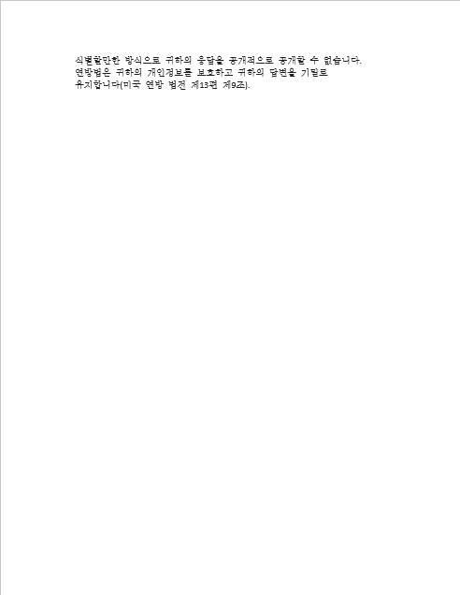

Attachment AM – Better Understanding (BUL) Vietnamese, Page 1

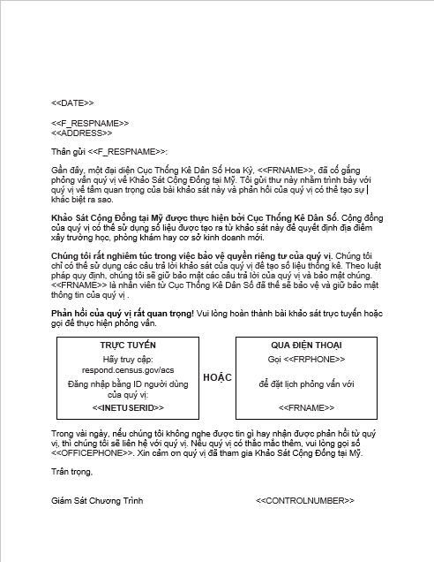

Attachment AM – Better Understanding (BUL) Vietnamese, Page 2

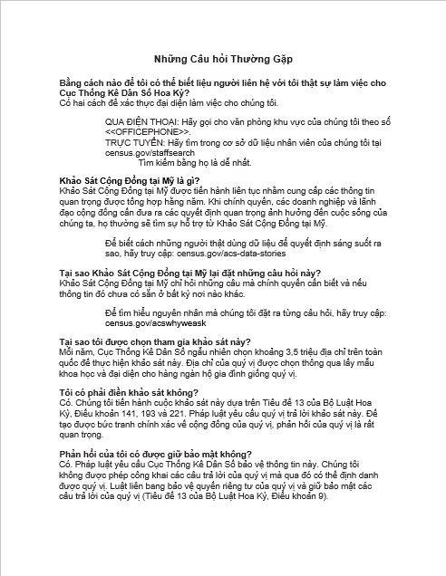

Attachment AN – Better Understanding (BUL) Russian, Page 1

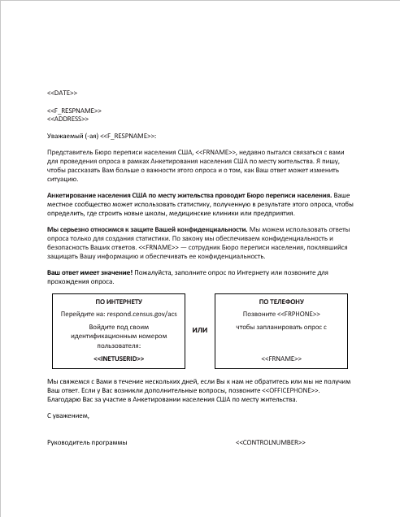

Attachment AN – Better Understanding (BUL) Russian, Page 2

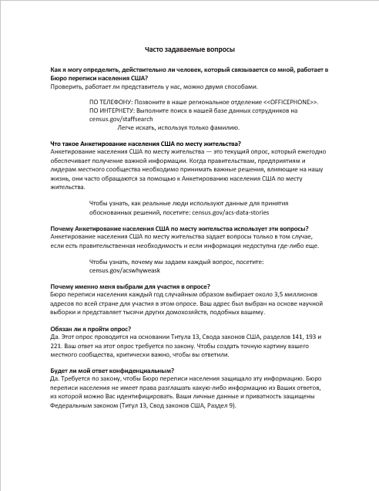

Attachment AO – No One Home (NOH) Simplified Chinese, Page 1

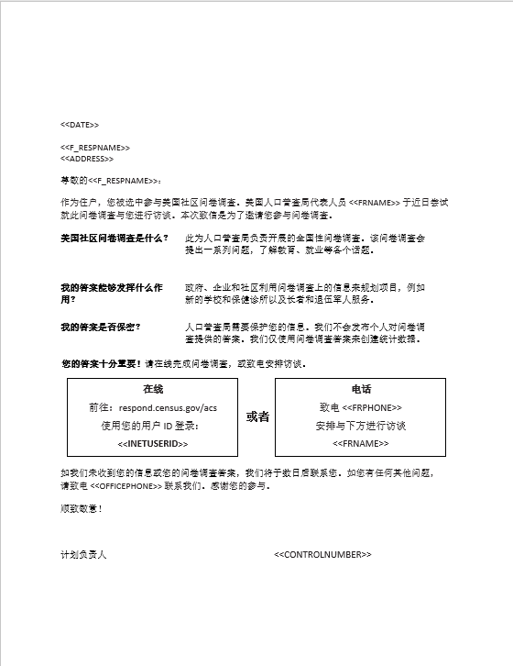

Attachment AO – No One Home (NOH) Simplified Chinese, Page 2

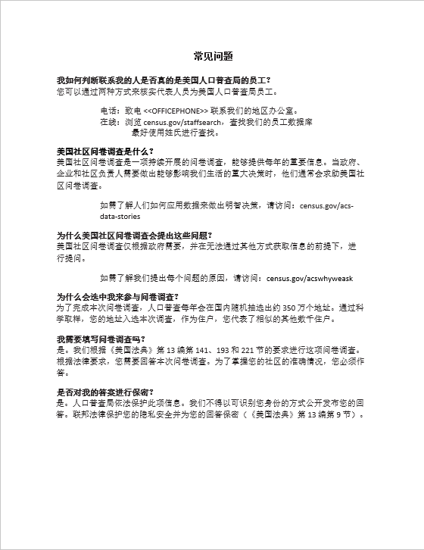

Attachment AP – No One Home (NOH) Korean, Page 1

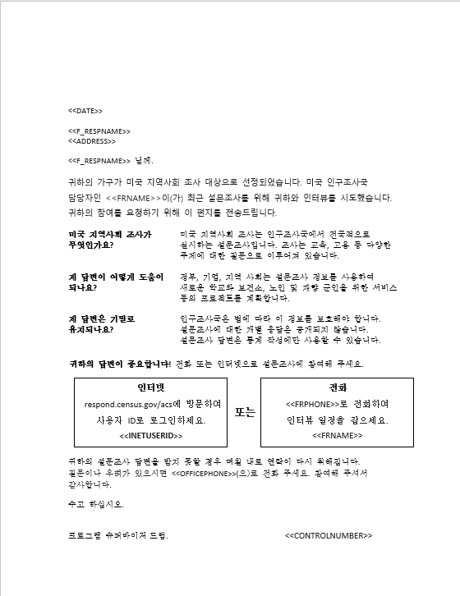

Attachment AP – No One Home (NOH) Korean, Page 2

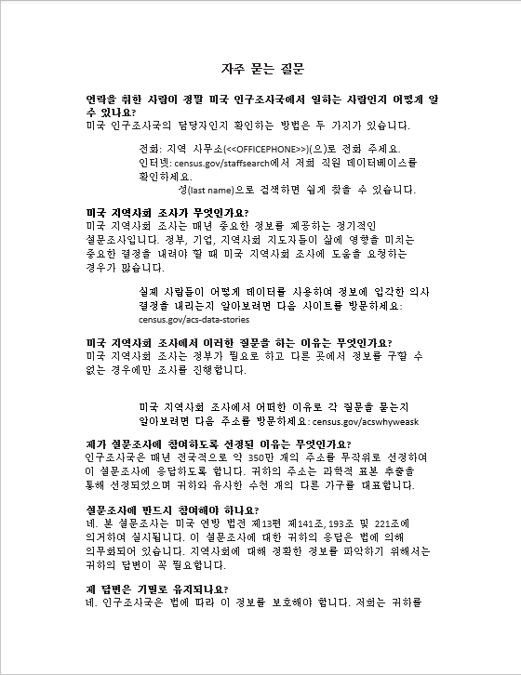

Attachment AP – No One Home (NOH) Korean, Page 3

Attachment AQ – No One Home (NOH) Vietnamese, Page 1

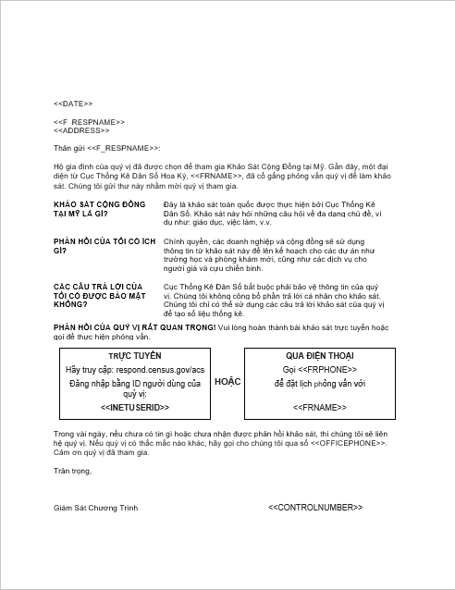

Attachment AQ – No One Home (NOH) Vietnamese, Page 2

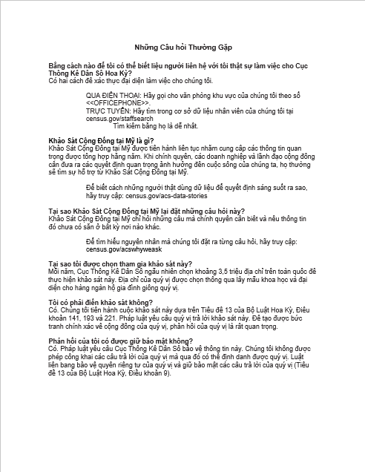

Attachment AR – No One Home (NOH) Russian, Page 1

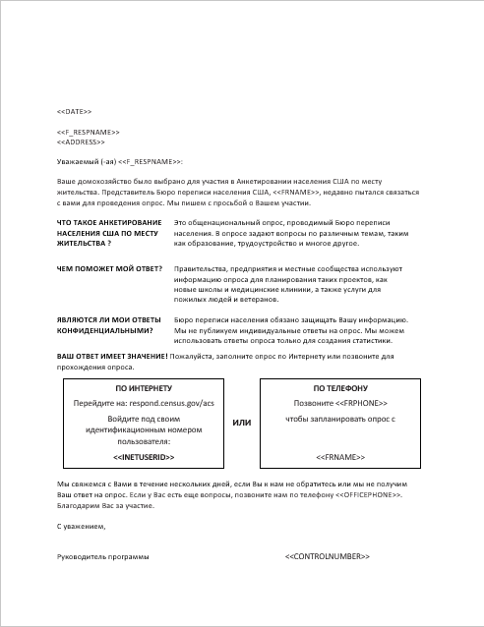

Attachment AR – No One Home (NOH) Russian, Page 2

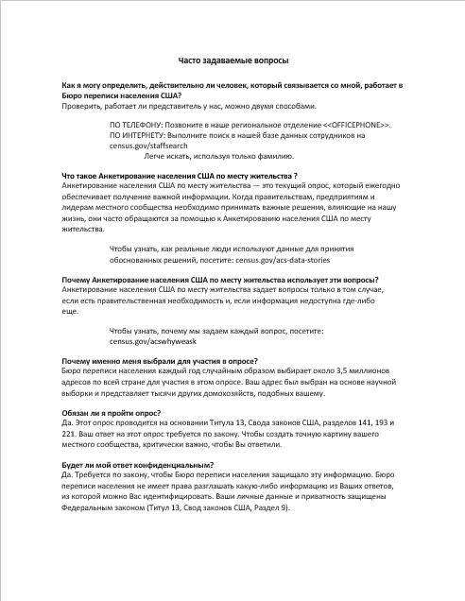

Attachment AS – Refusal, Simplified Chinese Page 1

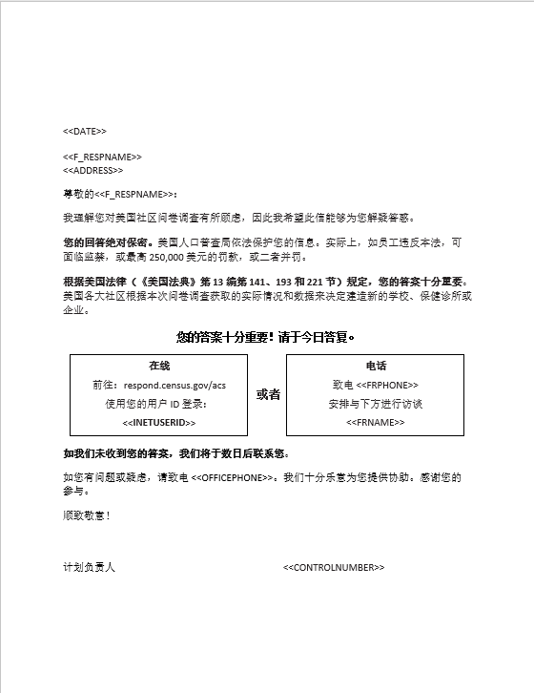

Attachment AS – Refusal, Simplified Chinese Page 2

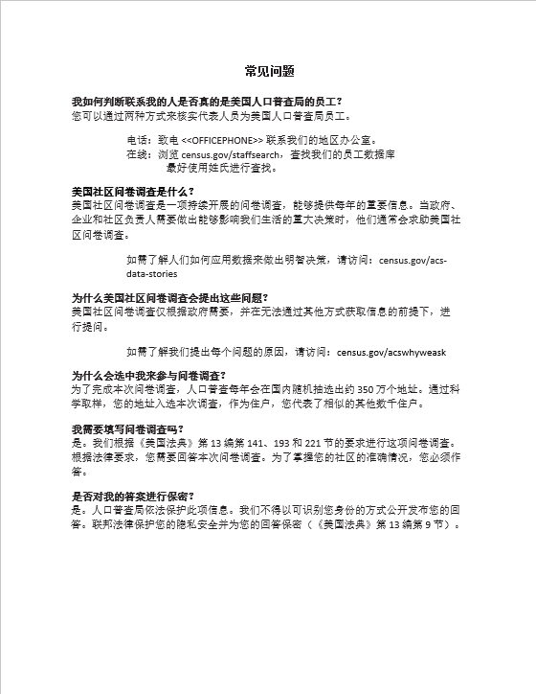

Attachment AT – Refusal, Korean Page 1

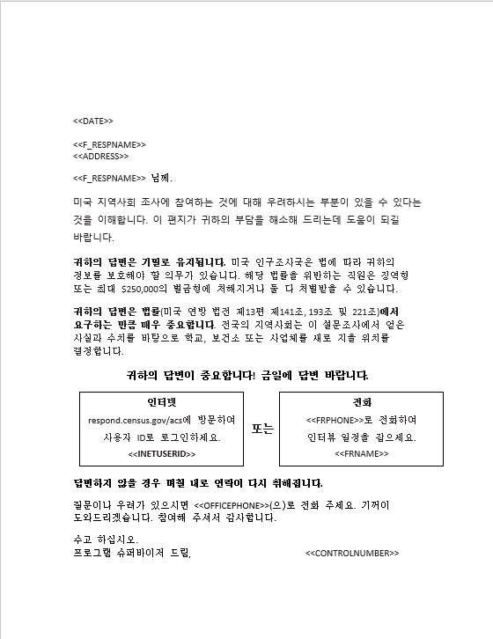

Attachment AT – Refusal, Korean Page 2

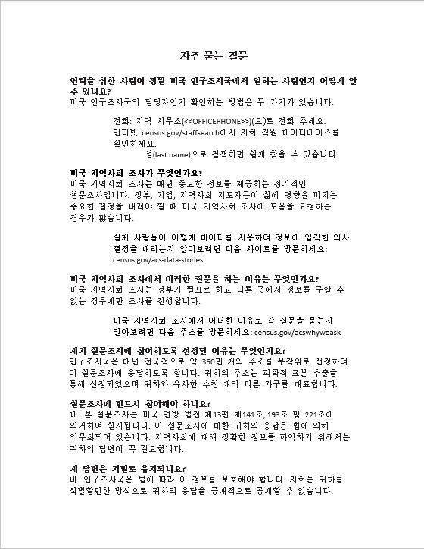

Attachment AT – Refusal, Korean Page 3

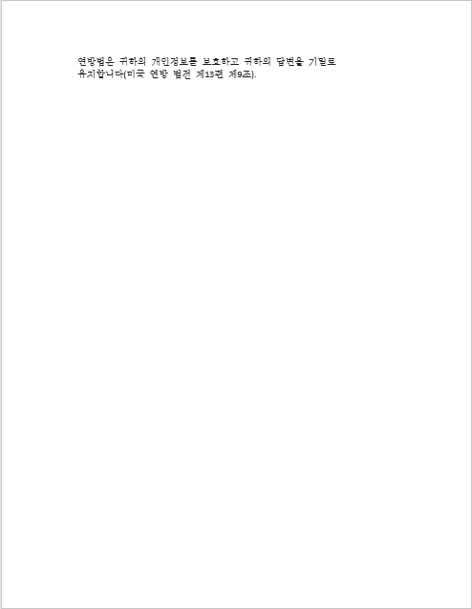

Attachment AU – Refusal, Vietnamese Page 1

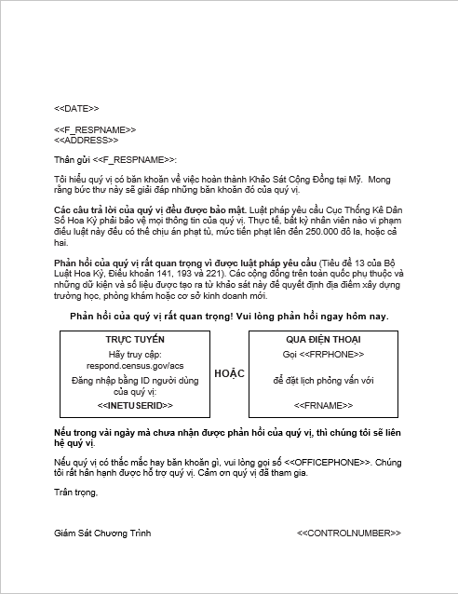

Attachment AU – Refusal, Vietnamese Page 2

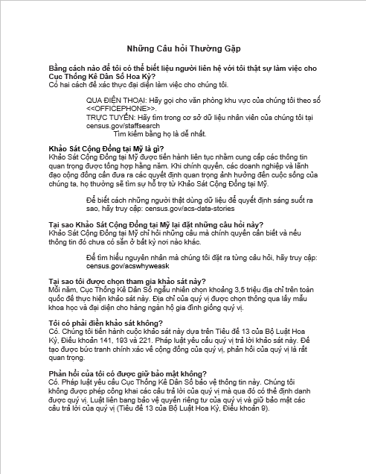

Attachment AV – Refusal, Russian Page 1

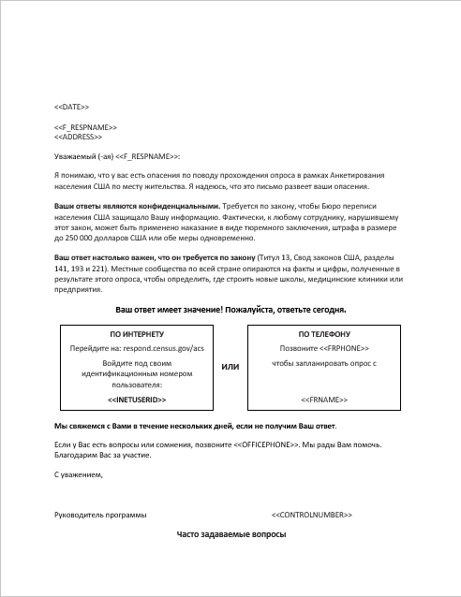

Attachment AV – Refusal, Russian Page 2

