FINRED Navigation Study
Research Plan

Research Details

Methodology

Card sorting is a method used to help design or evaluate the information architecture of a site. In a card sorting session, participants organize topics into categories that make sense to them, and they may also help you label these groups. In order to best identify how FINRED’s audience would navigate to and through material on the FINRED website, this study will involve two rounds of card sorting as well as two different methods:
- Hybrid: Respondents group cards using FINRED’s existing category labels, but have the option to add or rename categories.
- Closed: Respondents sort cards into existing categories, which will be determined by the results of the hybrid study.

For this research, Round 1 respondents will participate in the hybrid experience. Round 2 respondents will participate in a closed card sort based on the findings from Round 1.

Each round will have 45 unique participants. (We will recruit 60 for each round to ensure that we have a big enough sample of accurate and complete responses.)
- 15-minute, unmoderated sessions
- Active military service members and spouses
  - 15 service members
  - 15 military leaders
  - 15 military spouses/eligible partners
- Each respondent will participate in an individual session.
- Device to be used: Desktop (Card sorting exercise cannot be completed on mobile devices.)
- The screener and the study are conducted in the same step. (Participants will be screened, selected and immediately sent the study to complete).

Study Plan and Communication Materials

Recruitment
The following is an email template inviting participants to participate in the research.
Hello!
We are currently seeking military service members and military family members for a navigation study on the topic of financial resources, focusing on website labels and navigation.
​
Format: Unmoderated DESKTOP
Time Commitment: 10-15 minutes
Compensation: $15
To determine if you qualify for a needed segment, please click the link to begin our online screener: [LINK FOR SURVEY]. The online screener is completely voluntary, and you can choose to close/end the online screener at any time.
If your qualifications/experiences match what is needed for the study, you will be redirected to complete the study on our research platform. If you are not redirected, it likely indicates that one of your demographic segments has been filled or that your experience does not match what is currently needed.

​​​​​​​​​​We appreciate your time and interest!

Thank you,
[RECRUITER NAME]

Study
The following messages will be displayed on the participant’s screen:

Welcome Message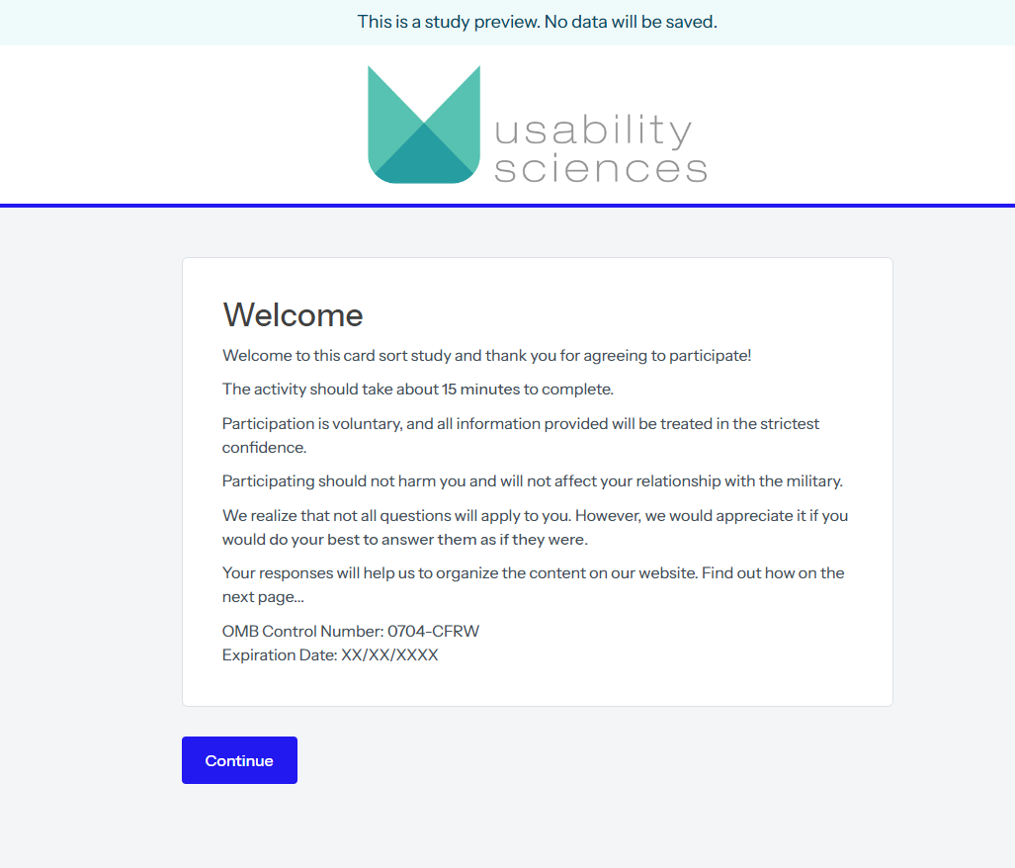

Instructions (for the Respondents)
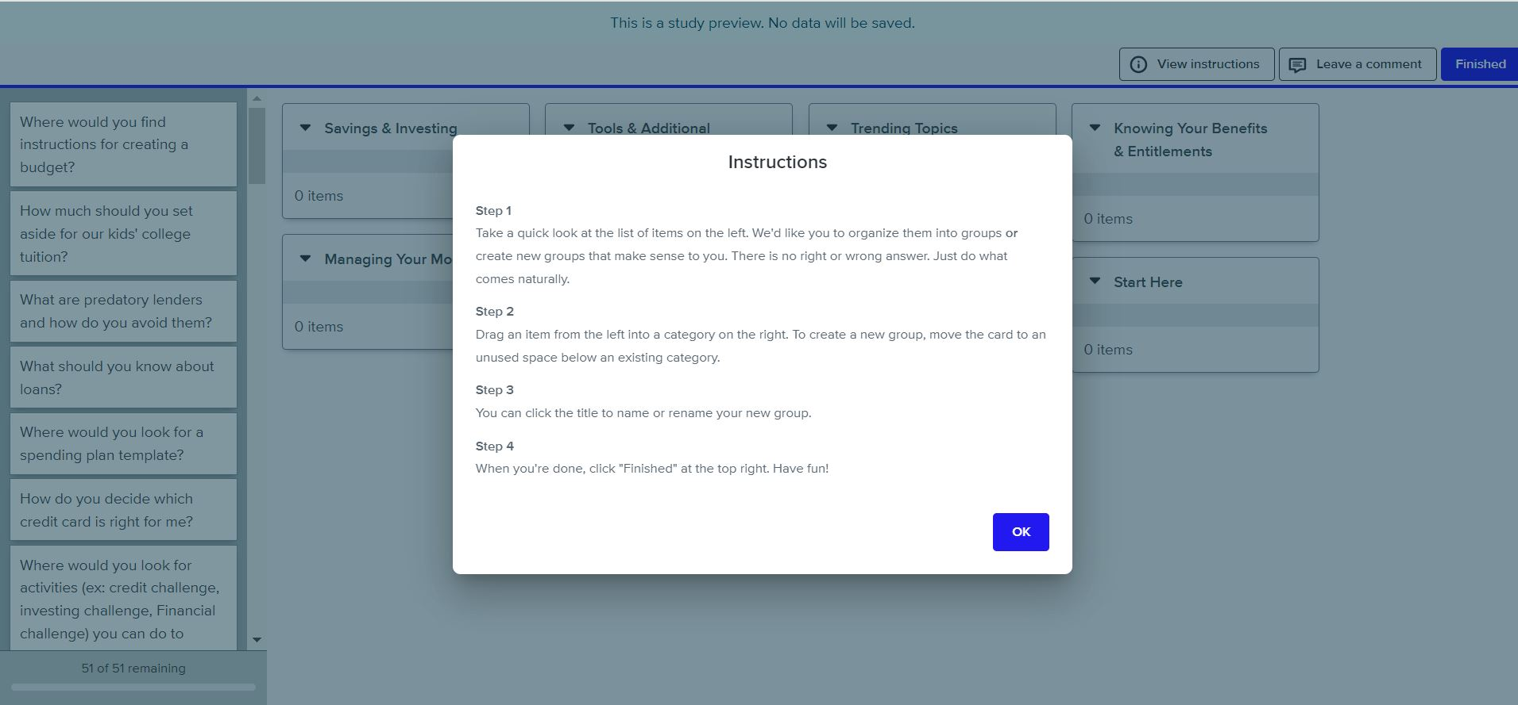

Study Layout
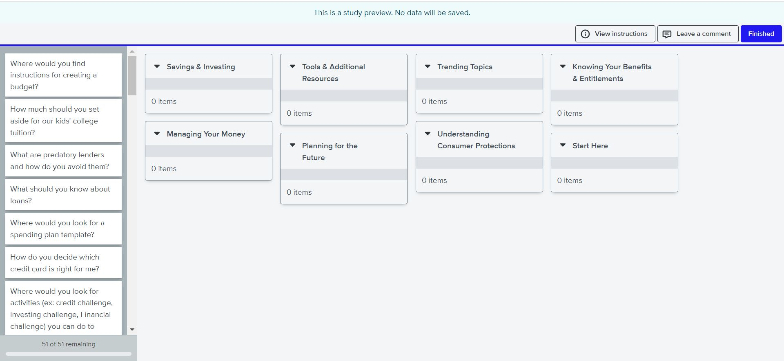

Open Ended Questions
After sorting the cards, participants will answer the following questions:
- Which, if any, topics did you struggle with the most? [Check all that apply.]
- What made grouping these topics difficult? [open-text response]

Post Study
Participants will then navigate to a screen with the following message:

All done, awesome! Thanks again for your participation. Your feedback is incredibly useful in helping to determine how our content should be organized, so we can make our website easier to use.
You may now close this window or navigate to another web page.

-------End Study-----

