**We want to know what it’s like to work here.**

Understanding our teams’ experiences with safety, communication and teamwork will help us get to know our culture better. It will also help us address complex issues like team burnout, patient safety and staff turnover more effectively.

**Your voice matters.**

**Take the anonymous SCORETM**

**culture and engagement survey, today!**

Help us better understand your work experiences, so we can learn about what we do well and where we can improve!

**Use this QR Code to access the survey**

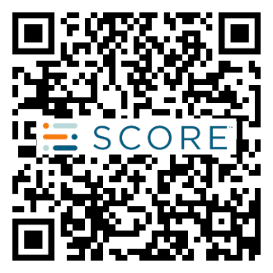

Insert

QR Code

SCORETM (Safety, Communication, Operational Risk, Resilience/Burnout, Engagement) is a highly validated survey tool that measures the culture and engagement of a healthcare organization’s workforce. SCORE helps leaders and teams improve the health of a work setting’s culture, which ensures a team can work together to address complex issues like patient safety, quality and burnout more effectively.

­­