COMPLETION AND CARRYOVER REPORT for GENERIC ICR 0920-1282

Initial period of approval for generic ICR 0920-1282: January 2020 – January 2023.
Requested period of approval for Revision ICR: January 2023 – January 2026 (estimated).
This report provides a summary of GENICs that were approved in the 2020-2022 timeframe and provides burden and response estimates for continuing these data collections in the next period of approval (est. January 2023 – January 2026). Finally, this report shows how these estimates were incorporated into the total burden request for the next period of approval.

UTILIZATION OF THE 0920-1282 GENERIC DURING THE INITIAL PERIOD OF APPROVAL (JANUARY 2020 – JANUARY 2023)
Generic ICR No. 0920-1282 was initially approved for 105,000 burden hours over 3 years. Six GENICs (representing 5* data collections] were approved and used 43,549 burden hours.
*One data collection (GENIC) was revised and resubmitted.

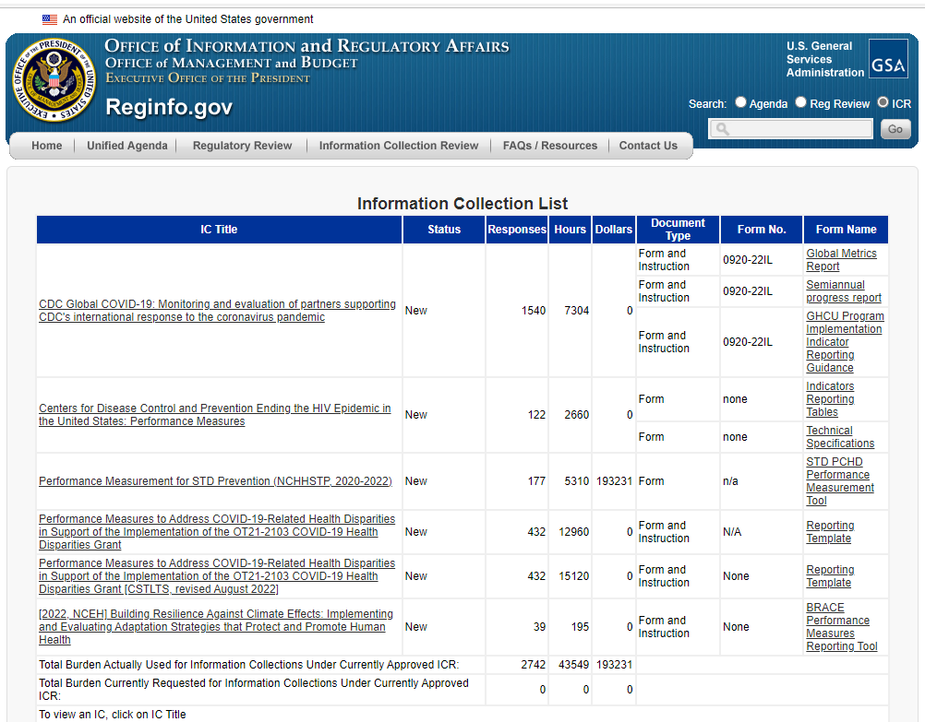

INFORMATION COLLECTION HAS BEEN COMPLETED FOR THE FOLLOWING GENICs
- None.

CONTINUATION OF PREVIOUSLY APPROVED COLLECTIONS
At CDC/ATSDR, grants and cooperative agreements are usually funded for multiple years, thus, there is a need to continue performance monitoring for previously approved GENICs in the next approval period (apx. January 2023 – January 2026).
The tables below show how CDC calculated burden and response estimates for carryover GENICs and the impact of these projects on the total burden and response estimates for the Revision ICR.

Continuation of Previously Approved Collections: Overview of Annualized and Total 3-Year Burden Hours
CDC Center, Institute, or Office (CIO) | Title | Changes | Annualized Burden Hours | Years of Collection, starting Jan. 2023 (est.) | Total Burden Hours Requested, 2023-2026 (est.)
NCHHSTP | Centers for Disease Control and Prevention Ending the HIV Epidemic in the United States: Performance Measures | None | 2,660 | 3 | 7,980
NCHHSTP | Performance Measurement for STD Prevention (NCHHSTP, 2020-2022) | None | 1,770 | 3 | 5,310
CSTLTS | Performance Measures to Address COVID-19-Related Health Disparities in Support of the Implementation of the OT21-2103 COVID-19 Health Disparities Grant [CSTLTS, revised August 2022] | None | 15,120 | 3 | 45,360
NCEH | [2022, NCEH] Building Resilience Against Climate Effects: Implementing and Evaluating Adaptation Strategies that Protect and Promote Human Health | None | 195 | 3 | 585
CGH | CDC Global COVID-19: Monitoring and Evaluation of Partners Supporting CDC’s International Response to the Coronavirus Pandemic | None | 7,304 | 3 | 21,912
 | TOTAL BURDEN HOURS ALLOCATED TO CONTINUE PREVIOUSLY APPROVED GENICs |  | 27,049 |  | 81,147

Continuation of Previously Approved Collections: Overview of Annualized and Total 3-Year Responses
CDC Center, Institute, or Office (CIO) | Title | Changes | Annualized Responses | Years of Collection, starting Jan. 2023 (est.) | Total Responses Requested, 2023-2025
NCHHSTP | Centers for Disease Control and Prevention Ending the HIV Epidemic in the United States: Performance Measures | None | 122 | 3 | 366
NCHHSTP | Performance Measurement for STD Prevention (NCHHSTP, 2020-2022) | None | 59 | 3 | 177
CSTLTS | Performance Measures to Address COVID-19-Related Health Disparities in Support of the Implementation of the OT21-2103 COVID-19 Health Disparities Grant [CSTLTS, revised August 2022) | None | 432 | 3 | 1,296
NCEH | [2022, NCEH] Building Resilience Against Climate Effects: Implementing and Evaluating Adaptation Strategies that Protect and Promote Human Health | None | 39 | 3 | 117
CGH | CDC Global COVID-19: Monitoring and Evaluation of Partners Supporting CDC’s International Response to the Coronavirus Pandemic | None | 1,540 | 3 | 4,620
 | TOTAL RESPONSES ALLOCATED TO CONTINUE PREVIOUSLY APPROVED GENICs |  | 2,192 |  | 6,576

New GENICs
CDC estimates that up to 40 CDC funded programs will be phased in over the next three-year project period. Programs may fund activities through a grant, cooperative agreement, or contract. There will be an approximate average of 35 awards (recipients) per program, and up to 875 recipients (also called awardees or respondents) across all participating programs (40 awardees x 35 awards per awardee = 875 recipients). The estimated burden per response is 40 hours. For purposes of burden estimation, CDC estimates semi-annual reporting (twice per year), although some programs may specify annual reporting (once per year). The estimated annualized number of responses is 1,750 (875 respondents x 2) and the estimated annualized burden is 70,000 hours (1,750 responses x 40 hours per response).

The annualized request for new GENICs is 1,750 responses and 70,000 burden hours.

New GENICs (2023 – 2026): Annualized Burden Estimates
Type of Respondents | Form Name | Number of Responses | Average burden per response (in hours) | Total burden (in hours)
CDC/ATSDR Award Recipients (new) | Performance Measures Project Information Collection Tool | 1,750 | 40 | 70,000

Over 3 years, the total capacity requested for new GENICs is 5,280 responses (1,750 x 3) and 210,000 burden hours (70,000 x 3).

New GENICs (2023 – 2026): Total Burden Estimates over 3-Year Period
Type of Respondents | Form Name | Number of responses | Average burden per response (in hours) | Total burden (in hours)
CDC/ATSDR Award Recipients (new) | Performance Measures Project Information Collection Tool | 5,250 | 40 | 210,000

SUMMARY OF ANNUALIZED AND 3-YEAR TOTALS: BURDEN HOURS AND RESPONSES, JAN 2023-JAN 2026 (EST)

SUMMARY OF ANNUALIZED RESPONSES REQUESTED, JANUARY 2023 – JANUARY 2026
Project Category (new or previously approved) | Responses Requested (annualized) | Responses Requested (3-year total)
New GENICs | 1,750 | 5,250
Continuation of previously approved GENICs | 2,192 | 6,576
Total | 3,942 | 11,826

SUMMARY OF ANNUALIZED BURDEN HOURS REQUESTED, JANUARY 2023 – JANUARY 2026
Project Category (new or previously approved) | Burden Hours Requested  (annualized) | Burden Hours Requested (3-year total)
New GENICs | 70,000 | 210,000
Continuation of previously approved GENICs | 27,049 | 81,147
Total | 97,049 | 291,147

SUMMARY IN BURDEN TABLE FORMAT
Type of Respondents | Form Name | Number of responses | Number of responses per respondent per year | Average burden per response (in hours) | Total burden (in hours)
CDC/ATSDR Award Recipients (new GENICs) | Performance Measures Project Information Collection Tool | 1,750 | 1 | 40 | 70,000
CDC/ATSDR Award Recipients (previously approved GENICs) | Performance Measures Project Information Collection Tool | 2,192 | 1 | Variable | 27,049
Total |  | 3,942 |  |  | 97,049

