**Attachment 3. Injury Control Research Centers (ICRC) Cooperative Agreement Management Platform (CAMP) Platform Screenshots**

**Injury Control Research Centers (ICRC) Grant Platform Homepage**

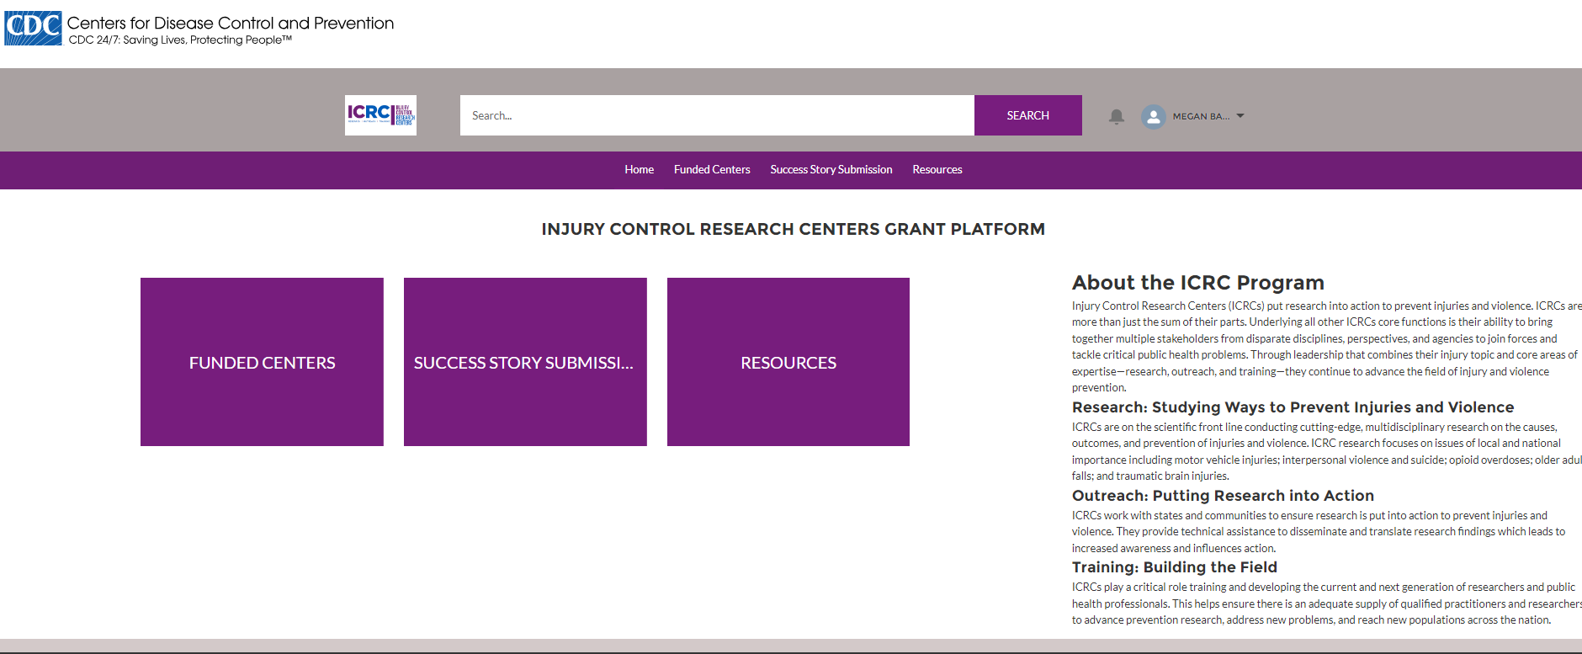

**ICRC Funded Centers list view**

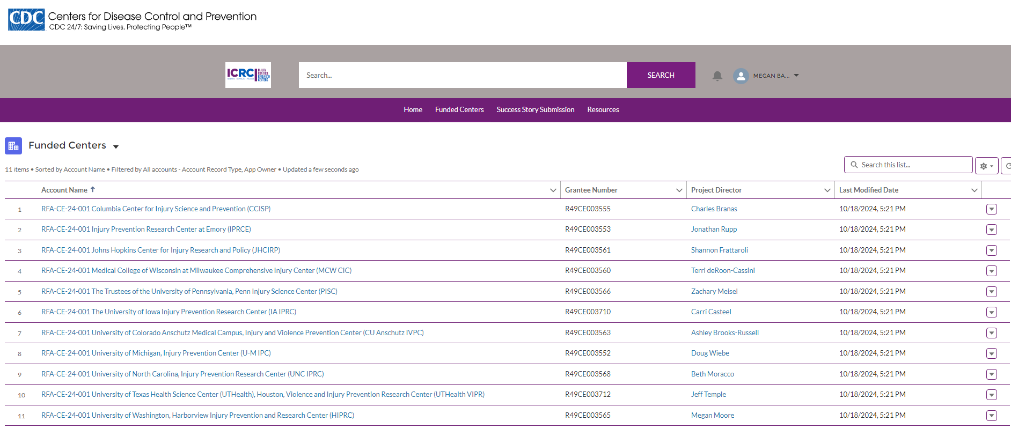

**ICRC work products page (with OMB form approval at top right, and public reporting burden time estimate at the bottom of the page)** 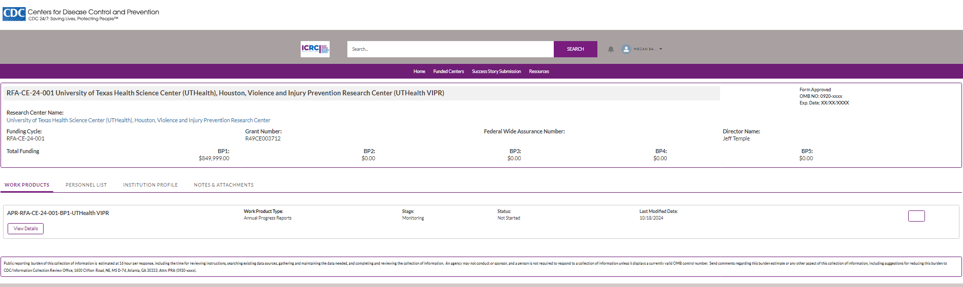

**ICRC work products detailed page** **(with OMB form approval at top right, and public reporting burden time estimate at the bottom of the page)** 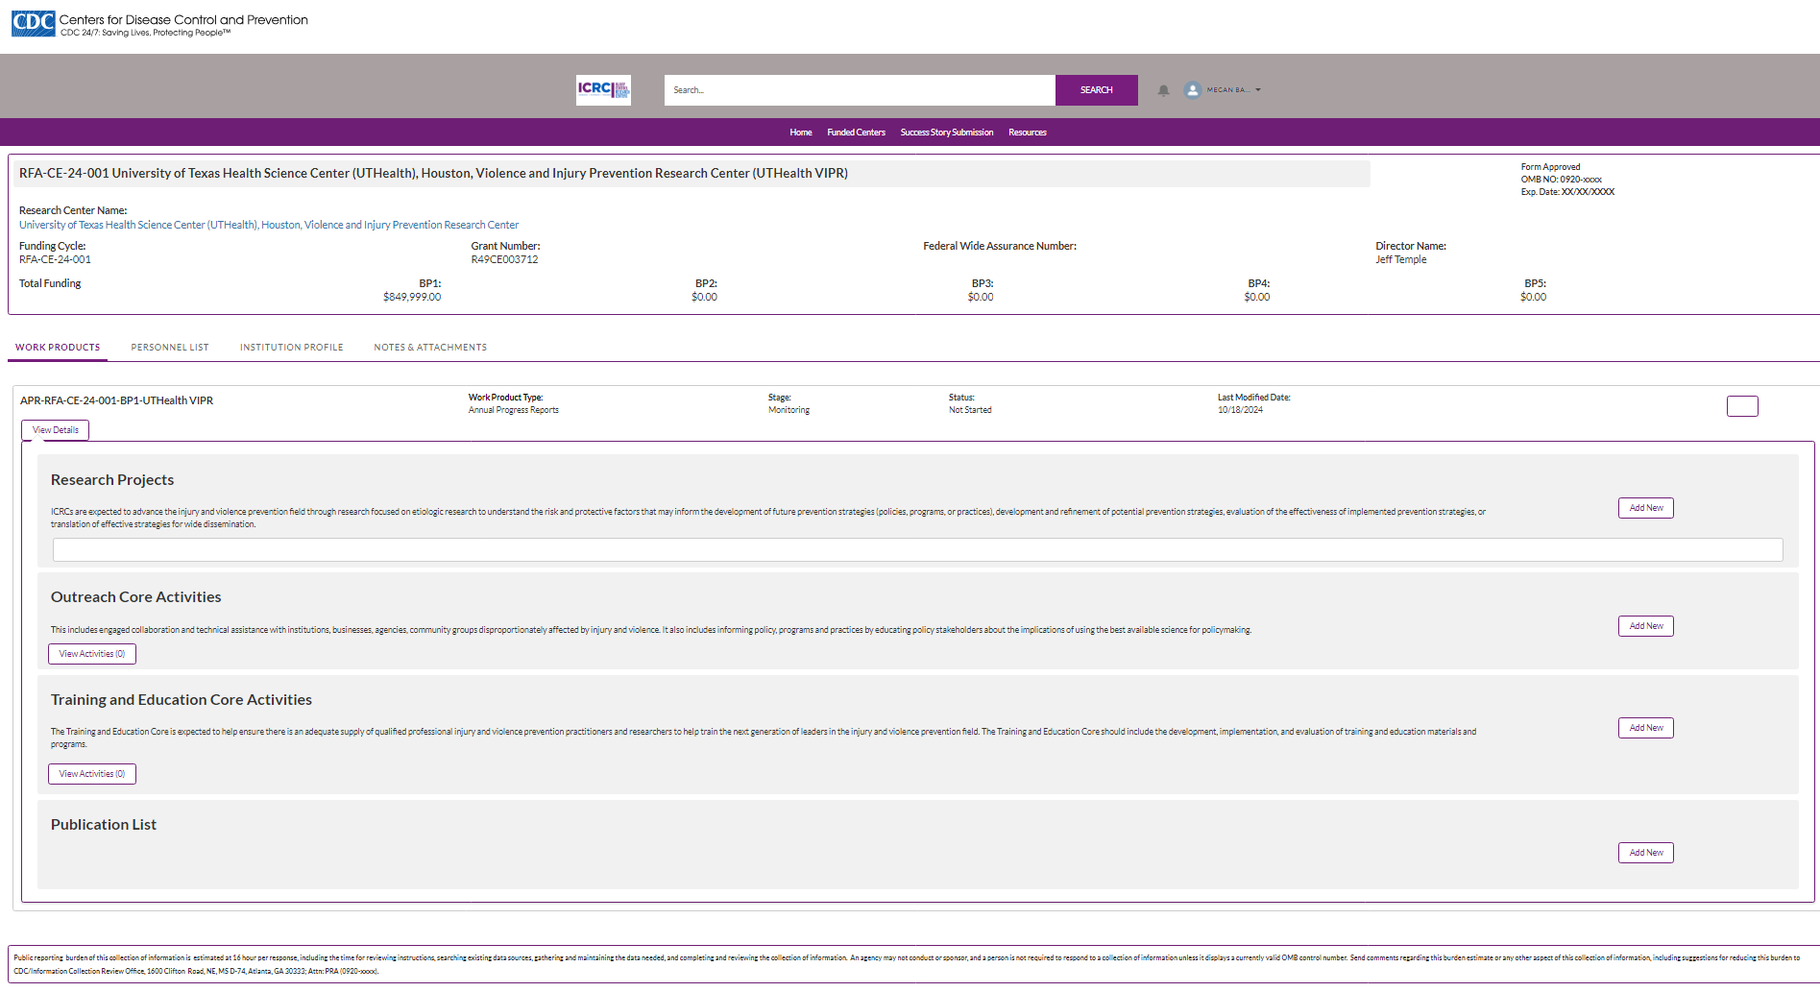

**ICRC add a research project details page 1**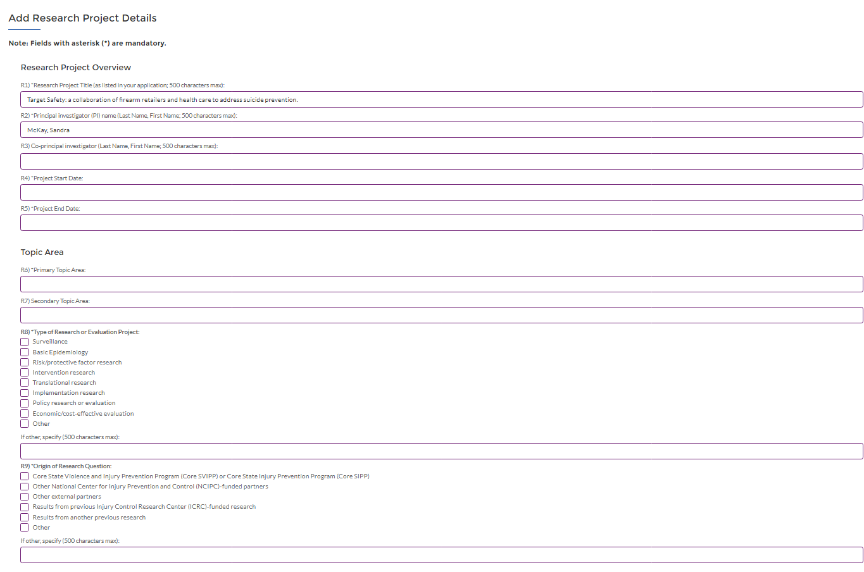

**ICRC add a research project details page 2**

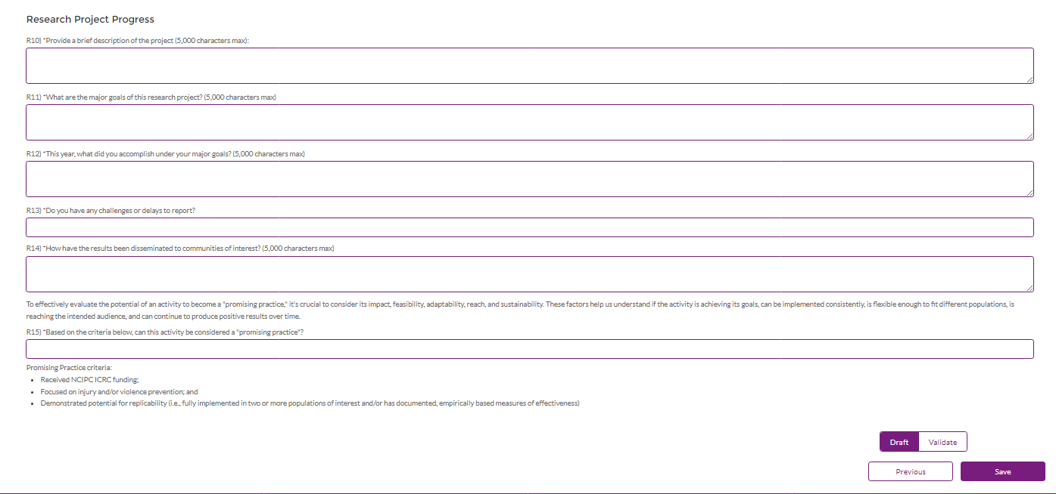

**ICRC add an outreach activity page**

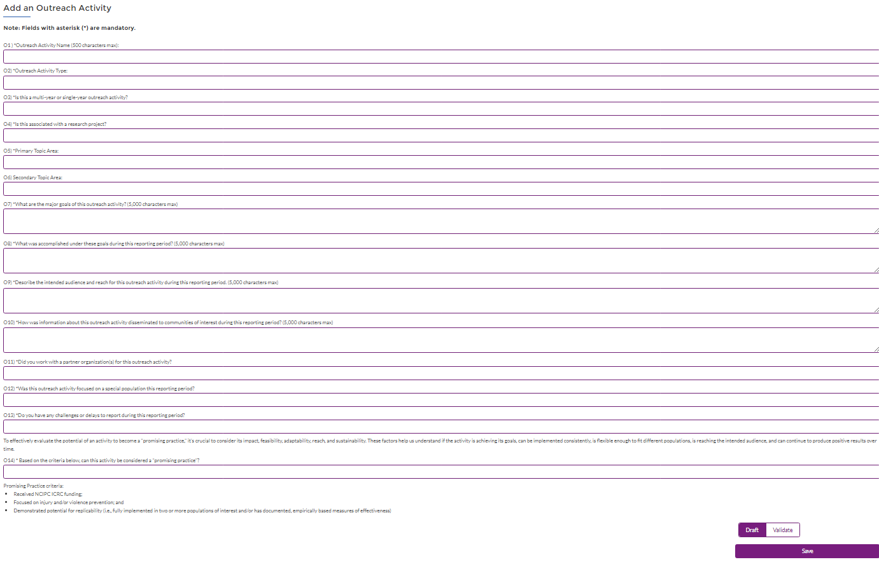

**ICRC add an Injury & Violence Prevention course page**

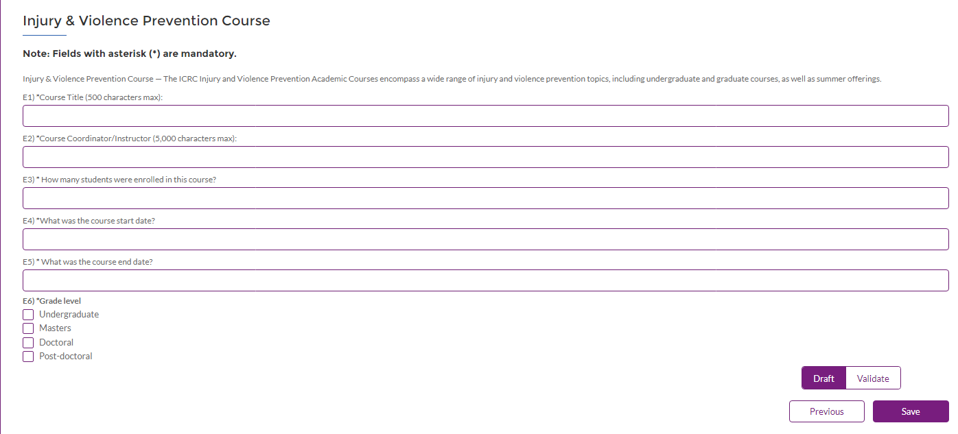

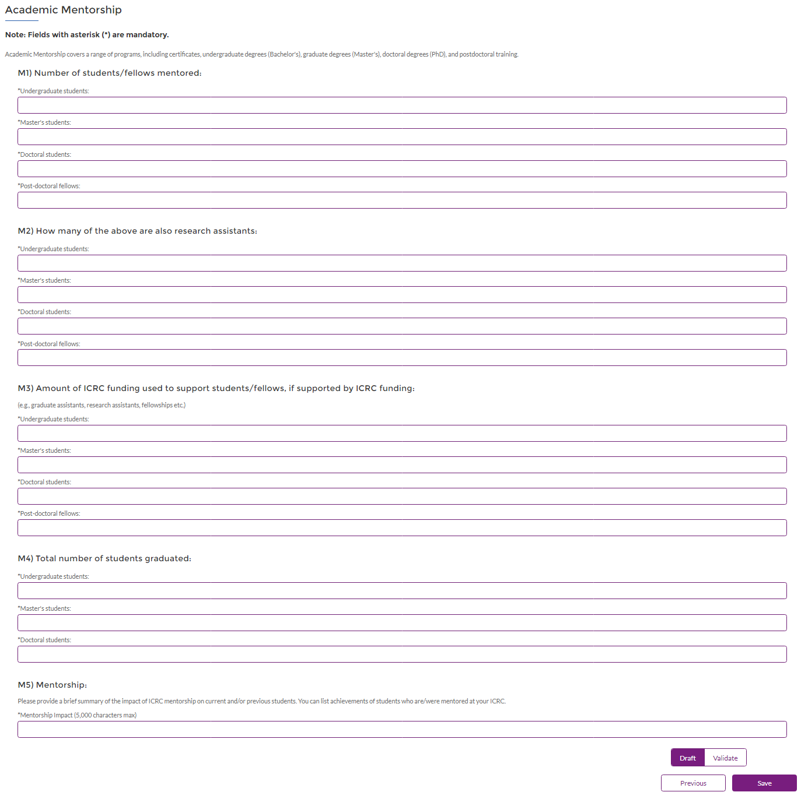**ICRC add Academic Mentorship page**

**ICRC add Other Training & Education Activities page**

