Operations, Maintenance, and Enhancements for OCSS Systems
System Framework
Portal User Page Flow
Version 4.1
March 11, 2024
Administration for Children and Families
Office of Child Support Services
330 C Street SW, 5th Floor
Washington, DC 20201
Revision History
Date | Revision | Section | Author
3/14/2024 | Updated instances of Office of Child Support Enforcement (OCSE) to Office of Child Support Services (OCSS), including web page images (figures). Template and editorial changes. | Version 4.1: Replaced figures | C. Stachlinski

Table of Contents
1 Registration 1-1
2 Activation 2-1
3 Log In 3-1
4 Profile Updates 4-1
5 Credential Management 5-1
6 General Pages 6-1
7 Chatbot 7-1
List of Figures and Charts
Figure 1-1: Welcome to the Child Support Portal 1-1
Figure 1-2: This Portal Page Is For You If 1-3
Figure 1-3: Child Support Portal User Registration, Step 1 1-4
Figure 1-4: Child Support Portal User Registration, Step 2 1-5
Figure 1-5: Child Support Portal User Registration, Step 3 1-6
Figure 1-6: Child Support Portal User Registration, Step 4 1-7
Figure 1-7: Child Support Portal User Registration, Step 5 1-8
Figure 1-8: Child Support Portal User Registration, Step 6 1-9
Figure 1-9: Child Support Portal User Registration Request Submitted 1-10
Figure 2-1: Log-In Certification 2-1
Figure 2-2: User Activation 2-2
Figure 2-3: Activation Confirmation 2-3
Figure 3-1: Log In 3-1
Figure 3-2: Log In – Enter Access Code 3-2
Figure 3-3: Child Support Portal Home Page 3-3
Figure 4-1: Profile Update 4-1
Figure 4-2: Profile Update Confirmation 4-2
Figure 5-1: Forgot User ID 5-1
Figure 5-2: Credential Management – Forgot User ID Confirmation 5-2
Figure 5-3: Log In – Forgot/Change Password 5-2
Figure 5-4: Forgot/Change Password 5-3
Figure 5-5: Forgot/Change Password – Challenge Questions 5-4
Figure 5-6: Forgot/Change Password – Reset Password 5-4
Figure 5-7: Change Password Confirmation 5-5
Figure 6-1: Timeout Warning 6-1
Figure 6-2: Session Timed Out 6-2
Figure 6-3: System Error 6-3
Figure 6-4: Account Locked (Credential Management and Activation Page) 6-4
Figure 6-5: Frequently Asked Questions 6-5
Figure 6-6: Contact Us 6-6
Figure 6-7: Security Alert – User Accepts Certificate 6-7
Figure 6-8: Disable Account Message 6-8
Figure 7-1: Chatbot Icon 7-1
Figure 7-2: Portal Virtual Assistant 7-2
Figure 7-3: Portal Virtual Assistant, Account Unlock – User ID 7-3
Figure 7-4: Portal Virtual Assistant, Account Unlock – Email Address 7-4
Figure 7-5: Portal Virtual Assistant, Account Unlock – Get Started 7-5
Figure 7-6: Portal Virtual Assistant, Account Unlock – Challenge Questions 7-6
Figure 7-7: Portal Virtual Assistant, Account Unlock – Challenge Questions 3-4 Correct 7-7
Figure 7-8: Portal Virtual Assistant, Account Unlock – Account is Unlocked 7-8
Figure 7-9: Portal Virtual Assistant, Password Reset – User ID 7-9
Figure 7-10: Portal Virtual Assistant, Password Reset – Email Address 7-10
Figure 7-11: Portal Virtual Assistant, Password Reset – Get Started 7-11
Figure 7-12: Portal Virtual Assistant, Password Reset – Challenge Questions 7-12
Figure 7-13: Portal Virtual Assistant, Password Reset – Challenge Questions 3-4 Correct 7-13
Figure 7-14: Portal Virtual Assistant, Password Reset – User Sent Email to Reset Password 7-14
Chart 1-1: Welcome to Child Support Portal 1-2
Chart 1-2: This Portal Page Is For You If Page 1-3
Chart 1-3: Enter User Affiliation 1-5
Chart 2-1: Log In Certification 2-2
Chart 2-2: User Activation 2-3
Chart 3-1: Log In 3-1
Chart 3-2: Log In – Enter Access Code 3-2
Chart 3-3: Child Support Portal Home Page 3-3
Chart 4-1: Profile Update 4-2
Chart 5-1: Forgot User ID 5-1
Chart 5-2: Log In – Forgot/Change Password 5-3
Chart 5-3: Log In Forgot/Change Password 5-3
Chart 5-4: Forgot/Change Password (Reset Password) 5-5
Chart 6-1: Frequently Asked Questions 6-6

Registration
This document describes the processes to submit a request for user registration to access the Child Support Portal (CSP or Portal).
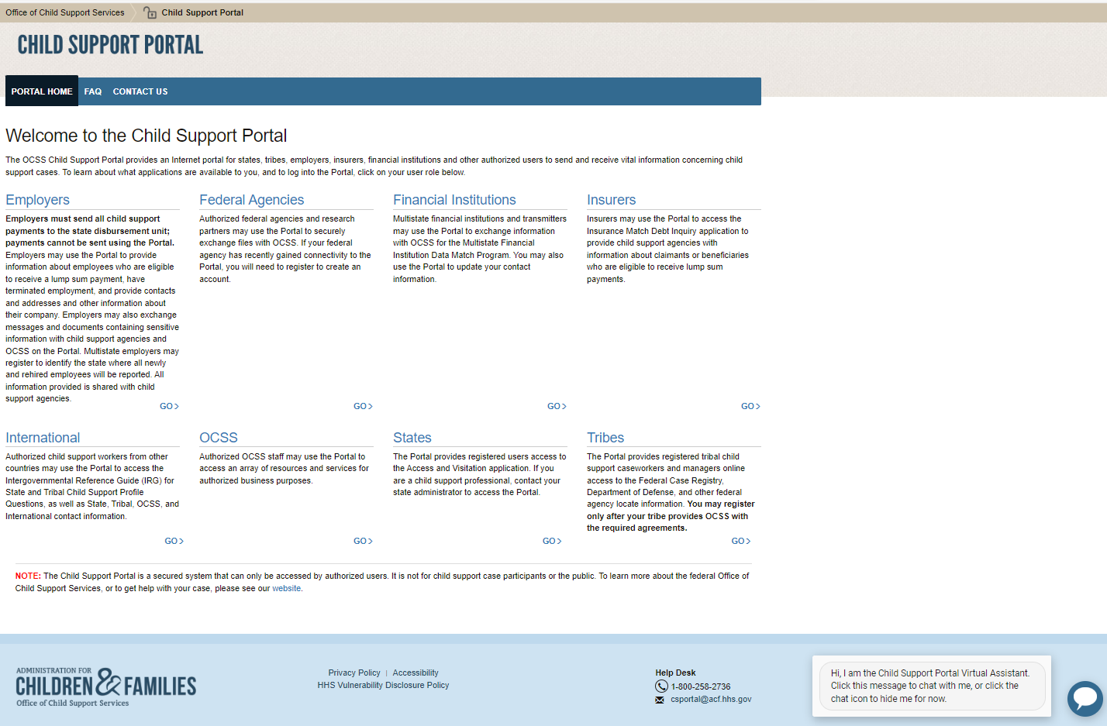
Figure 1-1: Welcome to the Child Support Portal
Notes:
- Figure 1-1 shows the header and footer for all CSP screens. The header may contain additional links (for example, Logout, Comments, FAQ, Contact Us, Print, Portal Home, and Chatbot); the footer may, too (for example, Office of Child Support Services, Privacy Policy, Accessibility, HHS Vulnerability Disclosure Policy, and the Help Desk email address).
- The footer also contains a small chat icon in the bottom right corner. This icon, which displays until the user accesses the Portal, offers help to the user to reset their password or unlock their account.
- To improve the readability of this document, the headers and footers on many web page images (figures) were excluded.
Chart 1-1 defines the functions available on the Welcome to the Child Support Portal page, including those in the header and footer.
Chart 1-1: Welcome to Child Support Portal
Link | Description
Portal Home | Indicates this is the home page for the Portal.
FAQ | Displays the Frequently Asked Questions (FAQ).
Contact Us | Displays the Help Desk Contact Page, which shows the phone number and email address for the Help Desk.
User Affiliations | Eight affiliations exist: Employers, Federal Agencies, Financial Institutions, Insurers, International, OCSS, States, and Tribes.  The user selects the affiliation they want to register for. A list of functions for the selected affiliation displays.
Office of Child Support Services | Opens a web page with details about the Office of Child Support Services (OCSS).
Privacy Policy | Displays the Child Support Portal Privacy Policy.
Accessibility | Opens a web page with details on the Administration for Children and Families’ commitment to making its websites accessible to the widest possible audience, including the disabled.
HHS Vulnerability Disclosure Policy | Opens a web page with details of the Health and Human Services Vulnerability Policy.
Help Desk | Shows the contact information for the Help Desk
GO | To select the user role the user is registering for, the user clicks GO in that user role’s section; an applications list displays for the selected user role. All roles take the user to the This Portal Page Is For You If page. The registration form is not role-specific at this point.
Chatbot icon | An interactive system to help a user change their password or unlock their account without Help Desk staff assistance.
Users click one of the user affiliations or GO to navigate to the This Portal Page Is For You If page; for an example, see Figure 1-2. On the left is a list of applications the user may be able to access, depending on the affiliation they select.
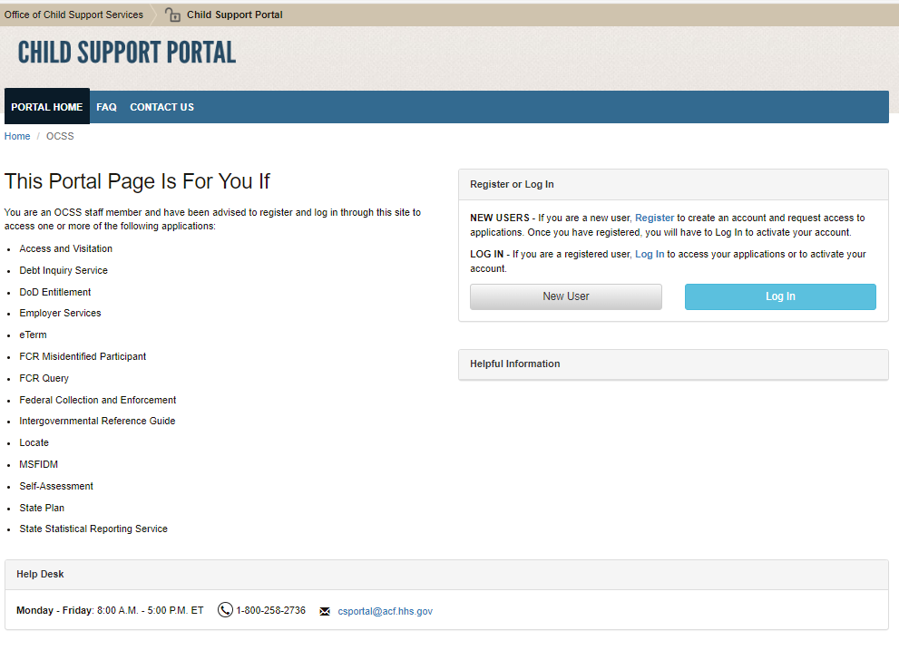
Figure 1-2: This Portal Page Is For You If
Chart 1-2 defines the functions available on the This Portal Page Is For You If page.
Chart 1-2: This Portal Page Is For You If Page
Link | Description
This Portal Page Is For You If | Displays a list of functions available to the user role the user selected
New User | Opens the Child Support Portal User Registration page
Log In | Opens the Child Support Portal Log In page
Helpful Information | Displays links to documents or websites that may be helpful when using the Portal
In the Register or Login box, the user clicks New User. The Child Support Portal User Registration page opens; see Figure 1-3.
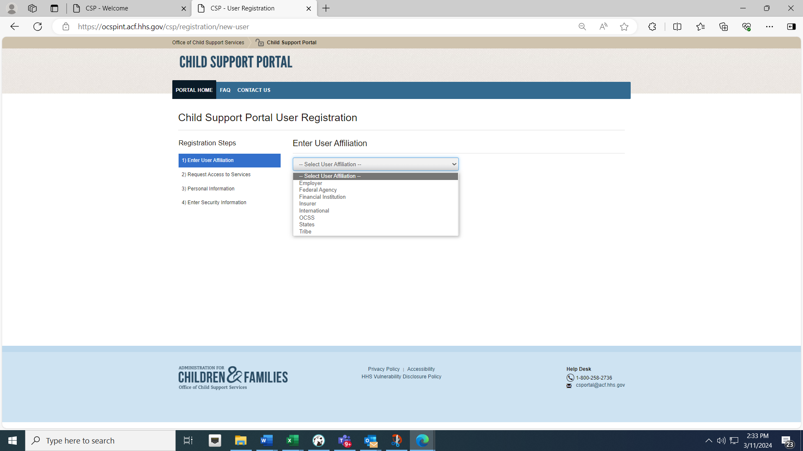
Figure 1-3: Child Support Portal User Registration, Step 1
To select an affiliation from the list of affiliations, the user clicks Enter User Affiliation to select the specific affiliation. For this example, the user clicked OCSS.
Depending on the affiliation selected, a new section with sub-groups may appear requesting more information. Continuing the above example, the Enter OCSS Sub-Group Information field displays; see Figure 1-4.
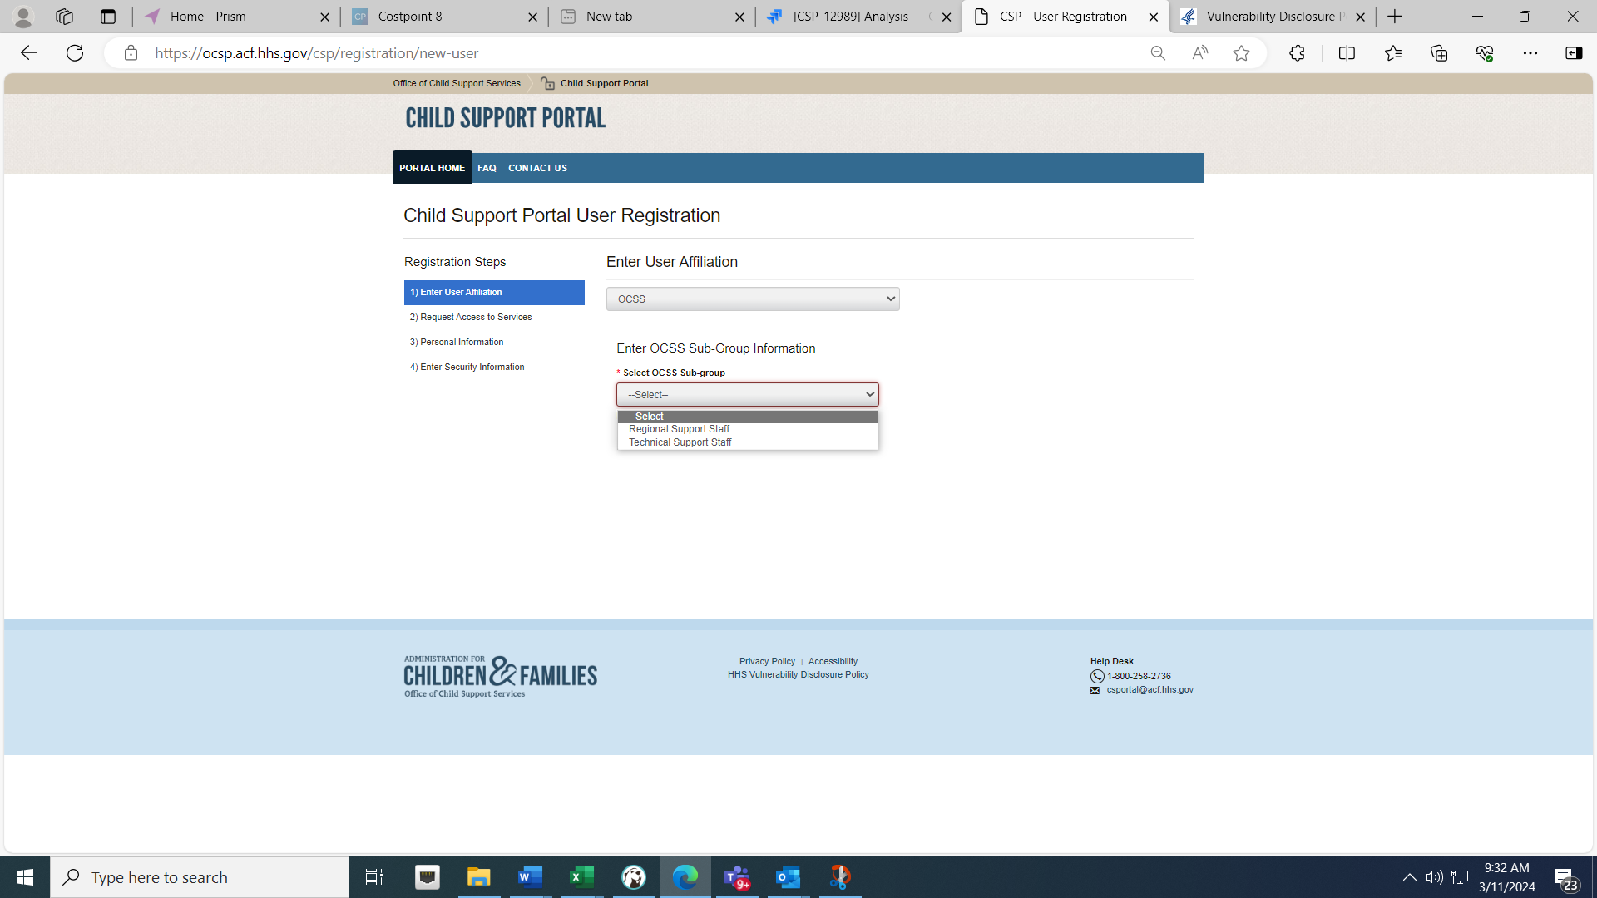
Figure 1-4: Child Support Portal User Registration, Step 2
Chart 1-3 defines the functions available on the Enter User Affiliation page.
Chart 1-3: Enter User Affiliation
Link | Description
Enter User Affiliation | Opens a list of user affiliations.
Enter OCSS Sub-Group Information | In this OCSS user affiliation example above, clicks Regional or Technical Support Staff.  Selections available for other affiliations vary from the example; see the next row.
Sub-Groups for Other Affiliations (Information requested for the other user types) | - Employer, Insurer, and Financial Institution: The user must enter the FEIN.  - Federal Agency: The user must enter the agency name.  - Tribe: The user must enter the tribe name.  - International: The user must enter the country name.  - State: The user must enter the state name.
After the user makes selections in the affiliation list, the page expands to display a list of functions in the Request Access to Services section; Figure 1-5 shows an example of this page.
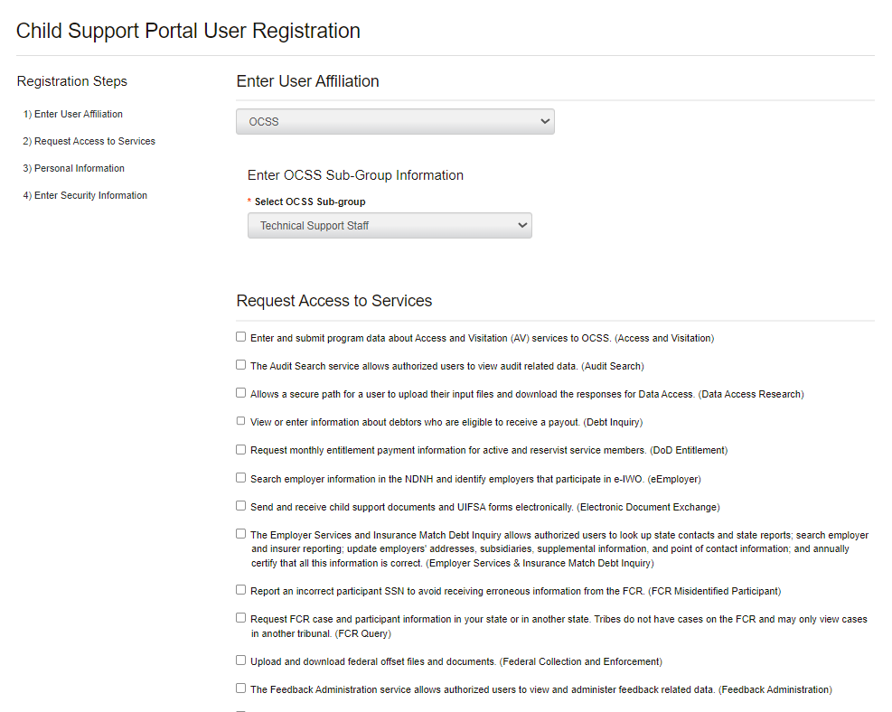
Figure 1-5: Child Support Portal User Registration, Step 3
The user clicks the functions they want to access. The next section the user completes is Enter Personal Information and Work Location; see Figure 1-6.
Required fields have red asterisks (*) before their labels.
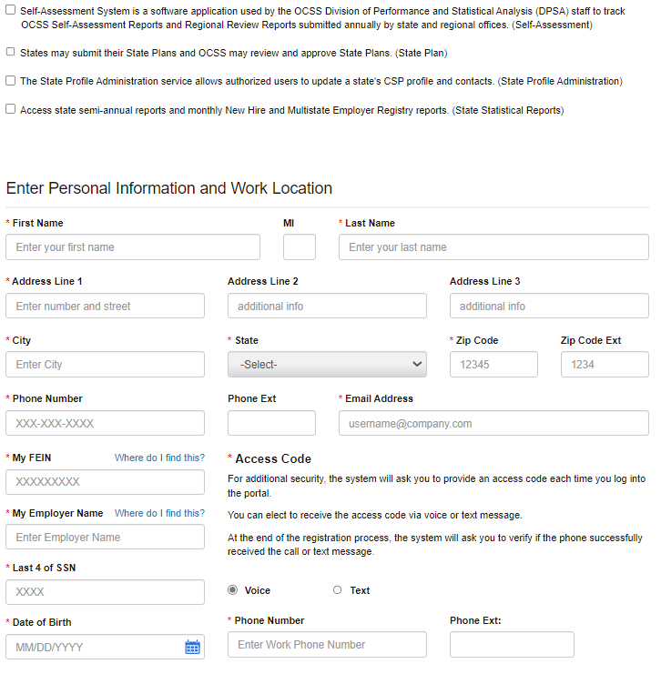
Figure 1-6: Child Support Portal User Registration, Step 4
The user completes the required fields in the Access Code sub-section. For enhanced security, OCSS requires users to enter an access code each time they log in. Users can select one of two options to receive the access code: Voice, a phone call, or Text, a text message on their cell phone.
The user also completes the required Security Information fields; Figure 1-7 shows an example of this page.
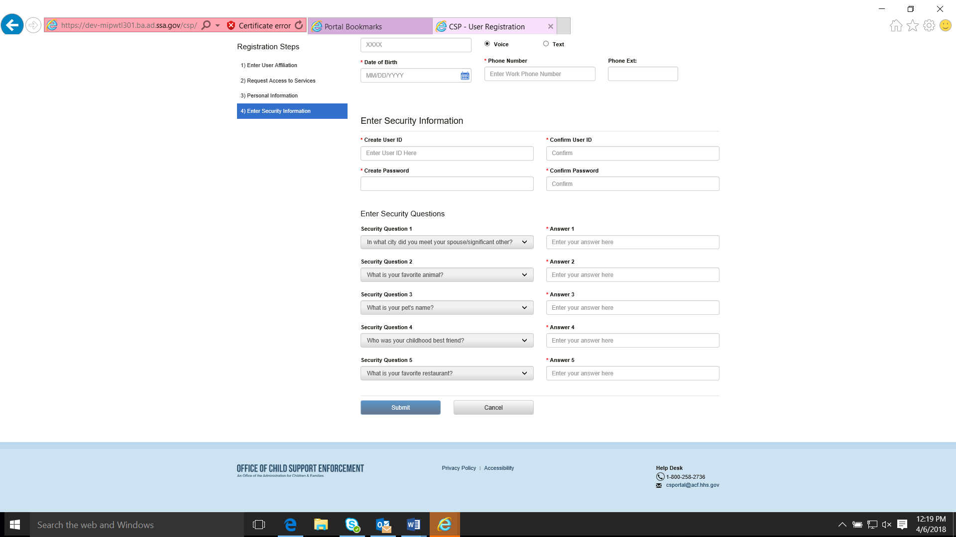
Figure 1-7: Child Support Portal User Registration, Step 5
To submit their registration, the user clicks Submit.
Figure 1-8 shows a summary of the entered information.
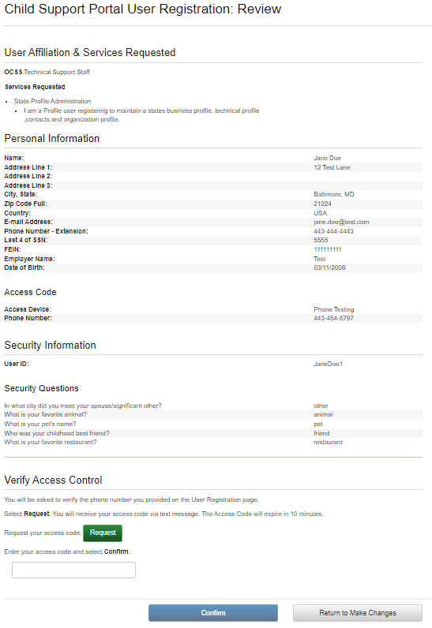
Figure 1-8: Child Support Portal User Registration, Step 6
To update any information, the user clicks Return to Make Changes and then makes the changes.
To receive a call or text message to enter an access code, the user clicks Request:
- As part of two-factor authentication, the system calls the user (Voice option) or sends a text message (Text option) with an access code to the phone number selected on the Child Support Portal User Registration page; see Figure 1-6.
- The user must enter the access code to complete the registration process.
- When the user clicks Confirm, the Child Support Portal User Registration Request Submitted page displays to inform the user their registration is complete; Figure 1-9 shows an example of this page.
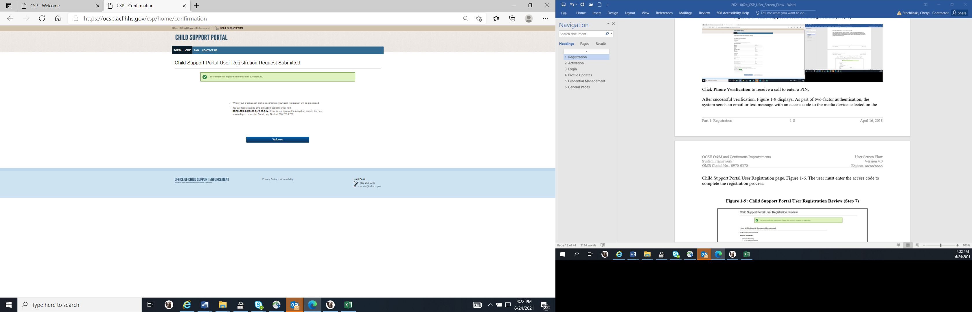
Figure 1-9: Child Support Portal User Registration Request Submitted
When the user clicks Welcome, the Welcome to the Child Support Portal page opens. The next part, “Activation,” covers activating the user’s account.
This portion of registration is complete. The Help Desk emails the user an access code so that the user can complete the activation process and log into the Portal.

Activation
On the Portal Home tab on the Welcome to the Child Support Portal Page (see Figure 1-1), the user clicks a user affiliation to open the This Portal Page Is For You If page. Figure 1-2 on page 1-3 shows this page; Chart 1-2 on page 1-3 defines the functions available.
In the Register or Login box, the user clicks Log In; the Log In Certification page opens. Figure 2-1 shows this page.
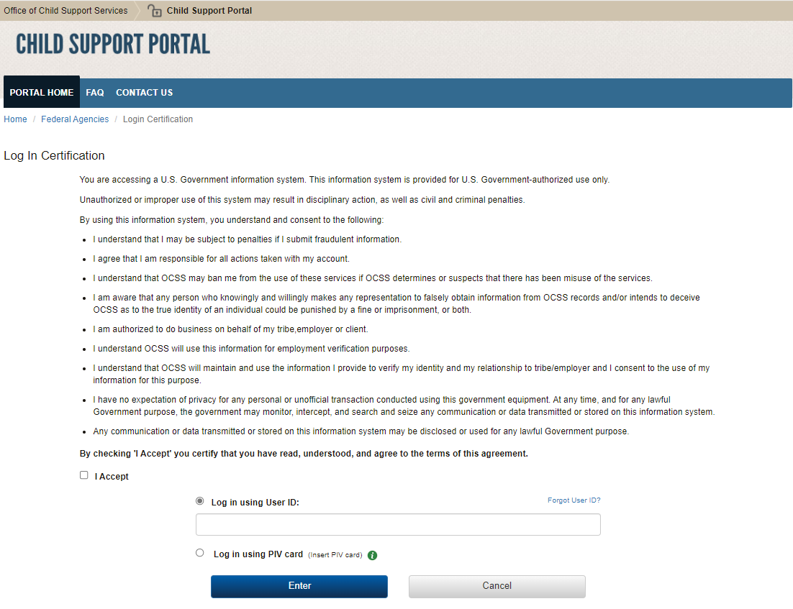
Figure 2-1: Log-In Certification
The user takes the following steps:
- Selects the I Accept check box to accept the terms of the agreement
- Enters their user ID
- Clicks Enter
Chart 2-1 defines the functions available on the Log In Certification page.
Chart 2-1: Log In Certification
Element | Description
I Accept | Certifies the user agrees to the terms of the agreement
Log In using User ID | Allows the user to access the Portal by entering a user ID
Forgot User ID? | Opens the Forgot User ID page
Log In using PIV card | Allows the user to access the Portal using a PIV card (internal users only)
Cancel | Cancels the login attempt and returns to the This Portal Page Is For You If page
i (information link) | Provides more information about PIV card access
When the user clicks Enter, the User Activation page opens for the user to complete their account activation. Figure 2-2 shows this page.
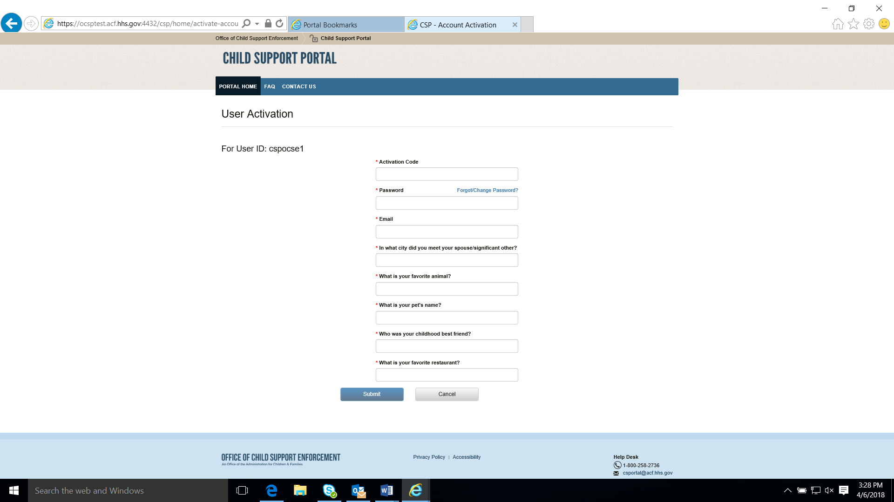
Figure 2-2: User Activation
Chart 2-2 defines the functions available on the User Activation page.
Chart 2-2: User Activation
Element | Description
User ID | Displays a system-generated user ID
Activation Code | Allows the user to enter the activation code the Portal sent
Password | Allows the user to enter a password
Forgot/Change Password | Opens the Forgot/Change Password page to reset the password
Challenge Questions | Requires the user to answer the questions
When the user clicks Submit, the Activation Confirmation page opens. Figure 2-3 shows an example with a message confirming the user’s account is activated.
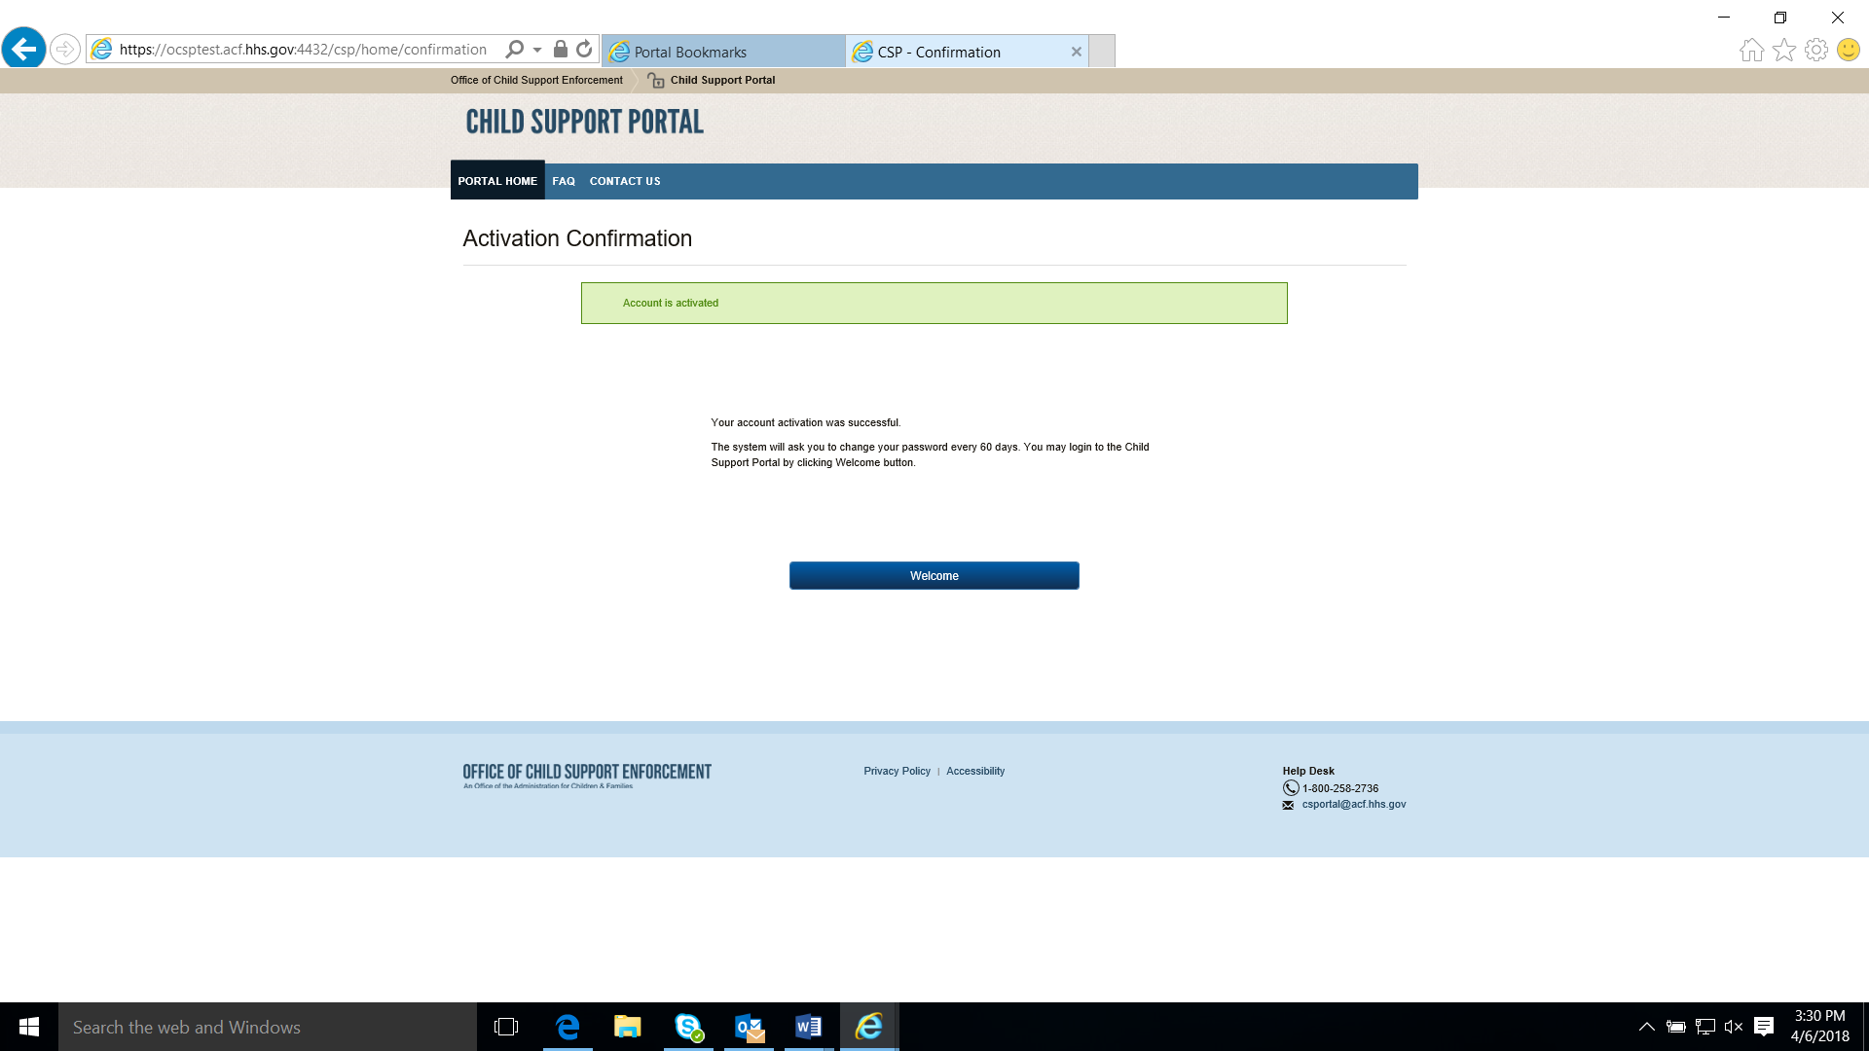
Figure 2-3: Activation Confirmation
When the user clicks Welcome, the Welcome to the Child Support Portal page opens.

Log In
This Portal Page is for You If page is where the user initiates the logging-in process. Figure 1-2 on page 2-1 shows this page; Chart 1-2 on page 1-3 defines the functions available on this page.
In the Register or Log In section, when the user click Log In, the Log In Certification page opens. Figure 2-1 on page 2-1 shows this page; Chart 2-1 on page 2-2 defines the functions available on this page.
The user takes the following steps:
- Selects the I Accept check box to accept the terms of the agreement
- Enters their user ID
- Clicks Enter
When the user clicks Enter, the Log In page opens. Figure 3-1 shows an example of this page.
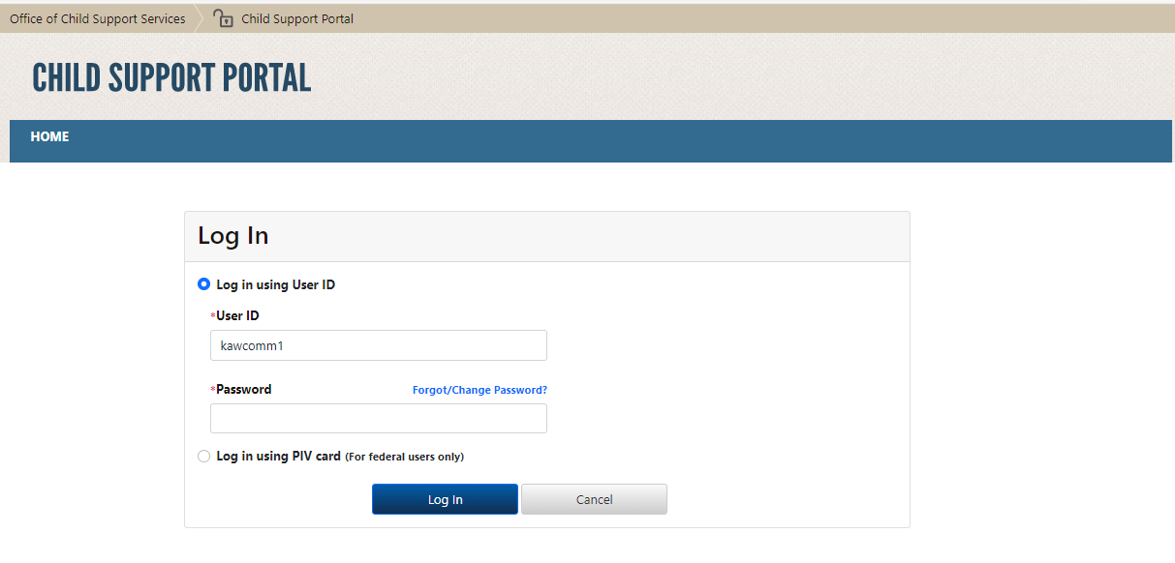
Figure 3-1: Log In
Chart 3-1 defines the functions available on the Log In page.
Chart 3-1: Log In
Element | Description
User ID | Shows the user ID from the This Portal Page Is For You If page (see Figure 1-2); the user can change this
Password | Enters a password
Forgot/Change Password? | Opens the Forgot/Change Password page
The user enters their password and then clicks Log In.
Figure 3-1 shows the Log In – Enter Access Code page.
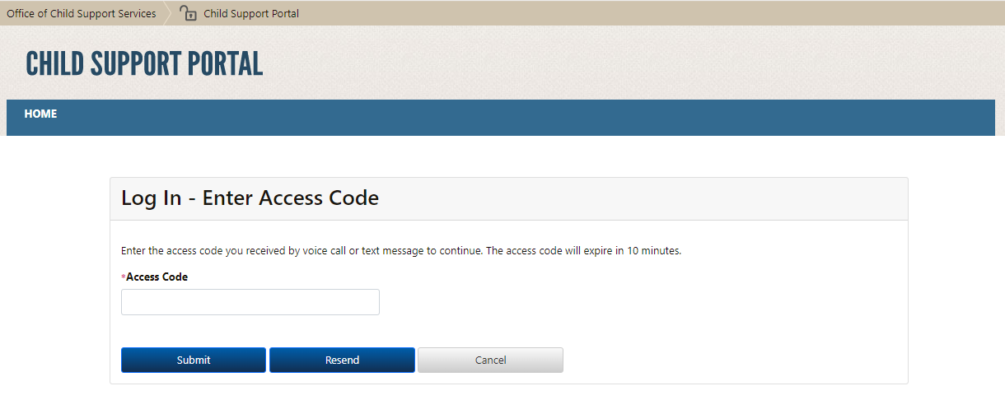
Figure 3-2: Log In – Enter Access Code
Chart 3-2 defines the function available on the Log In – Enter Access Code page.
Chart 3-2: Log In – Enter Access Code
Element | Description
Access Code | Enters the access code received by email or text (chosen during registration)
The user enters their access code received by voice (phone call) or a text message and then clicks Submit.
The Child Support Portal Home page opens; Figure 3-3 shows an example of this page.
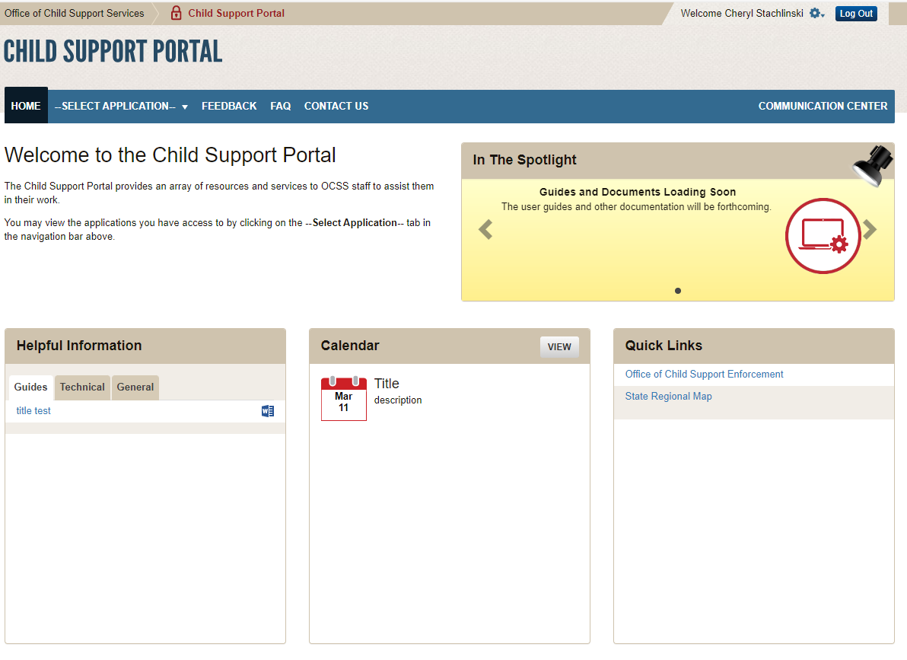
Figure 3-3: Child Support Portal Home Page
Chart 3-3 defines the functions available on this page.
Chart 3-3: Child Support Portal Home Page
Element | Description
Welcome <User Name> | Allows users to update their account profile
Broadcast Messages | Shows messages of interest for Portal users of all affiliations, such as availability, upcoming maintenance, and changes
Secure Home | Labels the Portal Home Page
Select Application | Lists Portal application the user has privileges for and can select
Feedback | Submits feedback about the Portal or a Portal application
FAQ | Displays FAQs about the Portal
Contact Us | Displays Help Desk contact information
In the Spotlight | Displays information about new items or events on the Portal
Helpful Information | Shows documents provided for more information
Calendar | Displays events of interest to users
Quick Links | Provides links to reference information

Profile Updates
When the user clicks Profile Update on the left menu of the Child Support Portal Home page (see Figure 3-3 on page 3-3), the Profile Update page opens; Figure 4-1 shows an example of this page.
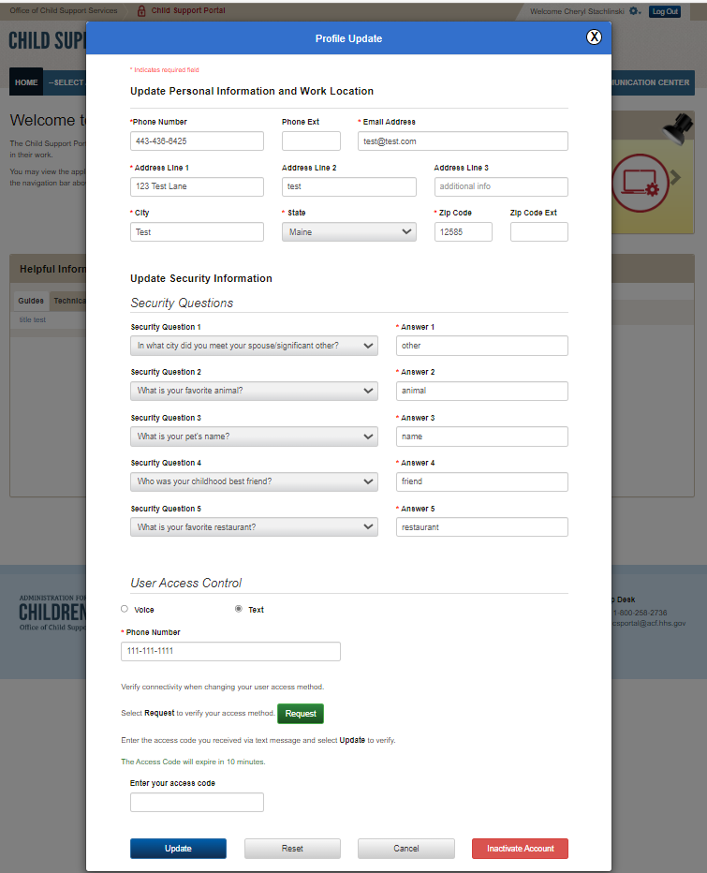
Figure 4-1: Profile Update
Chart 4-1 defines the information a user can add or update on this page.
Chart 4-1: Profile Update
Element | Description
Update Personal Information and Work Location Section | Displays the user’s personal and work location information
Update Security Information Section | Displays the challenge questions the user selected and the responses the user provided
User Access Control Section | Displays access code options – Voice or Text – used for two-factor authentication
Request | Requests an access code
Update | Saves and confirms the account update
Reset | Resets fields to the previously saved information or, if nothing was saved, blank fields
Cancel | Cancels the transaction and opens the Welcome to Child Support Portal page
Inactivate Account | Disables the account
Figure 4-2 shows the Profile Update Confirmation page displayed when the user updates their account.
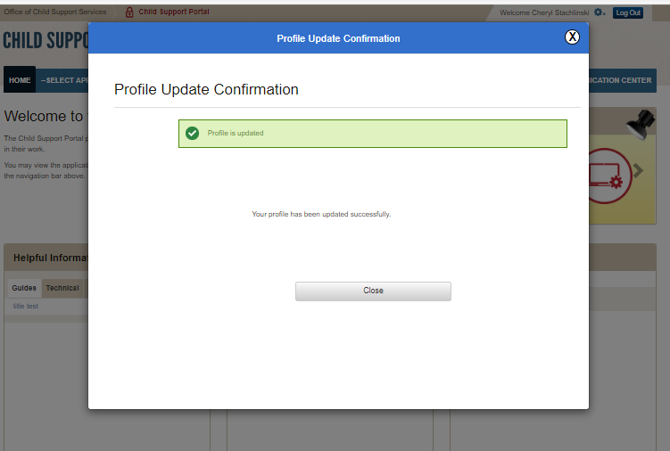
Figure 4-2: Profile Update Confirmation
When the user clicks Close, the Welcome to the Child Support Portal page reopens.

Credential Management
Each time the user wants to access the Portal, they go to the Log In Certification page. Figure 2-1 on page 2-1 shows this page; Chart 2-1 on page 2-2 defines the functions available on this page.
To accept the terms of the agreement, the user selects the I Agree check box.
If the user does not remember their user ID, they click Forgot User ID? Figure 5-1 displays the Forgot User ID page. They can also use the chatbot; for instructions, see Part 7, “Chatbot.”
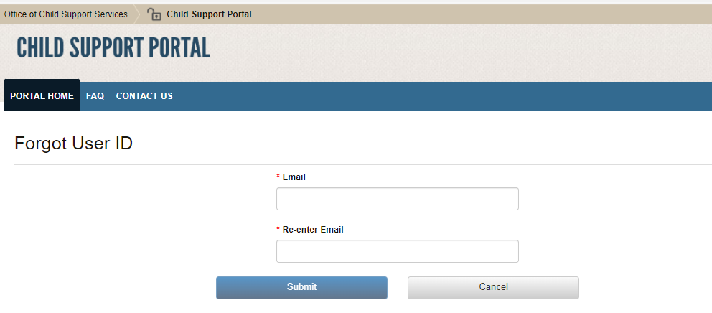
Figure 5-1: Forgot User ID
Chart 5-1 defines the functions available on this page.
Chart 5-1: Forgot User ID
Element | Description
Email Address | Enters an email address to request the user ID
Re-enter Email Address | Re-enters the email address to confirm it
When the user clicks Submit, the Credential Management – Forgot User ID Confirmation page opens. Figure 5-2 shows this page with the message confirming to the user the system sent the user ID to their email account.
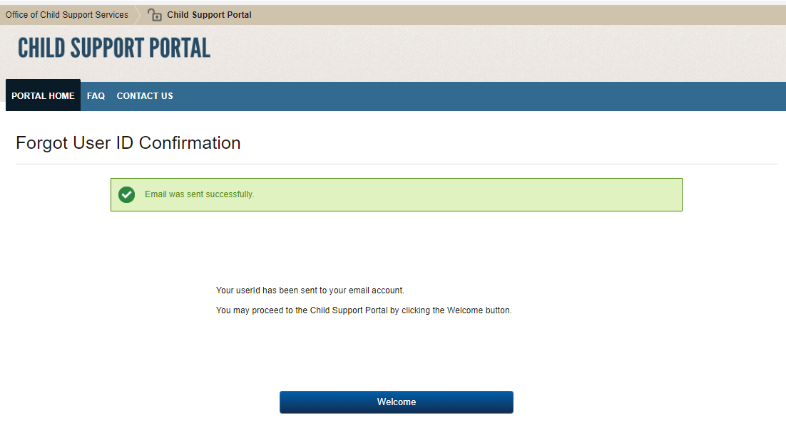
Figure 5-2: Credential Management – Forgot User ID Confirmation
To restart the log-in progress, the user clicks Welcome.
The Log In page is also where the user can change their password. Figure 5-3 shows an example of this page.
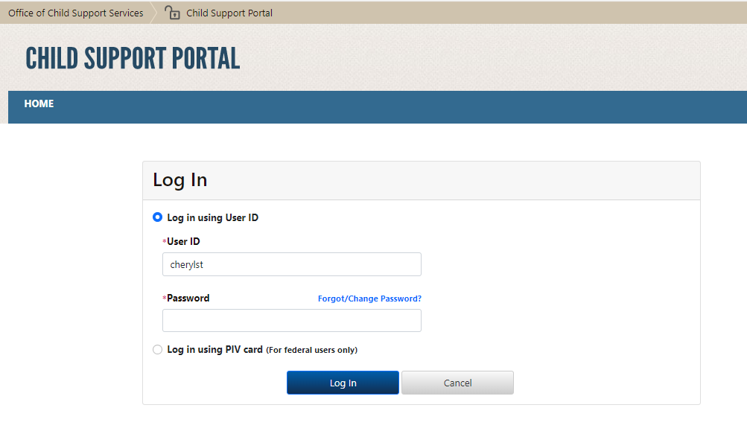
Figure 5-3: Log In – Forgot/Change Password
Chart 5-2 defines the functions available on the Log In – Forgot User ID page.
Chart 5-2: Log In – Forgot/Change Password
Element | Description
Password | Enters a password
Forgot/Change Password? | Opens the Forgot/Change Password page
Access Code | Enters the access code received by phone call or text (selected during registration)
Cancel | Returns to the Welcome to the Child Support Portal page
The user clicks Forgot/Change Password?
The user clicks Log In to authenticate the password.
If the user forgot or wants to change their password, they click Forgot/Change Password? The Forgot/Change Password page opens; Figure 5-4 shows an example of this page.
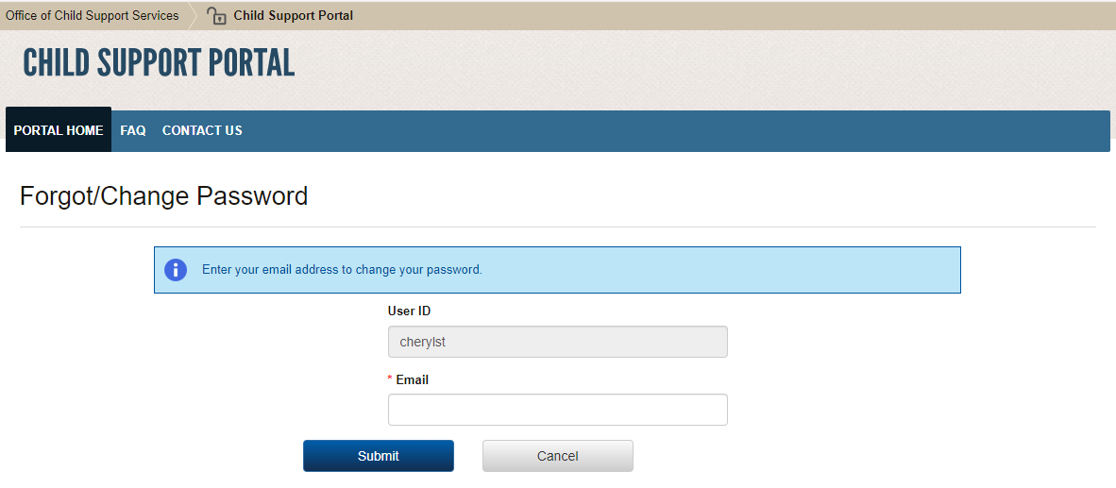
Figure 5-4: Forgot/Change Password
Chart 5-3 defines the functions available on the Forgot/Change Password page.
Chart 5-3: Log In Forgot/Change Password
Element | Description
User ID | Displays a system-generated user ID
Email | Enters an email address associated with the user ID
Submit | Sends the request to change the user’s password
Cancel | Returns to the Welcome to the Child Support Portal page
The user enters an email address to access to the password reset page and then clicks Submit. The Forgot/Change Password – Challenge Questions page opens. Figure 5-5 shows an example of the page where the user answers the challenge questions they selected on the Profile Update page; see Figure 4-1 on page 4-1.
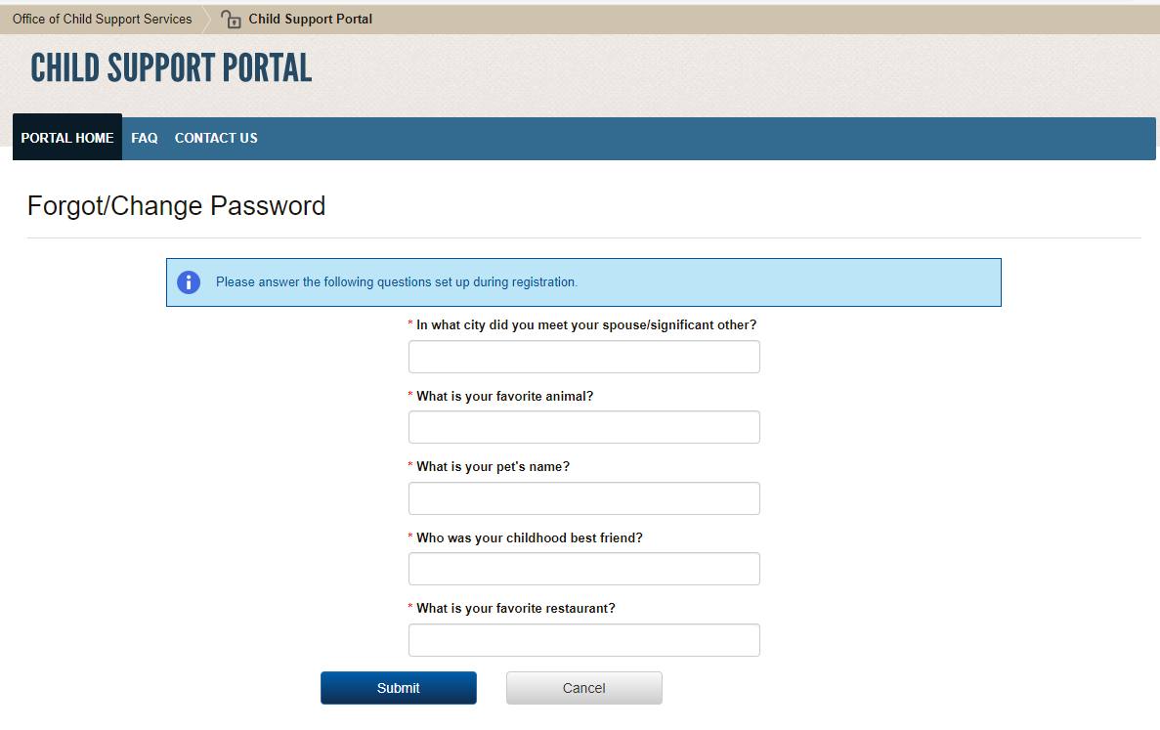
Figure 5-5: Forgot/Change Password – Challenge Questions
The user answers the challenge questions, and then clicks Submit to open the Forgot/Change Password –Reset Password page. Figure 5-6 shows an example of this page.
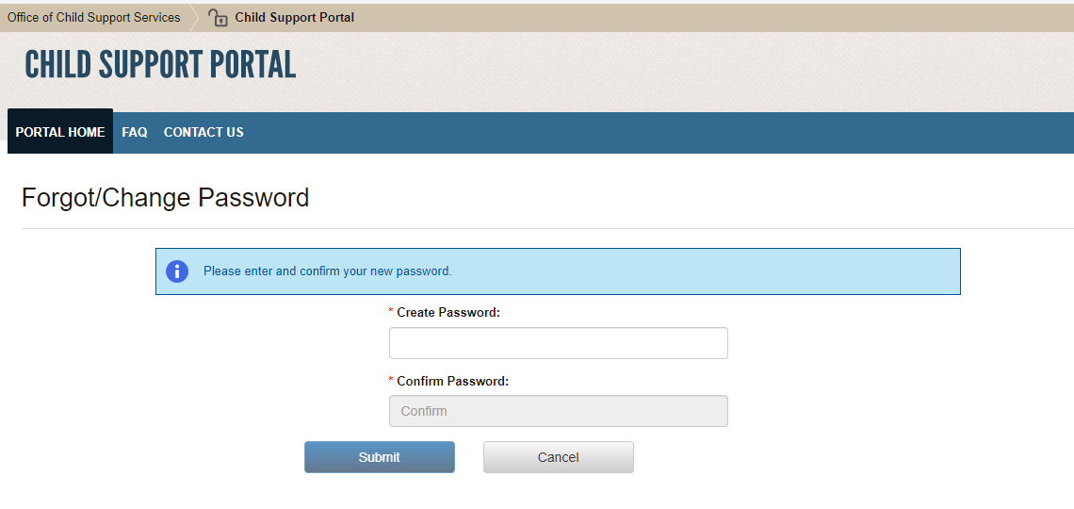
Figure 5-6: Forgot/Change Password – Reset Password
Chart 5-4 defines the functions available on this page.
Chart 5-4: Forgot/Change Password (Reset Password)
Element | Description
Create Password | Enables the user to enter a new password
Confirm Password | Enables the user to confirm the new password
Submit | Submits the reset password request
The user enters a new password, enters it again to confirm it, and then clicks Submit. The Change Password Confirmation page opens; Figure 5-7 shows an example of this page with the password change confirmation message.
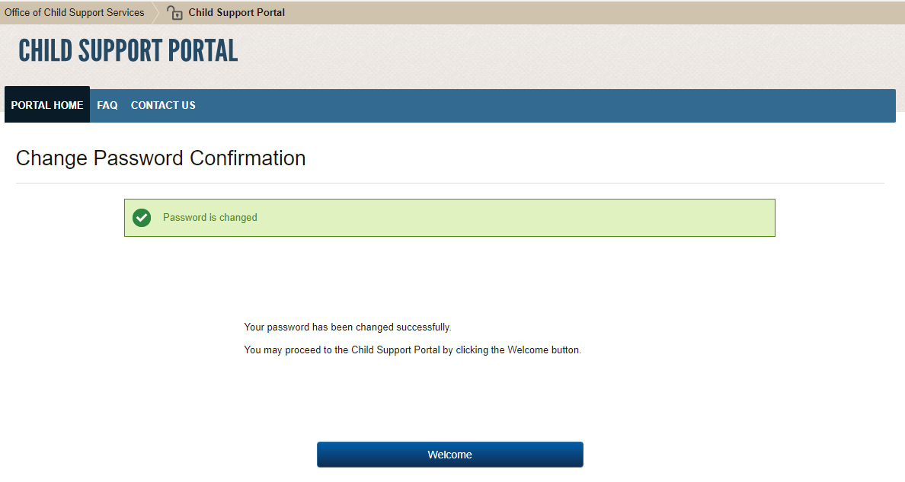
Figure 5-7: Change Password Confirmation
When the user clicks Welcome, the Welcome to the Child Support Portal page reopens.

General Pages
Figure 6-1 displays the timeout warning message.
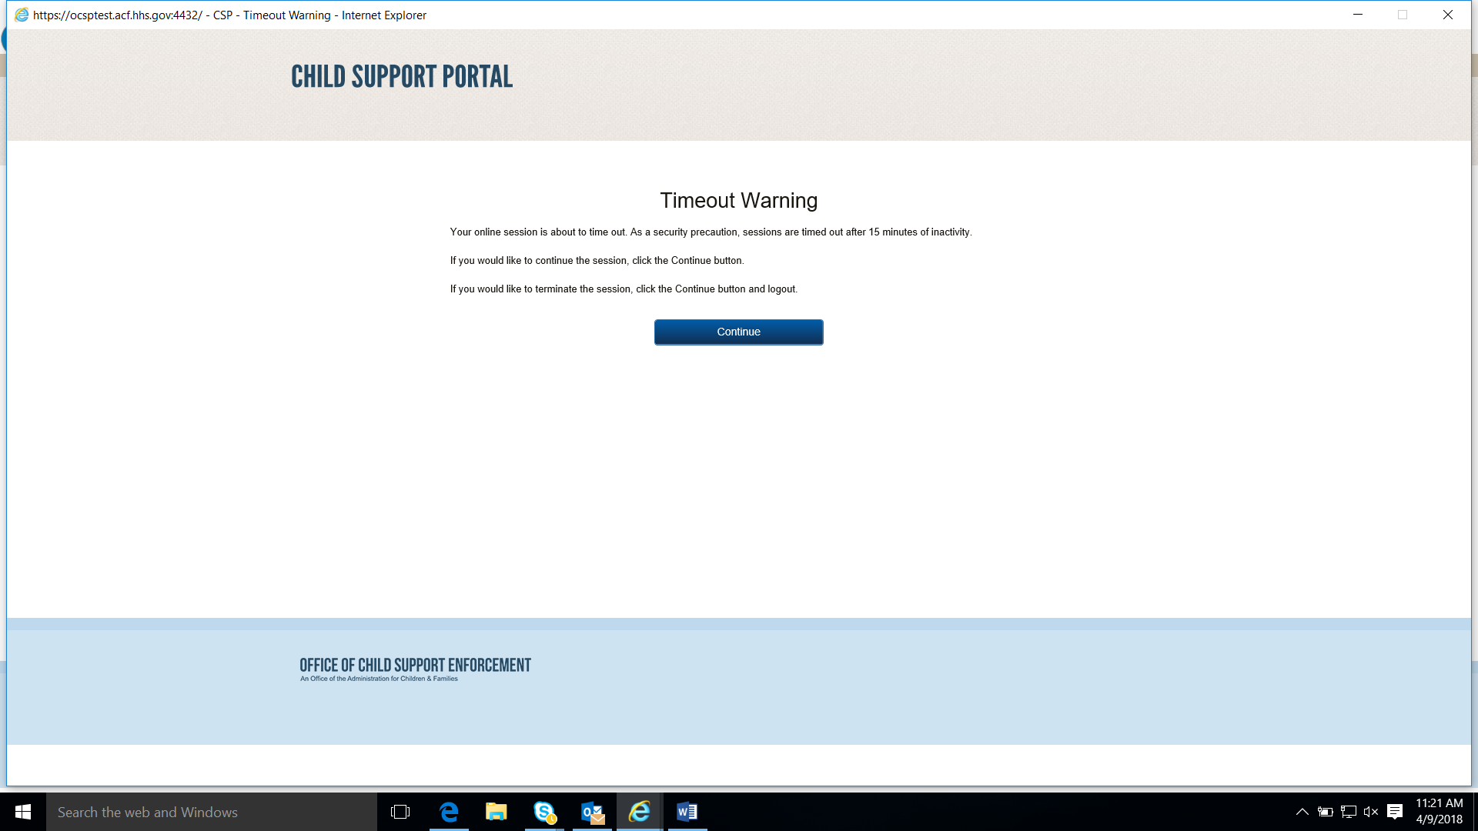
Figure 6-1: Timeout Warning
To refresh the session, close the browser, and return to the previously displayed page, the user clicks Continue.
Figure 6-2 displays the Session Timed Out message. When the user receives this message, they must log in again.
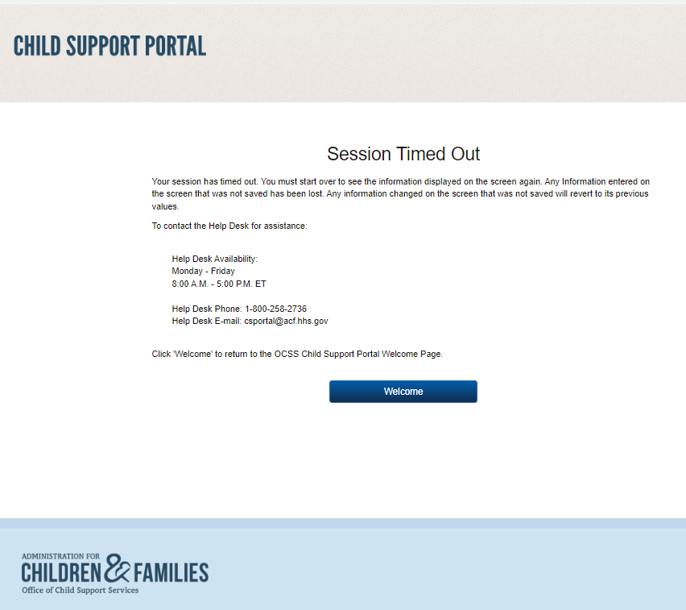
Figure 6-2: Session Timed Out
When the user clicks Welcome, the Welcome to the Child Support Portal page reopens.
Figure 6-3 displays an example of a system error page.
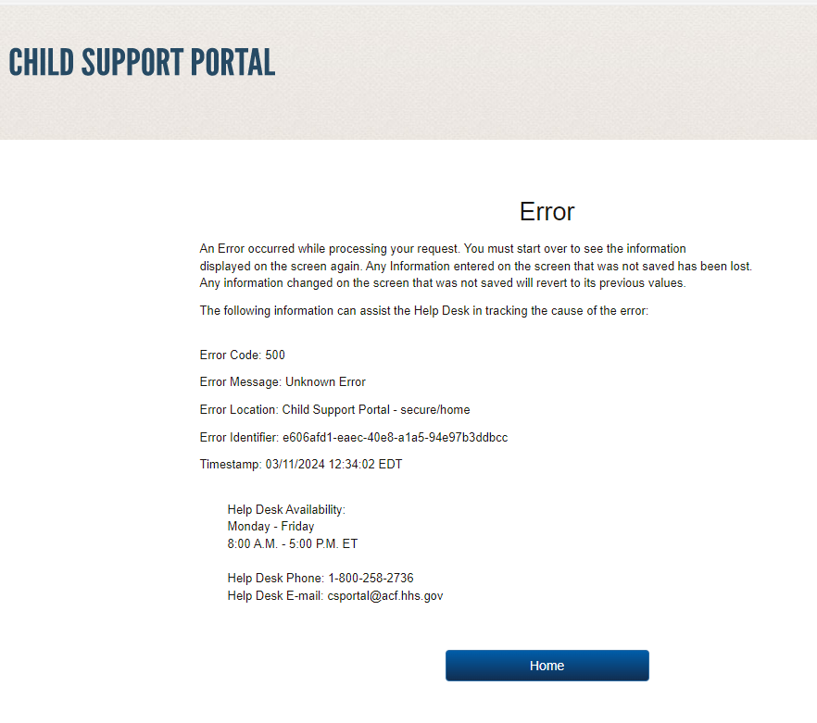
Figure 6-3: System Error
When the user clicks Home, the Welcome to the Child Support Portal page reopens.
Figure 6-4 displays a message informing the user that the system locked their account because of the number of invalid log-in attempts. To unlock their account, the user must contact the Help Desk or use the chatbot. (For instructions, see Part 7, “Chatbot.”)
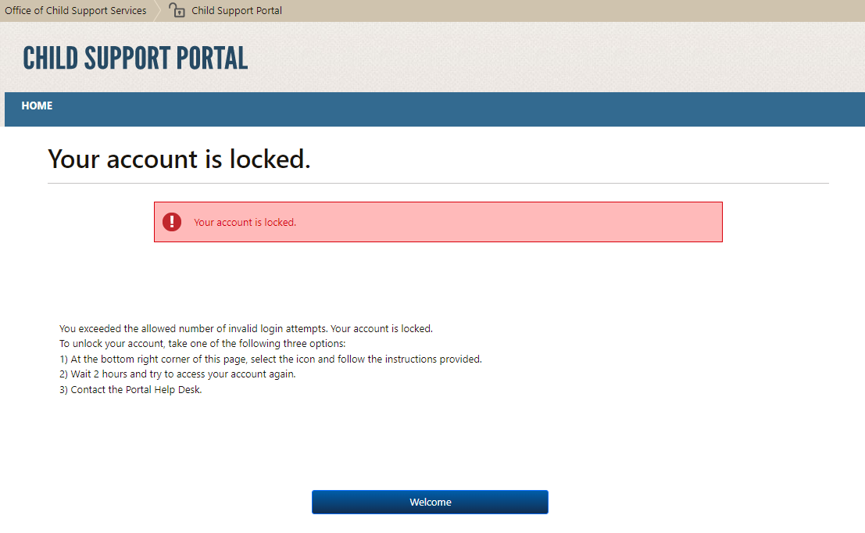
Figure 6-4: Account Locked (Credential Management and Activation Page)
When the user clicks Welcome, the Welcome to the Child Support Portal page reopens.
Figure 6-5 displays the Frequently Asked Questions (FAQ) page with answers to frequently asked questions about Portal applications. The link for this page is on the header of all applications that have an associated FAQ page; not all applications do. Figure 5-1 on page 5-1 shows an example of the FAQ link.
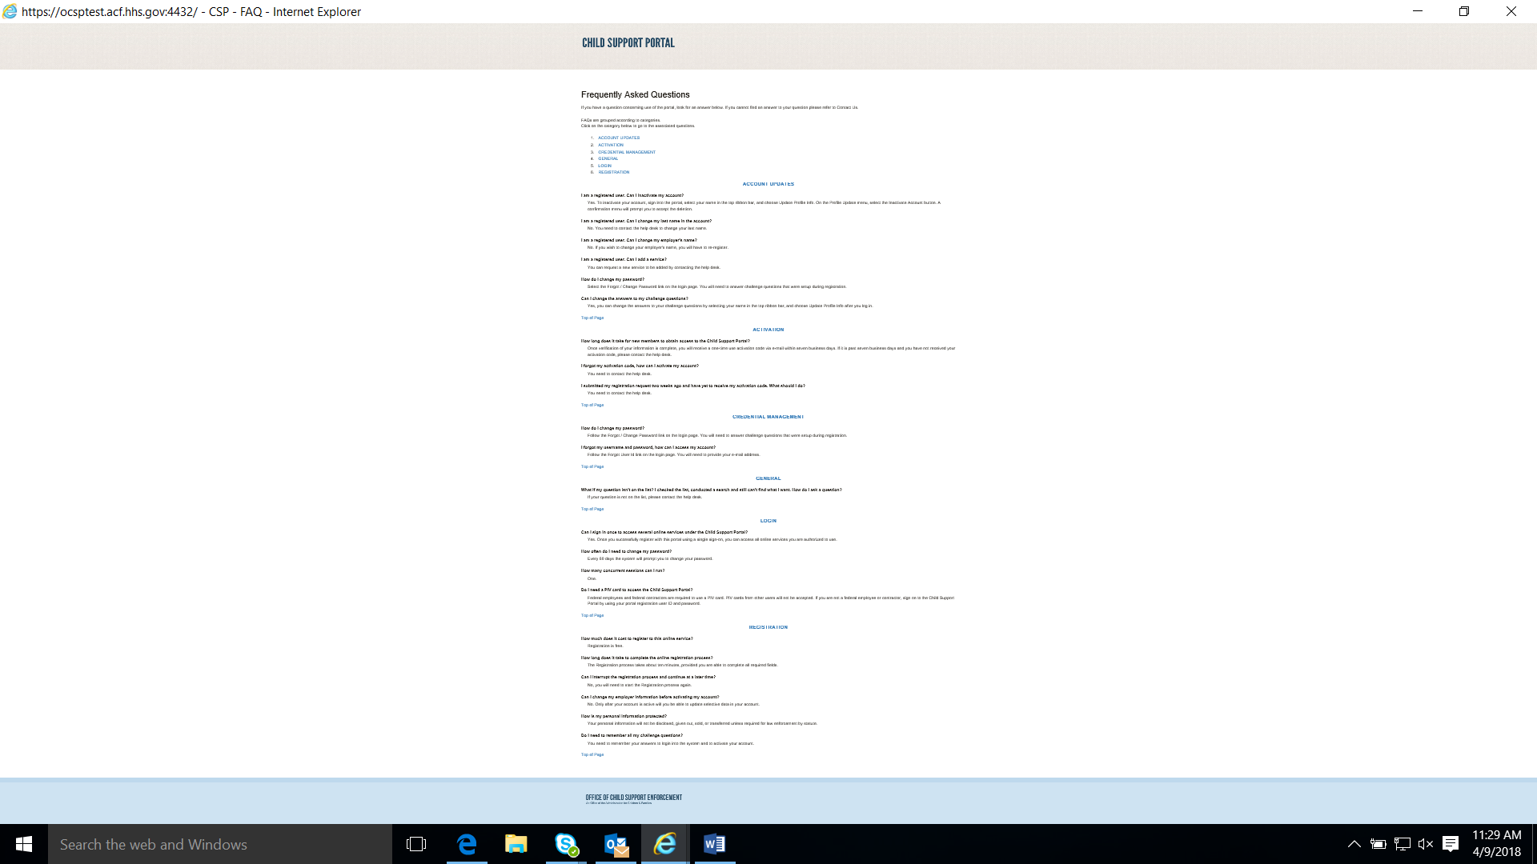
Figure 6-5: Frequently Asked Questions
Chart 6-1 defines the functions available on the Frequently Asked Questions page.
Chart 6-1: Frequently Asked Questions
Element | Description
Category List | Displays the FAQ in that section
Top of Page | Returns to the top of the page
Figure 6-6 displays the Contact Us information for the Portal Help Desk.
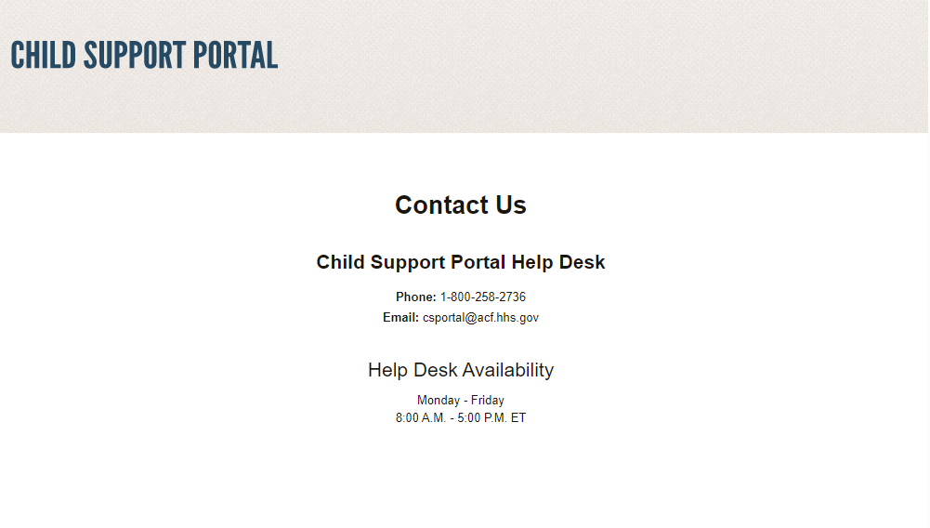
Figure 6-6: Contact Us
Figure 6-7 shows the security alert message displayed when the user’s system has an issue with the site security.
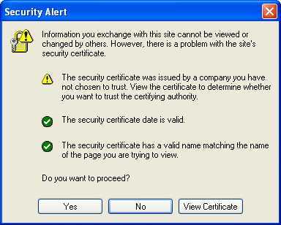
Figure 6-7: Security Alert – User Accepts Certificate
The user takes one of the following actions:
- To open the Welcome to Child Support Portal, clicks Yes.
- To cancel the current operation, clicks No.
- To open the certificate information, clicks View Certificate.
Figure 6-8 shows the message the system sends the user before inactivating their account.
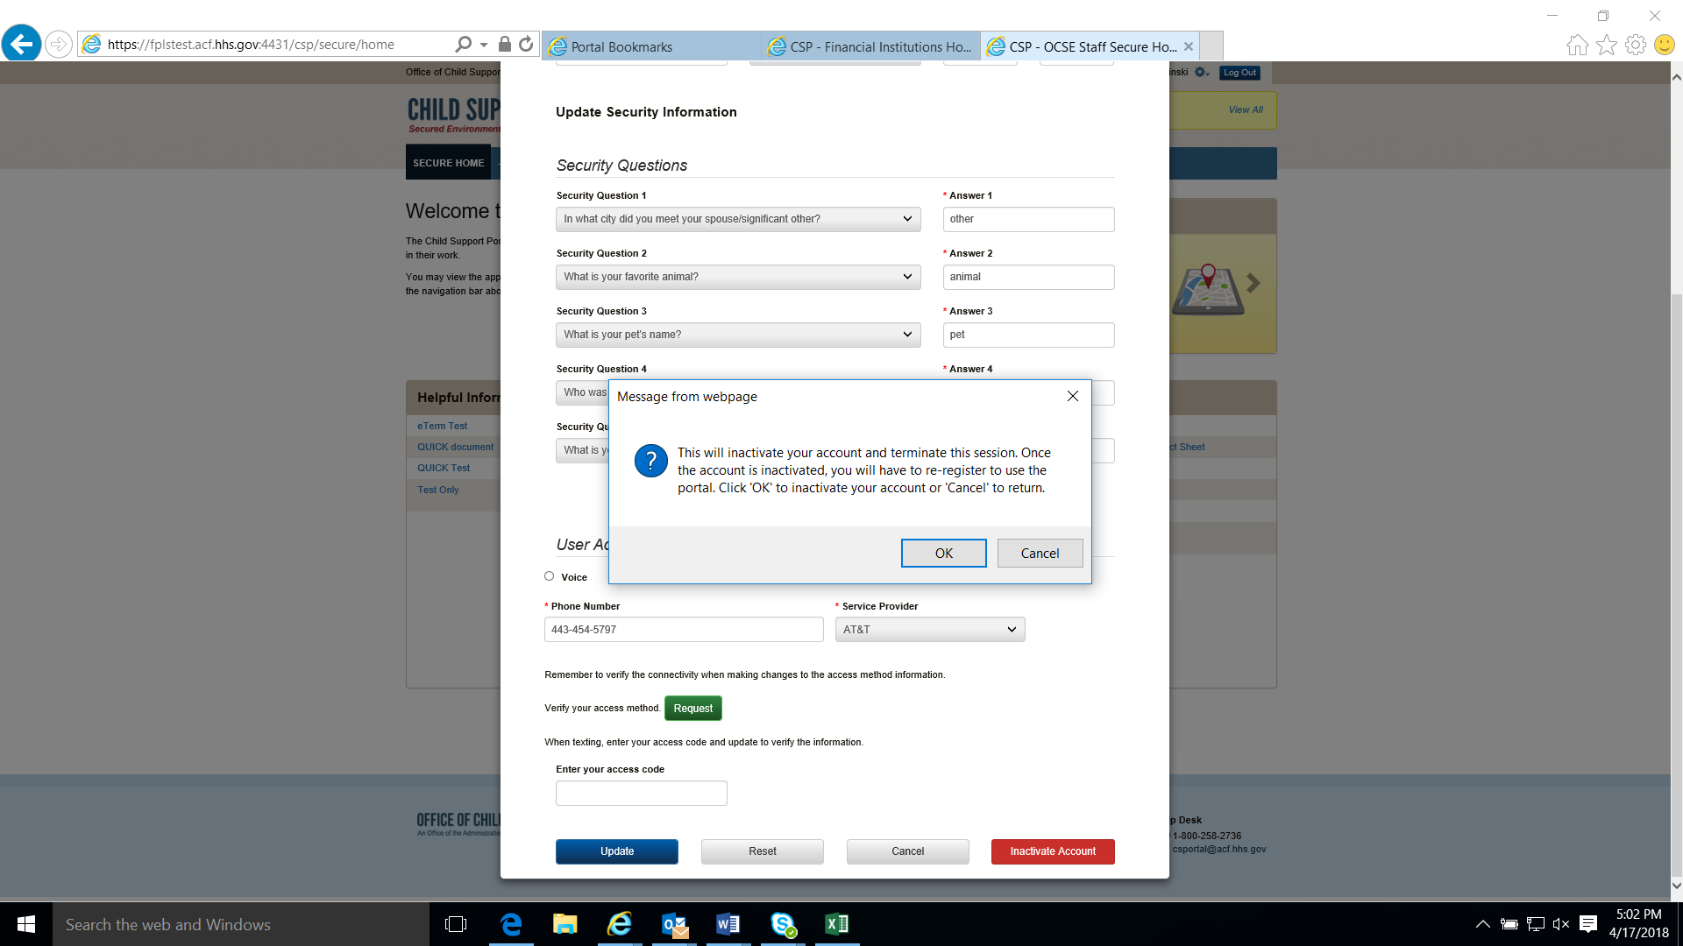
Figure 6-8: Disable Account Message
To inactivate their account, the user clicks OK.

Chatbot
A chatbot is an interactive chat system that helps the user to reset their password or unlock their account without Help Desk intervention.
Before accessing the Portal, when the user hovers over the chatbot icon in the bottom right corner of the footer, the message in Figure 7-1 displays in the information box.
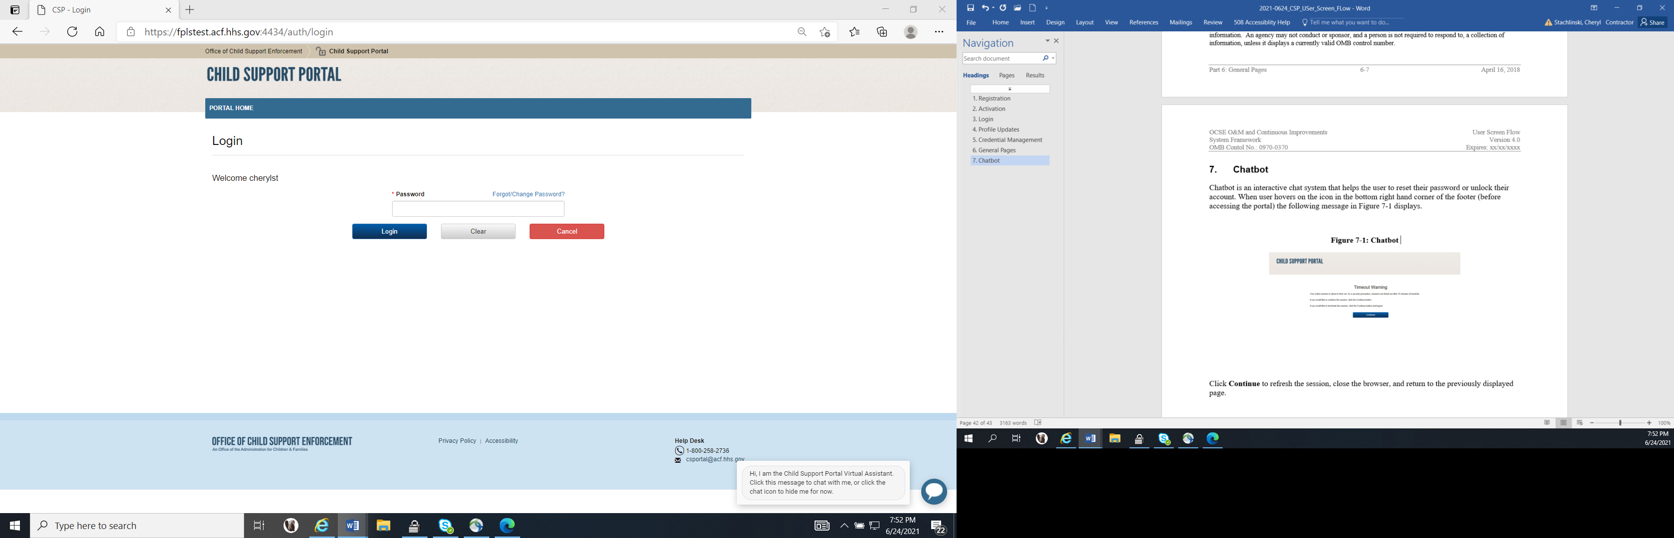
Figure 7-1: Chatbot Icon
To open the Child Support Portal Virtual Assistance pop-up, the user clicks inside the information box; Figure 7-2 shows the first Portal Virtual Assistant pop-up.
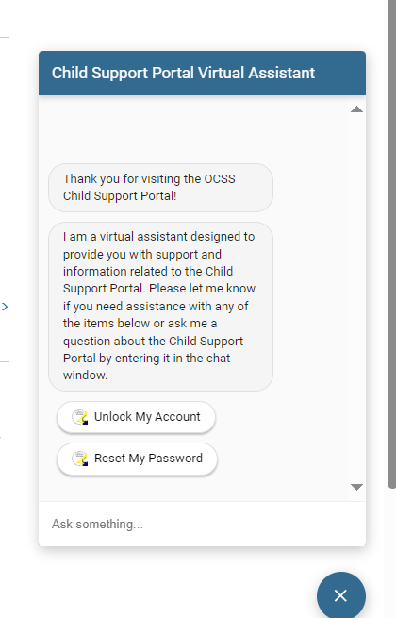
Figure 7-2: Portal Virtual Assistant
To start the process to unlock their Portal account, the user clicks Unlock My Account.
The virtual assistant asks the user to enter their Child Support Portal user ID; Figure 7-3 shows this request.
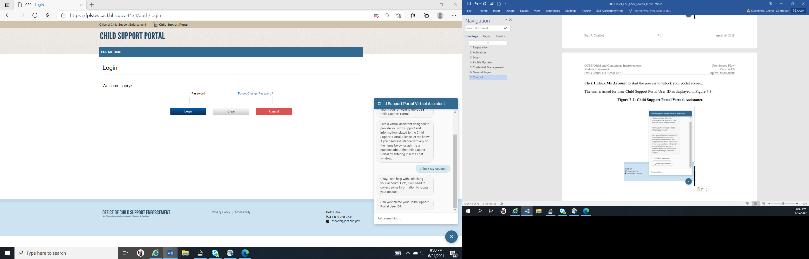
Figure 7-3: Portal Virtual Assistant, Account Unlock – User ID
The user enters their user ID and clicks Enter.
The virtual assistant prompts the user for the email address associated with their user ID; Figure 7-4 shows this request.
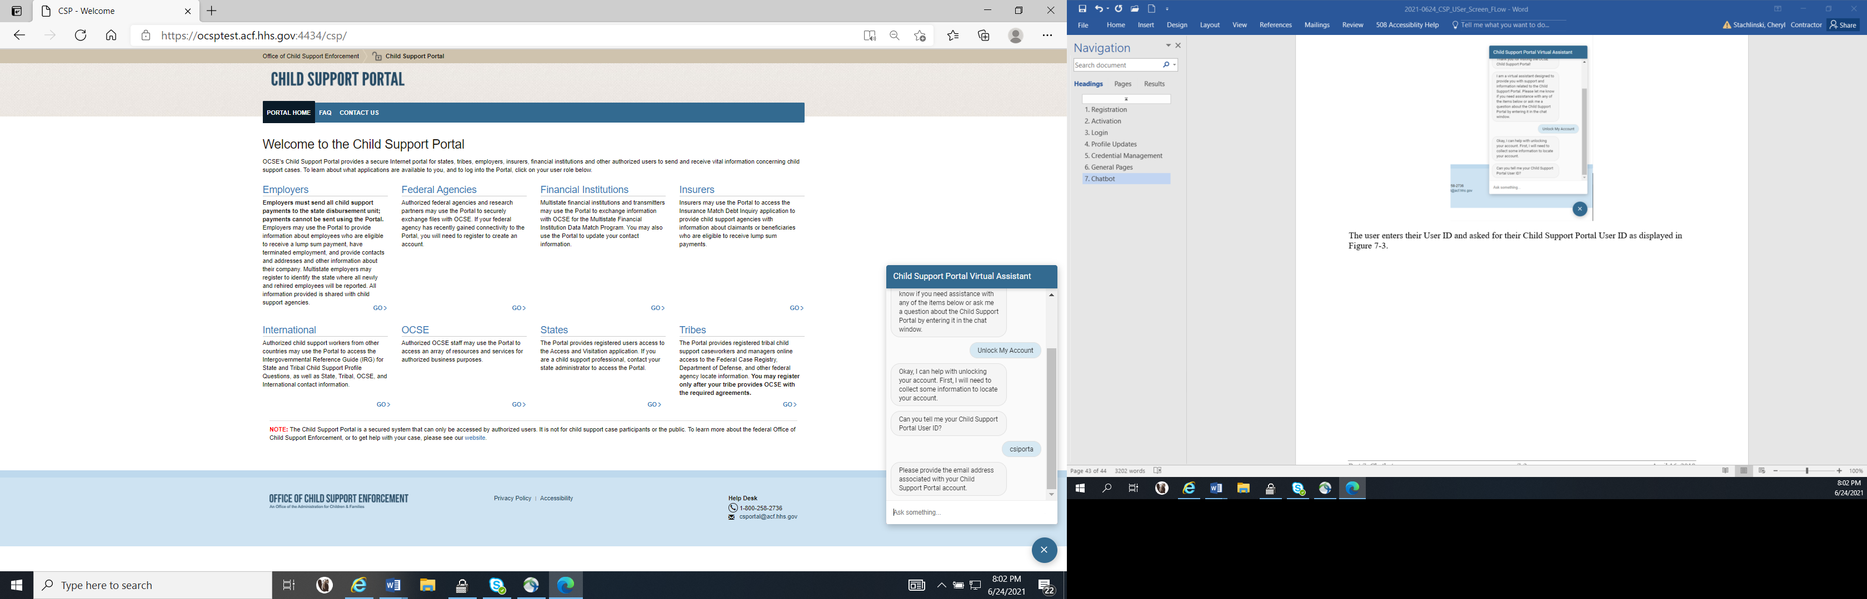
Figure 7-4: Portal Virtual Assistant, Account Unlock – Email Address
The user enters the email address associated with their Portal account and clicks Enter.
The virtual assistant informs the user that their Portal account was located (that is, verified) and asks whether they want to continue. Figure 7-5 shows the verification, the prompt, and the user’s options.
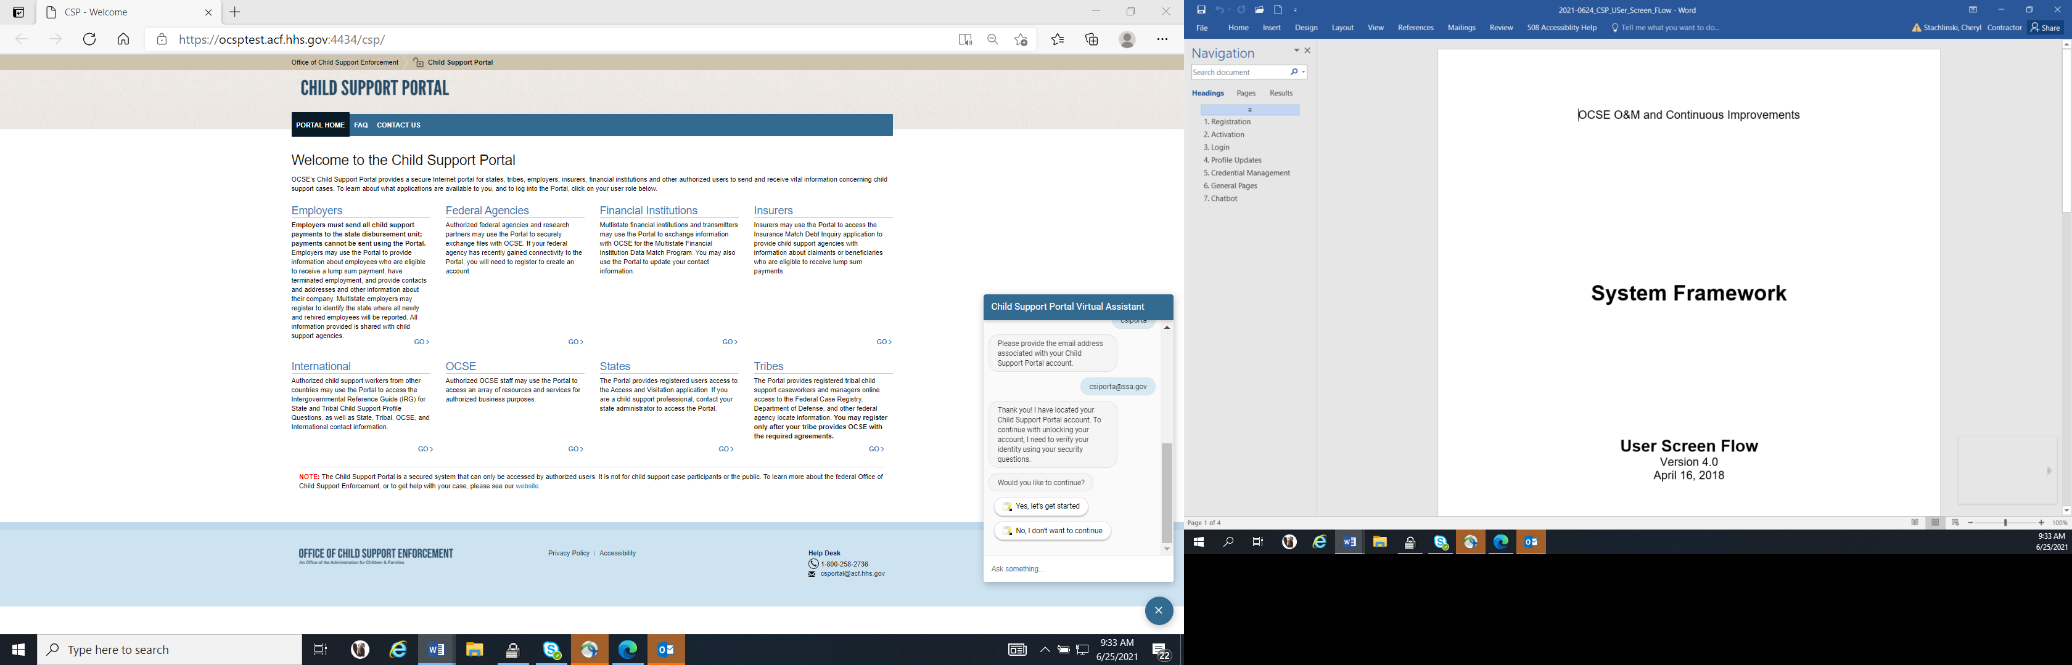
Figure 7-5: Portal Virtual Assistant, Account Unlock – Get Started
The user clicks Yes, let’s get started. The virtual assistant asks the user to answer the challenge questions they created when they registered their account. Figure 7-6 shows several example questions and answers.
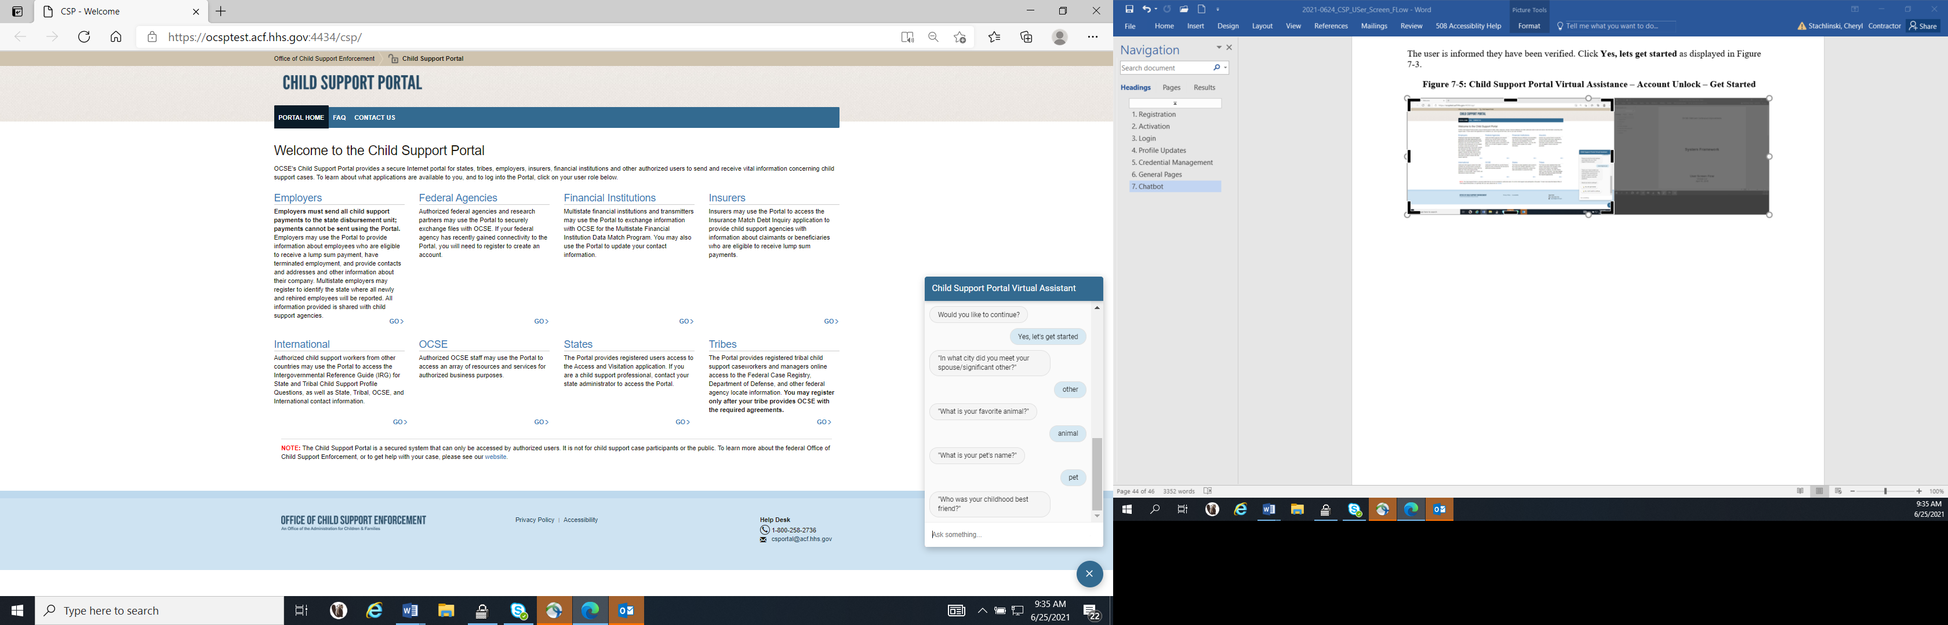
Figure 7-6: Portal Virtual Assistant, Account Unlock – Challenge Questions
If the user answers three or four of the five challenge questions correctly, the virtual assistant asks the user to enter their date of birth and SSN; Figure 7-7 shows this prompt.
Note: If the user answers less than three challenge questions correctly, the user must start over.
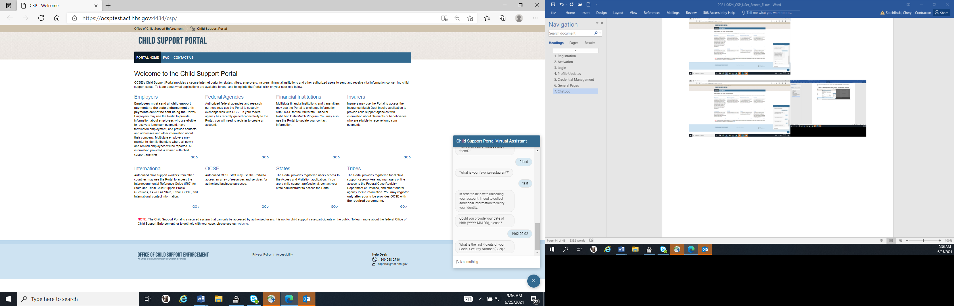
Figure 7-7: Portal Virtual Assistant, Account Unlock – Challenge Questions 3-4 Correct
When the user answers all five challenge questions correctly or enters their correct date of birth and SSN when prompted, their account is unlocked. Figure 7-8 shows how the virtual assistant informs the user that their account is unlocked and prompts them whether they want to change the password for their Portal account.
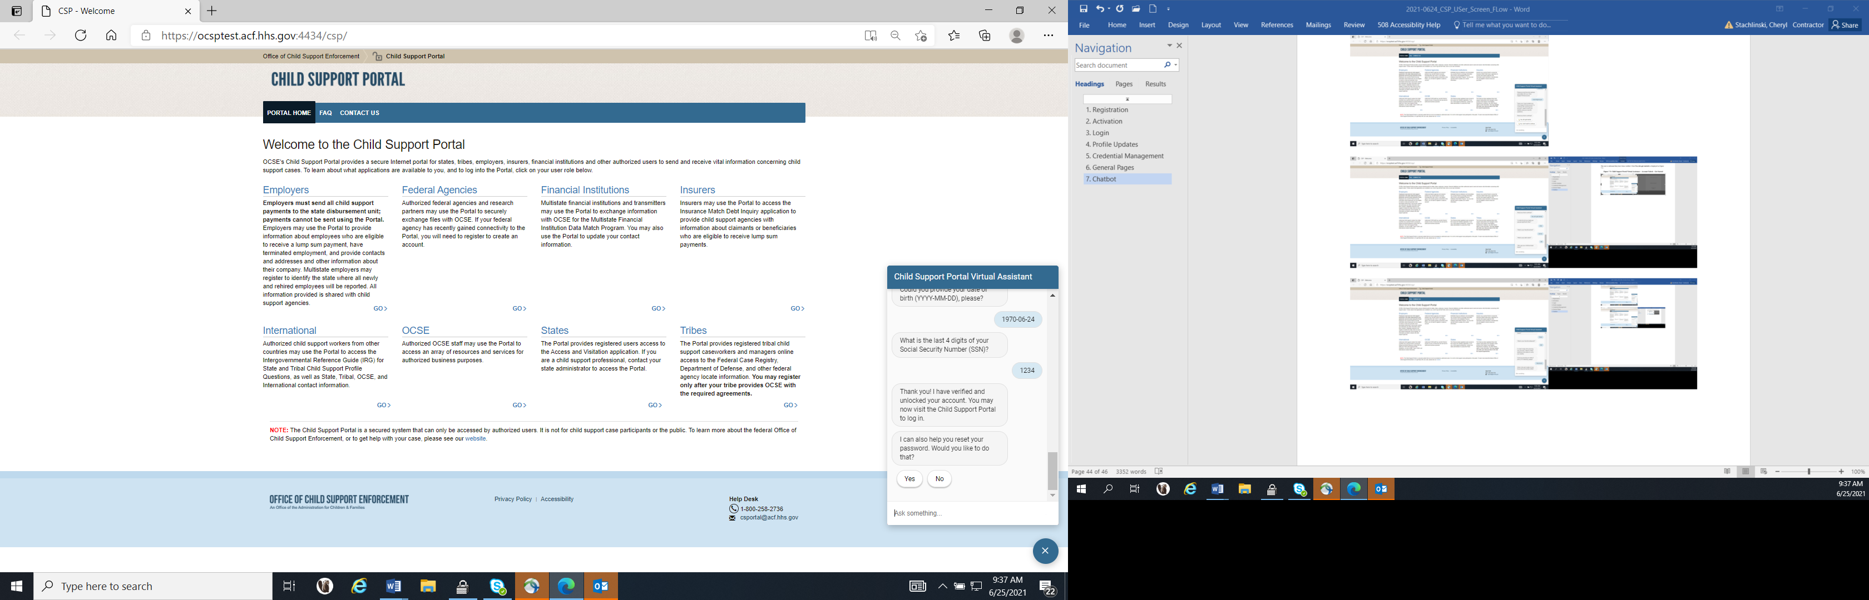
Figure 7-8: Portal Virtual Assistant, Account Unlock – Account is Unlocked
To start the process to reset the user’s password, the user clicks Yes. When the virtual assistant displays the Reset My Password option, the user clicks this option.
The virtual assistant asks the user to enter their Child Support Portal user ID; Figure 7-9 shows this request.
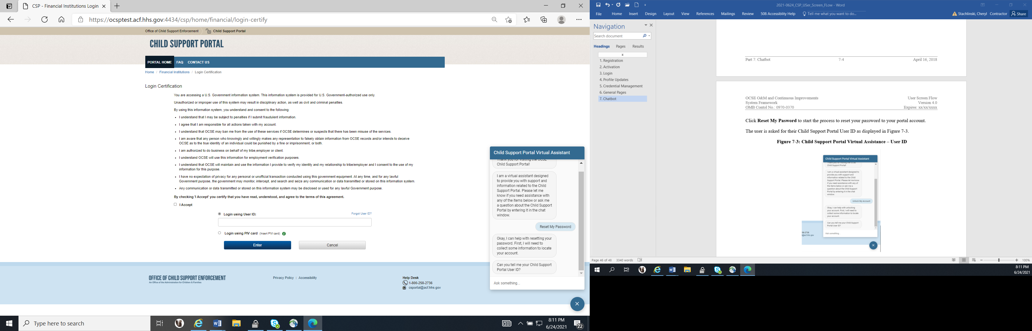
Figure 7-9: Portal Virtual Assistant, Password Reset – User ID
The user enters their user ID and clicks Enter.
The virtual assistant prompts the user for the email address associated with their user ID; Figure 7-10 shows this request.
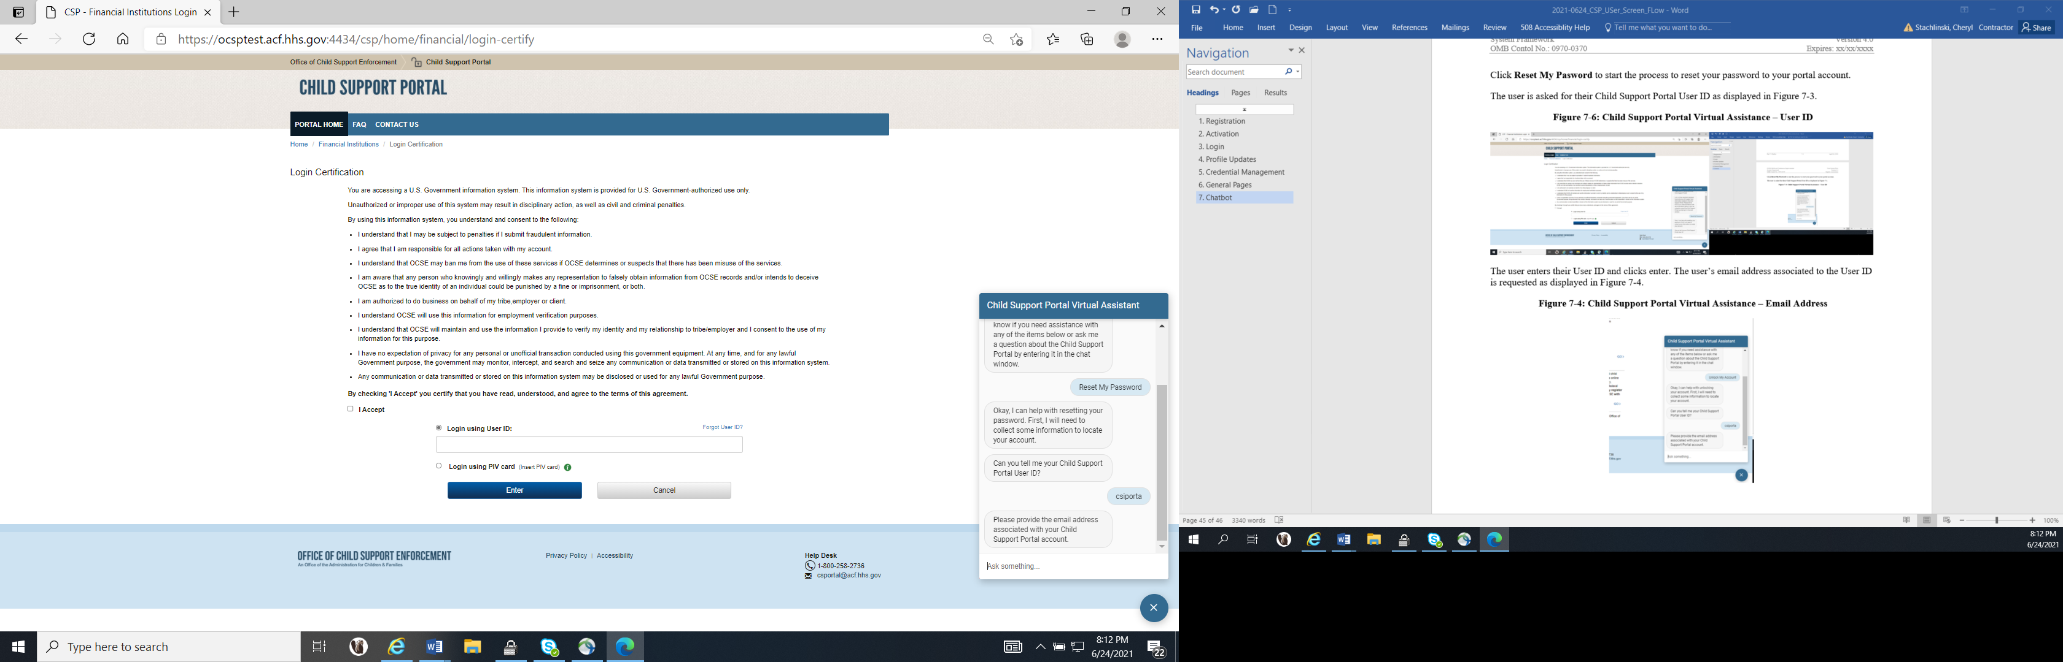
Figure 7-10: Portal Virtual Assistant, Password Reset – Email Address
The user enters the email address associated with their Portal account and clicks Enter.
The virtual assistant informs the user that their Portal account was located and asks whether they want to continue. Figure 7-11 shows the verification, the prompt, and the user’s options.
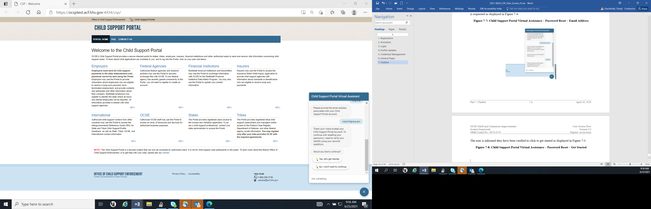
Figure 7-11: Portal Virtual Assistant, Password Reset – Get Started
The user clicks Yes, let’s get started.
The virtual assistant asks the user to answer challenge questions they created when they registered their account. Figure 7-12 shows some example questions and answers.
Figure 7-12: Portal Virtual Assistant, Password Reset – Challenge Questions
If the user correctly answers three or four of the five challenge questions, the virtual assistant prompts the user to enter their date of birth and SSN. Figure 7-13 shows these prompts.
Note: If the user answers less than three challenge questions correctly, the user must start over.
Figure 7-13: Portal Virtual Assistant, Password Reset – Challenge Questions 3-4 Correct
If the user answers all five challenge questions correctly or enters their correct date of birth and SSN, the virtual assistant tells them they will receive an email with instructions to reset their password; see Figure 7-14.
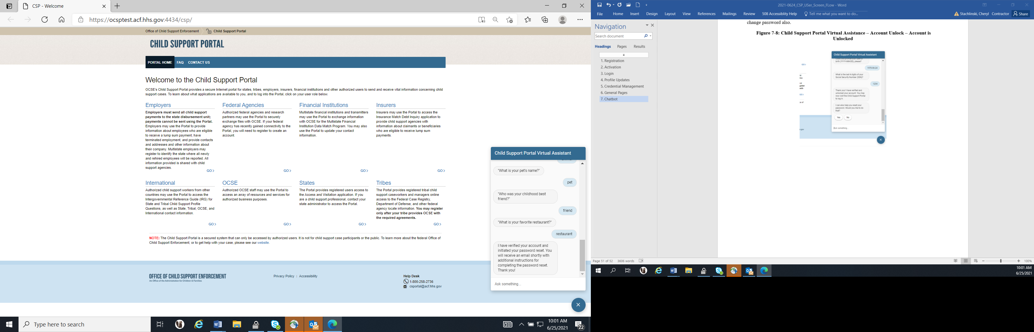
Figure 7-14: Portal Virtual Assistant, Password Reset – User Sent Email to Reset Password
PAPERWORK REDUCTION ACT OF 1995 (Pub. L. 104-13) STATEMENT OF PUBLIC BURDEN: The purpose of this voluntary information collection is for OCSS to register and authenticate authorized users to access applications on OCSS’ Child Support Portal. Public reporting estimated burden for this collection of information is 0.15 hours per respondent, including the time for reviewing instructions, gathering and maintaining the data needed, and reviewing the collection of information. As provided by 42 U.S.C. § 653(m)(2), any confidential information collected for this program is accessed only by authorized users. A federal agency may not conduct or sponsor an information collection without a valid OMB Control Number. No individual or entity is required to respond to, nor shall an individual or entity be subject to a penalty for failure to comply with a collection of information subject to the requirements of the Paperwork Reduction Act of 1995, without a current valid OMB Control Number. If you have any comments on this collection of information, please contact OCSSFedSystems@acf.hhs.gov.

