

 | Welcome | 
Security Notification:
You are about to access a Department of Homeland Security computer system. This computer system and data therein are property of the U.S. Government and provided for official U.S. Government information and use. There is no expectation of privacy when you use this computer system. The use of a password or any other security measure does not establish an expectation of privacy. By using this system, you consent to the terms set forth in this notice. You may not process classified national security information on this computer system. Access to this system is restricted to authorized users only. Unauthorized access, use, or modification of this system or of data contained herein, or in transit to/from this system, may constitute a violation of section 1030 of title 18 of the U.S. Code and other criminal laws. Anyone who accesses a Federal computer system without authorization or exceeds access authority, or obtains, alters, damages, destroys, or discloses information, or prevents authorized use of information on the computer system, may be subject to penalties, fines or imprisonment. This computer system and any related equipment is subject to monitoring for administrative oversight, law enforcement, criminal investigative purposes, inquiries into alleged wrongdoing or misuse, and to ensure proper performance of applicable security features and procedures. DHS may conduct monitoring activities without further notice.
The Electronic Advance Passenger Information System, or eAPIS, allows you to enter or upload passenger and crew manifests online. Reports are also available through eAPIS for Customs and Border Protection approved individuals.

 | Enrolled Users |  |  |  |  |  |  | New eAPIS Users
 |  |   Top of Form  To begin using this service, please enter your sender ID and password and select Log In.  Sender ID:  Password:  Bottom of Form |  | Need help logging in?  Select the link above to access enrollment, login, and account activation help information.  Reset your password  Forgot or need to reset your password? Select the link above to create a new password and re-activate your account.  Privacy Statement  Select the link above to review the eAPIS Privacy Statement. |  |  |  |   If you are a new user,  you will need to Enroll.

Paperwork Reduction Act Statement: An agency may not conduct or sponsor an information collection and a person is not required to respond to this information unless it displays a current valid OMB control number and an expiration date. The control number for this collection is 1651-0088. The estimated average time to complete this application is 15 minutes. If you have any comments regarding the burden estimate you can write to U.S. Customs and Border Protection, Regulations and Rulings, 90 K Street, NE, 10th Floor, Washington DC 20229. Exp. Jan 31, 2014

Terms and Conditions Page

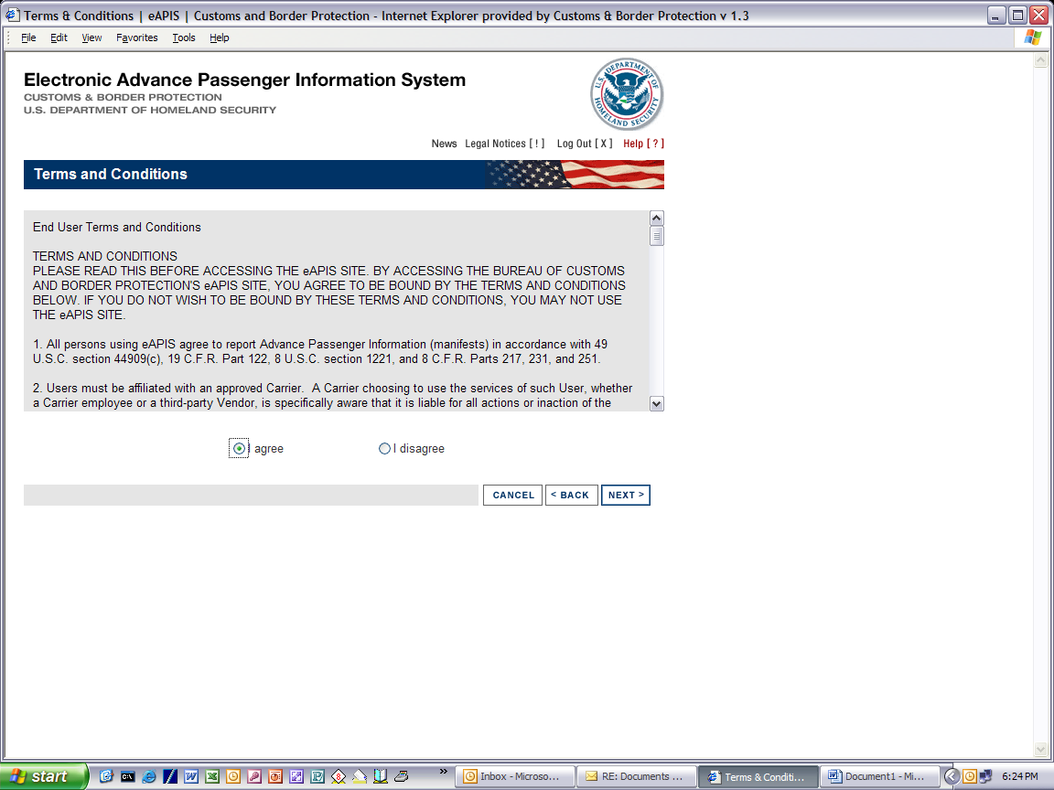

Manifest Options

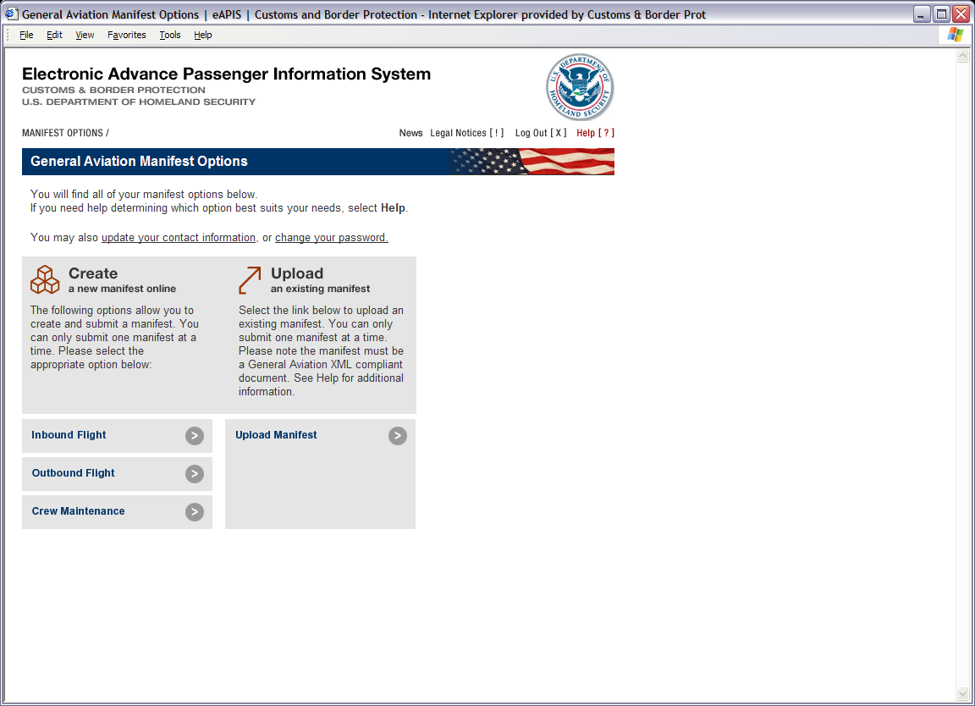

Notice of Arrival

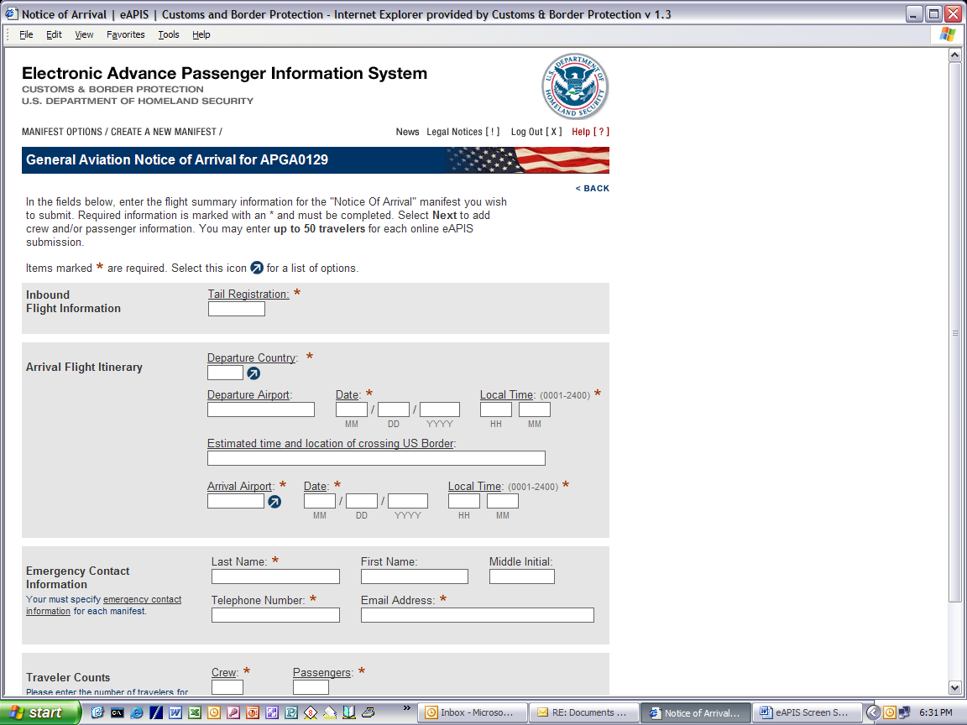
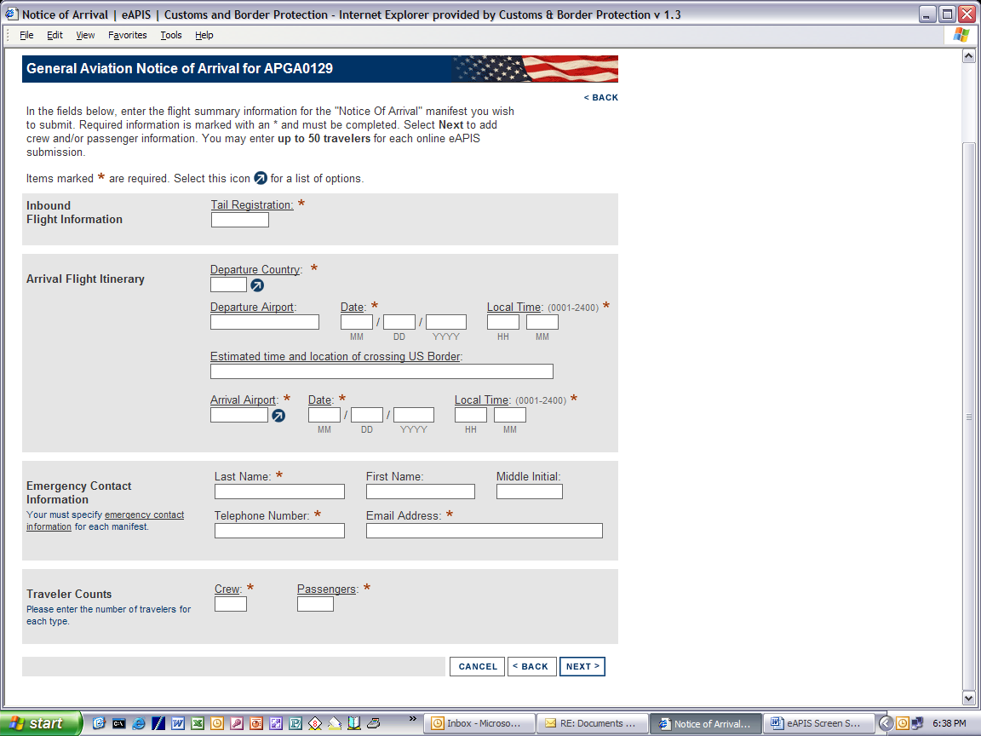

Notice of Departure

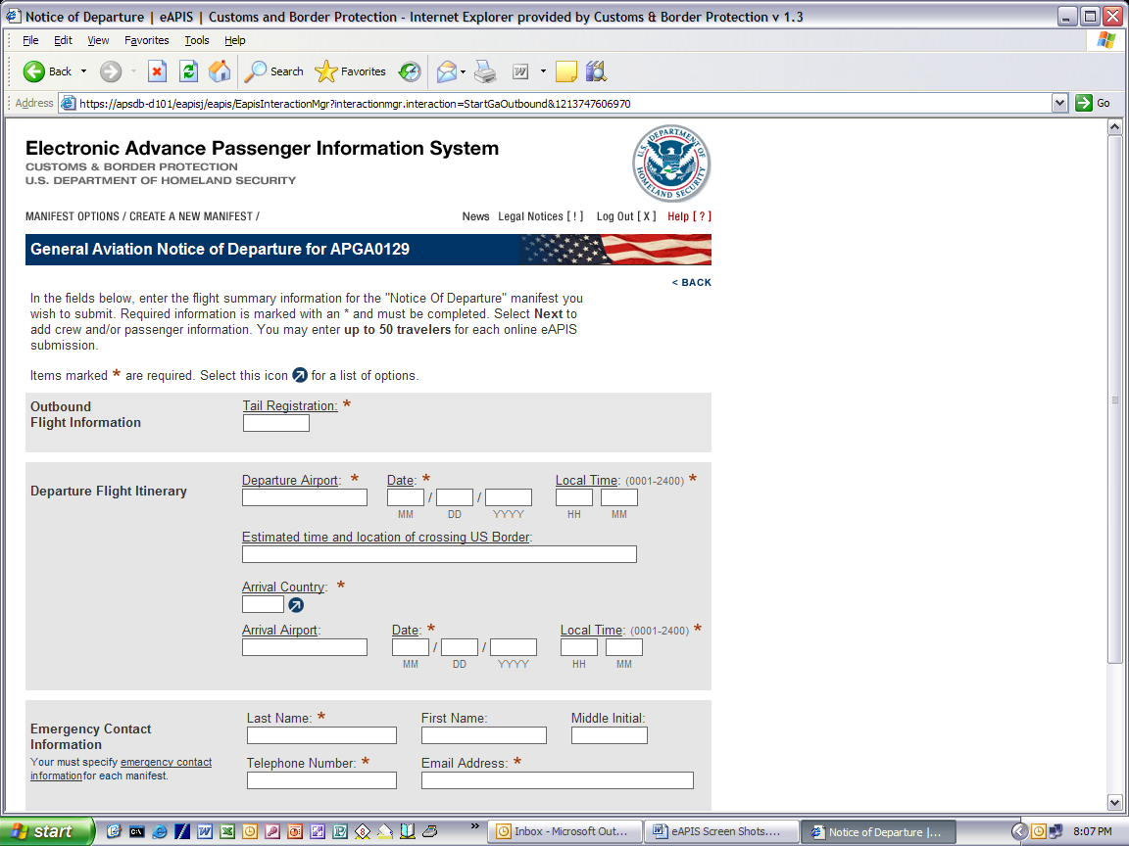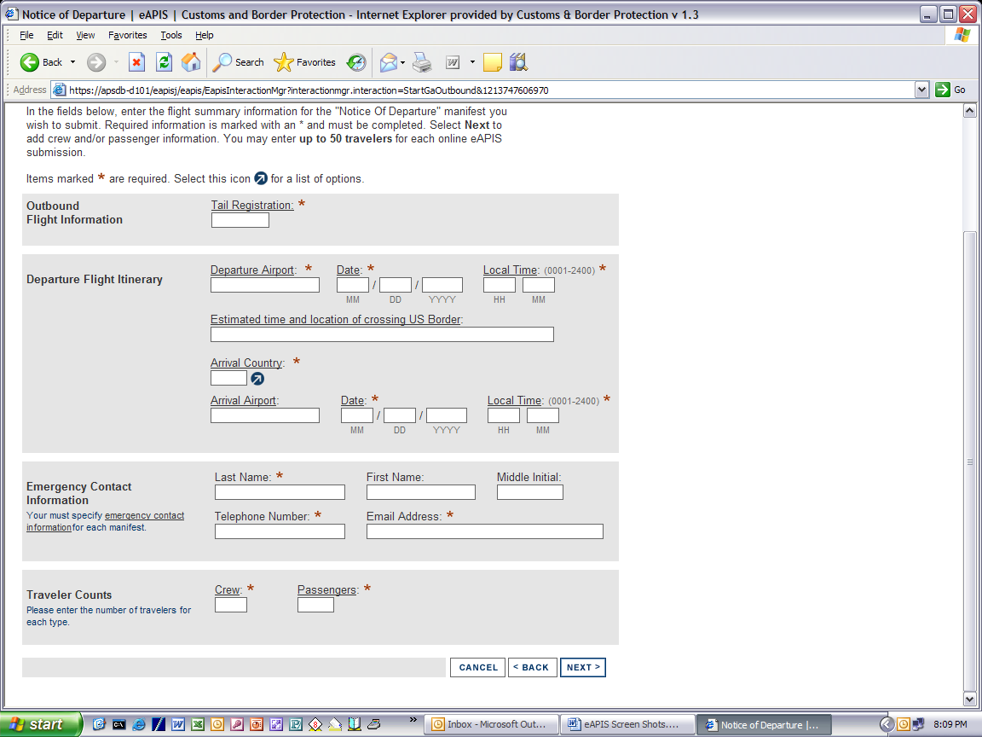

Aircraft Information

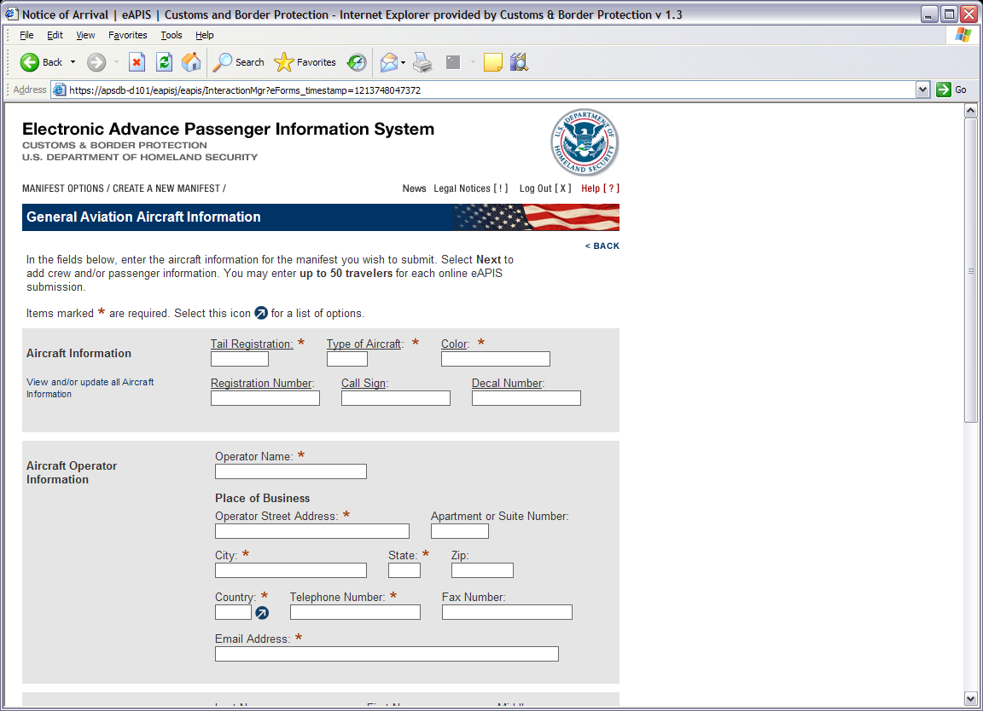
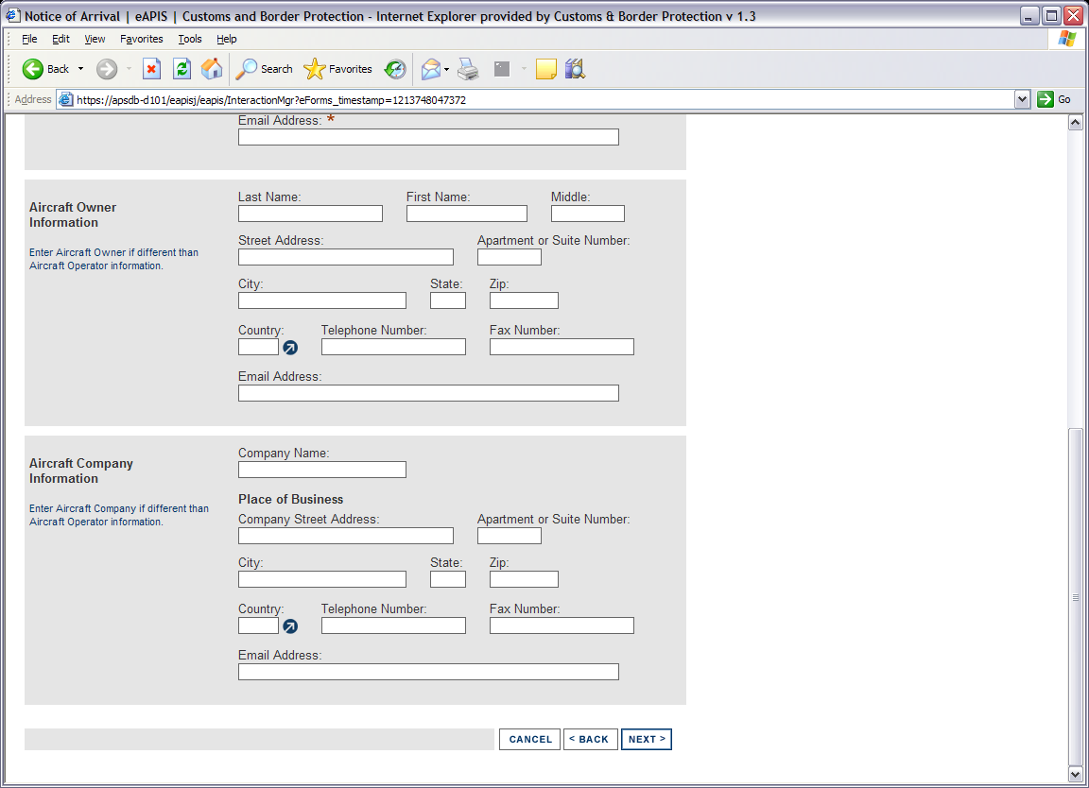

Crew Information

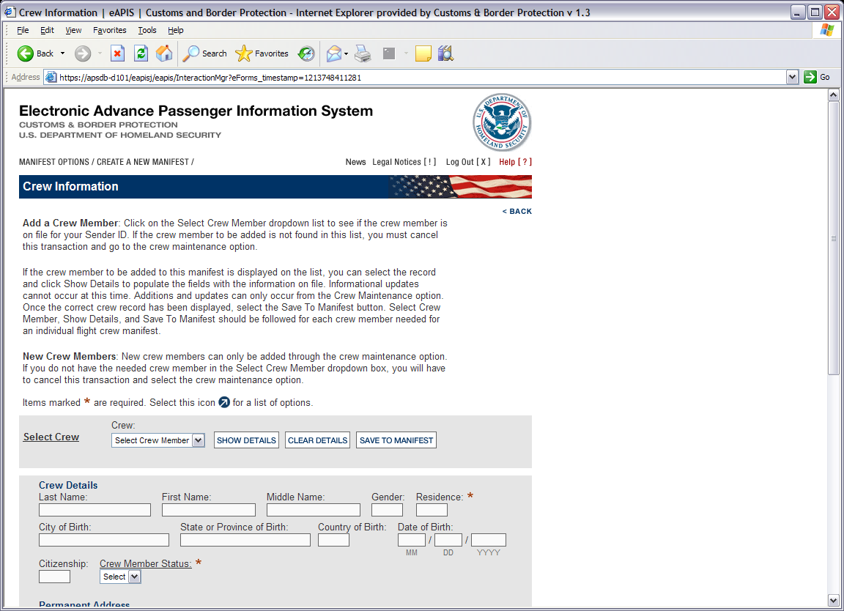
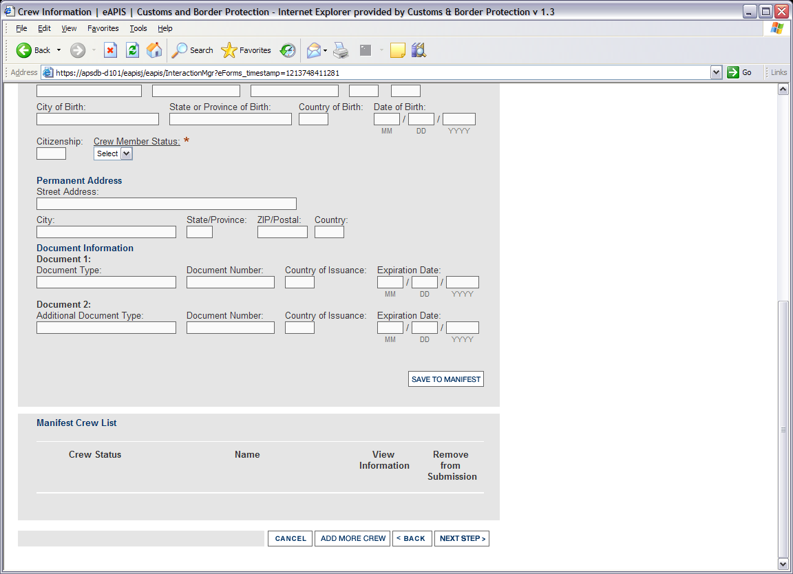

Passenger Information

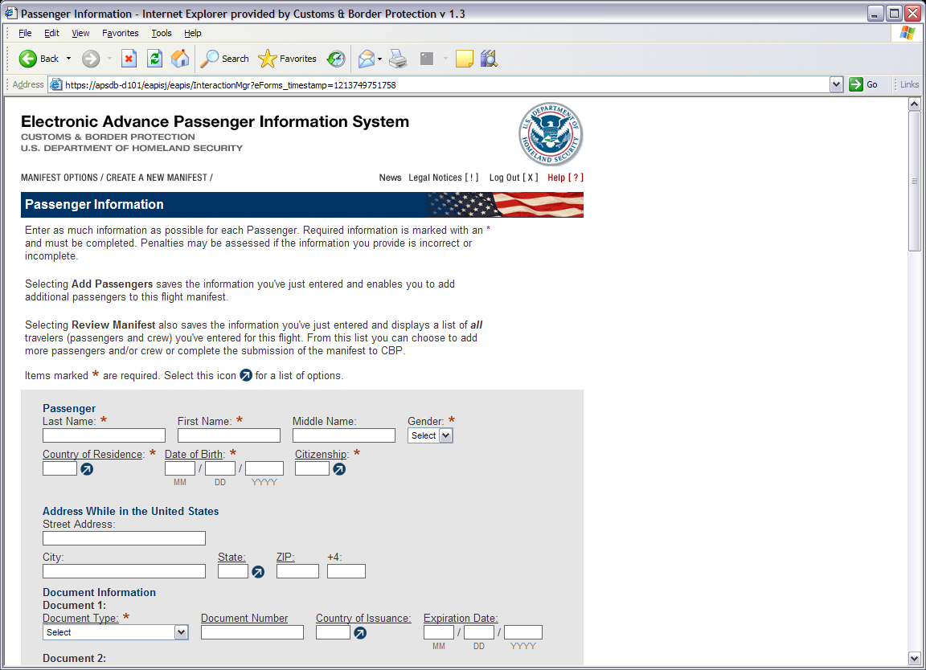
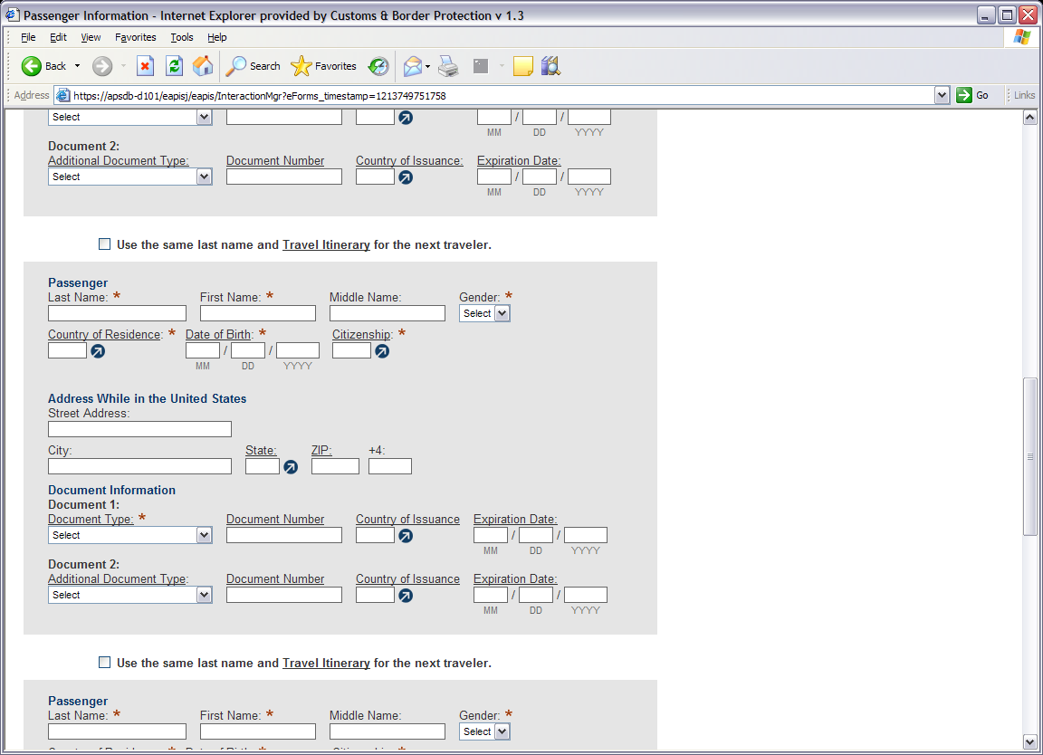

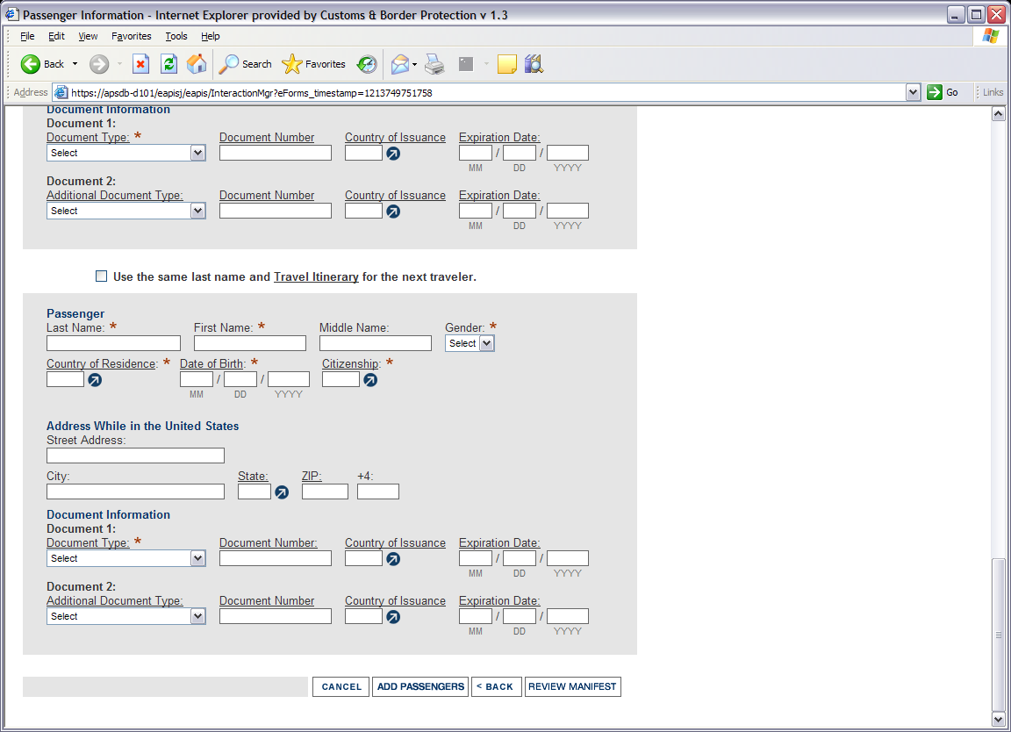

List of Travelers
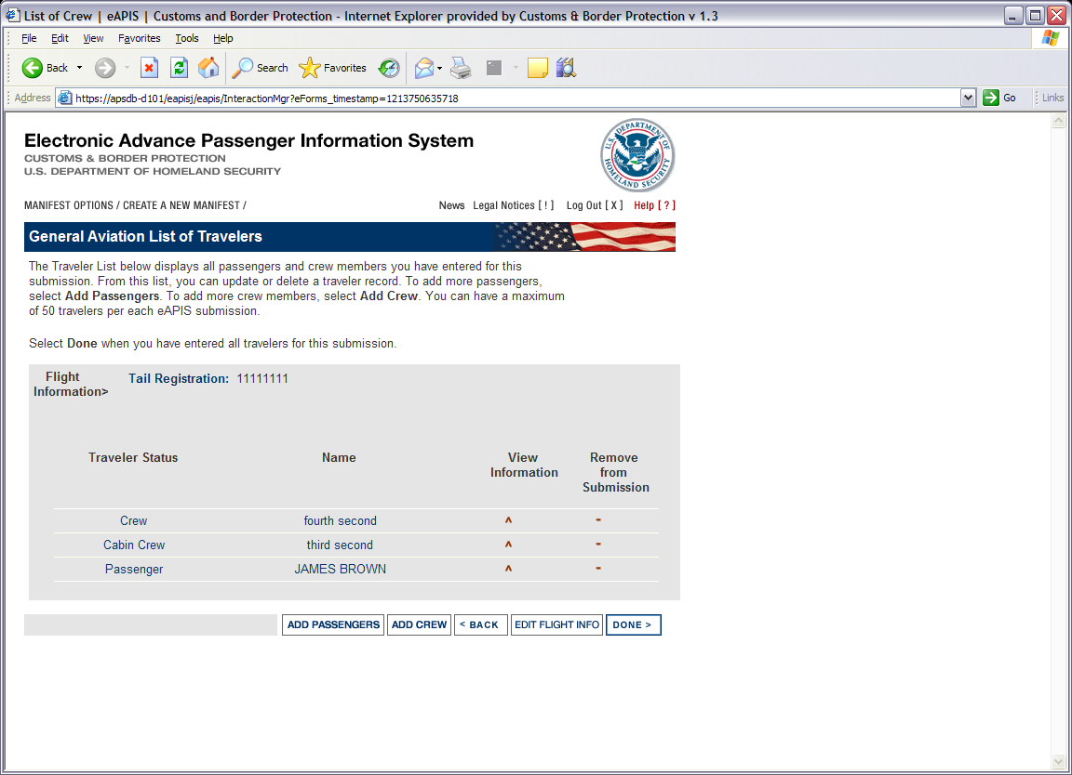

Notice of Saved Manifest

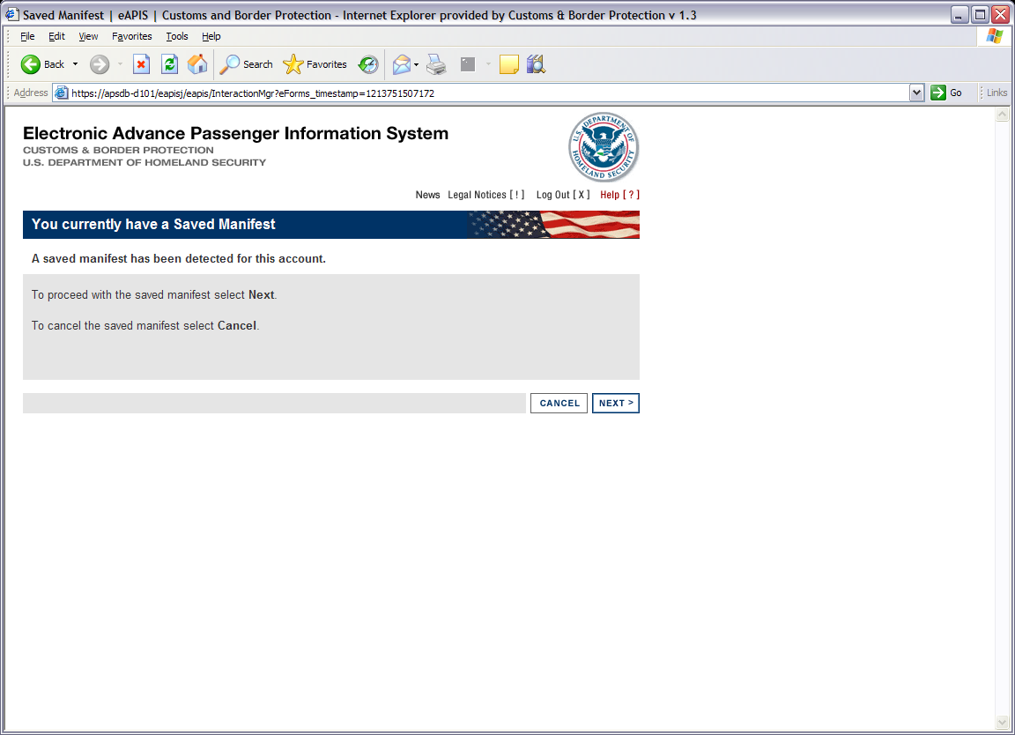

Cancellation of a Current Activity
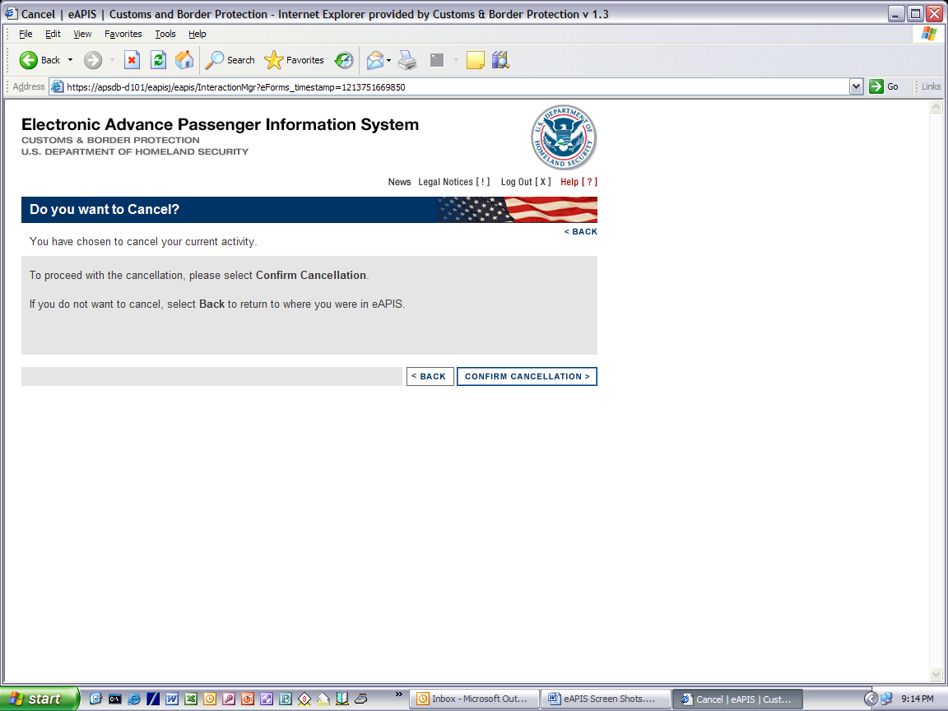

Cancellation Confirmed
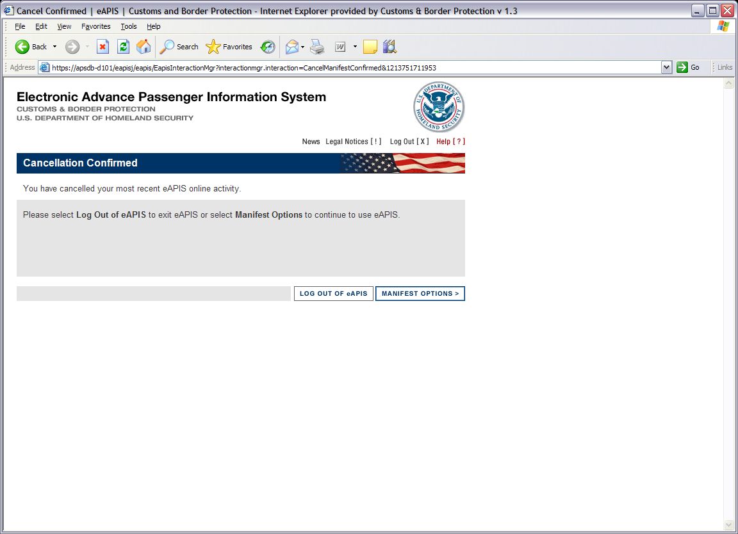

Crew Maintenance

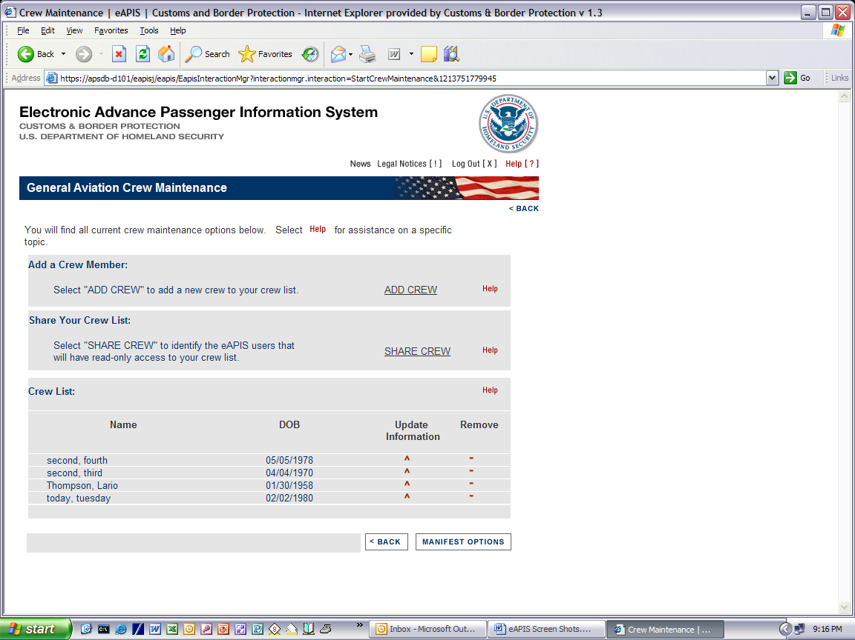

Initial Shared Access Code
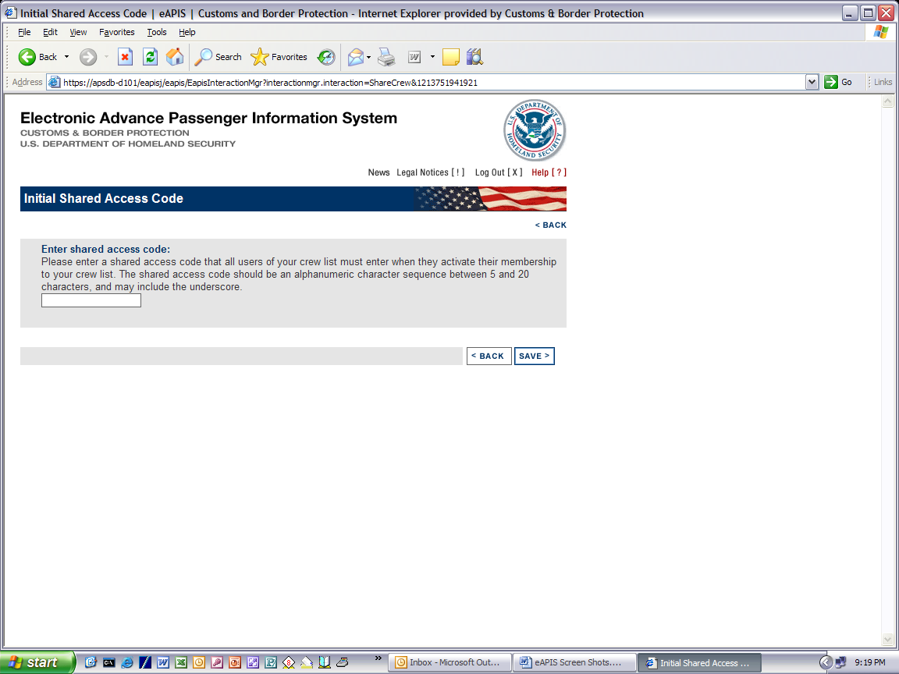

Share Crew List
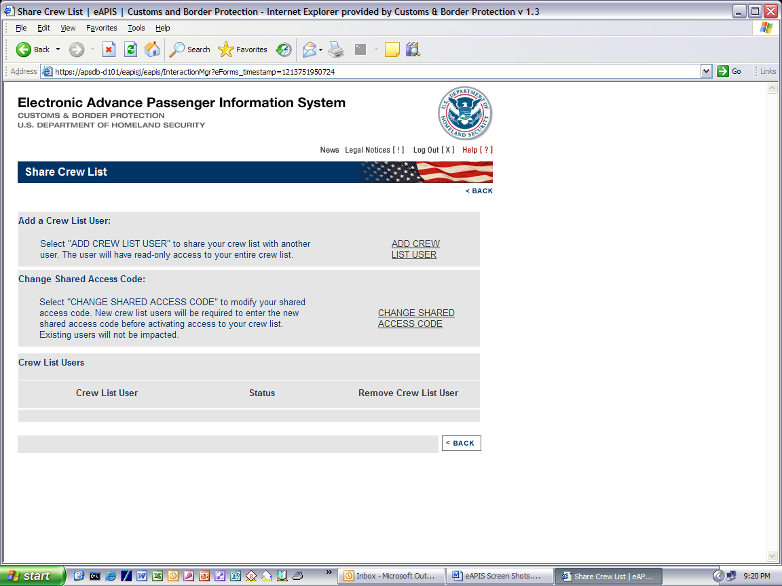

Upload Manifest
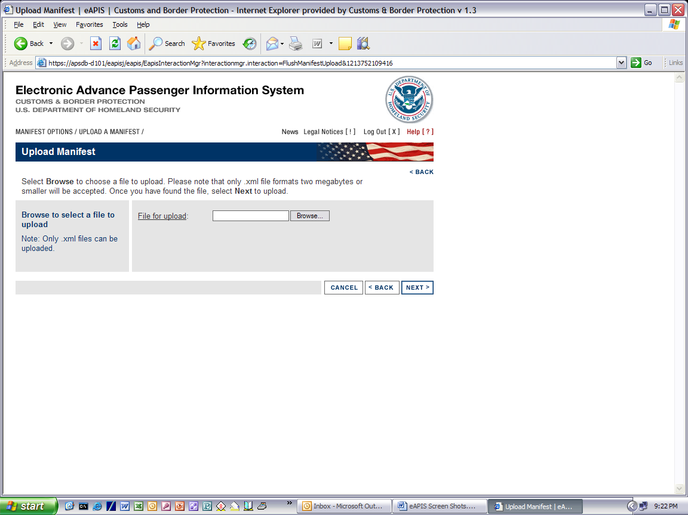

Warning for an Already Existing Active Session
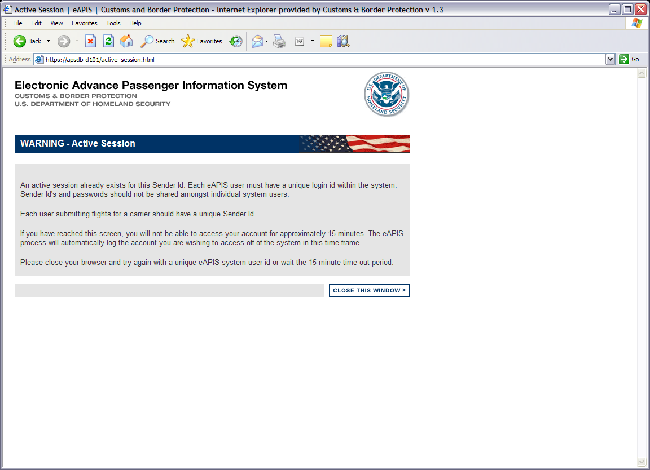

No Errors or Warnings Page
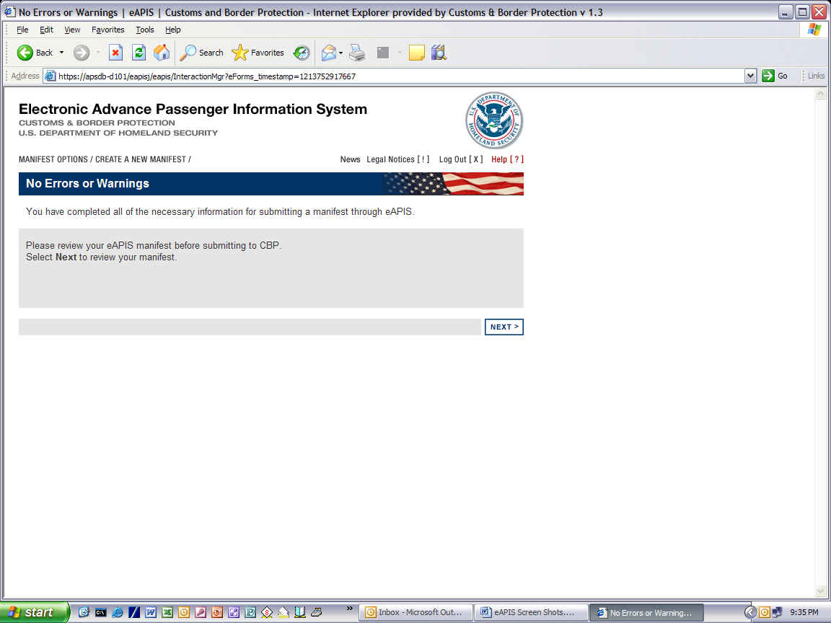

Final Review Page
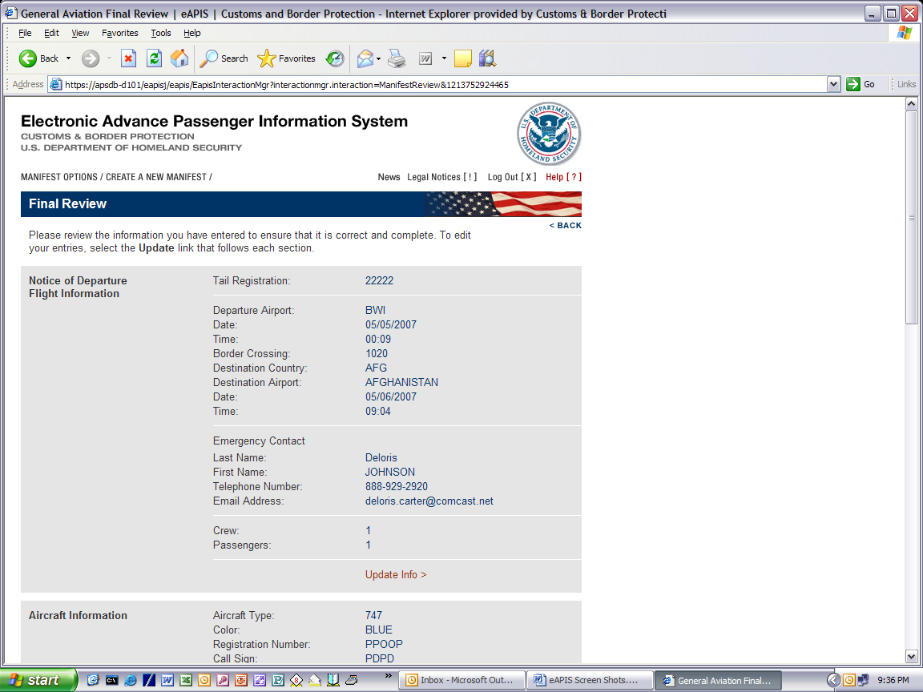
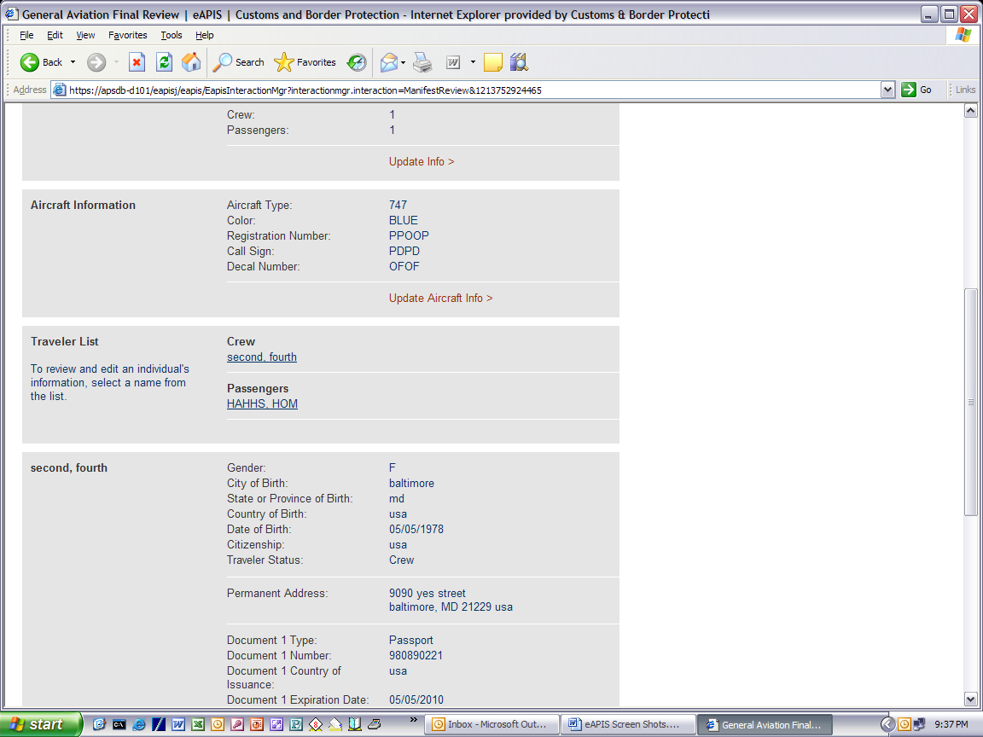
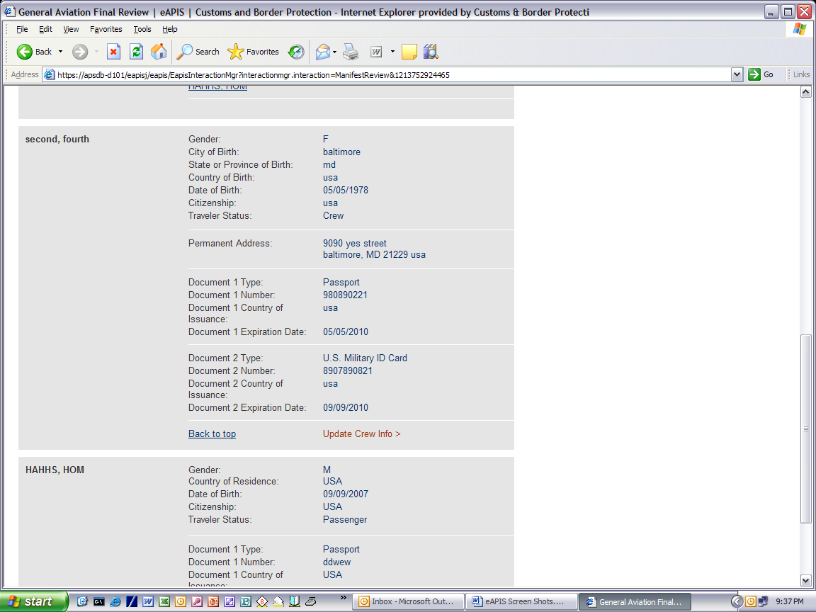
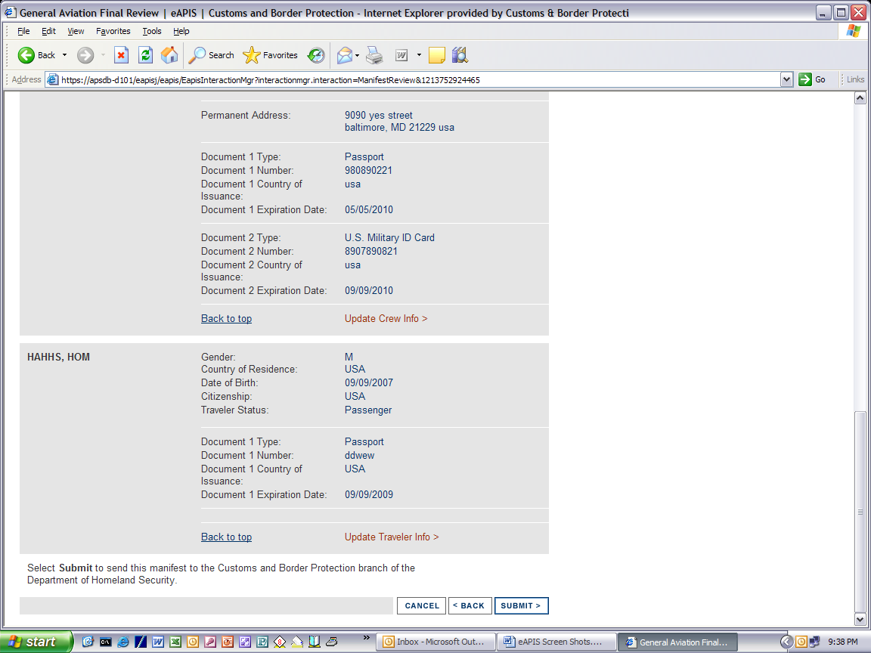

Confirmation Page
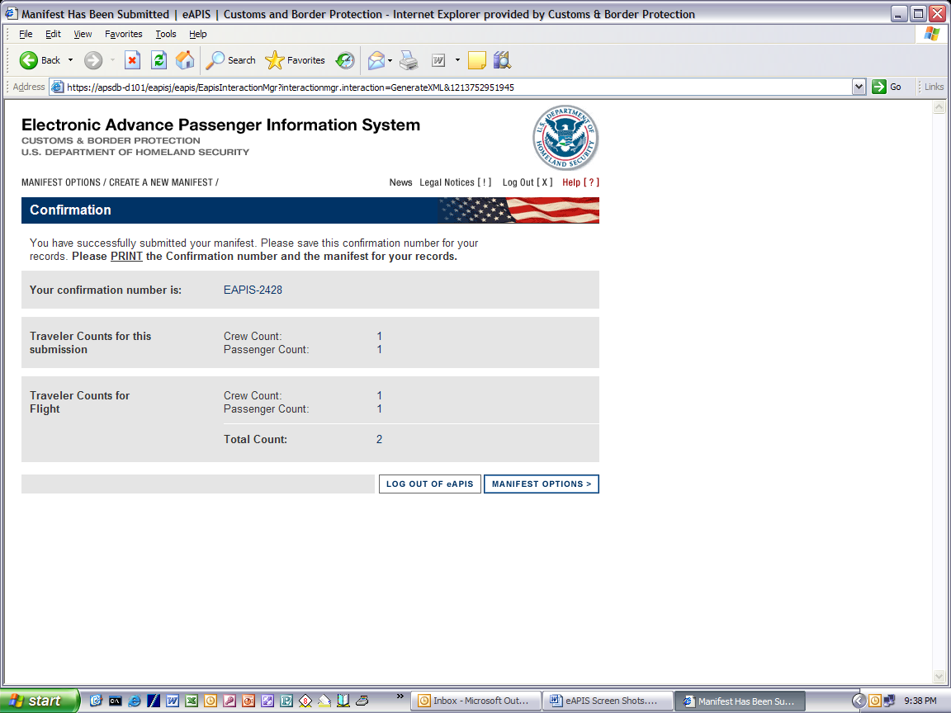

You Have Chosen to Log Out Of eAPIS

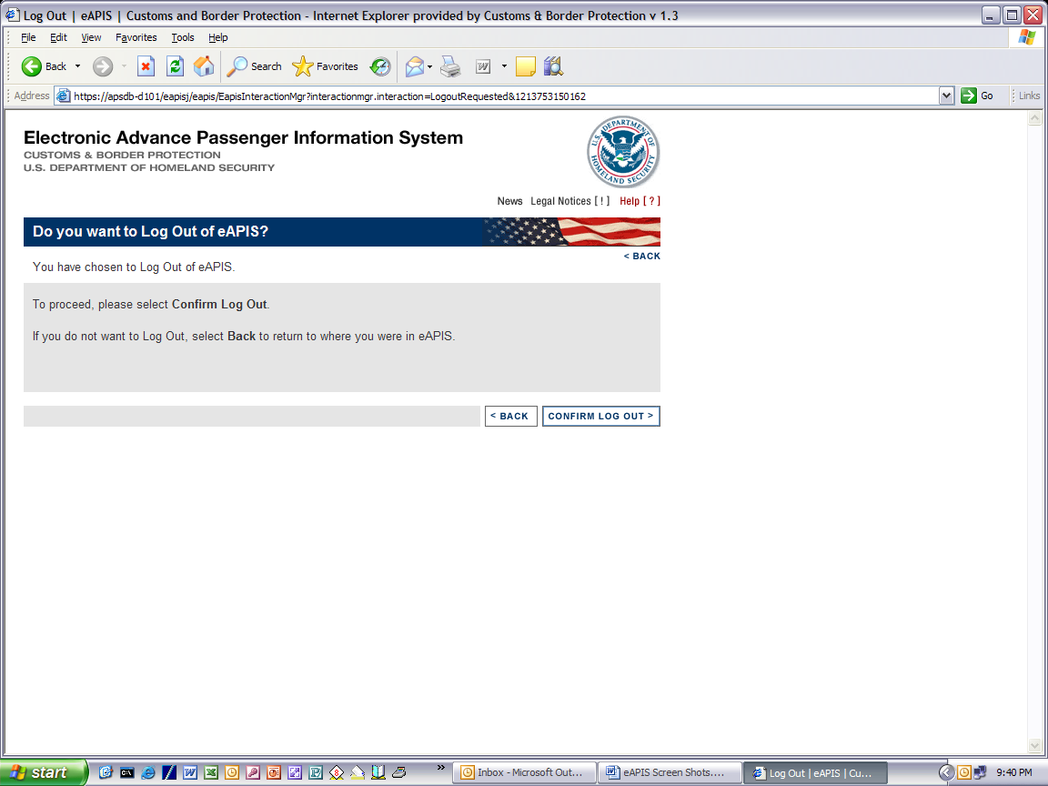

Log Out Confirmed
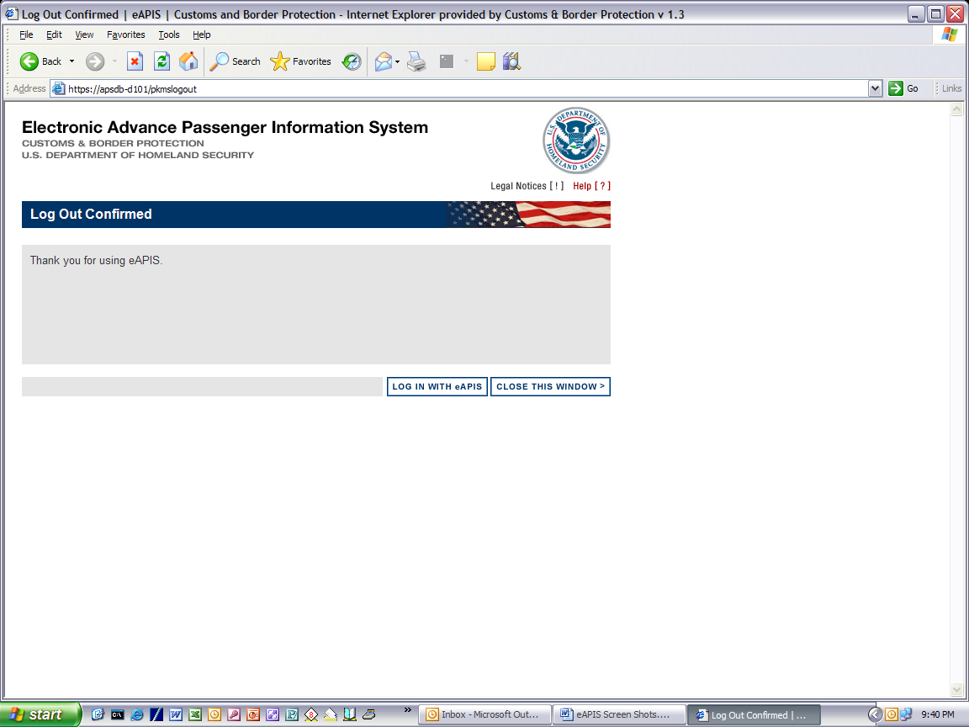

Select eAPIS Account Type
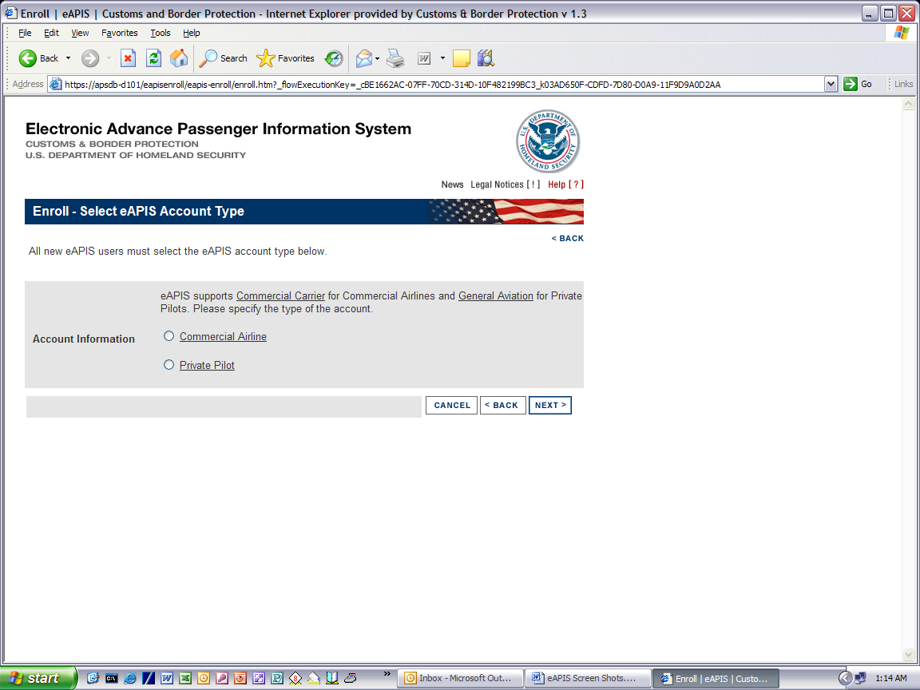

Enroll Commercial Airline Page
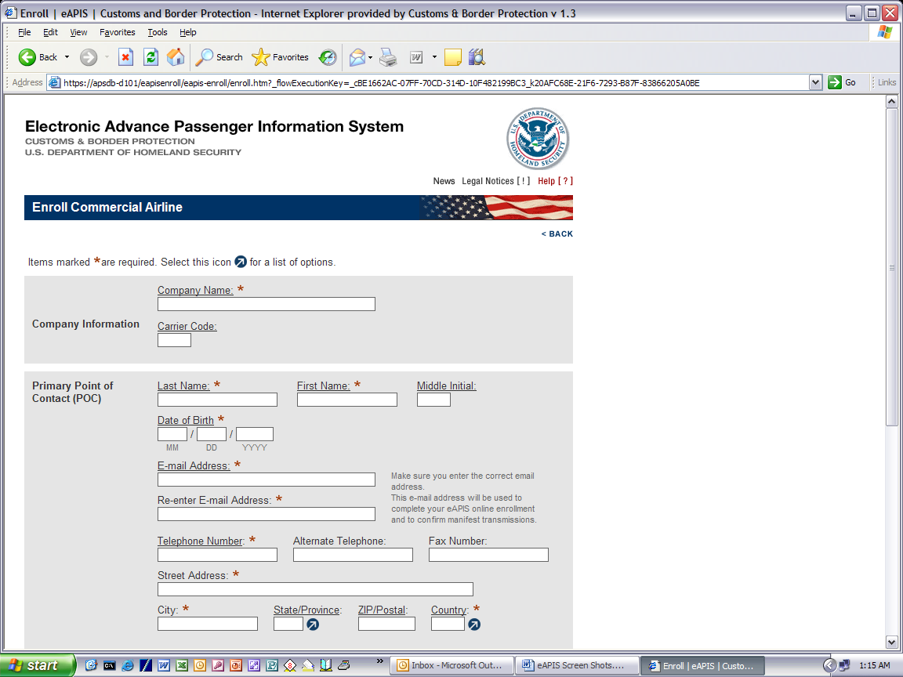
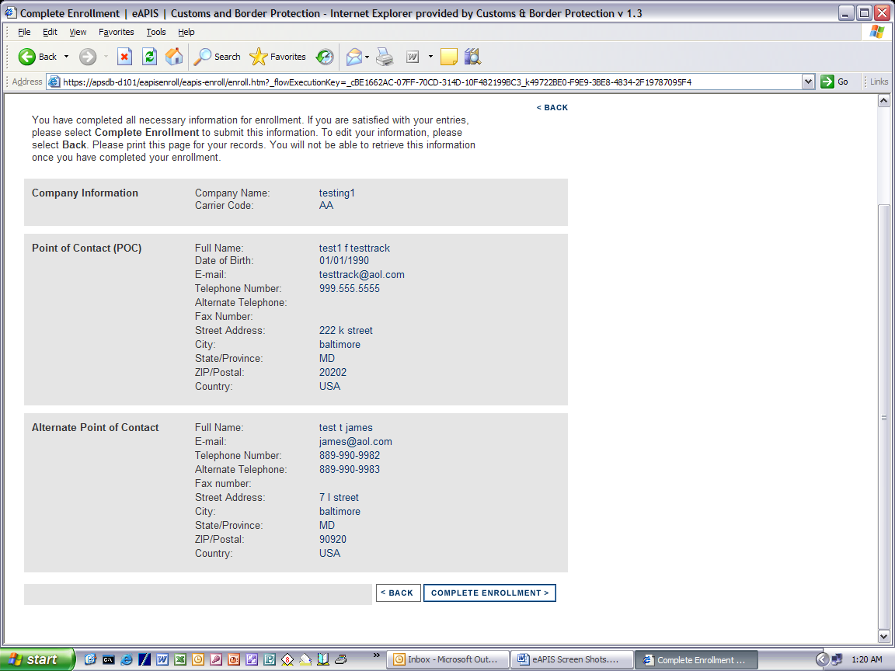

Enrollment Confirmation
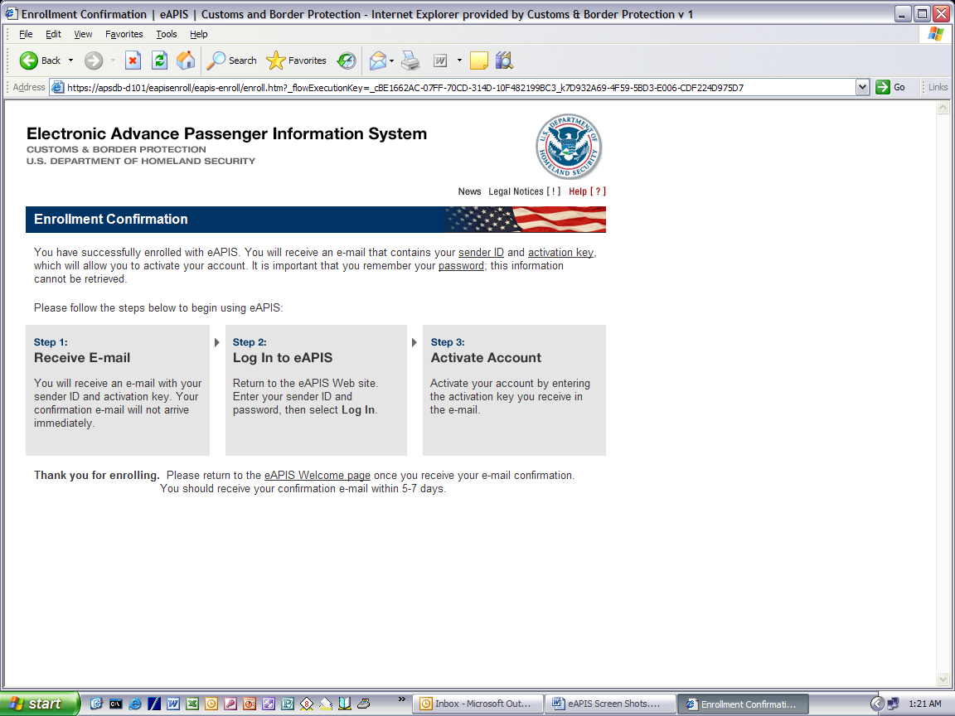

Enroll Private Pilot Page
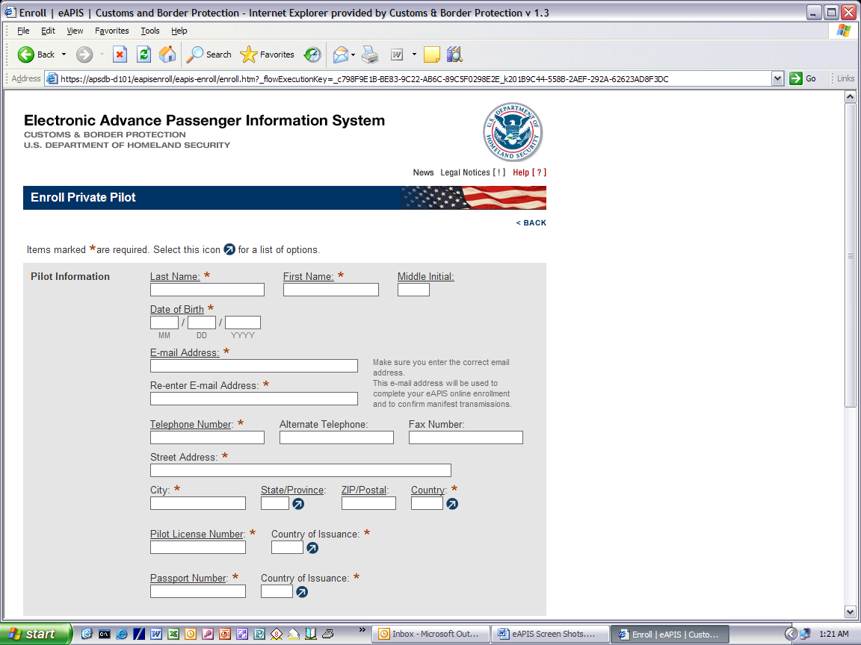
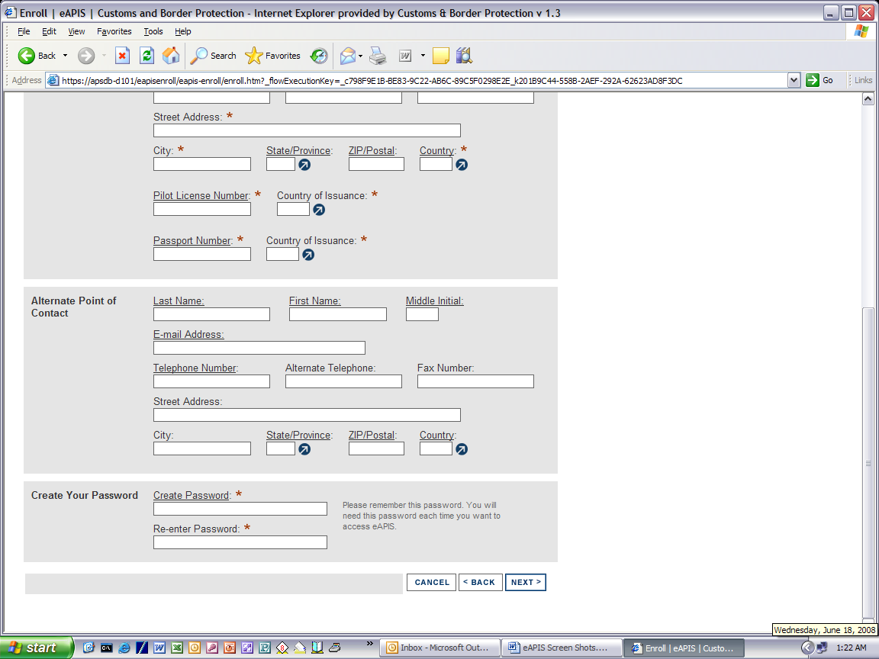

Complete Private Pilot Enrollment Page
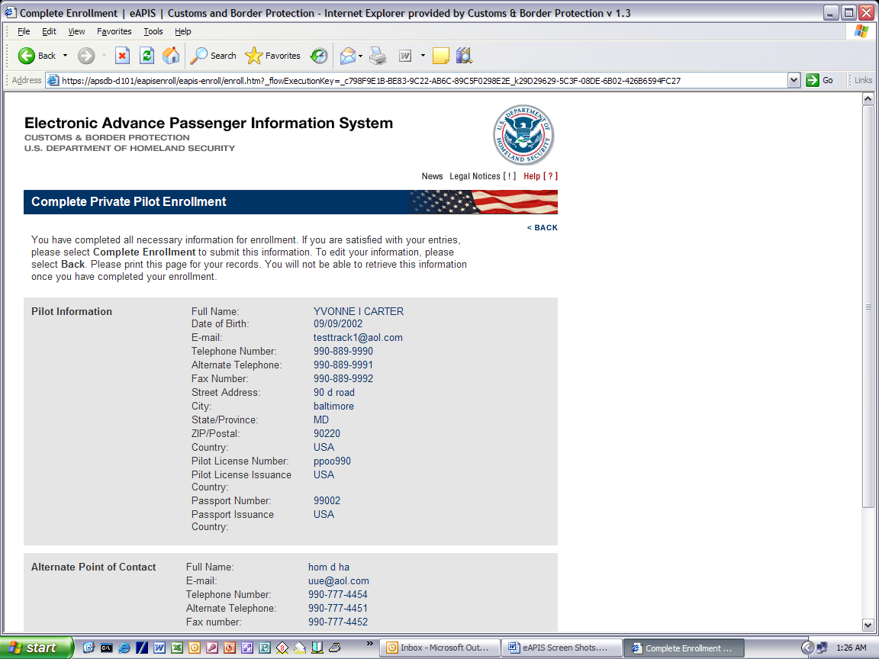
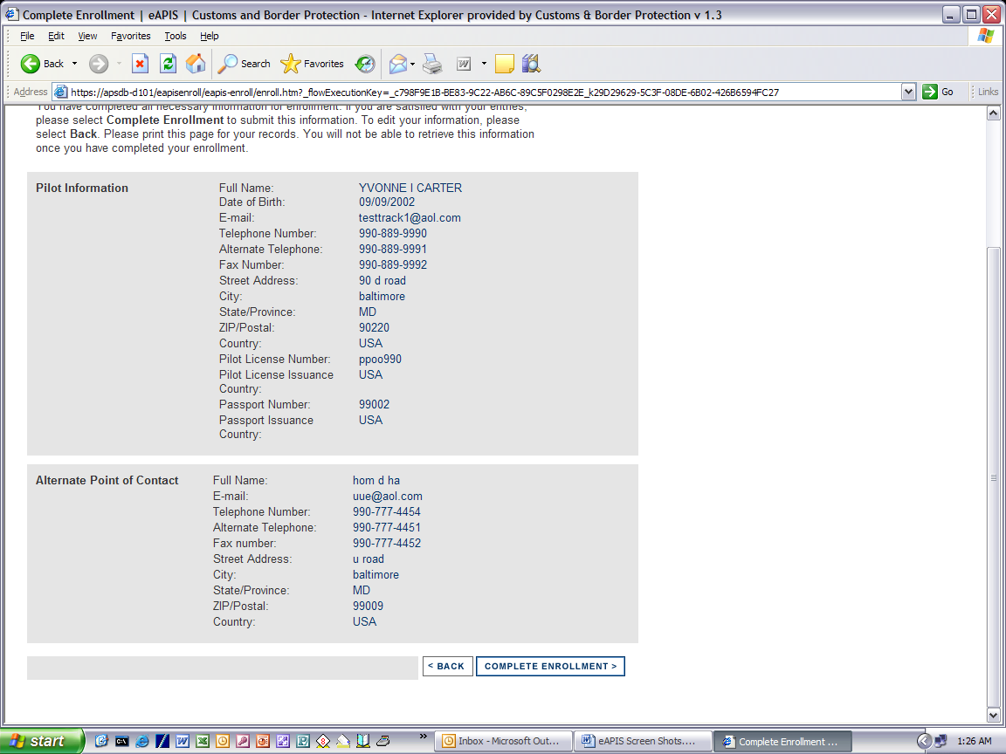

Legal Notes Page
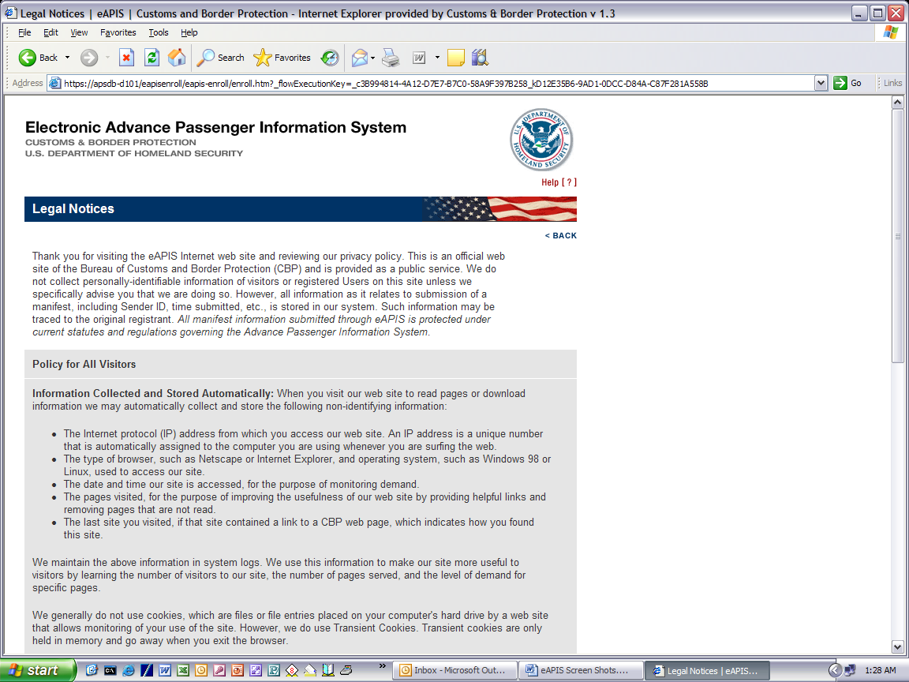
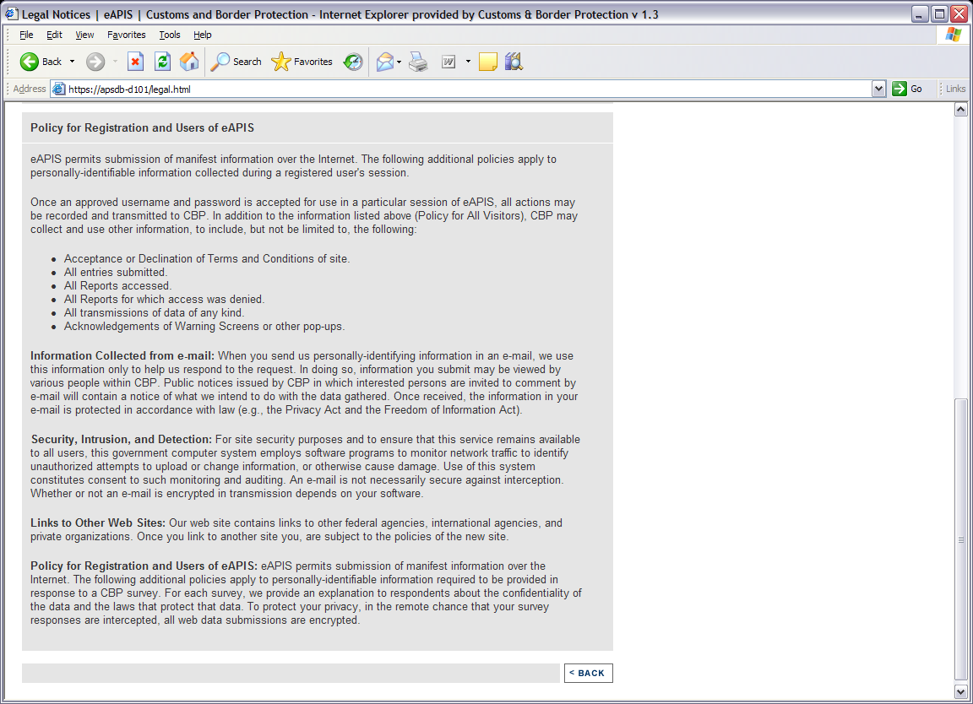

News Page
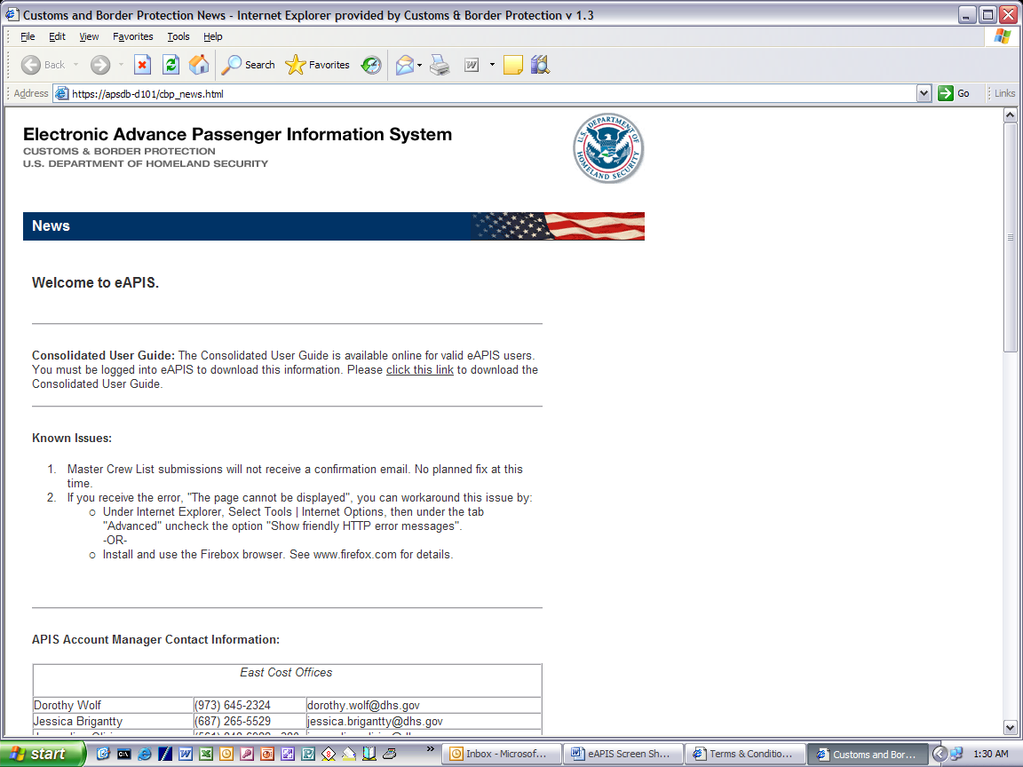
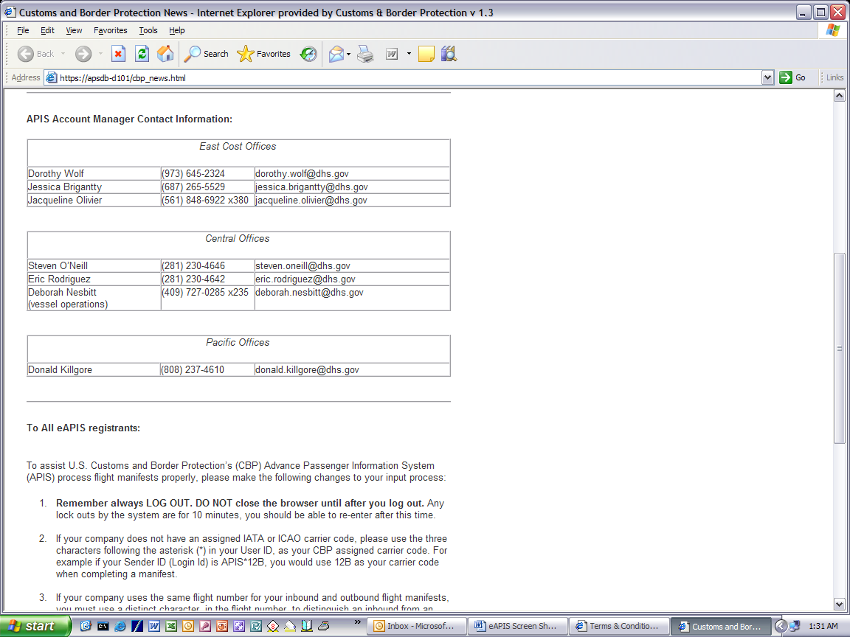

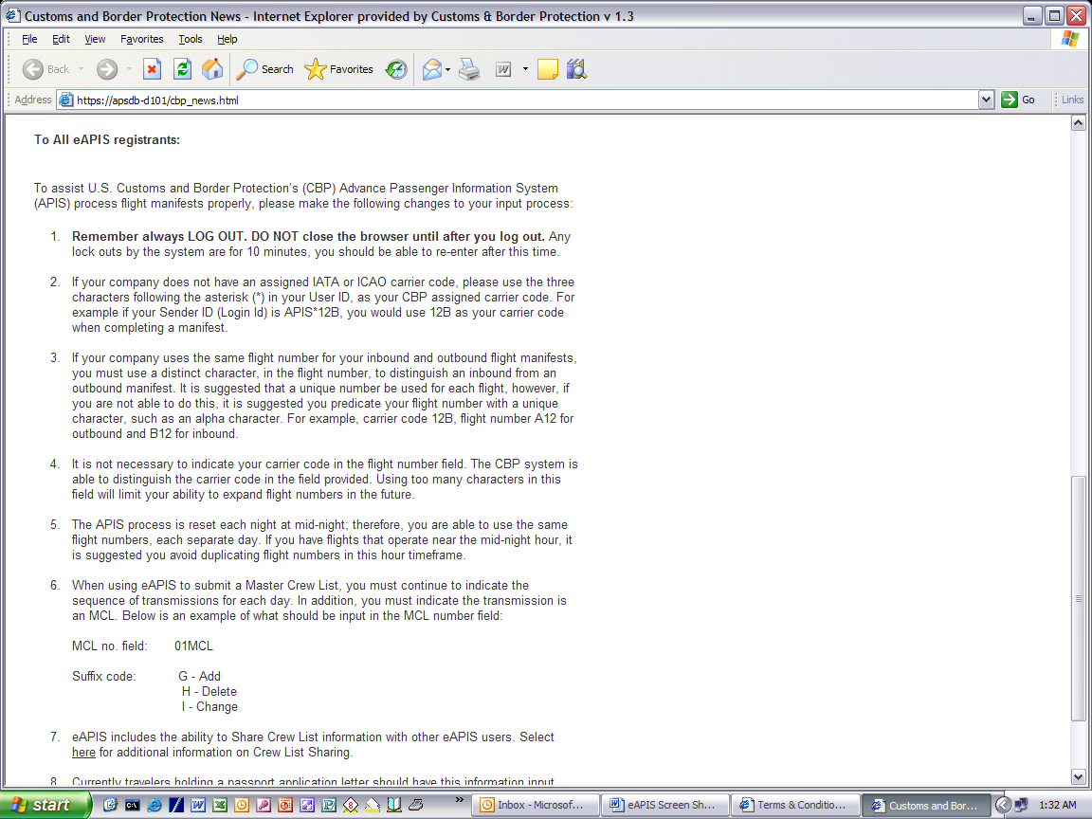
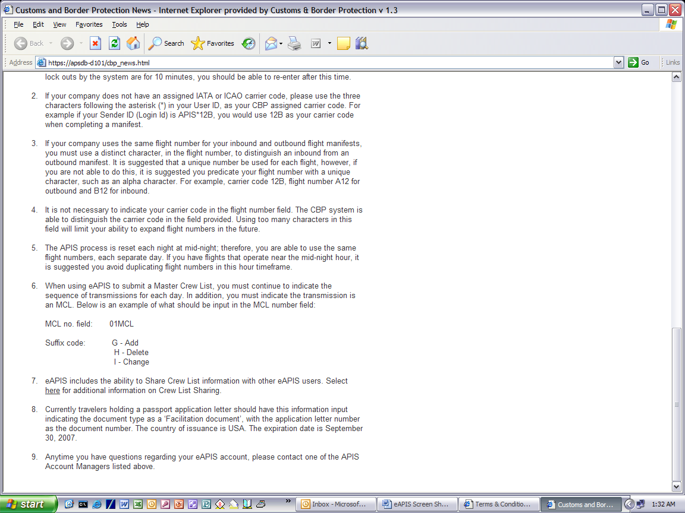

Help Page
