The e-GGRT system shows the paperwork reduction act information on the footer to every screen.

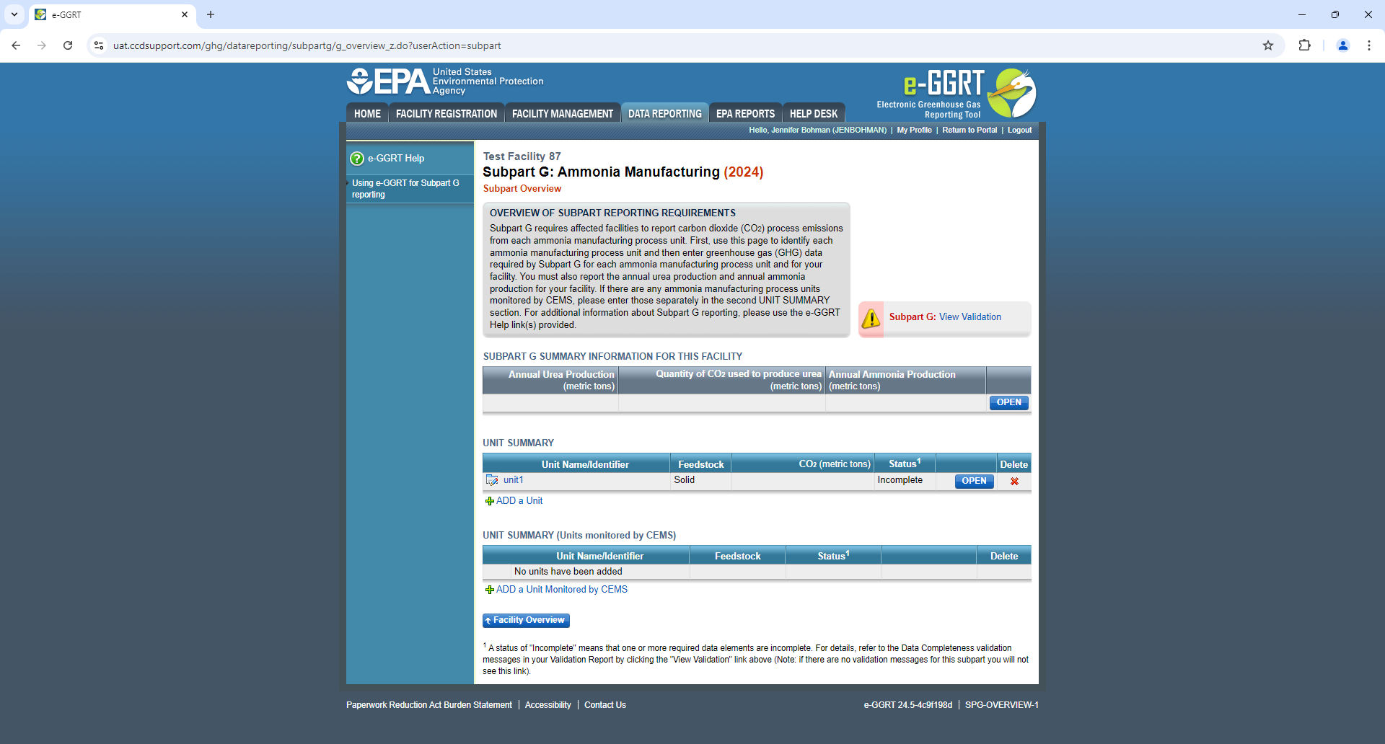

This links the page where we have the ICR statements listed for the information collected in the e-GGRT system:

<https://ccdsupport.com/confluence/display/help/Paperwork+Reduction+Act+Burden+Statements>

Reporters that elect to prepare their annual reports in XML instead of using the e-GGRT webforms, need to submit their XML files through the e-GGRT system. So these XML reporters would log into the e-GGRT system, upload their XML files, and proceed through the submission screens, all of which would include the link to the Paperwork Reduction Act Statement on every page.