**Attachment 3**

**12 U.S. Code § 1701z–6**

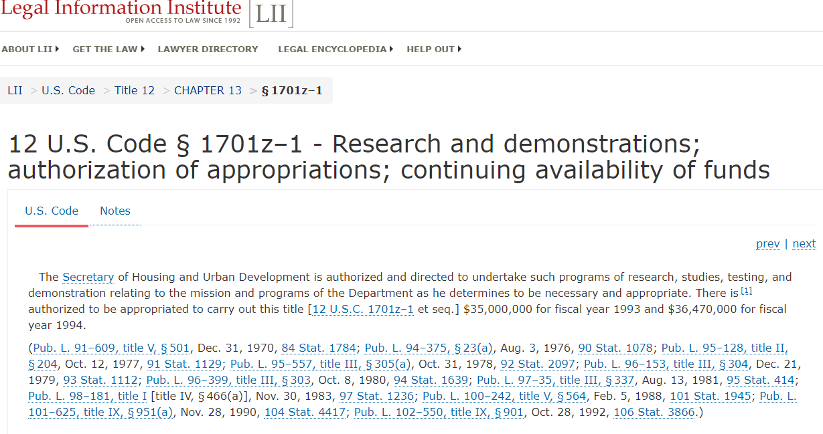

**12 U.S. Code § 1701z–1 - Research and demonstrations; authorization of appropriations; continuing availability of funds**

The Secretary of Housing and Urban Development is authorized and directed to undertake such programs of research, studies, testing, and demonstration relating to the mission and programs of the Department as he determines to be necessary and appropriate. There is [1] authorized to be appropriated to carry out this title [12 U.S.C. 1701z–1 et seq.] $35,000,000 for fiscal year 1993 and $36,470,000 for fiscal year 1994.

(Pub. L. 91–609, title V, § 501, Dec. 31, 1970, 84 Stat. 1784; Pub. L. 94–375, § 23(a), Aug. 3, 1976, 90 Stat. 1078; Pub. L. 95–128, title II, § 204, Oct. 12, 1977, 91 Stat. 1129; Pub. L. 95–557, title III, § 305(a), Oct. 31, 1978, 92 Stat. 2097; Pub. L. 96–153, title III, § 304, Dec. 21, 1979, 93 Stat. 1112; Pub. L. 96–399, title III, § 303, Oct. 8, 1980, 94 Stat. 1639; Pub. L. 97–35, title III, § 337, Aug. 13, 1981, 95 Stat. 414; Pub. L. 98–181, title I [title IV, § 466(a)], Nov. 30, 1983, 97 Stat. 1236; Pub. L. 100–242, title V, § 564, Feb. 5, 1988, 101 Stat. 1945; Pub. L. 101–625, title IX, § 951(a), Nov. 28, 1990, 104 Stat. 4417; Pub. L. 102–550, title IX, § 901, Oct. 28, 1992, 106 Stat. 3866.)

**12 U.S. Code § 1701z–2 - Advanced technologies, methods, and materials for housing construction, rehabilitation, and maintenance**

(**d)Technical assistance; reports; general dissemination and form of reports, data, and information**

In order to effectively carry out his activities under [section 1701z–1 of this title](https://www.law.cornell.edu/uscode/text/12/1701z%E2%80%931), the[Secretary](https://www.law.cornell.edu/definitions/uscode.php?width=840&height=800&iframe=true&def_id=12-USC-1264422296-1510435008&term_occur=999&term_src=title:12:chapter:13:section:1701z%E2%80%932)is authorized to provide such advice and technical assistance as may be required and to pay for the cost of writing and publishing reports on activities and undertakings financed under [section 1701z–1 of this title](https://www.law.cornell.edu/uscode/text/12/1701z%E2%80%931), as well as reports on similar activities and undertakings, not so financed, which are of significant value in furthering the purposes of that section. He may disseminate (without regard to the provisions of [section 3204 of title 39](https://www.law.cornell.edu/uscode/text/39/3204) or section 4154 of such title with respect to any period before the effective date of such section 3204 as provided in section 15(a) of the [Postal Reorganization Act](https://www.law.cornell.edu/topn/postal_reorganization_act)) any reports, data, or information acquired or held under this title [[12 U.S.C. 1701z–1](https://www.law.cornell.edu/uscode/text/12/1701z%E2%80%931) et seq.], including related data and information otherwise available to the[Secretary](https://www.law.cornell.edu/definitions/uscode.php?width=840&height=800&iframe=true&def_id=12-USC-1264422296-1510435008&term_occur=999&term_src=title:12:chapter:13:section:1701z%E2%80%932)through the operation of the programs and activities of the Department of Housing and Urban Development, in such form as he determines to be most useful to departments, establishments, and agencies of Federal,[State,](https://www.law.cornell.edu/definitions/uscode.php?width=840&height=800&iframe=true&def_id=12-USC-80204913-1510435009&term_occur=999&term_src=title:12:chapter:13:section:1701z%E2%80%932) and local governments, to industry, and to the general public.

**(e)Contracts or grants; authority; advance and progress payments; work limitation**

The [Secretary](https://www.law.cornell.edu/definitions/uscode.php?width=840&height=800&iframe=true&def_id=12-USC-1264422296-1510435008&term_occur=999&term_src=title:12:chapter:13:section:1701z%E2%80%932) is authorized to carry out the functions authorized in [section 1701z–1 of this title](https://www.law.cornell.edu/uscode/text/12/1701z%E2%80%931) either directly or, without regard to [section 6101 of title 41](https://www.law.cornell.edu/uscode/text/41/6101), by contract or by grant. Advance and progress payments may be made under such contracts or grants without regard to the provisions of subsections (a) and (b) of [section 3324 of title 31](https://www.law.cornell.edu/uscode/text/31/3324) and such contracts or grants may be made for work to continue for not more than four years from the date thereof.

**(g)Information and data; restriction on use or identification**

The Secretary is authorized to request and receive such information or data as he deems appropriate from private individuals and organizations, and from public agencies. Any such information or data shall be used only for the purposes for which it is supplied, and no publication shall be made by the Secretary whereby the information or data furnished by any particular person or establishment can be identified, except with the consent of such person or establishment.

([Pub. L. 91–609, title V, § 502](https://www.law.cornell.edu/rio/citation/Pub._L._91-609), Dec. 31, 1970, [84 Stat. 1784](https://www.law.cornell.edu/rio/citation/84_Stat._1784); [Pub. L. 94–375, § 23(c)](https://www.law.cornell.edu/rio/citation/Pub._L._94-375), Aug. 3, 1976, [90 Stat. 1078](https://www.law.cornell.edu/rio/citation/90_Stat._1078); [Pub. L. 98–479, title II, § 203(k)](https://www.law.cornell.edu/rio/citation/Pub._L._98-479), Oct. 17, 1984, [98 Stat. 2231](https://www.law.cornell.edu/rio/citation/98_Stat._2231).)

**12 U.S. Code § 1701z–6 - Special housing need research and demonstration authority**

**(a)Special demonstrations of housing design, structure, facilities, and amenities to meet needs of elderly, handicapped, etc.; contracts, grants, and assistance by Secretary**

In carrying out activities under section 1701z–1 of this title, the Secretary may undertake special demonstrations to determine the housing design, the housing structure, and the housing-related facilities, and amenities most effective or appropriate to meet the needs of groups with special housing needs including the elderly, the handicapped, the displaced, single individuals, broken families, and large households. For this purpose, the Secretary is authorized to enter into contracts with, to make grants to, and to provide other types of assistance to individuals and entities with special competence and knowledge to contribute to the planning, development, design, and management of such housing.

**(b)Areas of preferential attention**

In carrying out his functions under this section, the Secretary shall give preferential attention to demonstrations which in his judgment involve areas of housing user needs most neglected in past and current research and demonstration efforts.

**(c)Utilization of contract and loan authority of federally assisted housing programs; setting aside of development, etc., requirements during testing.**

The Secretary is authorized to undertake demonstrations involving the actual planning, development, and occupancy of housing utilizing the contract and loan authority of any federally assisted housing program. He is also authorized to set aside any development, construction, design, and occupancy requirements, for the purposes of these demonstrations, if in his judgment they inhibit the testing of housing designed to meet the special housing needs.

**(d)Evaluation of demonstration**

In carrying out this section, the Secretary shall include, as part of any demonstration, an evaluation of the demonstration to cover the full experience involved in planning, development, and occupancy.

**(e)Limitation on amounts available for research**

In addition to any other contract or loan authority which the Secretary may utilize under subsection (c), not more than $10,000,000 from amounts approved in appropriation Acts shall be available for research under this section.

(Pub. L. 91–609, title V, § 507, as added Pub. L. 93–383, title VIII, § 815, Aug. 22, 1974, 88 Stat. 738.)