SUPPORTING STATEMENT - PART A
Safety Standard for Infant Support Cushions
OMB Control Number 3041-0202

1. Need for the Information Collection

The Danny Keysar Child Product Safety Notification Act, section 104 of the Consumer Product Safety Improvement Act of 2008 (CPSIA), requires the U.S. Consumer Product Safety Commission (Commission or CPSC) to promulgate consumer product safety standards for durable infant or toddler products. Under this statutory authority, the Commission is issuing a safety standard for infant support cushions. The Commission is also amending CPSC’s consumer registration requirements to identify infant support cushions as durable infant or toddler products and amending CPSC’s list of notices of requirements (NORs) to include infant support cushions. This safety standard contains information collection requirements that are subject to public comment and review by the Office of Management and Budget (OMB) under the Paperwork Reduction Act of 1995 (PRA; 44 U.S.C. 3501–3521).

The final rule defines an infant support cushion as an infant product that is filled with or comprised of resilient material such as foam, fibrous batting, or granular material or with a gel, liquid, or gas, and which is marketed, designed, or intended to support an infant’s weight or any portion of an infant while reclining or in a supine, prone, or recumbent position. This is the definition that will be used for the information collection also. This definition includes any removable covers, or slipcovers, sold on or together with an infant support cushion. This includes infant pillows, infant loungers, nursing pillows with a lounging function, infant props or cushions used to support an infant for activities such as tummy time, and other similar products. The final rule includes information collection requirements addressing the risk of death and injury associated with infant support cushions primarily due to suffocation, entrapment, and fall hazards.

2. Use of the Information

The safety standard provides marking and labeling requirements for infant support cushions, including general markings, permanency, upholstery labeling, warning design for product, and warning statements. Figures 1 and 2 provide examples of the required warnings. The standard also provides requirements for instructional literature for infant support cushions, including requiring instructional literature be provided with the product. Specialized expertise in graphics design would not be required to develop the warnings and instructions.

Figure 1: Warning for Product Without Tummy Time
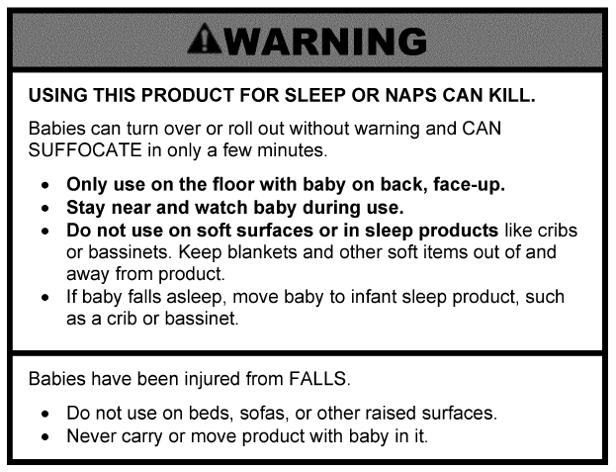

Figure 2: Warning for Tummy Time Product
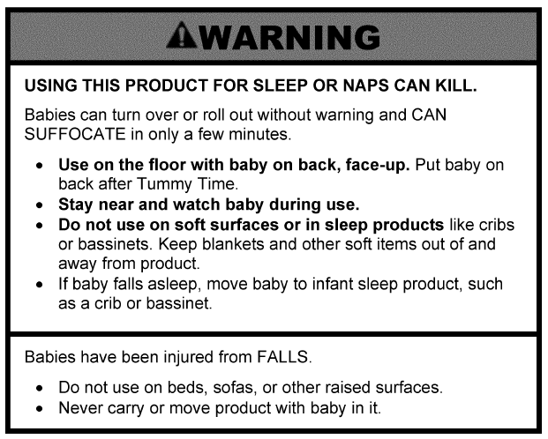

For this information collection respondents are persons who manufacture or import infant support cushions. While some infant support cushion products currently have labels, all of these products would have to meet the labeling requirements and instructions specified in the rule.

Most reporting and recordkeeping requirements in this rule would be new for all suppliers. The Commission is issuing this rule to establish mandatory performance and labeling requirements for infant support cushions to reduce injuries and deaths from the known hazards posed by these products.

3. Use of Information Technology

To address the hazard posed by infant support cushions, the rule requires warnings and labeling. The on-product warnings must be visible when the product is in each manufacturer’s recommended use position. On-product warnings are not digital in nature; however, CPSC staff utilizes appropriate forms of information technology, such as electronic communication to reduce unnecessary burden.

4. Non-duplication

The information obtained through this collection is unique and is not already available for use or adaptation from another source.

5. Burden on Small Businesses

Commission staff has identified more than 2,000 suppliers of infant support cushions to the U.S. market, including manufacturers, importers, and foreign direct shippers. The majority of these suppliers are small businesses. The information collection will likely have a significant impact on a substantial number of U.S. small entities.

To reduce the impact of the final rule on small firms, CPSC provides a variety of resources to help both new and experienced small businesses learn about safety requirements that apply to consumer products, including the CPSC Regulatory Robot, small business education videos, and the Small Business Ombudsman. Many of these resources can be accessed online at: https://www.cpsc.gov/Business--Manufacturing/Small-Business-Resources. Small firms can reach the Small Business Ombudsman by calling (888) 531-9070.

6. Less Frequent Collection

CPSC is aware of at least 79 reported fatalities involving infant support cushions from January 1, 2010, through December 31, 2022, as well as 124 nonfatal incidents or reports involving these products within the same time period. There were 17 deaths in 2020, and a minimum of 17 more in 2021. More than 80 percent of the known fatalities associated with these products involve infants three months old or younger. In more than 60 percent of the fatalities, the official cause of death was asphyxia or probable asphyxia. These incidents typically involved the use of an infant support cushion placed in or on a sleep-related consumer product such as an adult bed, futon, crib, bassinet, play yard, or couch. For the non-fatal incidents, the most common circumstances involved an infant falling from an infant support cushion placed on a raised surface such as a bed or a sofa, or a threat of asphyxia or entrapment.

If the information collection is conducted less frequently this could reduce the effectiveness of the rule.

7. Paperwork Reduction Act Guidelines
This collection of information does not require the collection to be conducted in a manner inconsistent with the guidelines delineated in 5 CFR 1320.5(d)(2).
8. Consultation and Public Comments
Part A: PUBLIC NOTICE
A 60-Day Federal Register Notice (FRN) for the collection published on Tuesday, January 16, 2024. The 60-Day FRN citation is 89 FRN 2530. The preamble to the NPR discussed the information collection burden of the proposed rule and specifically requested comments on the accuracy of CPSC’s estimates. The NPR described the provisions of the proposed rule and provided an estimate of the annual reporting burden for the rule under the PRA. CPSC did not receive any comments regarding the information collection burden in the NPR through OMB.
The estimated burden of this collection of information is unchanged from the NPR.
Part B: CONSULTATION
CPSC formally began the consultation process for this rulemaking in December 2021, via a letter from CPSC staff requesting that ASTM International (ASTM) form a working group to develop a voluntary standard to reduce the risk of death and injury from hazards associated with infant pillow products, including nursing pillows. In response, ASTM formed two subcommittees intended to develop two separate voluntary standards: the F15.16 Infant Feeding Supports subcommittee, intended to develop a standard for nursing pillows; and the F15.21 Infant Loungers subcommittee. CPSC staff has been actively participating in both ASTM subcommittees to develop voluntary standards that address hazards associated with these products.

Currently, there are no published U.S. voluntary standards for infant support cushions. ASTM is working on a voluntary standard for infant loungers under the Subcommittee F15.21 on Infant Carriers, Bouncers, and Baby Swings. On March 25, 2024, ASTM issued ballot F15.21 (24–01), which included the latest draft of the infant lounger’s voluntary standard. The ballot closed on April 29, 2024, and received eight negative votes and other comments including a comment from staff. On September 16, 2024, ASTM issued ballot F15 (24–18), Item #1 which addressed the negative comments and other comments on the draft standard for infant loungers included in ballot F15 (24–01). That ballot closed on October 16, 2024.

On April 23, 2024, CPSC published a notice of availability (NOA) in the Federal Register that announced the availability of the incident data relied upon for the infant support cushions NPR and sought comments from the public. 89 FR 30295. The Commission received one comment in response to the NOA.

9. Gifts or Payment

No payments or gifts are being offered to respondents as an incentive to participate in the collection.

10. Confidentiality

A Privacy Act Statement is not required for this collection because we are not requesting individuals to furnish personal information for a system of records.

A System of Record Notice (SORN) is not required for this collection because records are not retrievable by PII.

A Privacy Impact Assessment (PIA) is not required for this collection because PII is not being collected electronically.

11. Sensitive Questions

No questions considered sensitive are being asked in this collection.

12. Respondent Burden and its Labor Costs

CPSC estimates there are 2,000 entities that would respond to this collection annually, the majority of which would be small entities. We estimate that the time required to create and/or modify labeling and instructions is about two hours per response. Therefore, the estimated burden associated with this collection is 2,000 responses × one response per year × two hours per response = 4,000 hours annually. (See table 1.)

Table 1: Estimated Annual Reporting Burden
Burden Type | Number of Respondents | Frequency of Response | Total Annual Responses | Hours per Response | Total Burden Hours
Labeling and instructions | 2,000 | 1 | 2,000 | 2 | 4,000

We estimate the hourly compensation for the time required to respond to the collection is $37.88 (U.S. Bureau of Labor Statistics, ‘‘Employer Costs for Employee Compensation,’’ June 2023, Table 4, total compensation for all sales and office workers in goods-producing private industries: https://www.bls.gov/news.release/archives/ecec_09122023.pdf. Therefore, the estimated annual cost of the collection is $151,520 ($37.88 per hour × 4,000 hours = $151,520).

Based on this analysis, the proposed standard for infant support cushions would impose a burden to industry of 4,000 hours at a cost of $151,520.

13. Respondent Costs Other Than Burden Hour Costs

No operating, maintenance, or capital costs are associated with the collection.

14. Cost to the Federal Government

The estimated annual cost of the information collection requirements to the federal government is approximately $4,746, which includes 60 staff hours to examine and evaluate the information as needed for Compliance activities. This is based on a GS-12 level salaried employee. The average hourly wage rate for a mid-level salaried GS-12 employee in the Washington, DC metropolitan area (effective as of January 2024) is $53.87 (GS-12, step 5). This represents 68.1 percent of total compensation (U.S. Bureau of Labor Statistics, “Employer Costs for Employee Compensation,” September 2023, percentage of wages and salaries for all civilian management, professional, and related employees: https://www.bls.gov/news.release/archives/ecec_12152023.pdf). Adding an additional 31.9 percent for benefits brings average hourly compensation for a mid-level salaried GS-12 employee to $79.10. Assuming that approximately 60 hours will be required annually, this results in an annual cost of $4,746.

15. Reasons for Change in Burden

This is a new collection with a new associated burden.

16. Publication of Results

The results of this information collection will not be published.

17. Non-Display of OMB Expiration Date

We are not seeking approval to omit the display of the expiration date of the OMB approval on the collection instrument.

18. Exceptions to “Certification for Paperwork Reduction Submissions”

We are not requesting any exemptions to the provisions stated in 5 CFR 1320.9.

