**Attachment 15g:**

**Estimates of Respondent Burden and Annualized Cost**

**Estimates of Respondent Burden and Annualized Cost**

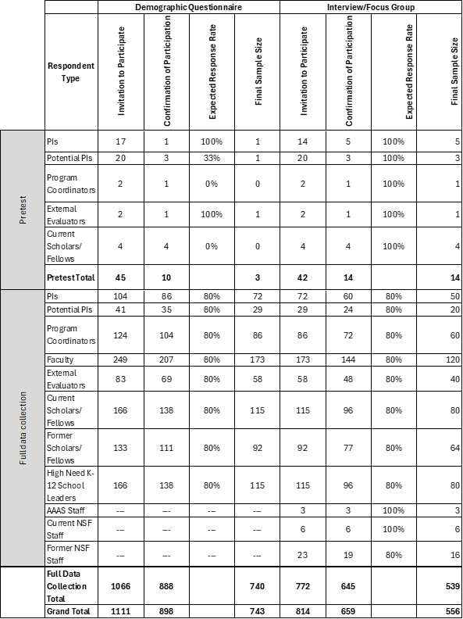

|  |  |  |  |  |  |  |
| --- | --- | --- | --- | --- | --- | --- |
| **Respondent Type** | **Collection Title** | **Total No. of Respondents in Category** | **Burden Hours Per Respondent** | **Total Hours Burden** | **Average Hourly Rate Estimate** | **Estimated Annual Cost** |
| **Pretest** | | | | | | |
| PIs | Pretest Demographic Questionnaire | 1 | 0.33 | 0.33 | $ 70.66 | $ 23.00 |
| Potential PIs | 1 | 0.33 | 0.33 | $ 58.66 | $ 19.00 |
| External Evaluators | 1 | 0.33 | 0.33 | $ 70.66 | $ 23.00 |
| PIs | Pretest Principal Investigator Interview Protocol | 5 | 1 | 5 | $ 70.66 | $ 353.00 |
| Potential PIs | Pretest Potential Principal Investigator Interview Protocol | 3 | 1 | 3 | $ 58.66 | $ 176.00 |
| Current Scholars/Fellows | Pretest Scholars and Fellows Focus Group Protocol | 4 | 1 | 4 | $ 47.84 | $ 191.00 |
| Program Coordinators | Pretest Program Coordinator Focus Group Protocol | 1 | 1 | 1 | $ 37.12 | $ 37.00 |
| External Evaluators | Pretest External Evaluators Focus Group Protocol | 1 | 1 | 1 | $ 70.66 | $ 71.00 |
| Subtotal |  | 17 |  |  |  | $ 893.00 |
| **Demographic Questionnaire** | | | | | | |
| PIs | Demographic Questionnaire | 78 | 0.33 | 25.74 | $ 23.00 | $ 1,794.00 |
| Potential PIs | 56 | 0.33 | 18.48 | $ 23.00 | $ 1,288.00 |
| Program Coordinators | 94 | 0.33 | 31.02 | $ 23.00 | $ 2,162.00 |
| Faculty | 188 | 0.33 | 62.04 | $ 23.00 | $ 4,324.00 |
| External Evaluators | 63 | 0.33 | 20.79 | $ 23.00 | $ 1,449.00 |
| Current Scholars/ Fellows | 125 | 0.33 | 41.25 | $ 23.00 | $ 2,875.00 |
| Former Scholars/Fellows | 100 | 0.33 | 33 | $ 23.00 | $ 2,300.00 |
| High Need K-12 School Leaders | 125 | 0.33 | 41.25 | $ 23.00 | $ 2,875.00 |
| **Subtotal** |  | **829** |  |  |  | **$ 19,067.00** |
| **Interviews** | | | | | | |
| PIs | Principal Investigator Interview Protocol | 50 | 1 | 50 | $ 70.66 | $ 3,533.00 |
| Potential PIs | Potential Principal Investigator Interview Protocol | 20 | 1 | 20 | $ 58.66 | $ 1,173.00 |
| **Focus Groups** | | | | | | |
| Program Coordinators | Program Coordinator Focus Group Protocol | 60 | 1 | 60 | $ 37.12 | $ 2,227.00 |
| Faculty | Faculty Focus Group Protocol | 120 | 1 | 120 | $ 70.66 | $ 8,479.00 |
| External Evaluators | External Evaluators Focus Group Protocol | 40 | 1 | 40 | $ 70.66 | $ 2,826.00 |
| Current Scholars/ Fellows | Current Scholars/Fellows Focus Group Protocol | 80 | 1 | 80 | $ 47.84 | $ 3,827.00 |
| Former Scholars/Fellows | Former Scholars/Fellows Focus Group Protocol | 64 | 1 | 64 | $ 47.84 | $ 3,062.00 |
| High Need K-12 School Leaders | High Need K-12 School/District Leaders Focus Group Protocol | 80 | 1 | 80 | $ 77.10 | $ 6,168.00 |
| AAAS Staff | AAAS Staff Focus Group Protocol | 3 | 1 | 3 | $ 42.24 | $ 127.00 |
| Current NSF Staff | Current and Former NSF Staff Focus Group Protocol | 6 | 1 | 6 | [$ 66.82](https://www.opm.gov/policy-data-oversight/pay-leave/salaries-wages/salary-tables/24Tables/html/GS_h.aspx) | $ 401.00 |
| Former NSF Staff | Current and Former NSF Staff Focus Group Protocol | 16 | 1 | 16 | $ 70.66 | $ 1,131.00 |
| Subtotal |  | **539** |  |  |  | **$ 32,974.00** |
|  | **Total** | **1,385** | **--** | **830** | **--** | **$ 52,919.00** |