Supporting Statement – Part A

**QUICK RESPONSE FOR COOPERATOR-FUNDED SURVEYS**

**GENERIC CLEARANCE**

**From the**

**NATIONAL AGRICULTURAL STATISTICS SERVICE (NASS)**

OMB No. 0535-0264

**A. JUSTIFICATION**

In addition to the many statistical activities directly related to its mission, the National Agricultural Statistics Service (NASS) will lend technical expertise to other Federal agencies, State governments, land grant universities, and other organizations which have a Memorandum of Understanding with NASS. These entities will be referred to as cooperators. NASS provides support and assistance in the areas of questionnaire & sample design as well as analysis of survey results. NASS would like to include data collection to its list of services, utilizing the existing Cooperative Agreement with the National State Departments of Agriculture (NASDA).

The data collection activities in this generic clearance request would be conducted through cooperative agreements with Federal agencies, State departments of agriculture, land-grant universities, or other organizations with which NASS has a Memorandum of Understanding (MOU). The surveys will be conducted under a full-cost recovery basis. These cooperators have sought out NASS’s assistance to provide statistics beneficial to agriculture, but are not covered by NASS’s annual Congressional appropriation. General authority for conducting cooperative projects is granted under U.S. Code Title 7, Section 450a which states that USDA officials may, “enter into agreements with and receive funds…for the purpose of conducting cooperative research projects…” This authority has been delegated to NASS. Response to all surveys collected under this generic clearance is voluntary.

NASS benefits from these cooperative agreements by: (1) obtaining additional data to update its list of farm operators; (2) encouraging both parties to coordinate Federal survey activities and activities funded under a cooperative agreement to reduce the need for overlapping data collection and/or spread out respondent burden; and (3) facilitating additional promotion of NASS surveys and statistical reports funded by annual Congressional appropriations.

Respondents benefit from these cooperative agreements by: (1) having their reported data protected by Federal Law (U.S. Code Title 18, Section 1905; U.S. Code Title 7, Section 2276; and Title III of Public Law 115-435 codified in 44 U.S.C. Ch. 35 and other applicable Federal laws, (CIPSEA)); (2) having data collection activities for Federal and Cooperative surveys coordinated to minimize respondent burden; and (3) having high-quality agricultural data that are important to a state or region be collected and published.

**1. Explain the circumstances that make the collection of information necessary. Identify any legal or administrative requirements that necessitate the collection. Attach a copy of the appropriate section of each statute and regulation mandating or authorizing the collection of information.**

The primary function of the National Agricultural Statistics Service (NASS) is to prepare and issue current official State and national estimates of crop and livestock production, value, disposition, and resource use.

General authority for these data collection activities is granted under U.S. Code Title 7, Section 2204. This statute specifies that "The Secretary of Agriculture shall procure and preserve all information concerning agriculture which he can obtain ... by the collection of statistics ... and shall distribute them among agriculturists."

NASS’s cooperators have sought NASS’s assistance to provide statistics beneficial to agriculture, but are not covered by NASS’s annual Congressional appropriation.

This generic clearance covers a variety of surveys that will provide valuable statistics to sponsoring cooperators. These data are needed by the cooperators in time frames that make individual clearances impractical. This generic clearance will go through the regular clearance process at the Office of Management and Budget (OMB) with a 60-day notice and a 30-day notice as part of the 120-day review period. This generic clearance package describes the general scope of the surveys, their quick turnaround time, their length, size of sample, sample design, and some typical topics. Each individual survey will go into the clearance process with an abbreviated clearance package that will justify the particular content of the survey, describe the sample design, the timeline for the survey activities, and the questionnaire. The review period for each individual survey is approximately 45 days, including a 30-day Federal Register notice period. OMB will provide comments as soon after the end of the 30-day notice period as possible.

**2. Indicate how, by whom, and for what purpose the information is to be used. Except for a new collection, indicate the actual use the agency has made of the information received from the current collection.**

NASS would like to conduct up to 10 surveys each year in response to requests from cooperators who have data needs that cannot be met through NASS’s annual Congressional appropriations.

This clearance will be used for surveys that cover topics that include, but not be limited to:

* Crop acreage, production, income, and cost of production for commodities not included in USDA’s Congressional Appropriation,
* Livestock inventory, production, income, and cost of production for commodities not included in USDA’s Congressional Appropriation
* Farm management practices (including labor),
* Food safety,
* Workplace safety,
* Conservation and land use practices,
* Water management and irrigation,
* Chemical use management practices,
* Crop quality,
* Agri-tourism, local foods, or other specific agricultural promotion programs, and
* Determine factors which may affect profitability for farmers.

The summarized and published information will be analyzed by the sponsoring cooperators and stakeholders in agriculture. Results will be used to study

* production agriculture as well as
* various programs and policies to determine their impact on agricultural producers and consumers.

**3. Describe whether, and to what extent, the collection of information involves the use of automated, electronic, mechanical, or other technological collection techniques or other forms of information technology, e.g., permitting electronic submission of responses, and the basis for the decision for adopting this means of collection. Also describe any consideration of using information technology to reduce burden.**

During this data collection, NASS will mail out a paper questionnaire along with a cover letter and return envelope. If the cooperators’ budget allows for Computer Aided Self Interviewing (CASI), there will be instructions to respond via CASI. Operators who do not respond to this mailing or by CASI will be contacted by a Computer Assisted Telephone Interview (CATI), or possibly a face-to-face interview. Data will be collected by a trained National Association of State Departments of Agriculture (NASDA) enumerator.

**4. Describe efforts to identify duplication. Show specifically why any similar information already available cannot be used or modified for use for the purposes described in Item 2 above.**

NASS cooperates with State departments of agriculture, land-grant universities, other State and Federal agencies, and other organizations to conduct surveys. Wherever possible, surveys are designed to meet both State and Federal needs, thus eliminating duplication and minimizing reporting burden on the agricultural industry.

A criterion for the surveys NASS will conduct in this generic request is to collect only data that are not available elsewhere. Prior to the implementation of a given survey, every effort is made to determine if the requested information is available from another source. Prior to conducting a survey for a cooperator, the request is thoroughly reviewed by NASS. This review process will identify if the data already exists, as well as provide the cooperator with methodological advice on all aspects of the survey.

**5. If the collection of information impacts small businesses or other small entities (Item 5 of OMB Form 83-I), describe any methods used to minimize burden.**

This information collection will not have a significant economic impact on small entities. Out of the estimated sample size of 225,000, approximately 85% or 191,250 are estimated to be classified as small operations.

**6. Describe the consequence to Federal program or policy activities if the collection is not conducted or is conducted less frequently, as well as any technical or legal obstacles to reducing burden.**

The surveys in this generic request will be conducted in response to requests from cooperators who have agricultural data needs that cannot be met through other USDA surveys. Cooperators will request additional data to help formulate policy; to make legislative, budgetary, and planning decisions for existing programs; and to develop new programs. Results from the surveys included in this general request may be included in reports published by the NASS and/or the cooperator, and used in peer-reviewed publications. The findings may also be used by State and local agricultural officials.

**7. Explain any special circumstances that would cause an information collection to be conducted in a manner inconsistent with the general information guidelines in 5 CFR 1320.5.**

There are no special circumstances associated with this information collection.

**8. Provide a copy and identify the date and page number of publication in the Federal Register of the agency's notice, required by 5 CFR 1320.8 (d), soliciting comments on the information collection prior to submission to OMB. Summarize public comments received in response to that notice and describe actions taken by the agency in response to these comments.**

The Federal Register Notice soliciting comments was published on August 20, 2024, on pages 67410 and 67411. No comments were received.

**Describe efforts to consult with persons outside the agency to obtain their views on the availability of data, frequency of collection, the clarity of instructions and record-keeping, disclosure, or reporting format (if any), and on the data elements to be recorded, disclosed, or reported.**

To determine if NASS can assist with a cooperator-funded survey, there will be a methodology review of the proposed survey that will include input from a NASS survey methodologist. In addition, the cooperator will either obtain input from select agricultural producers it works with or fund pretesting using less than 10 participants that resemble the target population. This work will be done prior to seeking OMB approval to conduct the full data collection.

**9. Explain any decision to provide any payment or gift to respondents.**

No payment or gifts will be provided to respondents.

**10. Describe any assurance of confidentiality provided to respondents and the basis for the assurance in statute, regulation, or agency policy.**

Questionnaires include a statement that individual reports are confidential. U.S. Code Title 18, Section 1905; U.S. Code Title 7, Section 2276; and Title III of Pub. L. No. 115-435 (CIPSEA) provide for confidentiality of reported information. All employees of NASS and all enumerators hired and supervised under a cooperative agreement with the National Association of State Departments of Agriculture (NASDA) must read the regulations and sign a statement of compliance.

Additionally, NASS employees and NASS contractors comply with the OMB implementation guidance document, “Implementation Guidance for Confidential Information Protection and Statistical Efficiency Act of 2018, Title III of Pub. L. No. 115-435, codified in 44 U.S.C. Ch. 35” CIPSEA supports NASS’s pledge of confidentiality to all respondents and facilitates the agency’s efforts to reduce burden by supporting statistical activities of collaborative agencies through designation of NASS agents, subject to the limitations and penalties described in CIPSEA.

The following confidentiality pledge statement will appear on all NASS questionnaires.

The information you provide will be used for statistical purposes only. Your responses will be kept confidential and any person who willfully discloses ANY identifiable information about you or your operation is subject to a jail term, a fine, or both. This survey is conducted in accordance with the Confidential Information Protection and Statistical Efficiency Act of 2018, Title III of Pub. L. No. 115-435, codified in 44 U.S.C. Ch. 35 and other applicable Federal laws. For more information on how we protect your information please visit: <https://www.nass.usda.gov/confidentiality>. Response to this survey is voluntary.

**11. Provide additional justification for any questions of a sensitive nature.**

There will likely be no questions of a sensitive nature. Questions will focus on production agriculture enterprise-level information rather than on personal information about individuals. Published data from the surveys consist of summarized information that does not identify individual respondents.

**12. Provide estimates of the hour burden of the collection of information. The statement should indicate the number of respondents, frequency of response, annual hour burden, and an explanation of how the burden was estimated. If this request for approval covers more than one form, provide separate hour burden estimates for each form and aggregate the hour burdens in Item 13 of OMB Form 83-I. Provide estimates of annualized cost to respondents for the hour burdens for collections of information, identifying and using appropriate wage rate categories.**

Burden hour calculations are shown below. The minutes-per-response figures come from cognitive interviews. Cost to the public of completing the questionnaire is assumed to be comparable to the hourly rate of those requesting the data. Reporting time of 111,512 hours is multiplied by $42.75 per hour for a total cost to the public of $4,767,138.

NASS uses the Bureau of Labor Statistics’ [Occupational Employment Statistics](https://gcc02.safelinks.protection.outlook.com/?url=https%3A%2F%2Fwww.bls.gov%2Foes%2Ftables.htm&data=05%7C01%7C%7C0dfa853ce58b450e4c6d08db4bf22e86%7Ced5b36e701ee4ebc867ee03cfa0d4697%7C0%7C0%7C638187275750778372%7CUnknown%7CTWFpbGZsb3d8eyJWIjoiMC4wLjAwMDAiLCJQIjoiV2luMzIiLCJBTiI6Ik1haWwiLCJXVCI6Mn0%3D%7C3000%7C%7C%7C&sdata=iyYh41NlowLuNPjL%2Fj1A320Wkyw3j46t1yzKMTWBPgY%3D&reserved=0) (most recently published on April 3, 2024 for the previous May) to estimate an hourly wage for the burden cost. The May 2023 mean wage for bookkeepers was $23.84. The mean wage for farm managers was $43.35. The mean wage for farm supervisors was $29.23. The mean wage of the three is $32.14. To calculate the fully loaded wage rate (includes allowances for Social Security, insurance, etc.) NASS will add 33% for a total of $42.75 per hour.

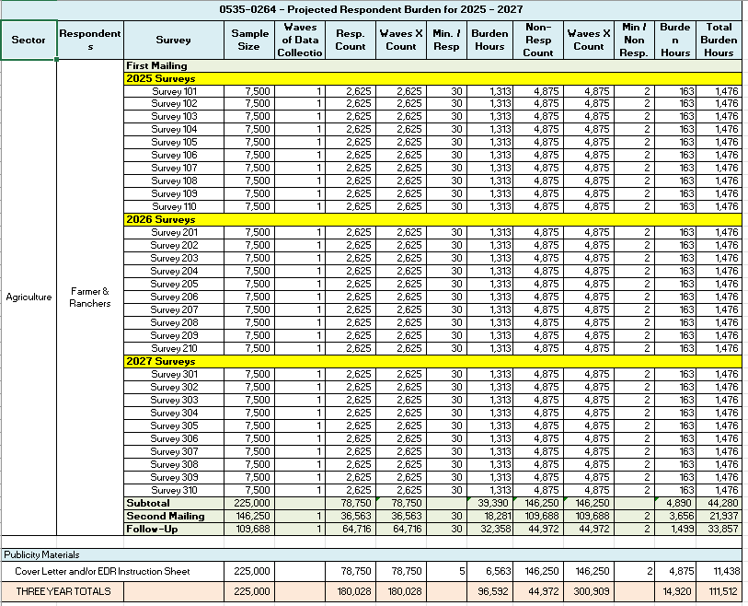

**13. Provide an estimate of the total annual cost burden to respondents or record-keepers resulting from the collection of information.**

There are no capital/start-up or ongoing operation/maintenance costs associated with this generic request.

**14. Provide estimates of annualized cost to the Federal government; provide a description of the method used to estimate cost which should include quantification of hours, operational expenses, and any other expense that would not have been incurred without this collection of information.**

The surveys in this generic request will be conducted under a full-cost recovery basis. There will be no cost to the Federal government.

Different surveys will carry different costs. Total survey costs, including the costs for survey preparation, data collection, data analysis, and report preparation and dissemination, will be provided for each survey by the cooperators, prior to each submission to OMB for approval.

**15. Explain the reasons for any program changes or adjustments reported in Items 13 or 14 of the OMB Form 83-I (reasons for changes in burden).**

There are no sample size or burden changes from the previous OMB approval.

**16. For collections of information whose results will be published, outline plans for tabulation and publication. Address any complex analytical techniques that will be used. Provide the time schedule for the entire project, including beginning and ending dates of the collection of information, completion of report, publication dates, and other actions.**

After each survey is approved by OMB, NASS will print and mail the questionnaires to the sampled entities. If budgeted by the cooperator, a second mailing or reminder postcard will occur approximately three weeks after the first mailing. Included in each mailing will be information about the option to complete a CASI version of the survey, if available. About three weeks after the final mailout, the NASS will begin telephone (or possibly face-to-face) follow-up for nonresponse and data consistency. For each survey, data collection is scheduled for completion about ten weeks after the first mailings.

A NASS Regional Field Office (RFO) will be responsible for manually editing and processing the questionnaires. The RFO creates and provides editing guidelines and estimation documentation to help ensure that all questionnaires are edited and analyzed in a consistent manner. After the data have been entered and run through computer edits, one of two processes occur:

1. NASS creates detailed computer analyses and summaries of the data.
2. The survey data, without Personally Identifiable Information (PII), will be made available to pre-approved staff from the cooperator for analysis, summarization, and estimation. Access will be in either a secure data enclave environment or a NASS data lab. All CIPSEA procedures will be followed. Any data that are removed from the enclave or data lab must meet NASS disclosure standards.

The anticipated time schedule for the surveys in this generic request:

Approximate workdays from

Task submission to OMB

Package to OMB 0 days

Package approved by OMB 45 days

Mailout 75 days

Second mailout 96 days

Phone follow-up start 117 days

End of Data Collection 130 days

Publication 150-365 days

A more defined schedule will be provided for each survey when it is submitted to OMB for approval. A defined publication plan (including website location) will be provided for each survey when it is submitted to OMB for approval.

**17. If seeking approval to not display the expiration date for OMB approval of the information collection, explain the reasons that display would be inappropriate.**

No approval is requested for non-display of the expiration date.

**18. Explain each exception to the certification statement identified in Item 19, “Certification for Paperwork Reduction Act Submissions” of OMB Form 83-I.**

There are no exceptions to the certification statement.

November 2024