**United States Department of Agriculture**

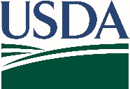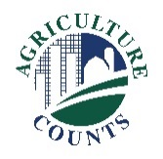

National Agricultural Statistics Service

October 15, 2025

You have been identified as a possible operator of land inside a USDA survey segment, and we need your help to complete the enclosed survey.

The results from this survey are used to develop comprehensive estimates of land uses and agricultural activities across the United States. Data from this survey are a critical foundation for other USDA reports.

An aerial photo of your property and county map are enclosed. Please review the enclosed map. **You are encouraged to respond online at agcounts.usda.gov** with your unique survey code, or you may respond by mail. You will be asked to confirm whether your property lies within the red segment boundaries, and questions about about agricultural land use on your property. If you do not respond by November 15, 2025, you may be contacted for a phone interview. The interview is estimated to take 20 minutes.

The information you provide will be used for statistical purposes only. **In accordance with federal law, your responses will be kept confidential**, and the survey results will be available in aggregate form only to ensure that no individual producer or operation can be identified.

Thank you for your help and for your support of U.S. agriculture. For more information about NASS surveys, please visit nass.usda.gov/Surveys. If you have any questions, please contact us at 888-424-7828.

Sincerely,

Lance Honig

Chair, Agricultural Statistics Board

National Agricultural Statistics Service

U.S. Department of Agriculture