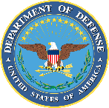
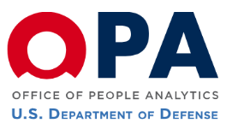
Service Academy Gender Relations Survey
Resource Handout
We appreciate your participation in this survey. In the event you would like to discuss issues related to this survey with someone from the DoD Office of People Analytics (OPA) during (or after) our visit to the U.S. Military Academy, please contact Ms. Lisa Davis, Deputy Director, OPA Health & Resilience Research Division, at elizabeth.h.davis18.civ@mail.mil. If you wish to provide feedback regarding this survey process or the survey content, please e-mail: SA-Survey@mail.mil. If you know of others who might like to contact a member of the OPA team, please share this information with them.
Academy Resources
In April 2011, the Department of Defense launched the DoD Safe Helpline to provide confidential, live, one-on-one expert advice to victims of sexual assault. Available 24/7, users can scan, call or text to access Safe Helpline services:
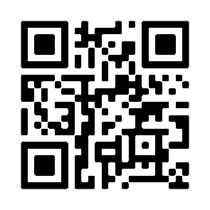
SCAN: Scanning this QR code or navigating on a web browser to www.SafeHelpline.org allows users to receive live, one-on-one confidential help with a trained professional through a secure instant-messaging format. The website also provides vital information about recovering from and reporting sexual assault.
CALL: Calling the telephone hotline (877) 995-5247 allows users to speak with trained Safe Helpline staff for access to resources and support. Safe Helpline staff can also transfer callers to installation or base Sexual Assault Response Coordinators (SARCs)/On-call SAPR Victim Advocates (VAs), civilian rape crisis centers or the Suicide Prevention Lifeline.
TEXT: Texting their location to 55-247 (inside the U.S.) or (202) 470-5546 (outside the U.S.) allows users to receive automated contact information for the SARC at their installation or base.

If you feel uncomfortable or uneasy after participating in this survey, and/or if you are a survivor of sexual assault, or have experienced sexual harassment or stalking, we strongly encourage you to contact the following resources that are available to you:
WEST POINT SHARP HOTLINE 24/7: (845) 659-7467

USCC SARC
(845) 938-7479; Cell: (845) 905-9185
Keller Army Community Hospital (SARC)
(845) 938-3261
Center for Personal Development (CPD)
(845) 938-3022
Military Police Desk
(845) 938-3333
West Point Duty Chaplain
(845) 401-8171
Garrison SARC
(845) 938-5657; Cell: (914) 382-8180
USMA Victim Advocate
(845) 938-5260; Cell: (845) 549-7285
USMAPS SARC
(845) 938-1950
Medical Attention
Keller Army Community Hospital
Emergency Room: (845) 938-4004
Behavioral Health: (845) 938-3441

