# DISCUSSION PROTOCOL 1

**INSTALLATION, MISSION, AND/OR UNIT COMMAND DP1**

**Required Materials:**

OFR POC Sheet

Resource POC Sheet

Figure 1 – Prevention Activities

Leader Survey (QR code, link, and/or paper version)*

Pens (if using paper surveys)

*\*for commanders O-6 and below*

*Audience: Installation Commander, Mission Commander, Unit Commander (O-3 level command minimum)*

|  |
| --- |
| **Guidance to data collectors:** Count the number of personnel in the room and tell the note-taker. Annotate the count in Question 1 response box.  Each question corresponds to specific data elements and specific sub-dimensions, which are listed in the boxes to the left. |

**[Note: If time with the participant(s) is short, please focus on asking the questions in bold.]**

**—START—**

**DIMENSION 1: HEALTHY & PROTECTIVE ENVIRONMENT** – **PRIORITY**

As we mentioned in our introduction, our focus today is on a range of harmful behaviors, including suicide, alcohol misuse, discrimination, sexual assault and harassment, child abuse and neglect, and domestic abuse. First, we would like to talk about how Service members here work together to build a protective environment and healthy climate. A protective environment is one that reduces the effects of stressful life events and increases the ability of Service members to avoid risks and promote healthy behaviors to thrive in all aspects of life.

1.1

1. **Do you have any** **strategies or vision for addressing harmful behaviors such as sexual assault, harassment, discrimination, alcohol misuse, child abuse and neglect, domestic abuse, and suicide?** 
   1. *IF NO:* Proceed to next question.
   2. ***IF YES:***
   * Is your vision or plan in writing? Or can you tell us what it is?
   * Do you communicate your strategies or your vision to your troops? How and when?
2. **What tools or reports do you have that allow you to monitor and track harmful behaviors amongst your personnel that help you understand the climate in which they work and live?** For example, indicators of climate might include Service members regularly missing work, disciplinary reports, complaints, or attrition rates. Indicators of harmful behaviors might include assault, harassment, discrimination, bullying, child abuse and neglect, domestic abuse, substance abuse, and suicide. Do you have a method to track these indicators and behaviors? These methods can be for anybody: Service members, Department of Defense (DoD) civilians, military families, or others.

1.2.1

* 1. *IF ANY*:

7.2.1

* + - How often do you monitor these indicators and behaviors?
    - If you begin to see problems, how do you address them? Do you follow up and make sure the problems have been fixed? How?
      * *IF MEETINGS ARE CITED:* How do you use the information provided in these meetings to address problems and make sure they are resolved?
  1. *IF NONE*: Mark a 0 for 7.2.1. and proceed to next question.

1.3.1

1. **Do you motivate Service members and staff to help maintain positive behaviors? Do you ensure they intervene if they see harmful behaviors like sexual assault, child abuse and neglect, domestic abuse, discrimination, substance abuse issues, suicidal thoughts, etc.?**
   1. *IF NO*: Proceed to next question.
   2. *IF YES*: How do you do this? Are there any reinforcement mechanisms in place? (Examples: Rewarding them with verbal praise, time off, awards, etc.when they promote positive behaviors/intervene. Or, correcting Service members that fail to maintain a safe and healthy environment (e.g., extra duty, counseling).)

**DIMENSION 2: INTEGRATED PREVENTION** – **PRIORITY**

Next, we’re going to ask some questions about what prevention efforts are underway here. Prevention includes stopping self-directed and other-directed harms BEFORE they occur or, in other words, getting out in front of potential problems. In responding, be sure to include ways that you use statistics, programs, or meetings with personnel to implement preventive measures. [*INTERVIEWERS*: Give them a couple of seconds to process the question.]

2.2.1

1. The last question we asked related to recognizing Service members and staff who support prevention informally through their daily activities and interactions. For your Service members and staff specifically assigned to implement prevention programs, do you give any awards or recognition to them for creating effective programs or prevention activities? Examples include creating training content, evaluation programs, or weekly/monthly activities included in your training schedule that impact command climate.
   1. *IF YES*:Please tell us about the awards or recognition you gave and why.
   2. *IF NO*: Why not?

2.1.1

1. How do you keep track of whether planned prevention efforts are carried out?

2.3.1

1. **Do you track the outcomes of any prevention efforts in order to improve prevention planning and decision-making?**
   1. *IF YES*: Which ones? How do you use the data to improve prevention planning? How do you know if your programs are effective?
   2. *IF NO*: Does someone else do that? Who?

2.4.1

1. How do you communicate the importance of prevention efforts to your subordinates? These include programs, events, or any services offered here.

**DIMENSION 8: INTEGRATED PREVENTION** – **IMPLEMENTATION**

1. **Using this handout and thinking about all the efforts here to prevent Service members from dying by suicide; misusing alcohol; assaulting, harassing, discriminating against, or bullying others; and engaging in other forms of interpersonal violence, which number on this scale best characterizes how prevention offices and staff work?**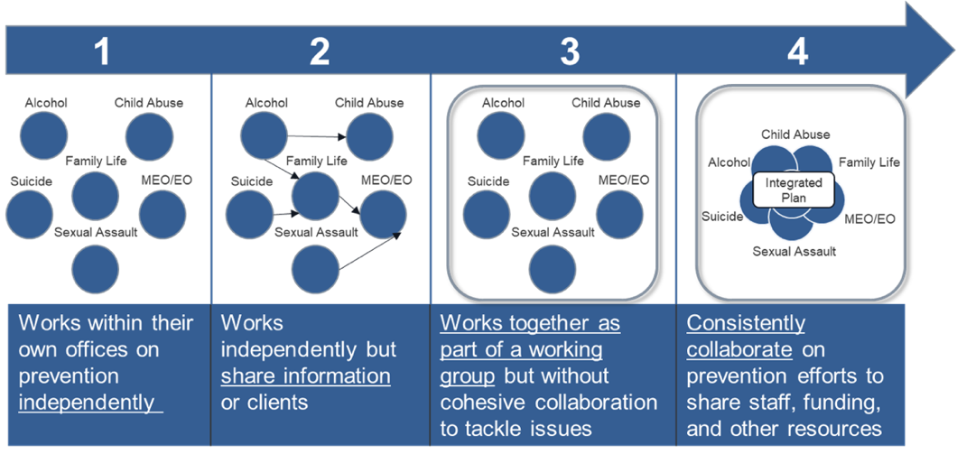

8.1.4

*Figure 1.* Prevention Activities

* 1. Can you explain why you selected that level of interaction?

*IF NEEDED*:

* 1. Can you share some examples of ways those prevention assets work together?

1. How do Service members under your leadership typically access support services related to harmful behaviors? Are there any issues or concerns that you have regarding access to support services?
2. Is there anything else important that you’d like us to be aware of or consider as it pertains to how harm to self or others is prevented or addressed within your unit or across your installation?

**CONCLUSION/TRANSITION TO LEADER SURVEY**

**For Installation/Mission/Unit Commanders O-6 or below:**

[DISPLAY QR CODE/SURVEY LINK TO **LEADER SURVEY** OR BEGIN PASSING OUT PAPER COPY AND PENS TO EACH PARTICIPANT.]

Before you leave, we would like to ask you to take about 5-8 minutes to complete a very short survey. The survey is anonymous. [*IF COMPLETING ON PAPER*: Please do not put your name on it.] We will NOT be looking at your individual responses. There are NO right or wrong answers to the survey, so please just respond based on your view. If you could please complete the survey before you leave today, that would be much appreciated. [*IF COMPLETING ON PAPER*: Please place your completed survey in this envelope.]

Thank you very much for spending time with us today and answering our questions. The information you provided is extremely valuable and useful to us.

**For all other participants:**

Thank you very much for spending time with us today and answering our questions. The information you provided is extremely valuable and useful to us.