DISCUSSION PROTOCOL 2

**SERVICE MEMBERS DP2**

**Required Materials:**

OFR POC Sheet

Resource POC Sheet

Figure 5 – Spectrum of Participation

Leader Survey (QR code, link, and/or paper version)*

Pens (if using paper surveys)

*\*for O1-O3/W1-W3*

*Audience: E1-E4 Men; E1-E4 Women; O1-O2 Men; O1-O2 Women; W1-W2 Men; W1-W2 Women*

|  |
| --- |
| **Guidance to data collectors:** Count the number of personnel in the room and tell the note-taker. Annotate the count in Question 1 response box.  Each question corresponds to specific data elements and specific sub-dimensions, which are listed in the boxes to the left. |

**—START—**

**DIMENSION 1: HEALTHY & PROTECTIVE ENVIRONMENT – PRIORITY**

As we mentioned in our introduction, our focus today is on a range of harmful behaviors, including suicide, alcohol misuse, discrimination, sexual assault and harassment, child abuse and neglect, and domestic abuse. First, we would like to talk about how Service members here work together to build a protective environment and healthy climate. A protective environment is one that reduces the effects of stressful life events and increases the ability of Service members to avoid risks and promote healthy behaviors to thrive in all aspects of life.

1.1

1. Does your leadership have any strategies or vision for addressing harmful behaviors such as sexual assault, harassment, discrimination, alcohol misuse, child abuse and neglect, domestic abuse, and suicide? By leadership, we mean the officers and senior enlisted to whom you report, including your commander.
   1. *IF NO*: Proceed to next question.
   2. *IF YES*:
   * What can you tell us about their strategy or vision?
   * How has your leadership communicated this strategy or vision? How often does your leadership talk to you about having a safe and healthy environment?
2. How does your leadership motivate those in this command (e.g., Service members and staff) to maintain positive behaviors? For example, what do they do to reduce sexual assault, child abuse and neglect, domestic abuse, discrimination, or substance abuse issues? Or, how do they address suicide-related behaviors?

1.3.1

* 1. *IF NONE*: Proceed to next question.
  2. *IF EFFORTS REPORTED*: Could you give examples of how leadership recognizes or rewards positive behavior? For example, have you or anyone you know received praise, time off, etc. for promoting positive behaviors or intervening to stop negative behaviors?

1.3.3

1. How much do the following affect your standing with leadership or impact a Service member’s chance of being selected for a leadership position?
   1. Intervening with a peer struggling with a serious problem like alcohol misuse or suicidal thoughts? Or, intervening when you see a peer acting inappropriately, such as telling offensive jokes?
   2. Do you talk about maintaining a safe and protective environment during performance evaluations?

**DIMENSION 4: HEALTHY & PROTECTIVE ENVIRONMENT – PREPARATION**

4.3.1

1. How and how often does your leadership meet with you to provide advice or support for anything to include: job-related advice or support, personal/home life concerns, etc.? By your leadership, we mean the officer or senior enlisted to whom you directly report, including your commander.

4.3.3

1. How comfortable are you talking to your leadership (i.e., your immediate supervisor and chain of command) about serious problems you are struggling with? This could be marital or financial problems, alcohol or substance abuse issues, suicidal thoughts, or any problems affecting your morale or readiness.

4.3.3

1. How comfortable are you talking to your leadership (i.e., your immediate supervisor and chain of command) about serious problems your peers or co-workers may be struggling with? What about sharing when you witness or hear about negative behaviors (e.g., bullying, substance use)?

4.3.2

1. How and how often does your leadership tell you about the ways to get help for issues like mental health, childcare, discrimination, or sexual assault?

**DIMENSION 2: INTEGRATED PREVENTION – PRIORITY**

Next, we’re going to ask some questions about what prevention efforts are underway here. Prevention includes stopping self-directed and other-directed harms BEFORE they occur or, in other words, getting out in front of potential problems. In responding, be sure to include ways that your leadership aids in preventing negative behaviors. [*INTERVIEWERS*: Give them a couple of seconds to process the question.]

1. Do you feel like your leadership stresses the importance of recognizing and preventing negative behavior to keep a safe and healthy environment?

2.4.1

* 1. *REMINDER, IF NEEDED*: By your leadership, we mean the officer and senior enlisted to whom you report, including your commander.

**DIMENSION 9: STAKEHOLDER ENGAGEMENT – IMPLEMENTATION**

Next, I would like to know how often your leadership asks for your opinions and feedback to address interpersonal violence, substance abuse, sexual assault, harassment, suicide, discrimination, or other harmful behaviors.

9.1

1. Using this handout and thinking about all the efforts here to prevent Service members from dying by suicide; misusing alcohol; assaulting, harassing, discriminating against, or bullying others; and engaging in other forms of interpersonal violence, where do you think they fall on this scale?
   1. Can you explain why you selected this? 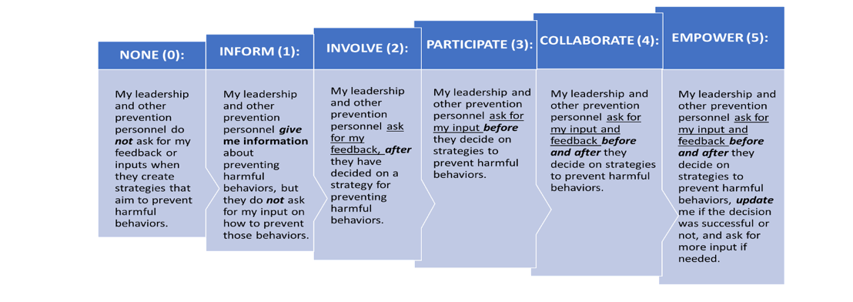

*Figure 5.* Spectrum of Participation

*IF NEEDED:*

* 1. What are some ways that input is solicited? When does this happen?
  2. Can you provide an example of when stakeholder feedback was used to improve prevention or future prevention efforts?
  3. Are Service members informed about why their input was or was not used? Are all relevant groups of Service members able to share their views? Why or why not? What groups are not represented?

**DIMENSION 3: STAKEHOLDER ENGAGEMENT – PRIORITY**

3.1.2

1. Does your leadership express how valuable your feedback is to combat negative behavior and other issues seen at your unit or installation?
2. Similar to receiving rewards for maintaining a healthy and safe environment, have you or anyone you know been credited or rewarded for their opinions and/or feedback that might have helped change policies?
   1. How have you seen your or others’ feedback make a difference in promoting a healthy environment? (e.g., Was your feedback acted on? If so, how?)
3. How do Service member`s typically access support services related to harmful behaviors? Are there any issues or concerns that you have regarding access to support services?
4. Is there anything else important that you’d like us to be aware of or consider as it pertains to how harm to self or others is prevented or addressed within your unit or across your installation?

**CONCLUSION/TRANSITION TO LEADER SURVEY**

**For O1-O2 Men; O1-O2 Women; W1-W2 Men; W1-W2 Women:**

[DISPLAY QR CODE/SURVEY LINK TO **LEADER SURVEY** OR BEGIN PASSING OUT PAPER COPY AND PENS TO EACH PARTICIPANT.]

Before you leave, we would like to ask you to take about 5-8 minutes to complete a very short survey. The survey is anonymous. [*IF COMPLETING ON PAPER:* Please do not put your name on it.] We will NOT be looking at your individual responses. There are NO right or wrong answers to the survey, so please just respond based on your view. If you could please complete the survey before you leave today, that would be much appreciated. [*IF COMPLETING ON PAPER*: Please place your completed survey in this envelope.]

Thank you very much for spending time with us today and answering our questions. The information you provided is extremely valuable and useful to us.

**For E1-E4 Men; E1-E4 Women:**

Thank you very much for spending time with us today and answering our questions. The information you provided is extremely valuable and useful to us.