DISCUSSION PROTOCOL 5

**LEADERS DP5**

**Required Materials:**

OFR POC Sheet

Resource POC Sheet

Figure 5 – Spectrum of Participation

Leader Survey (QR code, link, and/or paper version)

Pens (if using paper surveys)

*Audience: E7-E8 Men; E7-E8 Women (Also use for any E9 personnel not in command positions)*

|  |
| --- |
| **Guidance to data collectors:** Count the number of personnel in the room and tell the note-taker. Annotate the count in Question 1 response box.  Each question corresponds to specific data elements and specific sub-dimensions, which are listed in the boxes to the left. |

**—START—**

**DIMENSION 4: HEALTHY & PROTECTIVE ENVIRONMENT – PREPARATION**

As we mentioned in our introduction, our focus today is on a range of harmful behaviors, including suicide, alcohol misuse, discrimination, sexual assault and harassment, child abuse and neglect, and domestic abuse. First, we would like to talk about how Service members here work together to build a protective environment and healthy climate. A protective environment is one that reduces the effects of stressful life events and increases the ability of Service members to avoid risks and promote healthy behaviors to thrive in all aspects of life.

4.3.1

1. Could you tell us a little bit about the Service members who report to you; for example, the number, their pay grades, and military occupational specialties?
2. How and how often do you meet with your subordinates to provide advice or support? By your subordinates, we mean the Service members who report to you.
   1. *PROBE*: Does this differ for different types of subordinates (e.g., do you meet more often with mid-level enlisted than junior enlisted)?

**DIMENSION 7: HEALTHY & PROTECTIVE ENVIRONMENT – IMPLEMENTATION**

1. How and how often do you check in with your subordinates about their stress levels? What does this look like?

7.3.1

**DIMENSION 4: HEALTHY & PROTECTIVE ENVIRONMENT – PREPARATION**

4.3.2

1. How and how often do you tell your subordinates about the ways to get help for issues like mental health, childcare, discrimination, or sexual assault?

**DIMENSION 7: HEALTHY & PROTECTIVE ENVIRONMENT – IMPLEMENTATION**

7.1.1

1. How often do you formally or informally refer subordinates to available supportive resources and programs? An example would be substance use programs, family advocacy programs, mental health care, financial literacy education and counseling, or anything of that nature.
   1. What about your peers? How do you refer them to available support resources and programs?

7.1.2

* 1. Have you ever been unsure if it is the right decision to refer someone to a program? Do you feel like it is outside your roles or responsibilities, or maybe you don’t know if the person qualifies for a program? Have you ever been unsure of the right program to refer someone to?

1. What guidance, if any, have you given your subordinates about their roles and responsibilities in maintaining safe and healthy environments? An example could be written guidance or policy, mentorship, or any form of communication (e.g., email, formation announcement, commander’s call).

7.2.2

* 1. Could you describe for me what their roles and responsibilities are?

7.5.1

1. How do you reward or recognize subordinates’ efforts to promote protective environments or correct subordinates if they fail to maintain protective environments? Do you have an example of this you can share?

**DIMENSION 9: STAKEHOLDER ENGAGEMENT – IMPLEMENTATION**

Next, I would like to hear how Service member input is used to inform prevention activities (not all activities – just prevention activities) to address interpersonal violence, substance abuse, sexual assault, harassment, discrimination, suicide, or other harmful behaviors. For example, how is their input used to develop education efforts on prevention resources or to drive improvements in command climate?

9.1

1. Using the handout and thinking about all the efforts here to prevent Service members from dying by suicide; misusing alcohol; assaulting, harassing, discriminating against, or bullying others; and engaging in other forms of interpersonal violence, where do you think they fall on this scale?
   1. Can you explain why you selected this?

*Figure 5.* Spectrum of Participation

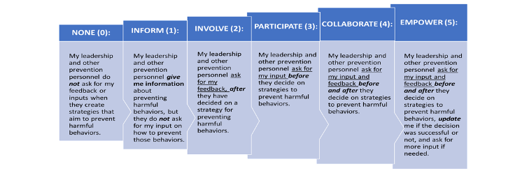

*IF NEEDED:*

* 1. What are some ways that input is solicited? When does this happen?
  2. Can you provide an example of when stakeholder feedback was used to improve prevention or future prevention efforts?
  3. Are Service members informed about why their input was or was not used?
  4. Are all relevant groups of Service members able to share their views? Why or why not? What groups are not represented?

1. How do you access support services related to harmful behaviors? Are there any issues or concerns that you have regarding access to support services?
2. Is there anything else important that you’d like us to be aware of or consider as it pertains to how harm to self or others is prevented or addressed within your unit or across your installation?

**CONCLUSION/TRANSITION TO LEADER SURVEY**

[DISPLAY QR CODE/SURVEY LINK TO **LEADER SURVEY** OR BEGIN PASSING OUT PAPER COPY AND PENS TO EACH PARTICIPANT.]

Before you leave, we would like to ask you to take about 5-8 minutes to complete a very short survey. The survey is anonymous. [*IF COMPLETING ON PAPER*: Please do not put your name on it.] We will NOT be looking at your individual responses. There are NO right or wrong answers to the survey, so please just respond based on your view. If you could please complete the survey before you leave today, that would be much appreciated. [*IF COMPLETING ON PAPER*: Please place your completed survey in this envelope.]

Thank you very much for spending time with us today and answering our questions. The information you provided is extremely valuable and useful to us.