DISCUSSION PROTOCOL 8

**CADETS/MIDSHIPMEN DP8**

**Required Materials:**

OFR POC Sheet

Resource POC Sheet

Figure 5 – Spectrum of Participation

Leader Survey (QR code, link, and/or paper version)*

Pens (if using paper surveys)

*\*for Class 2 & 1*

*Audience: 2nd Class and 1st Class (Junior and Senior) Men; 2nd Class and 1st Class (Junior and Senior) Women; Cadets/Midshipmen in Leadership Roles*

|  |
| --- |
| **Guidance to data collectors:** Count the number of personnel in the room and tell the note-taker. Annotate the count in Question 1 response box.  Each question corresponds to specific data elements and specific sub-dimensions, which are listed in the boxes to the left. |

**—START—**

**DIMENSION 1: HEALTHY & PROTECTIVE ENVIRONMENT – PRIORITY**

As we mentioned in our introduction, our focus today is on a range of harmful behaviors, including suicide, alcohol misuse, discrimination, sexual assault and harassment, child abuse and neglect, and domestic abuse. First, we would like to talk about how cadets/midshipmen here work together to build a protective environment and healthy climate. A protective environment is one that reduces the effects of stressful life events and increases the ability of cadets/midshipmen to avoid risks and promote healthy behaviors to thrive in all aspects of life.

1.1

1. Does your leadership have any strategies or vision for addressing harmful behaviors such as sexual assault, harassment, discrimination, alcohol misuse, child abuse and neglect, domestic violence, and suicide? By your leadership, we mean any cadets/midshipmen in the academy chain of command and/or officers and civilians who serve as mentors, instructors, or coaches.
   1. *IF NO*: Proceed to next question.
   2. *IF YES*:
   * What can you tell us about their strategy or vision?
   * How has your leadership communicated this strategy or vision? How often does your leadership talk to you about having a safe and healthy environment?
2. How does your leadership motivate cadets/midshipmen to maintain positive behaviors? For example, what do they do to reduce sexual assault, child abuse and neglect, domestic abuse, discrimination, or substance abuse issues? Or, how do they address suicide-related behaviors?

1.3.1

* 1. *IF NONE*: Proceed to next question
  2. *IF EFFORTS REPORTED*: Could you give examples of how leadership recognizes or rewards positive behavior? For example, have you or anyone you know received praise, time off, etc. for promoting positive behaviors or intervening to stop negative behaviors?

1.3.3

1. How much do the following affect your standing with leadership or impact a cadet’s/midshipmen’s chance of being selected for a leadership position?
   1. Intervening with a peer struggling with a serious problem like alcohol misuse or suicidal thoughts? Or, intervening when you see a peer acting inappropriately, such as telling offensive jokes?
   2. Do you talk about maintaining a safe and protective environment during performance evaluations?

**DIMENSION 4: HEALTHY & PROTECTIVE ENVIRONMENT – PREPARATION**

4.3.1

1. How and how often does your leadership meet with you to provide advice or support for anything to include: education- and academy-related advice or support, personal/home life concerns, etc.? By leadership, we mean any cadets/midshipmen in the academy chain of command and/or the officers and civilians who serve as mentors, instructors, or coaches.

4.3.3

1. How comfortable are you talking to your leadership (e.g., cadet chain of command, instructors, permanent party) about serious problems you are struggling with? This could be dating relationships or financial problems, alcohol or substance abuse issues, suicidal thoughts, or any problems affecting your morale or performance.

4.3.3

1. How comfortable are you talking to your leadership (e.g., cadet chain of command, instructors, permanent party) about serious problems your peers or classmates may be struggling with? What about sharing when you witness or hear about negative behaviors (e.g., bullying/hazing, substance use)?
2. How and how often does your leadership tell you about the ways to get help for issues like mental health, discrimination, bullying/hazing, academic standing, or sexual assault?

4.3.2

**DIMENSION 2: INTEGRATED PREVENTION – PRIORITY**

Next, we’re going to ask some questions about what prevention efforts are underway here. Prevention includes stopping self-directed and other-directed harms BEFORE they occur or, in other words, getting out in front of potential problems. In responding, be sure to include ways that your leadership aids in preventing negative behaviors. [*INTERVIEWERS*: Give them a couple of seconds to process the question.]

2.4.1

1. Do you feel like your leadership stresses the importance of recognizing and preventing negative behavior to keep a safe and healthy environment?
   1. *REMINDER, IF NEEDED*: By leadership, we mean any cadets/midshipmen in the academy chain of command and/or the officers and civilians who serve as mentors, instructors, or coaches.

**DIMENSION 9: STAKEHOLDER ENGAGEMENT – IMPLEMENTATION**

Next, I would like to know how often your leadership asks for your opinions and feedback to address interpersonal violence, substance abuse, sexual assault, harassment, suicide, discrimination, or other harmful behaviors.

9.1

1. Using this handout and thinking about all the efforts here to prevent cadets/midshipman from dying by suicide; misusing alcohol; assaulting, harassing, discriminating against, or bullying others; and engaging in other forms of interpersonal violence, where do you think they fall on this scale?
   1. Can you explain why you selected this? 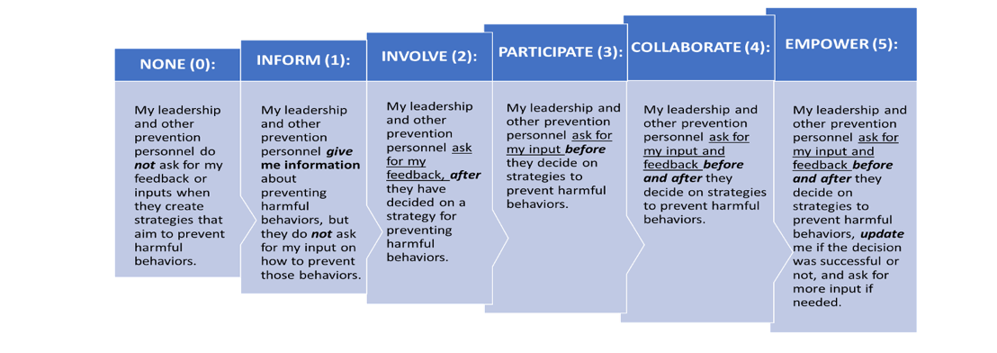

*IF NEEDED:*

*Figure 5.* Spectrum of Participation

* 1. What are some ways that input is solicited? When does this happen?
  2. Can you provide an example of when stakeholder feedback was used to improve prevention or future prevention efforts?
  3. Are cadets/midshipmen informed about why their input was or was not used?
  4. Are all relevant groups of cadets/midshipmen able to share their views? Why or why not? What groups are not represented?

**DIMENSION 3: STAKEHOLDER ENGAGEMENT – PRIORITY**

3.1.2

1. Does your leadership express how valuable your feedback is to combat negative behavior and other issues seen at the academy?
2. Similar to receiving rewards for maintaining a healthy and safe environment, have you or anyone you know been credited or rewarded for their opinions and/or feedback that might have helped change policies?

3.2.1

* 1. How have you seen your or others’ feedback make a difference in promoting a healthy environment? (e.g., Was your feedback acted on? If so, how?)

1. How do cadets/midshipmen typically access support services related to harmful behaviors? Are there any issues or concerns that you have regarding access to support services?
2. Is there anything else important that you’d like us to be aware of or consider as it pertains to how harm to self or others is prevented or addressed at the academy?

**CONCLUSION/TRANSITION TO LEADER SURVEY**

**For Cadets/Midshipmen in Leadership Roles:**

[DISPLAY QR CODE/SURVEY LINK TO **LEADER SURVEY** OR BEGIN PASSING OUT PAPER COPY AND PENS TO EACH PARTICIPANT.]

Before you leave, we would like to ask you to take about 5-8 minutes to complete a very short survey. The survey is anonymous. [*IF COMPLETING ON PAPER*: Please do not put your name on it.] We will NOT be looking at your individual responses. There are NO right or wrong answers to the survey, so please just respond based on your view. If you could please complete the survey before you leave today, that would be much appreciated. [*IF COMPLETING ON PAPER*: Please place your completed survey in this envelope.]

Thank you very much for spending time with us today and answering our questions. The information you provided is extremely valuable and useful to us.