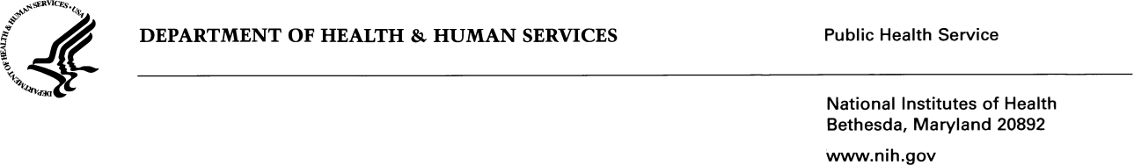

**DATE: 05/14/2024**

**TO: Rebecca F. Rosen, Ph.D.,** Director of the Office of Data Science and Sharing, *Eunice Kennedy Shriver* National Institute of Child Health and Human Development (NICHD), National Institutes of Health (NIH), Department of Health and Human Services (HHS)

**FROM: Rolando Romero, Privacy Coordinator**, NICHD, NIH, HHS

**SUBJECT:** Applicability of Privacy Act: Data and Specimen Hub (DASH)

I have reviewed the DASH Privacy Impact Analysis submission and its components to the National Institute of Child Health and Human Development (NICHD). The Privacy Act safeguards privacy through the implementation of the Code of FAIR Information Practice Principles in operational and procedural requirements. The Code of FAIR Information Practice Principles serve as the basis for analyzing privacy risks and determining mitigation strategies. The Department of Health and Human Services (HHS) regulations govern the notification and access requirements for Privacy Act systems of records maintained by NIH.

I have determined that the Privacy Act will apply to data collection which involves the collection of Personally Identifiable Information (PII) such as but not limited to; name, date of birth, social security number, mailing address, telephone number, medical record number, email address, gender, ethnicity, financial information, and educational level. This data collection is covered by NIH Privacy Act System of Records 09-25-0200, “Clinical, Basic and Population-based Research Studies of the National Institutes of Health (NIH), HHS/NIH/OD.”



**Name: Rolando Romero**

Title: Privacy Coordinator