Glossary of Health Coverage and Medical Terms
- This glossary defines many commonly used terms, but isn’t a full list. These glossary terms and definitions are intended to be educational and may be different from the terms and definitions in your plan or health insurance policy. Some of these terms also might not have exactly the same meaning when used in your policy or plan, and in any case, the policy or plan governs. (See your Summary of Benefits and Coverage for information on how to get a copy of your policy or plan document.)
- Underlined text indicates a term defined in this Glossary.
- See page 6 for an example showing how deductibles, coinsurance and out-of-pocket limits work together in a real life situation.
Allowed Amount  This is the maximum payment the plan will pay for a covered health care service. May also be called “eligible expense,” “payment allowance,” or “negotiated rate.”  Appeal  A request that your health insurer or plan review a decision that denies a benefit or payment (either in whole or in part).  Balance Billing  When a provider bills you for the balance remaining on the bill that your plan doesn’t cover. This amount is the difference between the actual billed amount and the allowed amount. For example, if the provider’s charge is $200 and the allowed amount is $110, the provider may bill you for the remaining $90. This happens most often when you see an out-of-network provider (non-preferred provider). A network provider (preferred provider) may not balance bill you for covered services.  Claim  A request for a benefit (including reimbursement of a health care expense) made by you or your health care provider to your health insurer or plan for items or services you think are covered.  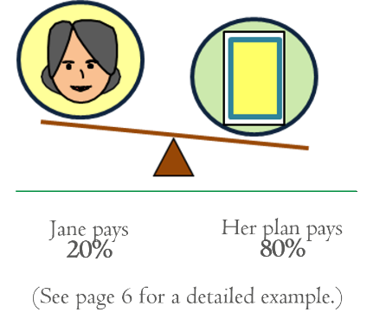  Coinsurance  Your share of the costs of a covered health care service, calculated as a percentage (for example, 20%) of the allowed amount for the service. You generally pay coinsurance plus  any deductibles you owe. (For example, if the health insurance or plan’s allowed amount for an office visit is $100 and you’ve met your deductible, your coinsurance payment of 20% would be $20. The health insurance or plan pays the rest of the allowed amount.) | Complications of Pregnancy  Conditions due to pregnancy, labor, and delivery that require medical care to prevent serious harm to the health of the mother or the fetus. Morning sickness and a non- emergency caesarean section generally aren’t complications of pregnancy.  Copayment  A fixed amount (for example, $15) you pay for a covered health care service, usually when you receive the service (sometimes called “copay”). The amount can vary by the type of covered health care service.  Cost Sharing  Your share of costs for services that a plan covers that you must pay out of your own pocket (sometimes called “out-of-pocket costs”). Some examples of cost sharing are copayments, deductibles, and coinsurance. Family cost sharing is the share of cost for deductibles and out- of-pocket costs you and your spouse and/or child(ren) must pay out of your own pocket. Other costs, including your premiums, penalties you may have to pay, or the cost of care a plan doesn’t cover usually aren’t considered cost sharing.  Cost-sharing Reductions  Discounts that reduce the amount you pay for certain services covered by an individual plan you buy through the Marketplace. You may get a discount if your income is below a certain level, and you choose a Silver level health plan or if you're a member of a federally- recognized tribe, which includes being a shareholder in an Alaska Native Claims Settlement Act corporation.

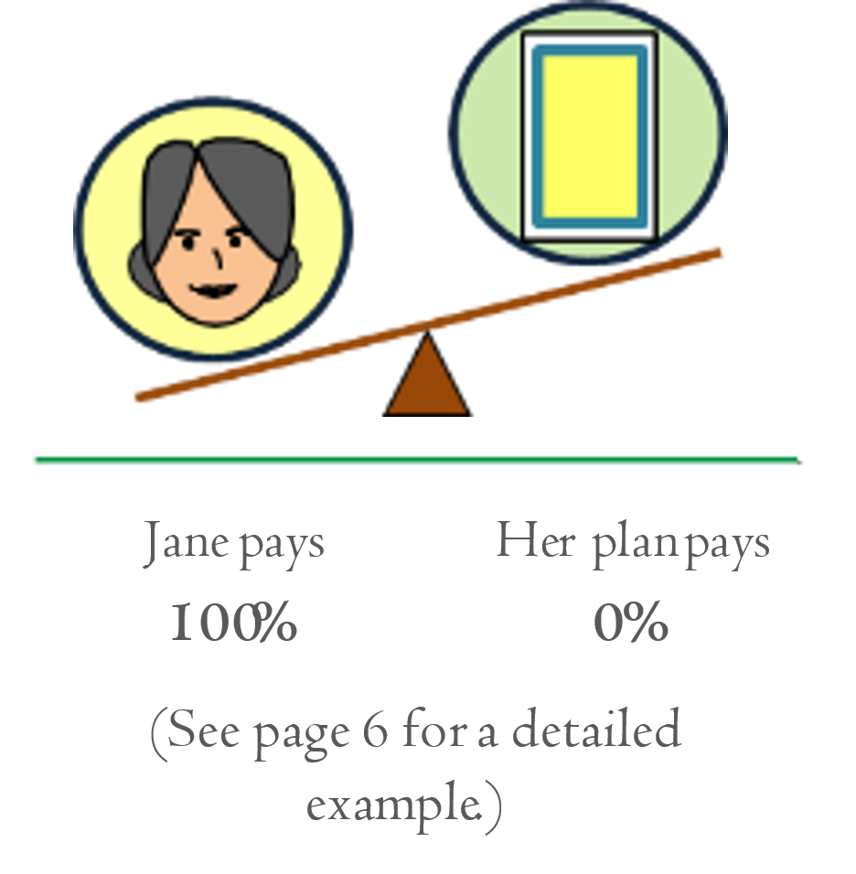  Deductible  An amount you could owe during a coverage period (usually one year) for covered health care services before your plan begins to pay. An overall deductible applies to all or almost all covered items and services. A plan with an overall deductible may also have separate deductibles that apply to specific services or groups of services. A plan may also have only separate deductibles. (For example, if your deductible is $1000, your plan won’t pay anything until you’ve met your $1000 deductible for covered health care services subject to the deductible.)  Diagnostic Test  Tests to figure out what your health problem is. For example, an x-ray can be a diagnostic test to see if you have a broken bone.  Durable Medical Equipment (DME)  Equipment and supplies ordered by a health care provider for everyday or extended use. DME may include: oxygen equipment, wheelchairs, and crutches.  Emergency Medical Condition  An illness, injury, symptom (including severe pain), or condition severe enough to risk serious danger to your health if you didn’t get medical attention right away. If you didn’t get immediate medical attention you could reasonably expect one of the following: 1) Your health would be put in serious danger; or 2) You would have serious problems with your bodily functions; or 3) You would have serious damage to any part or organ of your body.  Emergency Medical Transportation  Ambulance services for an emergency medical condition. Types of emergency medical transportation may include transportation by air, land, or sea. Your plan may not cover all types of emergency medical transportation, or may pay less for certain types.  Emergency Room Care / Emergency Services  Services to check for an emergency medical condition and treat you to keep an emergency medical condition from getting worse. These services may be provided in a licensed hospital’s emergency room or other place that provides care for emergency medical conditions. | Excluded Services  Health care services that your plan doesn’t pay for or cover.  Formulary  A list of drugs your plan covers. A formulary may include how much your share of the cost is for each drug. Your plan may put drugs in different cost-sharing levels or tiers. For example, a formulary may include generic drug and brand name drug tiers and different cost-sharing amounts will apply to each tier.  Grievance  A complaint that you communicate to your health insurer or plan.  Habilitation Services  Health care services that help a person keep, learn or improve skills and functioning for daily living. Examples include therapy for a child who isn’t walking or talking at the expected age. These services may include physical and occupational therapy, speech-language pathology, and other services for people with disabilities in a variety of inpatient and/or outpatient settings.  Health Insurance  A contract that requires a health insurer to pay some or all of your health care costs in exchange for a premium. A health insurance contract may also be called a “policy” or “plan.”  Home Health Care  Health care services and supplies you get in your home under your doctor’s orders. Services may be provided by nurses, therapists, social workers, or other licensed health care providers. Home health care usually doesn’t include help with non-medical tasks, such as cooking, cleaning, or driving.  Hospice Services  Services to provide comfort and support for persons in the last stages of a terminal illness and their families.  Hospitalization  Care in a hospital that requires admission as an inpatient and usually requires an overnight stay. Some plans may consider an overnight stay for observation as outpatient care instead of inpatient care.  Hospital Outpatient Care  Care in a hospital that usually doesn’t require an overnight stay.

In-network Coinsurance  Your share (for example, 20%) of the allowed amount for covered health care services. Your share is usually lower for in-network covered services.  In-network Copayment  A fixed amount (for example, $15) you pay for covered health care services to providers who contract with your health insurance or plan. In-network copayments usually are less than out-of-network copayments.  Marketplace  A marketplace for health insurance where individuals, families and small businesses can learn about their plan options; compare plans based on costs, benefits and other important features; apply for and receive financial help with premiums and cost sharing based on income; and choose a plan and enroll in coverage. Also known as an “Exchange.” The Marketplace is run by the state in some states and by the federal government in others. In some states, the Marketplace also helps eligible consumers enroll in other programs, including Medicaid and the Children’s Health Insurance Program (CHIP). Available online, by phone, and in-person.  Maximum Out-of-pocket Limit  Yearly amount the federal government sets as the most each individual or family can be required to pay in cost sharing during the plan year for covered, in-network services. Applies to most types of health plans and insurance. This amount may be higher than the out-of- pocket limits stated for your plan.  Medically Necessary  Health care services or supplies needed to prevent, diagnose, or treat an illness, injury, condition, disease, or its symptoms, including habilitation, and that meet accepted standards of medicine.  Minimum Essential Coverage  Minimum essential coverage generally includes plans, health insurance available through the Marketplace or other individual market policies, Medicare, Medicaid, CHIP, TRICARE, and certain other coverage. If you are eligible for certain types of minimum essential coverage, you may not be eligible for the premium tax credit. | Minimum Value Standard  A basic standard to measure the percent of permitted costs the plan covers. If you’re offered an employer plan that pays for at least 60% of the total allowed costs of benefits, the plan offers minimum value and you may not qualify for premium tax credits and cost-sharing reductions to buy a plan from the Marketplace.  Network  The facilities, providers and suppliers your health insurer or plan has contracted with to provide health care services.  Network Provider (Preferred Provider)  A provider who has a contract with your health insurer or plan who has agreed to provide services to members of a plan. You will pay less if you see a provider in the network. Also called “preferred provider” or “participating provider.”  Orthotics and Prosthetics  Leg, arm, back and neck braces, artificial legs, arms, and eyes, and external breast prostheses after a mastectomy. These services include: adjustment, repairs, and replacements required because of breakage, wear, loss, or a change in the patient’s physical condition.  Out-of-network Coinsurance  Your share (for example, 40%) of the allowed amount for covered health care services to providers who don’t contract with your health insurance or plan. Out-of- network coinsurance usually costs you more than in- network coinsurance.  Out-of-network Copayment  A fixed amount (for example, $30) you pay for covered health care services from providers who do not contract with your health insurance or plan. Out-of-network copayments usually are more than in-network copayments.  Out-of-network Provider (Non-Preferred Provider)  A provider who doesn’t have a contract with your plan to provide services. If your plan covers out-of-network services, you’ll usually pay more to see an out-of-network provider than a preferred provider. Your policy will explain what those costs may be. May also be called “non-preferred” or “non-participating” instead of “out- of-network provider.”

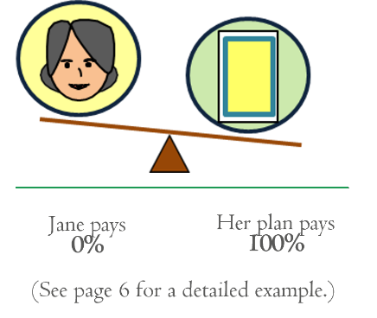  Out-of-pocket Limit  The most you could pay during a coverage period (usually one year) for your share of the costs of covered services.  After you meet this limit the plan will usually pay 100% of the allowed amount. This limit helps you plan for health care costs. This limit never includes your premium, balance-billed charges or health care your plan doesn’t cover. Some plans don’t count all of your copayments, deductibles, coinsurance payments, out-of- network payments, or other expenses toward this limit.  Physician Services  Health care services a licensed medical physician, including an M.D. (Medical Doctor) or D.O. (Doctor of Osteopathic Medicine), provides or coordinates.  Plan  Health coverage issued to you directly (individual plan) or through an employer, union or other group sponsor (employer group plan) that provides coverage for certain health care costs. Also called “health insurance plan,” “policy,” “health insurance policy,” or “health insurance.”  Preauthorization  A decision by your health insurer or plan that a health care service, treatment plan, prescription drug or durable medical equipment (DME) is medically necessary.  Sometimes called “prior authorization,” “prior approval,” or “precertification.” Your health insurance or plan may require preauthorization for certain services before you receive them, except in an emergency. Preauthorization isn’t a promise your health insurance or plan will cover the cost.  Premium  The amount that must be paid for your health insurance or plan. You and/or your employer usually pay it monthly, quarterly, or yearly. | Premium Tax Credits  Financial help that lowers your taxes to help you and your family pay for private health insurance. You can get this help if you get health insurance through the Marketplace and your income is below a certain level. Advance payments of the tax credit can be used right away to lower your monthly premium costs.  Prescription Drug Coverage  Coverage under a plan that helps pay for prescription drugs. If the plan’s formulary uses “tiers” (levels), prescription drugs are grouped together by type or cost. The amount you'll pay in cost sharing will be different for each “tier” of covered prescription drugs.  Prescription Drugs  Drugs and medications that by law require a prescription.  Preventive Care (Preventive Service)  Routine health care, including screenings, check-ups, and patient counseling, to prevent or discover illness, disease, or other health problems.  Primary Care Physician  A physician, including an M.D. (Medical Doctor) or  D.O. (Doctor of Osteopathic Medicine), who provides or coordinates a range of health care services for you.  Primary Care Provider  A physician, including an M.D. (Medical Doctor) or  D.O. (Doctor of Osteopathic Medicine), nurse practitioner, clinical nurse specialist, or physician assistant, as allowed under state law and the terms of the plan, who provides, coordinates, or helps you access a range of health care services.  Provider  An individual or facility that provides health care services. Some examples of a provider include a doctor, nurse, chiropractor, physician assistant, hospital, surgical center, skilled nursing facility, and rehabilitation center. The plan may require the provider to be licensed, certified, or accredited as required by state law.  Reconstructive Surgery  Surgery and follow-up treatment needed to correct or improve a part of the body because of birth defects, accidents, injuries, or medical conditions.

Referral  A written order from your primary care provider for you to see a specialist or get certain health care services. In many health maintenance organizations (HMOs), you need to get a referral before you can get health care services from anyone except your primary care provider. If you don’t get a referral first, the plan may not pay for the services.  Rehabilitation Services  Health care services that help a person keep, get back, or improve skills and functioning for daily living that have been lost or impaired because a person was sick, hurt, or disabled. These services may include physical and occupational therapy, speech-language pathology, and psychiatric rehabilitation services in a variety of inpatient and/or outpatient settings.  Screening  A type of preventive care that includes tests or exams to detect the presence of something, usually performed when you have no symptoms, signs, or prevailing medical history of a disease or condition.  Skilled Nursing Care  Services performed or supervised by licensed nurses in your home or in a nursing home. Skilled nursing care is not the same as “skilled care services,” which are services performed by therapists or technicians (rather than licensed nurses) in your home or in a nursing home.  Specialist  A provider focusing on a specific area of medicine or a group of patients to diagnose, manage, prevent, or treat certain types of symptoms and conditions.  Specialty Drug  A type of prescription drug that, in general, requires special handling or ongoing monitoring and assessment by a health care professional, or is relatively difficult to dispense. Generally, specialty drugs are the most expensive drugs on a formulary.  UCR (Usual, Customary and Reasonable)  The amount paid for a medical service in a geographic area based on what providers in the area usually charge for the same or similar medical service. The UCR amount sometimes is used to determine the allowed amount. | Urgent Care  Care for an illness, injury, or condition serious enough that a reasonable person would seek care right away, but not so severe as to require emergency room care.

How You and Your Insurer Share Costs - Example
Jane’s Plan Deductible: $1,500 | Coinsurance: 20% | Out-of-Pocket Limit: $5,000
January 1st  Beginning of Coverage Period | December 31st  End of Coverage Period

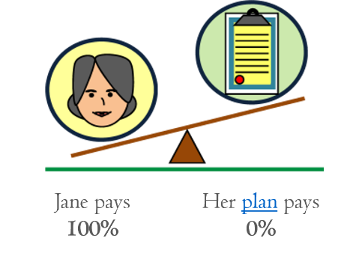    Jane hasn’t reached her $1,500 deductible yet.  Her plan doesn’t pay any of the costs  Office visit costs: $125  Jane pays: $125  Her plan pays: $0 |  | 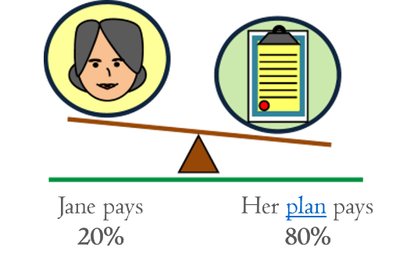    Jane reaches her $1,500 deductible, coinsurance begins.  Jane has seen a doctor several times and paid $1,500 in total, reaching her deductible. So her plan pays some of the costs for her next visit.  Office visit costs: $125  Jane pays 20% of $125 = $25  Her plan pays: 80% of $125 = $100 |  | 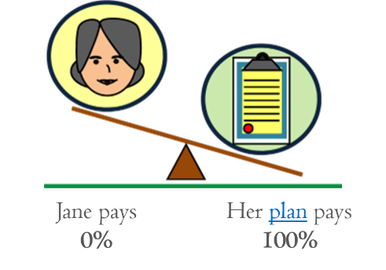  Jane reaches her $5,000 out-of-pocket limit.  Jane has seen the doctor often and paid $5,000 in total. Her plan pays the full cost of her covered health care services for the rest of the year.  Office visit costs: $125  Jane pays: $0  Her plan pays: $125
PRA Disclosure Statement: According to the Paperwork Reduction Act of 1995, no persons are required to respond to a collection of information unless it displays a valid OMB control number. The valid OMB control number for this information collection is 0938-1146. The time required to complete this information collection is estimated to average 0.02 hours per response, including the time to review instructions, search existing data resources, gather the data needed, and complete and review the information collection. If you have comments concerning the accuracy of the time estimate(s) or suggestions for improving this form, please write to: CMS, 7500 Security Boulevard, Attn: PRA Reports Clearance Officer, Mail Stop C4-26-05, Baltimore, Maryland 21244-1850.

