Attachment 1

informed CONSENT FORM and baseline information form FOR study PARTICIPANTS

informed consent form

**[Grantee/Subgrantee][1]**

**Consent Form for Impact Evaluation of the Senior Community Service Employment Program Sector-based Training Grants Demonstration for Low-income Older Workers (“Sector Demonstration”)**

**[GRANTEE/SUBGRANTEE] IS PART OF A SECTOR DEMONSTRATION STUDY**

[GRANTEE/SUBGRANTEE] is part of a study of the Senior Community Service Employment Program Sector-based Training Grants Demonstration for Low-income Older Workers—the “Sector Demonstration”—sponsored by the U.S. Department of Labor (DOL). The study will learn how sector-based classroom training and on-the-job training can help improve the employment outcomes of Senior Community Service Employment Program (SCSEP) participants. DOL asked researchers from the Urban Institute in Washington, DC, and its partner, Capital Research Corporation in Arlington, VA, to help with the study. We invite you to join the study.

**WHAT IS THE SECTOR DEMONSTRATION?**

The one-year Sector Demonstration includes classroom and on-the-job training in an in-demand occupation in your area. Before agreeing to participate, you will hear about the specific type(s) of training available and other details about the demonstration services. Sector Demonstration participants will be paid for their time in classroom and on-the-job training. Career navigators will help participants enroll in and complete classroom training; identify and apply for on-the-job training opportunities with employers; and find jobs in their occupational area at the end of the demonstration. Sector Demonstration participants can access the same supportive services that are available to all [Grantee/Subgrantee] SCSEP participants.

**THE STUDY INCLUDES TWO GROUPS**

SCSEP participants who join the study will be assigned at random to one of two groups: (1) a group that can participate in Sector Demonstration services, and (2) a group that can receive standard SCSEP services. The study will compare outcomes for participants in each group.

**WHICH GROUP WILL I BE IN?**

A computer will pick your group through a lottery that is like a flip of a coin. Half of everyone who agrees to be in the study will be assigned to the group that can receive the Sector Demonstration services and half will be assigned to the group that can receive standard SCSEP services. This procedure makes sure that group assignments are fair. Everyone who agrees to be in the study has the same chance of being in either group. The chance to be in the Sector Demonstration group is not influenced by when you learn about and express interest in the services, or any personal characteristics, such as your previous work experience. We will let you know which group you are in soon after you agree to join the study.

**WHAT HAPPENS IF I AM NOT SELECTED TO RECEIVE THE SECTOR DEMONSTRATION SERVICES?**

If you are not in the Sector Demonstration group, you will receive standard SCSEP services. You will still be in the study.

**WHO IS ELIGIBLE FOR THE STUDY AND LOTTERY?**

All SCSEP new and continuing participants with at least one year of SCSEP eligibility left and who are interested in the Sector Demonstration may participate in the study and the lottery. Those who are not eligible for the Sector Demonstration or are not interested in it will receive standard SCSEP services and will not be in the study or lottery.

**WHAT INFORMATION WILL BE COLLECTED ABOUT ME?**

If you agree to be in the study and participate in the lottery the researchers will collect some information about you.

1. Prior to the lottery, you will complete a short information form that includes questions about you. It should take about 15 minutes.
2. [Grantee/Subgrantee] will share information with the researchers about the services you receive from the Sector Demonstration or standard SCSEP program.
3. The researchers will gather information about your employment and earnings from a federal agency using your name and Social Security Number. The researchers will request this information for two (2) years before you join the study and up to three (3) years after you join.
4. The researchers may ask you in the future to complete a voluntary survey about your participation in the Sector Demonstration or SCSEP and your employment experiences. Your decision whether to complete the survey will not affect any services or be known to [Grantee/Subgrantee] staff.

**WILL MY PRIVACY BE PROTECTED?**

The researchers will have access to the data collected about you. They are committed to keeping your personal information private. Researchers must follow strict data security procedures and sign a privacy agreement. However, there is a small risk of loss of privacy. The researchers will take strong precautions to make sure this doesn’t happen. They will keep all data securely. Your personal information will be protected to the extent allowable by law. Your name will never appear in connection with the study. Instead, information about you will be combined with information about other people in the study, so researchers can describe the overall program and participants’ experiences.

**WHAT ARE THE BENEFITS AND RISKS OF PARTICIPATING IN THE STUDY?**

You will receive either the Sector Demonstration or standard SCSEP services. By participating in the study, you can help improve the services offered to future SCSEP participants. You will not receive payment or other form of compensation for being in the study.

There are minimal risks. You may feel uncomfortable answering some questions, but you can always refuse to answer those questions. Although researchers will take steps to protect the privacy of your information, there is a small risk that non-researchers could see your data, including your name, Social Security Number, employment status, or earnings. This is known as a data breach and it is exceedingly rare. In the unlikely instance of a breach, we will alert you and describe how we will address it.

**IS MY PARTICIPATION VOLUNTARY?**

We hope you will want to be in the study and the lottery but your participation is voluntary. If you do not want to participate in the study, the researchers will not collect information about you and you will not be in the lottery. You will be or continue to be in the SCSEP program.

If you join the study you will be in the lottery. You can stop participating in the study later, but if you are in the group that can receive the Sector Demonstration services, you will stop receiving those services and start receiving standard SCSEP services. The researchers will also use the information collected about you prior to the date you left the study. To withdraw from the study, you must email the researchers at [SectorDemo@urban.org](mailto:SectorDemo@urban.org).

**WHO CAN ANSWER MY QUESTIONS ABOUT THIS RESEARCH?**

If you have any questions or concerns about the study, please email the researchers at SectorDemo@urban.org.

**SUBJECT’S STATEMENT OF CONSENT**

I consent to take part in this study. [Grantee/subgrantee] explained the study and this consent form to me. I read this consent form or it was read to me. I had the opportunity to ask questions and my questions were answered satisfactorily.

* I consent to participate in the study
* I do not consent to participate in the study

Baseline INFORMATION FORM

Impact Evaluation of the Senior Community Service Employment Program Sector-based Training Grants Demonstration for Low-income Older Workers

Baseline Information Form

DATE

Public Burden Statement

Public reporting burden for this Baseline Information Form is estimated to average 15 minutes. The burden estimate includes the time for reviewing instructions, searching existing data sources, gathering and maintaining the data needed, and completing and submitting the Baseline Information Form. This collection of information is voluntary and will be retained for 60 days after the study final report is posted on the U.S. Department of Labor’s website. You are not required to respond to this collection of information unless it displays a valid OMB control number. Please send comments regarding the burden estimate or any other aspect of this collection of information to [Chiefevaluationoffice@DOL.gov](mailto:Chiefevaluationoffice@DOL.gov) and reference OMB control number [1290-0NEW]. NOTE: Please do not send your completed Baseline Information Form to this address.

1. **Background**
2. Please enter your full name (first, middle, last) (ABA item A1)
3. What is your social security number? (ABA item A3)
4. What is your highest level of education? (ABA item B1, with modification to combine high school diploma with GED)
   * Did not complete high school or GED
   * High school: received diploma or GED
   * Some college or postsecondary vocational courses
   * 2-year or 3-year college degree (Associate’s Degree) of Vocational School Diploma
   * 4-year college degree
   * Some graduate work/no graduate degree
   * Graduate or professional degree
   * Never attended school
   * No response
5. How do you currently describe yourself? (mark all that apply) (Recommendations on the Best Practices for the Collection of Sexual Orientation and Gender Identity Data on Federal Statistical Surveys)
   * Male
   * Female
   * Transgender, non-binary, or another gender
   * Don’t know
   * Refused
6. What is your current marital status? (select only one) (ABA item B6)
   * Married
   * Separated
   * Divorced
   * Widowed
   * Never married
   * No response
7. What is your race and/or ethnicity? (OMB revision to Statistical Policy Directive (SPD) 15)

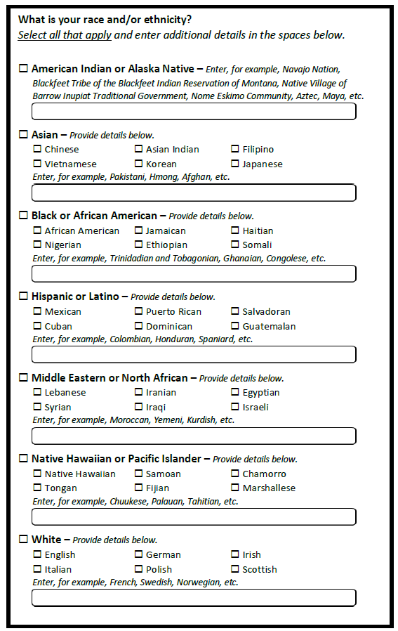

1. We are interested in when you started receiving SCSEP services. Which of the following accurately describes your time in the program? (new)
   * Less than 1 month
   * Between 1 and 6 months
   * More than 6 months but less than 1 year
   * More than 1 year
2. What is/are the primary reason(s) you are interested in the sector training activities? (Choose all that apply) (new)
   * I am interested in the occupational sector(s)
   * I want to participate in occupational training
   * I want to participate in on-the-job training
   * I am not satisfied with my current SESCEP activities
   * The services described will help me find employment
   * Other (please describe: ____________________)
3. **Employment History**

Now we would like to ask you about your longest job prior to the SCSEP program. This job could have immediately preceded your SCSEP participation or it could have been years ago.

1. Have you ever worked for pay?
   * Yes
   * No (go to section C)
2. Did you work for pay in the last 12 months?
   * Yes
   * No
3. Which of the following describes the general occupational area of your most recent job (as opposed to your job title)? (new)
   * Administrative services
   * Education
   * Food services
   * Government
   * Information Technology
   * Healthcare
   * Manufacturing
   * Retail
   * Other (please describe: ________________)
4. Have you ever worked in [grantee focus sector]? (new)
   * Yes
   * No
5. At the time you left your job, what was your pay, before taxes and other deductions? Your best estimate is fine. (CPS)
   * Per hour
   * Per week
   * Per month
   * Per year
6. Was this job full-time or part-time? (CPS definition)
   * Full time (35 or more hours per week)
   * Part time (less than 35 hours per week)
7. **Quality of Life**

|  |  |  |  |  |  |
| --- | --- | --- | --- | --- | --- |
| Now we would like to ask you some questions about how you are doing more generally in terms of health and happiness. Responding to these questions is voluntary and you do not have to answer any question that makes you uncomfortable.   1. Taken all together, how would you say things are these days--would you say that you are very happy, pretty happy, or not too happy? (GSS <https://gssdataexplorer.norc.org/trends>) 2. Would you say your health is excellent, very good, good, fair, or poor? (HRS) 3. We are interested in how people are getting along financially these days. So far as you and your family are concerned, would you say that you are pretty well satisfied with your present financial situation, more or less satisfied, or not satisfied at all? (GSS <https://gssdataexplorer.norc.org/trends>) 4. The next questions are about how you feel about different aspects of your life. For each one, tell me how often you feel that way. (NIH <https://www.ncbi.nlm.nih.gov/pmc/articles/PMC2394670/>) | | | | | |
| *Question* | *Hardly Ever* | *Some of the Time* | *Often* | |  | |
|  | | | | | |
| First, how often do you feel that you lack companionship: Hardly ever, some of the time, or often? | 1 | 2 | 3 |  | |
| How often do you feel left out: Hardly ever, some of the time, or often? | 1 | 2 | 3 |  | |
| How often do you feel isolated from others? (Is it hardly ever, some of the time, or often?) | 1 | 2 | 3 |  | |

NOTE: For both scales, the score is the sum of all items.

<https://www.ncbi.nlm.nih.gov/pmc/articles/PMC2394670/>

1. **Contact Information** (ABA D1-D5, modified to not ask about a second cell number)
2. What is your street address?
3. What is your cell phone number?
   * Check here if you do not have a cell phone
4. As part of the follow-up for this evaluation, we may reach out to you periodically by text over the next year to see how things are going for you. May we send you text messages at this number? Message and data rates may apply.
   * Yes
   * No
   * No response
5. What is another phone number where you can be reached?
6. What is your email address?
   * Check here if you do not have an email address
7. In case the study team has trouble reaching you, they would like to have the names of two people who would be most likely to know where you are or who keep close contact with you, such as a relative or a friend. For each, please provide:
8. Name
9. Relationship
   * Spouse/partner
   * Sister/brother
   * Son/daughter
   * Friend
   * Other
   * No response
10. Telephone number
11. Address

1. All fill-in brackets will be customized for each study site.