**How Helpful is this Page Survey (2025) — Screen shots of collection instruments.**

Standard TTB Webpages:

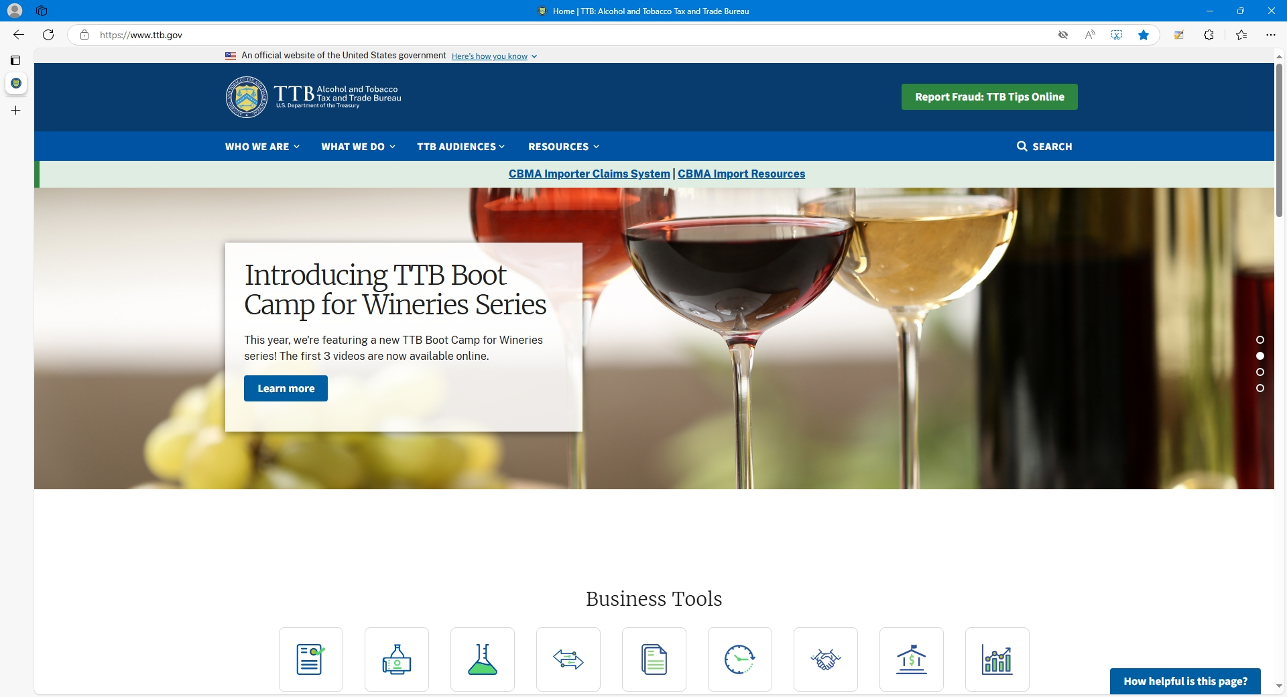

Clicking on the “How helpful is this page?” link results in this survey instrument:

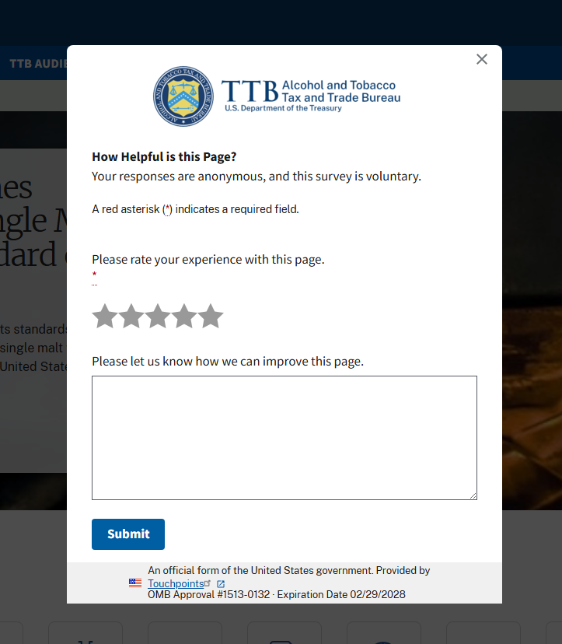

For the “myTTB” webpages, the “How helpful is this page” link leads to this survey instrument:

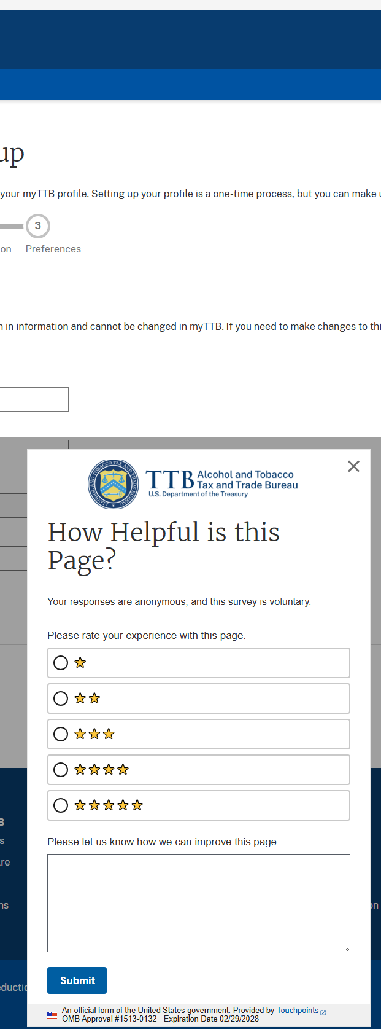

[END]