**Instructions for TTB F 5110.40, Monthly Report of Production Operations**

Posted at <https://www.ttb.gov/forms/all-forms> / <https://www.ttb.gov/ttb-form-511040>

*Introductory page:*

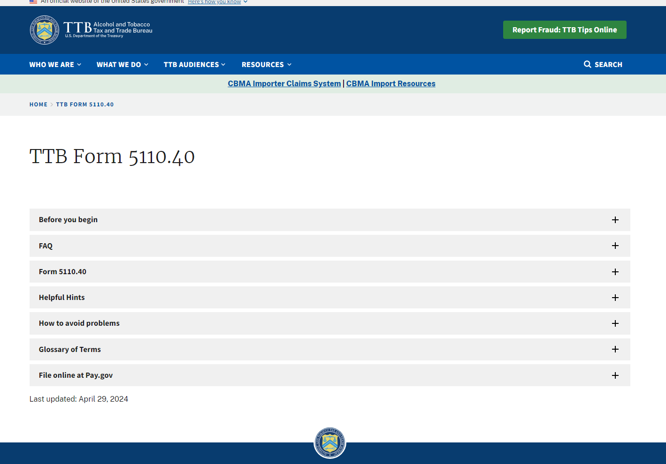

*Before you begin page:*

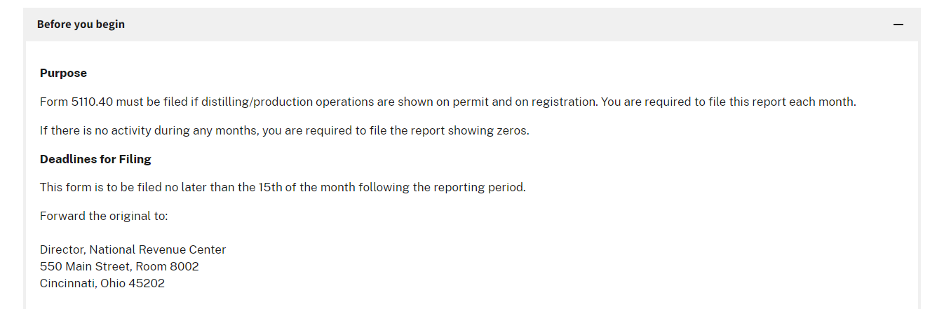

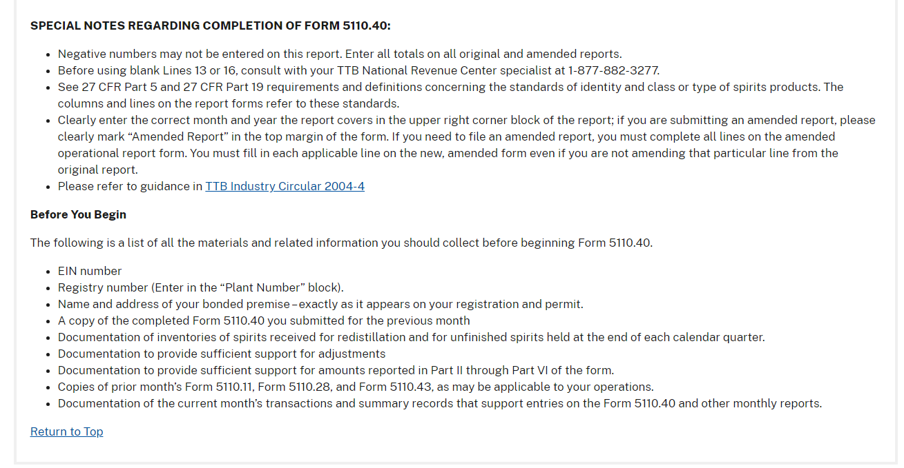

*FAQ page:*

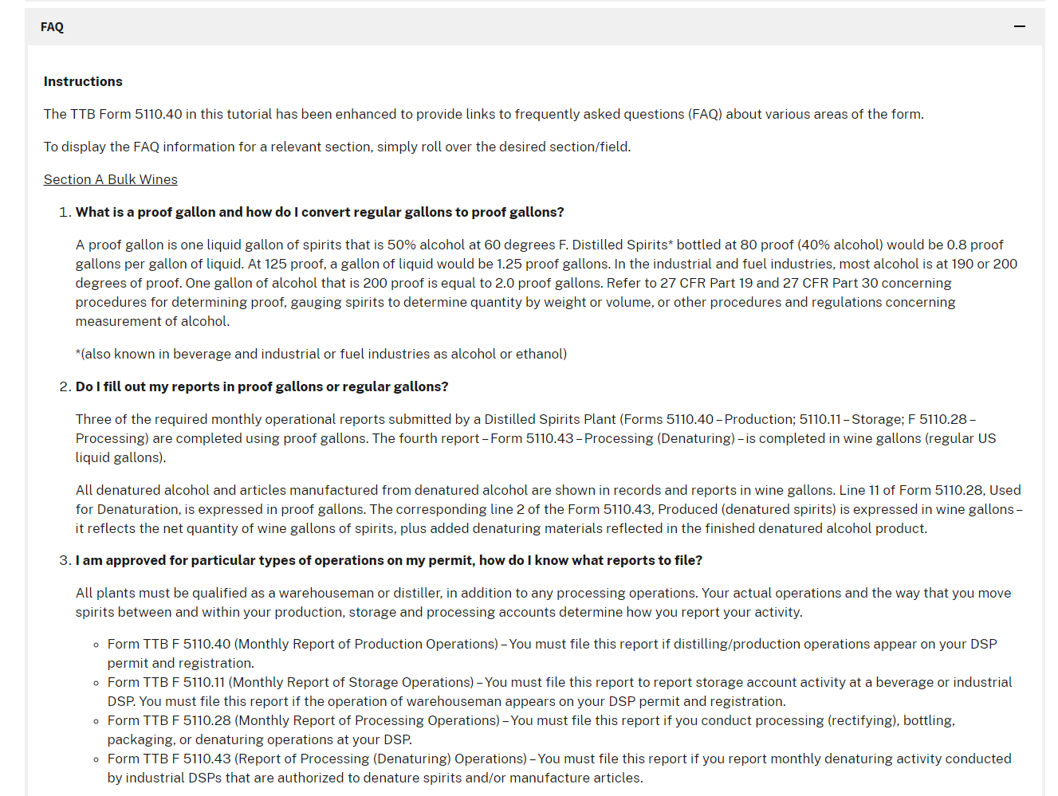

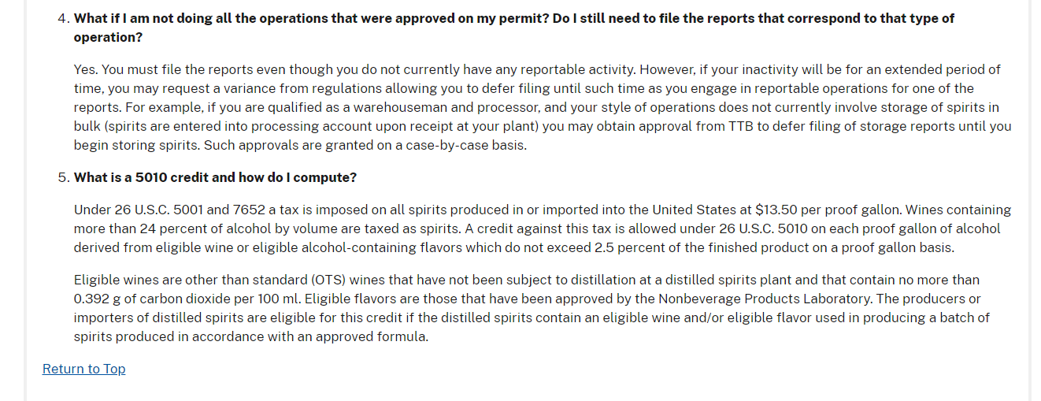

*Form 511.40 page:*



*Helpful hints page:*



*Helpful hints link:* 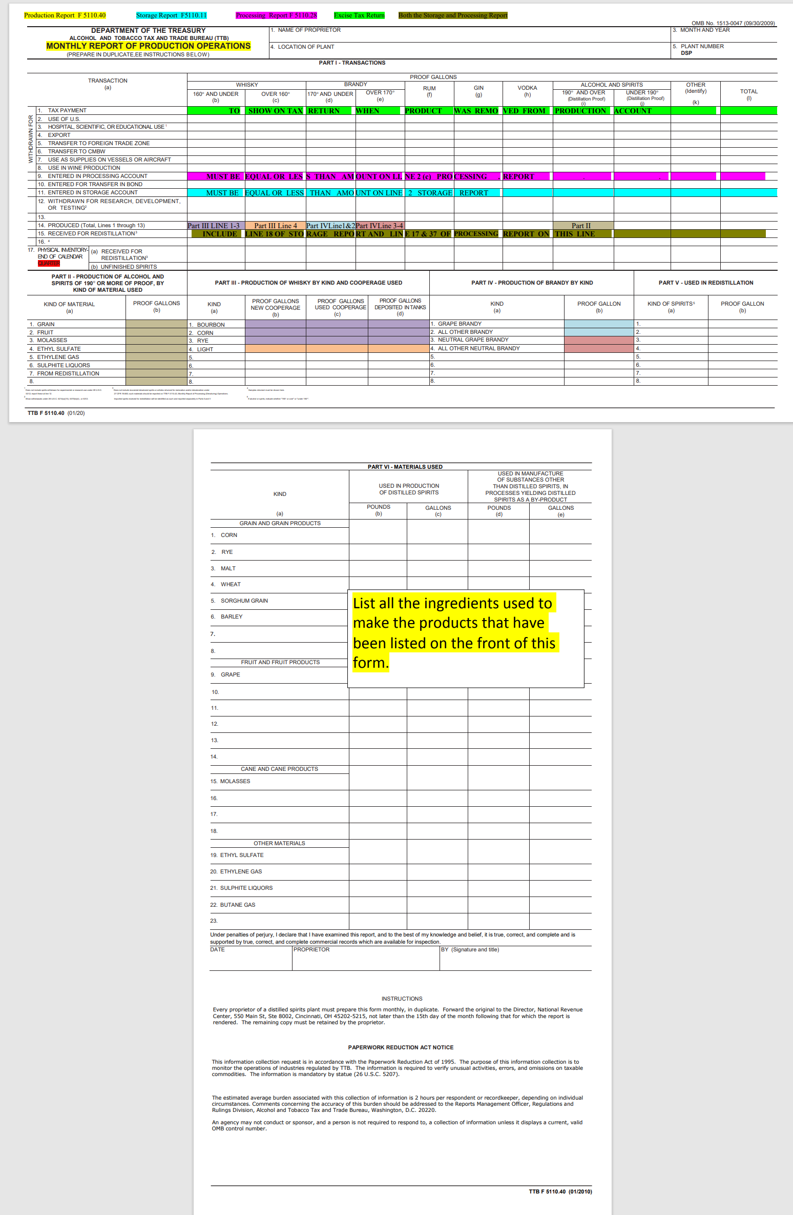

*How to avoid problems page:*

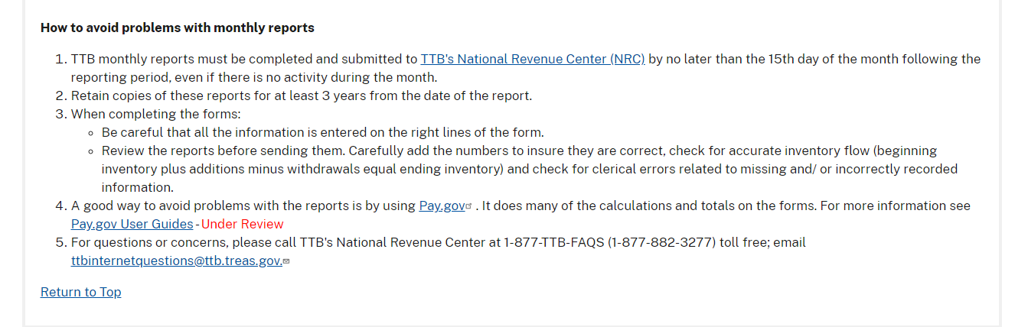

*Glossary of terms page:*

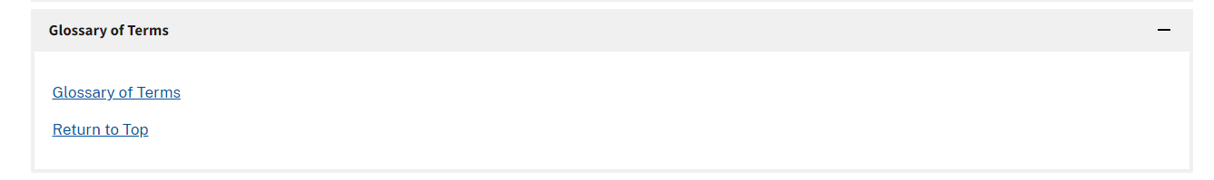

*Glossary of terms link:*

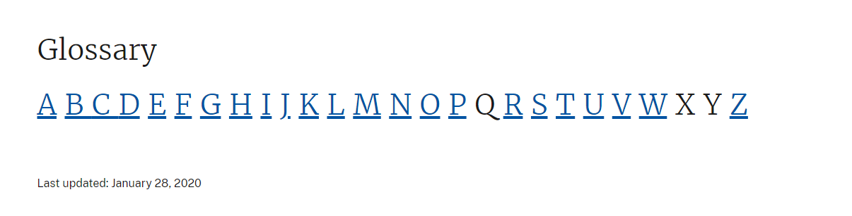

*File online at Pay.gov page:*

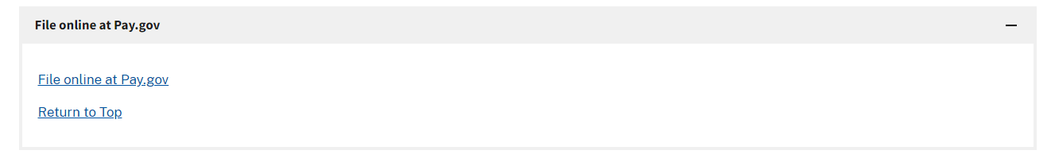

[END]