U.S. Department of Education

Agency Information Collection: Evaluation of the REL Appalachia Teaching Math to Young Children Toolkit

AGENCY: Department of Education (ED), Institute of Education Sciences (IES)

OMB Control Number: 1850-0991

SUMMARY:

In accordance with the Paperwork Reduction Act of 1995 (44 U.S.C. chapter 3501 et seq.), ED is submitting a simple change request to the existing information collection for the following changes outlined in this memo. The Department has assessed the upcoming changes and believes based on previously executed change requests that these changes fall under that guise.

- Revise response options for Q2 of the toolkit implementation checklist

The study team proposes to revise question two of the implementation checklist to replace the word “Which” with “How much,” so that the wording is “How much of the following toolkit learning activities did you implement?” In addition, the study team proposes changing the response options to None/Some/All, to encourage honest responses and reflect that it is acceptable that some teachers may not have completed all components of all toolkit learning activities. The final updated wording would be as follows.
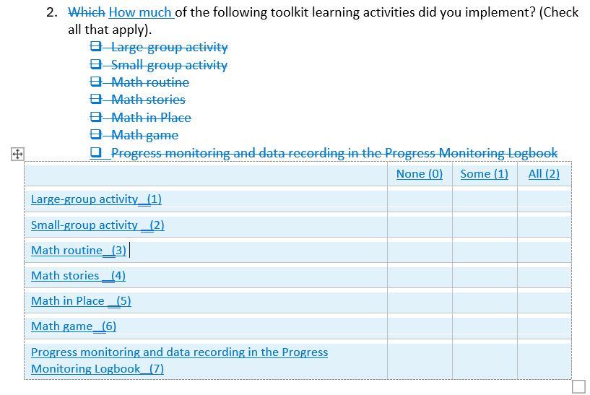
This request does not affect the estimated annual hour or cost burden on respondents.

