Supporting Statement A
Transit COVID-19 Response Program
OMB Number 2132- 0581

ABSTRACT:

In accordance with the Paperwork Reduction Act (PRA) of 1995, the Federal Transit Administration (FTA) is requesting Office of Management and Budget (OMB) 3-year approval of an extension without change for a currently approved collection. Although the Public Health Emergency for the COVID-19 pandemic ended in May 2023 and the FTA discontinued COVID-19 reporting requirements in September 2022, the FTA is seeking to renew this information collection to ensure that an existing framework can be readily updated to address future health emergencies. In the event the collection will be updated, the information collection name would also be updated. Approval for changes to an existing information collection would be submitted to OMB as required under the PRA.
Key Justifications for Renewal:
- Future Health Emergencies: The existing framework can be quickly updated to collect timely data in response to future health crises, reducing the time required for emergency approvals.
- No New Data Collection: FTA is not requesting any new data collection from transit agencies under this renewal. The renewal will simply maintain an approved framework that can be adjusted as needed.
- Support for Transit Industry: Data collected during the pandemic supported critical safety oversight and decision-making, and it remains necessary to monitor ongoing issues such as vaccine access and worker safety.
- Efficient Response: Having an existing, approved information collection will allow for more rapid responses to future emergencies without the need to restart the approval process from scratch.

1. Explain the circumstances that make the collection of information necessary. Identify any legal or administrative requirements that necessitate the collection.
Although the Public Health Emergency for the COVID-19 pandemic officially ended in May 2023 and FTA discontinued COVID-19 reporting requirements in September 2022, the FTA seeks to renew the information collection to maintain an existing framework that can be readily updated in the event of future public health emergencies. This renewal ensures that FTA will be able to respond more swiftly to future health emergencies by collecting relevant data on their impact on the transit industry. Notably, FTA will not be collecting new data from transit agencies under this renewal; however, having an approved information collection in place will allow for timely modifications in case of future outbreaks. Relying on a new or emergency approval process in the future could be time-consuming, whereas updating an existing approved collection would significantly expedite the response.
If a future emergency arises, FTA would alter the data collection instruments specifically to address the new public health emergency. Transit agencies would be engaged prior to initiating any new requests for data collection, and FTA will incorporate feedback from transit agencies and lessons learned during the COVID-19 pandemic to shape any future collection activities.
The collection of this information was necessary during the COVID-19 pandemic for FTA to provide risk-based guidance and support for transit industry recovery efforts. Additionally, the collected data assisted FTA in assessing compliance with the CDC Order and TSA Security Directive mandating masks on public transportation. The information collection played an essential role in FTA’s safety oversight and grant-making functions, which are critical to the Agency’s mission of improving public transportation for America's communities.
Disruptions in acquiring this data could hinder Federal efforts regarding emergency funding and delay the assessment of the impacts of public health emergencies on the transit industry. This delay could increase risks associated with future health threats to transit systems, workers, and passengers.
While the direct impacts of COVID-19 on the transit industry may have lessened, transit providers continue to face substantial challenges due to public health concerns. Despite service reductions and suspensions during the COVID-19 pandemic, transit agencies nationwide continued to provide millions of trips for essential services, such as transporting healthcare personnel and supporting other critical infrastructure. Additionally, transit agencies provided services like meal delivery, Wi-Fi access in underserved areas, and vaccine access services, all of which are vital to the communities they serve. For these reasons, transit workers remain designated as essential critical infrastructure workers by the Cybersecurity and Infrastructure Security Agency (CISA).
Throughout the pandemic, transit agencies implemented various measures to mitigate the transmission of SARS-CoV-2. However, frontline transit workers continue to face elevated risks due to their work, which requires close proximity to the public and coworkers. Many transit workers are also part of racial and socioeconomic demographics that are disproportionately impacted by COVID-19, increasing the need for ongoing monitoring and response efforts.
During the public health emergency, the CDC issued an Order requiring masks on public transportation to reduce the spread of COVID-19. This Order was supported by a TSA Security Directive, and compliance with these mandates was a key focus of FTA’s data collection. Although the immediate threat of COVID-19 may have decreased, variants of the virus continue to emerge, highlighting the need for an adaptable framework that can be quickly adjusted to assess and respond to new threats.
Renewing the information collection ensures that FTA is prepared to assess ongoing impacts on the transit industry, monitor future risks, and support the sector’s recovery efforts in the event of another public health emergency.

Authority

FTA’s authority to collect this information is derived from 49 U.S.C § 5334.

The American Rescue Plan Act of 2021 (ARP), enacted on March 11, 2021, includes $30.5 billion in Federal funding to support the nation’s public transportation systems as they continue to respond to the COVID-19 pandemic and support vaccination of the U.S. population

Since April 2020, FTA also allocated $25 billion in emergency relief funding to the U.S. transit industry through the Coronavirus Aid, Relief and Economic Security (CARES) Act (P.L. 116–136) and another $14 billion provided through the Coronavirus Response and Relief Supplemental Appropriations Act of 2021 (CRRSAA) (P.L.116-260). Funding through ARP and CRRSAA, like the CARES Act, is at 100-percent Federal share with no local match required.

In addition, for Fiscal Year 2020, FTA apportioned over $12.5 billion in funding authorized under the Fixing America's Surface Transportation Act (FAST Act) (P.L. 114-94) and the Further Consolidated Appropriations Act, 2020 (P. L. 116-94).

2. Indicate how, by whom, and for what purpose the information is to be used. Except for a new collection, indicate the actual use the agency has made of the information received from the current collection.

If needed in the future, FTA would collect this information via an online fillable application. The purpose of this data collection is to enable FTA to provide risk-based guidance and support for future health emergencies in the transit industry’s recovery efforts.

Although the information collection reporting data may have to be altered for any specific health emergency, the baseline data would be collected and submitted monthly.
- Transit Worker Counts: Total number of transit operators, other frontline essential personnel, and other workers during the reporting period. This information is critical to identifying the number of transit workers supporting transportation for essential workers across the country. The information may become necessary to inform the distribution of vaccine doses based on risk to the transit workforce.
- Impacts on Transit Agency Service Levels: Yes or no responses to indicate if the agency suspended service, reduced service, or operated at normal levels during the reporting period. This information is critical to understanding agency-level impacts and continued risk to transit agencies’ capability to provide transportation to support essential services in communities across the country, including transportation to vaccination sites.
- Impacts on Transit Workforce: Cumulative counts of transit worker positives, fatalities, recoveries, and possibly unvaccinated employees during the reporting period, to the extent the grant recipient is able to compile such information consistent with applicable privacy laws, and whether the agency has implemented any CDC Orders and TSA Security Directives and whether the agency has used FTA funds to support required public health emergency services. This information would be critical to understanding future public health emergency risk to transit workers and passengers, and the follow-on effects of worker shortages on operational capacity. This information will help inform policy and guidance on recovery efforts in transit with consideration for the health and safety of transit workers and passengers.

3. Describe whether, and to what extent, the collection of information involves the use of automated, electronic, mechanical, or other technological collection techniques or other forms of information technology.

FTA will collect this information via a fillable online electronic application. To reduce the burden on reporters, the application leverages FTA’s existing Transit Integrated Appian Development (TrIAD) platform, the same platform that hosts FTA’s National Transit Database. Applicable users access the COVID-19 online application using their existing login credentials.

4. Describe efforts to identify duplication. Show specifically why any similar information already available cannot be used or modified for use for the purposes described in Item 2 above.

The specific information requested is unique to this situation and the transit industry. The information is not publicly available elsewhere. Though FTA has other approved information collections under the PRA that collects select aspects of service levels, this data cannot be used for the purpose of this information collection as it is retrospective and does not provide the contemporaneous information needed for this purpose.

5. If the collection of information involves small businesses or other small entities, describe the methods used to minimize burden.

This information collection has been designed to minimize the burden on all respondents. Each data point will be a single entry, with the option of clicking a single button to indicate no change from the previous reporting period.

6. Describe the consequence to Federal program or policy activities if the collection is not conducted or is conducted less frequently, as well as any technical or legal obstacles to reducing burden.

By renewing the information collection for FTA ensures that it will be well-positioned to support transit agencies and respond swiftly to any future public health emergencies, thereby continuing to safeguard public transportation systems, workers, and communities. Although the requirement to collect COVID-19 data has discontinued, the framework of this information collection can be updated to collect timely data in response to future health crises, reducing the time required for OMB approvals.

As the public health emergency evolve, guidance from CDC and other public health entities will change, and States and transit agencies may adjust their approaches in response. Delays or reduced frequency in acquiring this information may hinder Federal action to support response and recovery in the transit industry. Delays or reduced reporting frequency may also impact FTA’s efforts to assess compliance with Federal mandates.
7. Explain any special circumstances that would cause an information collection to be conducted in a manner inconsistent with OMB guidelines 5 CFR 1320.6:

FTA would collect information to enable rapid Federal response to a quickly evolving public health emergency and the assessment of compliance with Federal requirements. Quarterly updates of data will not provide FTA with an understanding of the present transit operational realities sufficient to inform its activities to support the transit industry’s efforts. In order to make risk-based decisions to aid in the vaccine distribution efforts, FTA must have access to up-to-date data. Monthly information collection balances the need for up-to-date information and the potential burden placed on respondents.

There is no required written response and no requirement for respondents to submit documentation or retain records beyond what is already required by FTA.

This is not a statistical data collection; it is a fillable electronic online application that leverages FTA’s existing TrIAD platform, the same platform that hosts FTA’s National Transit Database.

This information collection does not require respondents to submit proprietary information.

8. Provide information on the PRA Federal Register Notice that solicited public comments on the information collection prior to this submission. Summarize the public comments received in response to that notice and describe the actions taken by the agency in response to those comments. Describe the efforts to consult with persons outside the agency to obtain their views on the availability of data, frequency of collection, the clarity of instructions and recordkeeping, disclosure, or reporting format (if any), and on the data elements to be recorded, disclosed, or reported.

On October 24, 2024, (Vol. 89 No. 8500), FTA issued a 60-day Federal Register Notice for the three-year approval under the PRA. FTA received (1) comment in response to this 60-day Federal Register Notice (FRN).

The comment received and dated on December 16, 2024 noted concerns to FTA to renew the “Transit COVID-19 Response program due the following reasons; (1) the COVID-19 public health emergency ended and normal business operations resumed, and the program information being sought is now outdated.

While FTA discontinued COVID-19 reporting requirements in September 2022, it is important to note FTA is not requesting any new data collection from transit agencies under this renewal. The renewal will simply maintain an approved framework that can be adjusted as needed for future public health emergencies. Having an existing, approved information collection will allow for more rapid responses to future emergencies without the need to restart the approval process from scratch.

A 30-Day Federal Register Notice was published on December 30, 2024, Vol. 89 No. 249 and page 106732. The 30-Day FRN has been uploaded and submitted in ROCIS as part of the ICR.

9. Explain any decisions to provide payments or gifts to respondents, other than remuneration of contractors or grantees.

FTA will not provide payments or gifts.

10. Describe any assurance of confidentiality provided to respondents and the basis for assurance in statute, regulation, or agency policy.

FTA offers no assurance of confidentiality. However, responses will not include personally identifying information.

11. Provide additional justification for any questions of a sensitive nature, such as sexual behavior and attitudes, religious beliefs, and other matters that are commonly considered private.

FTA will not ask questions of a sensitive nature.

12. Provide estimates of the hour burden of the collection of information.

Estimated Total Respondents: 2,390 Comprised of 943 (Section 5307 respondents), 52 (Rural-Section 5311 respondents), 128 (Tribal-Section 5311 respondents), and 1267 (Section 5310 respondents)
Estimated Total Responses: 28,680
Estimated Total Burden Hours: 10,356
Estimated Total Cost: $1,284,144
Frequency: Monthly
This information collection will apply to recipients and subrecipients of FTA funds under the Urbanized Area Formula Funding program (49 U.S.C. § 5307) and/or the Formula Grants for Rural Areas program (49 U.S.C. § 5311) that operate transit systems or pass through funds to subrecipients that operate transit systems. Recipients of FTA funds under the Enhanced Mobility of Seniors and Individuals with Disabilities program (49 U.S.C. § 5310) may be asked to provide this information on a voluntary basis in the future.
FTA anticipates the total annualized burden to the transit industry, assuming forms are submitted every month for one year, to be 10,356 hours, and the total annualized cost to the transit industry to be $1,284,144.
Section 5307 Public Transportation Agencies = 943 Total Respondents
FTA intends to continue its request for monthly responses from approximately 943 transit agencies. On average, we expect each transit agency to spend approximately 10 minutes responding to monthly collection.
943 x 10 minutes (monthly) = 9,430 minutes (monthly) = 157 hours (rounded)
As FTA plans to collect information for a 12-month period, the total burden will be as follows:
157 hours x 12 months = 1,884 annual burden hours (rounded)
FTA estimates the total annualized cost to Section 5307 transit agencies to be $233,616.

This estimate is based on the mean hourly wage of a General and Operations Manager. The mean hourly pay for a General and Operations Manager is $62 (rounded), multiplied by 2 to account for benefits plus other overhead costs such as rent, utilities, and office equipment, for a fully-loaded hourly wage of $124.

$124 x 1,884 hours = $233,616
Section 5311 Rural Public Transportation Providers
FTA intends to continue its request for monthly responses from all recipients of Section 5311 grants that provide funds to 1,300 rural public transportation providers. Fifty-two (52) Section 5311 recipients will be required to respond to the information collection on behalf of the 1,300 rural public transportation providers.
On average, a Section 5311 recipient will provide responses on behalf of 25 Section 5311 subrecipients. We expect Section 5311 recipients and associated rural public transportation providers to spend approximately 16 minutes per subrecipient to respond to each monthly collection. The 16-minute estimate covers the capture of information from the subrecipient and the entering of information into the form by the recipient.
52 x 25 x 16 minutes (monthly) = 20,800 minutes (monthly) = 347 hours (rounded)
As FTA plans to collect information for a 12-month period, the total burden will be as follows:
347 hours x 12 months = 4,164 hours
FTA estimates the total annualized cost to 5311 recipients and subrecipients to be $516,336.

This estimate is based on the mean hourly wage of a General and Operations Manager. The mean hourly pay for a General and Operations Manager is $62 (rounded), multiplied by 2 to account for benefits plus other overhead costs such as rent, utilities, and office equipment, for a fully-loaded hourly wage of $124.

$124 x 4,164 hours = $516,336
Section 5311 Tribal Transit Providers
FTA intends to continue its request for responses from all Section 5311 recipient tribal transit providers. One-hundred and twenty-eight (128) tribal transit providers will be required to respond directly to the information collection. On average, we expect each tribal transit agency to spend approximately 10 minutes responding to each monthly collection.
128 x 10 minutes (monthly) = 1,280 minutes (monthly) = 21 hours (rounded)
As FTA plans to collect information for a 12-month period, the total burden will be as follows:
21 hours x 12 months = 252 hours
FTA estimates the total annualized cost to Section 5311 tribal transit providers to be $31,248.

This estimate is based on the mean hourly wage of a General and Operations Manager. The mean hourly pay for a General and Operations Manager is $62 (rounded), multiplied by 2 to account for benefits plus other overhead costs such as rent, utilities, and office equipment, for a fully-loaded hourly wage of $124.

$124 x 252 hours = $31,248
Section 5310 Providers (FUTURE VOLUNTARY COLLECTION)
FTA may request voluntary responses from all recipients of Section 5310 grants that cover approximately 1,267 Section 5310 subrecipients. Section 5310 recipients will report data on behalf of their Section 5310 subrecipients.

We expect the information collection to take Section 5310 recipients approximately 16 minutes per subrecipient to respond to each monthly collection. The 16-minute estimate covers the capture of information from the subrecipient and entering the information into the form by the recipient.
1,267 x 16 minutes (monthly) = 20,272 minutes (monthly) = 338 hours (rounded)
As FTA plans to collect information for a 12-month period, the total burden will be as follows:
338 hours x 12 months = 4,056 hours
FTA estimates the total annualized cost to 5310 agencies to be as high as $502,944.

This estimate is based on the mean hourly wage of a General and Operations Manager. The mean hourly pay for a General and Operations Manager is $62 (rounded), multiplied by 2 to account for benefits plus other overhead costs such as rent, utilities, and office equipment, for a fully-loaded hourly wage of $124.

$124 x 4,056 hours = $502,944

Summary (Annual numbers) | Reporting | Recordkeeping
Section 5307 Agencies
# of Respondents | 943 | —
# of Responses per respondent | 12
Time per response | 10 min.
Total # of responses | 11,316
Total burden (hours) | 1,884
Section 5311 Rural Agencies
# of Respondents | 52 | —
# of Responses per respondent | 12
Time per response | 400 min.
Total # of responses | 624
Total burden (hours) | 4,164
Section 5311 Tribal Agencies
# of Respondents | 128 | —
# of Responses per respondent | 12
Time per response | 10 min.
Total # of responses | 1,536
Total burden (hours) | 252
Section 5310 Agencies (VOLUNTARY)
# of Respondents | 1,267 | —
# of Responses per respondent | 12
Time per response | 16 min.
Total # of responses | 15,204
Total burden (hours) | 4,056

13. Provide an estimate for the total annual cost burden to respondents or record keepers resulting from the collection of information.

As this collection will be fully online, there is no additional cost burden to respondents.

14. Provide estimates of annualized costs to the Federal government. Also, provide a description of the method used to estimate cost, which should include quantification of hours, operational expenses (such as equipment, overhead, printing, and support staff), and any other expense that would not have been incurred without this collection of information.

The total estimated annualized cost to the Federal Government is $372,200. This is based on administering the collection monthly for a 12-month period.

FTA anticipates that one agency employee at the GS-14-1 level SALARY TABLE 2023-DCB ($111 per hour including 75 percent overhead costs) will provide project management support. FTA anticipates the effort will take the individual approximately 8 hours per collection.

25($103 x 8 hours) = $22,200

FTA estimates that it will use contractor support resources to conduct ongoing validation and analysis of the collected information. FTA estimates the cost of these support services to be approximately $350,000.

15. Explain the reasons for any program changes or adjustments.
This is an extension of a previously approved information collection FTA has not applied any substantive changes or adjustments. Although FTA is not currently collecting data related to this information collection, renewal is requested to ensure a framework is in place to capture data collection in the event of future health related emergencies.

16. For collections of information whose results will be published, outline plans for tabulation and publication. Address any complex analytical techniques that will be used. Provide the time schedule for the entire project, including beginning and ending dates of the collection of information, completion of report, publication dates, and other actions.

To ensure transparency for respondents, FTA provided a summary of key data points collected monthly on its website as part of its Spotlight Newsletter.
FTA’s Office of Transit Safety and Oversight discussed aspects of COVID-19 recovery, including transit agency and state best practices to ensure transit is safe, clean, and reliable, resources available under FTA’s Enhanced Transit Safety and Crime Prevention Initiative, and vaccination access best practices from transit agencies and states.COVID-19 Supplemental Funding, COVID Lessons Learned and Transit Recovery: | FTA

17. If seeking approval to not display the expiration date for OMB approval of the information collection, explain the reasons why display would be inappropriate.

FTA is not seeking such approval and will include all appropriate OMB information on the fillable application.

18. Explain each exception to the topics of the certification statement identified in “Certification for Paperwork Reduction Act Submissions.”

There are no exceptions.

Data Collection Format
Data collection will vary depending on the health emergency. Questions and data would be adjusted specific to that health crisis. The application used during the COVID-19 event used use two data collection formats to collect information from respondents:
- Baseline Request - (one-time) used to capture historical data on service reductions and suspensions during the COVID-19 public health emergency.
- Recurring Request - will be submitted monthly to capture data on:
  - Service levels
  - Worker counts
  - Worker positives
  - Worker fatalities
  - Worker recoveries
  - Worker vaccinations
  - Compliance with Federal face mask mandates
  - Support for vaccine access

The application will have the required PRA Statement and contain links to key terms and associated policies. FTA has also published a user manual that provides reporting instructions and guidance. A sample screenshot of the application is provided below followed by the list of questions.
Initial Log-in Screen with the PRA Statement
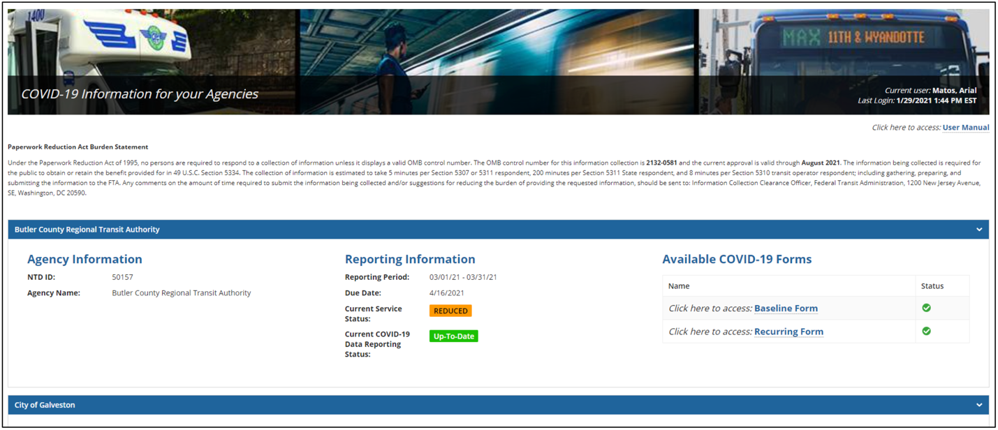

Baseline Submission
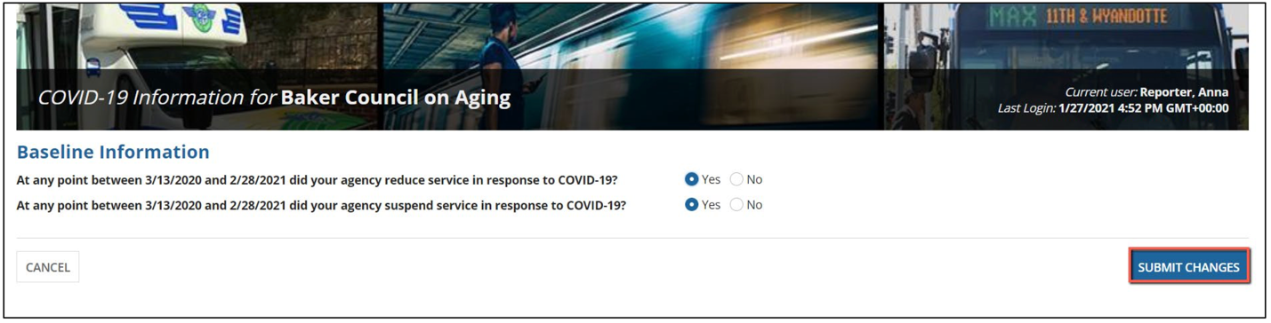
Recurring Submission
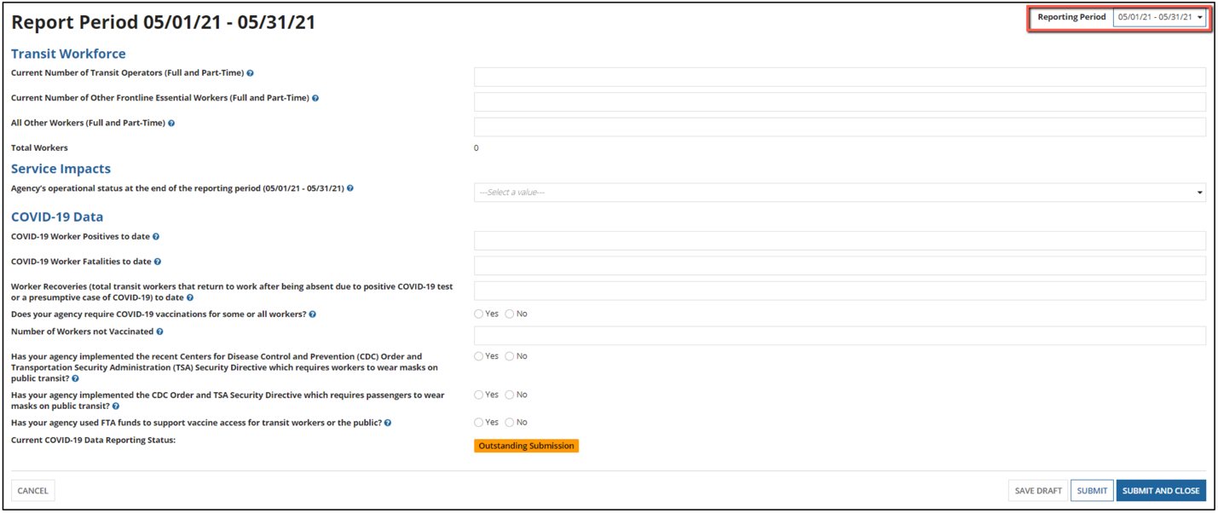
COVID-19 Baseline Questions
- At any point between 3/13/2020 and 2/1/2021 did your agency reduce service in response to COVID-19? Yes or No
- At any point between 3/13/2020 and 2/1/2021 did your agency suspend service in response to COVID-19? Yes or No
Recurring Submission Questions
Transit Workforce
- Current Number of Transit Operators (Full and Part-Time)
- Current Number of Other Frontline Essential Workers (Full and Part-Time)
- All Other Workers (Full and Part-Time)
Service Impacts
- Agency’s operational status at the end of the monthly period (Normal, Reduced, or Suspended)
COVID-19 Data
- COVID-19 Worker Positives to date
- COVID-19 Worker Fatalities to date
- Worker Recoveries (total transit workers that return to work after being absent due to positive COVID-19 test or presumptive case of COVID-19) to date
- Does your agency require COVID-19 vaccinations for some or all workers? Yes or No
- Number of workers not vaccinated
- Has your agency implemented the recent Centers for Disease Control and Prevention (CDC) Order and Transportation Security Administration (TSA) Security Directive which require workers to wear masks on public transit? Yes or No
- Has your agency implemented the CDC Order and TSA Security Directive which require passengers to wear masks on public transit? Yes or No
- Has your agency used FTA funds to support vaccine access for transit workers or the public? Yes or No

General and Operations Managers BLS May 2023
U.S. Department of Health and Human Services, Guidelines for Regulatory Impact Analysis, Table 4.2, Constructing Default Estimates of the Value of Time, 2016. See https://aspe.hhs.gov/system/files/pdf/242926/HHS_RIAGuidance.pdf.
. General and Operations Managers BLS May 2023
U.S. Department of Health and Human Services, Guidelines for Regulatory Impact Analysis, Table 4.2, Constructing Default Estimates of the Value of Time, 2016. See https://aspe.hhs.gov/system/files/pdf/242926/HHS_RIAGuidance.pdf.
U.S. Department of Health and Human Services, Guidelines for Regulatory Impact Analysis, Table 4.2, Constructing Default Estimates of the Value of Time, 2016. See https://aspe.hhs.gov/system/files/pdf/242926/HHS_RIAGuidance.pdf.
Based on Occupation 11-1021, BLS Occupational Employment Statistics, May 2023. See General and Operations Managers.
U.S. Department of Health and Human Services, Guidelines for Regulatory Impact Analysis, Table 4.2, Constructing Default Estimates of the Value of Time, 2016. See https://aspe.hhs.gov/system/files/pdf/242926/HHS_RIAGuidance.pdf.
https://www.opm.gov/policy-data-oversight/pay-leave/salaries-wages/salary-tables/pdf/2021/DCB_h.pdf
https://www.transit.dot.gov/sites/fta.dot.gov/files/2021-07/COVID-19-Information-Collection-Online-Application-User-Guide-v2-1.pdf

