June Area Changes 2024

Tract Questionnaire

Face Page: No change.

Section A: (Operation Description): No change.

Section C: (Sections to be Completed): No change.

Section D: (Crops and Land use on Tract):

Arkansas

Dropped:
Oats Planted (533)
Oats Harvested (534)
Oats To Be Planted (737)
Oats Other Uses (796)
Hay Alfalfa (653)

California

Dropped:
Oats Planted (533)
Oats Harvested (534)
Oats To Be Planted (737)
Oats Other Uses (796)
Hay Alfalfa (653)

Added:
Dry Beans All (607)
Dry Beans To Be Planted (741)
Small Chickpeas (706)
Large Chickpeas (705)

Colorado

Added:
Safflower (683)

Delaware

Dropped:
Rapeseed (685)

Georgia

Dropped
Tobacco Flue-Cured (315)

Idaho

Dropped:
Wheat Durum Planted (553)
Wheat Durum Harvested (554)
Wheat Durum To Be Planted (614)
Wheat Durum Other Uses (920)
Lentils (715)

Added:
Canola (684)
Canola To Be Planted (735)

Indiana

Added:
Rapeseed (685)

Louisiana

Dropped:
Sugarcane (264)

Missouri

Dropped:
Oats Planted (533)
Oats Harvested (534)
Oats To Be Planted (737)
Oats Other Uses (796)

Added:
Peanuts (690)
Peanuts To Be Planted (739)

New Jersey

Dropped:
Wheat Winter Planted (540)
Wheat Winter Harvested (541)
Wheat Winter Other Uses (792)

New Mexico

Dropped:
Peanuts (690)
Peanuts To Be Planted (739)

Oklahoma

Dropped:
Oats Planted (533)
Oats Harvested (534)
Oats To Be Planted (737)
Oats Other Uses (796)

Oregon

Added:
Mustard Seed (686)

Pennsylvania

Dropped:
Tobacco Burley (732)
Tobacco PA Type (859)
Tobacco MD Type (316)
Tobacco Other (874)

South Carolina

Dropped:
Tobacco Flue-Cured (315)
Rapeseed (685)

South Dakota

Dropped:
Dry Edible Peas (714)

Washington

Added:
Rapeseed (685)
Mustard Seed (686)

Wyoming

Dropped:
Dry Beans All (607)
Dry Beans To Be Planted (741)

Section F: (Grains and Oil Seeds in Storage on Entire Operation): No change.

Section G: (Hogs and Pigs): No change.
Section H: (Total Cattle and Calves): No change.
Section I: (Sheep and Lambs): No change.

Section J: (Goats and Kids): No change.

Section K: (Equine): No change.

Section L: (Other Agricultural Information): No change.

Section M: (Land Values): No change.

Section N: (Economic Data on Entire Operation): No change.

Section O: (Technology Use): Removed for 2024.

Section P- (Operator Characteristics): No change.

Section R- (Conclusion) Back Page: See below for the updated version.
- Dropped the following item code: 1095.
- Added the following item codes: 9929, 9917, 9918 and 9920.
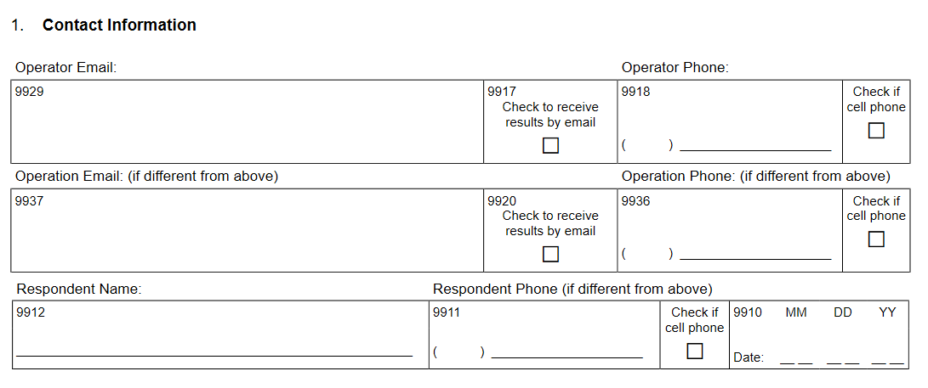
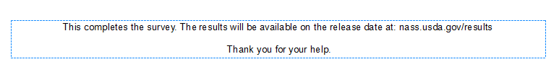

Screening Forms: No change.

