**Request for Nonsubstantive Change**

**ICR 0579-0101**

**October 9, 2024**

APHIS conducted a review of VS Form 5-13, Owner/Hauler Statement for Sheep and Goats, and requests approval for nonsubstantive changes.

Section GROUP LOT ID NUMBER:

* Change 1 – Added instructions for SHEEP/GOATS Moving without an official ID.
* Change 2 – Grey box with text “Declaration of number and type of sheep/goats covered by the form was change from grey fill to white fill.

The changes do not affect response time or burden.

**CURRENT**

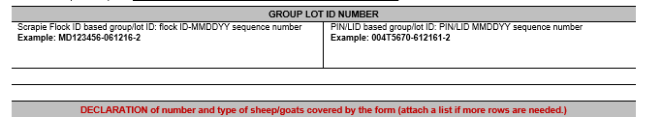

**FUTURE**

