**Request for Nonsubstantive Change**

**ICR 0579-0101**

**January 31, 2025**

APHIS conducted a review of VS Forms 5-29 and 5-29A and requests approval for nonsubstantive changes.

The changes includes terminology and instructions. The changes do not affect response time or burden.

**FORM: VS 5-29 Scrapie Test Record (3 changes)**

**Change 1: Reasons 6 changed from “IMPORTED” TO “IMPORT/EXPORT”.**

**CURRENT CHANGE**

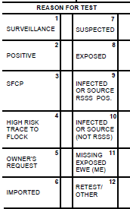

**Change 2: Changed “(circle one #) to “(Type one #)**

**CURRENT CHANGE**

**Change 3: Two changes**

1. Left side, changed “DSE Name” to “DSE/VMO Name”.
2. Right side, instruction item 3, changed “circle the quadrant where the biopsy sample was collected” to “type the quadrant number in the space next to the diagram”.

**CURRENT**

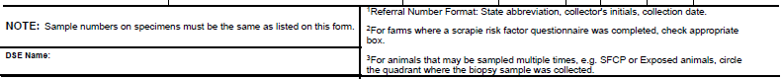

**CHANGE**

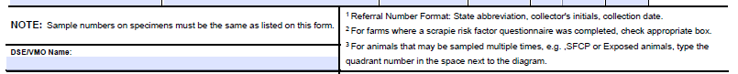

**FORM 2: VS 5-29A Continuation Sheet - Scrapie Test Record (2 changes)**

**Change 1: Changed “(circle one #) to “(Type one #)**

**CURRENT CHANGE**

**Change 2: Changed “circle the quadrant where the biopsy sample was collected” to “type the quadrant number in the space next to the diagram”.**

**CURRENT CHANGE**

** **