Appendix K1. Thank You Letter (English)
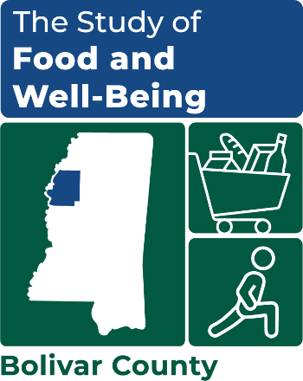

OMB Number: 0584-XXXX
Expiration Date: XX/XX/20XX

[NAME]
[ADDRESS]
[CITY], [ST] [ZIP]

Dear [NAME]:
Thank you for participating in the Study of Food and Well-Being. We are grateful for the time you took to complete the survey, as the information you provided during your interview is very valuable. Enclosed is a $35 Visa gift card in appreciation of your time. You may use this gift card at any store that accepts Visa. If you have any problems using your gift card, please call 1-XXX-XXX-XXXX and ask for XXXX XXXXXXXX.

Sincerely,

---insert signature image here---

Kim McDonald
Survey Director

