**Appendix P  
  
WIC & FMNP vendor/outlet staff experience survey**

OMB Number: 0584-xxxx

Expiration Date: xx/xx/20xx

**Public Burden Statement**

This information is being collected to assist the Food and Nutrition Service to better understand the implementation and impact of the Special Supplemental Nutrition Program for Women, Infants, and Children (WIC) modernization efforts on WIC State and local agencies, WIC vendors, and WIC participants. This is a voluntary collection and FNS will use the information to monitor and strengthen WIC program modernization efforts. This collection does not request any personally identifiable information under the Privacy Act of 1974. According to the Paperwork Reduction Act of 1995, an agency may not conduct or sponsor, and a person is not required to respond to, a collection of information unless it displays a valid OMB control number. The valid OMB control number for this information collection is 0584-[xxxx]. The time required to complete this information collection is estimated to average 10 minutes (0.167 hours) per response, including the time for reviewing instructions, searching existing data sources, gathering and maintaining the data needed, and completing and reviewing the collection of information. Send comments regarding this burden estimate or any other aspect of this collection of information, including suggestions for reducing this burden, to: U.S. Department of Agriculture, Food and Nutrition Service, Evidence, Analysis, and Regulatory Affairs Office, 1320 Braddock Place, 5th Floor, Alexandria, VA 22306, ATTN: PRA (0584-xxxx). Do not return the completed form to this address.

**WIC & FMNP Vendor/Outlet Staff Experience Survey**

**WIC & FMNP Outreach, Innovation, and Modernization Evaluation**

Date

**INTRODUCTION**

Thank you for participating in the WIC & Farmers’ Market Nutrition Program (FMNP) Outreach, Innovation, and Modernization Evaluation. The U.S. Department of Agriculture Food and Nutrition Service (USDA FNS) is sponsoring the study. Mathematica, an independent research organization, is conducting the study on behalf of FNS.

FNS is working with key partners to modernize WIC and FMNP; the goal of the study is to understand how WIC and FMNP modernization efforts are transforming the programs to better meet the needs of families. This survey will help FNS understand the experience of WIC vendor staff and farmer/market staff with recent modernization efforts.

**We know you are busy, and we appreciate your feedback! This survey will take about 10 minutes to complete.** You can complete it all at once, or you can save your responses and return to finish the survey later. If you don’t know a response to a question, please feel free to consult with a colleague.

Your participation in this study is voluntary. There are no risks or benefits associated with participating in the study. You may skip any questions you are not comfortable answering; however, we hope you will answer as many questions as you can. The information you provide will be used only for research purposes. Your responses will be kept private to the extent permitted by law. They will not be shared in a way that identifies you without your permission.

If you have any questions about the study or about completing this survey, please contact the study team at [EMAIL] or [PHONE]. If you have any questions about your rights as a research participant, please call Health Media Lab IRB at 202-246-8504.

Please use the buttons at the bottom of each page to move through the survey. You may need to scroll down on the page to view the buttons. Using your browser’s “Back” function may cause errors.

Do you agree to participate in this study? YES NO

IF YES: Please click on the link below to begin your survey.

<<SURVEY LINK>>

**Section A. Vendor/Outlet Background**

|  |
| --- |
| FILL WITH VENDOR/OUTLET NAME AND STATE AGENCY NAME FROM SAMPLE FILE |

**The following questions are about you and your experience with [VENDOR/OUTLET NAME] as a WIC vendor or WIC/FMNP authorized outlet for [STATE AGENCY NAME]**

|  |
| --- |
| ALL |
| FILL WITH VENDOR/OUTLET NAME FROM SAMPLE FILE |

**A1.** **What type of WIC vendor or WIC/Farmers’ Market Nutrition Program (FMNP) authorized outlet is [VENDOR/OUTLET NAME]?**

*Select the one that best applies*

m Farmer 1

m Farmers’ market 2

m Roadside produce stand 3

m Conventional supermarket (such as Kroger, Albertsons, Publix, H.E.B, Meijer, Hy-Vee) 4

m Discount department store or supercenter (such as Target, Walmart, SuperTarget, Walmart Supercenter) 5

m Discount/limited assortment retailer (such as Aldi, Trader Joe’s, Sav-A-Lot) 6

m Conventional club (such as Costco, Sam’s club) 7

m Natural/gourmet store 8

m Pharmacy – only exempt infant formula/nutritionals 9

m Dollar store (such as Dollar General, Dollar Tree, Family Dollar) 10

m Corner store 11

m Convenience store 12

m Commissary 13

m Other type of retailer 14

m Not a WIC vendor or WIC/FMNP authorized outlet 0 [END SURVEY]

NO RESPONSE M

|  |
| --- |
| IF A1=4, 5, 6, 7, 8, 9, 10, 11, 12, 13, 14 |
| FILL WITH VENDOR NAME FROM SAMPLE FILE |

**A1a.** **Is [VENDOR NAME] an A50 vendor, a WIC-only vendor, or neither?***A WIC A50 vendor is a store that derives more than 50% of their food sales from WIC benefit redemptions. A WIC-only vendor provides only WIC foods or identifies as a WIC-only store.*

*Select all that apply*

m No, not an A50 vendor or WIC-only vendor 0

m A50 vendor – for profit 1

m A50 vendor – nonprofit 2

m WIC-only vendor 3

m Don’t know D

NO RESPONSE M

|  |
| --- |
| A1 = 2, or 3 |

**A1b.** **What is your role at [OUTLET NAME]?**

*Select the one that best applies*

m Farmer 1

m Employee or volunteer for a farmer 2

m Farmers’ market manager, coordinator, or staff 3

m Manager, coordinator, staff, or volunteer of another organization 4

NO RESPONSE M

|  |
| --- |
| IF A1=4, 5, 6, 7, 8, 9, 10, 11, 12, 13, or 14 |
| FILL WITH VENDOR NAME FROM SAMPLE FILE |

**A1c. What is your role at [VENDOR NAME]?** *If you fill multiple roles, please choose the one that you spend the most time in.*

*Select one only*

m Owner 1

m Manager or supervisor 2

m Cashier 3

m Corporate-level staff 4

m Information technology (IT) staff 5

m Other type of staff 6

m Don’t know D

NO RESPONSE M

|  |
| --- |
| ALL |
| FILL WITH VENDOR/OUTLET NAME FROM SAMPLE FILE |

**A2.** **In what year did [VENDOR/OUTLET NAME] first become a WIC vendor or WIC/FMNP authorized farmer/market/roadside produce stand?**

*Select one only*

m [FOR SURVEYS FIELDED IN 2027 ONLY] In 2027 1

m [FOR SURVEYS FIELDED IN 2027 ONLY] In 2026 2

m In 2025 3

m In 2024 4

m In 2023 5

m In 2022 6

m In 2021 7

m In 2020 8

m Prior to 2020 9

m Don’t know D [GO TO A2a]

NO RESPONSE M

|  |
| --- |
| IF A2=D |
| FILL WITH VENDOR/OUTLET NAME FROM SAMPLE FILE |

**A2a.** **Approximately when did [VENDOR/OUTLET NAME] first become a WIC vendor or WIC/FMNP authorized farmer/market/roadside produce stand?** *Please provide your best guess.*

*Select one only*

m In 2023 or later 1

m In 2022 or earlier 2

NO RESPONSE M

**Section B. WIC vendor staff satisfaction and experiences**

|  |
| --- |
| FILL WITH VENDOR/OUTLET NAME AND STATE AGENCY NAME FROM SAMPLE FILE |

**The following questions are about your satisfaction and experience as a WIC vendor staff member. Please answer the questions about the location(s) of [VENDOR NAME] in [STATE AGENCY NAME] that you know best.**

|  |
| --- |
| ALL |
| FILL WITH VENDOR NAME FROM SAMPLE FILE |

**B1. Currently,** **how do you feel about [VENDOR NAME] being a WIC vendor?**

*Select one only*

m Very satisfied 1

m Satisfied 2

m Neither satisfied nor dissatisfied 3

m Dissatisfied 4

m Very dissatisfied 5

m Don’t know D

NO RESPONSE M

|  |
| --- |
| ALL |
| FILL WITH VENDOR NAME FROM SAMPLE FILE  IF A2=3 OR 4 FILL WITH “SINCE YOU BECAME A WIC VENDOR”  IF A2=5, 6, 7, 8, OR 9 FILL WITH “SINCE JANUARY 2023” |

**B2.** **Since [January 2023/you became a WIC vendor], how has your satisfaction with [VENDOR NAME] being a WIC vendor changed?**

*Select one only*

m Satisfaction has gotten **a lot better** 1

m Satisfaction has gotten **a little better** 2

m Satisfaction **has not changed** 3

m Satisfaction has gotten **a little worse** 4

m Satisfaction has gotten **a lot worse** 5

m Don’t know D

NO RESPONSE M

|  |
| --- |
| A1=4, 5, 6, 7, 8, 9, 10, 11 |
| FILL WITH VENDOR NAME FROM SAMPLE FILE |

**B3. Which of these shopping services does [VENDOR NAME] currently offer?**

*Select all that apply*

o In-person shopping 1 [GO TO B12]

o Online shopping with in-person payment 2 [GO TO B4]

o Online shopping with online payment 3 [GO TO B7]

NO RESPONSE M

**The following are questions about your experience and satisfaction with offering online shopping with in-person payment to WIC participants.**

|  |
| --- |
| IF B3=2 |
| FILL WITH VENDOR NAME FROM SAMPLE FILE |

**B4.** **What year did [VENDOR NAME] begin offering online shopping with in-person payment to WIC participants?**

(FIELD DESCRIPTION)

YYYY

(RANGE DATE RANGE)

m Don’t know D

NO RESPONSE M

|  |
| --- |
| IF B3=2 |

**B5.** **In your opinion, how easy or difficult was it to start offering online shopping with in-person payment to WIC participants?** *When responding, consider tasks related to starting up the activity.*

*Select one only*

m Very easy 1

m Easy 2

m Neither easy nor difficult 3

m Difficult 4

m Very difficult 5

m Don’t know D

NO RESPONSE M

|  |
| --- |
| IF B3=2 |

**B6.** **In your opinion, how easy or difficult has it been to continue offering online shopping with in-person payment to WIC participants?** *When responding, consider tasks related to maintaining the activity.*

*Select one only*

m Very easy 1

m Easy 2

m Neither easy nor difficult 3

m Difficult 4

m Very difficult 5

m Don’t know D

NO RESPONSE M

|  |
| --- |
| IF B3=2 |

**B7. Since you started offering it, how has your satisfaction with offering online shopping with in-person payment to WIC participants changed?**

*Select one only*

m Satisfaction has gotten **a lot better** 1

m Satisfaction has gotten **a little better** 2

m Satisfaction has **not changed** 3

m Satisfaction has gotten **a little worse** 4

m Satisfaction has gotten **a lot worse** 5

m Don’t know D

NO RESPONSE M

**The following are questions about your experience and satisfaction with offering online shopping with online payment to WIC participants.**

|  |
| --- |
| IF B3=3 |
| FILL WITH VENDOR NAME FROM SAMPLE FILE |

**B8.** **What year did [VENDOR NAME] begin offering online shopping with online payment to WIC participants?**

(FIELD DESCRIPTION)

YYYY

(RANGE DATE RANGE)

m Don’t know D

NO RESPONSE M

|  |
| --- |
| IF B3=3 |

**B9.** **In your opinion, how easy or difficult was it to start offering online shopping with online payment to WIC participants?** *When responding, consider tasks related to starting up the activity.*

*Select one only*

m Very easy 1

m Easy 2

m Neither easy nor difficult 3

m Difficult 4

m Very difficult 5

m Don’t know D

NO RESPONSE M

|  |
| --- |
| IF B3=3 |

**B10.** **In your opinion, how easy or difficult has it been to continue offering online shopping with online payment to WIC participants?** *When responding, consider tasks related to maintaining the activity.*

*Select one only*

m Very easy 1

m Easy 2

m Neither easy nor difficult 3

m Difficult 4

m Very difficult 5

m Don’t know D

NO RESPONSE M

|  |
| --- |
| IF B3=3 |

**B11. Since you started offering it, how has your satisfaction with offering online shopping with online payment to WIC participants changed?**

*Select one only*

m Satisfaction has gotten **a lot better** 1

m Satisfaction has gotten **a little better** 2

m Satisfaction has **not changed** 3

m Satisfaction has gotten **a little worse** 4

m Satisfaction has gotten **a lot worse** 5

m Don’t know D

NO RESPONSE M

**The following are questions about your experience and satisfaction with offering in-person shopping to WIC participants.**

|  |
| --- |
| IF B3=1 |
| FILL WITH VENDOR NAME FROM SAMPLE FILE |

**B12.** **Does [VENDOR NAME] currently allow WIC participants to transact their benefits using mobile payments (e.g., through payments managed in eWallets or a WIC app) when shopping in-person?**

*Select one only*

m Yes 1

m No 0 [GO TO B17]

m Don’t know D

NO RESPONSE M

|  |
| --- |
| IF B12=1 |
| FILL WITH VENDOR NAME FROM SAMPLE FILE |

**B13.** **What year did [VENDOR NAME] start allowing WIC participants to transact their benefits using mobile payments when shopping in-person?**

(FIELD DESCRIPTION)

YYYY

(RANGE DATE RANGE)

m Don’t know D

NO RESPONSE M

|  |
| --- |
| IF B12=1 |

**B14.** **In your opinion, how easy or difficult was it to start allowing WIC participants to transact their benefits using mobile payments when shopping in-person?** *When responding, consider tasks related to starting up the activity.*

*Select one only*

m Very easy 1

m Easy 2

m Neither easy nor difficult 3

m Difficult 4

m Very difficult 5

m Don’t know D

NO RESPONSE M

|  |
| --- |
| IF B12=1 |

**B15.** **In your opinion, how easy or difficult has it been to continue allowing WIC participants to transact their benefits using mobile payments when shopping in-person?** *When answering, consider tasks related to maintaining the activity.*

*Select one only*

m Very easy 1

m Easy 2

m Neither easy nor difficult 3

m Difficult 4

m Very difficult 5

m Don’t know D

NO RESPONSE M

|  |
| --- |
| IF B12=1 |

**B16.** **Since you started allowing it, how has your satisfaction with allowing WIC participants to transact their benefits using mobile payments when shopping in-person changed?**

*Select one only*

m Satisfaction has gotten **a lot better** 1

m Satisfaction has gotten **a little better** 2

m Satisfaction has **not changed** 3

m Satisfaction has gotten **a little worse** 4

m Satisfaction has gotten **a lot worse** 5

m Don’t know D

NO RESPONSE M

|  |
| --- |
| IF B3=1 |
| FILL WITH VENDOR NAME FROM SAMPLE FILE |

**B17.** **Does [VENDOR NAME] currently allow WIC participants to transact their benefits using self-checkout when shopping in-person?**

*Select one only*

m Yes 1

m No 0 [GO TO B22]

m Don’t know D

NO RESPONSE M

|  |
| --- |
| IF B17=1 |
| FILL WITH VENDOR NAME FROM SAMPLE FILE |

**B18. What year did [VENDOR NAME] start allowing WIC participants to transact their benefits using self-checkout when shopping in-person?**

(FIELD DESCRIPTION)

YYYY

(RANGE DATE RANGE)

m Don’t know D

NO RESPONSE M

|  |
| --- |
| IF B17=1 |

**B19. In your opinion, how easy or difficult was it to start allowing WIC participants to transact their benefits using self-checkout when shopping in-person?** *When responding, consider tasks related to starting up the activity.*

*Select one only*

m Very easy 1

m Easy 2

m Neither easy nor difficult 3

m Difficult 4

m Very difficult 5

m Don’t know D

NO RESPONSE M

|  |
| --- |
| IF B17=1 |

**B20. In your opinion, how easy or difficult has it been to continue allowing WIC participants to transact their benefits using self-checkout when shopping in-person?** *When answering, consider tasks related to maintaining the activity.*

*Select one only*

m Very easy 1

m Easy 2

m Neither easy nor difficult 3

m Difficult 4

m Very difficult 5

m Don’t know D

NO RESPONSE M

|  |
| --- |
| IF B17=1 |
| IF B18=1 OR D FILL WITH “JANUARY 2023”  IF B18=2 FILL WITH “YOU STARTED ALLOWING IT” |

**B21. Since [January 2023/you started allowing it], how has your satisfaction changed about the process of allowing WIC participants to transact their benefits using self-checkout when shopping in-person?**

*Select one only*

m Satisfaction has gotten **a lot better** 1

m Satisfaction has gotten **a little better** 2

m Satisfaction has **not changed** 3

m Satisfaction has gotten **a little worse** 4

m Satisfaction has gotten **a lot worse** 5

m Don’t know D

NO RESPONSE M

|  |
| --- |
| B3=1 |
| FILL WITH VENDOR NAME FROM SAMPLE FILE |

**B22. What other efforts has [VENDOR NAME] implemented since January 2023 to improve the in-person shopping experience?**

*Select all that apply*

o Placing WIC items together (e.g., WIC aisle or WIC store within the store) 1

o Improving signage and labels for WIC-eligible items 2

o Training employees on the WIC program 3

o Improving customer service to WIC participants at checkout 4

m Don’t know D

NO RESPONSE M

**Section C. Farmer/market/roadside produce stand staff satisfaction and experiences with WIC/FMNP electronic benefit redemption**

**The following are questions about your experience and satisfaction with accepting WIC/FMNP benefits electronically at a farmers’ market or roadside produce stand. You might accept WIC/FMNP benefits electronically through a WIC electronic benefit transfer (EBT) card, mobile pay, or a QR code.**

|  |
| --- |
| IF A1=1,2,3 |
| FILL WITH OUTLET NAME FROM SAMPLE FILE |

**C1.** **Currently, how do you feel about [OUTLET NAME] being a WIC/FMNP authorized farmer/market/roadside produce stand?**

*Select one only*

m Very satisfied 1

m Satisfied 2

m Neither satisfied nor dissatisfied 3

m Dissatisfied 4

m Very dissatisfied 5

m Don’t know D

NO RESPONSE M

|  |
| --- |
| IF A1=1,2,3 |
| FILL WITH OUTLET NAME FROM SAMPLE FILE  IF A2=3 OR 4 FILL WITH “SINCE YOU BECAME A WIC/FMNP AUTHORIZED FARMER/MARKET/ROADSIDE PRODUCE STAND”  IF A2=5, 6, 7, 8, OR 9 FILL WITH “SINCE JANUARY 2023” |

**C2.** **Since [January 2023/you became a WIC/FMNP authorized farmer/market/roadside produce stand], how has your satisfaction with [OUTLET NAME] being a WIC/FMNP authorized farmer/market/roadside produce stand changed?**

*Select one only*

m Satisfaction has gotten **a lot better** 1

m Satisfaction has gotten **a little better** 2

m Satisfaction **has not changed** 3

m Satisfaction has gotten **a little worse** 4

m Satisfaction has gotten **a lot worse** 5

m Don’t know D

NO RESPONSE M

|  |
| --- |
| IF A1=1, 2, 3 |
| FILL WITH OUTLET NAME FROM SAMPLE FILE |

**C3.** **Does [OUTLET NAME] currently accept electronic benefits for the Farmers’ Market Nutrition Program (FMNP) or the WIC cash value benefit (CVB; the WIC fruit and vegetable benefit)?**

*Select all that apply*

m Accept electronic FMNP benefits 1 [GO TO C4]

m Accept electronic WIC CVB 2 [GO TO C8]

m Do not accept electronic benefits 0 [GO TO D1]

m Don’t know D [GO TO D1]

NO RESPONSE M

|  |
| --- |
| IF C3=1 |
| FILL WITH OUTLET NAME FROM SAMPLE FILE |

**C4.** **What year did [OUTLET NAME] start accepting electronic FMNP benefits?**

(FIELD DESCRIPTION)

YYYY

(RANGE DATE RANGE)

m Don’t know D

NO RESPONSE M

|  |
| --- |
| IF C3=1 |

**C5.** **In your opinion, how easy or difficult was it to start accepting electronic FMNP benefits?** *When responding, consider tasks related to starting up the activity.*

*Select one only*

m Very easy 1

m Easy 2

m Neither easy nor difficult 3

m Difficult 4

m Very difficult 5

m Don’t know D

NO RESPONSE M

|  |
| --- |
| IF C3=1 |

**C6.** **In your opinion, how easy or difficult has it been to continue accepting electronic FMNP benefits?** *When answering, consider tasks related to maintaining the activity.*

*Select one only*

m Very easy 1

m Easy 2

m Neither easy nor difficult 3

m Difficult 4

m Very difficult 5

m Don’t know D

NO RESPONSE M

|  |
| --- |
| IF C3=1 |

**C7.** **Since you started accepting them, how has your satisfaction with accepting electronic FMNP benefits changed?**

*Select one only*

m Satisfaction has gotten **a lot better** 1

m Satisfaction has gotten **a little better** 2

m Satisfaction has **not changed** 3

m Satisfaction has gotten **a little worse** 4

m Satisfaction has gotten **a lot worse** 5

m Don’t know D

NO RESPONSE M

|  |
| --- |
| IF C3=2 |
| FILL WITH OUTLET NAME FROM SAMPLE FILE |

**C8. What year did [OUTLET NAME] start accepting electronic WIC CVB (the WIC fruit and vegetable benefit)?**

(FIELD DESCRIPTION)

YYYY

(RANGE DATE RANGE)

m Don’t know D

NO RESPONSE M

|  |
| --- |
| IF C3=2 |

**C9. In your opinion, how easy or difficult was it to start accepting the WIC CVB (the WIC fruit and vegetable benefit)?** *When responding, consider tasks related to starting up the activity.*

*Select one only*

m Very easy 1

m Easy 2

m Neither easy nor difficult 3

m Difficult 4

m Very difficult 5

m Don’t know D

NO RESPONSE M

|  |
| --- |
| IF C3=2 |

**C10. In your opinion, how easy or difficult has it been to continue accepting the WIC CVB (the WIC fruit and vegetable benefit)?** *When answering, consider tasks related to maintaining the activity.*

*Select one only*

m Very easy 1

m Easy 2

m Neither easy nor difficult 3

m Difficult 4

m Very difficult 5

m Don’t know D

NO RESPONSE M

|  |
| --- |
| IF C3=2 |

**C11. Since you started accepting it, how has your satisfaction with accepting the WIC CVB (the WIC fruit and vegetable benefit) changed?**

*Select one only*

m Satisfaction has gotten **a lot better** 1

m Satisfaction has gotten **a little better** 2

m Satisfaction has **not changed** 3

m Satisfaction has gotten **a little worse** 4

m Satisfaction has gotten **a lot worse** 5

m Don’t know D

NO RESPONSE M

|  |
| --- |
| IF C3=1 OR 2 |
| FILL WITH OUTLET NAME FROM SAMPLE FILE |

**C12.** **How can your WIC or FMNP State agency improve [OUTLET NAME]’s experience accepting electronic FMNP benefits and/or the WIC CVB?**

*Select all that apply*

o Communicate WIC/FMNP program updates in a timely manner 1

o Provide accessible information about WIC/FMNP program changes at the farmers’ market 2

o Provide information about WIC/FMNP program changes at the farmers’ market in languages other than English 3

o Provide support to resolve technical issues related to accepting electronic WIC/FMNP benefits 4

o Provide training on how to accept electronic WIC/FMNP benefits 5

o Provide hardware (such as iPads, hotspots, etc.) to support acceptance of electronic WIC/FMNP benefits 6

o Provide software to allow for better mobile pay options 7

o Make the reimbursement process easier and faster 8

o Provide an offline option for accepting electronic WIC/FMNP benefits 9

o Provide dedicated on-site staff at the market/roadside produce stand to assist with accepting electronic WIC/FMNP benefits 10

m Don’t know D

NO RESPONSE M

**Section D. WIC vendor and farmer/market/roadside produce stand staff satisfaction with State agency communications and interactions**

**You’re almost done with the survey!**

**We have a few more questions about your experience and satisfaction with communications and interactions with your WIC/FMNP State agency.**

|  |
| --- |
| ALL |
| FILL WITH STATE AGENCY NAME FROM SAMPLE FILE  FILL WITH VENDOR/OUTLET NAME FROM SAMPLE FILE  FILL WITH VENDOR TYPE IF A1=1, 2, 3 [WIC/FMNP PROGRAM LANGUAGE]  FILL WITH VENDOR TYPE, IF A1=4, 5, 6, 7, 8, 9, 10, 11 [WIC VENDOR LANGUAGE] |

**D1.** **Has [VENDOR/OUTLET NAME] used the [STATE AGENCY NAME]’s website or online system to obtain information about the [WIC/FMNP] program?**

*Select one only*

m Yes 1

m No 0 [GO TO D4]

m Don’t know D [GO TO D4]

NO RESPONSE M

|  |
| --- |
| IF D1=1 |
| FILL WITH STATE AGENCY NAME FROM SAMPLE FILE  FILL WITH VENDOR TYPE IF A1=1, 2, 3 [WIC/FMNP PROGRAM LANGUAGE]  FILL WITH VENDOR TYPE, IF A1=4, 5, 6, 7, 8, 9, 10, 11 [WIC VENDOR LANGUAGE] |

**D2.** **In your opinion, how easy or difficult has it been to use the [STATE AGENCY NAME]’s website or online system to obtain information about the program?**

*Select one only*

m Very easy 1

m Easy 2

m Neither easy nor difficult 3

m Difficult 4

m Very difficult 5

m Don’t know D

NO RESPONSE M

|  |
| --- |
| IF D1=1 |
| FILL WITH STATE AGENCY NAME FROM SAMPLE FILE  FILL WITH VENDOR/OUTLET NAME FROM SAMPLE FILE  FILL WITH VENDOR TYPE IF A1=1, 2, 3 [WIC/FMNP PROGRAM LANGUAGE]  FILL WITH VENDOR TYPE, IF A1=4, 5, 6, 7, 8, 9, 10, 11 [WIC VENDOR LANGUAGE] |

**D3. Since you started using it, how has your satisfaction with the [STATE AGENCY NAME]’s website or online system changed?**

*Select one only*

m Satisfaction has gotten **a lot better** 1

m Satisfaction has gotten **a little better** 2

m Satisfaction has **not changed** 3

m Satisfaction has gotten **a little worse** 4

m Satisfaction has gotten **a lot worse** 5

m Don’t know D

NO RESPONSE M

|  |
| --- |
| ALL |
| FILL WITH VENDOR TYPE IF A1=1, 2, 3 [WIC/FMNP PROGRAM LANGUAGE]  FILL WITH VENDOR TYPE, IF A1=4, 5, 6, 7, 8, 9, 10, 11 [WIC VENDOR LANGUAGE] |

**D4.** **Overall, in what ways could the [WIC/FMNP] program improve its outreach and support to [WIC vendors and farmers/markets/roadside produce stands] and their staff?**

*Select all that apply*

o Increase frequency of communication 1

o Decrease frequency of communication 2

o Translate the communication into additional languages 3

o Conduct communication in different ways (such as email, text messages, etc.) 4

o Improve training content 5

o Increase the frequency of in-person visits by WIC/FMNP staff to offer support 6

o Decrease the frequency of in-person visits by WIC/FMNP staff to offer support 7

o Increase the frequency of in-person monitoring visits by WIC/FMNP staff 6

o Decrease the frequency of in-person monitoring visits by WIC/FMNP staff 7

o Increase the frequency of training 8

o Decrease the frequency of training 9

o Other (SPECIFY) 99

Specify (STRING (NUM))

m Don’t know D

NO RESPONSE M

|  |
| --- |
| IF D4=3 |

**D5.** **You indicated that the [WIC/FMNP] program could improve its outreach and support to [WIC vendors/farmers/markets/roadside produce stands] and their staff by translating their communication into more languages. Which languages would you prefer?**

*Select all that apply*

o English 1

o Spanish 2

o Arabic 3

o Mandarin 4

o Haitian/Creole 5

o Korean 6

o Vietnamese 7

o Tagalog (including Filipino) 8

o Dari 9

o Other 99

NO RESPONSE M

**THANK YOU FOR COMPLETING THIS SURVEY!**

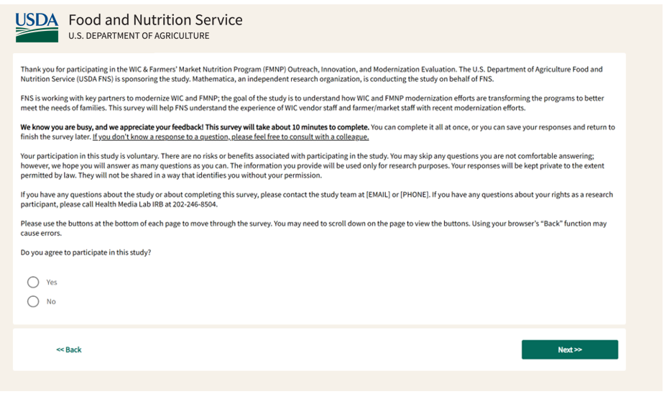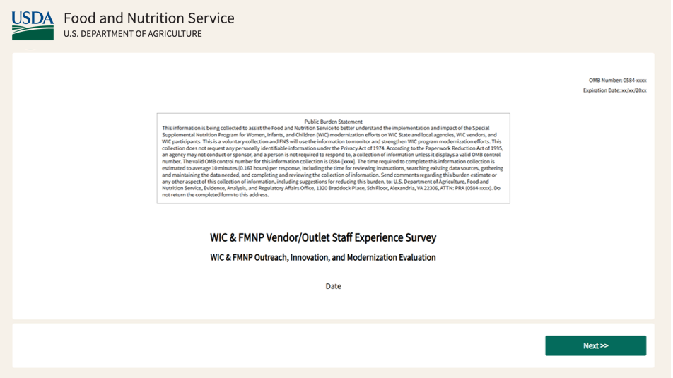The following screenshots show the first four pages of the survey as they will appear to the respondent. We do not include screenshots for the full survey because the remainder of the survey is still being programmed. In addition, due to the length of the survey, providing screenshots for the full survey would be cumbersome.

