**UNITED STATES DEPARTMENT OF COMMERCE**

**Bureau of Industry and Security**

**Information and Communications Technology and Services**

Washington, D.C. 20230



**SUBJECT: PAPERWORK REDUCTION ACT – INFORMATION COLLECTION FOR RULEMAKING**

**INTRODUCTION**

The new information collection for this rule will primarily take the form of Declarations of Conformity, specific authorizations applications, and advisory opinion requests. After the rule is published, OICTS will electronically intake Declarations of Conformity, specific authorization applications, and advisory opinion requests through the Compliance Application and Reporting System (CARS), a web-based submission portal owned by BIS.

The following disclaimers appear at the beginning of the Declaration of Conformity submission, specific authorization application, and advisory opinion request.

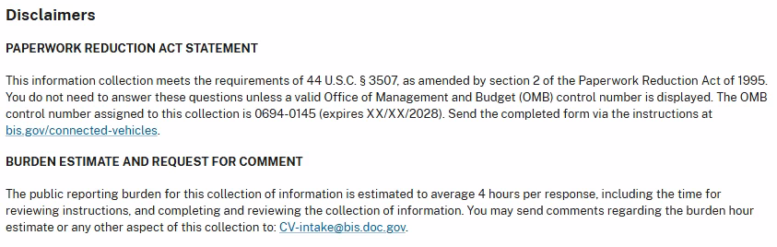

**DECLARATIONS OF CONFORMITY**

1. Company Information

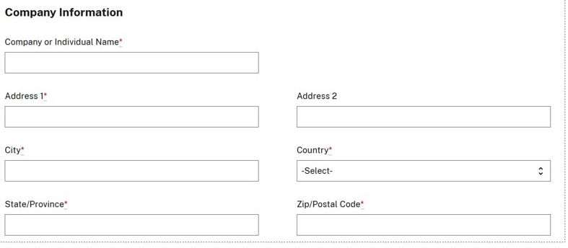

1. Point of Contact Information

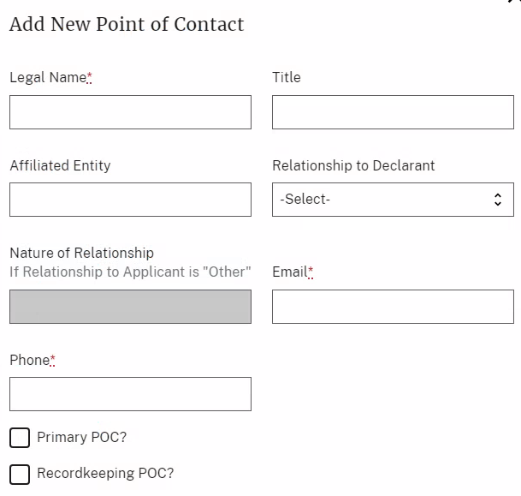

1. Declaration Purpose

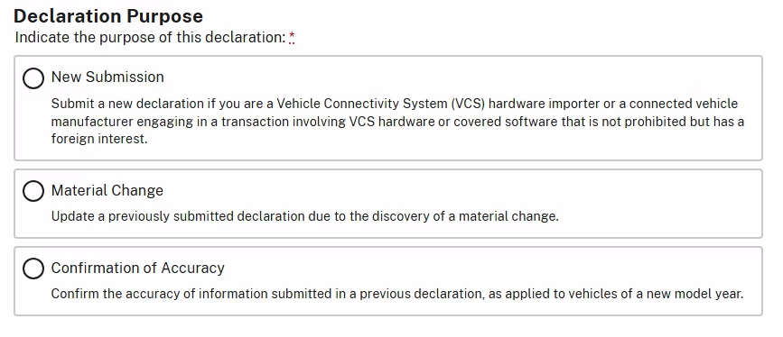

1. Transaction Information – Adding a VCS Hardware Transaction

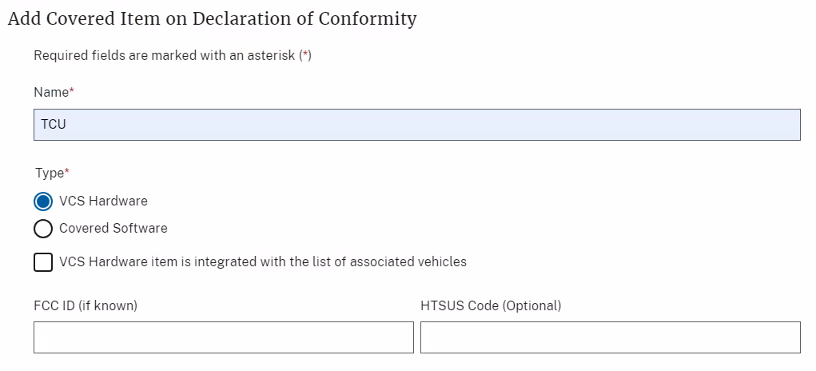

1. Transaction Information – Adding a Covered Software Transaction

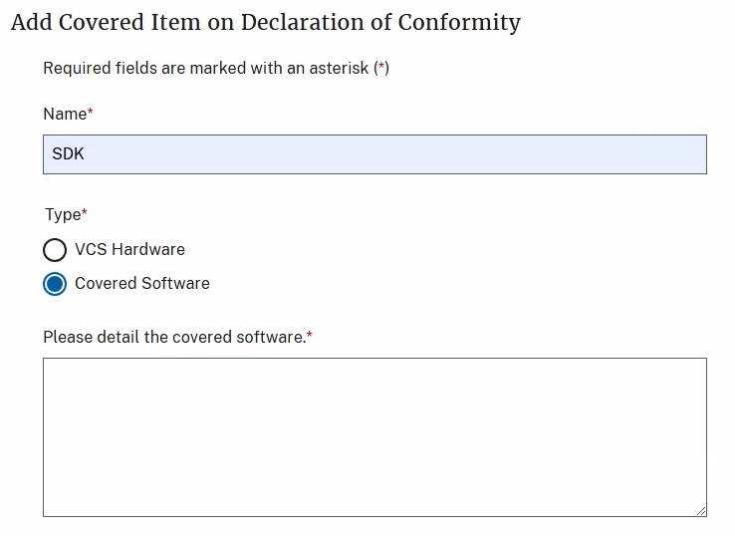

1. Transaction Information – Associating a Make and Model to the VCS Hardware or Covered Software

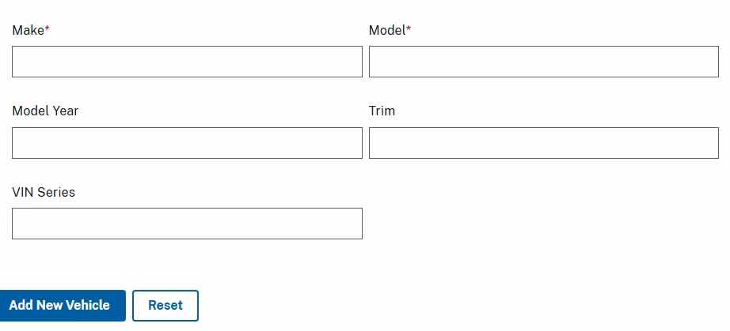

1. Voluntarily Provided Information

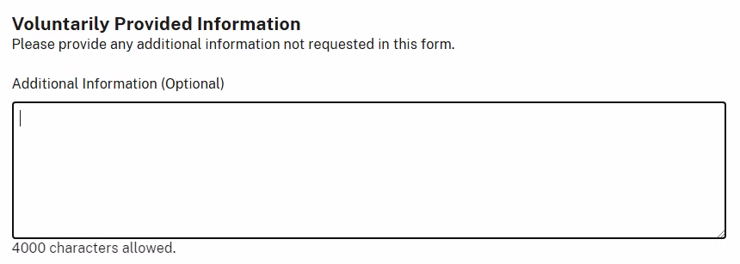

1. Related Documentation

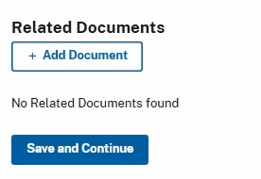

1. Certifications

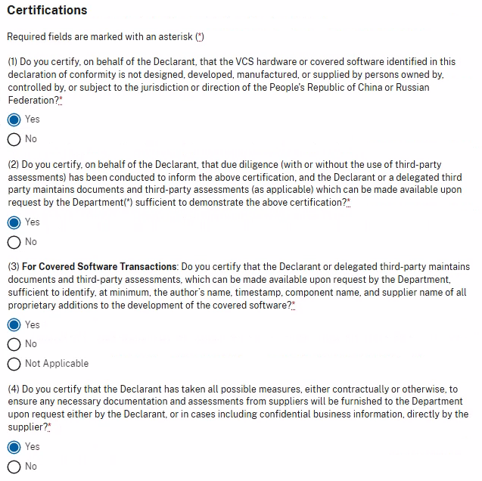

**SPECIFIC AUTHORIZATION APPLICATION**

1. Company Information



1. Company Corporate Ownership

**Additional Directions:** For examples of helpful documentation you can submit in relation to a description of ownership, refer to the *What documentation should I submit in support of my Specific Authorization Application?* FAQ here: https://www.bis.gov/oicts/connected-vehicles/specific-authorizations.

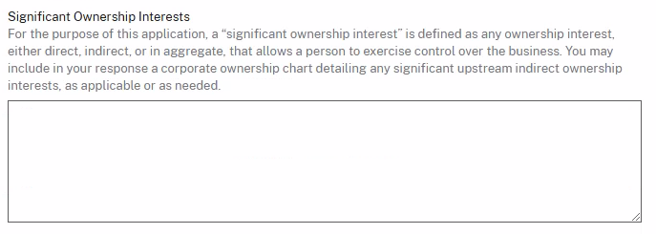

1. Point of Contact Information



1. Whether the Specific Authorization Relates to a Previously Submitted Declaration of Conformity

**Additional Directions:** Pursuant to 15 CFR Part 791.305(f), if a connected vehicle manufacturer or VCS hardware importer determines that articles subject to a Declaration of Conformity are no longer eligible, it must, within 30 days, cease any prohibited conduct and submit a specific authorization application. If this is the reason for your specific authorization application, please associate the previous Declaration of Conformity below.

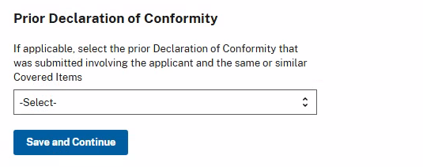

1. Application Type

* Is the entity filing this Specific Authorization Application engaged in related prohibited transactions with respect to 15 CFR § 791.304?
  + Yes
  + No

By selecting “Yes,” you are required to list all covered software and VCS hardware that is designed, developed, manufactured, or supplied by you or a third-party. Please ensure to list all parties that are engaged in the otherwise prohibited transactions, including yourself, and associate the relevant covered software or VCS hardware item to each party.

1. Party Engaged in an Otherwise Prohibited Transaction – Relevant Corporate Identifiers

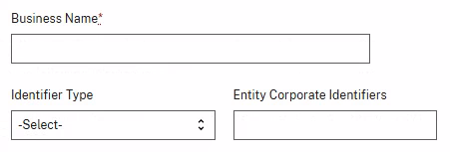

1. Party Engaged in an Otherwise Prohibited Transaction – Information Sufficient to Identify Ultimate Beneficial Ownership & Point of Contact Information

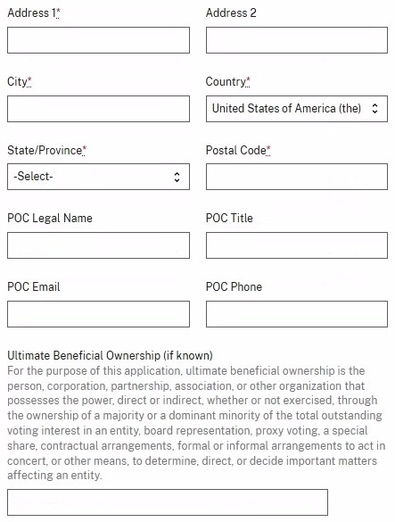

1. Transaction Information – Party Transaction Role and Associated Covered Items

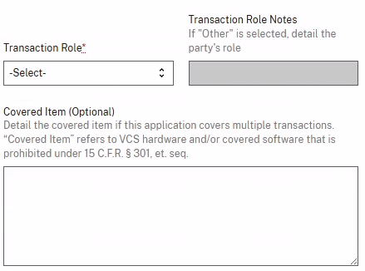

1. Transaction Information – Adding a VCS Hardware Transaction

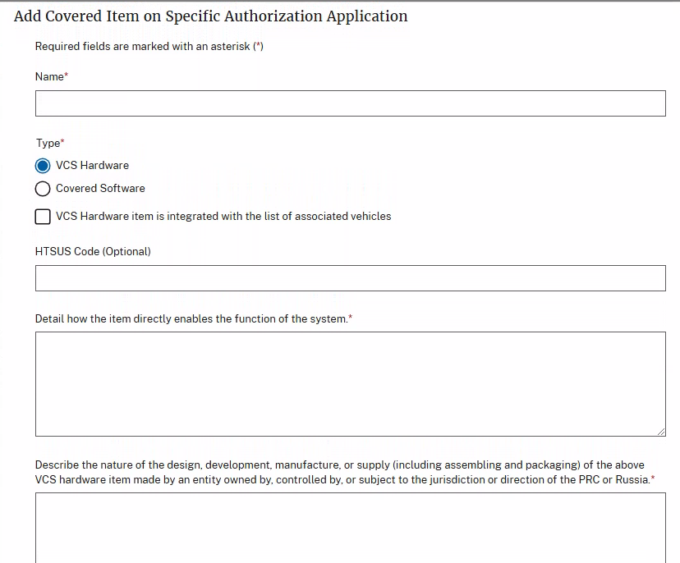

1. Transaction Information – Adding a Covered Software Transaction

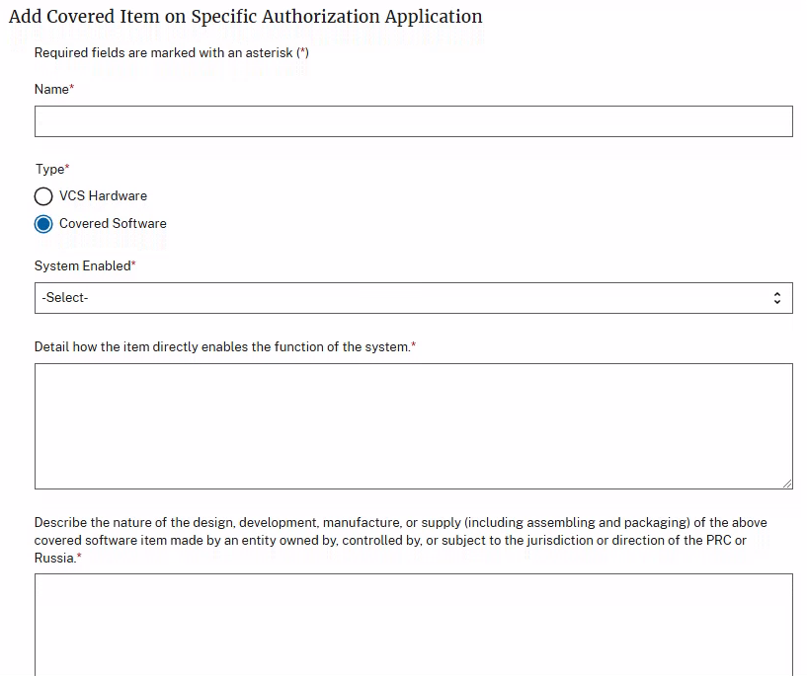

1. Transaction Information – Associating a Make and Model to the VCS Hardware or Covered Software



1. Internal Controls Assessment

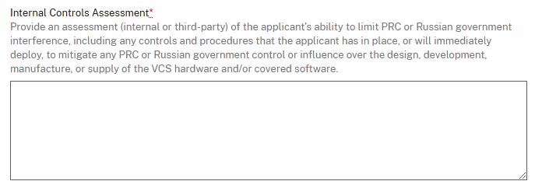

1. Security Standards Used

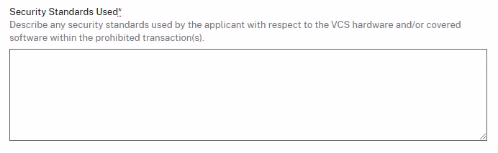

1. Other Actions and Proposals

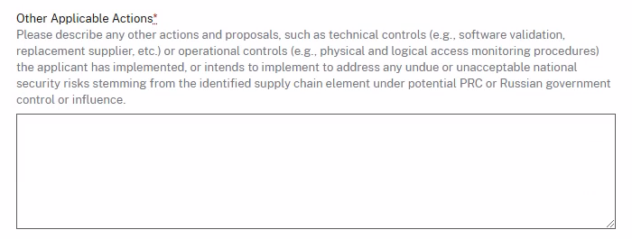

1. Voluntarily Provided Information



1. Related Documentation



**ADVISORY OPINION REQUESTS**

1. Company Information



1. Point of Contact Information

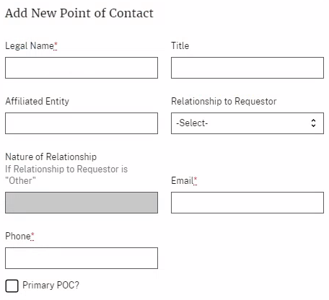

1. Party Engaged in Prospective Transaction – Relevant Corporate Identifiers

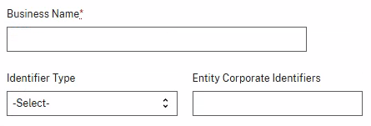

1. Party Engaged in Prospective Transaction – Identifying Information

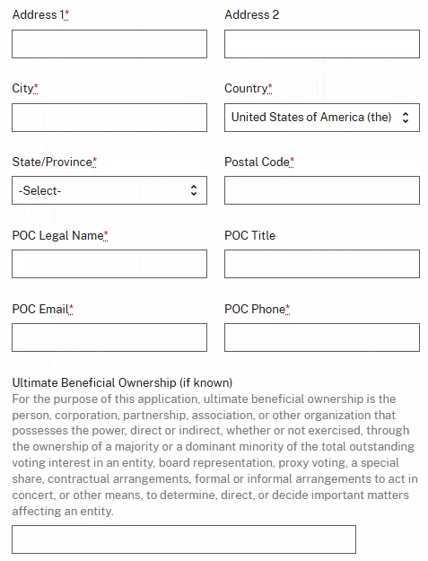

1. Transaction Information – Party Transaction Role and Associated Covered Items

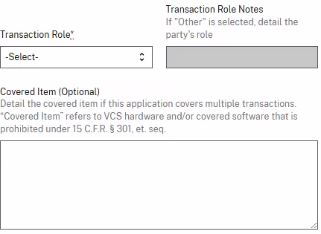

1. Transaction Information – Information Regarding VCS Hardware

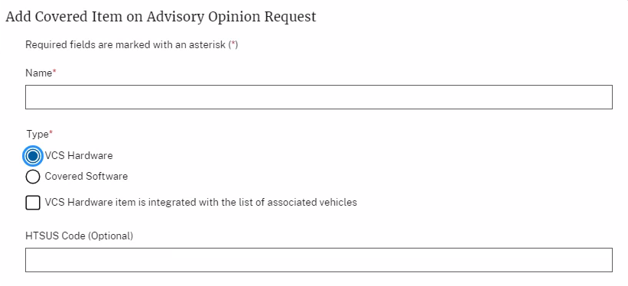

1. Transaction Information – Information Regarding Covered Software

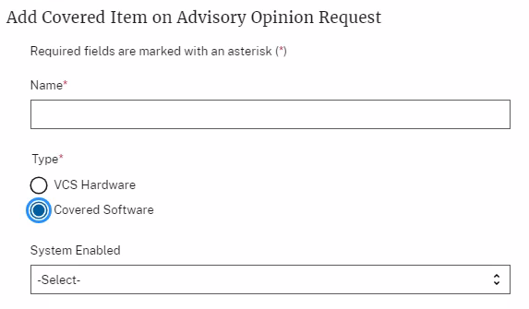

1. Transaction Information – Associating a Make and Model to the VCS Hardware or Covered Software



1. Advisory Opinion Request

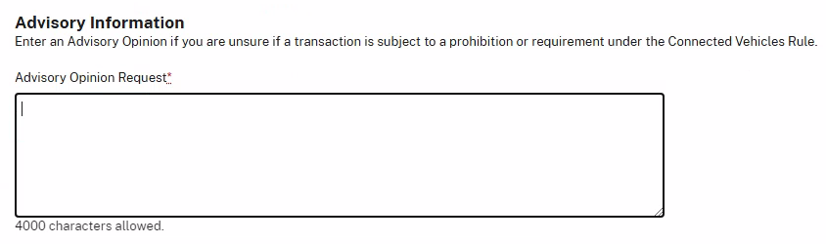

1. Related Documentation

