**NBCCEDP Clinic-Level Data Instrument (Screenshots)**

**Welcome Screen**

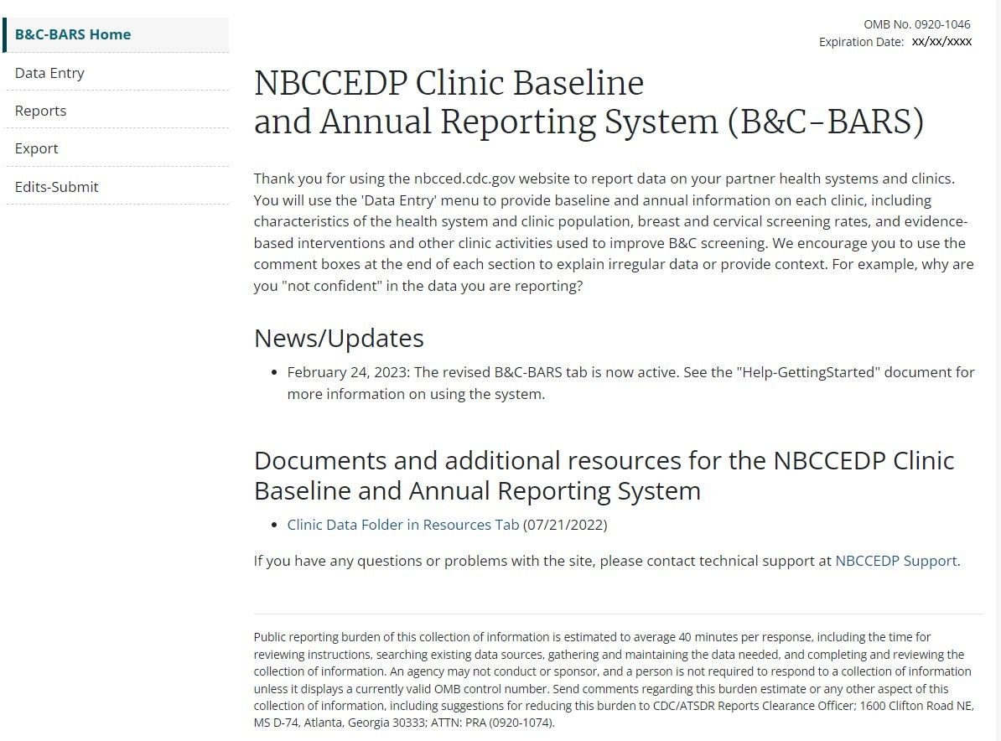

**Navigation**

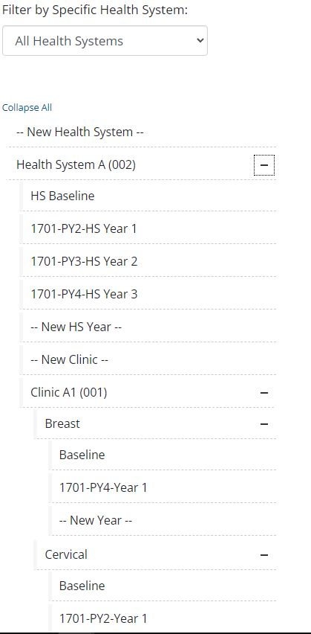

**Health System Data**

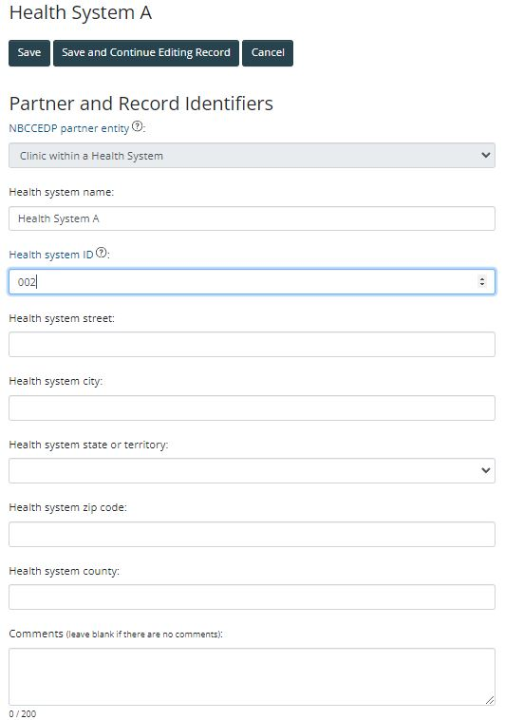

**Health System Data – Baseline**

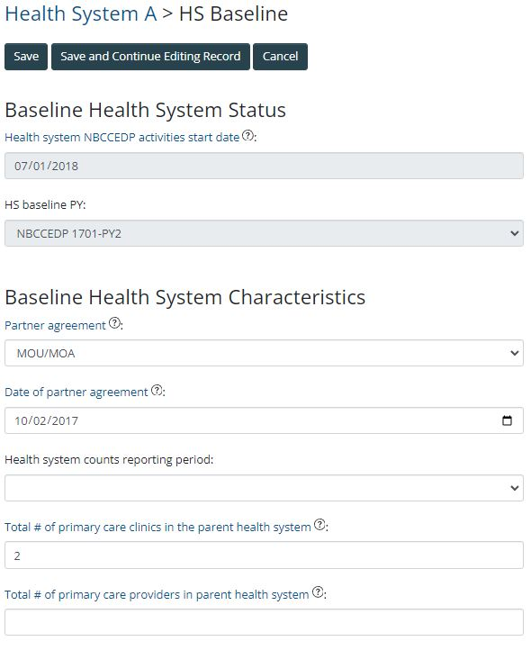

**Health System Data – Annual**

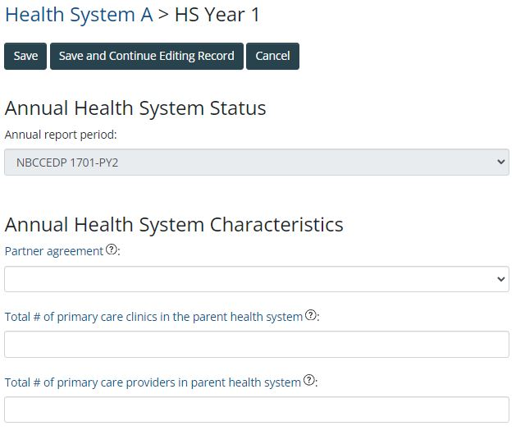

**Clinic Data - Characteristics**

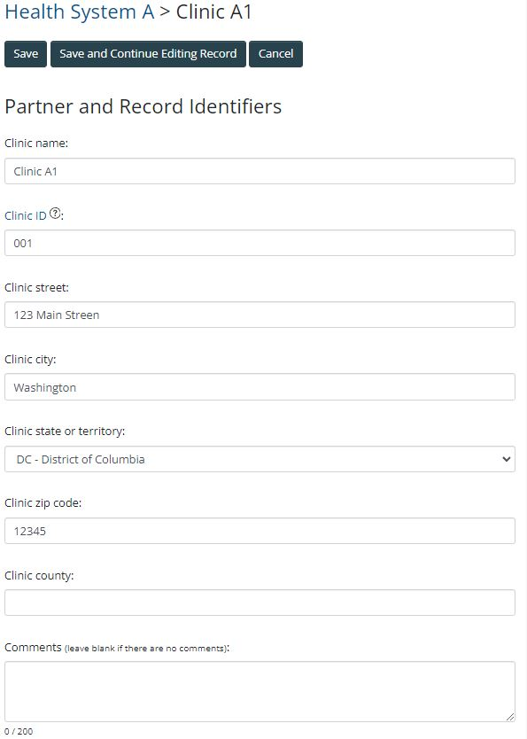

**Clinic Data – Baseline Breast**

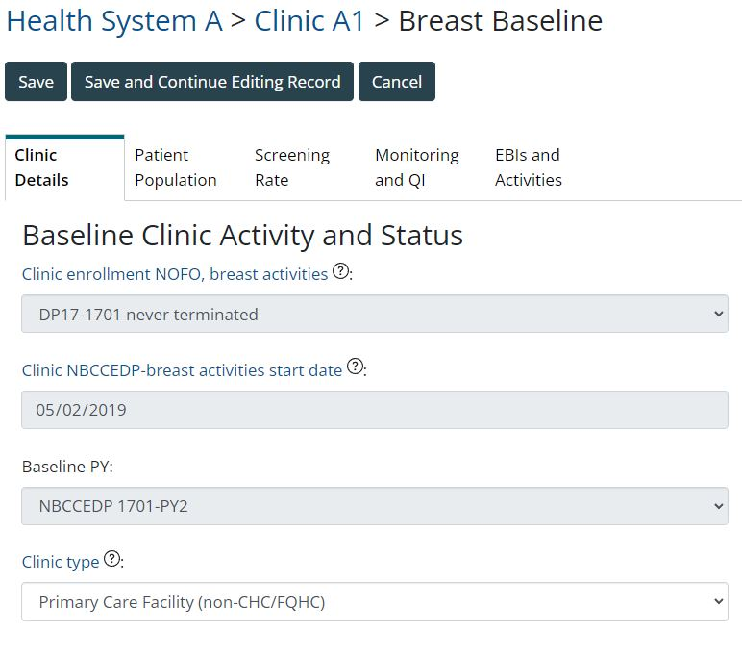

**Clinic Data – Baseline Breast (continued)**

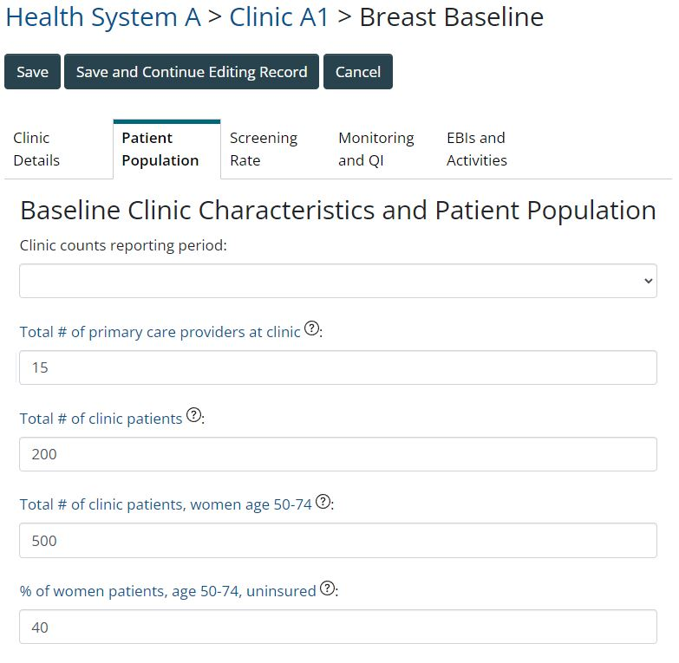

**Clinic Data – Baseline Breast (continued)**

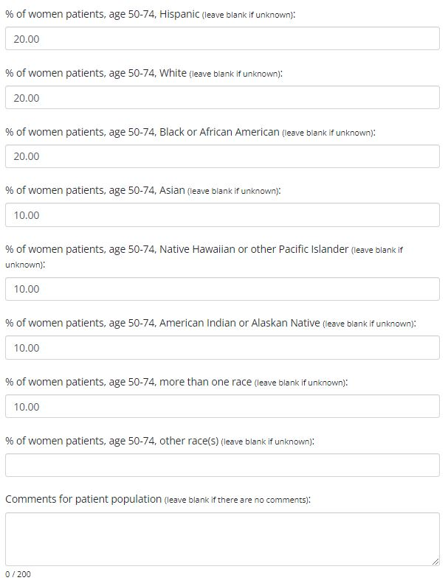

**Clinic Data – Baseline Breast (continued)**

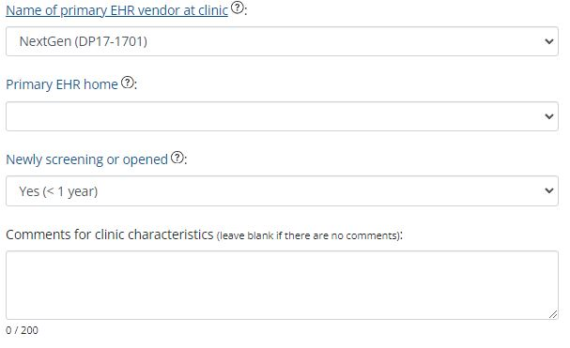

**Clinic Data – Baseline Breast (continued)**

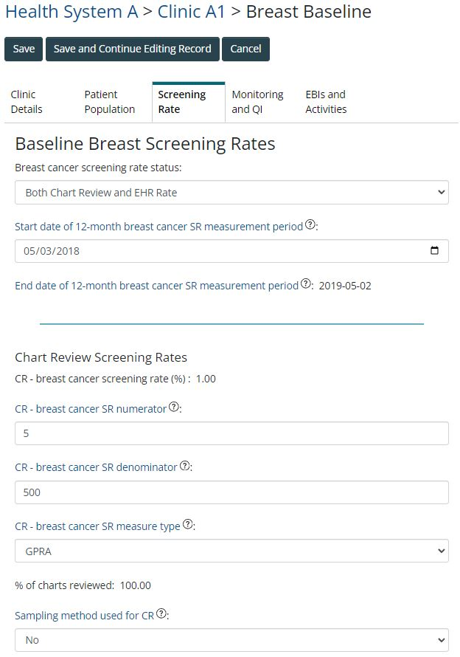

**Clinic Data – Baseline Breast (continued)**



**Clinic Data – Baseline Breast (continued)**

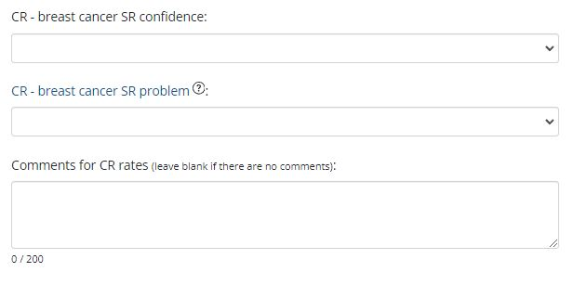

**Clinic Data – Baseline Breast (continued)**

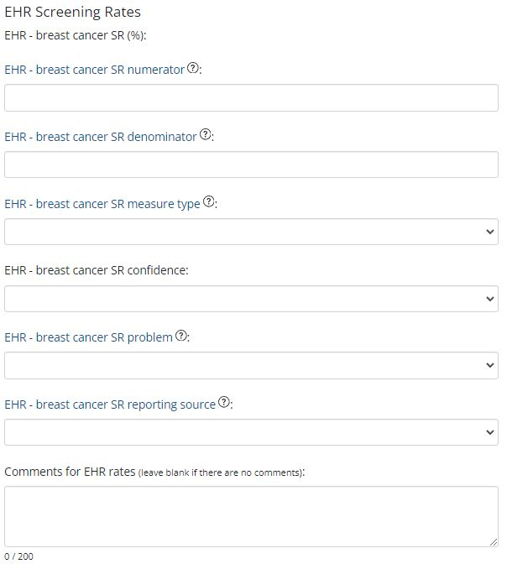

**Clinic Data – Baseline Breast (continued)**

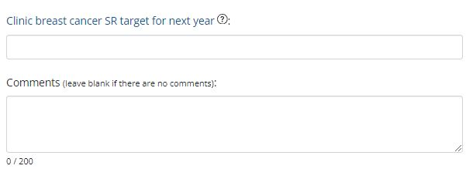

**Clinic Data – Baseline Breast (continued)**

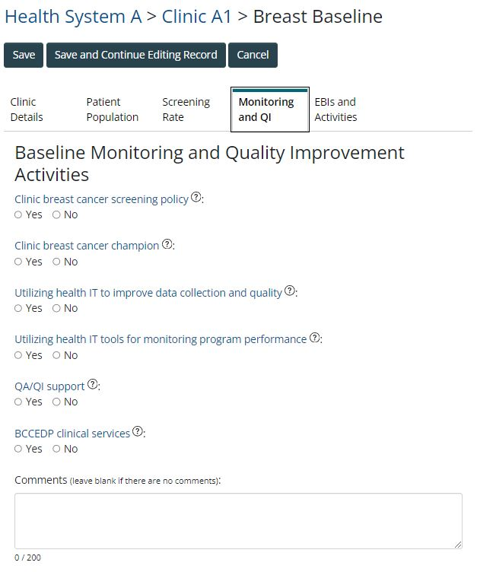

**Clinic Data – Baseline Breast (continued)**

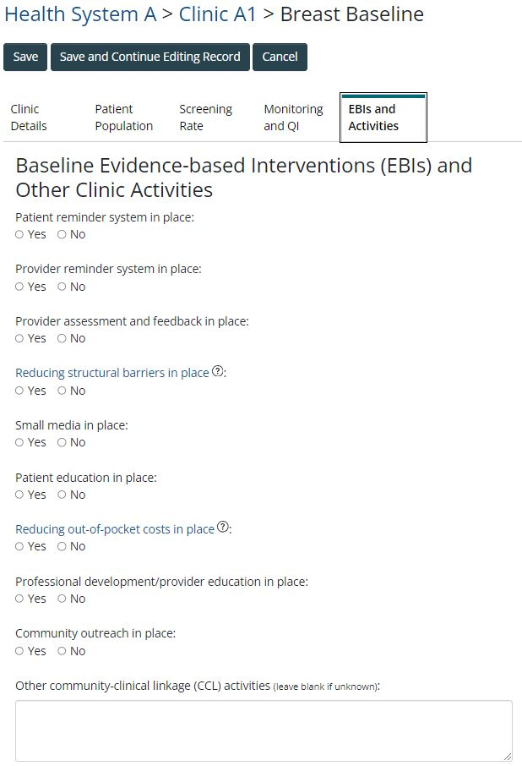

**Clinic Data – Baseline Breast (continued)**

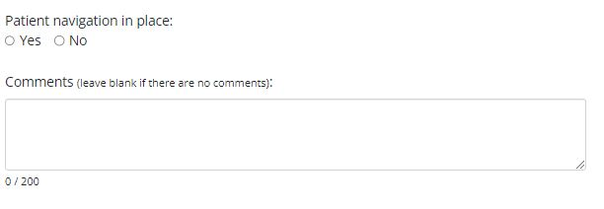

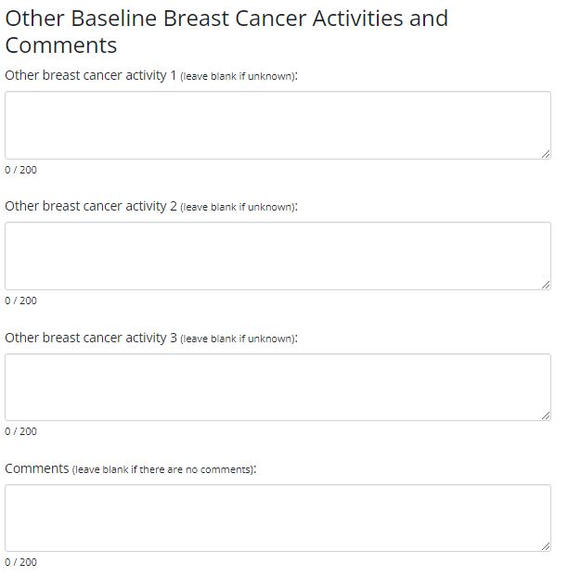

**Clinic Data – Annual Breast**

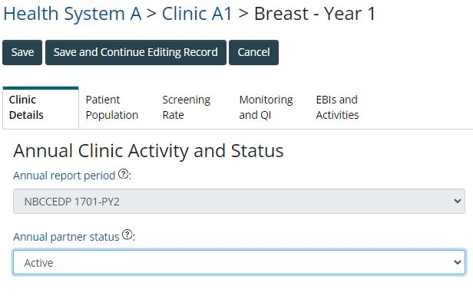

**Clinic Data – Annual Breast (continued)**

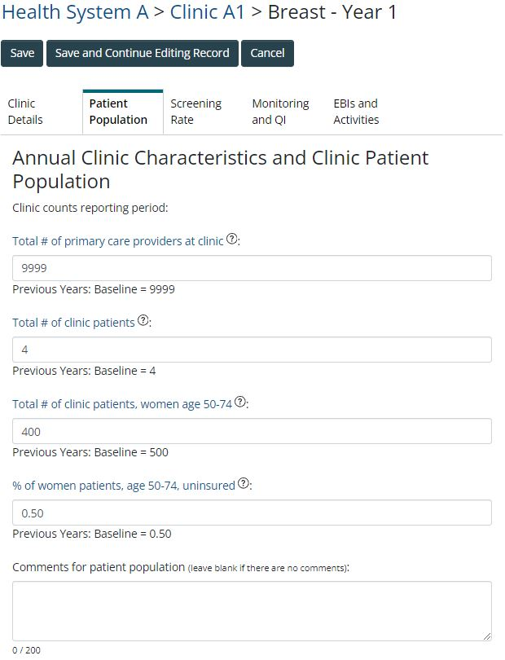

**Clinic Data – Annual Breast (continued)**

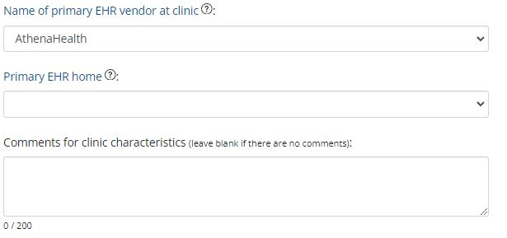

**Clinic Data – Annual Breast (continued)**

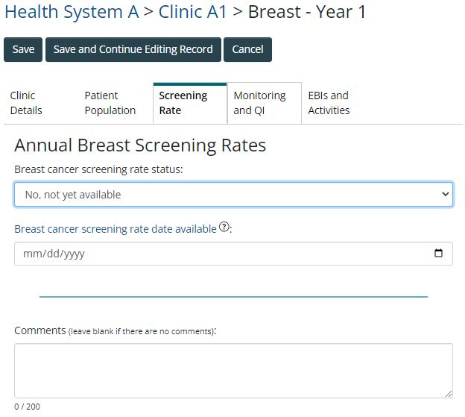

**Clinic Data – Annual Breast (continued)**

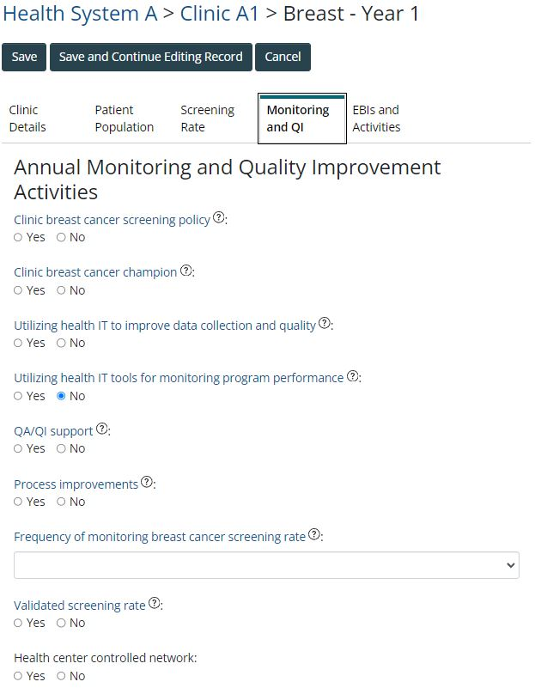

**Clinic Data – Annual Breast (continued)**

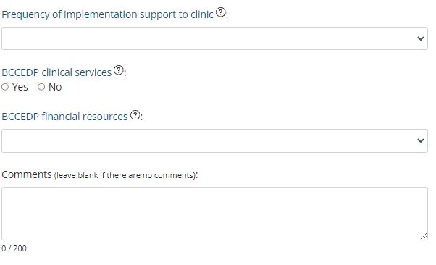

**Clinic Data – Annual Breast (continued)**

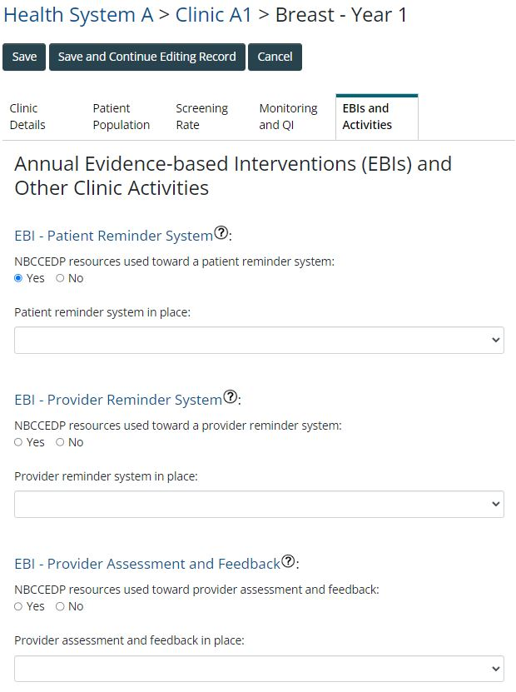

**Clinic Data – Annual Breast (continued)**

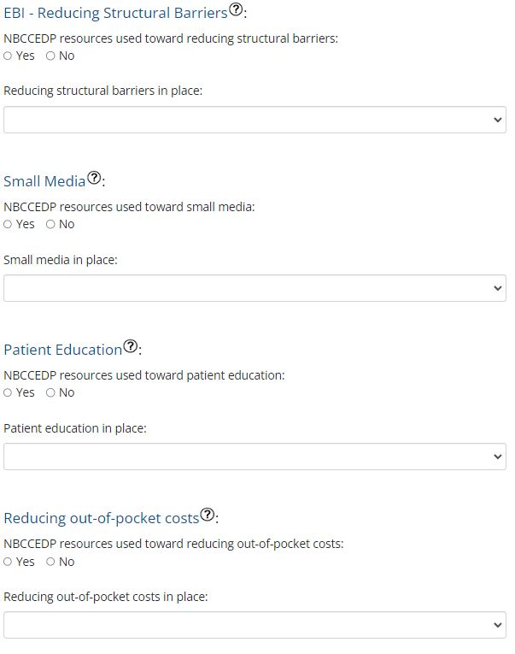

**Clinic Data – Annual Breast (continued)**

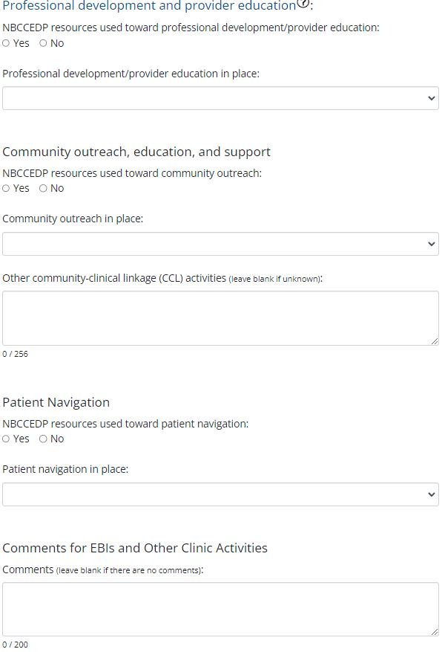

**Clinic Data – Baseline Cervical**

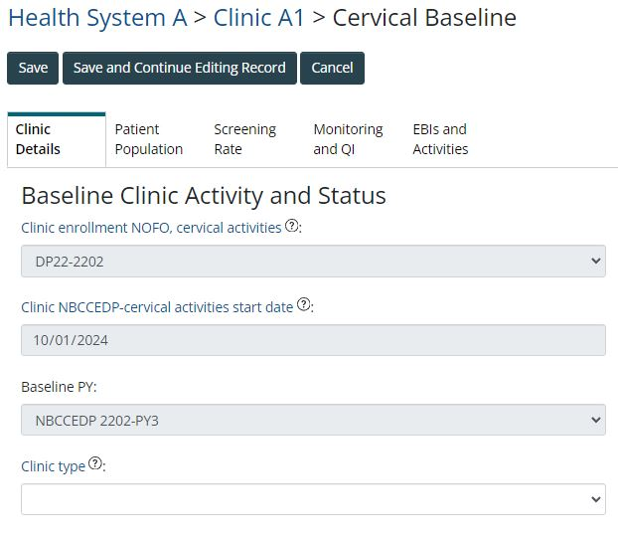

**Clinic Data – Baseline Cervical (continued)**

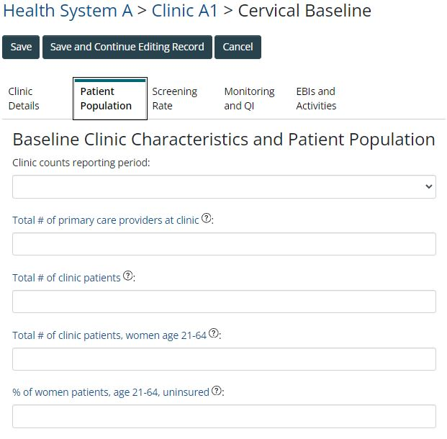

**Clinic Data – Baseline Cervical (continued)**

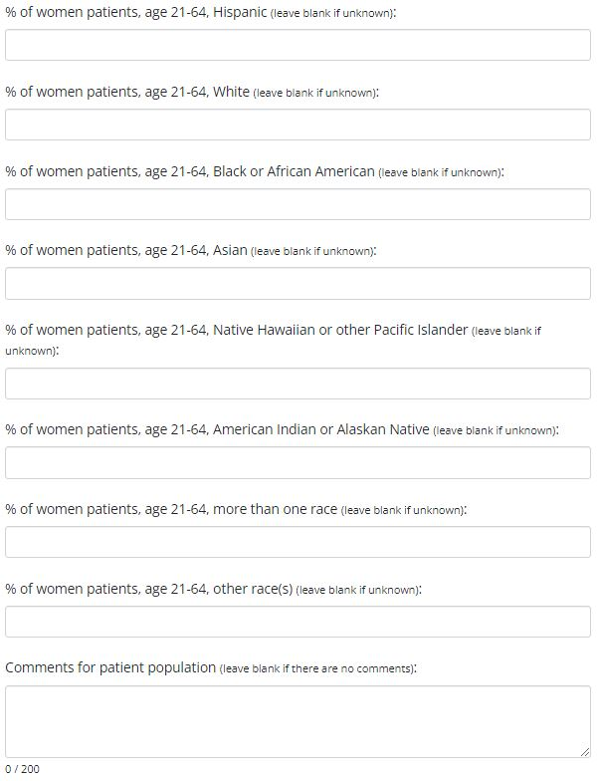

**Clinic Data – Baseline Cervical (continued)**

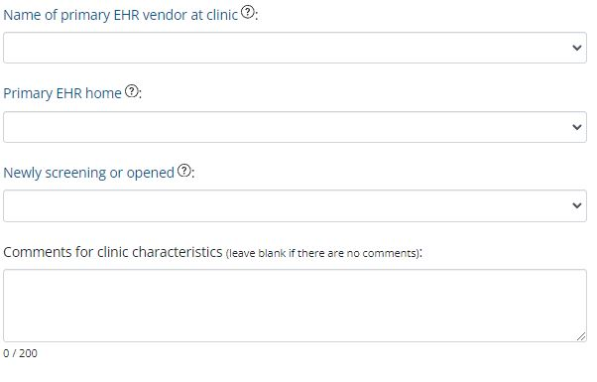

**Clinic Data – Baseline Cervical (continued)**

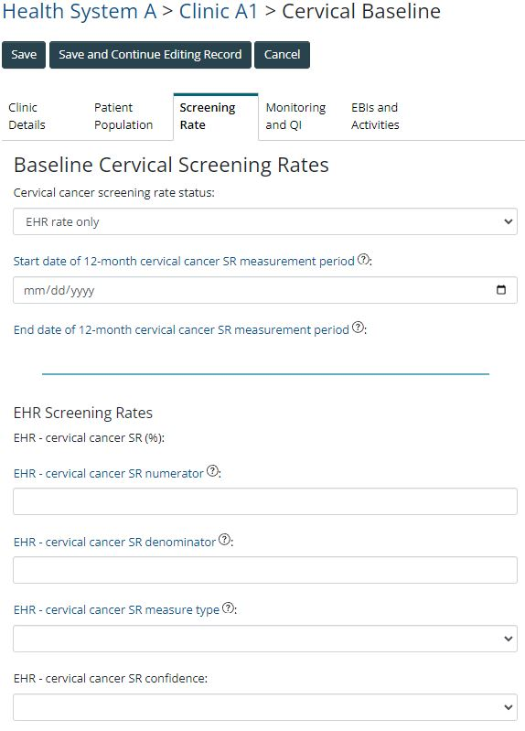

**Clinic Data – Baseline Cervical (continued)**

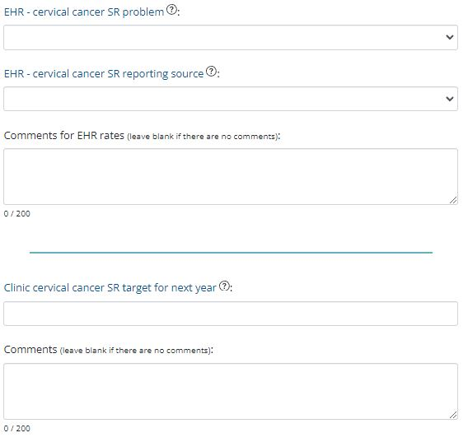

**Clinic Data – Baseline Cervical (continued)**

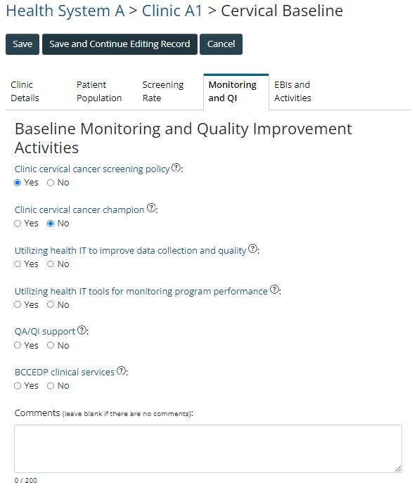

**Clinic Data – Baseline Cervical (continued)**

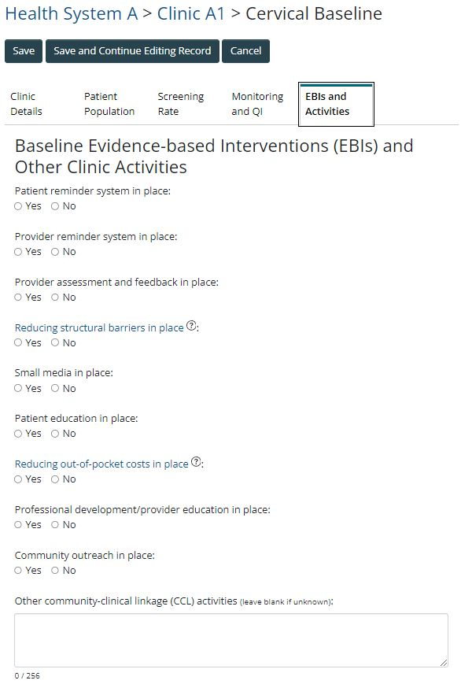

**Clinic Data – Baseline Cervical (continued)**

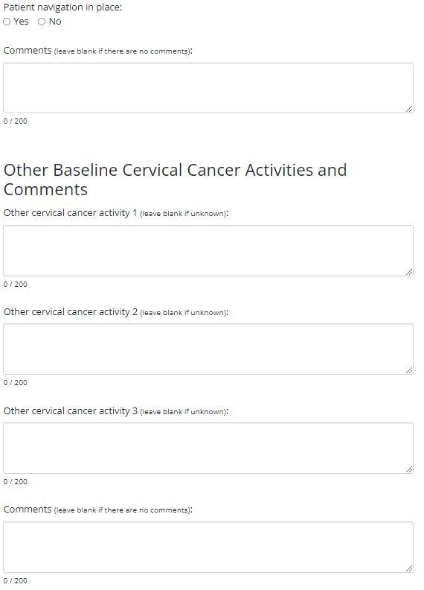

**Clinic Data – Annual Cervical**

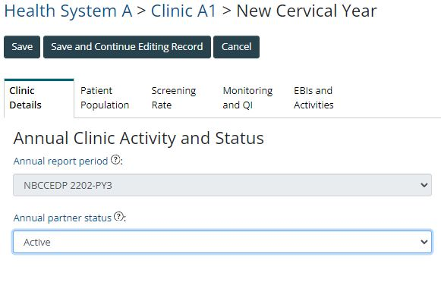

**Clinic Data – Annual Cervical (continued)**

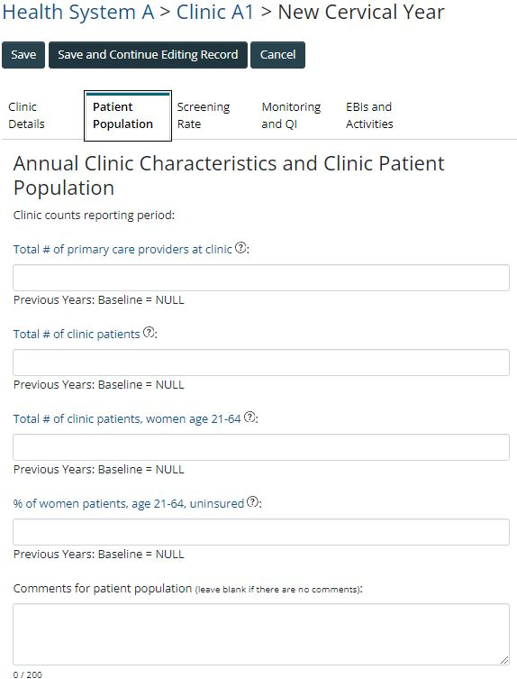

**Clinic Data – Annual Cervical (continued)**

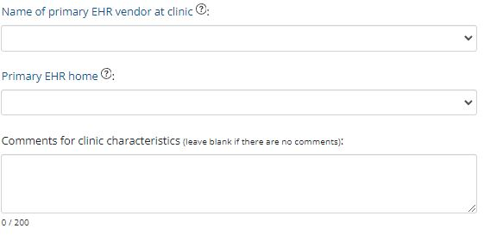

**Clinic Data – Annual Cervical (continued)**

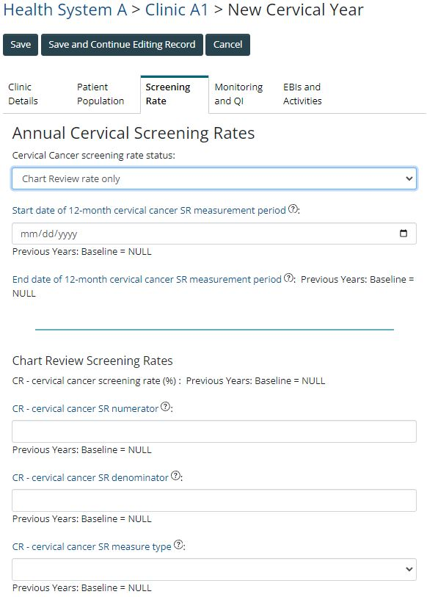

**Clinic Data – Annual Cervical (continued)**

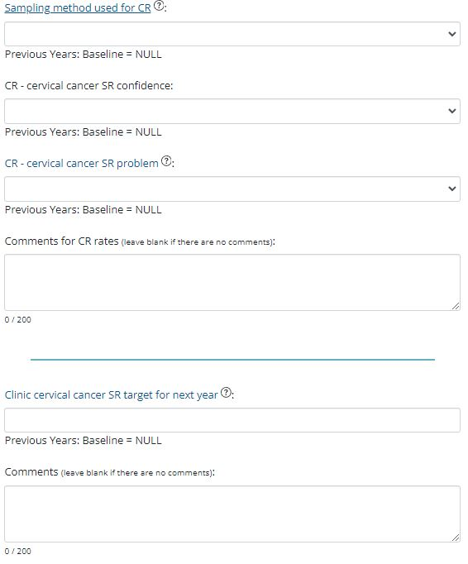

**Clinic Data – Annual Cervical (continued)**

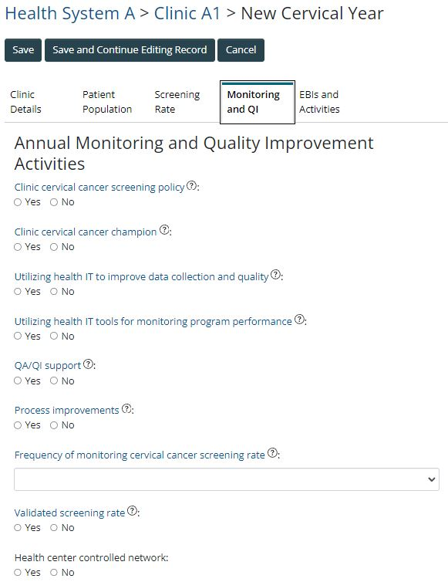

**Clinic Data – Annual Cervical (continued)**

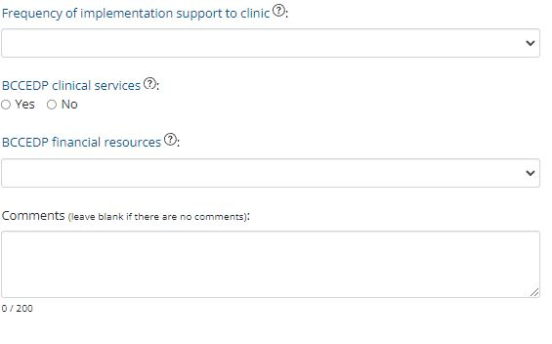

**Clinic Data – Annual Cervical (continued)**

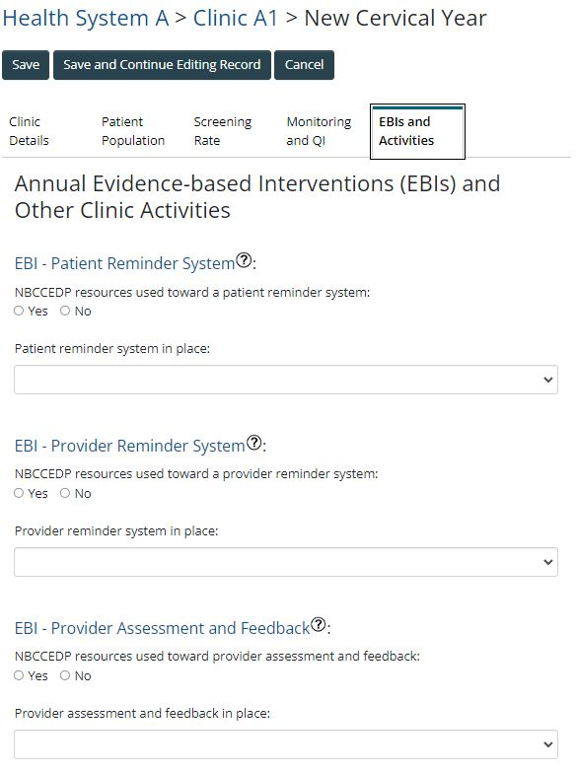

**Clinic Data – Annual Cervical (continued)**

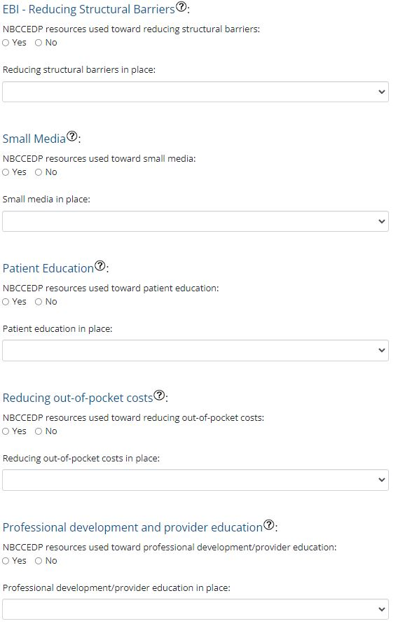

**Clinic Data – Annual Cervical (continued)**

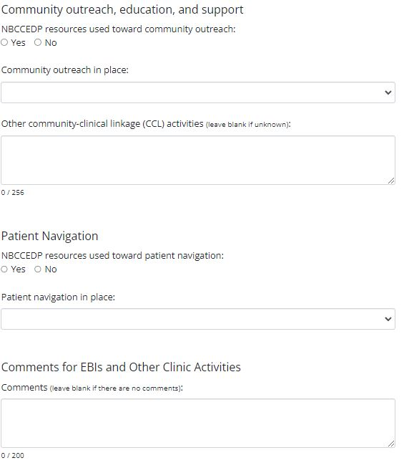

**Clinic Data – Annual Cervical (continued)**

