NBCCEDP Clinic-Level Data Instrument (Screenshots)

Welcome Screen
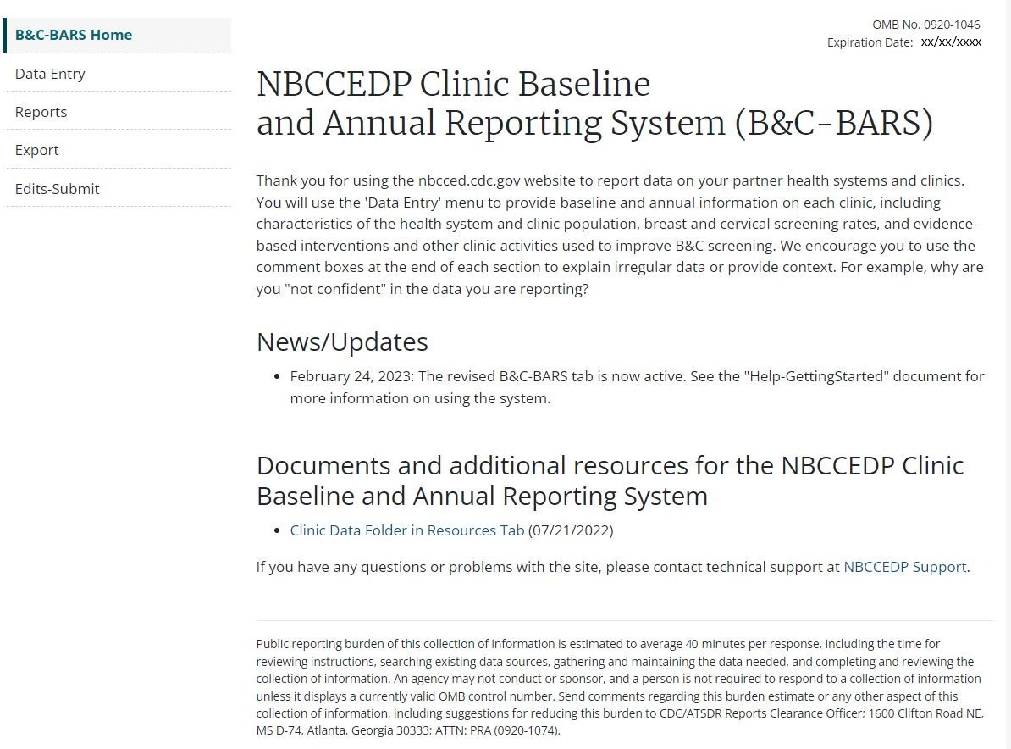
Navigation

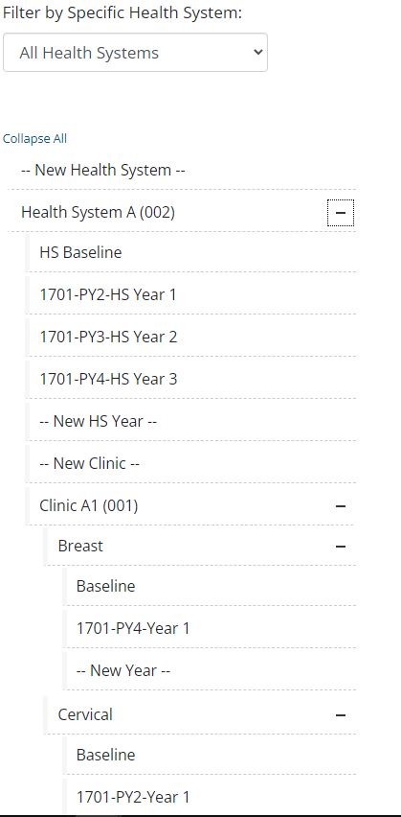
Health System Data

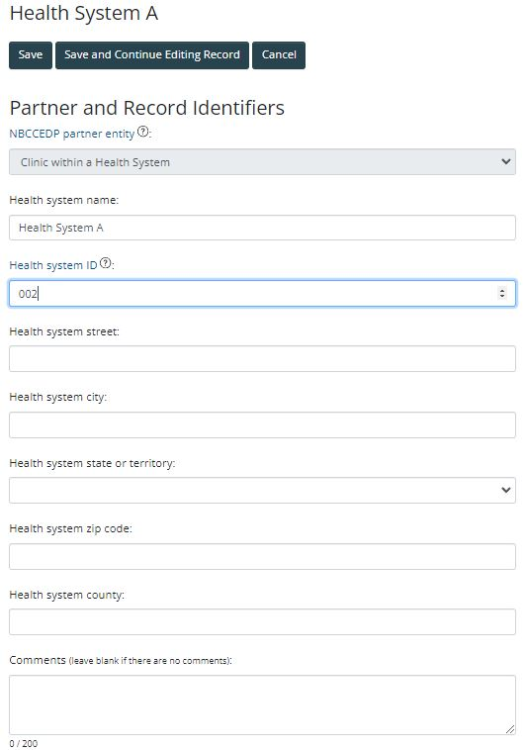

Health System Data – Baseline
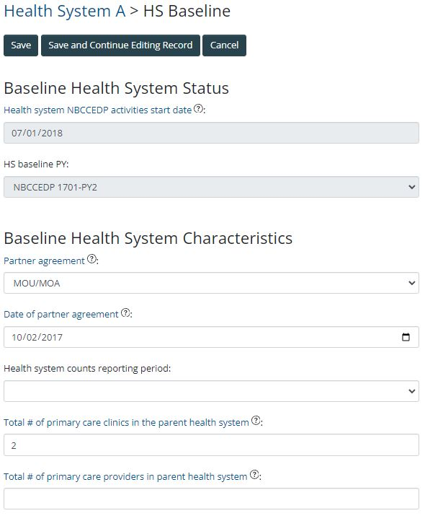

Health System Data – Annual
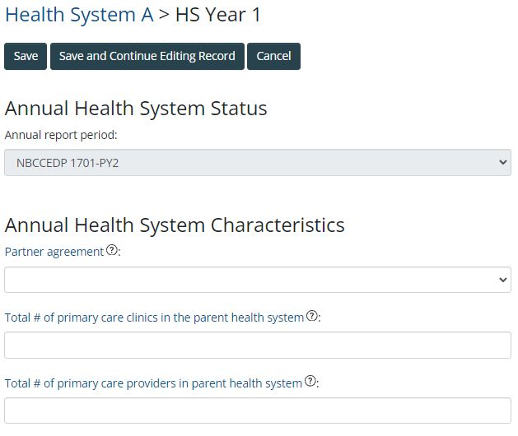

Clinic Data - Characteristics
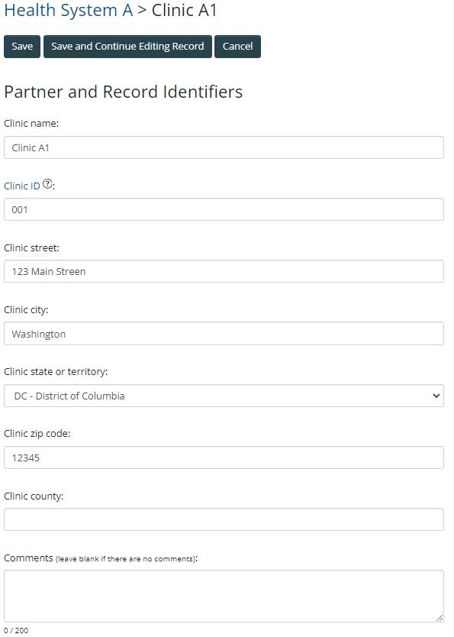

Clinic Data – Baseline Breast
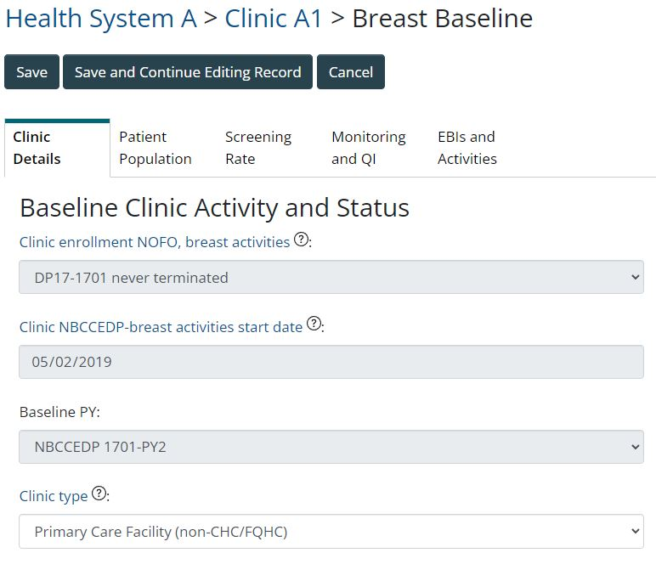
Clinic Data – Baseline Breast (continued)
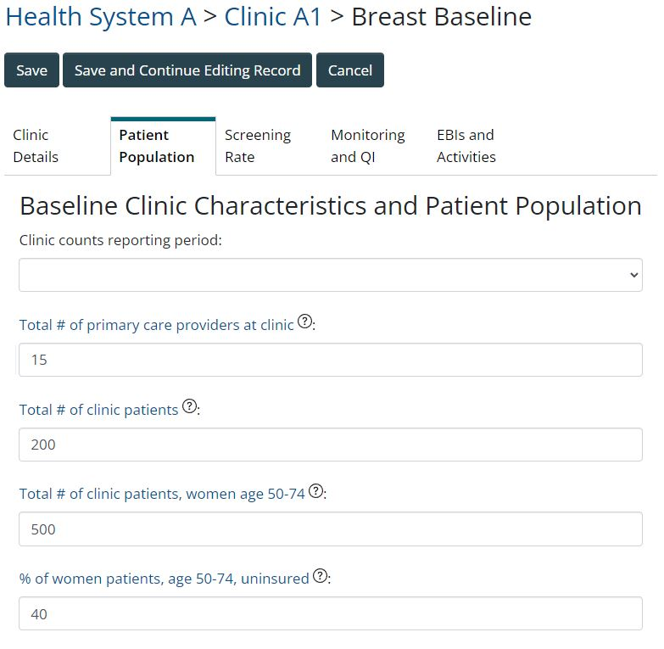
Clinic Data – Baseline Breast (continued)
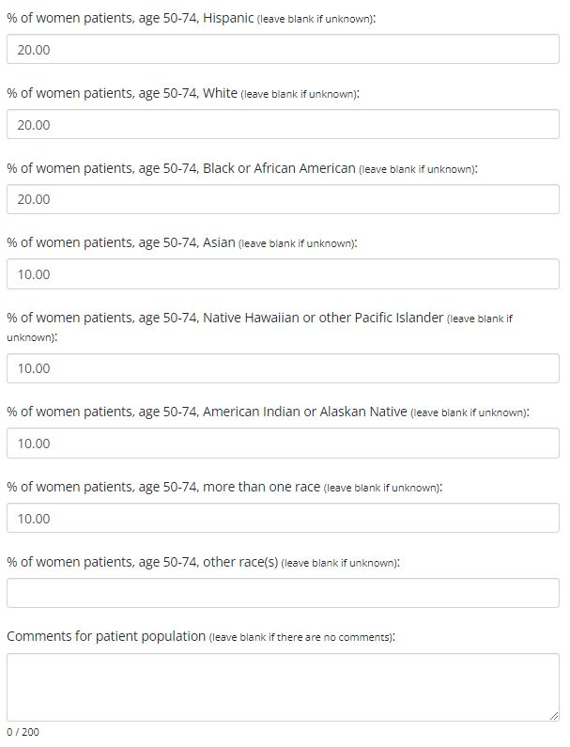

Clinic Data – Baseline Breast (continued)
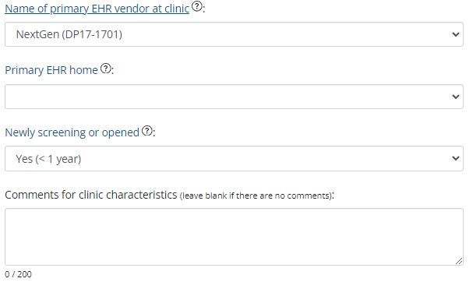

Clinic Data – Baseline Breast (continued)
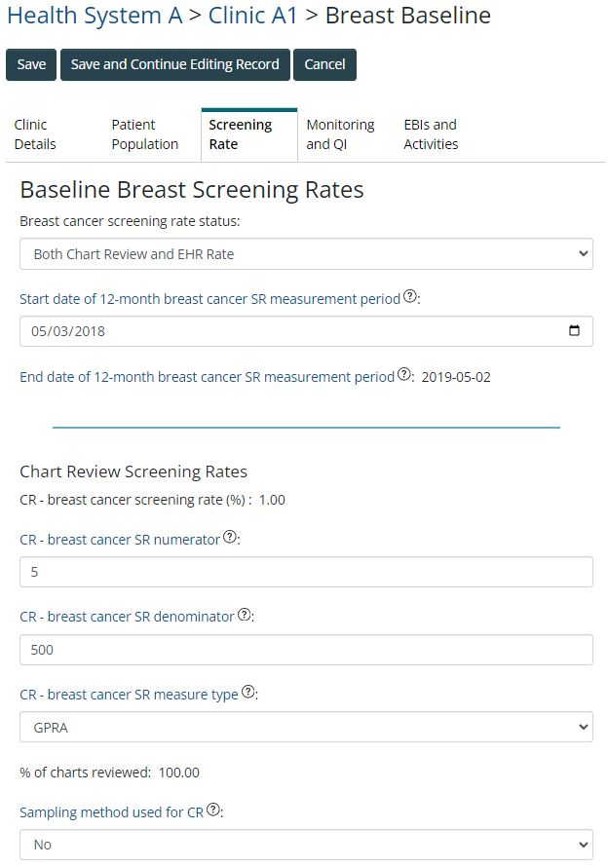
Clinic Data – Baseline Breast (continued)
Clinic Data – Baseline Breast (continued)
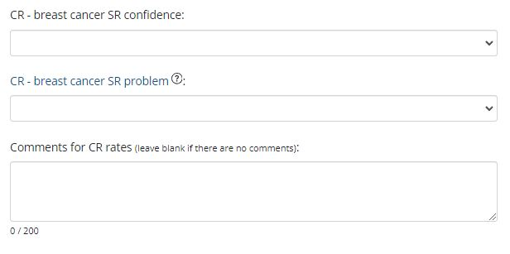

Clinic Data – Baseline Breast (continued)
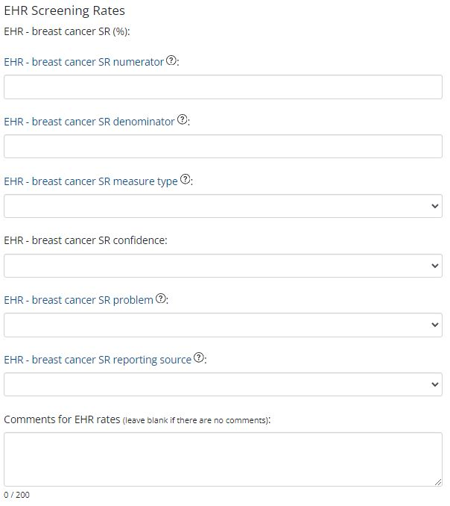

Clinic Data – Baseline Breast (continued)
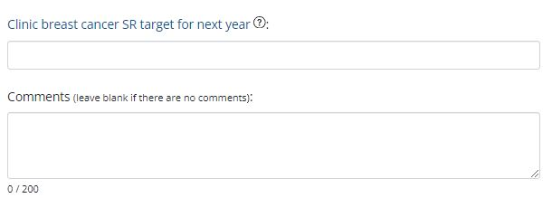

Clinic Data – Baseline Breast (continued)
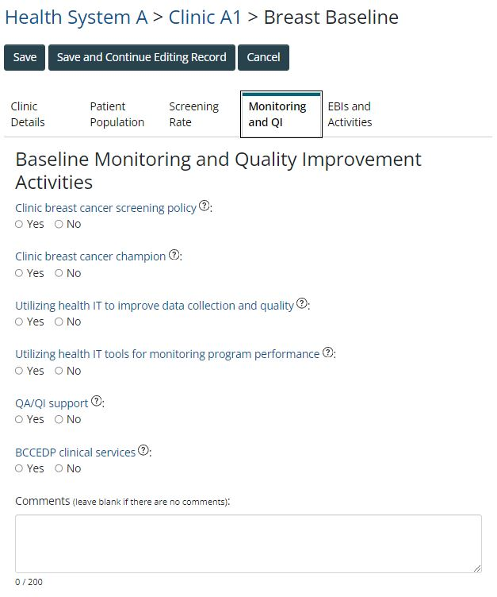

Clinic Data – Baseline Breast (continued)
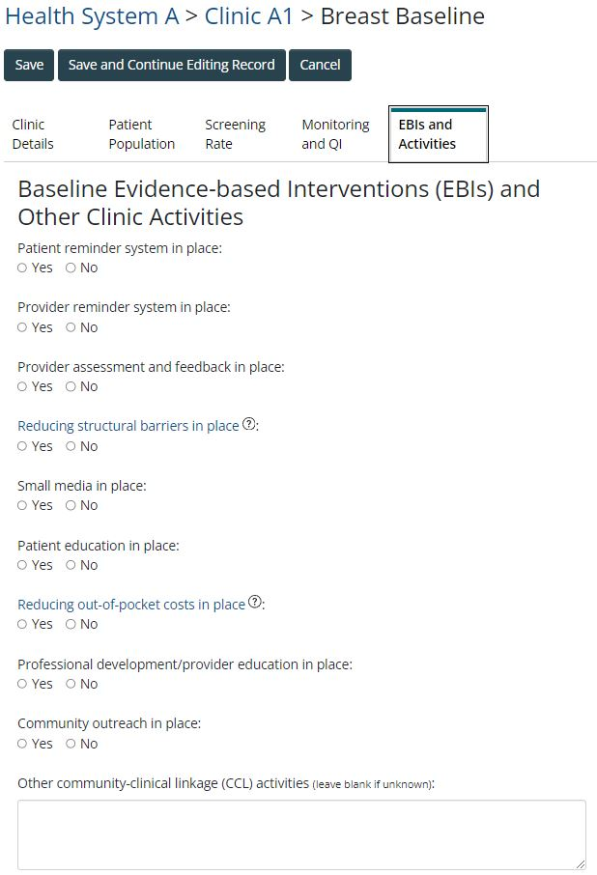
Clinic Data – Baseline Breast (continued)
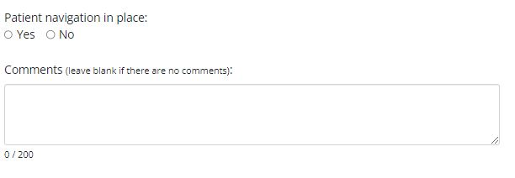
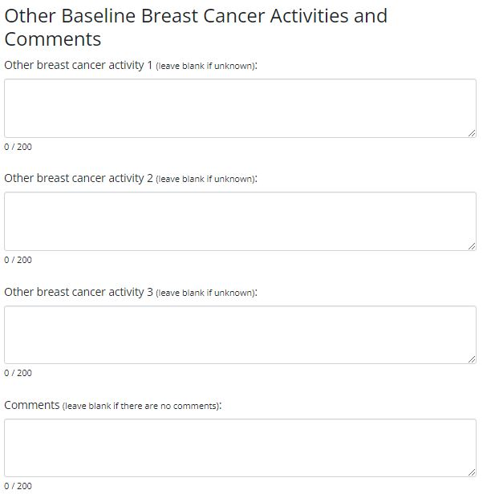

Clinic Data – Annual Breast
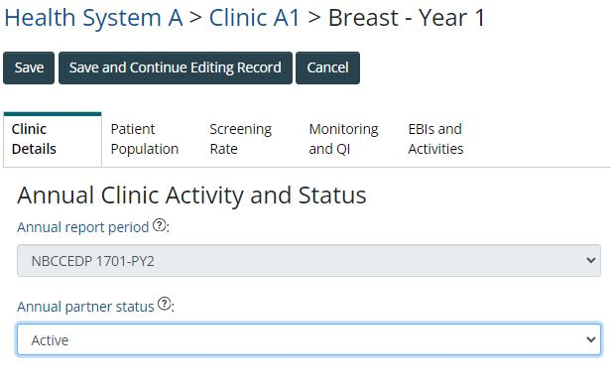

Clinic Data – Annual Breast (continued)
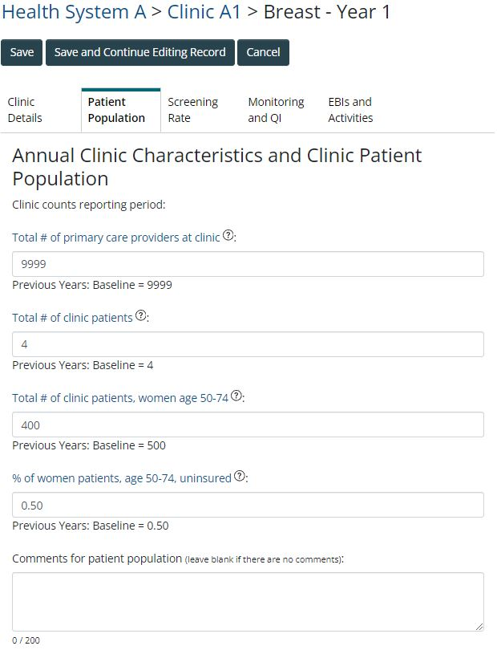

Clinic Data – Annual Breast (continued)
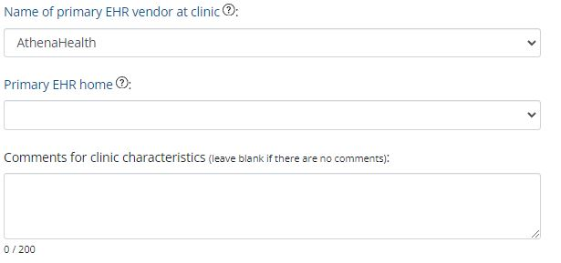

Clinic Data – Annual Breast (continued)
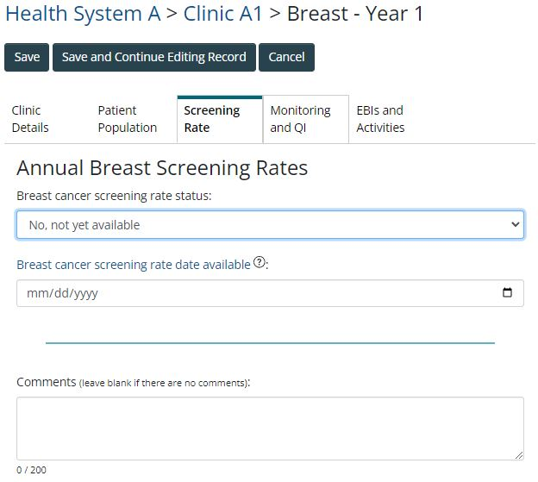

Clinic Data – Annual Breast (continued)
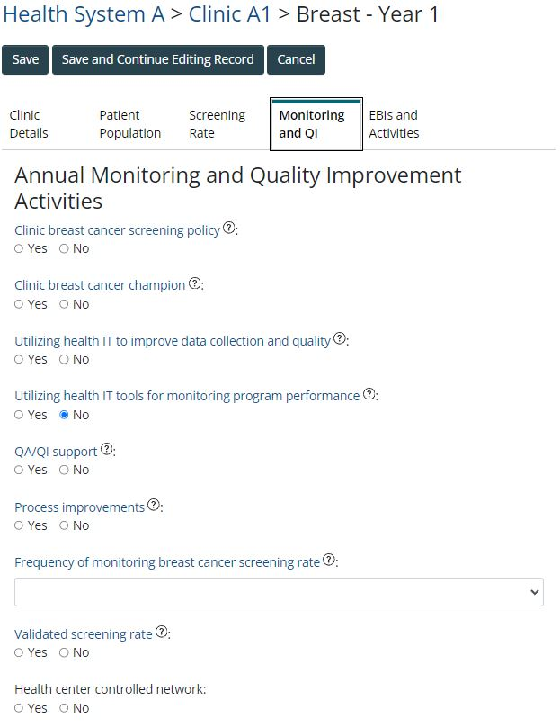

Clinic Data – Annual Breast (continued)
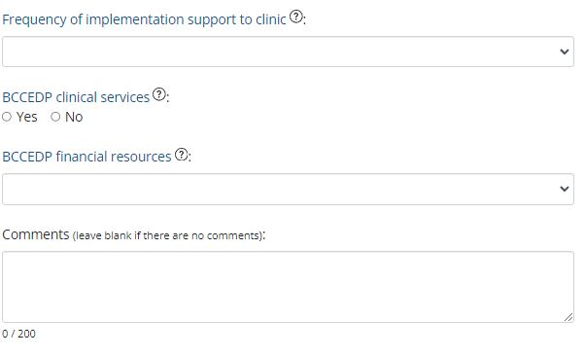

Clinic Data – Annual Breast (continued)
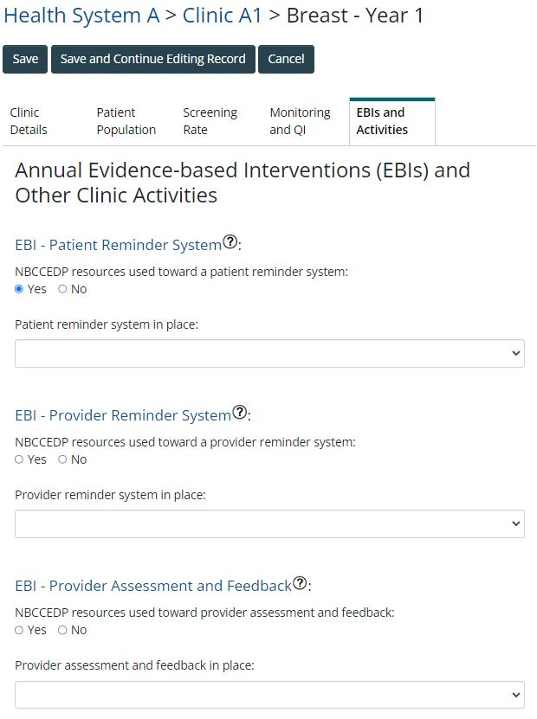

Clinic Data – Annual Breast (continued)
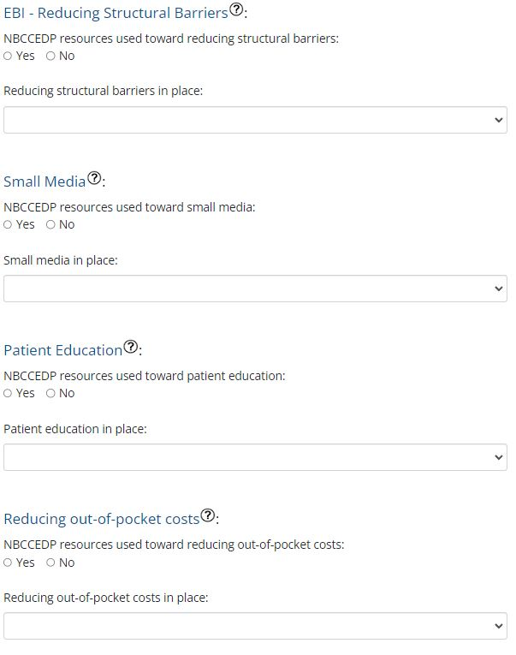

Clinic Data – Annual Breast (continued)
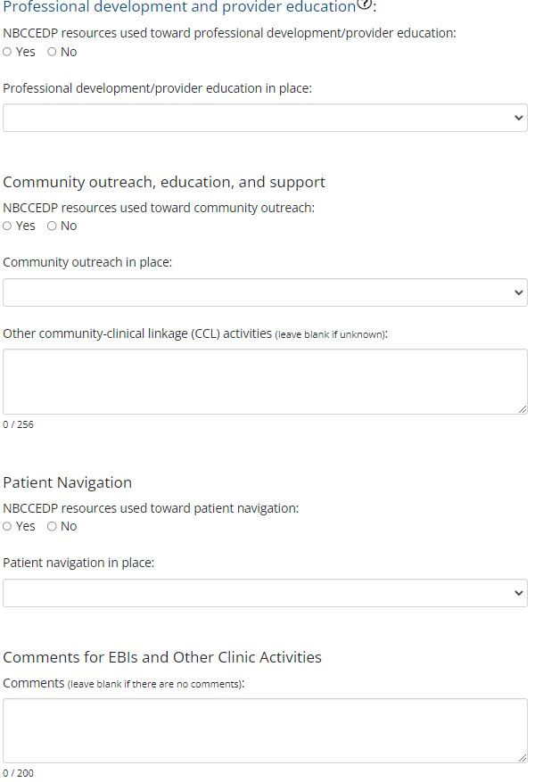

Clinic Data – Baseline Cervical
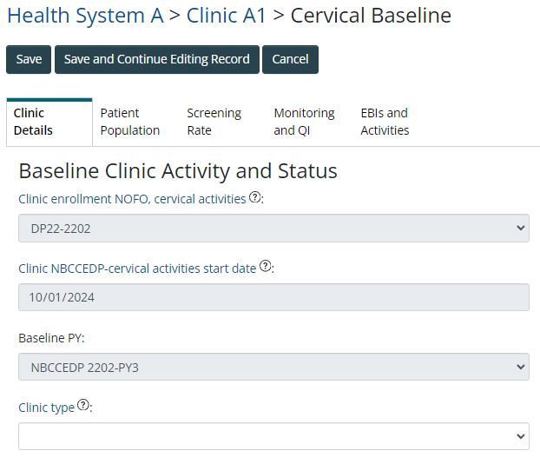

Clinic Data – Baseline Cervical (continued)
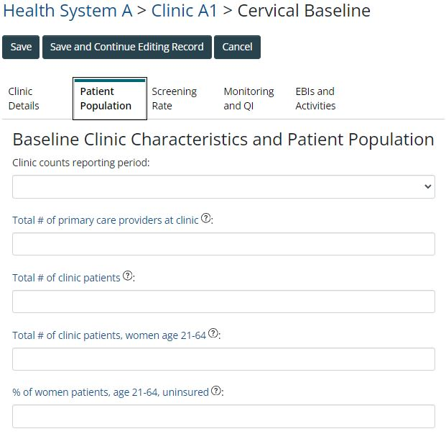

Clinic Data – Baseline Cervical (continued)
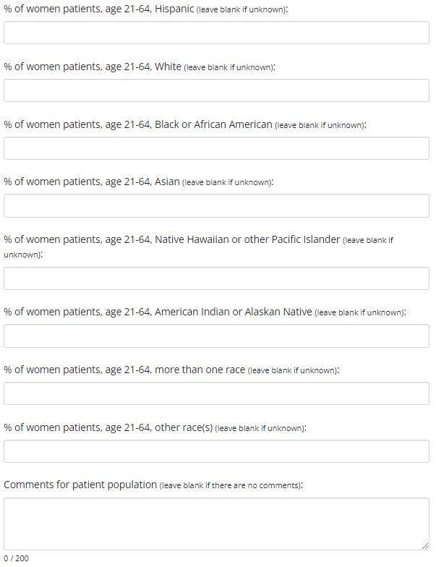

Clinic Data – Baseline Cervical (continued)
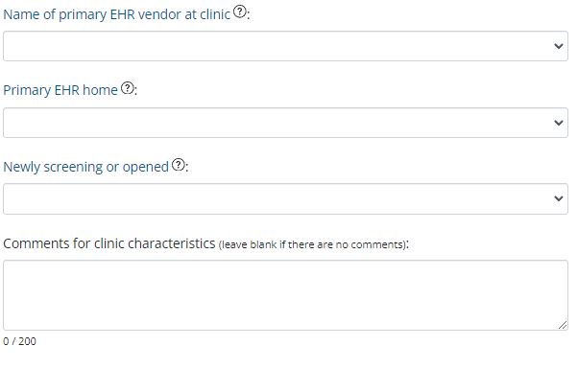

Clinic Data – Baseline Cervical (continued)
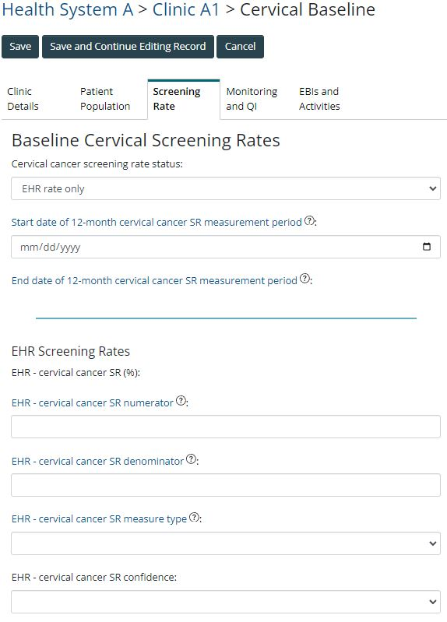

Clinic Data – Baseline Cervical (continued)
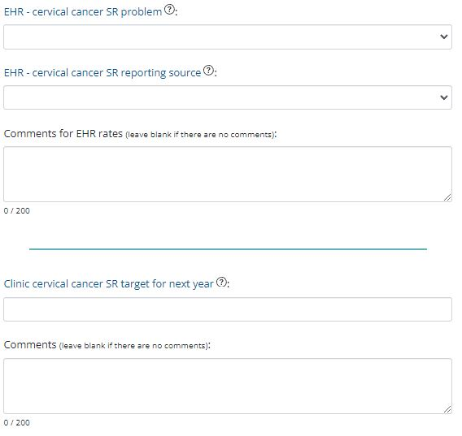

Clinic Data – Baseline Cervical (continued)
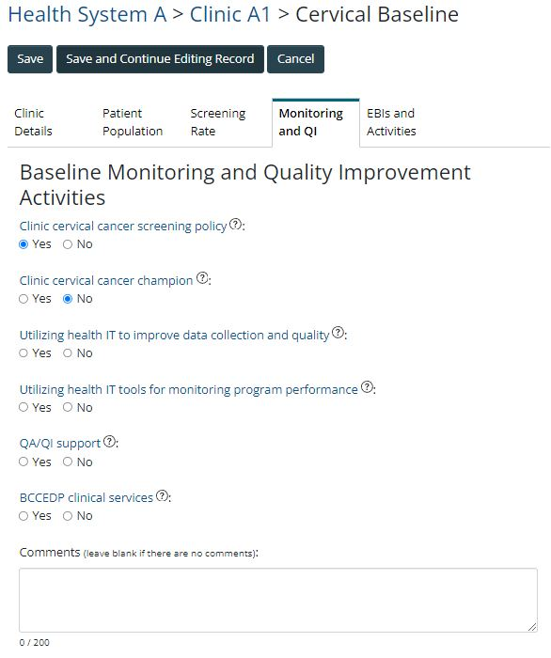

Clinic Data – Baseline Cervical (continued)
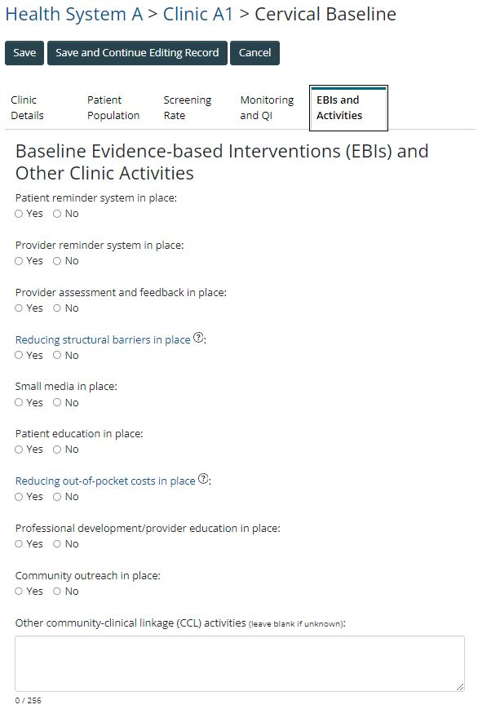

Clinic Data – Baseline Cervical (continued)
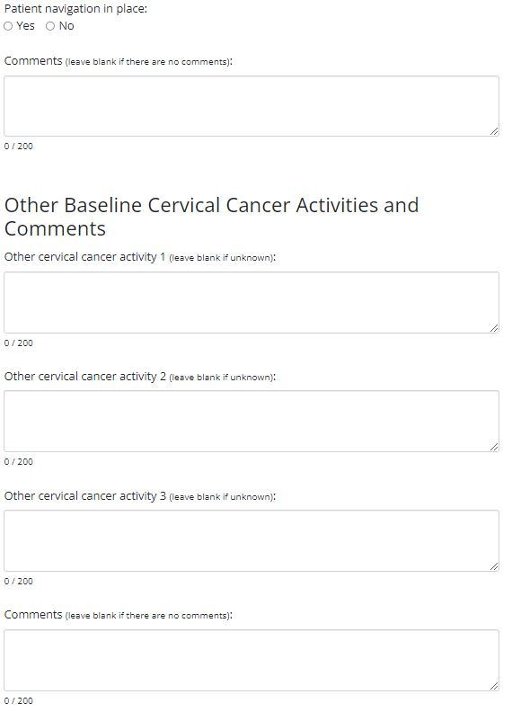

Clinic Data – Annual Cervical
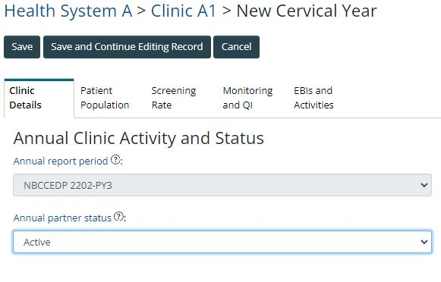

Clinic Data – Annual Cervical (continued)
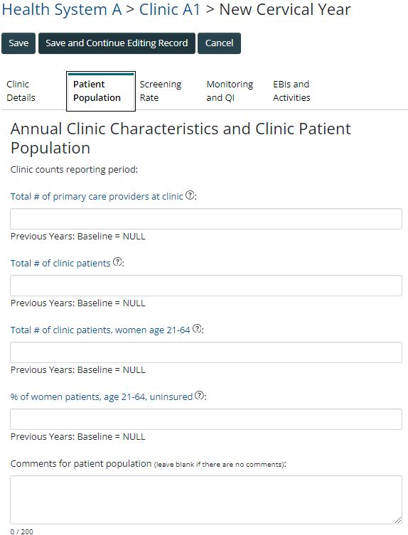

Clinic Data – Annual Cervical (continued)
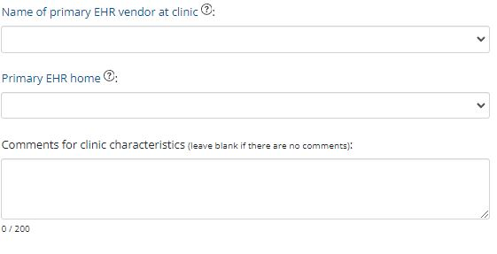

Clinic Data – Annual Cervical (continued)
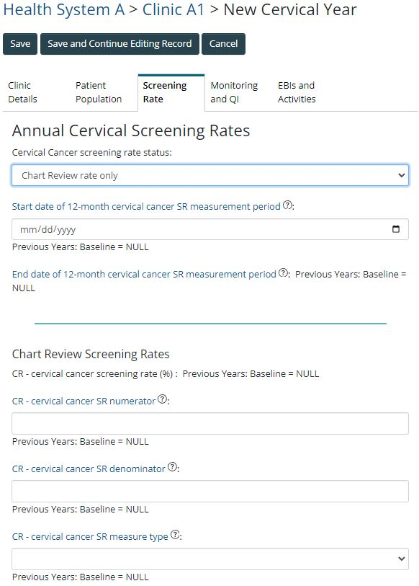

Clinic Data – Annual Cervical (continued)
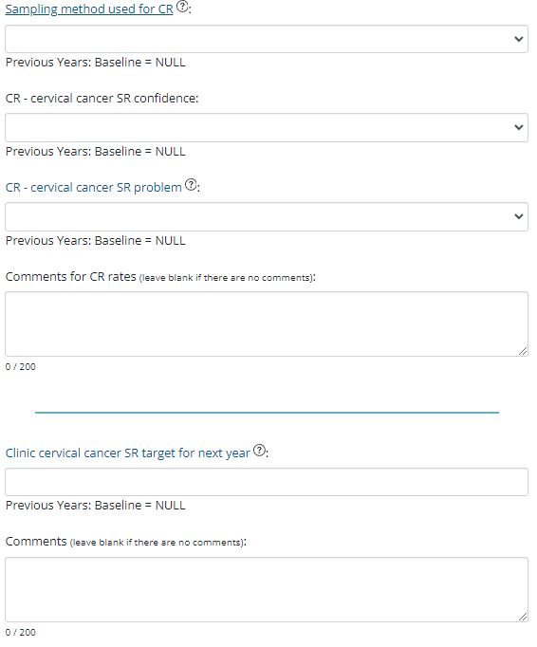

Clinic Data – Annual Cervical (continued)
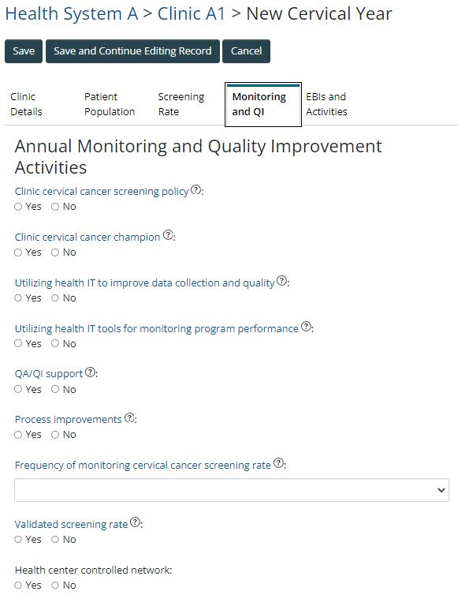

Clinic Data – Annual Cervical (continued)
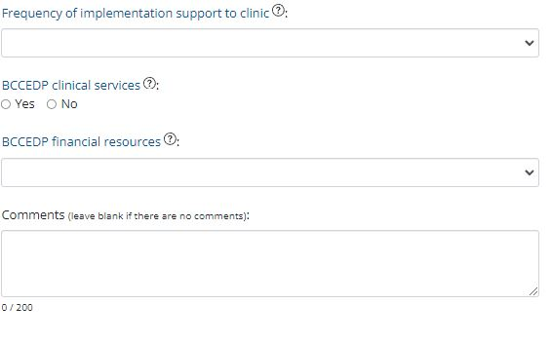

Clinic Data – Annual Cervical (continued)
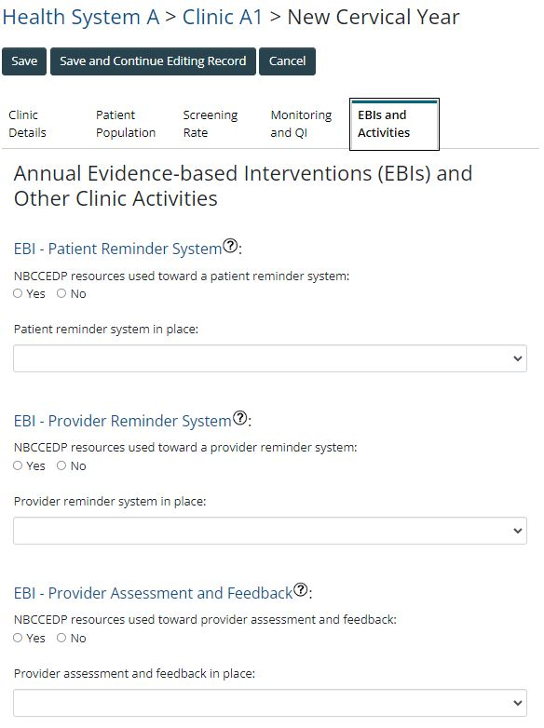

Clinic Data – Annual Cervical (continued)
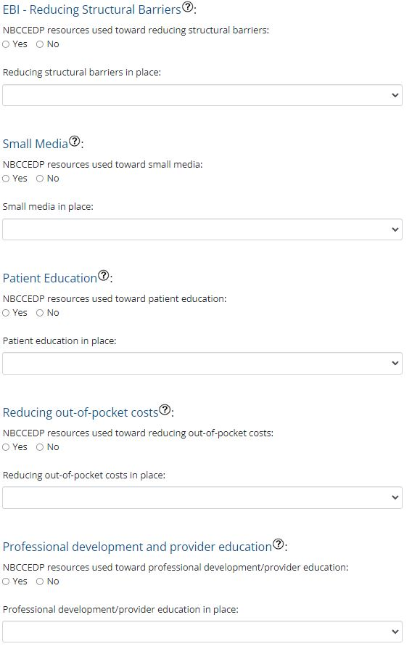
Clinic Data – Annual Cervical (continued)
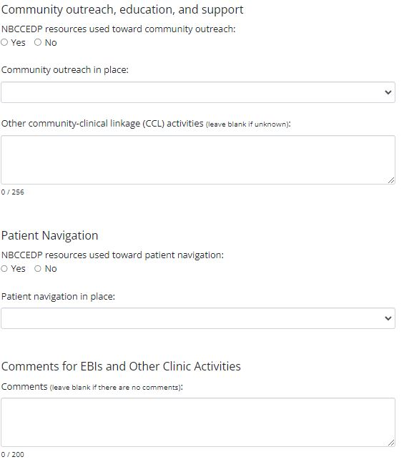

Clinic Data – Annual Cervical (continued)
