Dear <Participant Name>,

Thank you for taking part in the congenital heart defects (CHD) focus group. We value your time and feedback. Your participation has helped us to better understand how people with CHD experience both general and cardiac healthcare and what would bring people with CHD back to cardiac care. The findings from these focus groups may help us learn what people with CHD are missing from their healthcare and find ways to help people with CHD get regular care for their heart.

**IF E-GIFT**

As a token of our appreciation for your time and effort, use the link below to access your $75 virtual gift card or voucher.

<LINK>

**IF DEPOSIT**

As a token of our appreciation for your time and effort, you will receive a direct deposit of $75 via Venmo or Zelle.

If you have any questions or concerns, please contact Lindsay Gutekunst, Project Director, at lgutekunst@krcresearch.com.

Thank you again for your participation.

Sincerely,

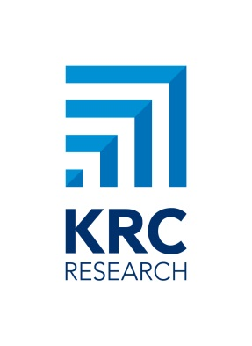**Lindsay Gutekunst**  |  Senior Vice President

(202) 585-2922 (office)

lgutekunst@krcresearch.com

733 10th Street NW Suite 500, Washington, DC 20001

*Our insight. Your breakthrough.* |  www.krcresearch.com

*Please consider the environment before printing this email.*