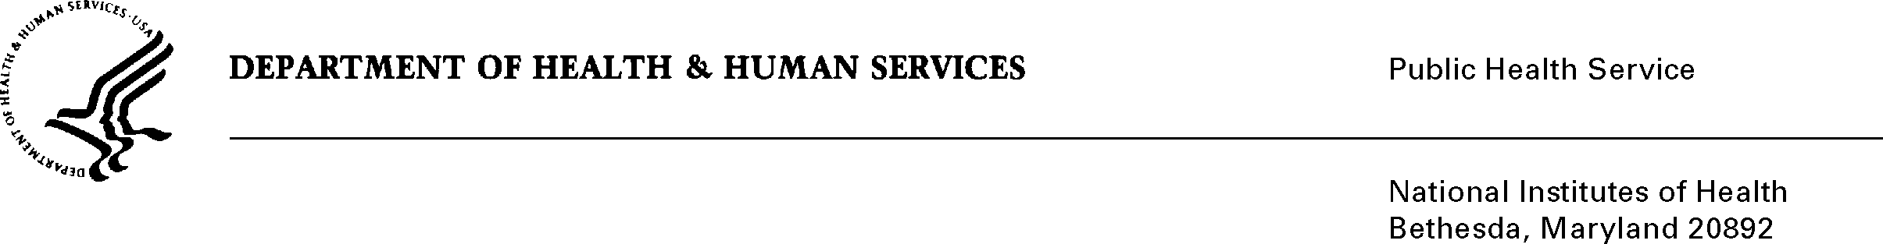

DATE: January 15, 2025

TO: NIH OMB Desk Officer

Office of Management and Budget (OMB)

Reports Clearance Officer, DHHS

FROM: Mikia P. Currie

Chief, Project Clearance Branch

SUBJECT: Nonmaterial/Non-substantive change request for:

National Institute of Drug Abuse (NIDA) Adolescent Brain Cognitive Development Study (ABCD Study®) – Audience Feedback Teams

(OMB #0925-0781, Expiration Date 11/30/27)

This is a request for OMB to approve a nonmaterial/non-substantive change to the NIDA ABCD Study Audience Feedback Teams. (OMB #0925-0781, Expiration Date 11/30/27).

As described in the revised Supporting Statement A dated September 12, 2024 and approved on 11/27/2024:

* The instruments are used to pre-test and obtain feedback on questions and instructions proposed for use in the ABCD Study.
* **The respondents only provide feedback on the test questions, they are not asked to answer the test questions.**
* The stimuli included in data collection instruments (web surveys, group discussion guides, online bulletin board guides, or at-home materials review) will be updated up to twice per year; this includes adding new stimuli when pre-testing needs are identified, updating stimuli to test revisions to the stimuli, and removing and replacing stimuli when feedback is complete.
* **These non-substantive revisions to the information collection instruments will be communicated via change memos.**

As per the above, this memo communicates changes to the stimuli in the data collection instruments in Attachments G, I, K and M for upcoming testing.

This non-substantive request does not change the information collection’s purpose, objectives, or overall burden to the public.

**Summary of Changes:**

The requested changes to the data collection instruments are as follows:

All attachments: Displaying new OMB expiration date.

Attachment G – Teen Web Survey

* Removed completed pre-test stimuli and associated questions: (23 questions total)
  + Disability test question (8 questions)
  + Return of Genetic Testing Results draft consent form (5 questions)
  + Draft study fliers (10 questions)
* Added new pre-test stimuli and associated questions: (24 questions total)
  + Employment test questions (8 questions)
  + Social support test questions (12 questions)
  + Electronic Health Record (EHR) Sharing draft consent form (4 questions)
* Removed participant demographics question for updated race/ethnicity categories
* Added participant demographics question for age
* Moved participant ID question to start of survey, updated final survey button to “Submit”

Attachment I – Teen Virtual Discussion Group Guide

* Re-ordered sections of the background/introduction script to improve timing
* Removed completed pre-test stimuli and associated questions: (23 questions total)
  + Disability test question and alternate version (4 questions)
  + Return of Genetic Testing Results draft consent form (16 questions)
  + Asking about life experiences (3 questions)
* Added new pre-test stimuli and associated questions: (22 questions total)
  + Employment and earnings test question and alternate version (3 questions)
  + Subjective social status test question and alternate version (3 questions)
  + EHR Sharing draft consent form (16 questions)
* Updated icebreaker question and final reflection question

Attachment K – Parent or Caregiver Interview Guide

* Re-ordered sections of the background/introduction script to improve timing
* Removed completed pre-test stimuli and associated questions (21 questions total)
  + Disability test question (3 questions)
  + Asking about mental health life experiences (2 questions)
  + Return of Genetic Testing Results draft consent form (16 questions)
* Added new pre-test stimuli and associated questions (14 questions total)
  + EHR Sharing draft consent form (12 questions)
  + Feedback on medical history form and experiences (2 questions)

Attachment M – Parent or Caregiver “At Home” Materials Review

* Updated instructions
* Removed completed stimuli (Draft Visual Consent Form pages, Return of Genetic Testing Results draft consent form pages)
* Added new test stimuli (EHR Sharing draft consent form pages, medical history form pages)

Revised attachment files show the proposed changes. New sections are highlighted in yellow and deletions or moved sections are noted in comments. Clean attachment files show the updated forms with no highlights/comments.

Your full consideration is appreciated.