**SEP Screenshots**

HIHI Screen

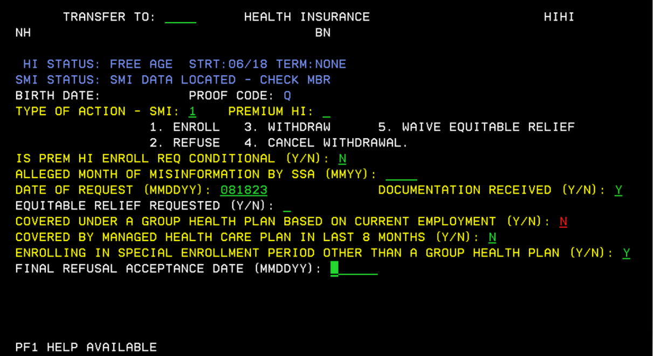

Landing Page with no prior SEP occurrences

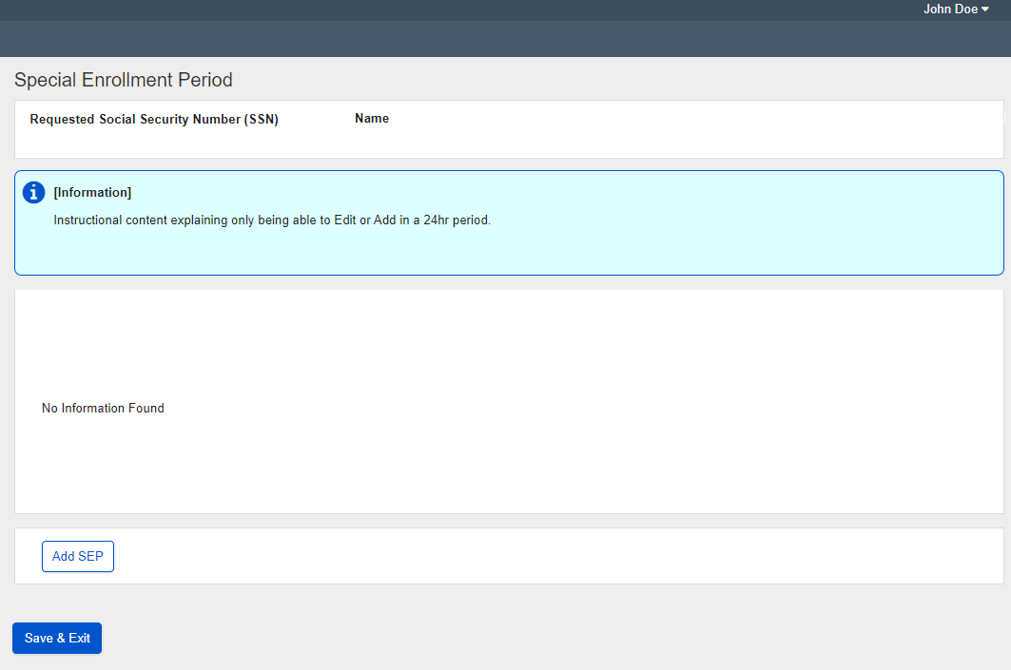

Landing Page with 1 prior SEP occurrence

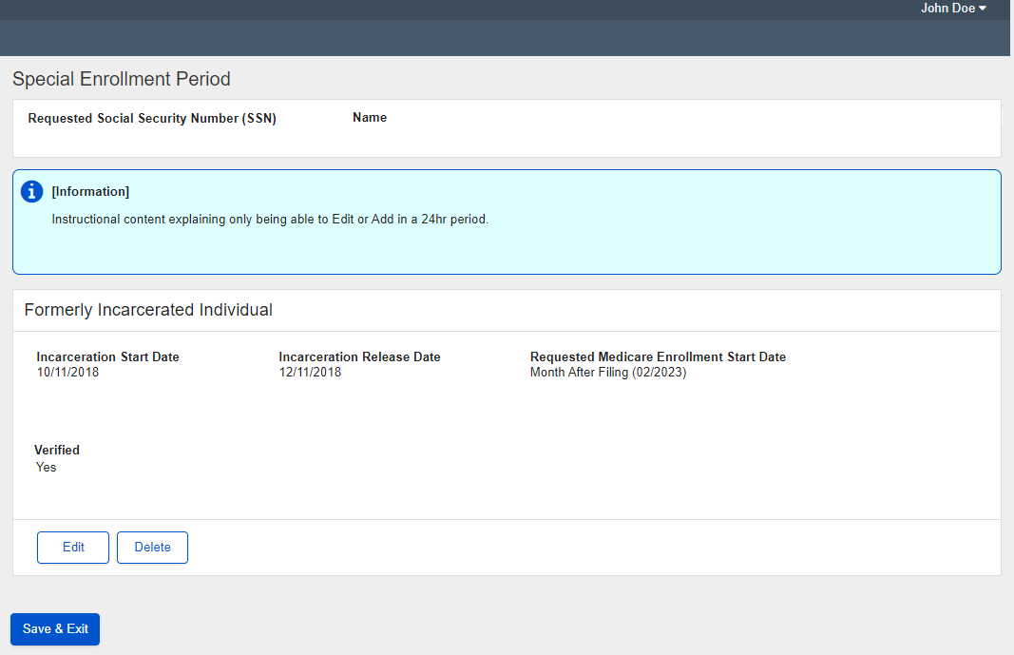

Landing page with 2 prior SEP occurrence

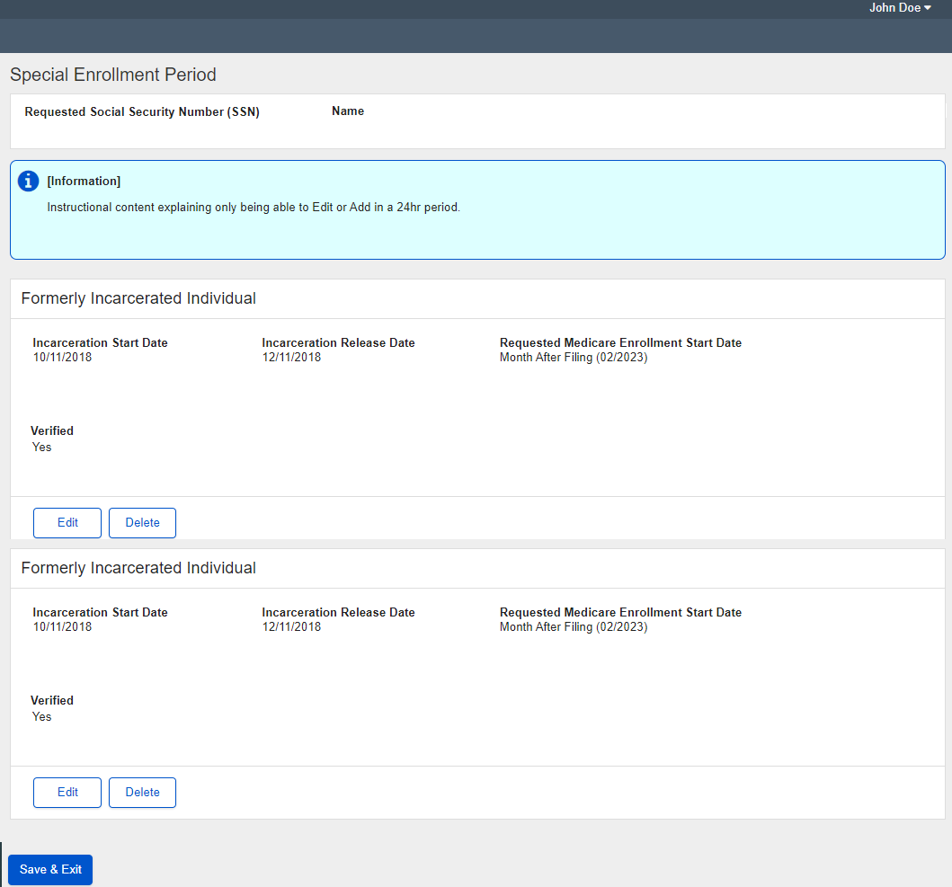

Add SEP Page prior to SEP selection

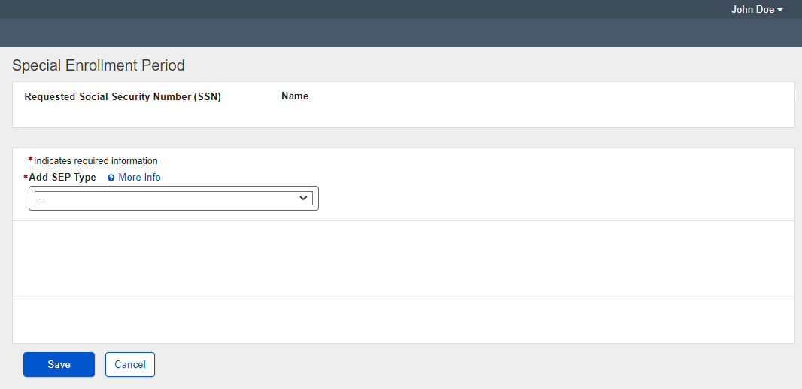

Add SEP with International Volunteer Selected

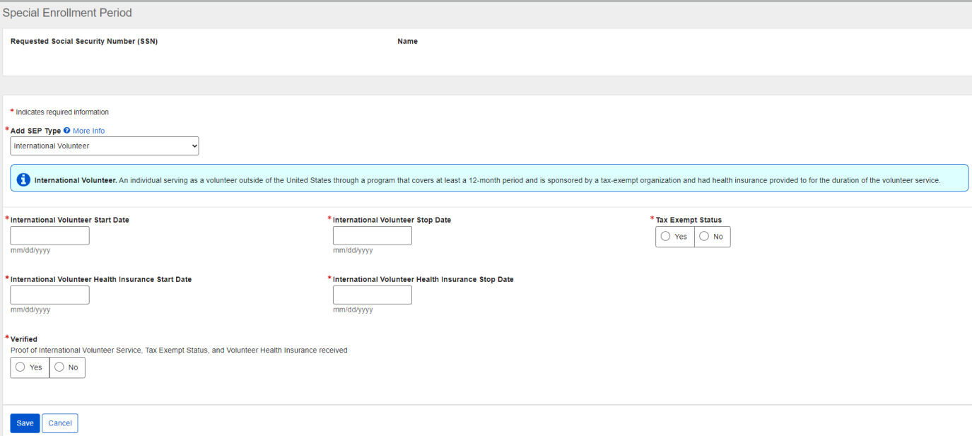

Add SEP Page with Other (United States Postal Service) Selected

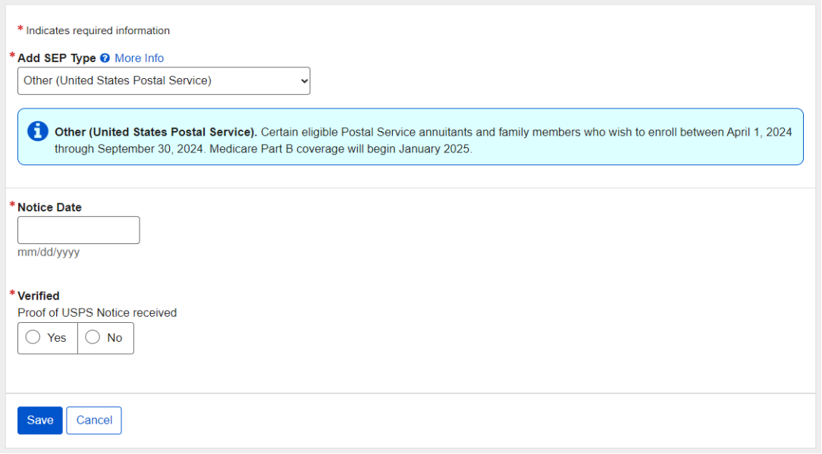

Edit SEP Page when an existing SEP is edited

