**Welcome screen with PRA**

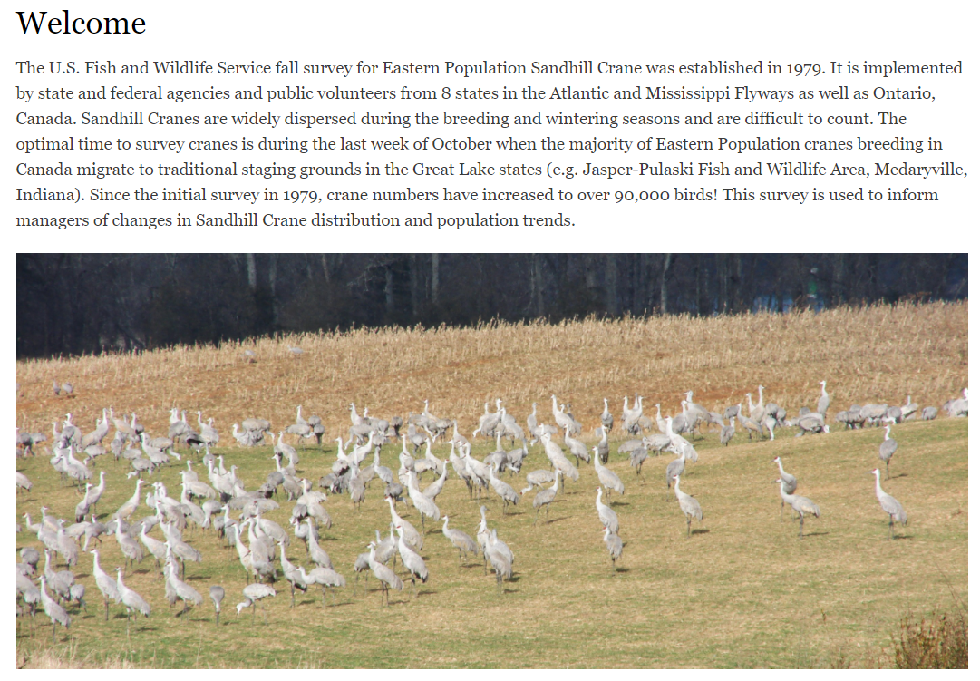

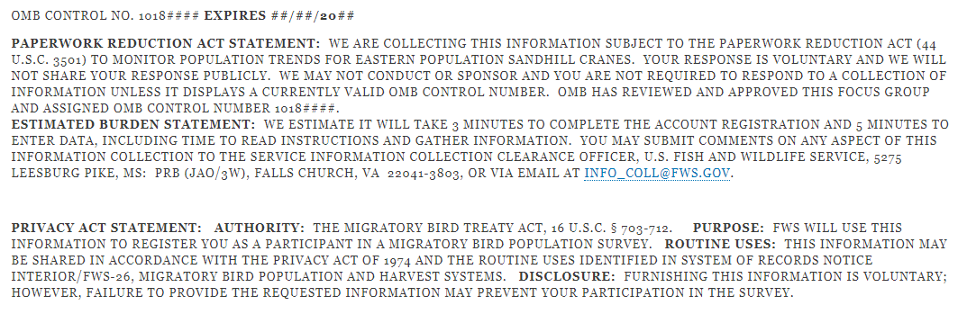

**Online registration page**

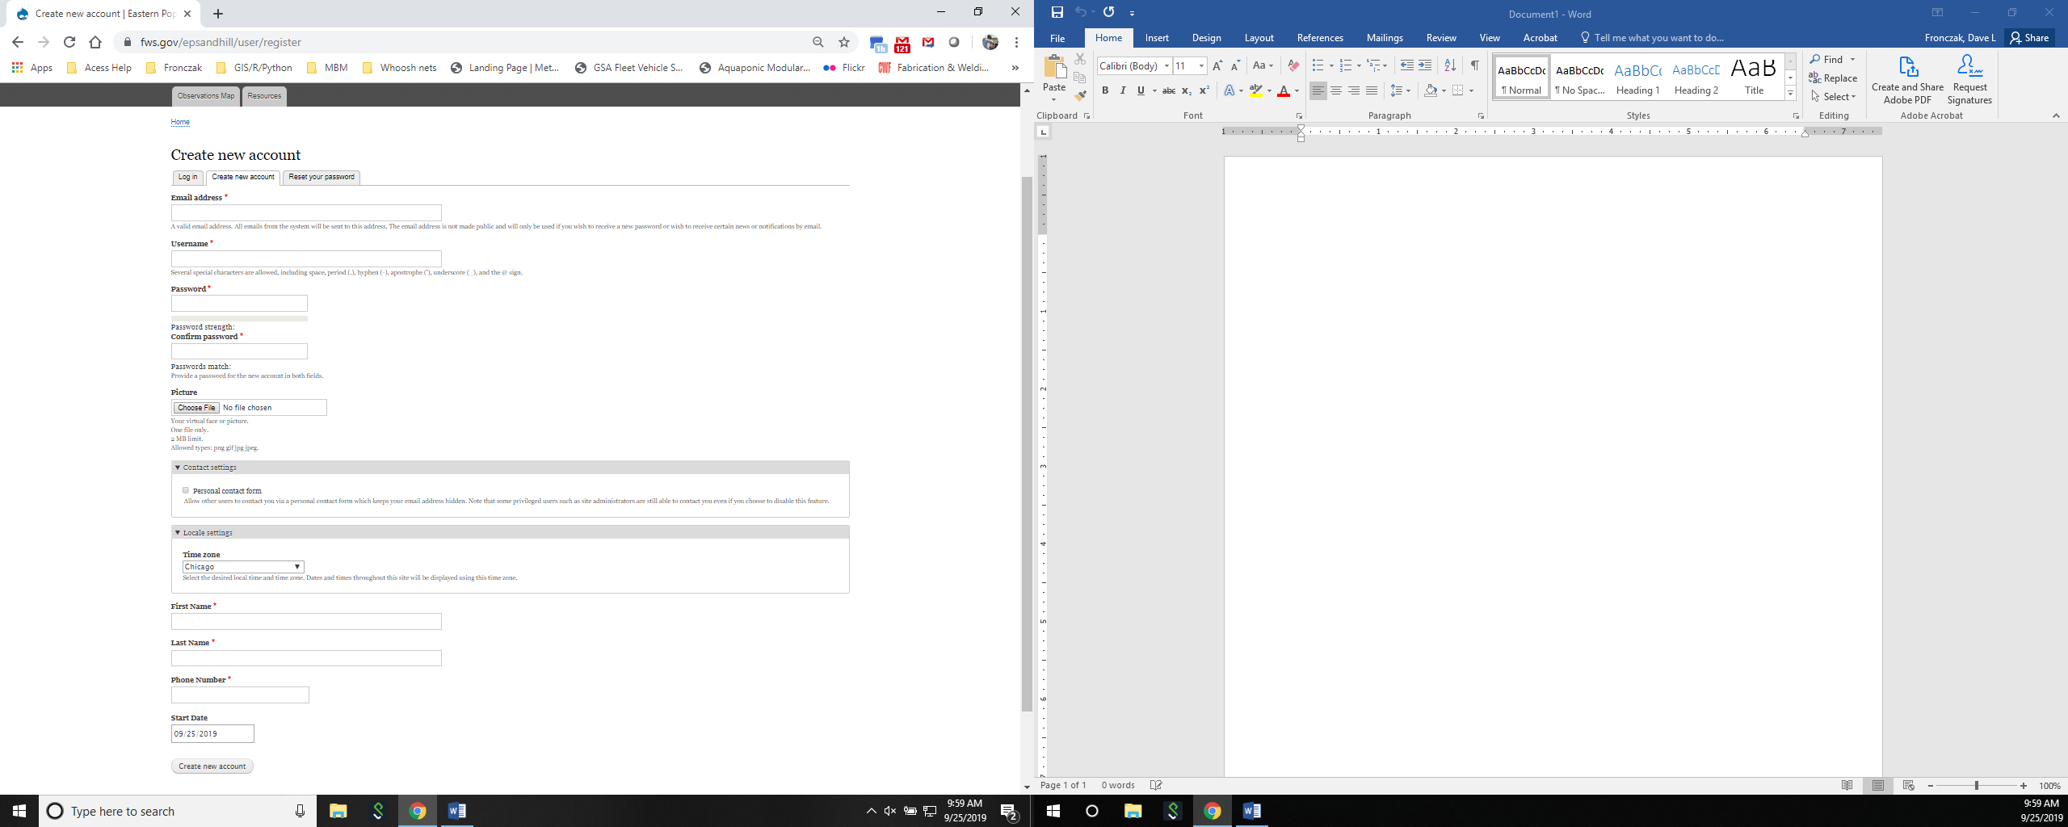

**Survey information screen – note - the initial location is placed on the google map.**

