**Screenshots of instruction changes to 4010 e-filing portal**

**Change #1**

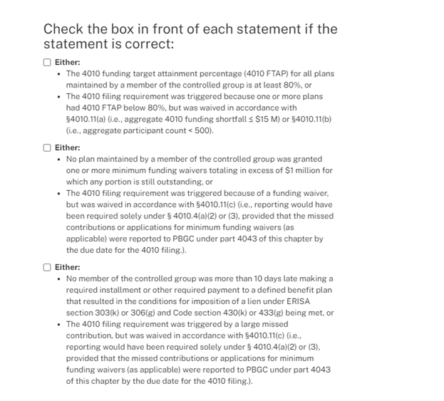

**Change #2**



