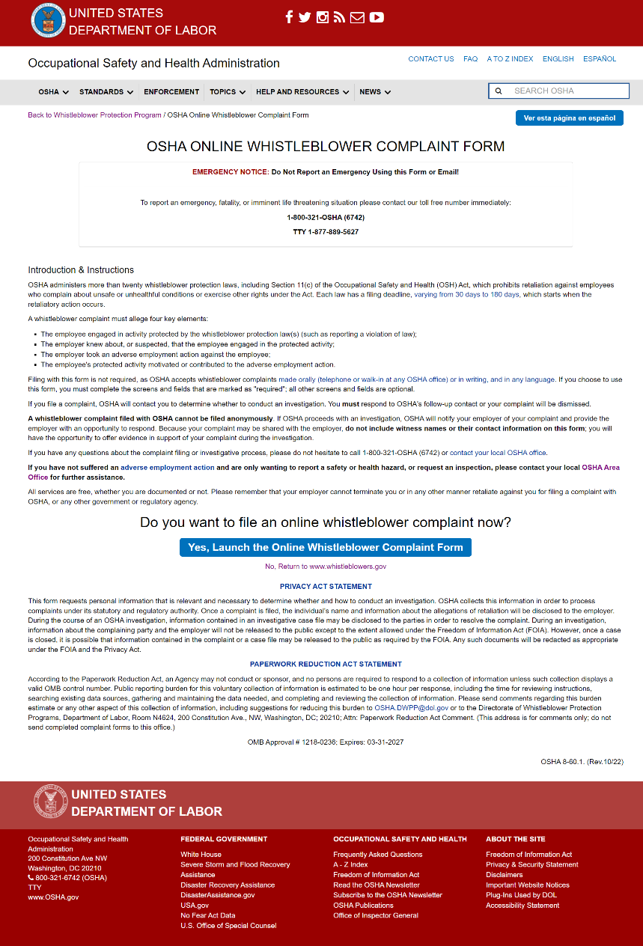
Screen 1: “Introduction and Instruction” and form “Launch” button. A final paragraph has been added to the Introduction, with the language: “All services are free, whether you are documented or not. Please remember that your employer cannot terminate you or in any other manner retaliate against you for filing a complaint with OSHA, or any other government or regulatory agency.”

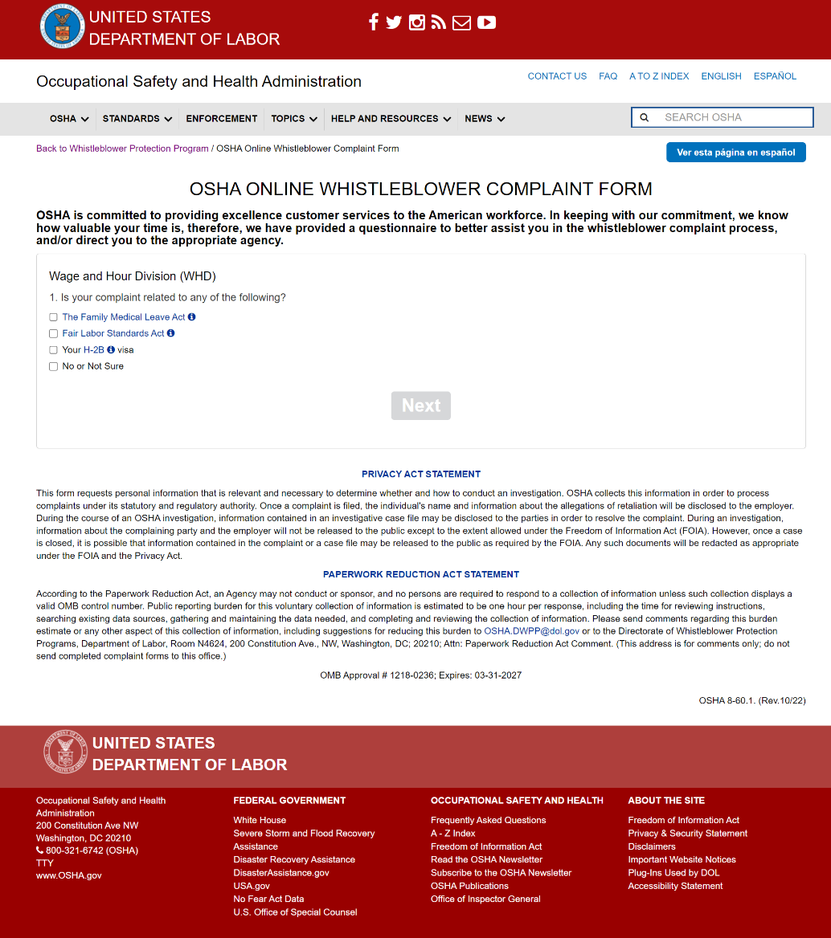
Screen 2: New questionnaire. The first screen asks questions regarding to Wage and Hour Division.
The text: “Privacy Act Statement” and “Paperwork Reduction Act Statement” toggle the full statements open and closed. This is available at any time when using the Whistleblower Complaint Form and are toggled closed by default when the form is launched.
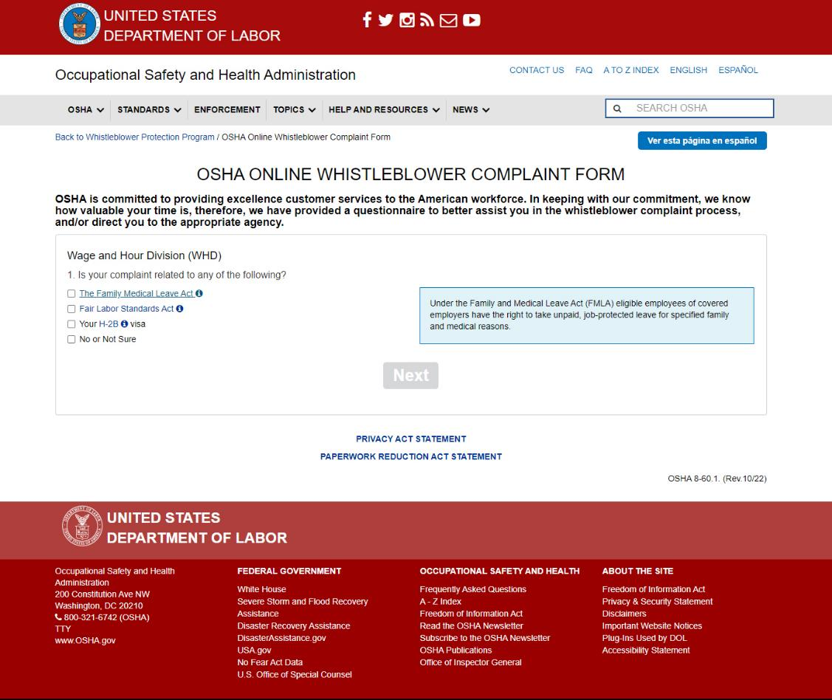
Screen 2: Helper text displays when the user clicks the hyperlink for “The Family Medical Leave Act.”
It reads: “Under the Family and Medical Leave Act (FMLA) eligible employees of covered employers have the right to take unpaid, job-protected leave for specified family and medical reasons.”
In all cases, the helper text is toggled to display or hide when the hyperlink is clicked. If the current helper text is displaying when another helper text hyperlink is clicked, it will be hidden to allow the new helper text to display.

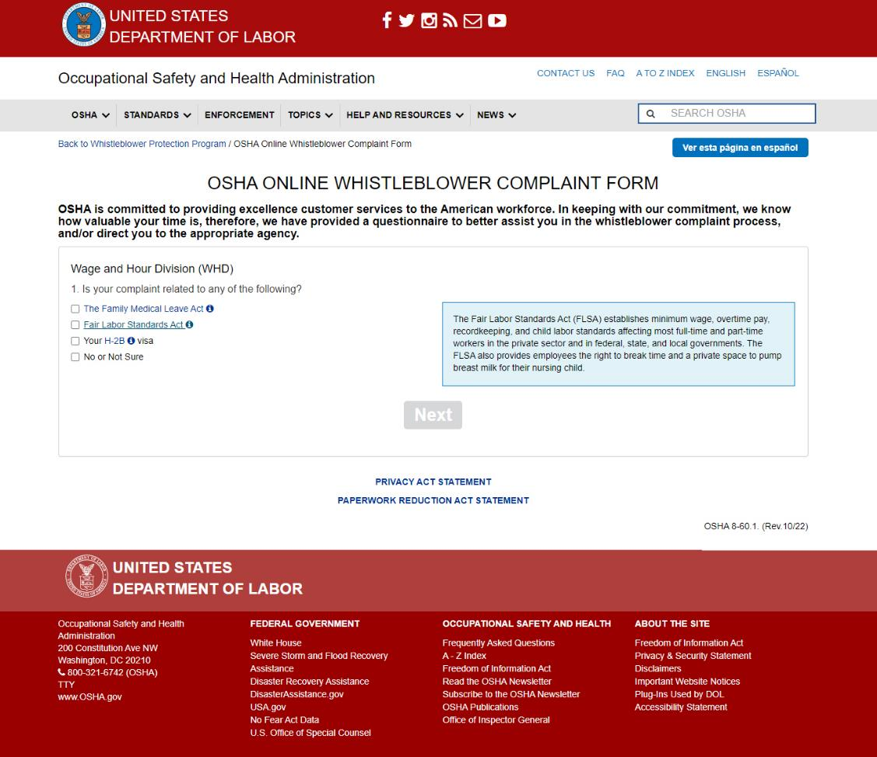
Screen 2: Helper text when the user hovers over “Fair Labor Standards Act”.
It reads: “The Fair Labor Standards Act (FLSA) establishes minimum wage, overtime pay, recordkeeping, and child labor standards aﬀecting most full-time and part-time workers in the private sector and in federal, state, and local governments. The FLSA also provides employees the right to break time and a private space to pump breast milk for their nursing child.”

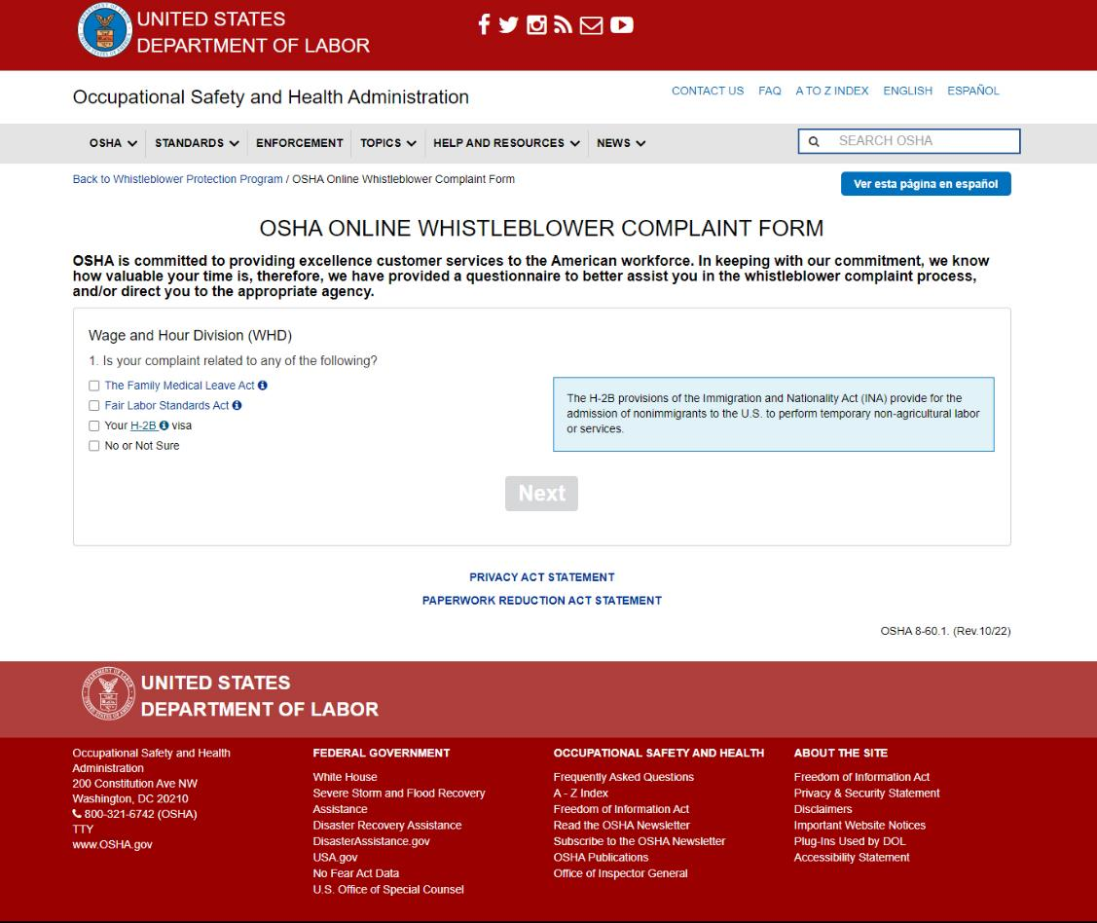
Screen 2: Helper text when the user hovers over “H-2B”.
It reads: “The H-2B provisions of the Immigration and Nationality Act (INA) provide for the admission of nonimmigrants to the U.S. to perform temporary non-agricultural labor or services.”

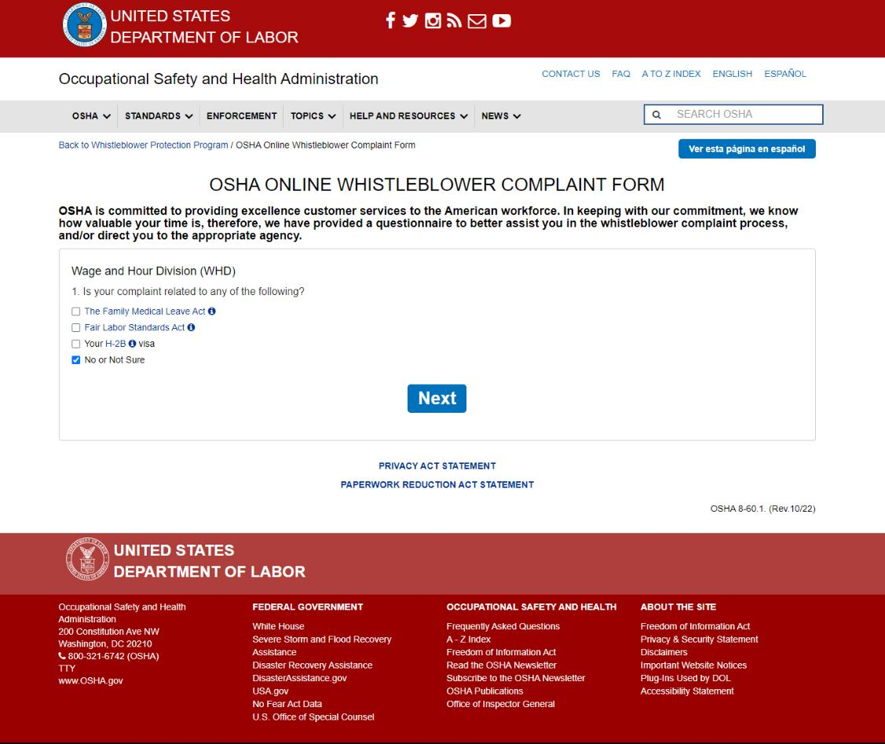
Screen 2: If “No or Not Sure” is selected. The “Next” button becomes available and will display the next section of the questionnaire when clicked.
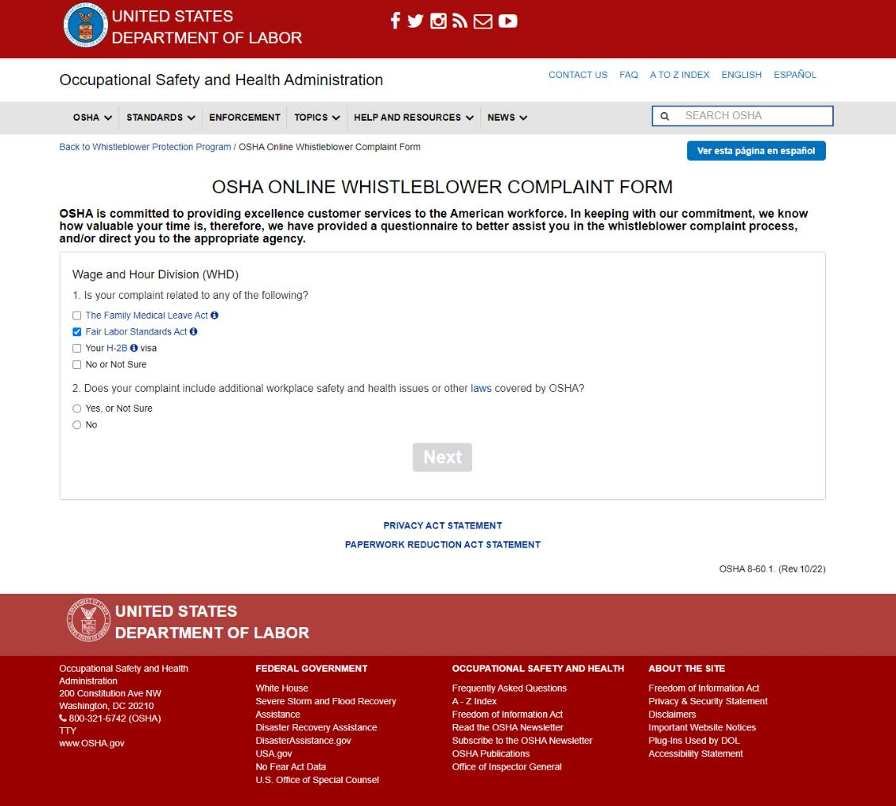
Screen 2: If any items other than “No or Not Sure” are checked, a second question is displayed.
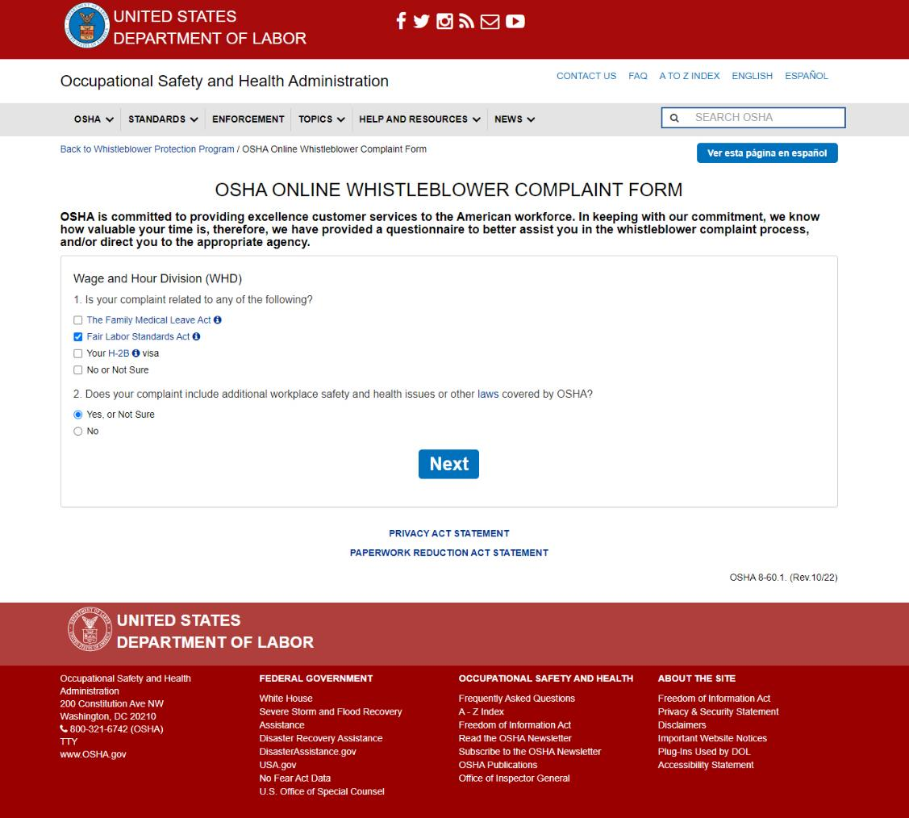
Screen 2: If “Yes, or Not Sure” is selected, the “Next” button becomes available and will display the next section of the questionnaire when clicked.
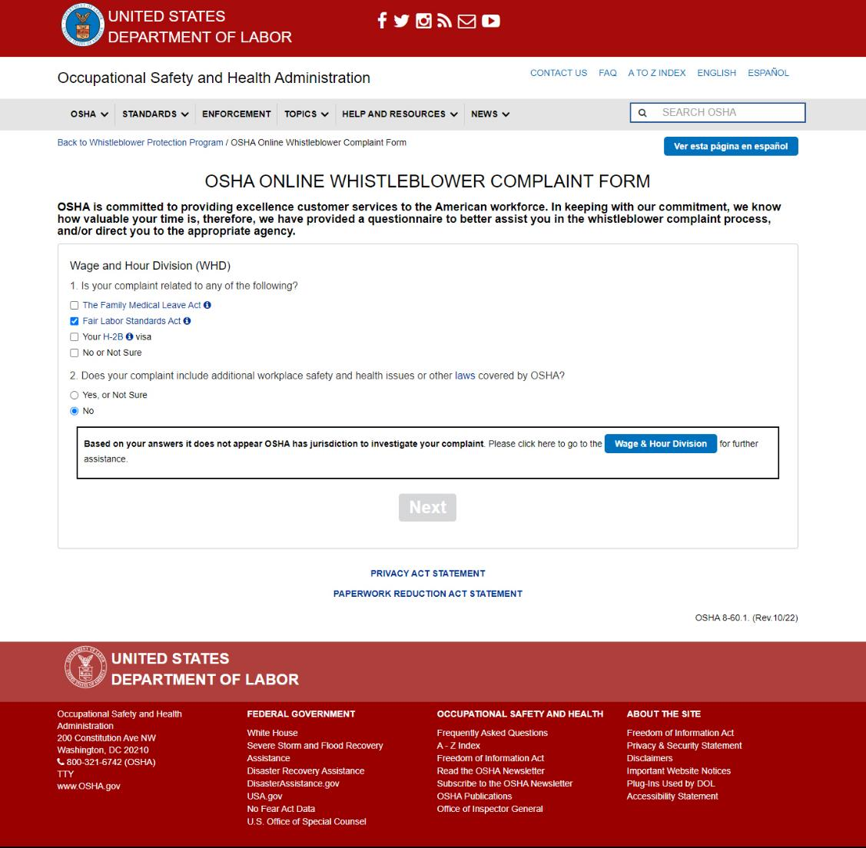
Screen 2: If “No” is selected, text displays instructing the user that OSHA does not have the jurisdiction to investigate their complaint. They are recommended to go to the Wage & Hour Division for further assistance, with a button that links to https://www.dol.gov/agencies/whd.
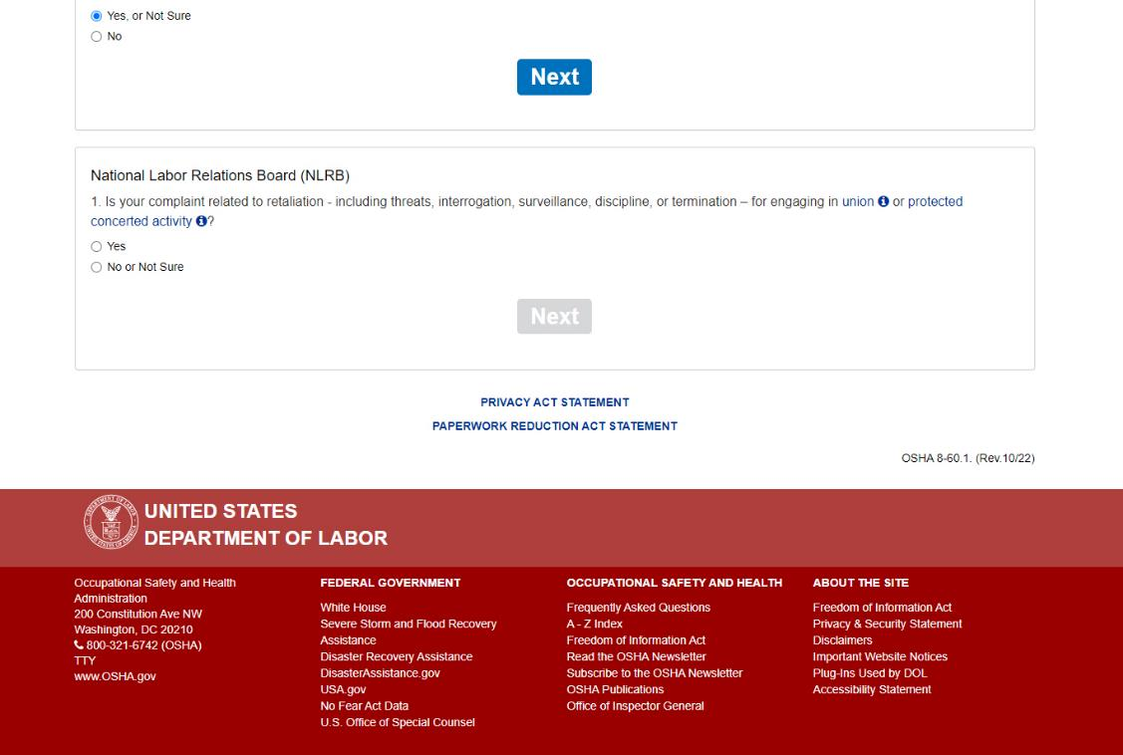
Screen 3: The next section asks questions regarding the National Labor Relations Board.
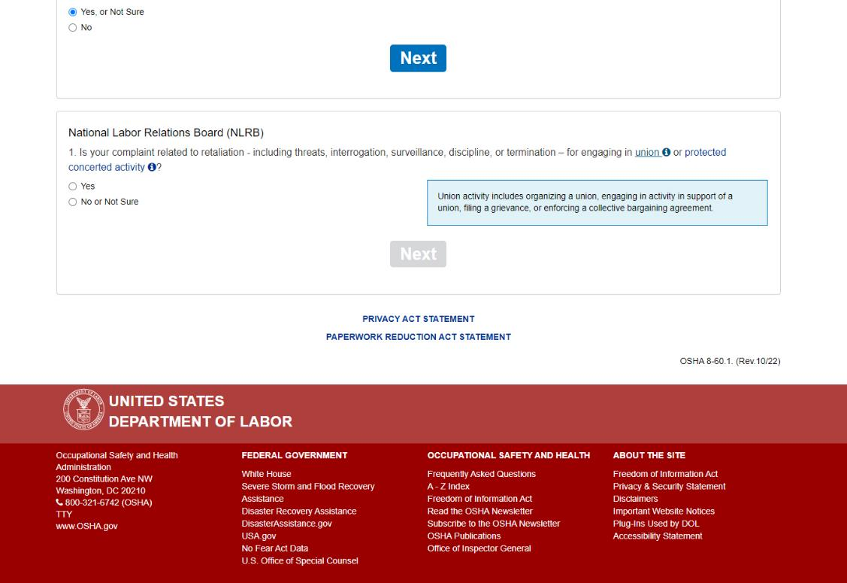
Screen 3: Helper text when the user clicks the hyperlink for “union”.
It reads: “Union activity includes organizing a union, engaging in activity in support of a union, filing a grievance, or enforcing a collective bargaining agreement.”

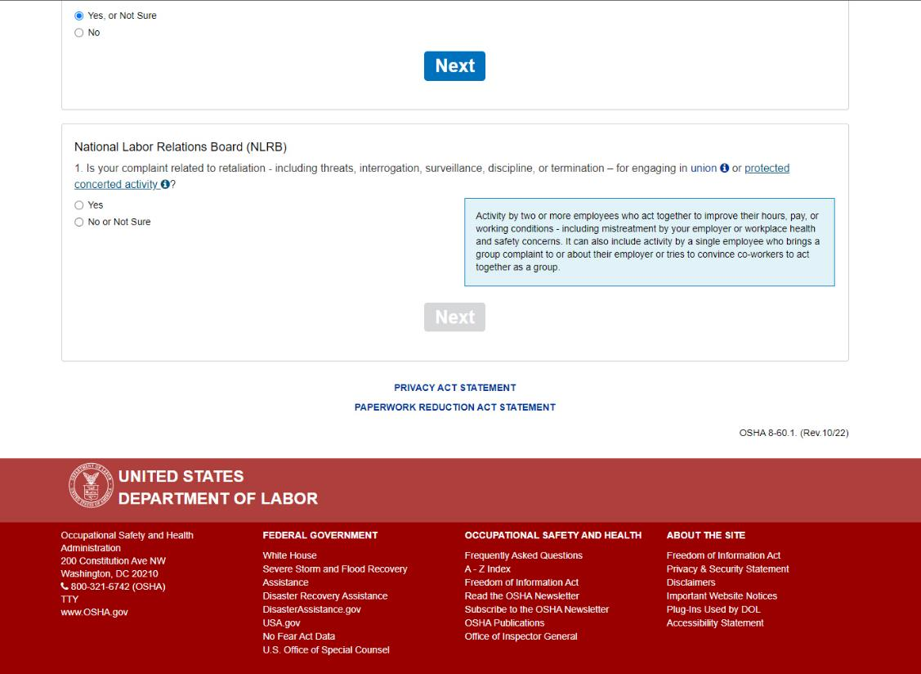
Screen 3: Helper text when the user clicks the hyperlink for “protected concerted activity”.
It reads: “Activity by two or more employees who act together to improve their hours, pay, or working conditions - including mistreatment by your employer or workplace health and safety concerns. It can also include activity by a single employee who brings a group complaint to or about their employer or tries to convince co-workers to act together as a group.”

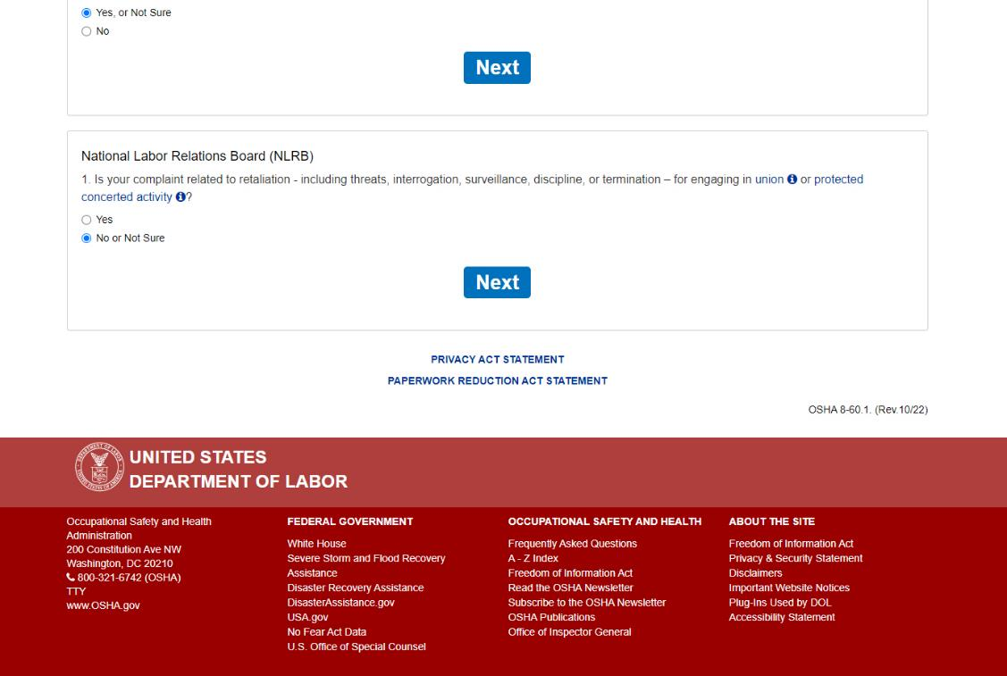
Screen 3: If “No or Not Sure is selected, the “Next” button becomes available and will display the next section of the questionnaire when clicked.
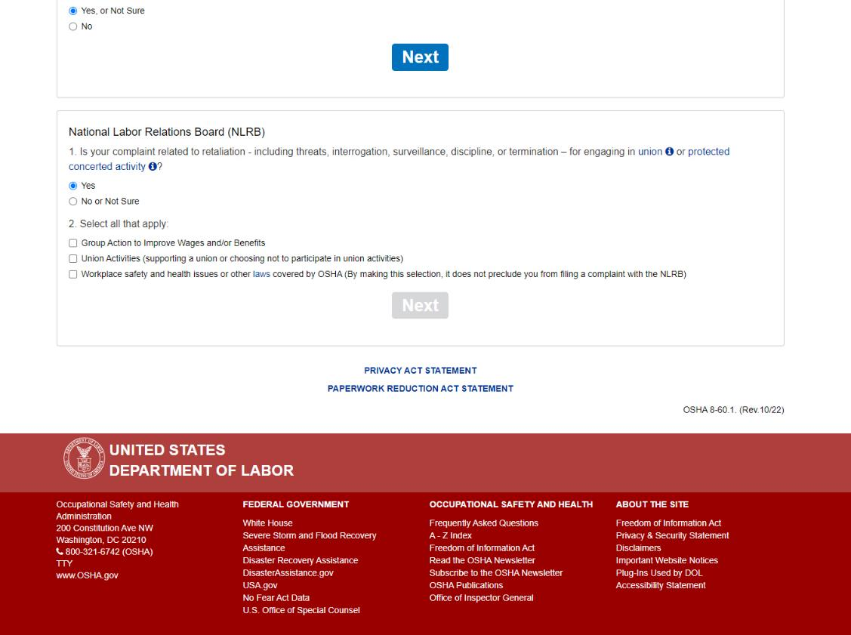
Screen 3: If “Yes” is selected, a second question is displayed.
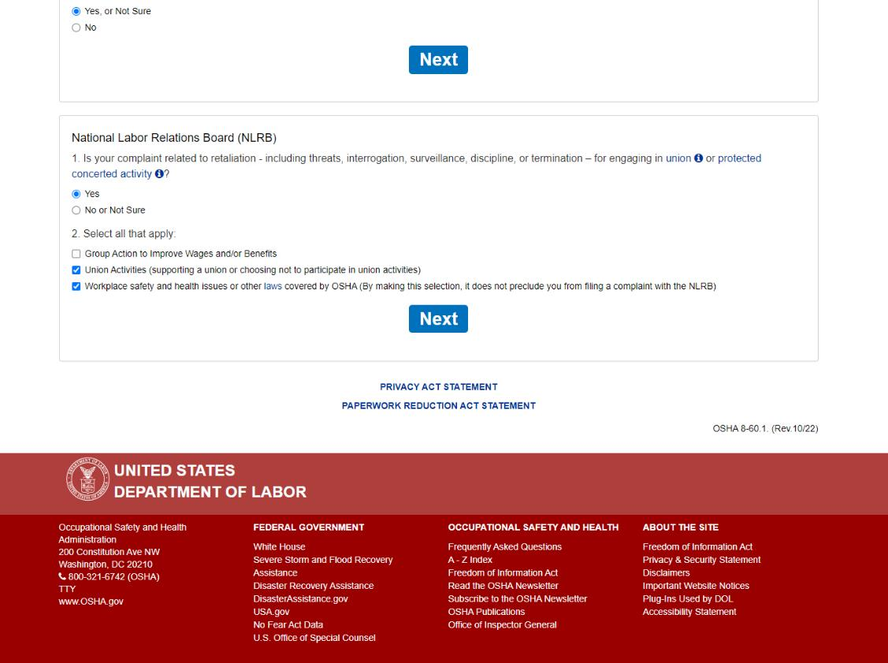
Screen 3: “Workplace Safety and Health” must be selected for the “Next” button to become available.
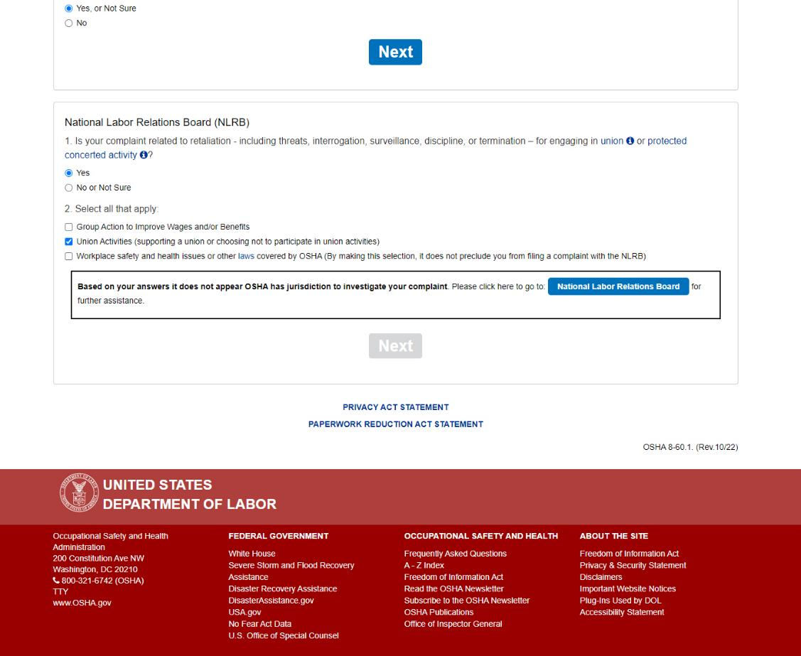
Screen 3: If “Workplace Safety and Health” is not selected, the user is informed that OSHA does not have jurisdiction to investigate their complaint. They are instructed to go to the National Labor Relations Board for assistance, with a button that takes them to https://www.nlrb.gov/.
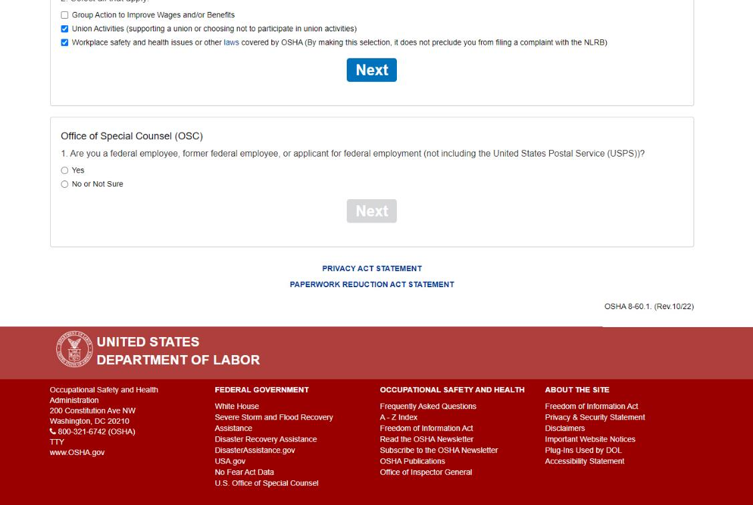
Screen 4: The next section asks questions regarding the Office of Special Counsel.
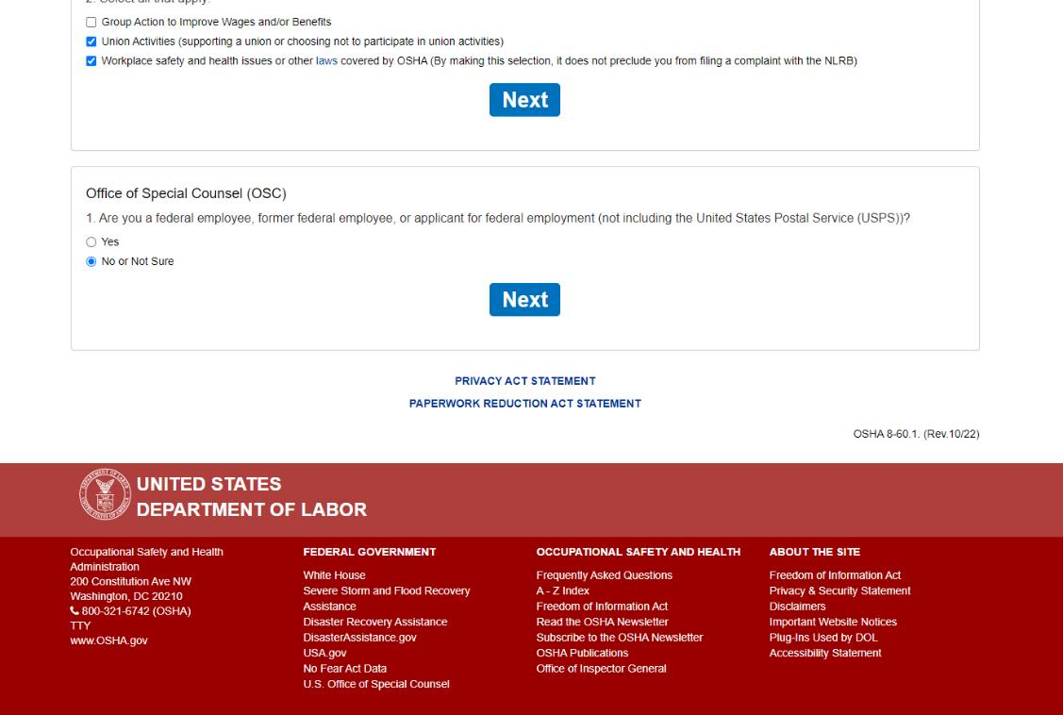
Screen 4: If “No or Not Sure” is selected, the “Next” button becomes available and will display the next section of the questionnaire when clicked.
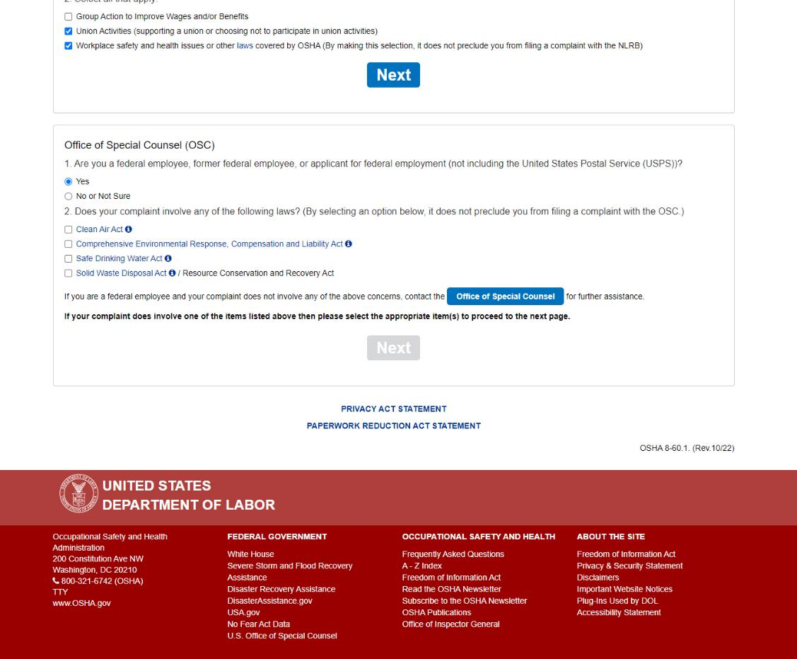
Screen 4: If “Yes” is selected, a second question is displayed to the user, informing them that if their complaint does not involve any of the concerns in the checklist, they will need to contact the Office of Special Council, with a button that will take them to http://www.osc.gov/.
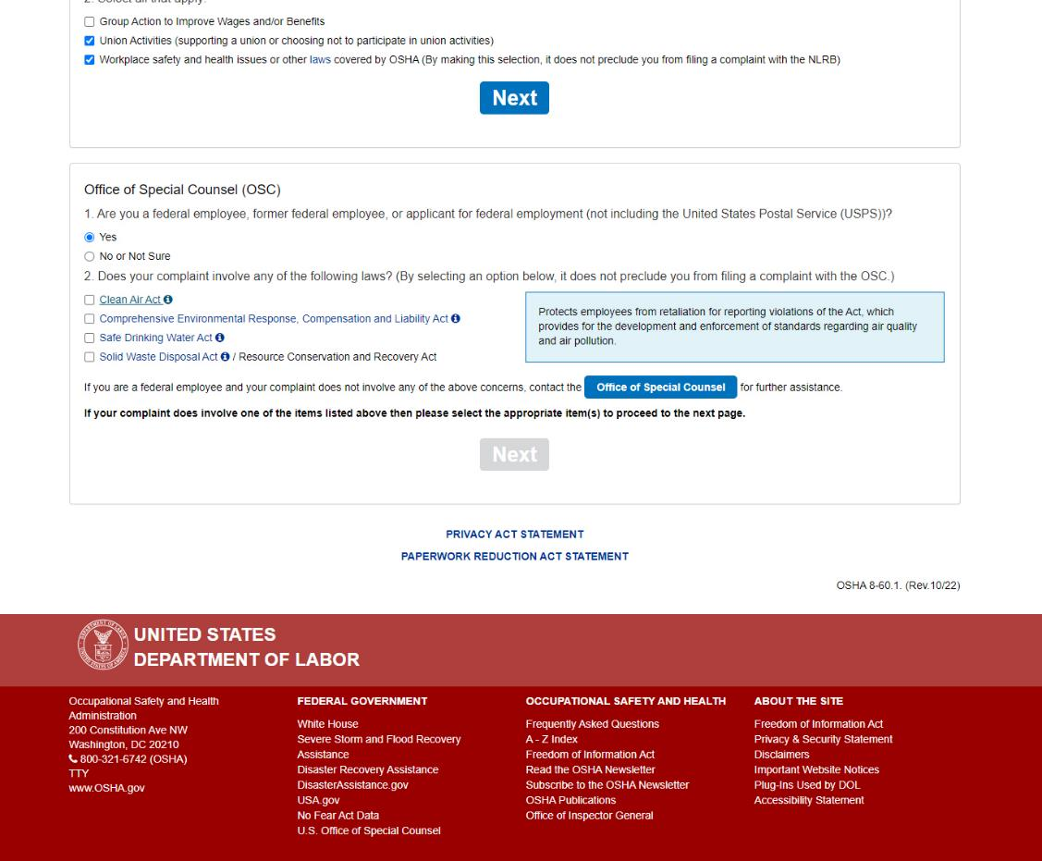
Screen 4: Helper text when the user clicks the hyperlink for “Clean Air Act.”
It reads: “Protects employees from retaliation for reporting violations of the Act, which provides for the development and enforcement of standards regarding air quality and air pollution.”

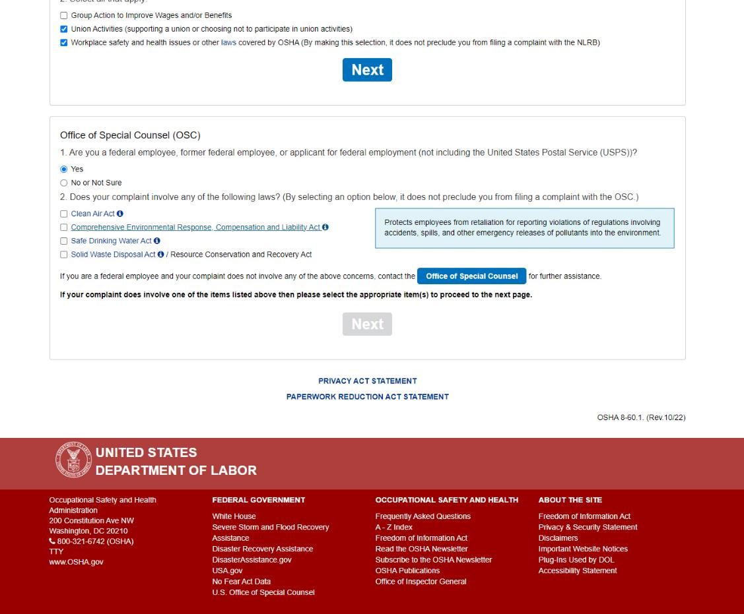
Screen 4: Helper text when the user clicks the hyperlink for “Comprehensive Environmental Response Compensation and Liability Act.”
It reads: “Protects employees from retaliation for reporting violations of regulations involving accidents, spills, and other emergency releases of pollutants into the environment.”
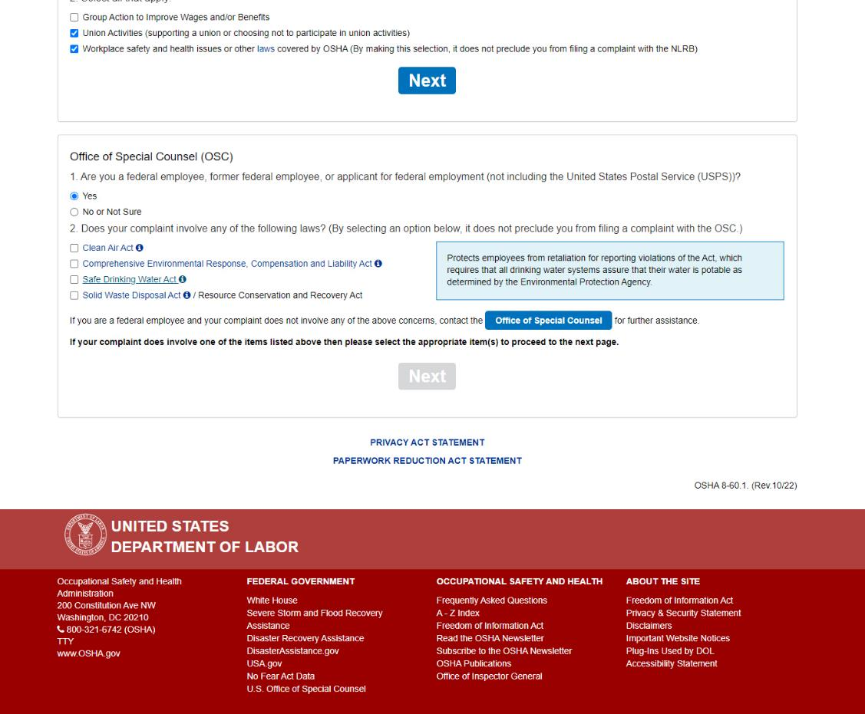
Screen 4: Helper text when the clicks the hyperlink for “Safe Drinking Water Act.”
It reads: “Protects employees from retaliation for reporting violations of the Act, which requires that all drinking water systems assure that their water is potable as determined by the Environmental Protection Agency.”
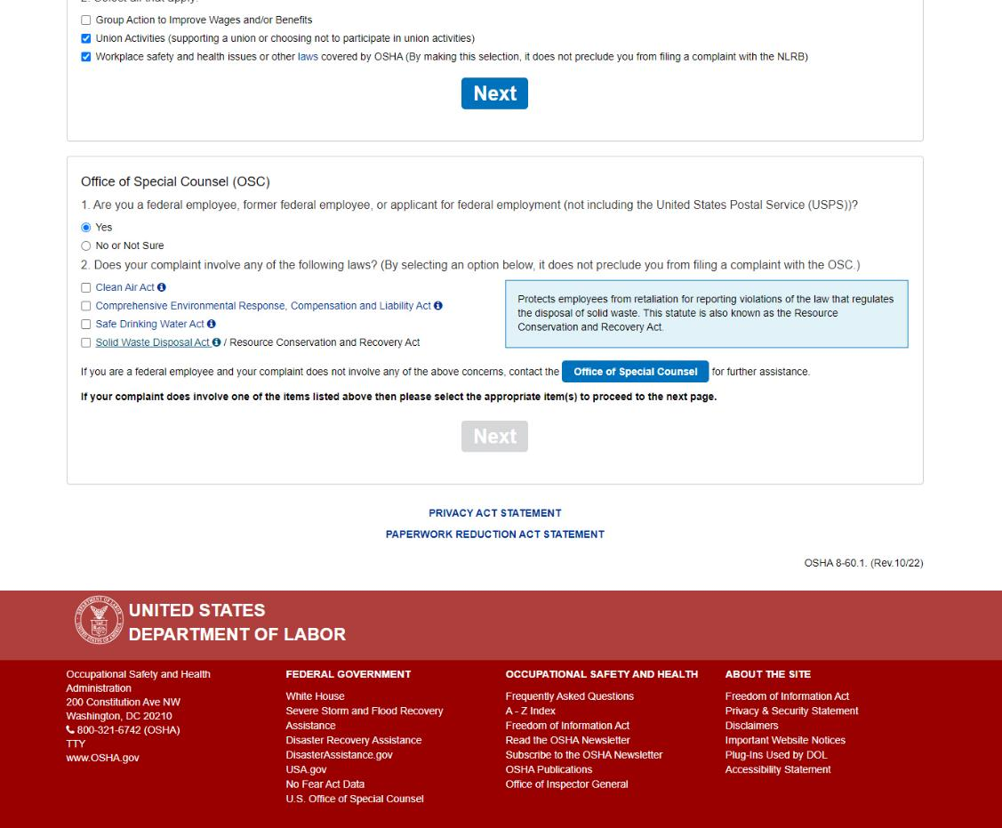
Screen 4: Helper text when the user clicks the hyperlink for “Solid Waste Disposal Act”.
It reads: “Protects employees from retaliation for reporting violations of the law that regulates the disposal of solid waste. This statute is also known as the Resource Conservation and Recovery Act.”

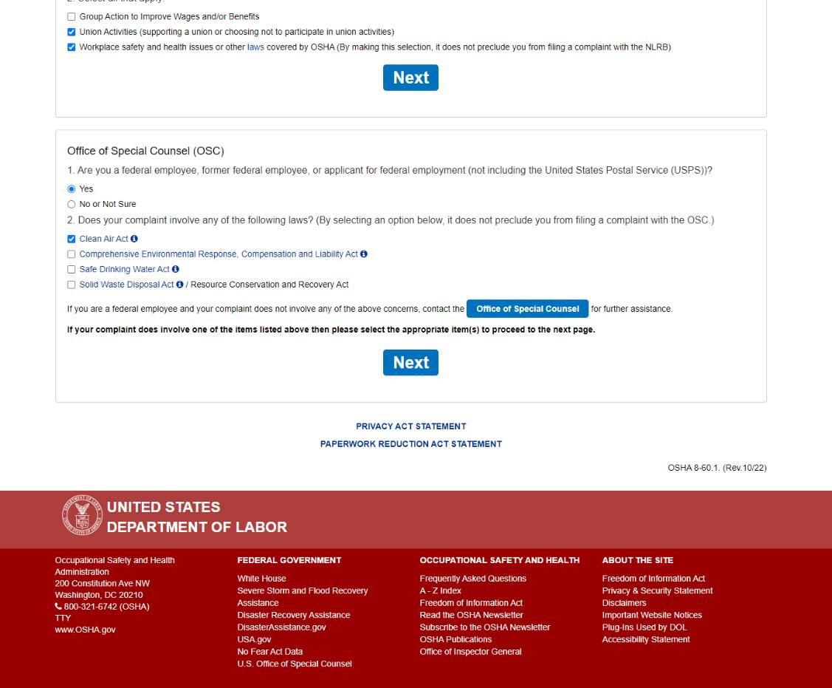
Screen 4: The “Next” button becomes available when the user checks any of the check boxes and will display the next section of the questionnaire when clicked.
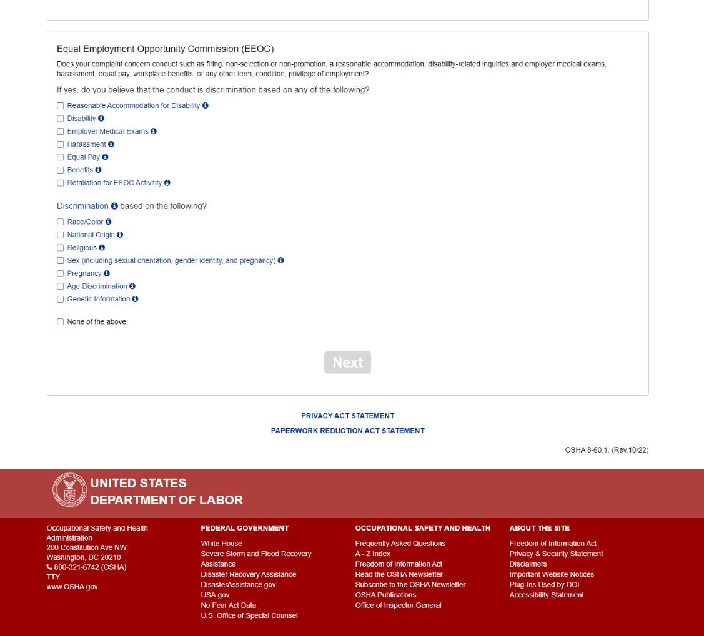
Screen 5: The next section asks questions regarding the Equal Employment Opportunity Commission.
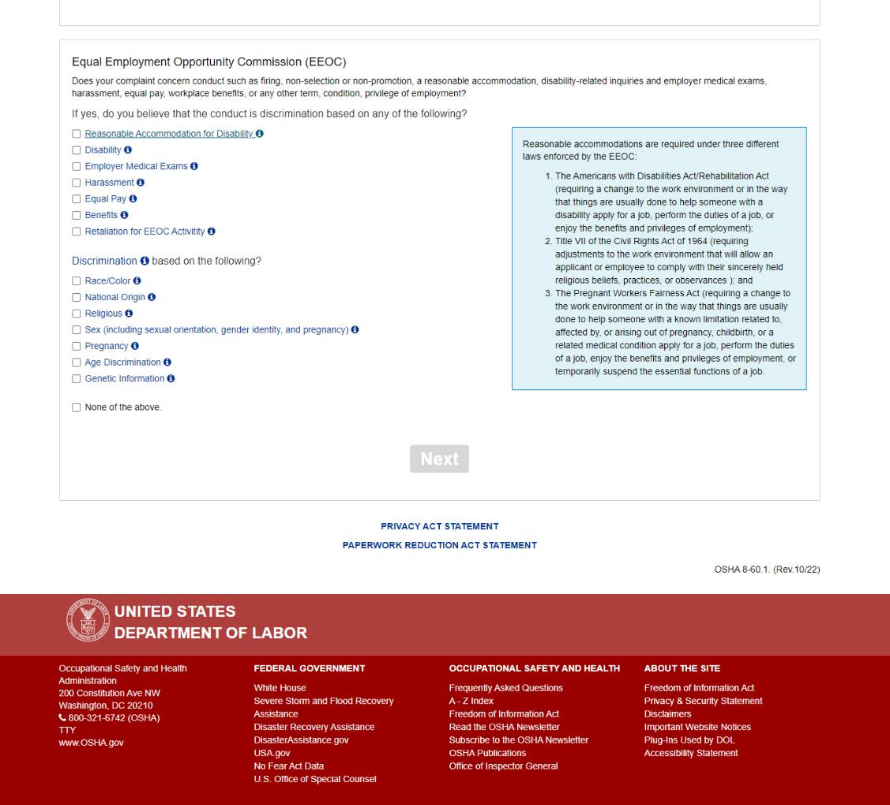
Screen 5: Helper text when the user clicks the hyperlink for “Reasonable accommodation for Disability.”
It reads: “Reasonable accommodations are required under three different laws enforced by the EEOC:
- The Americans with Disabilities Act/Rehabilitation Act (requiring a change to the work environment or in the way that things are usually done to help someone with a disability apply for a job, perform the duties of a job, or enjoy the benefits and privileges of employment);
- Title VII of the Civil Rights Act of 1964 (requiring adjustments to the work environment that will allow an applicant or employee to comply with their sincerely held religious beliefs, practices, or observances ); and
- The Pregnant Workers Fairness Act (requiring a change to the work environment or in the way that things are usually done to help someone with a known limitation related to, affected by, or arising out of pregnancy, childbirth, or a related medical condition apply for a job, perform the duties of a job, enjoy the benefits and privileges of employment, or temporarily suspend the essential functions of a job.”

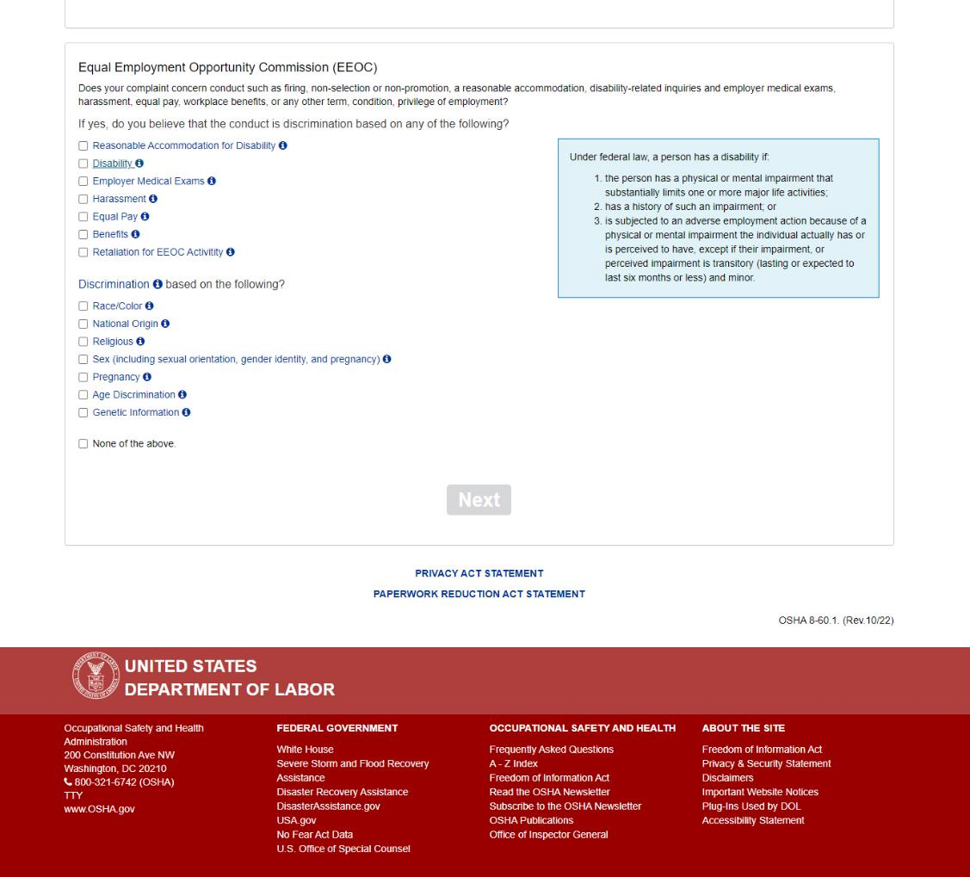
Screen 5: Helper text when the user clicks the hyperlink for “Disability.”
It reads: “Under federal law, a person has a disability if:
- the person has a physical or mental impairment that substantially limits one or more major life activities;
- has a history of such an impairment; or
- is subjected to an adverse employment action because of a physical or mental impairment the individual actually has or is perceived to have, except if their impairment, or perceived impairment is transitory (lasting or expected to last six months or less) and minor.”

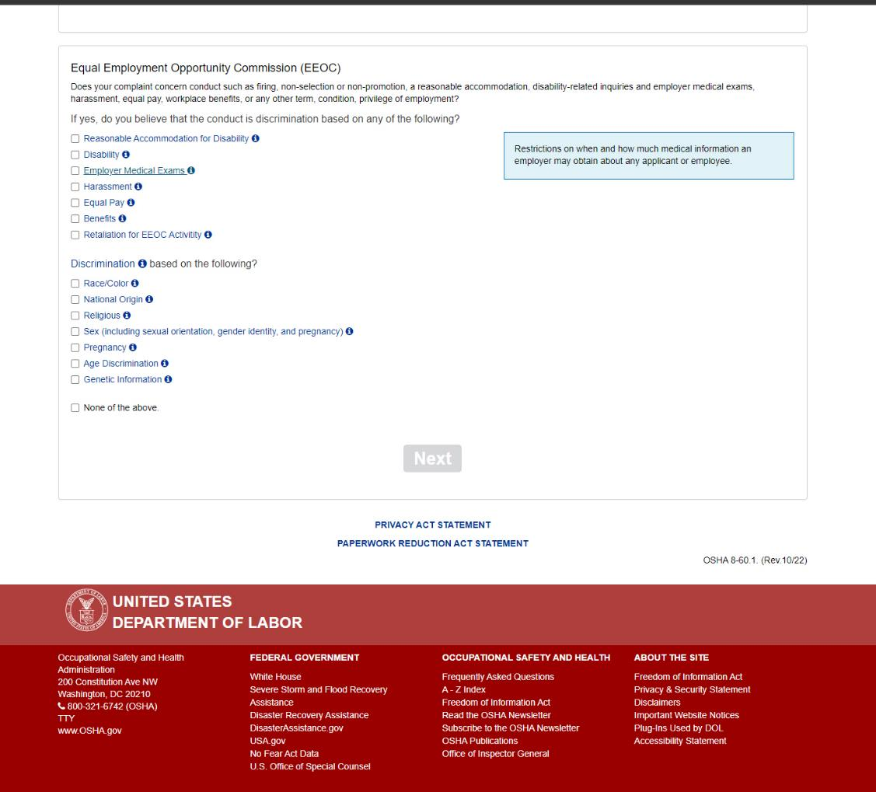
Screen 5: Helper text when the user clicks the hyperlink for “Employer Medical Exams.”
It reads: “Restrictions on when and how much medical information an employer may obtain about any applicant or employee.”

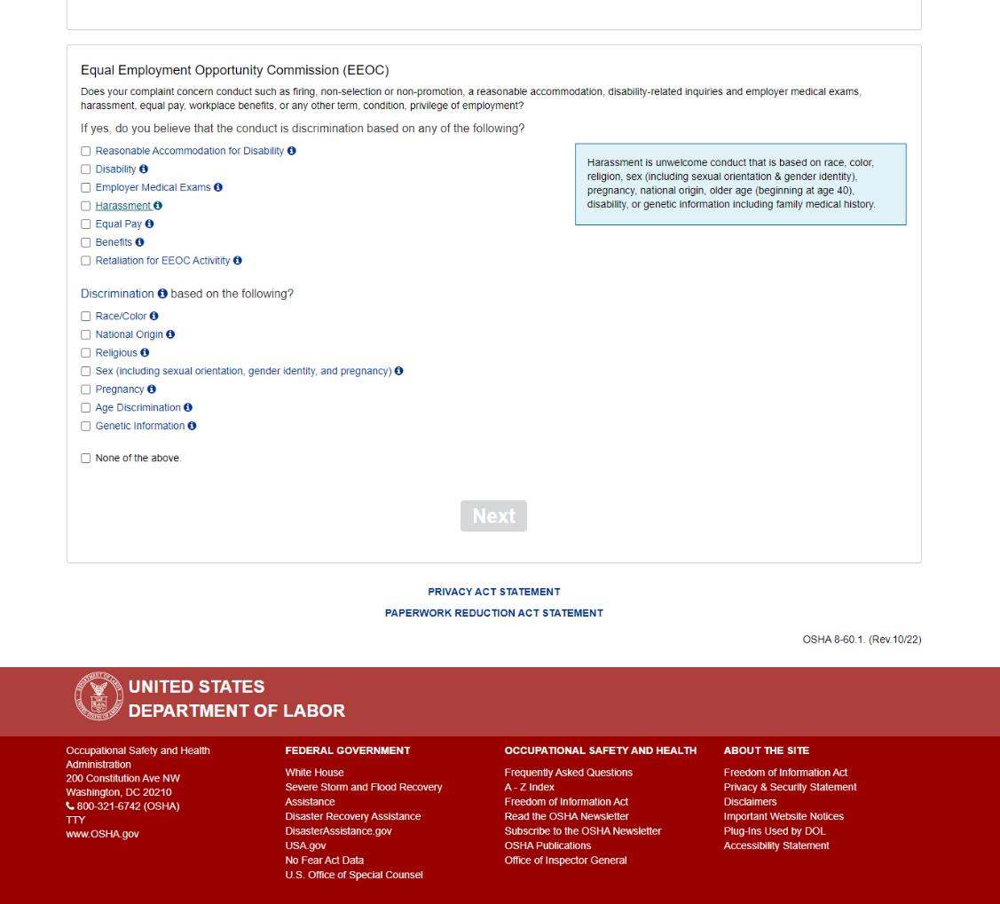
Screen 5: Helper text when the user clicks the hyperlink for “harassment.”
It reads: “Harassment is unwelcome conduct that is based on race, color, religion, sex (including sexual orientation & gender identity, national origin, older age (beginning at age 40), disability, or genetic information including family medical history.”

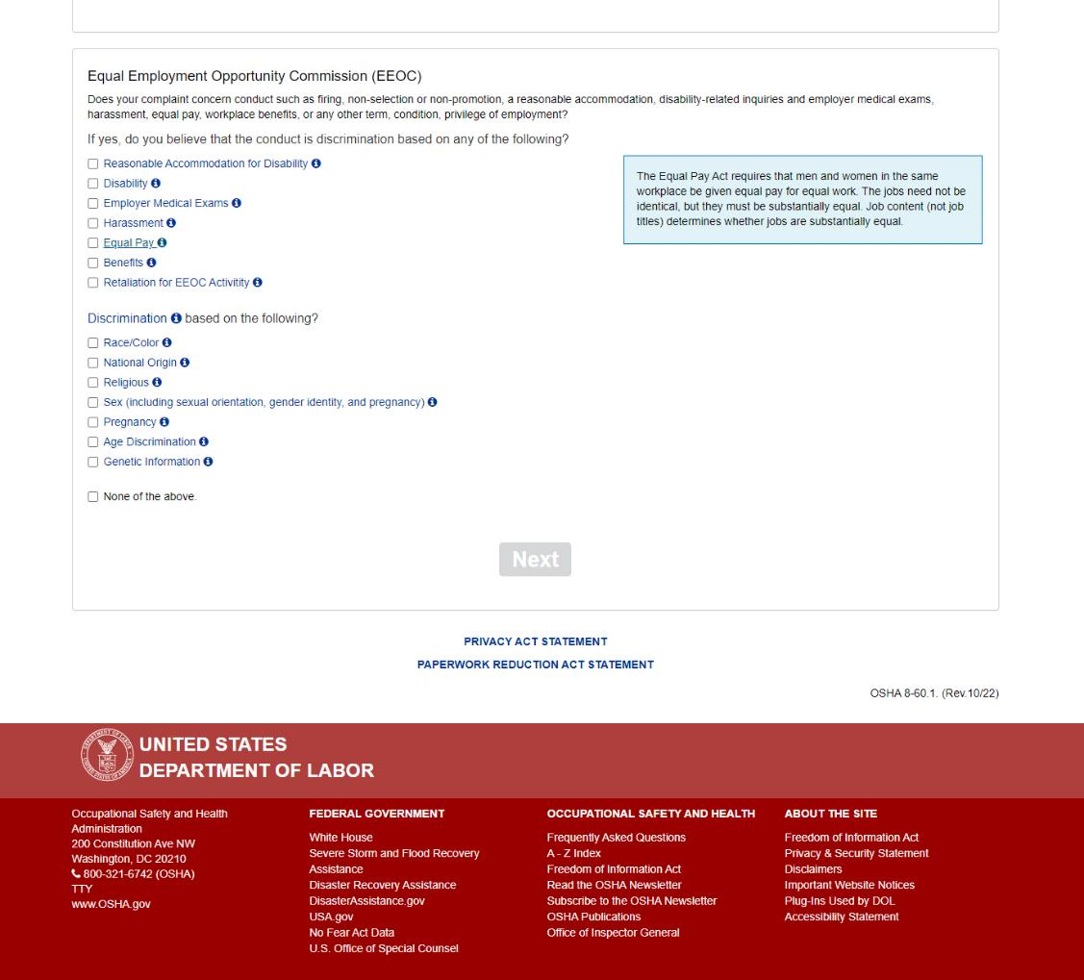
Screen 5: Helper text when the user clicks the hyperlink for “Equal Pay.”
It reads: “The Equal Pay Act requires that men and women in the same workplace be given equal pay for equal work. The jobs need not be identical, but they must be substantially equal. Job content (not job titles) determines whether jobs are substantially equal.”

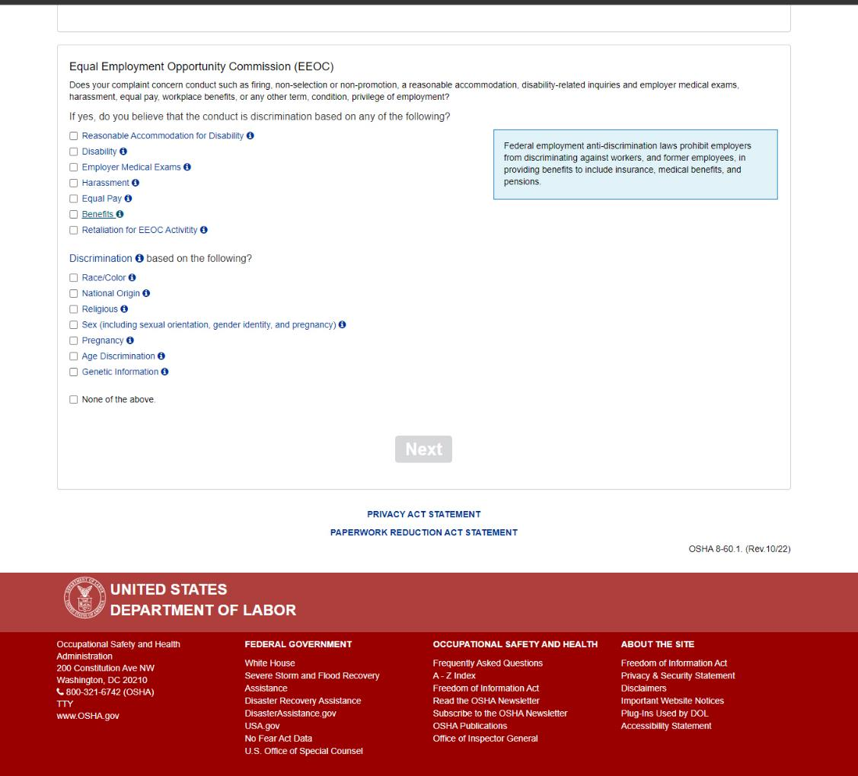
Screen 5: Helper text when the user clicks the hyperlink for “Benefits.”
It reads: “Federal employment anti-discrimination laws prohibit employers from discriminating against workers, and former employees, in providing benefits to include insurance, medical benefits, and pensions.”

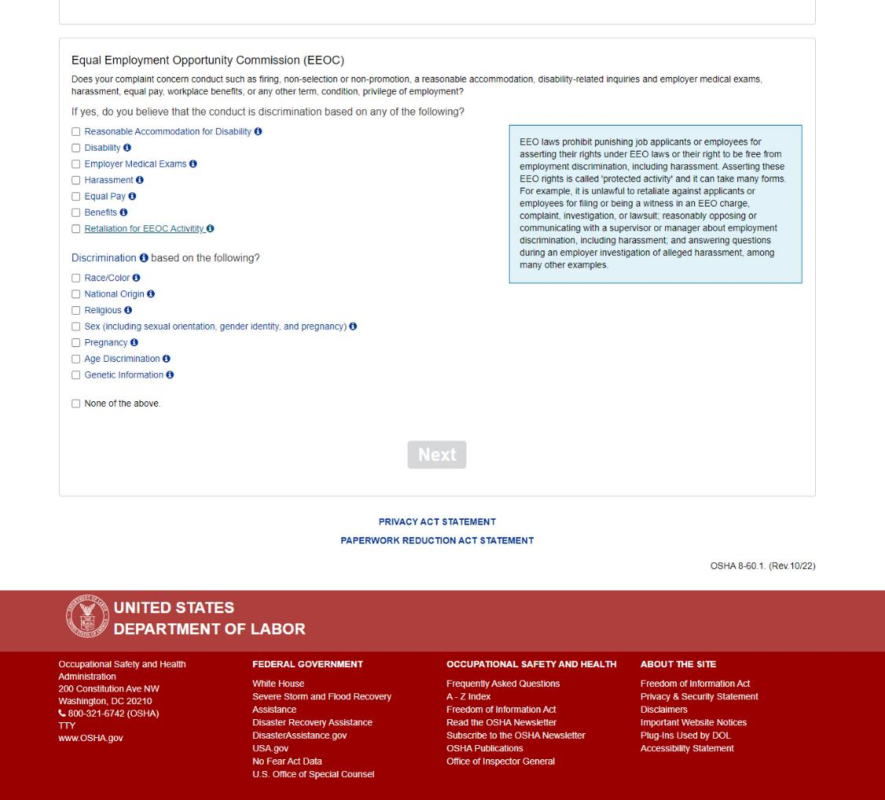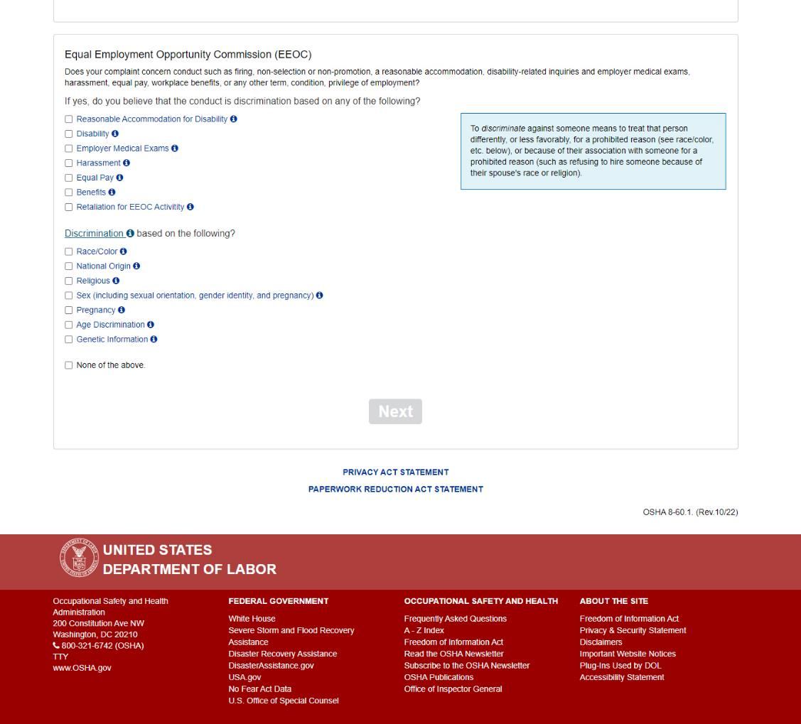
Screen 5: Helper text when the user clicks the hyperlink for “Retaliation for Complaining to the EEOC.”
It reads: “EEO laws prohibit punishing job applicants or employees for asserting their rights under EEO laws or their right to be free from employment discrimination, including harassment. Asserting these EEO rights is called 'protected activity' and it can take many forms. For example, it is unlawful to retaliate against applicants or employees for filing or being a witness in an EEO charge, complaint, investigation, or lawsuit; reasonably opposing or communicating with a supervisor or manager about employment discrimination, including harassment; and answering questions during an employer investigation of alleged harassment, among many other examples.”

Screen 5: Helper text when the user clicks the hyperlink for “Discrimination.”
It reads: “against someone means to treat that person differently, or less favorably, for a prohibited reason (see race/color, etc. below), or because of their association with someone for a prohibited reason (such as refusing to hire someone because of their spouse's race or religion).”

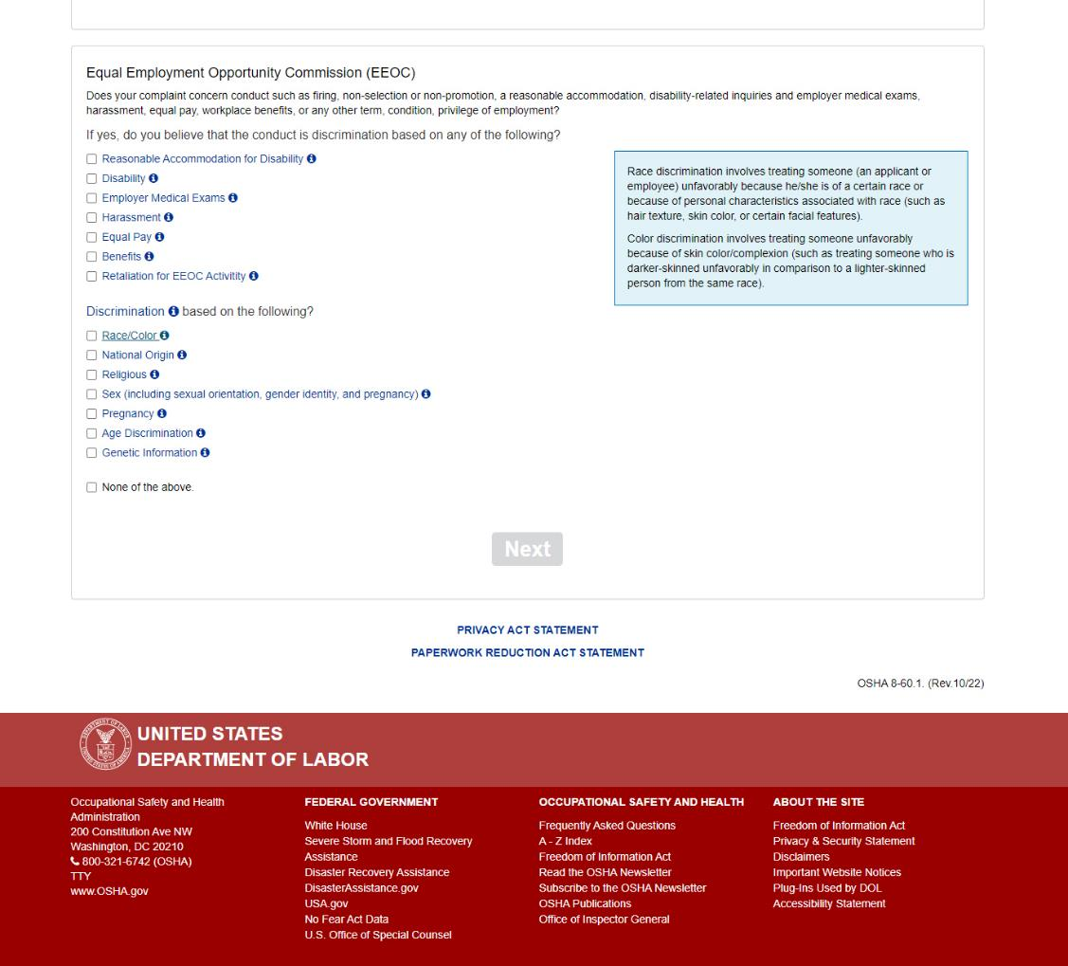
Screen 5: Helper text when the user clicks the hyperlink for “Race/Color.”
It reads: “Race discrimination involves treating someone (an applicant or employee) unfavorably because he/she is of a certain race or because of personal characteristics associated with race (such as hair texture, skin color, or certain facial features).
Color discrimination involves treating someone unfavorably because of skin color/complexion (such as treating someone who is darker-skinned unfavorably in comparison to a lighter-skinned person from the same race).”

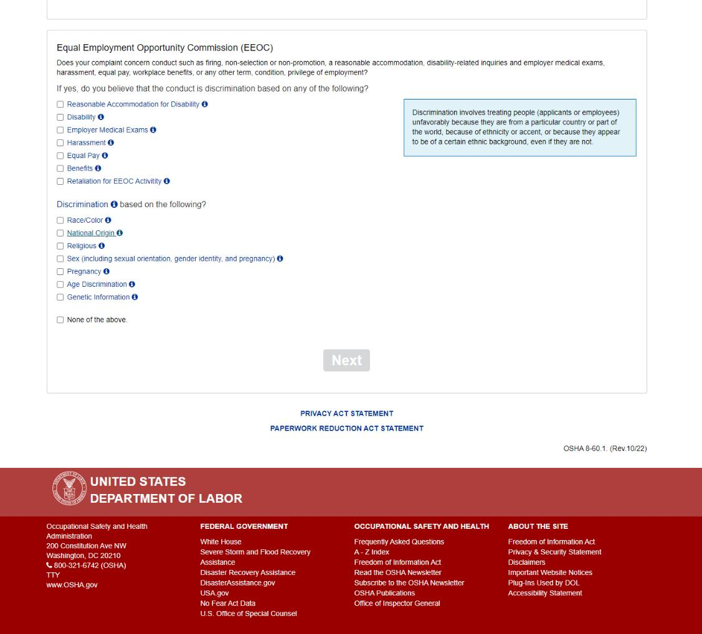
Screen 5: Helper text when the user clicks the hyperlink for “National origin.”
It reads: “Discrimination involves treating people (applicants or employees) unfavorably because they are from a particular country or part of the world, because of ethnicity or accent, or because they appear to be of a certain ethnic background, even if they are not.”

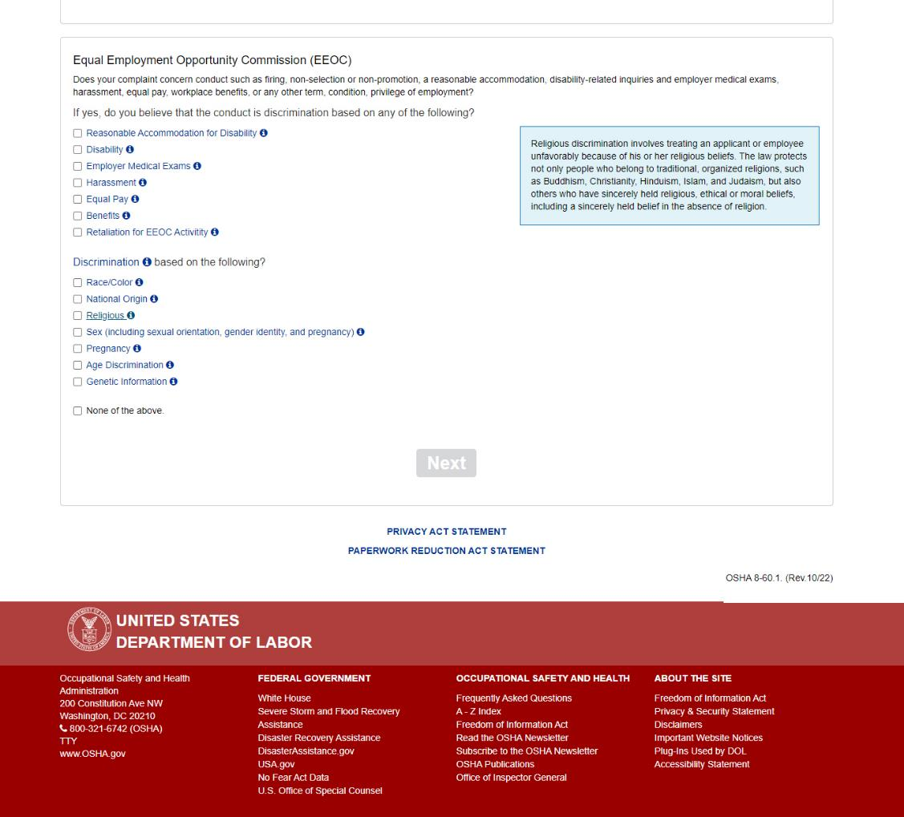
Screen 5: Helper text when the user clicks the hyperlink for “Religious.”
It reads: “Religious discrimination involves treating an applicant or employee unfavorably because of his or her religious beliefs. The law protects not only people who belong to traditional, organized religions, such as Buddhism, Christianity, Hinduism, Islam, and Judaism, but also others who have sincerely held religious, ethical or moral beliefs, including a sincerely held belief in the absence of religion.”

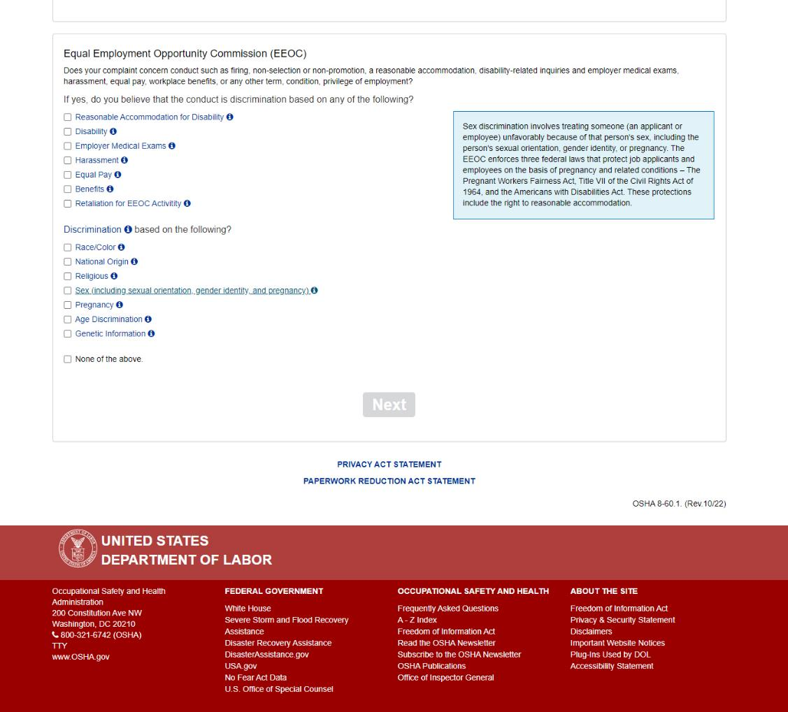
Screen 5: Helper text when the user clicks the hyperlink for “Sex (including sexual orientation, gender identity, and pregnancy).”
It reads: “Sex discrimination involves treating someone (an applicant or employee) unfavorably because of that person's sex, including the person's sexual orientation, gender identity, or pregnancy. The EEOC enforces three federal laws that protect job applicants and employees on the basis of pregnancy and related conditions – The Pregnant Workers Fairness Act, Title VII of the Civil Rights Act of 1964, and the Americans with Disabilities Act. These protections include the right to reasonable accommodation.”

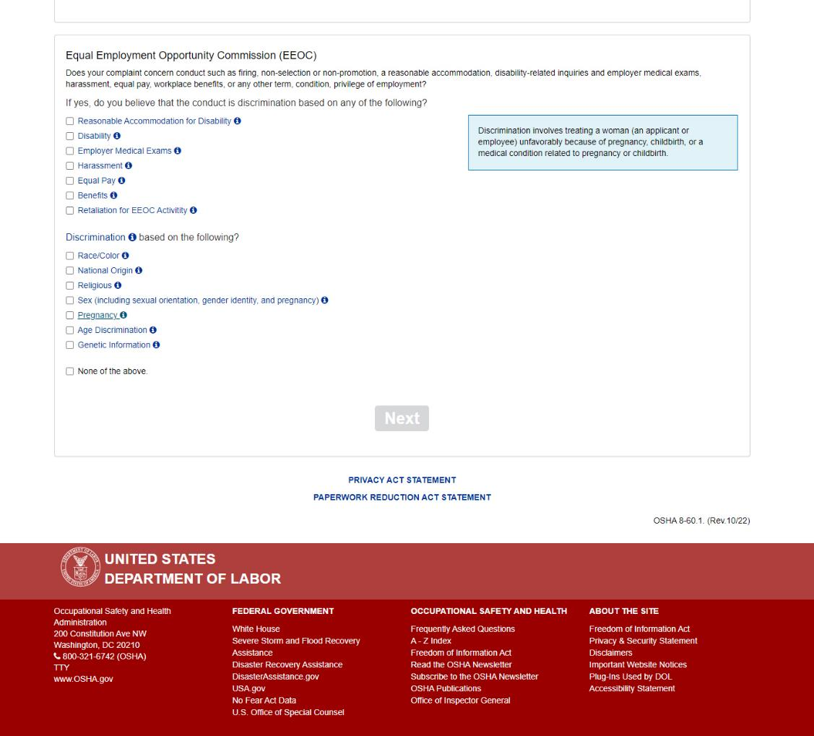
Screen 5: Helper text when the user clicks the hyperlink for “Pregnancy.”
It reads: “Discrimination involves treating a woman (an applicant or employee) unfavorably because of pregnancy, childbirth, or a medical condition related to pregnancy or childbirth.”

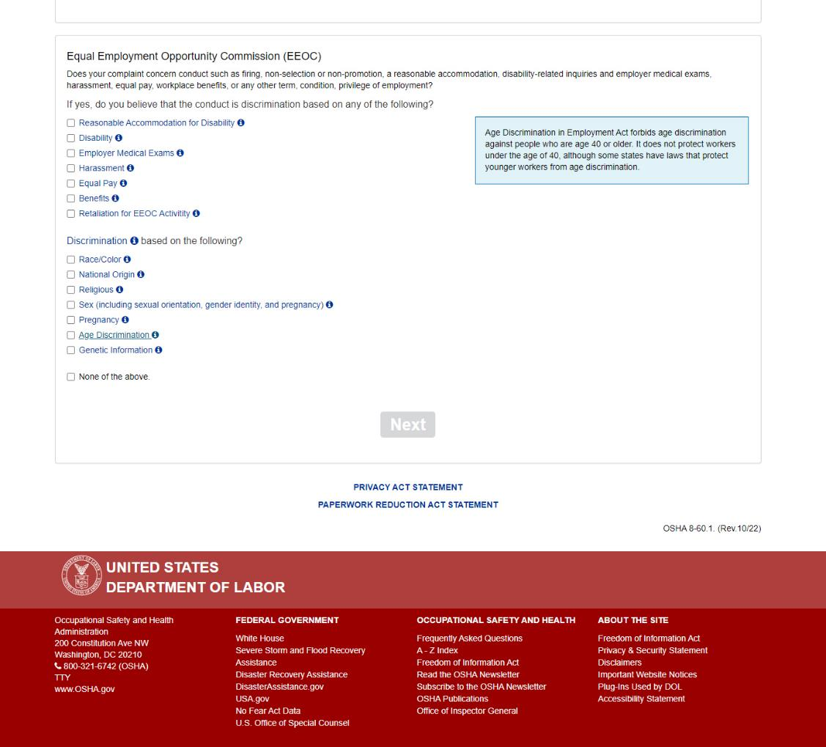
Screen 5: Helper text when the user clicks the hyperlink for “Age discrimination.”
It reads: “Age Discrimination in Employment Act forbids age discrimination against people who are age 40 or older. It does not protect workers under the age of 40, although some states have laws that protect younger workers from age discrimination.”

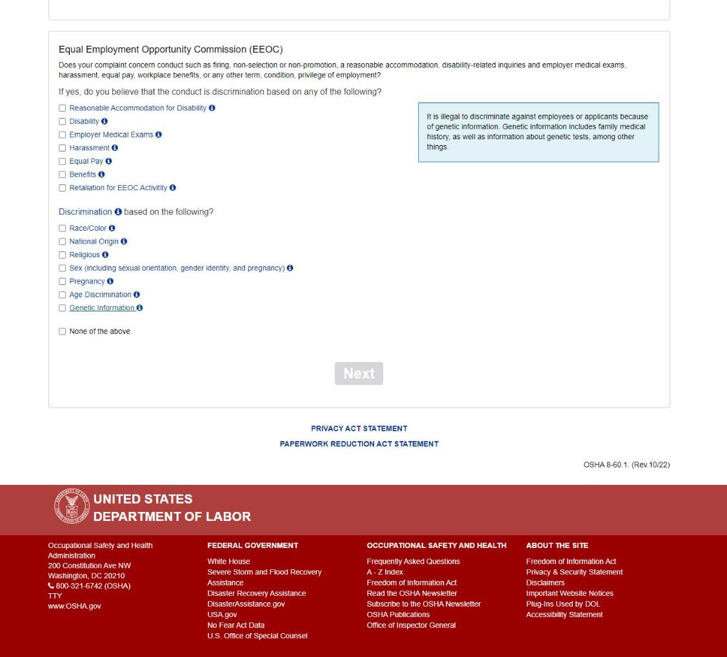
Screen 5: Helper text when the user clicks the hyperlink for “Genetic Information.”
It reads: “It is illegal to discriminate against employees or applicants because of genetic information. Genetic information includes family medical history, as well as information about genetic tests, among other things.”

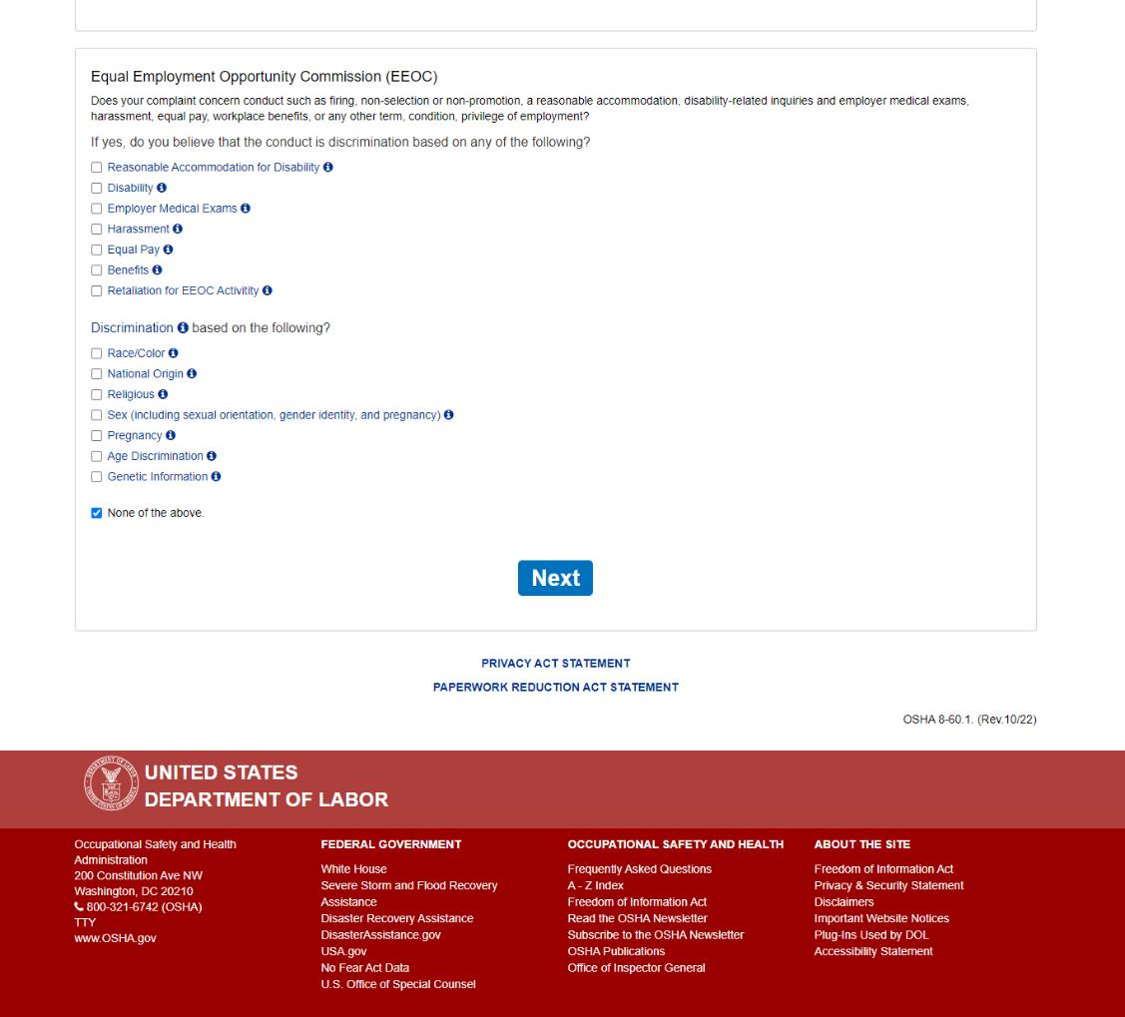
Screen 5: If “None of the above” is checked, the “Next” button becomes available and will display the next section of the questionnaire when clicked.
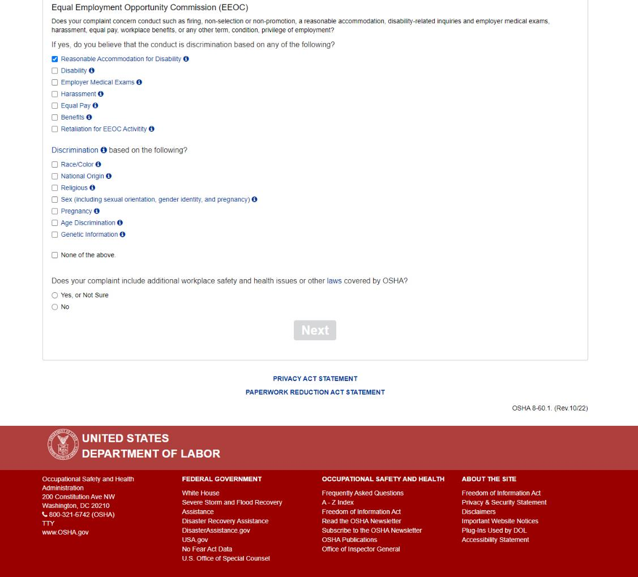
Screen 5: If any other items in the list are checked, a second question is displayed.
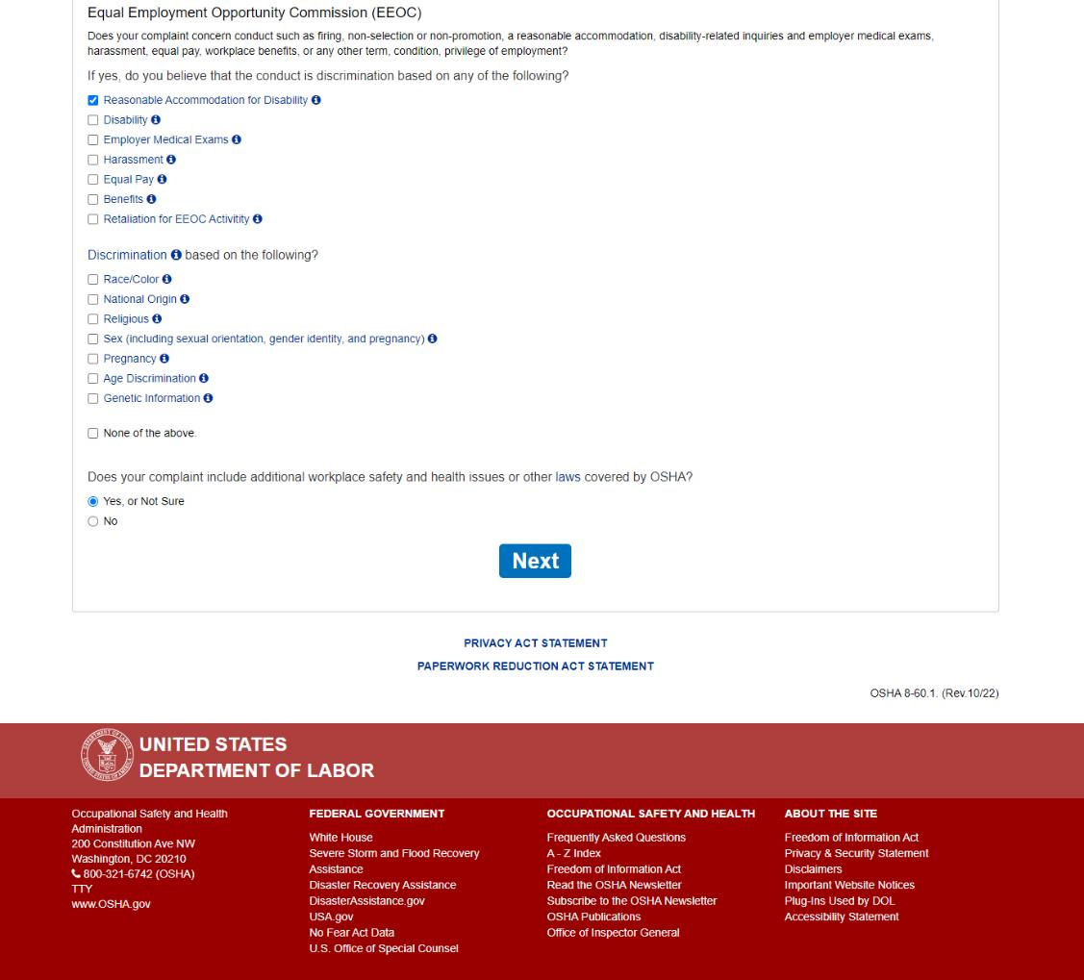
Screen 5: If “Yes, or Not Sure” is selected, the “Next” button becomes available and will display the next section of the questionnaire when clicked.
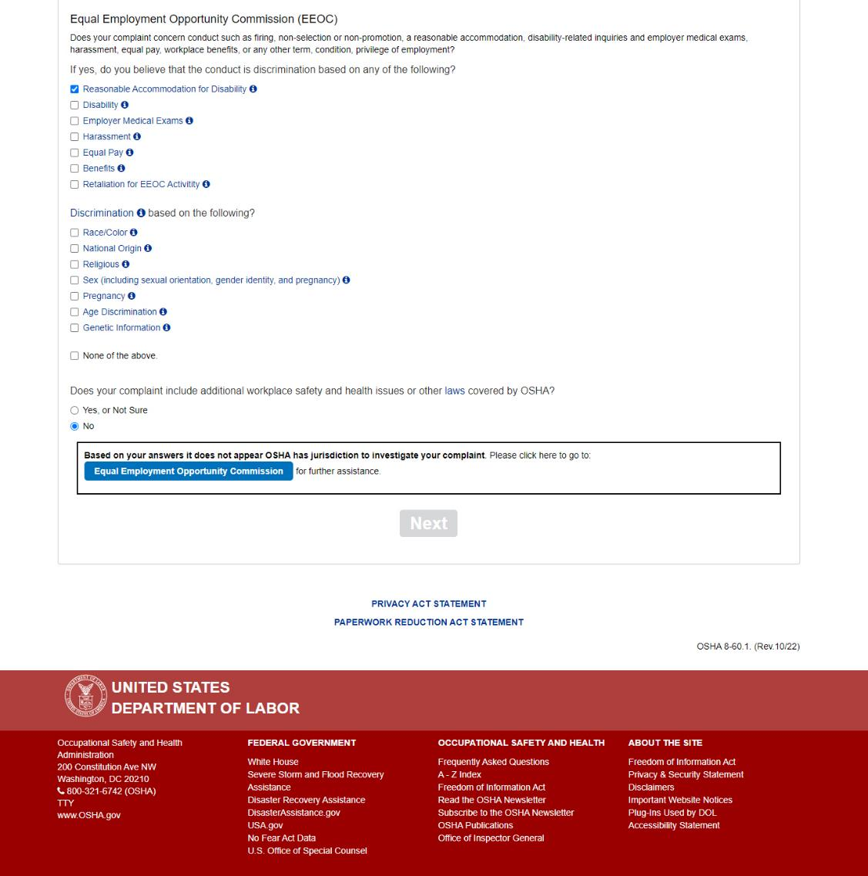
Screen 5: If “No” is selected, the user is informed that OSHA does not have jurisdiction to investigate their complaint. They are instructed to go to the Equal Employment Opportunity Commission for assistance, with a button that takes them to https://www.eeoc.gov/.
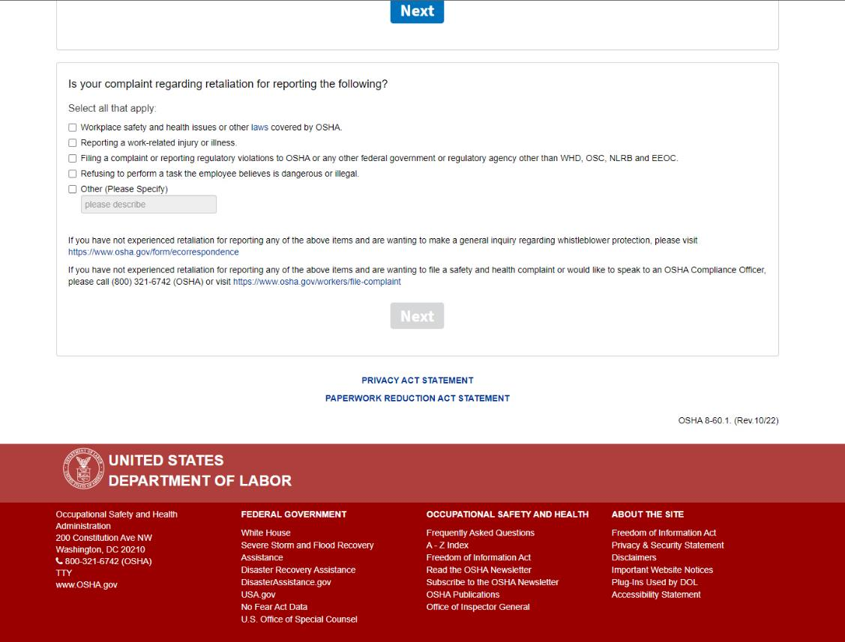
Screen 6: The final section of the questionnaire asks the type of retaliation the user is reporting.

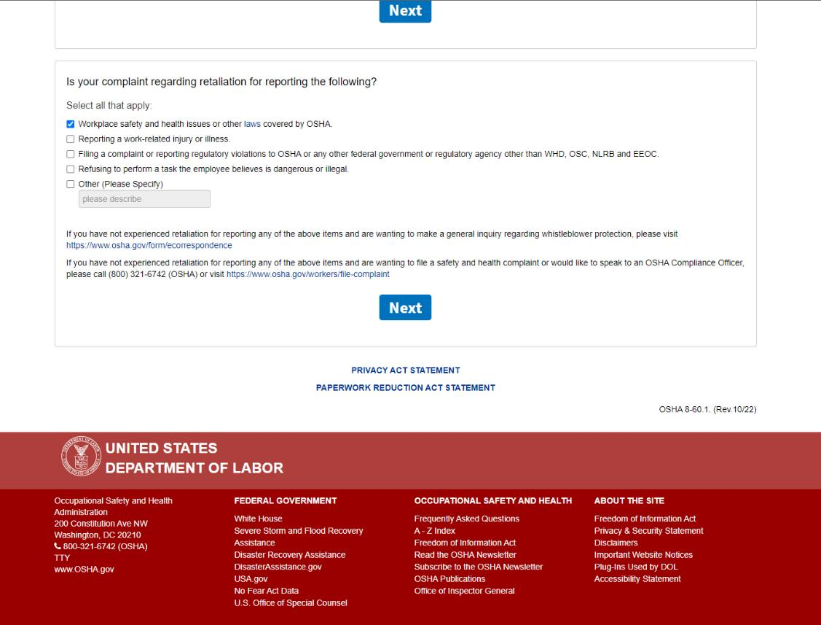
When any item in the list is checked, the “Next” button becomes available. This will launch the Whistleblower Complaint Form when clicked.
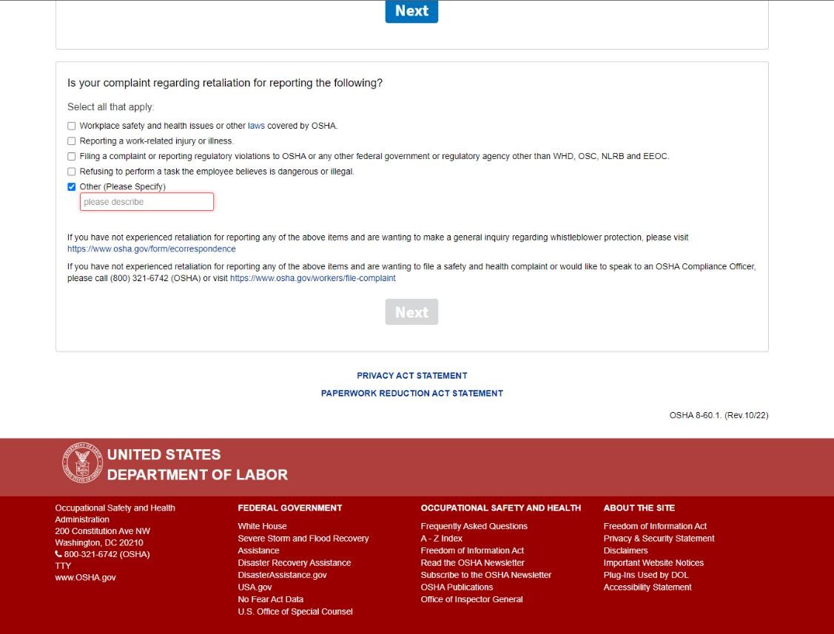
Screen 6: If “Other” is checked, the “Please Describe” text box is enabled, and the “Next” button is disabled until it is completed.
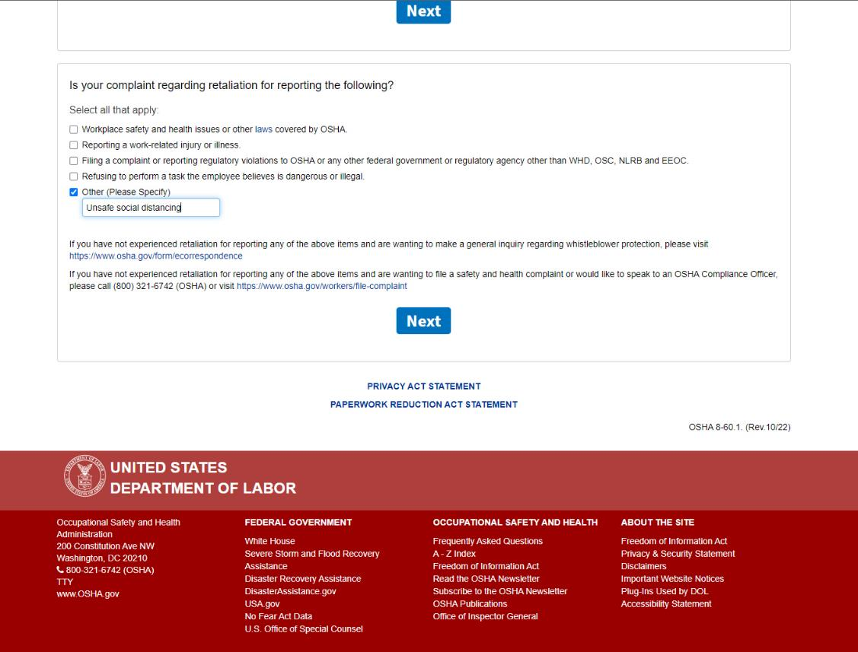
Screen 6: Entering text in the “Please Describe” text box will enable the “Next” button.
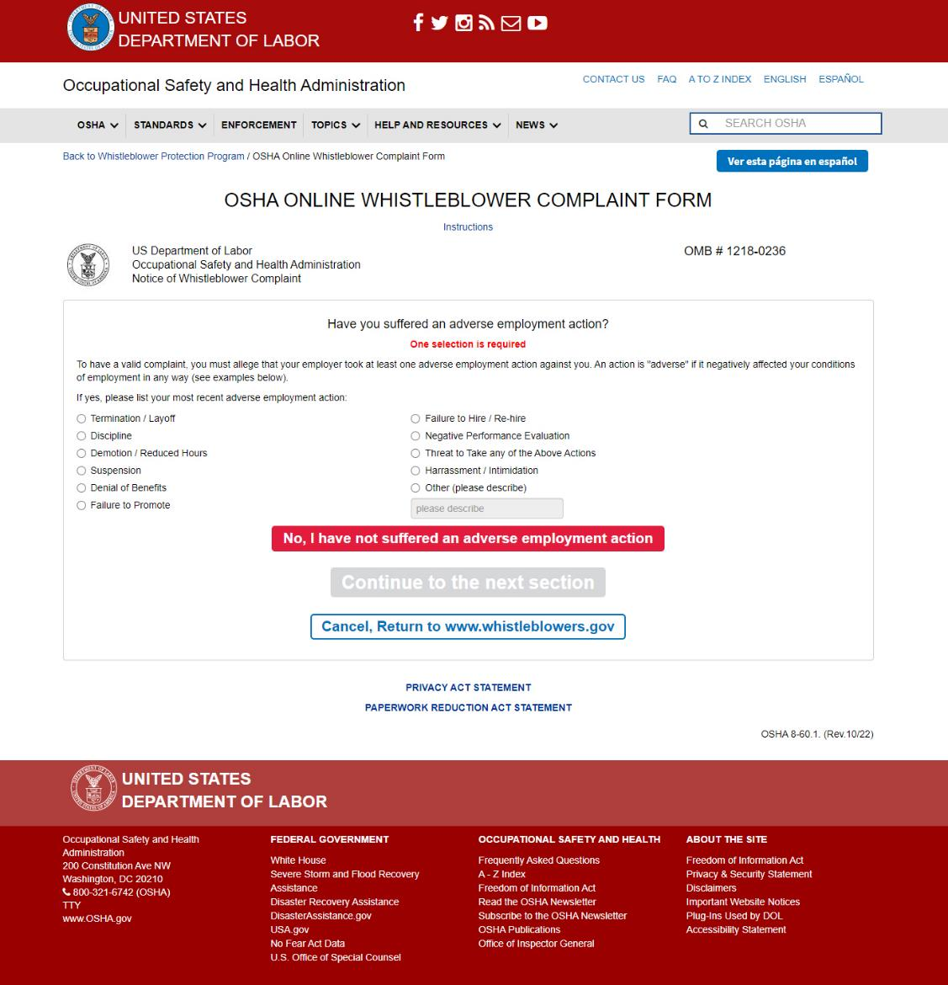
Screen 7: “Have you suffered an adverse employment action?”
The user is required to select their most recent adverse employment action.
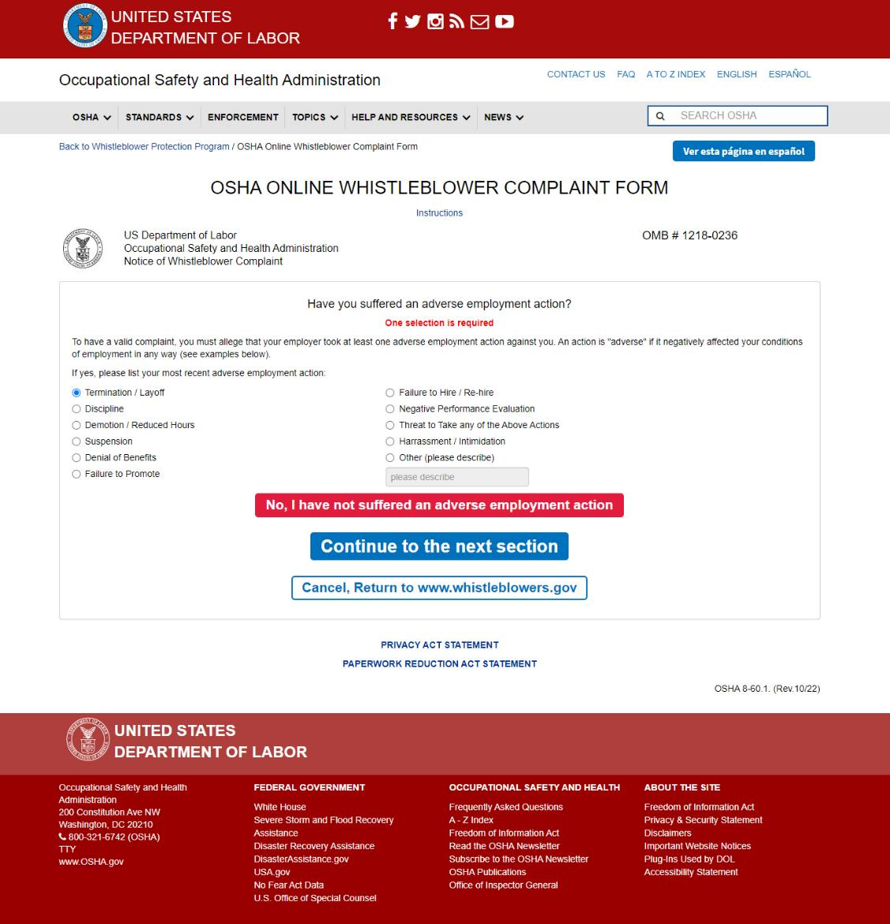
Screen 7: One selection is required to enable the “Continue to the next section” button. A user can only make one selection from this list and cannot move forward in the form without selecting an adverse action.

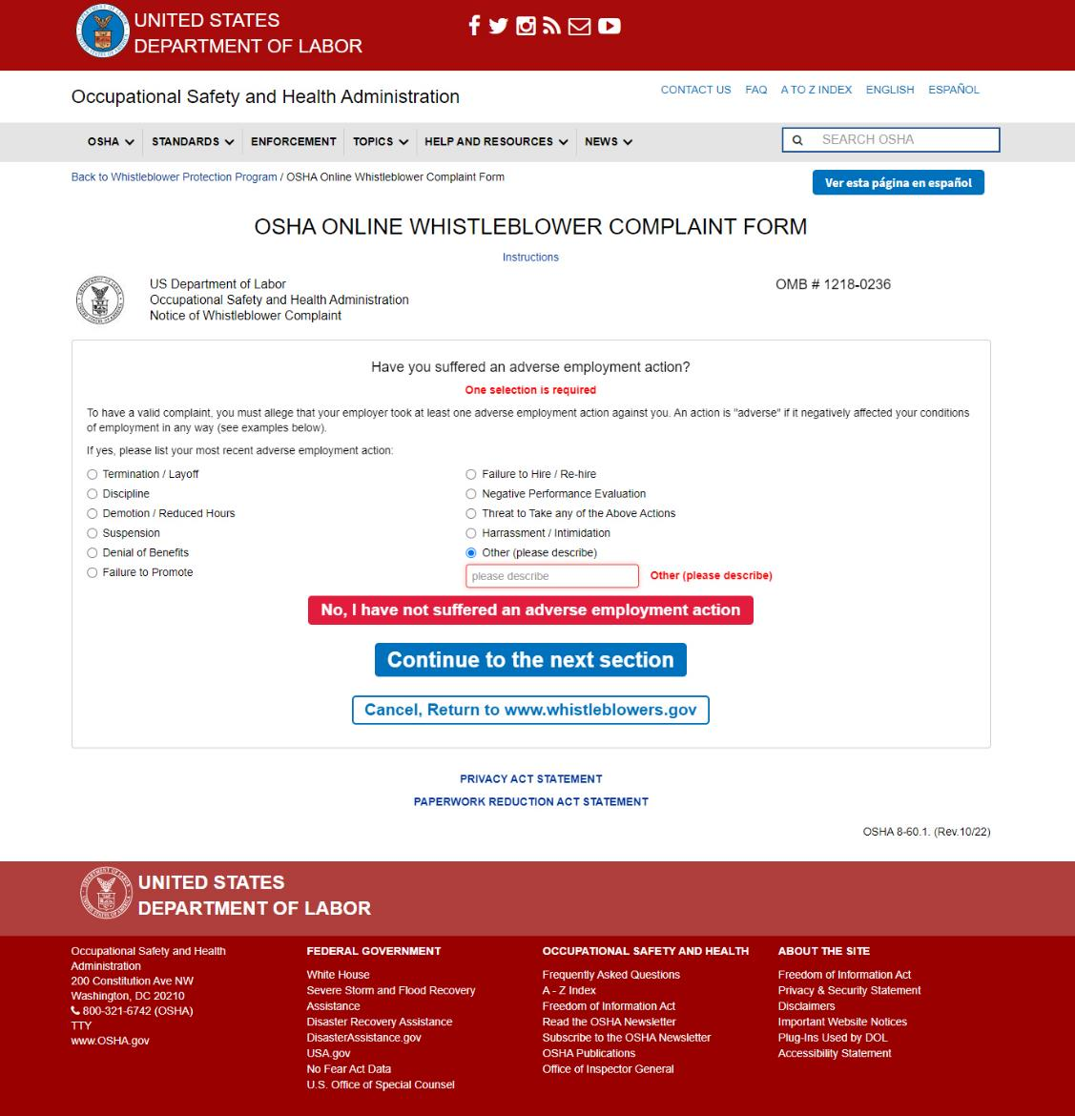
Screen 7: If “Other” is checked, the “Please Describe” text box is enabled, and the user will not be permitted to continue the form until it is completed. Required description field notated in red.

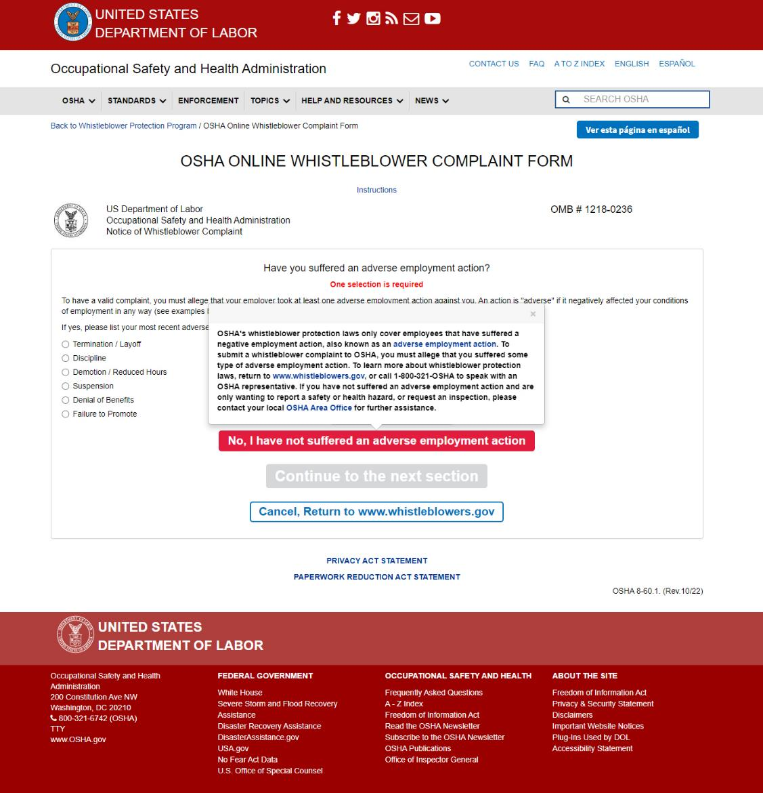
Screen 7: When “No, I have not suffered an adverse employment action” is clicked, the following displays above the button:
“OSHA's whistleblower protection laws only cover employees that have suffered a negative employment action, also known as an adverse employment action. To submit a whistleblower complaint to OSHA, you must allege that you suffered some type of adverse employment action. To learn more about whistleblower protection laws, return to www.whistleblowers.gov, or call 1-800-321-OSHA to speak with an OSHA representative. If you have not suffered an adverse employment action and are only wanting to report a safety or health hazard, or request an inspection, please contact your local OSHA Area Office for further assistance.”
Hovering over “adverse employment action” displays the following helper text: “An action is an adverse employment action if a reasonable employee would have found the action materially adverse, which means it might have dissuaded a reasonable worker from engaging in a protected activity.”
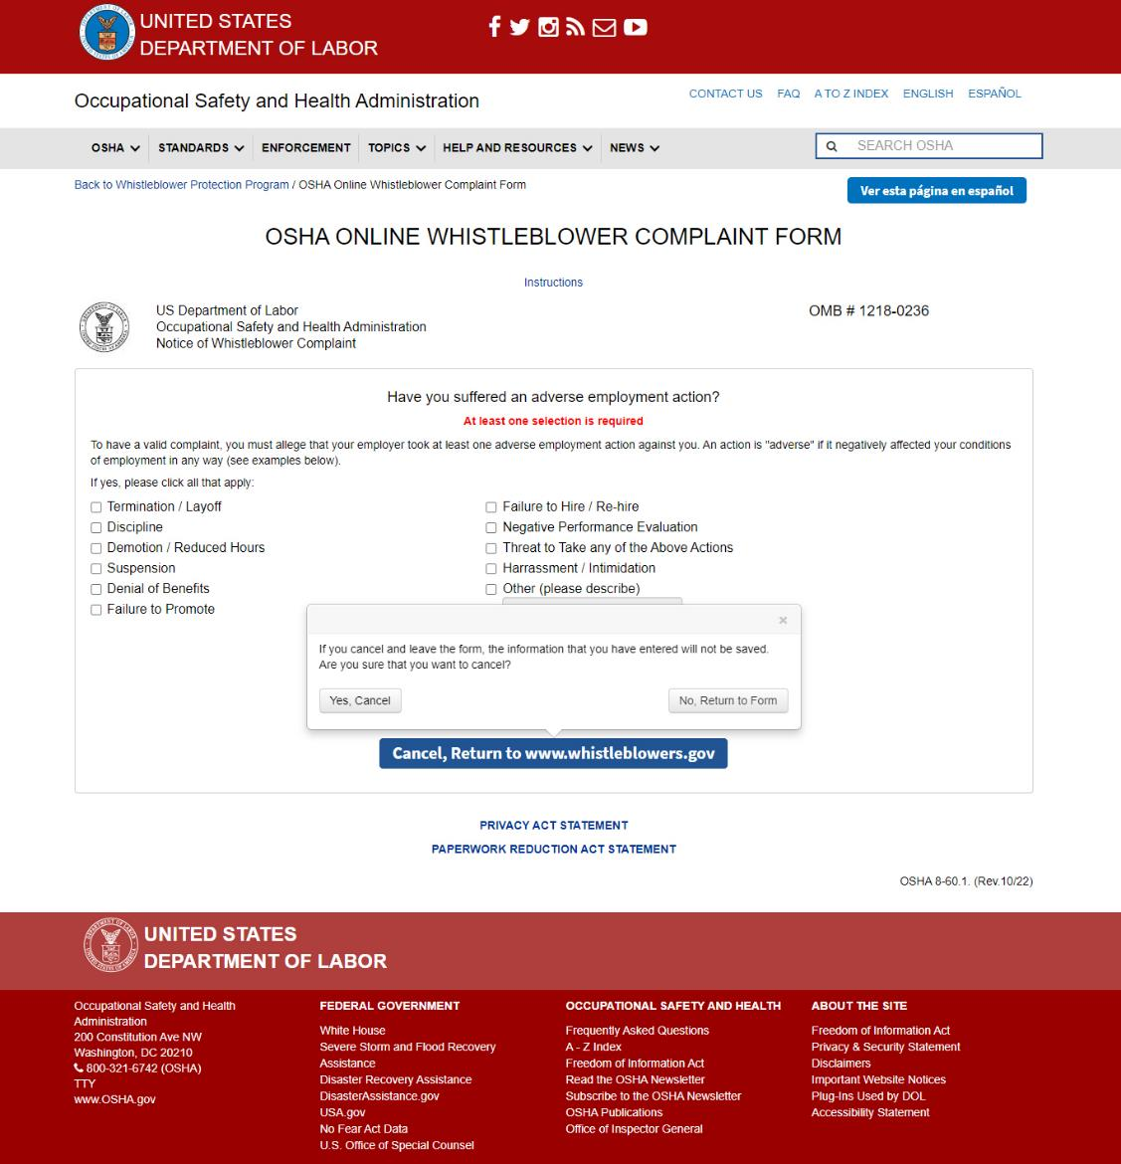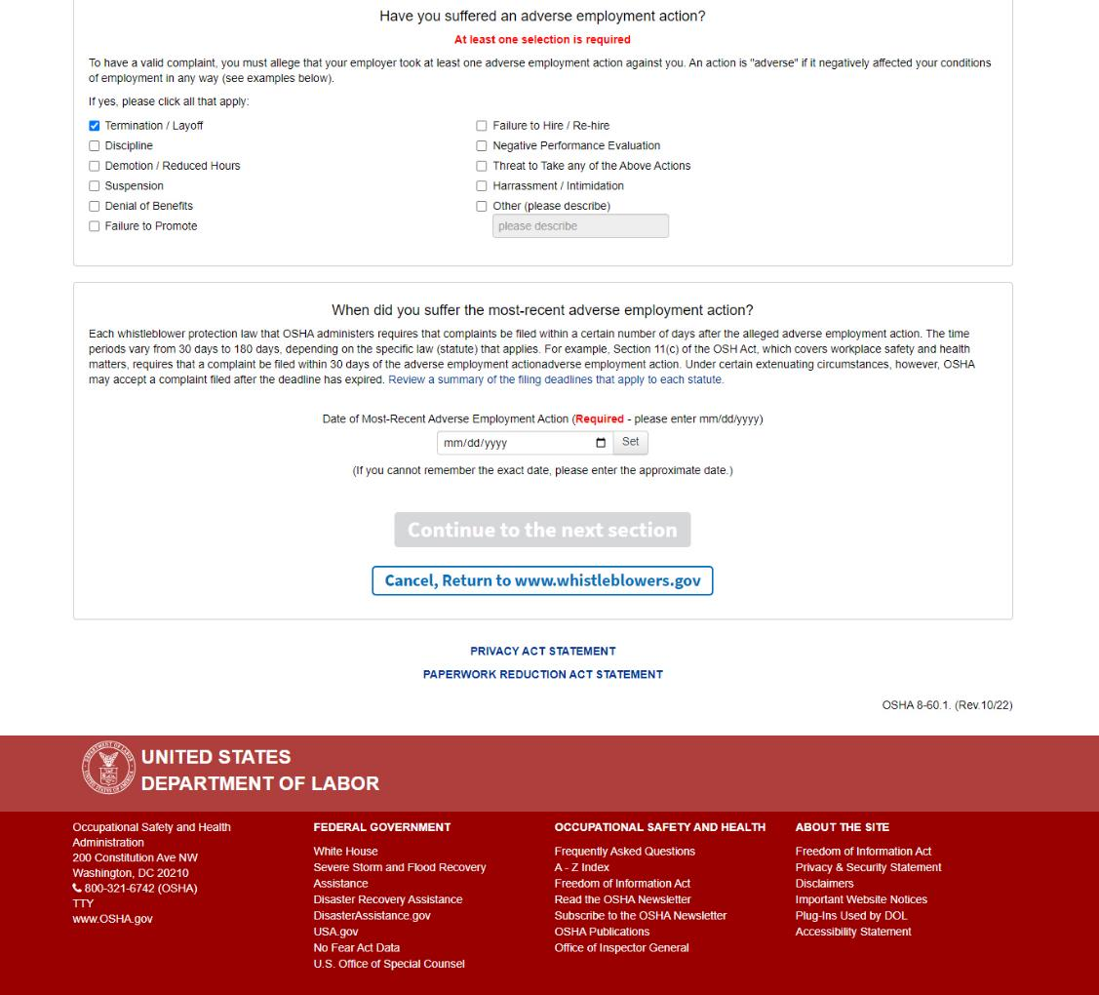
Screen 7: In all cases in this form, when the user clicks “Cancel, Return to www.whistleblowers.gov”, a the following is displayed above the button:
“If you cancel and leave the form, the information that you have entered will not be saved. Are you sure that you want to cancel?”
If the user selects: “Yes, Cancel”, they are redirected to www.whistleblowers.gov. If they select “No, return to form” the popover box closes, and they can continue with the form.
Screen 8: “When did you suffer the most-recent adverse employment action?”
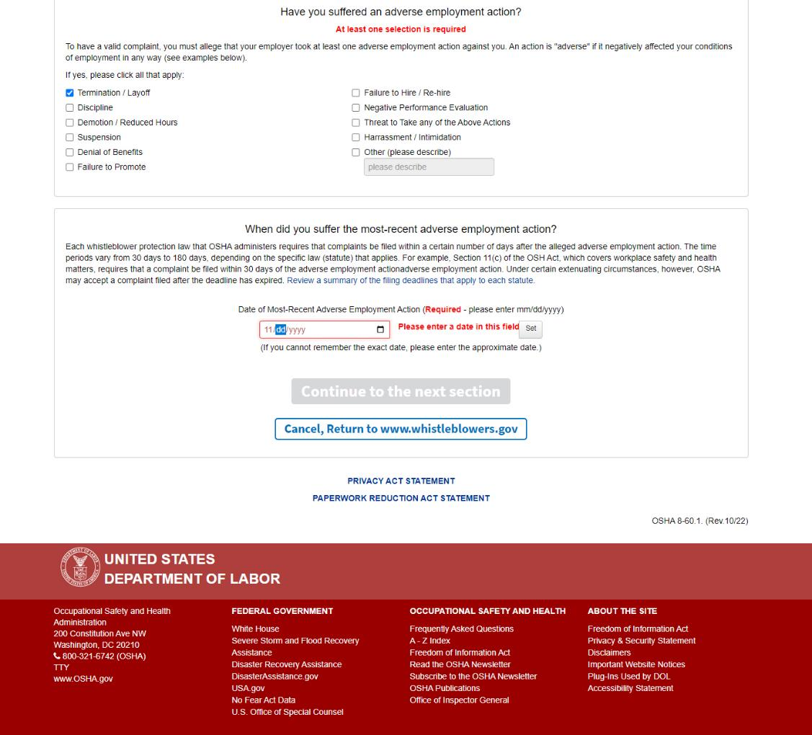
Screen 8: Existing required date field and format notated in red.

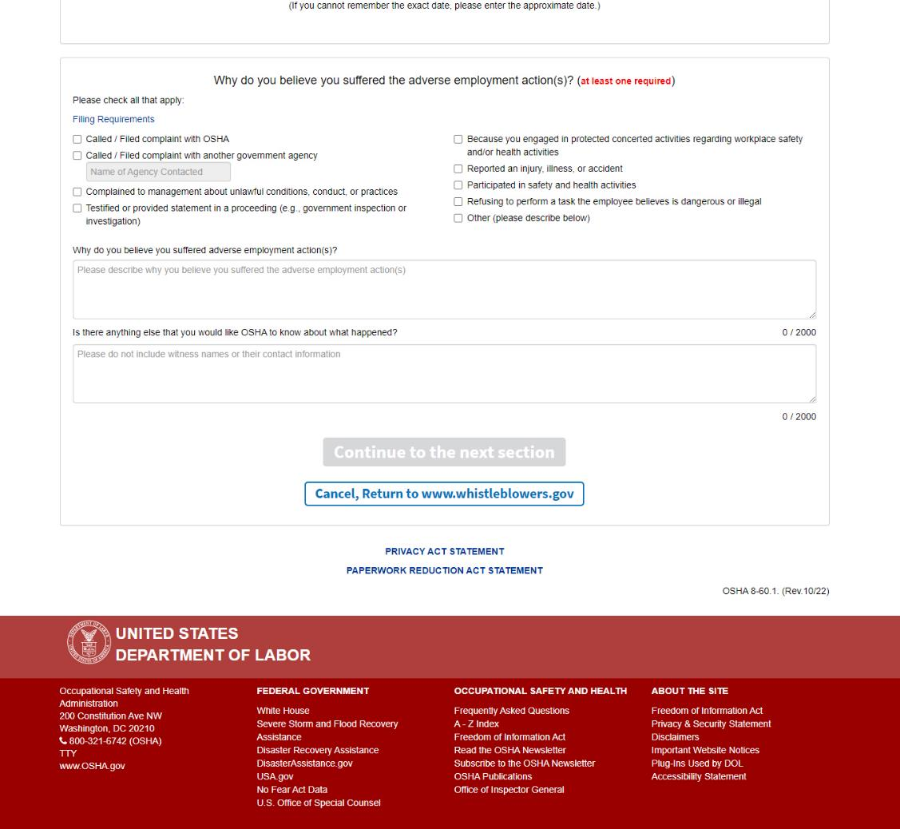
Screen 9: “Why do you believe you suffered adverse employment action(s)?”
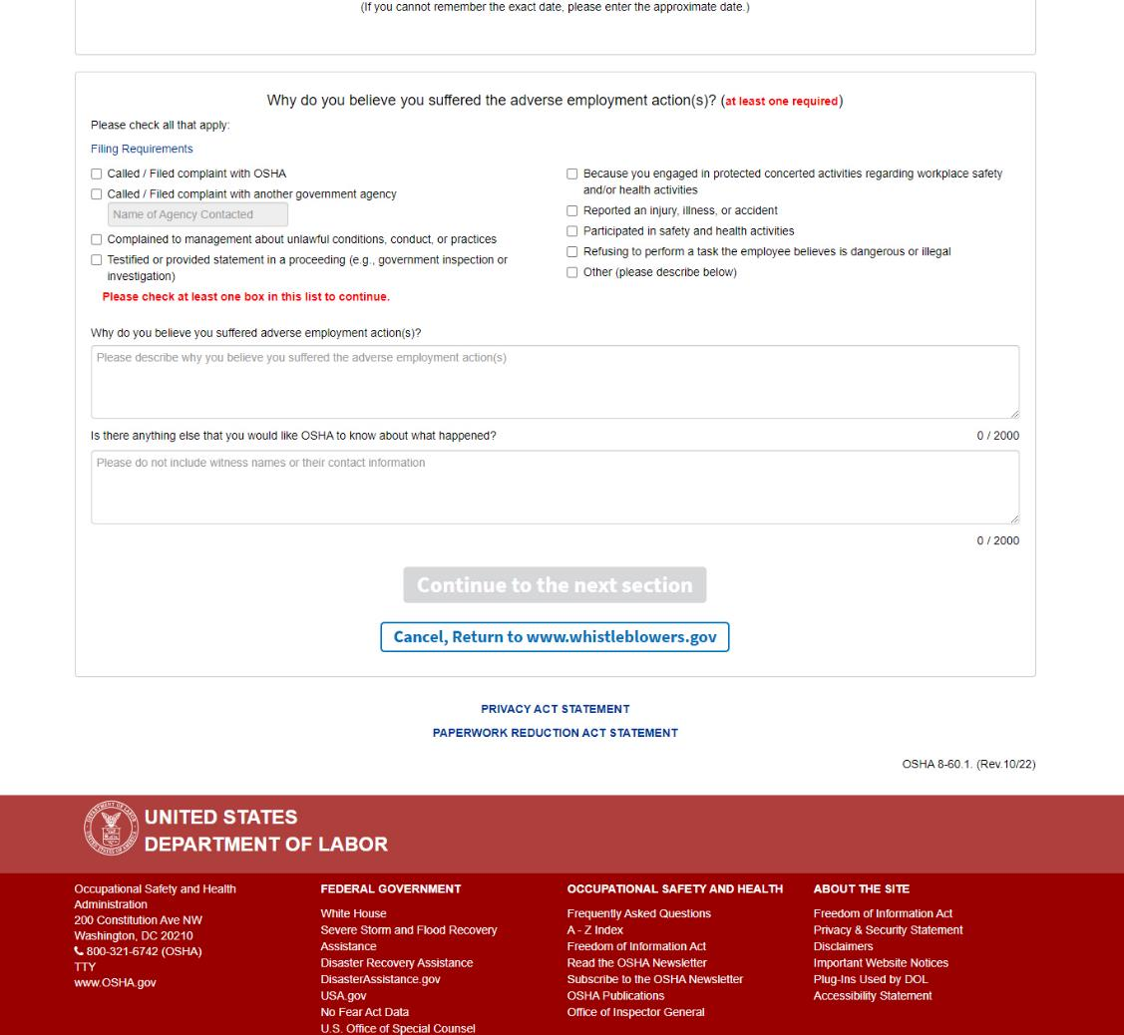
Screen 9: Required selection notated in red.

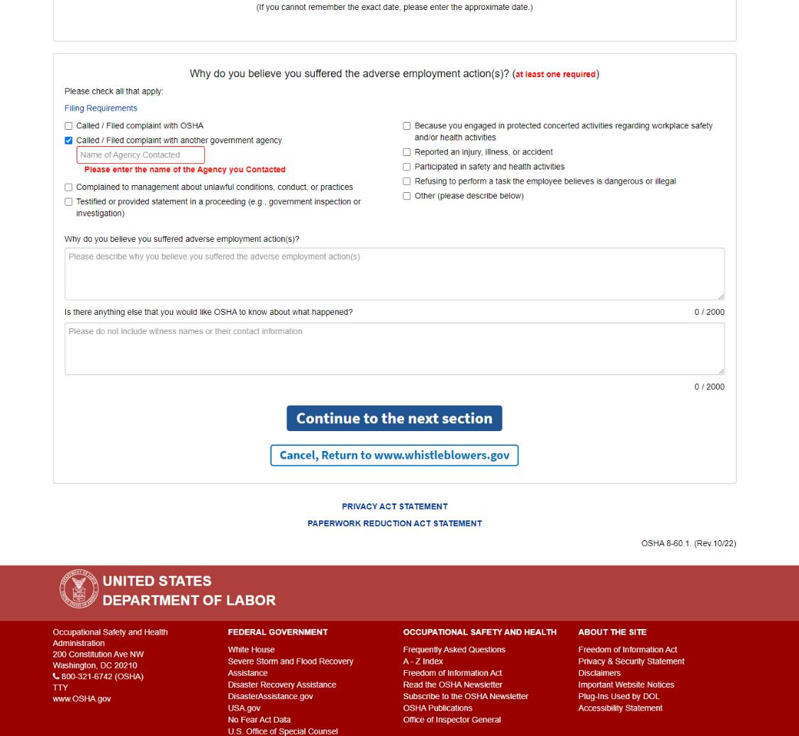
Screen 9: Existing required description notated in red.

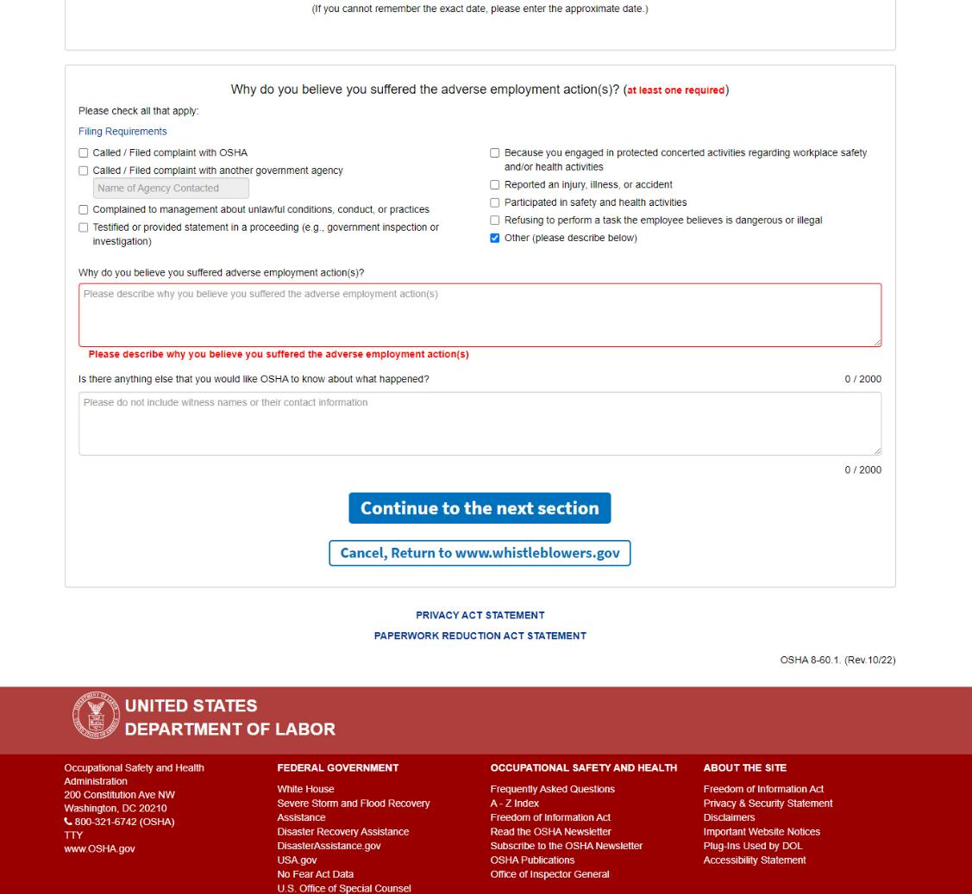
Screen 9: Existing required description notated in red.

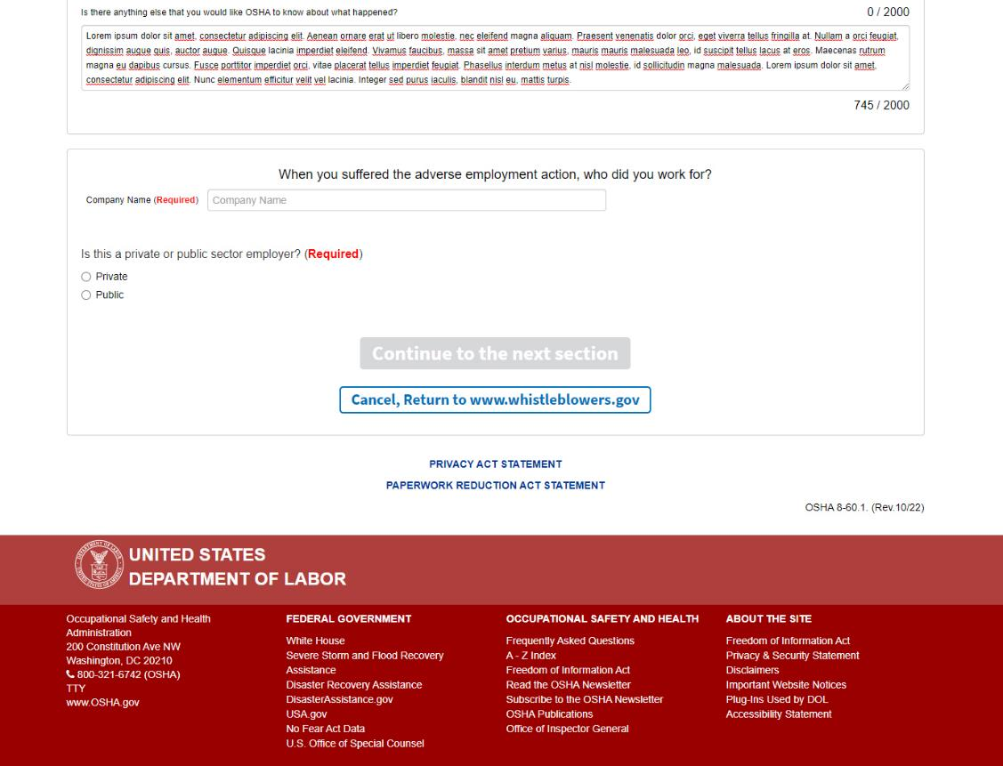
Screen 10: “When you suffered the adverse employment action, who did you work for?”
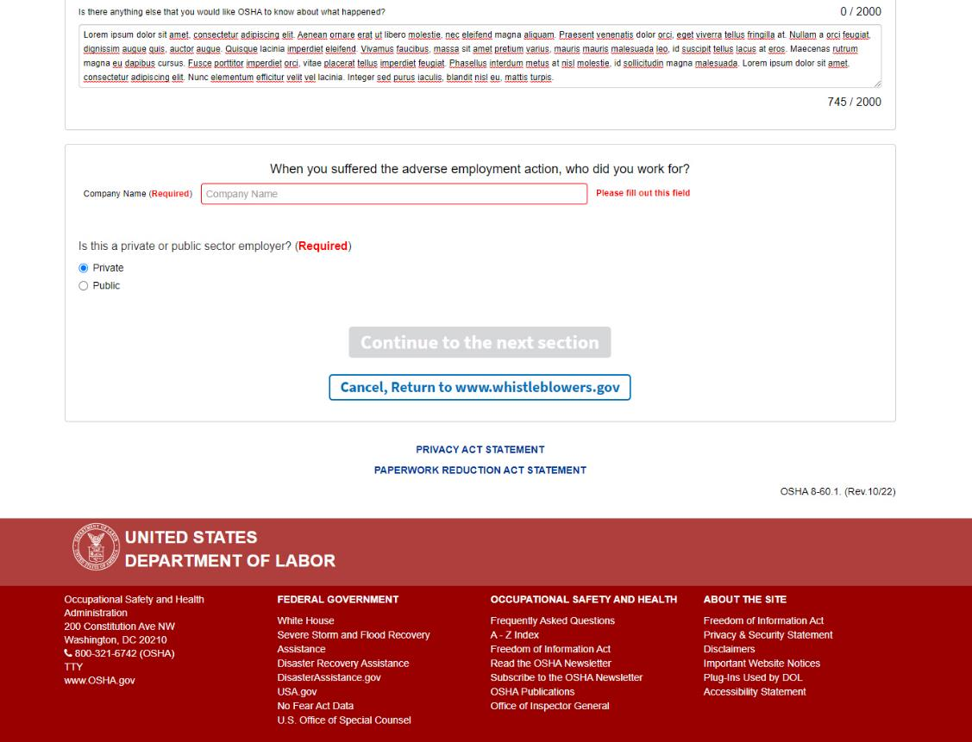
Screen 10: Existing required fields noted in red.
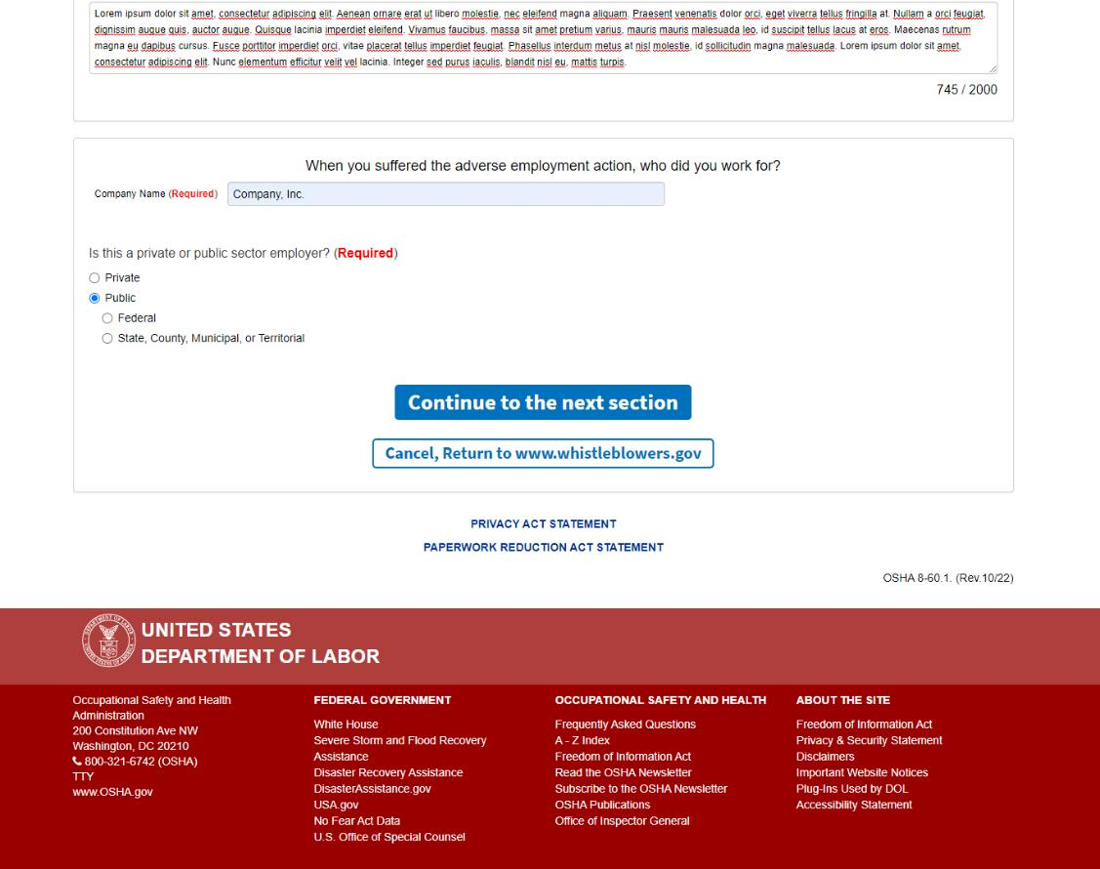
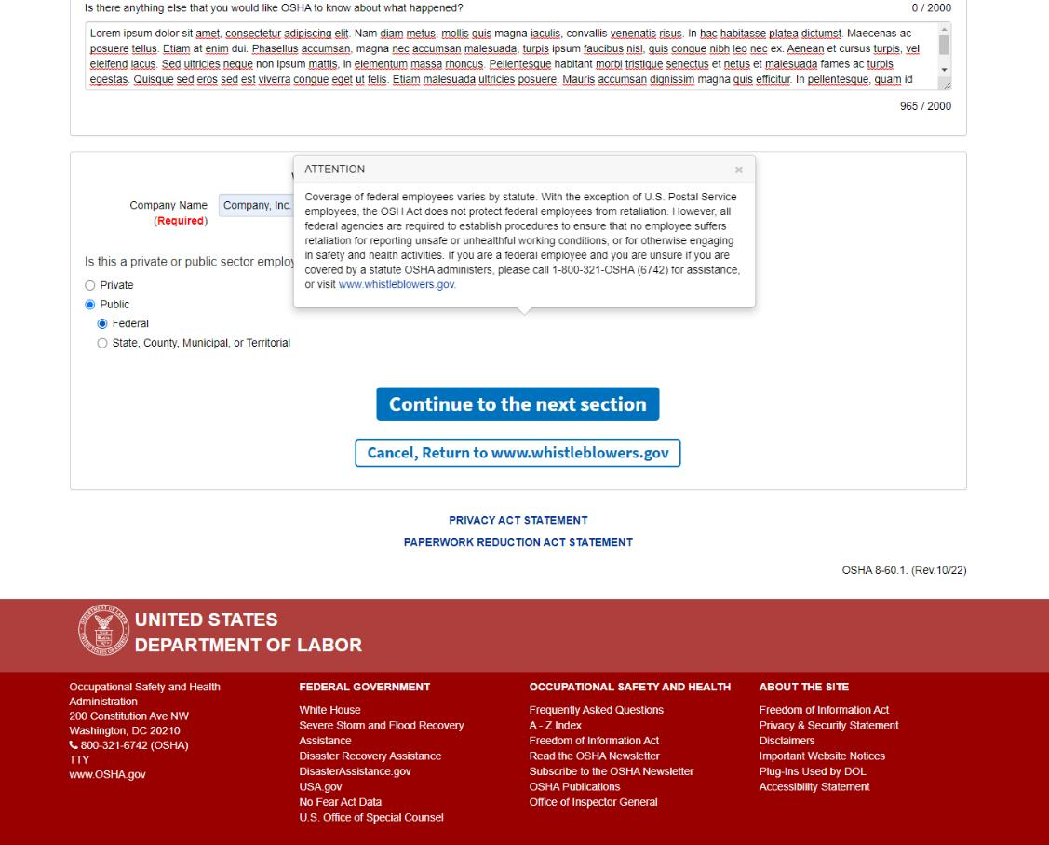
Screen 10: When “Public” is selected, the user is required to select either “Federal” or “State, County, Municipal, or Territorial” before they can move on to the next screen.
Screen 10: When “Federal” is selected, text displays regarding coverage of federal employees against retaliation actions and provides additional information and links to the Office of Special Council, OSHA’s Office of Federal Agency Programs, and whistleblowers.gov.
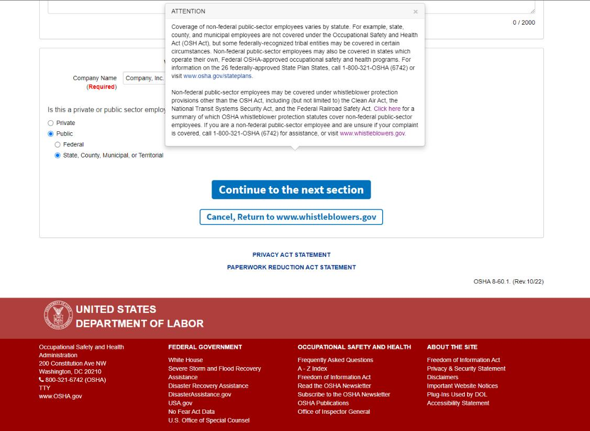
Screen 10: When “State, County, Municipal, or Territorial” is selected, text displays regarding state plans and directs the user to the Office of State Plans page.
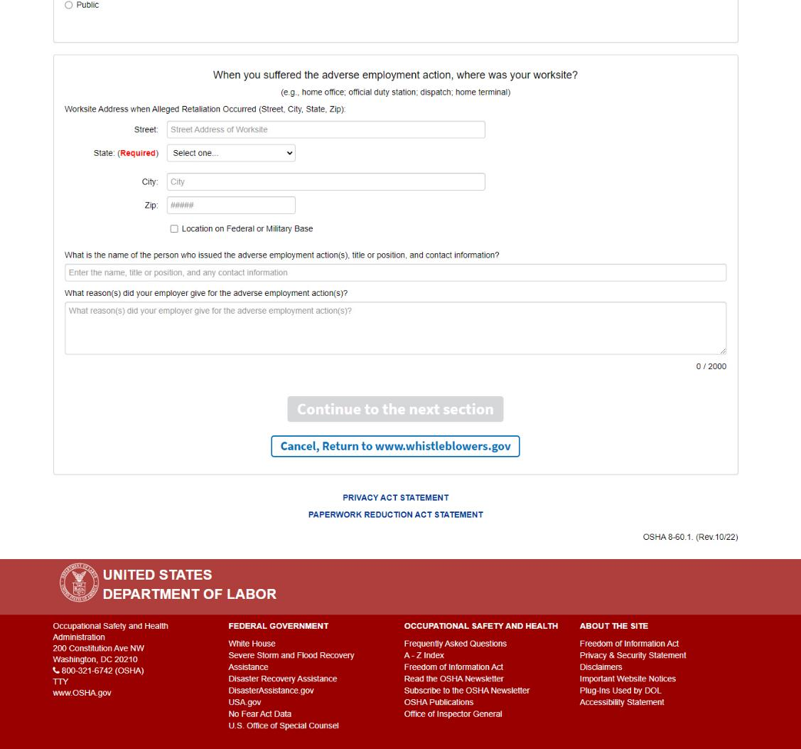
Screen 11: “When you suffered the adverse employment action, where was your worksite?”
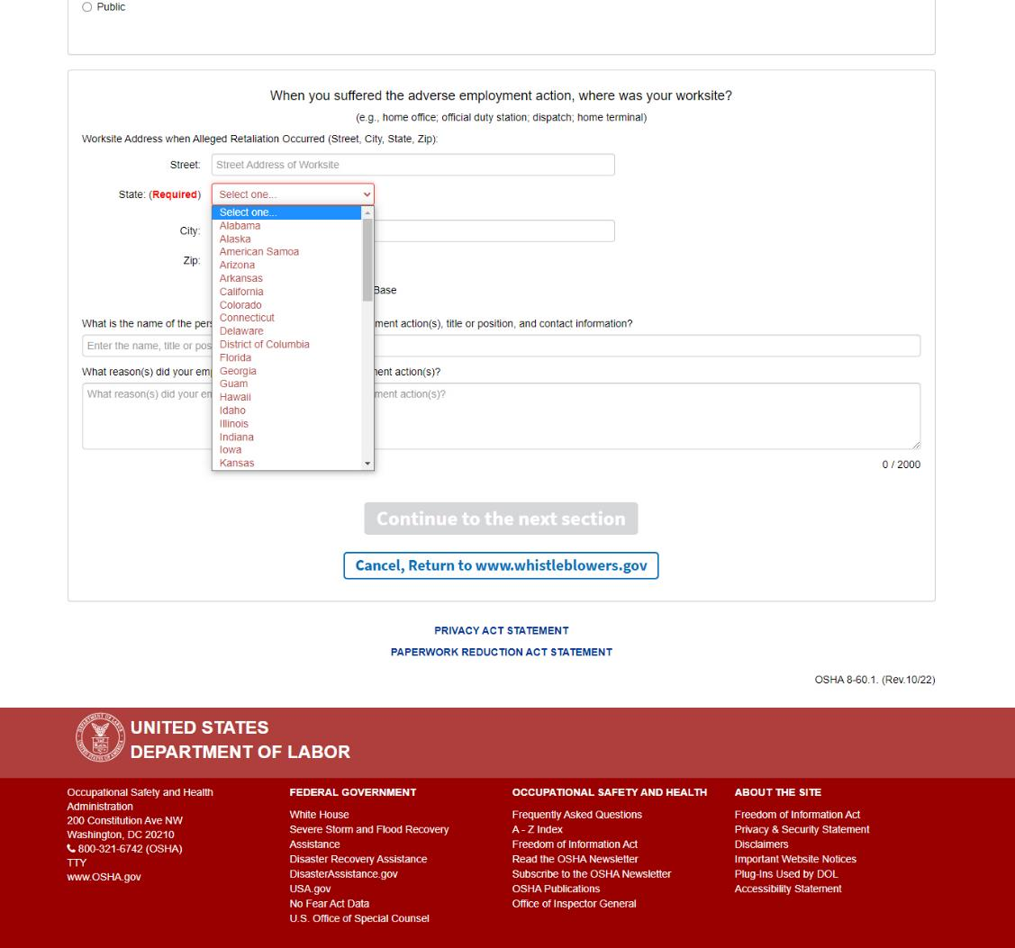
Screen 11: Required field notated in red.
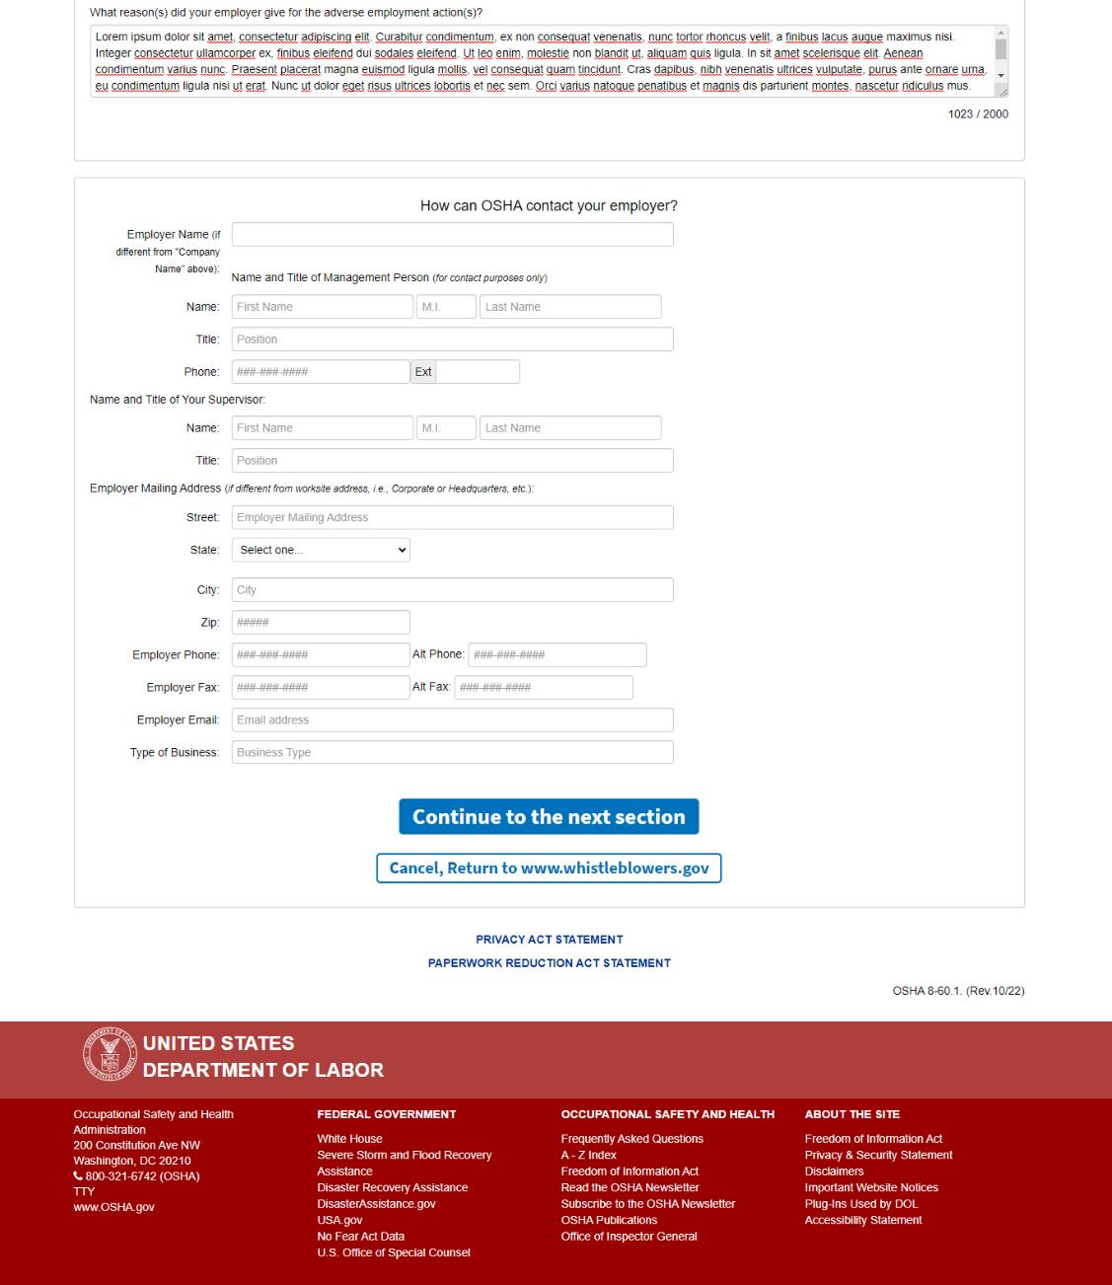
Screen 12: “How can OSHA contact your employer?”
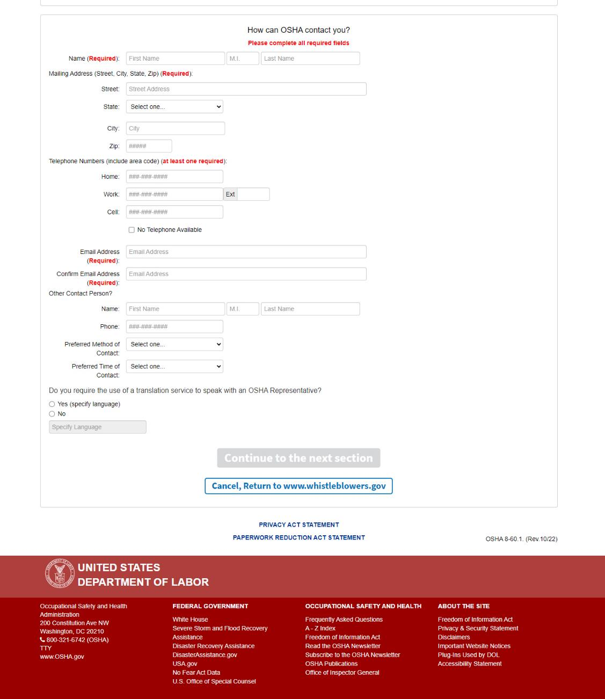
Screen 13: “How can OSHA contact you?”
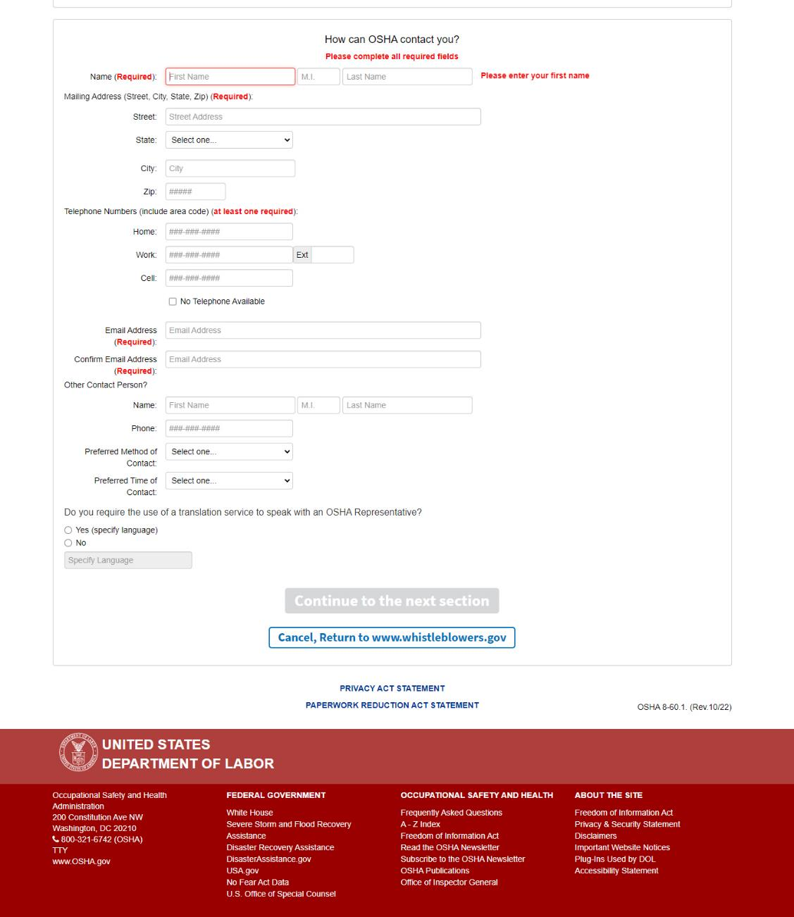
Screen 13: Required fields notated in red.
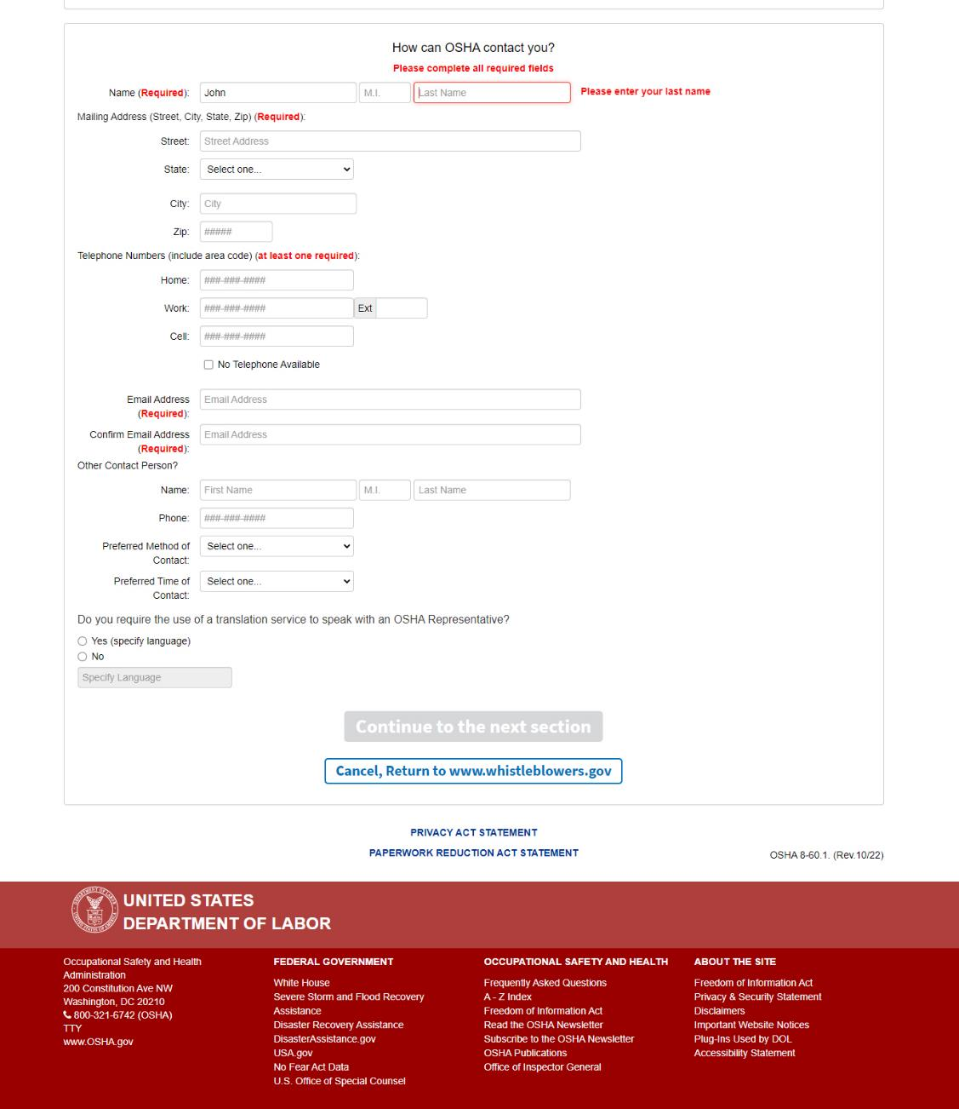
Screen 13: Existing required fields notated in red.
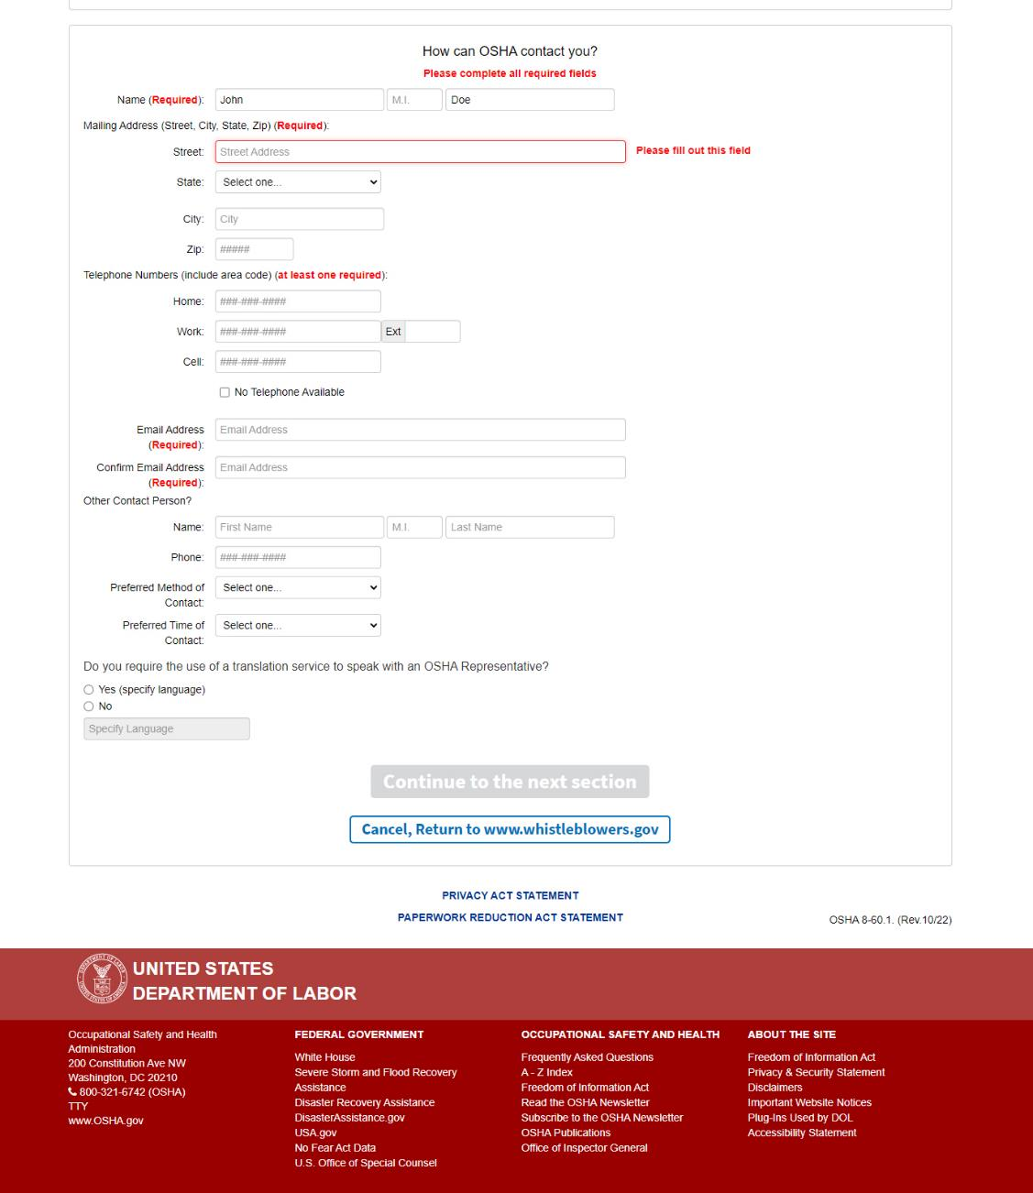
Screen 13: Existing required fields notated in red.
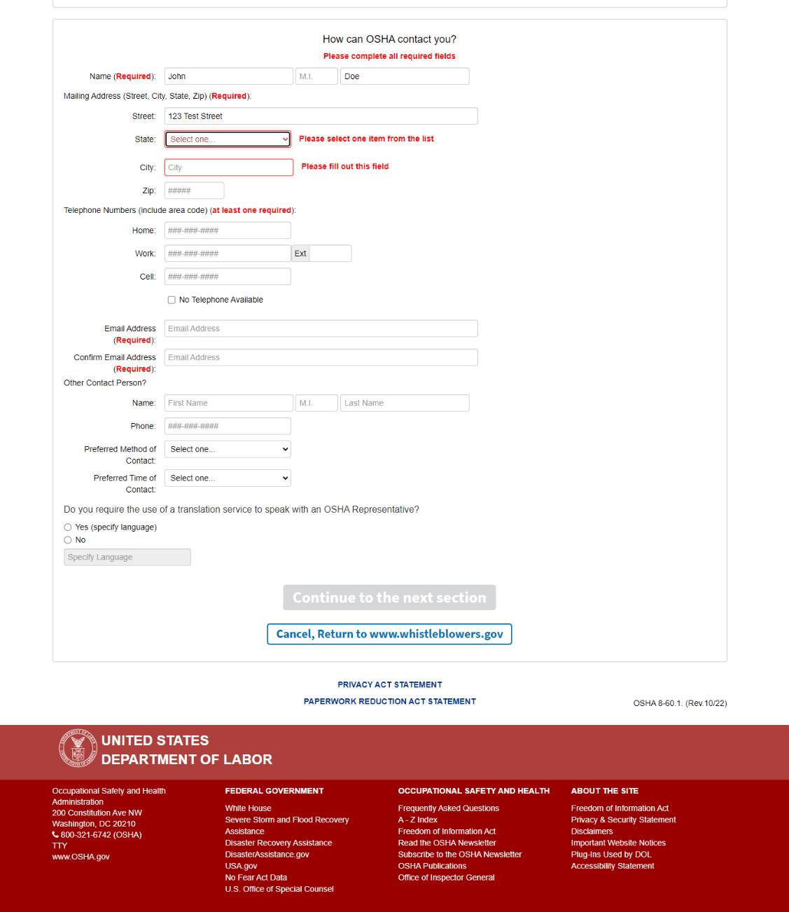
Screen 13: Existing required fields notated in red.
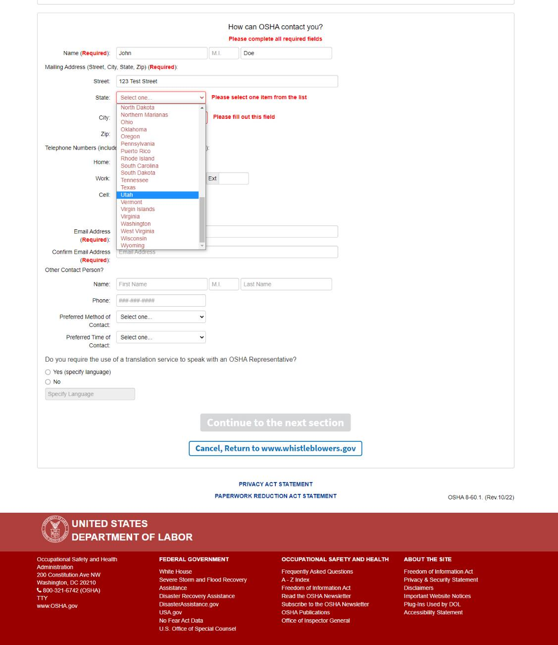
Screen 13: Existing required fields notated in red.
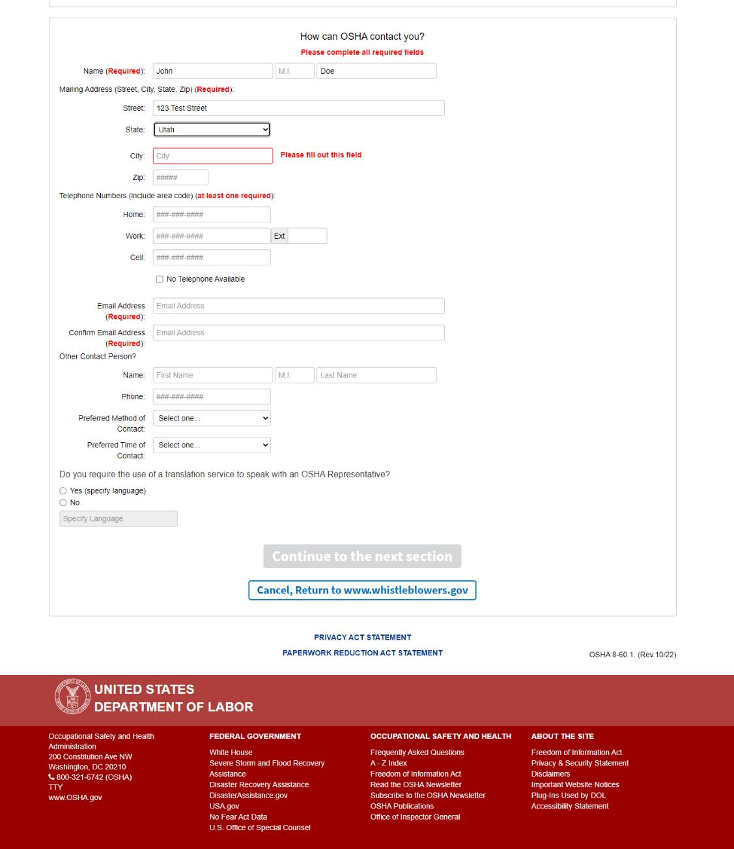
Screen 13: Existing required fields notated in red.
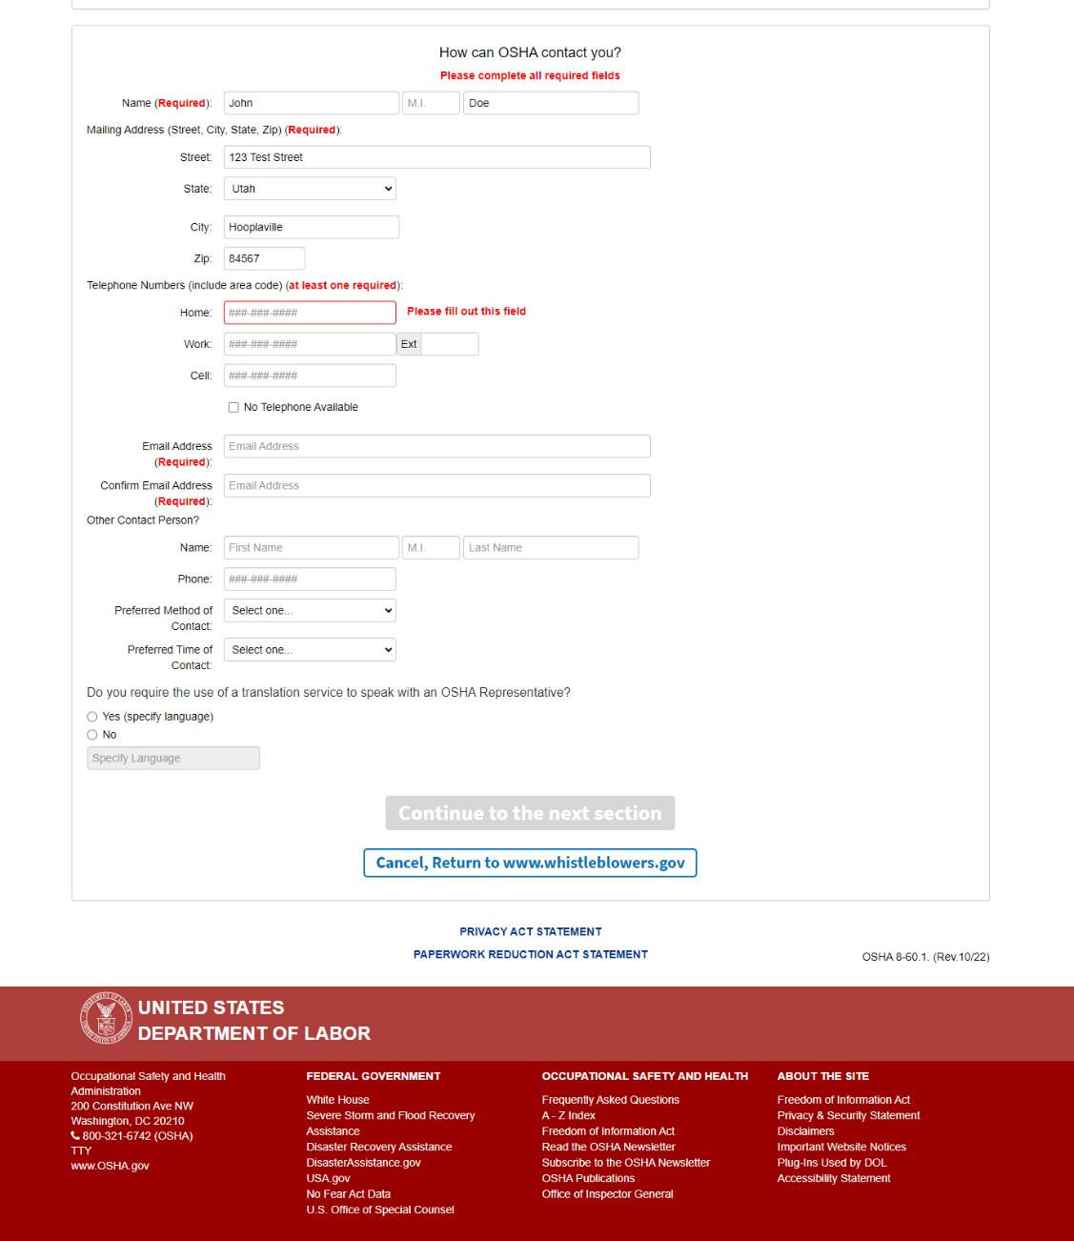
Screen 13: Existing required fields notated in red.
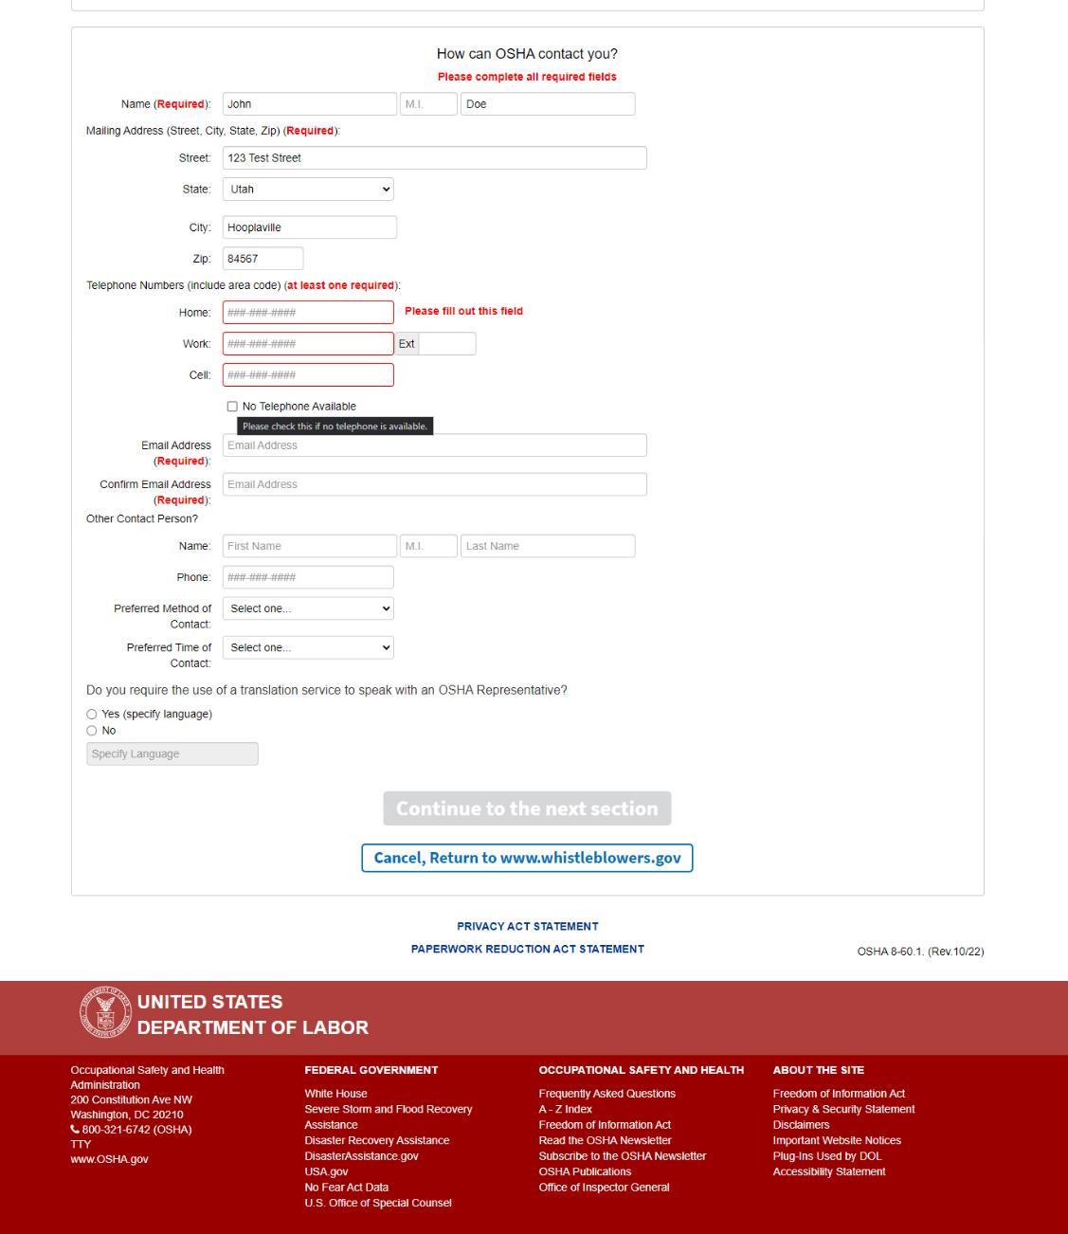
Screen 13: When a user does not populate any one of the 3 telephone number fields, the following text is displayed when the user hovers over the “No Telephone Available” box: “Please check this if no telephone is available.”

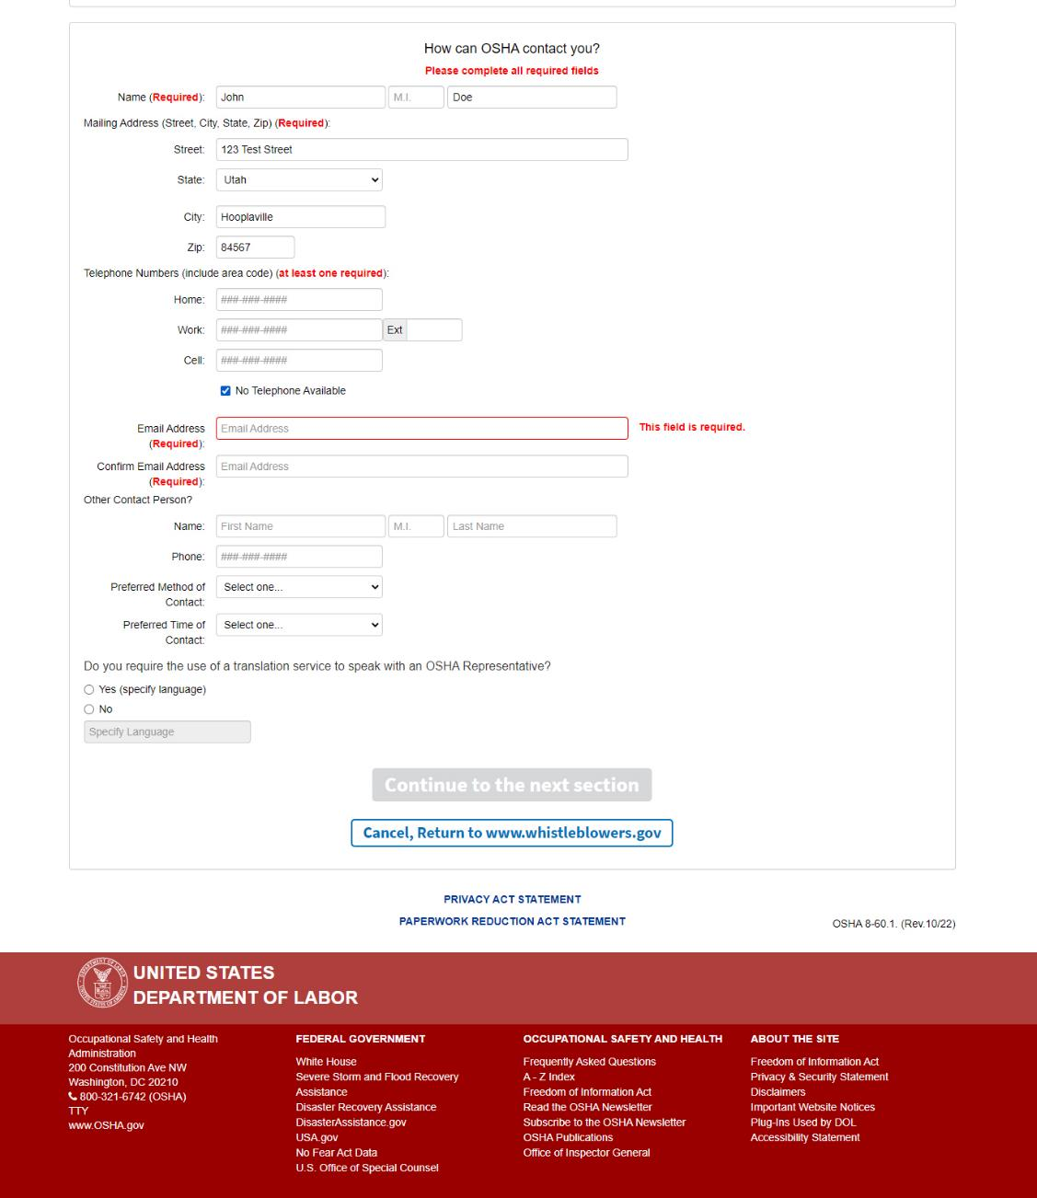
Screen 13: Existing required fields notated in red.
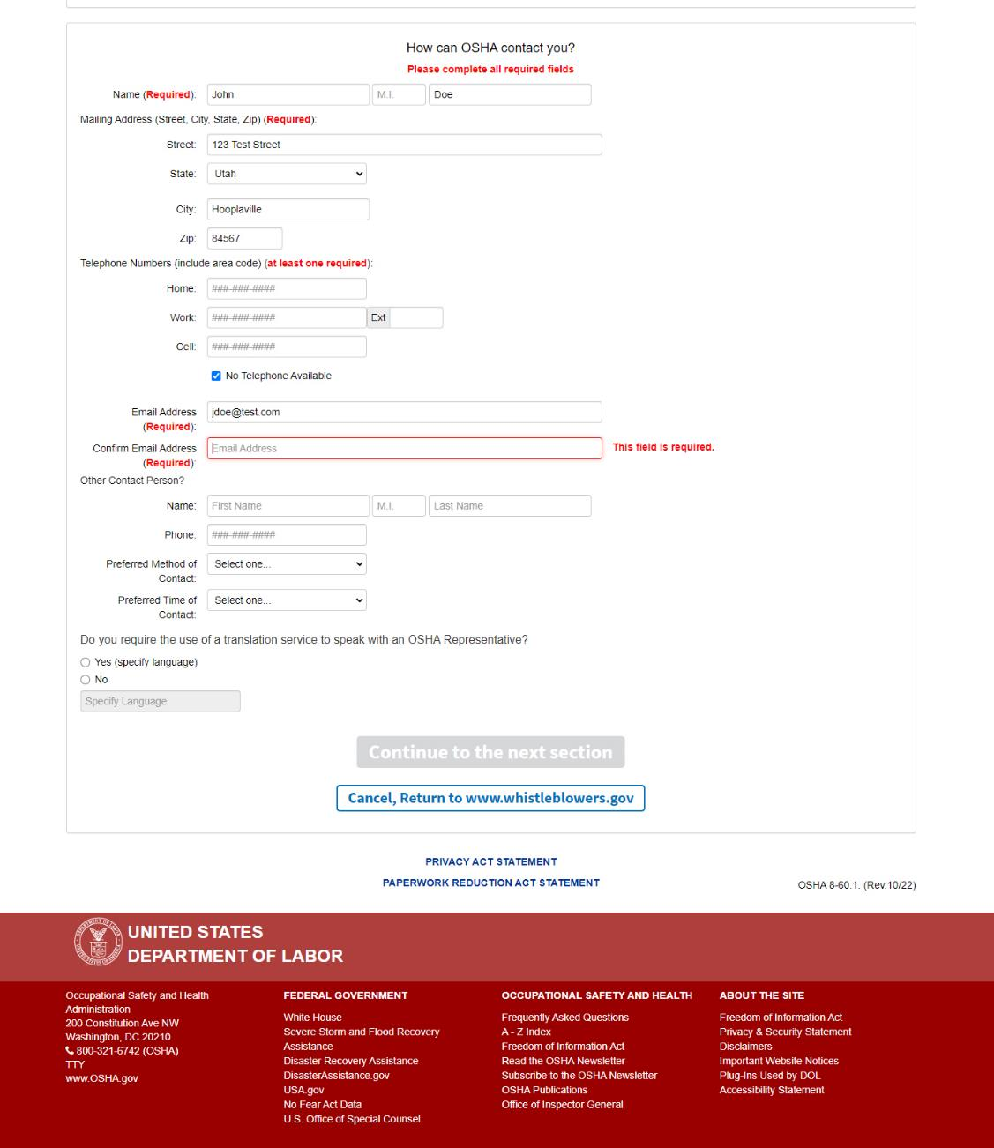
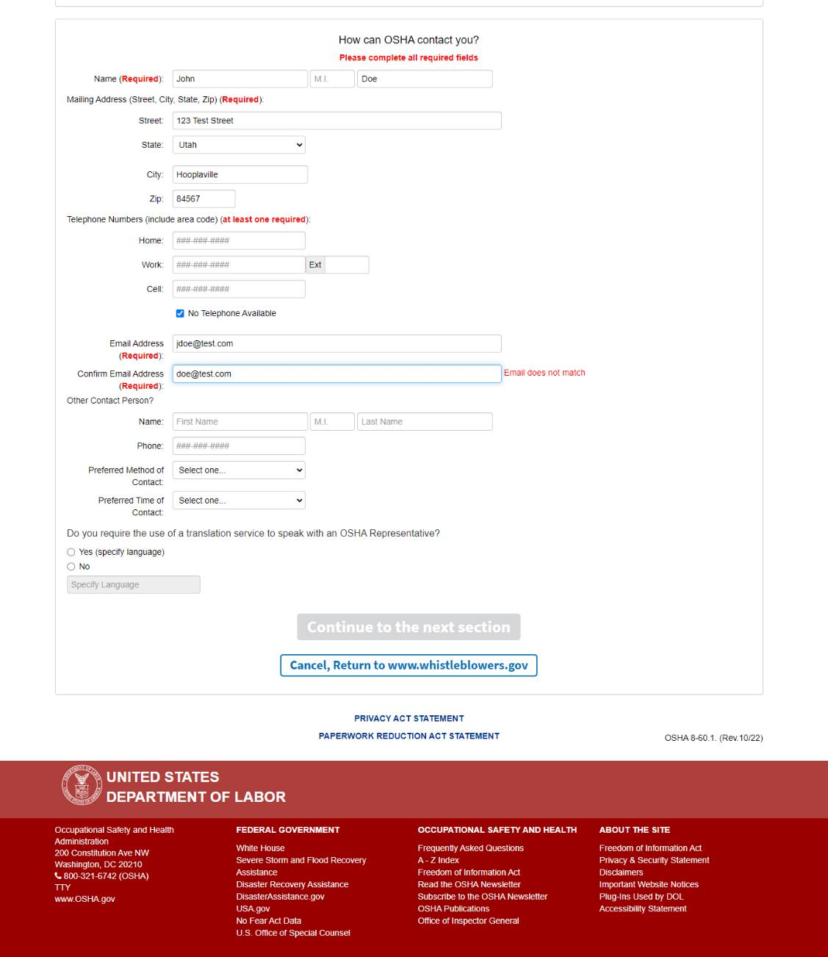
Screen 13: Existing required fields notated in red.
Screen 13: The user is required to confirm their email address. If the addresses do not match, “Email does not match” is displayed in red.
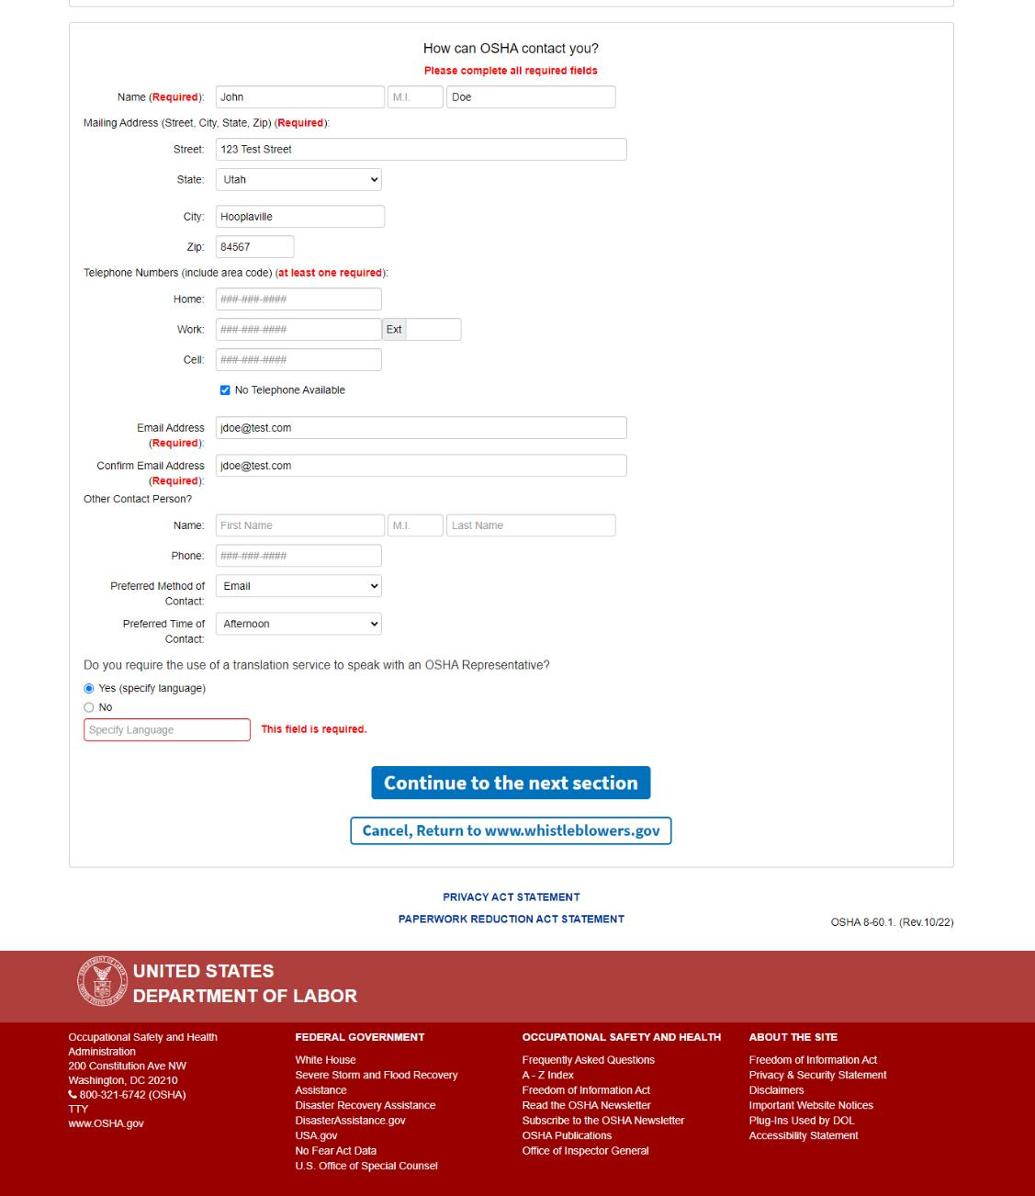
Screen 13: A new section has been added asking the user “Do you require the use of a translation service to speak with an OSHA Representative.” If “Yes” is selected the “Specify Language” field is enabled, and required, with “this field is required” displayed in red.

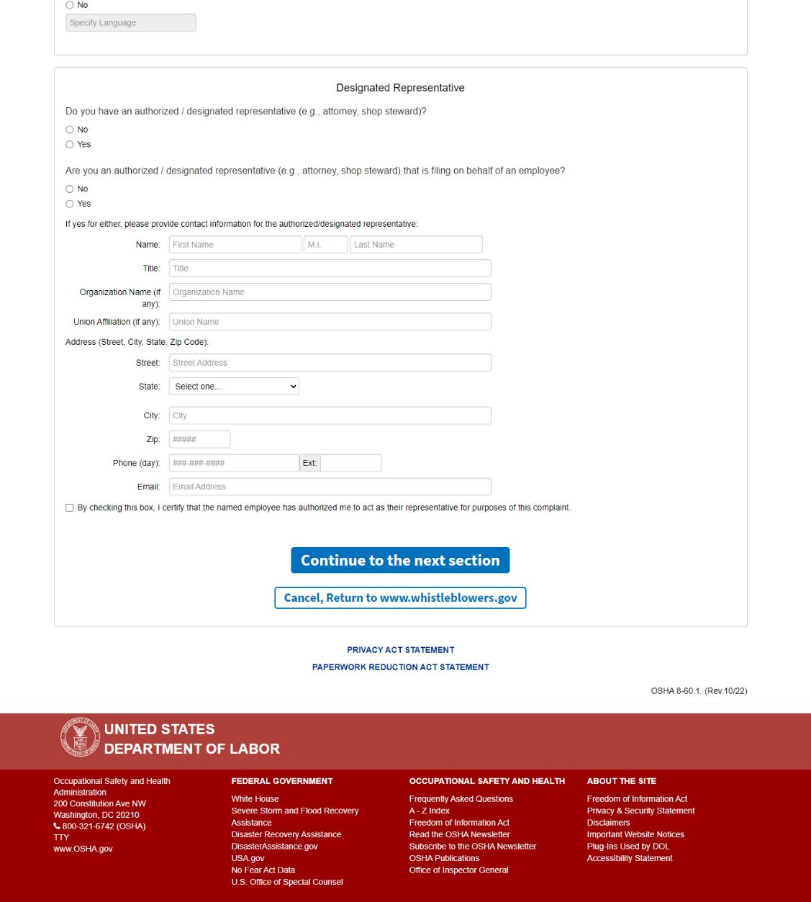
Screen 14: “Designated Representative"
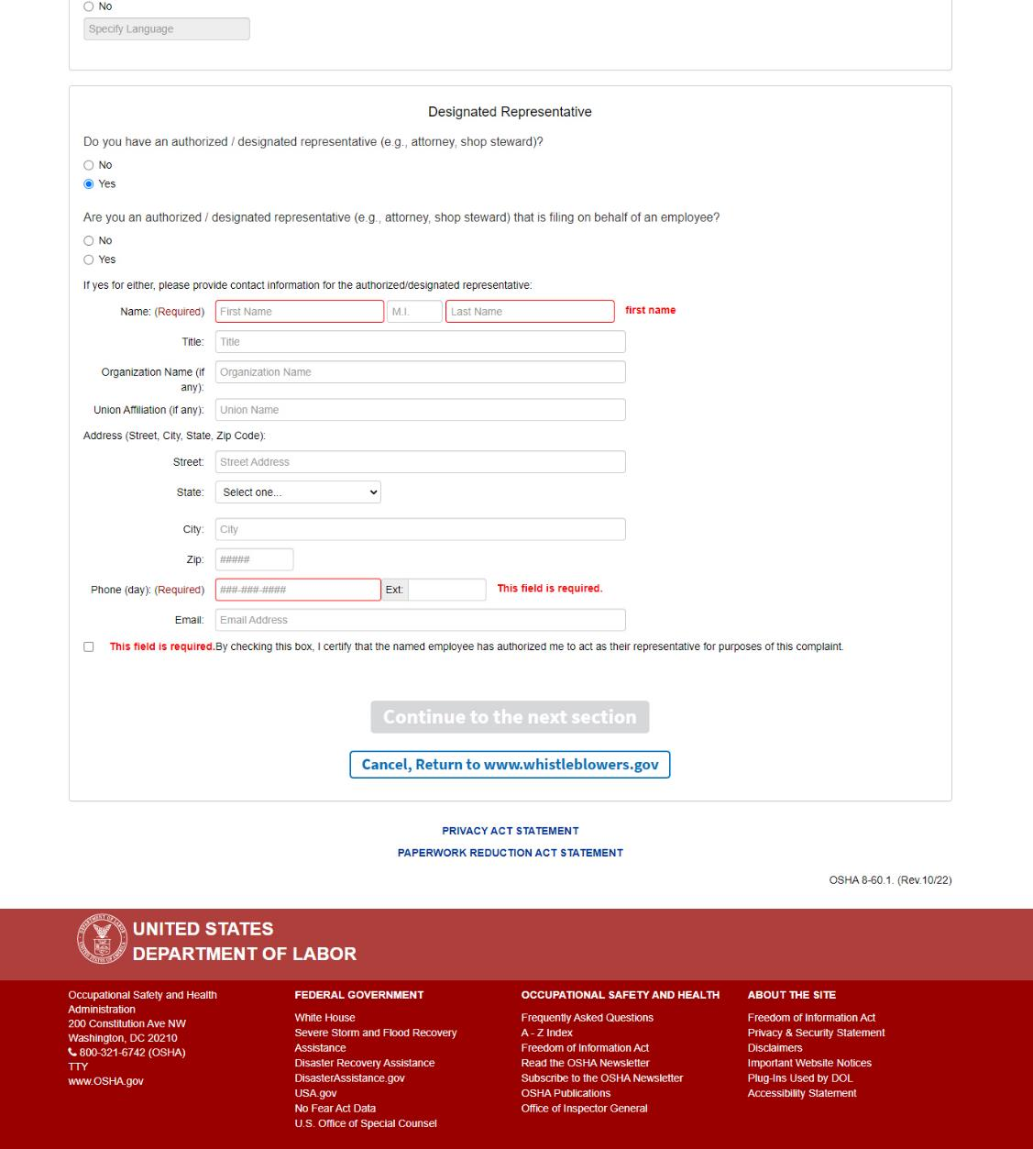
Screen 14: When “Yes” is selected under: “Do you have an authorized / designated representative (e.g., attorney, shop steward)?” The authorized/designated representative Name, Phone Number, and certification checkbox become required.
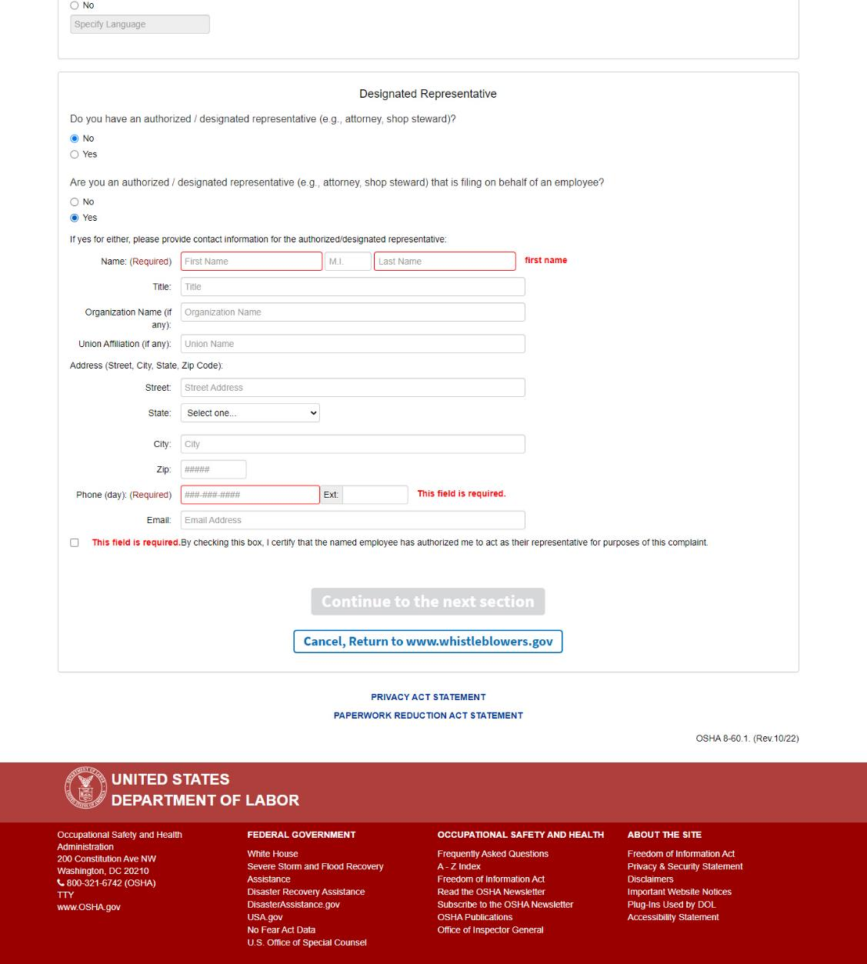
Screen 14: When “Yes” is selected under: “Are you an authorized / designated representative (e.g., attorney, shop steward) that is filing on behalf of an employee?” The authorized/designated representative Name, Phone Number, and certification checkbox become required.
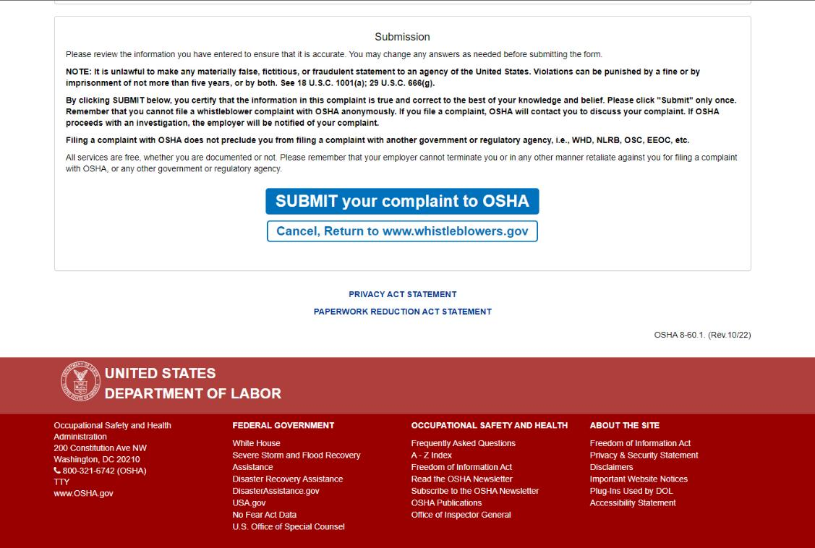
Screen 15: Form Submission
Paragraphs have been added, with the language:
“Filing a complaint with OSHA does not preclude you from filing a complaint with another government or regulatory agency, i.e., WHD, NLRB, OSC, EEOC, etc.
All services are free, whether you are documented or not. Please remember that your employer cannot terminate you or in any other manner retaliate against you for filing a complaint with OSHA, or any other government or regulatory agency.”
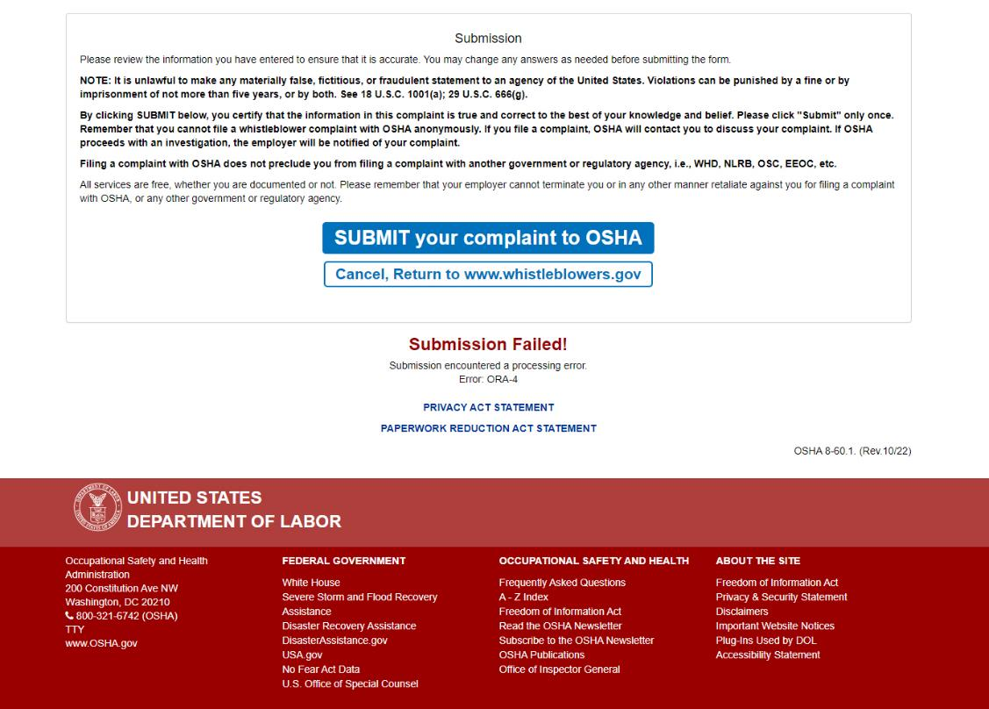
Screen 15: Form Submission displaying a failure.
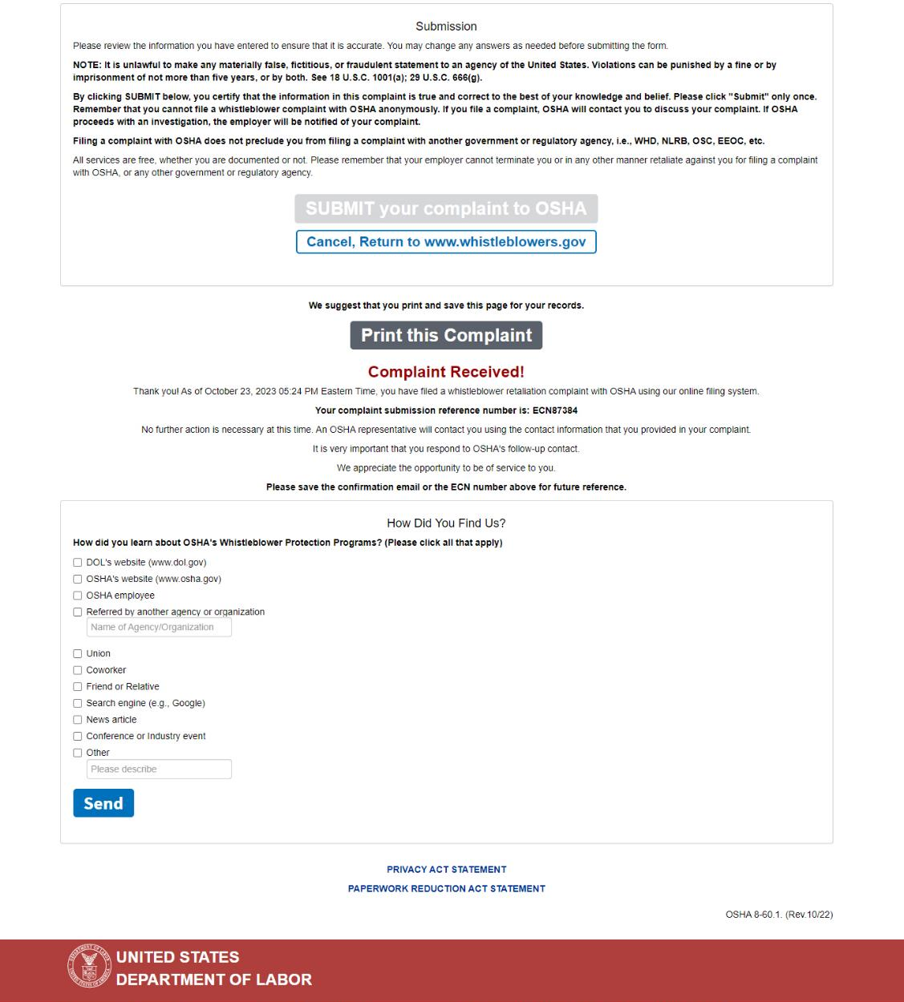
Screen 16: Submission Confirmation and Optional Survey.
Print this Complaint button is made available upon successful submission.

