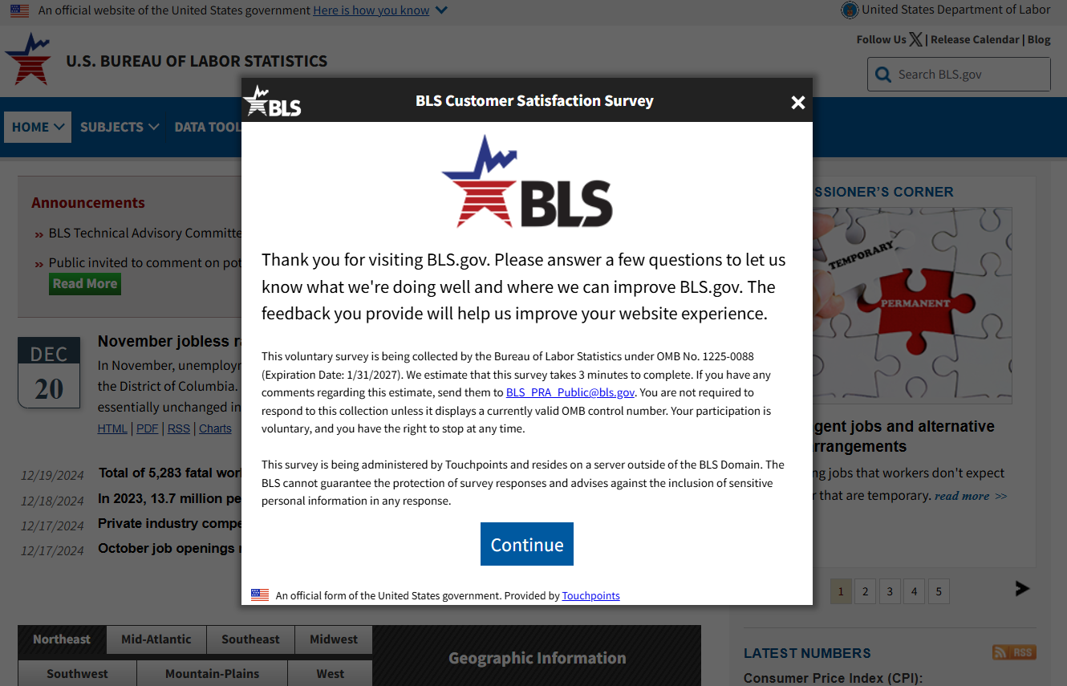

**(Question 6 only displays if the answer to questions 5 is “yes.”)**

**(Question 7 only displays if the answer to question 6 is “a little relevant” or “not at all relevant.**