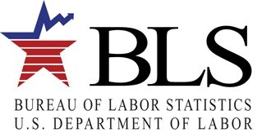

Producer Price Index

2 Massachusetts Avenue, NE

Washington, DC 20212

On [Date], the Producer Price Index (PPI) program at the U.S. Bureau of Labor Statistics (BLS) requested your participation in our data user survey. If you have not done so already, we would greatly appreciate your participation.

Please click [HERE](-) to take this survey or go to the PPI homepage ([www.bls.gov/ppi](http://www.bls.gov/ppi)) and use the link under “Announcements” to access the survey. Please respond by [Date].

If you have any questions about the survey, you may contact us at (202) 691-7705 or email [PPI_UserSurveyTeam@bls.gov](mailto:PPI_UserSurveyTeam@bls.gov).

We look forward to your response.

Thank you.

Bonnie H Murphy

Assistant Commissioner of Industrial Prices and Price Indexes