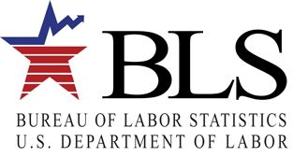

Producer Price Index

2 Massachusetts Avenue, NE Room

Washington, DC 20212

Dear [First name] [Last name]

The Producer Price Index program at the Bureau of Labor Statistics ([www.bls.gov/ppi](http://www.bls.gov/ppi)) invites you and the members of your association to participate in our user survey. Your members have been identified as past PPI data users and we would like to receive their input. We kindly ask you to forward this e-mail to your members so that we can hear what they have to say. The survey will only take a few minutes and the information you and your members provide will be used to improve our data and products to better meet your expectations.

Jerome Powell, Chairman of the Federal Reserve Board of Governors has said:

“Price Statistics help us monitor inflation in the prices that consumers pay, and producers receive for goods and services.”

Participants in the PPI “help enhance our understanding of the increasingly complex U.S. economy.”

PPI data “provide the vital statistics we use to analyze our economy and keep it strong.”

Please click Here to take this survey or go to the PPI home page ([www.bls.gov/ppi](http://www.bls.gov/ppi)) to access the survey. Please respond by (DATE).

If you have any questions about the survey, you may contact us by phone at (202) 691-7705, or by e-mail at [PPI_UserSurveyTeam@bls.gov](mailto:PPI_UserSurveyTeam@bls.gov).

Thank you in advance for your participation.

Bonnie H Murphy

Assistant Commissioner of Industrial Prices and Price Indexes