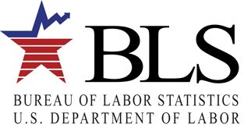

Producer Price Index

2 Massachusetts Avenue, NE

Washington, DC 20212

Dear PPI Data User,

The Producer Price Index (PPI) program at the U.S. Bureau of Labor Statistics (BLS) invites you to participate in our user survey. The survey will only take a few minutes and the information you provide will help us improve our products to better meet your needs.

Regarding the work of the BLS, Jerome Powell, Chairman of the Federal Reserve Board of Governors has said:

“Price Statistics help us monitor inflation in the prices that consumers pay, and producers receive for goods and services.”

Participants in the PPI “help enhance our understanding of the increasingly complex U.S. economy.”

PPI data “provide the vital statistics we use to analyze our economy and keep it strong.”

Please click HERE to take this survey or go to the PPI homepage ([www.bls.gov/ppi](http://www.bls.gov/ppi)) and use the link under ‘Announcements’ to access the survey. Please respond by (DATE).

If you have any questions about the survey, you may e-mail us at PPI_UserSurveyTeam@bls.gov.

We look forward to your response.

Thank you.

Bonnie H Murphy

Assistant Commissioner of Industrial Prices and Price Indexes