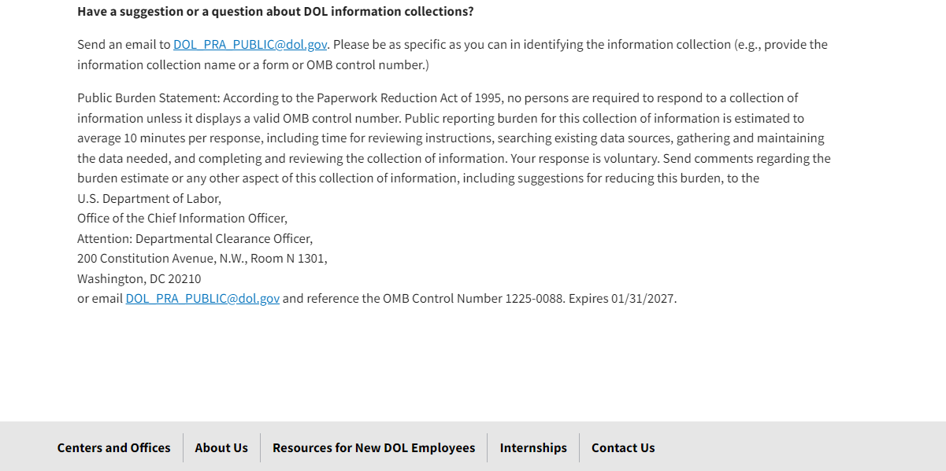

[Paperwork Reduction Act | U.S. Department of Labor (dol.gov)](https://www.dol.gov/agencies/oasam/centers-offices/ocio/paperwork-reduction-act)