**Program for International Student Assessment 2025 (PISA 2025)**

**Appendix C2-b**

**PISA 2025 Questionnaire – Student ICT**

**U.S. Adaptations**

**OMB# 1850-0755 v.31**

#### National Center for Education Statistics (NCES)

#### U.S. Department of Education Institute of Education Sciences

#### Washington, DC

#### July 2023

#### Revised August 2024

#### Revised January 2025

### Table of Contents

ICT Questionnaire 1

## Proposed adaptations to PISA 2025 Main Study Questionnaires

This package provides the U.S. versions of the full-scale questionnaires for the 2025 main study. The changes comprise questions that will be deleted based on review and discussion within NCES and feedback from other stakeholders.

PISA includes both student and school questionnaires. In addition, there are two sets of student questionnaires—core and survey questions related to Information Communication Technology (ICT). Due to the size of these files, the submission is broken into three separate files—Student Core (C-2a), Student ICT (C-2b), and School Questionnaire (C-2c).

PISA 2025

# ICT Questionnaire

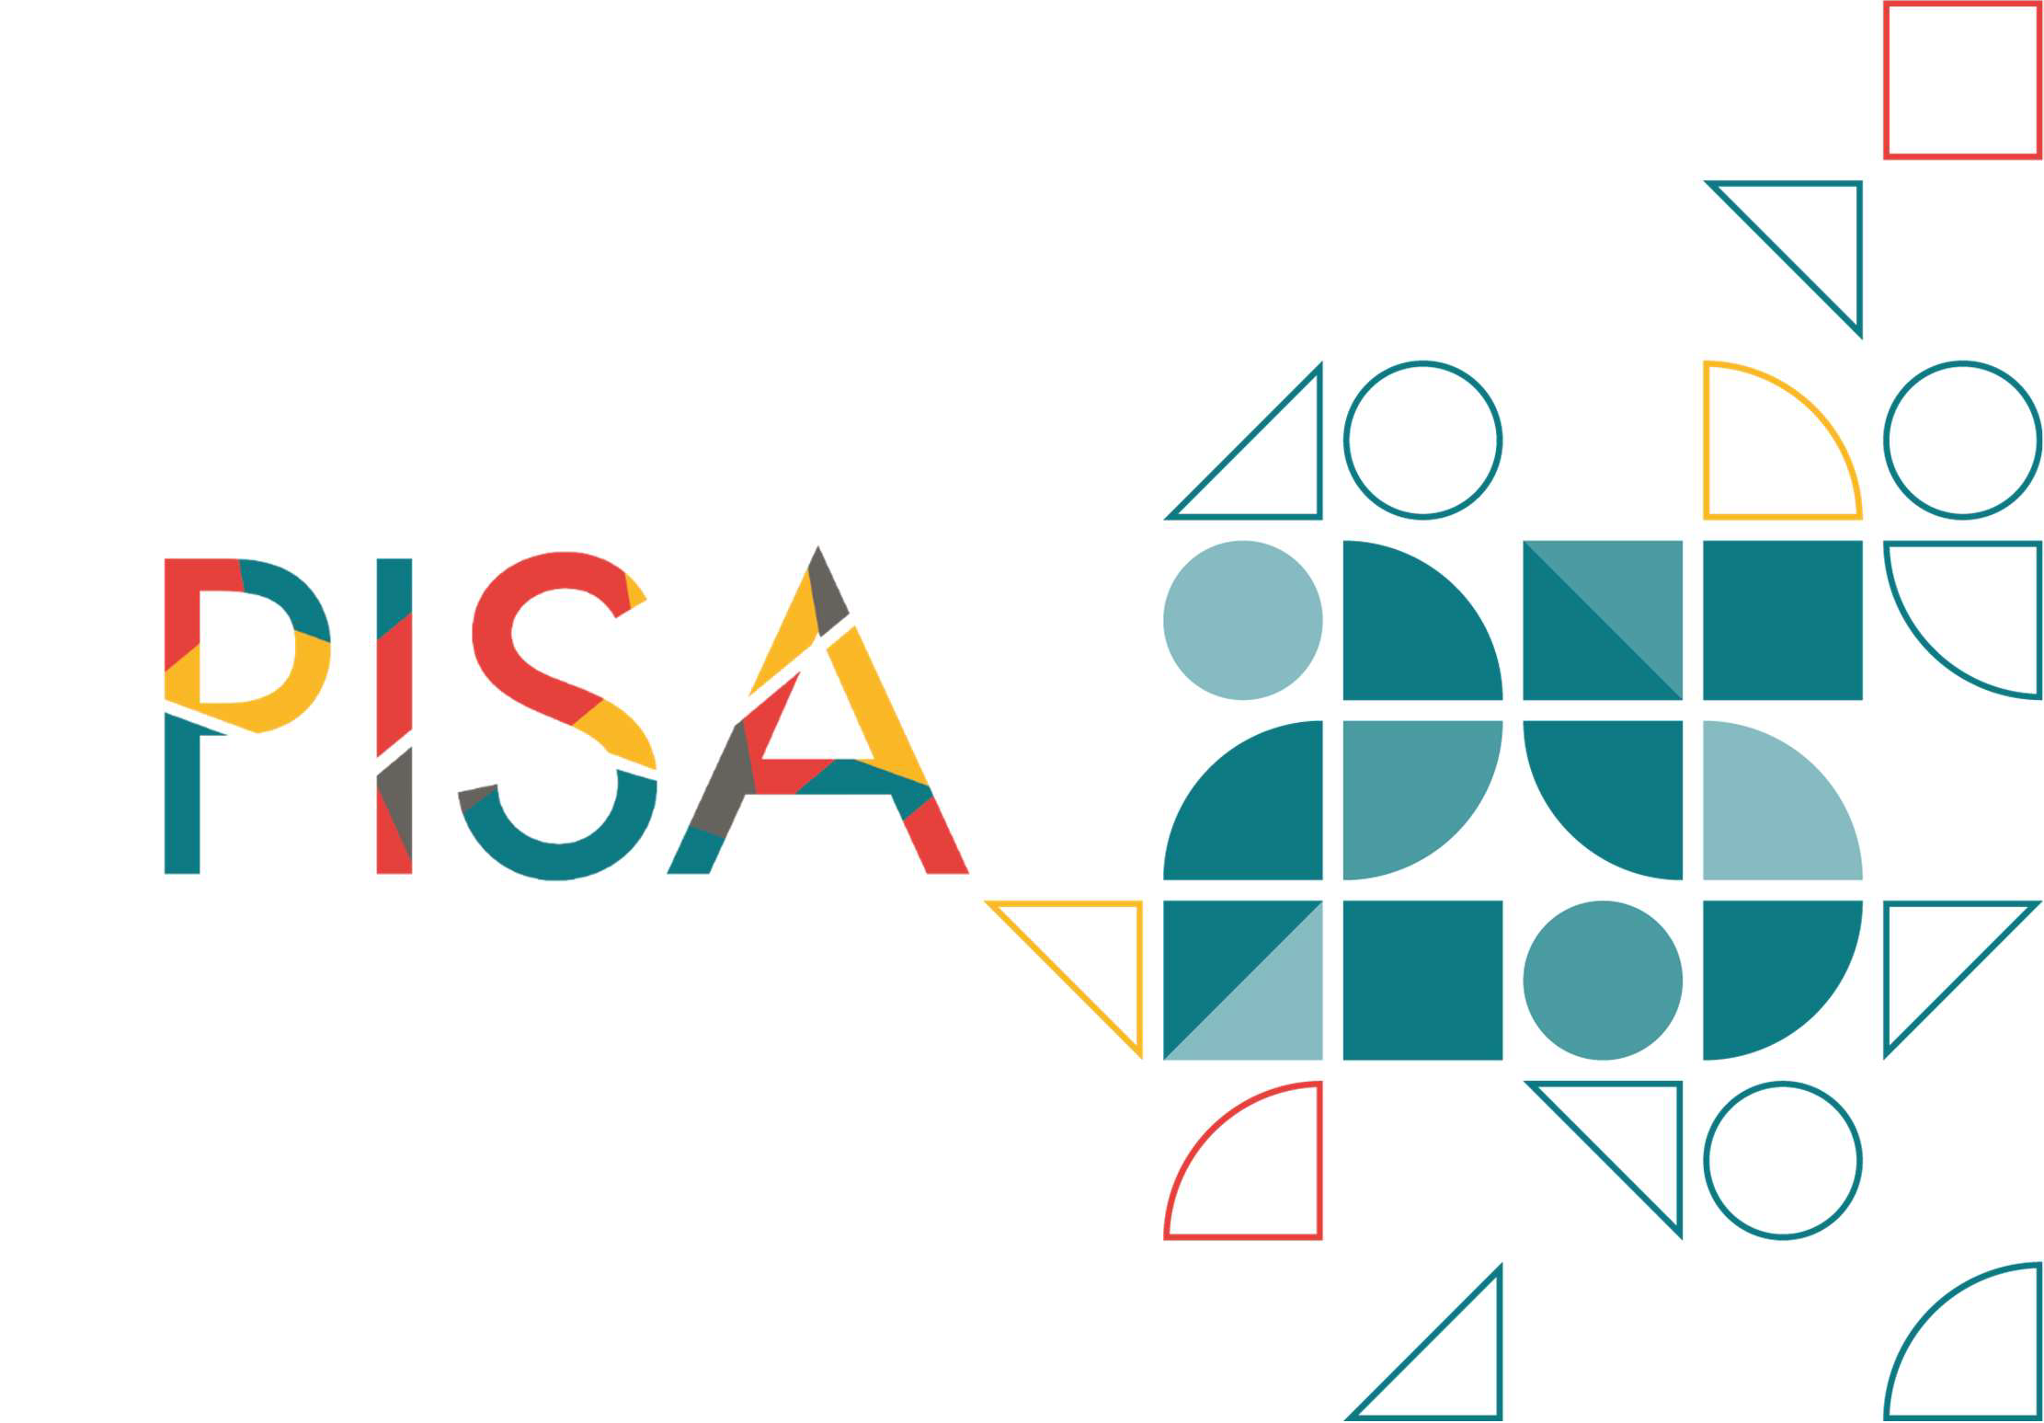

**ICT QUESTIONNAIRE FOR PISA 2025**

**(U.S. Option)**



**Instruction**

The following questions will ask you about digital resources that you may use, both inside and outside of school. Digital resources refer here to the following:

* digital devices or “hardware” (e.g., computers, tablets, smartphones, 3D printers)
* software (e.g., programs, apps, communication tools, educational learning tools); and
* online resources (e.g., websites, web portals).

Please think of all of these when answering the questions on the following screens.

**IC170**

###### This school year, how often did you use the following digital resources at school?

(Please select one response in each row.)

*Every day or almost every day*

|  |  |  |
| --- | --- | --- |
|  | *About* | *About* |
| *Never* | *once or* | *once* |
| *or* | *twice a* | *or* |
| *almost* | *month* | *twice* |
| *never* |  | *a* |
|  |  | *week* |

*Several times a day*

*This resource is not available to me at school.*

**IC170Q02JA** Desktop or laptop computer

Smartphone (i.e., cell phone with

**IC170Q02JA**

**IC170Q03JA**

Internet access)

Tablet device (e.g., iPad®,

Galaxy Tab®, Surface) or e- book

reader (e.g., Amazon® Kindle™)

**IC170Q04JA**

**IC170Q05JA**

**IC170Q06JA**

**IC170Q07JA**

Internet access (except on

smartphones)

School portal (to consult class

schedule, absences, etc.)

Educational software, games or apps, other learning tools (e.g., Khan Academy, CK-12™, or Mathalicious® online support)

A learning management system or school learning platform (e.g., Edmodo®, Moodle®, Google® Classroom™, Canvas)

**IC170Q07**

Virtual reality (VR) hardware (e.g.,

Google Cardboard®,Oculus, Class VR)

**IC170Q08**

Robotic devices (e.g., 3D printers, laser cutters, drones)

**IC170Q09**

Artificial Intelligence (AI) tools or software (e.g., ChatGPT, MidJourney, Stable Diffusion)

|  |  |
| --- | --- |
| Year(s) Administered | 2022 |
| Construct | Frequency of ICT use at school |
| Routing information (if applicable) | No |
| Status from PISA 2022 (Unchanged, modified, new) | Modified |

**Question notes:** This question has been modified from PISA 2022.

**IC171**

###### This school year, how often did you use the following digital resources outside of school (e.g., at home or where you usually access digital resources)?

(Please select one response in each row.)

Desktop or laptop

*Never or almost never*

*About once or twice a month*

*About once or twice a week*

*Every day or almost every day*

*Several times a day*

*This resource is not available to me outside of school.*

**IC171Q01JA**

**IC171Q02JA**

**IC171Q03JA**

computer

Smartphone (i.e., cell phone with Internet access)

Tablet device (e.g., iPad®, Galaxy Tab®, Surface) or e-book reader (e.g., Amazon® Kindle™)

**IC171Q04JA** Internet access (except

on smartphones)

Educational software, games or apps, other learning tools (e.g.,

**IC171Q05JA**

**IC171Q06JA**

Khan Academy, CK-12™, or Mathalicious® online support)

Video or online games (e.g., used with game consoles such as a PlayStation 5® or Nintendo Switch®, online gaming platforms such as Steam® or gaming apps such as Candy Crush®)

**IC171Q07**

**IC171Q08**

**IC171Q09**

**IC171Q10**

Smartwatch (e.g., Apple Watch®, Samsung Galaxy Watch®, or fitness tracker (e.g., FitBit®)

Virtual reality (VR) hardware (e.g., Google Cardboard®, Oculus, Class VR)

Robotic devices (e.g., 3D printers, laser cutters, drones)

Artificial Intelligence (AI) tools or software (e.g., ChatGPT, MidJourney, Stable Diffusion)

**IC172**

The following question is about the availability, accessibility, and quality of digital resources at your school.

###### To what extent do you agree or disagree with the following statements?

(Please think of different kinds of digital resources such as desktop computers, laptops, smartphones, and tablet devices as well as educational software and other digital learning tools.)

(Please select one response in each row.)

*Strongly disagree*

*Disagree Agree Strongly*

*agree*

**IC172Q01JA**

**IC172Q02JA**

There are enough digital resources for

every student at my school.

There are enough digital devices with

access to the Internet at my school

**IC172Q10** The school’s Internet is stable.

**IC172Q03JA** The school’s Internet speed is sufficient.

**IC172Q04JA**

Digital devices function properly at my school.

**IC172Q07JA**

**IC172Q08JA**

The school provides sufficient technical support to help students in their use of digital resources.

Teachers at my school have the necessary skills to use digital devices during instruction.

|  |  |
| --- | --- |
| Year(s) Administered | 2022 |
| Construct | Quality of access to ICT resources at school |
| Routing information (if applicable) | No |
| Status from PISA 2022 (Unchanged, modified, new) | Modified |

**Question notes:** This question is modified from PISA 2022, with a new item reflecting instability of internet connections.

**IC175**

The following statements are about the use of digital resources for school-related activities in general (i.e., during lessons or when completing homework).

###### This school year, how often did you use digital resources for the following activities?

(Please select one response in each row.)

Read or listen to feedback

**IC175Q01JA** sent by my teachers

regarding my work or

academic results

*Never or almost never*

*About once or twice a year*

*About once or twice a month*

*About once or twice a week*

*Every day or almost every day*

**IC175Q02JA**

Read or listen to feedback sent by other students on my work

Read or listen to feedback

**IC175Q03JA** automatically selected for

me by an educational

software or app

Work on drill and practice

**IC175Q05JA** exercises using an

educational software or

app

|  |  |
| --- | --- |
| Year(s) Administered | 2022 |
| Construct | Teacher support and feedback with ICT |
| Routing information (if applicable) | No |
| Status from PISA 2022 (Unchanged, modified, new) | Modified |

**Question notes:** This question is unchanged from PISA 2022 (with a minor modification to IC175Q01JA “and” to “or”).

**IC176**

The following statements are about the use of digital resources for school-related activities *outside of classroom hours.*

###### This school year, how often did you use digital resources for the following activities?

(Please select one response in each row.)

**IC176Q01JA**

**IC176Q02JA**

**IC176Q03JA**

**IC176Q04JA**

**IC176Q05JA**

See my grades or results from specific assignments (e.g., homework or tests)

Browse the Internet for schoolwork (e.g., for preparing an essay or presentation)

Browse the Internet to follow up on lessons (e.g., for finding explanations)

Receive or download assignments or instructions (via digital resources) from my teacher

Upload my work (e.g., documents or presentations) to a school portal or another platform to share materials with my teacher and/or students

*Never or almost never*

*About once or twice a year*

*About once or twice a month*

*About once or twice a week*

*Every day or almost every day*

**IC176Q06JA** Communicate with my teacher

**IC176Q07JA** Communicate with other students about schoolwork

Search for information on school-

**IC176Q08JA**

related activities or assignments

|  |  |
| --- | --- |
| Year(s) Administered | 2022 |
| Construct | ICT support to school related activities |
| Routing information (if applicable) | No |
| Status from PISA 2022 (Unchanged, modified, new) | Unchanged |

**Question notes:** This question is unchanged from PISA 2022.

**IC177**

###### During a *typical* weekday, how much time do you spend doing the following leisure activities?

(Please select one response in each row.)

**IC177Q01JA**

**IC177Q02JA**

**IC177Q03JA**

**IC177Q04JA**

**IC177Q05JA**

**IC177Q06JA**

Play video games (using my smartphone, a gaming console, an online platform, or apps)

Browse social networks (e.g., Instagram®,

TikTok®, Twitter®)

Browse the Internet (excluding social networks) for fun (e.g., reading news, listening to podcasts and music, or watching videos)

Look for practical information online (e.g., find a place, book a train ticket, buy a product)

Communicate and share digital content on social networks or any communication platform (e.g., TikTok®, Instagram®, Twitter®, emails, chat)

Read, listen to, or view informational materials to learn how to do something (e.g., tutorial, podcast)

*No time at all*

*Less than 1*

*hour a day*

*Between 1 and 3 hours a day*

*More than 3 hours and up to 5 hours a day*

*More than 5 hours and up to 7 hours a day*

*More than 7 hours a day*

**IC177Q07JA** Create or edit my own digital

content (e.g., pictures, videos,

music, computer programs)

|  |  |
| --- | --- |
| Year(s) Administered | 2022 |
| Construct | Exposure to various ICT practices / Excessive use of ICT |
| Routing information (if applicable) | No |
| Status from PISA 2022 (Unchanged, modified, new) | Unchanged |

**Question notes:** This question is unchanged from PISA 2022 (minor modifications to examples).

**IC178**

###### During a *typical* weekend day, how much time do you spend doing the following leisure activities?

(Please select one response in each row.)

**IC178Q01JA**

**IC178Q02JA**

**IC178Q03JA**

**IC178Q04JA**

**IC178Q05JA**

**IC178Q06JA**

**IC178Q07JA**

Play video games (using my smartphone, a gaming console, or an online platform or apps)

Browse social networks (e.g., Instagram®, TikTok®, Twitter®)

Browse the Internet (excluding social networks) for fun (e.g., reading news, listening to podcasts and music, or watching videos)

Look for practical information online (e.g., find a place, book a train ticket, buy a product)

Communicate and share digital content on social networks or any communication platform (e.g., TikTok®, Instagram®, Twitter®, emails, chat)

Read, listen to, or view informational materials to learn how to do something (e.g., tutorial, podcast)

Create or edit my own digital content (pictures, videos, music, computer programs)

*No time at all*

*Less than 1 hour a day*

*Between 1 and 3 hours a day*

*More than 3 hours and up to 5 hours a day*

*More than 5 hours and up to 7 hours a day*

*More than 7 hours a day*

|  |  |
| --- | --- |
| Year(s) Administered | 2022 |
| Construct | ICT leisure time |
| Routing information (if applicable) | No |
| Status from PISA 2022 (Unchanged, modified, new) | Unchanged |

**Question notes:** This question is unchanged from PISA 2022 (minor modifications to examples)

**IC179**

The following statements are about *your views on school rules regarding digital resources.*

###### To what extent do you agree or disagree with the following statements?

(Please select one response in each row.)

**IC179Q01JA** Students should not be allowed to bring cell phones to class.

Students should not be allowed to

*Strongly disagree*

*Disagree Agree Strongly*

*agree*

**IC179Q02JA**

**IC179Q03JA**

**IC179Q04JA**

**IC179Q05JA**

**IC179Q06JA**

bring their own laptop (or tablet device) to class.

Students should collaborate with teachers to decide on the rules regarding the use of digital devices during lessons.

The school should set up filters to prevent students from going on social media.

The school should set up filters to prevent students from playing games online.

Teachers should monitor what students do on their laptop or tablet device.

|  |  |
| --- | --- |
| Year(s) Administered | 2022 |
| Construct | Students’ opinion regarding ICT use in school |
| Routing information (if applicable) | No |
| Status from PISA 2022 (Unchanged, modified, new) | Unchanged |

**Question notes:** This question is unchanged from PISA 2022.

**IC180**

The next statements are about the quality, credibility, and accuracy of information online.

###### To what extent do you agree or disagree with the following statements?

(Please select one response in each row.)

**IC180Q01JA** I trust what I read online.

*Strongly disagree*

*Disagree Agree Strongly*

*agree*

**IC180Q02JA** When searching for information online I compare different sources.

**IC180Q03JA** I check the accuracy of online

information before sharing it on social

networks

**IC180Q04JA**

**IC180Q05JA**

**IC180Q06JA**

I discuss the accuracy of online information with my teachers or in class.

I discuss the accuracy of online information with friends or other students.

I discuss the accuracy of online information with my parents (or family).

**IC180Q07JA** I try to flag wrong information when I encounter it online.

|  |  |
| --- | --- |
| Year(s) Administered | 2022 |
| Construct | Students’ practices regarding online information |
| Routing information (if applicable) | No |
| Status from PISA 2022 (Unchanged, modified, new) | Unchanged |

**Question notes:** This question is unchanged from PISA 2022.

**IC181** The following question is about your experience when browsing online content or using social media.

###### How upset were you the last time the following situations occurred?

(Please select one response in each row.)

**IC181Q01JA** Encountering content online that was inappropriate for my age

Encountering discriminatory

*This did not happen to me*

*Not at all upset*

*A little upset*

*Quite upset*

*Very upset*

**IC181Q02JA**

**IC181Q03JA**

**IC181Q05**

**IC181Q04JA**

content online (e.g., about race, gender, sexual orientation, or physical appearance)

Receiving unkind, vulgar or offending messages, comments, or videos

Encountering unkind, vulgar or offending messages, comments, or videos about someone I know

Information about me was publicly displayed online without my consent

|  |  |
| --- | --- |
| Year(s) Administered | 2022 |
| Construct | Reaction about exposure to unfit online content and bullying |
| Routing information (if applicable) | No |
| Status from PISA 2022 (Unchanged, modified, new) | Modified |

**Question notes:** This question is modified from PISA 2022 (one new item added).

**IC182**

###### To what extent do you agree or disagree with the following statements?

(Please select one response in each row.)

**IC182Q01JA** I am interested in learning more about digital resources.

**IC182Q02JA** I am interested in learning computer programming.

*Strongly disagree*

*Disagree Agree Strongly*

*agree*

**IC182Q03JA**

I am interested in learning about digital resources because it could be useful in a job.

**IC182Q04** I like using digital resources to find new ways to do things

**IC182Q05**

I am interested in learning about machine learning and artificial intelligence (AI).

|  |  |
| --- | --- |
| Year(s) Administered | 2022 |
| Construct | Interest in computer programming |
| Routing information (if applicable) | No |
| Status from PISA 2022 (Unchanged, modified, new) | Modified |

**Question notes:** This question is modified from PISA 2022 (one new item added).

**IC013/IC400**

###### Thinking about your experience with digital resources, to what extent do you disagree or agree with the following statements?

(Please think of different kinds of digital devices such as desktop computers, portable laptops, notebooks, smartphones, tablet devices, cell phones without Internet access, game consoles, or Internet-connected television.)

(Please select one response in each row.)

**IC013Q01** I forget about time when I’m using

|  |
| --- |
| digital devices. |
| The Internet is a great resource for obtaining information I am  interested in (e.g., news, sports, |
| dictionary). |
| It is very useful to have social networks on the Internet. |
| I am really excited discovering new digital devices or |
| applications. |
| I really feel bad if no Internet connection is possible. |
| I like using digital devices. |

*Strongly disagree*

*Disagree Agree Strongly agree*

**IC013Q04**

**IC013Q05**

**IC013Q11**

**IC013Q12**

**IC013Q13**

|  |  |
| --- | --- |
| Year(s) Administered | 2018 and 2015 (IC013) |
| Construct | ICT engagement: ICT interest |
| Routing information (if applicable) | No |
| Status from PISA 2022 (Unchanged, modified, new) | New |

**Question notes:** This question was not included in 2022, but it was in previous ICQ (2015 and 2018). Consistent with 2022, the term digital resources has been added to the question text replacing “digital media and digital devices”.

**IC016/IC401**

###### Thinking about your experience with digital resources, to what extent do you disagree or agree with the following statements?

(Please select one response in each row.)

*Strongly disagree*

*Disagree Agree Strongly agree*

**IC016Q01** To learn something new about

digital devices, I like to talk about them with my friends.

**IC016Q02** I like to exchange solutions to

problems with digital devices with others on the Internet.

**IC016Q04** I like to meet friends and play

computer and video games with them.

**IC016Q05** I like to share information about

digital devices with my friends.

**IC016Q07** I learn a lot about digital media by discussing with my friends and relatives.

|  |  |
| --- | --- |
| Year(s) Administered | 2018 and 2015 (IC016) |
| Construct | ICT engagement: ICT interest |
| Routing information (if applicable) | No |
| Status from PISA 2022 (Unchanged, modified, new) | New |

**Question notes:** This question was not included in 2022, but it was in previous ICQ (2015 and 2018). Consistent with 2022, the term digital resources has been added to the question text replacing “digital media and digital devices”.