INFORMATION COLLECTION REQUEST (ICR):  
Child Strength Study  
OMB Control Number: 3041-0187

1. JUSTIFICATION

# Circumstances Making the Collection of Information Necessary

This is a request to renew the strength data collection study of children ages 3 months through 5 years old. CPSC uses data on human strength and capabilities to develop product safety standards and to inform other CPSC staff activities. Strength capabilities of children are essential information to develop product performance requirements in standards to reduce or eliminate the risk such products might pose to a child (e.g., breaking, collapsing, or liberating a small part). Manufacturers can also use this information when designing products intended for children. In addition, products that are not intended for children, but that can be hazardous to children, can be made safer by adopting performance requirements that consider children’s ability to interact with product components.

In the 1970s, CPSC sponsored studies to conduct research on human size and strength, particularly the landmark Snyder et al. (1975 and 1977) studies on child anthropometry and Owings et al. (1975 and 1977) studies on child strength.[1] Although the research results were instrumental in developing product safety standards for many years, the information is out of date, given that these strength studies were conducted more than 40 years ago. The current CPSC Child Strength information collection activity provides information that more accurately reflects the strength capabilities of today’s children and provides additional data that are missing from the available literature, including data for younger children and additional strength measures. Accordingly, CPSC seeks to continue its update of these data using the child strength study.

# Purpose and Use of the Information Collection

CPSC awarded a contract to the University of Michigan to conduct a study to update and expand child strength data with a focus on real-world scenarios. The information collected from this study has provided CPSC with updated child strength measures, including upper and lower extremities and bite strength, with expanded age ranges (strength data for children from 6 months through 5 years of age and bite strength for children from 3 months through 5 years of age). With this information, CPSC staff has offered more accurate and up-to-date data for voluntary and mandatory standard development activities. These data have also help staff to analyze injuries and deaths of children interacting with consumer products and determine whether a product presents a safety hazard. The study collects strength information from up to 1000 children who reside in the United States. The contractor has created a customized tool for data collection and feedback, which allows the contractor to tailor the interface for each exertion of interest; check values against expected ranges to identify potential errors; and gather and synchronize data from multiple sensors.

A team of researchers at the University of Michigan Transportation Research Institute (UMTRI), which has decades of experience in human measurement, including extensive anthropometry and ergonomics research involving child participants and strength measurement, has lead the study. The research team has obtained an Institutional Review Board (IRB) approval for this project from the University of Michigan Health Sciences and Behavioral Sciences (IRB HSBS, FWA00004969).

## Description of study

The contract for this study was awarded with multiple task orders under an indefinite delivery/indefinite quantity (IDIQ) contract (contract 61320618D0004).

Seven task orders involve human subjects. Task Order 1 (general strength measures for children 24 through 71 months old), Task Order 2 (general strength measures for children 6 through 23 months old), Task Order 3 (bite strength for children 36 through 71 months old), Task Order 4 (bite strength for children 3 through 35 months old), Task Order 7 (product-specific strength data), and Task Order 8 (hand strength measures) are discussed in this application. Task Order 5 (child climbing study/focus group) was conducted under OMB Control Number 3041-0136. Task Orders 1, 2, 3 and 4 completed in completed in August 2023, Task Order 7 completed in September 2024, Task Order 8 is scheduled to complete in January 2025.

Two additional task orders, Task Order 6 (posture analysis) and Task Order 11 (trends and predictive analysis), involve analysis of human subject data collected in other task orders, but no additional human subjects. Task Order 6 completed in August 2024 and Task Order 11 is scheduled to complete in September 2025.[2]

For the study under this request, CPSC staff anticipates that, over the 3-year period of this request and the 3-year period of the previous request, the contractor will collect data from a total of 1000 children ranging in age 3 months to 5 years.[3] The study will take up to 2 hours per session. UMTRI researchers recruit children via their caregivers through the University of Michigan Engage site, Craigslist, and with flyers placed at UMTRI. (For an example of the flyer and online advertisement text to be used for recruitment, see the document called Flyer and Ad Text.) The participants are screened via a phone conversation with the caregiver. (For an example of the phone screening conversation, see the document called Telephone Screening Script.) Inclusion criteria is based on age, lack of current illness or injury; age-appropriate cognitive and motor development, as reported by the caregiver; and the caregiver’s ability to understand written and spoken English (children in the older age categories should be able to understand spoken English). UMTRI researchers assign a subject ID number to each participant. UMTRI researchers retain a key file linking the subject ID to identifiable information separately from the data and will destroy the key file at the conclusion of the testing. The study is conducted at UMTRI Laboratories in Ann Arbor, MI. Figure 1 shows the primary test fixture.

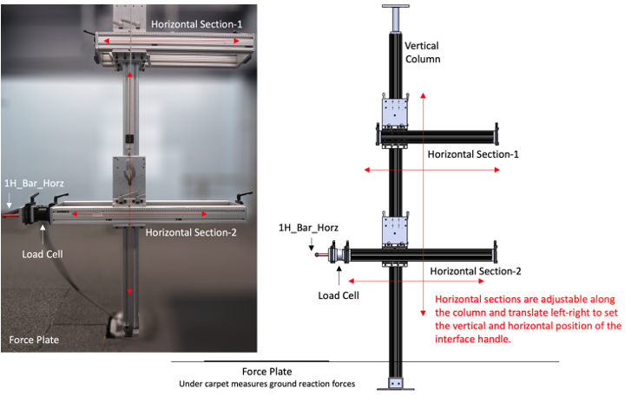

Figure 1. Test fixture for measuring strength for pushing and pulling tasks in the UMTRI Laboratory.

Before a child performs exertions, a research assistant explains and demonstrates the procedures to the caregiver and child. Written consent is obtained from the caregivers, who remain with the children at all times. Researchers obtain verbal assent from the children who are old enough to provide it. (For an example of the written consent form, see the document called Research Study Consent.)

Researchers obtain several standard anthropometric measurements from each child, including body weight and standing height. Researchers also record the participant’s body shape using a whole-body laser scanner (VITUS XXL) and a Microsoft Kinect sensor.

In the laboratory, the children perform a sequence of tasks to test maximal exertions with their hands, feet, and body, using the test fixture shown in Figure 1. Children interact with a test interface (e.g., a horizontal bar, a knob, a grip dynamometer, or flat surface) and exert force (e.g., push or pull) as hard as they can. Each exertion will be targeted for approximately 5 seconds, including the ramp-up and release. Feedback will be provided to the participants via a graphic display that shows their maximum level achieved, so that they can be encouraged to go beyond that level, if possible. Figure 2 shows example strength exertions: a child pushing and pulling with one hand on the horizontal bar and pushing with both feet on the flat surface.

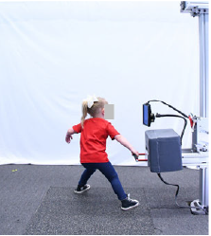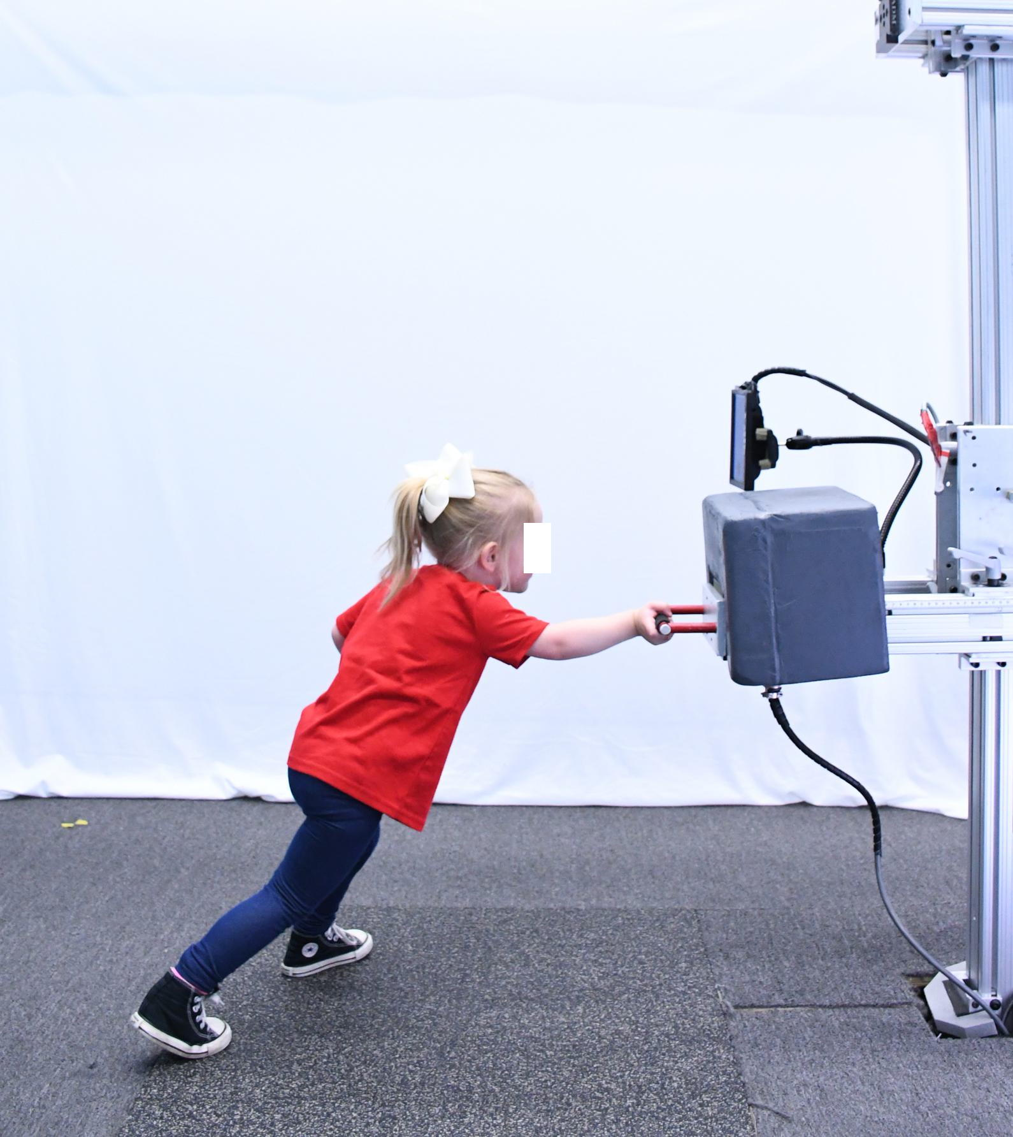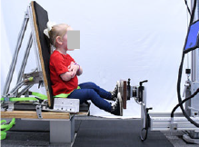

Figure 2. Examples of a child strength exertions.

Researchers created toy-like interfaces (e.g., a tissue box, a spinner, and a cart) for the youngest children to better capture their attention and communicate the desired interaction. Figure 3 shows example strength exertions with toy-like interfaces: pulling on the tissue box, pushing on the spinner, and pulling on the cart.

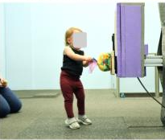 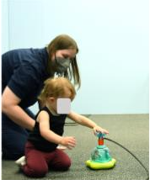 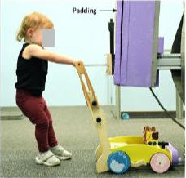

Figure 3. Examples of strength exertions with toy-like test interfaces.

For some trials, the participant sits or lays down in in a specially constructed laboratory chair, which is adjustable, based on the child’s size. Seated exertions include pushes and pulls with the hands and pushes with one foot and both feet. Conditions are varied to avoid exertion of one part of the body consecutively. For example, a hand pull might be followed by a hand or foot push.

The research team uses video and images to assess the children’s performance, particularly their tactics in achieving the requested exertions. The number of trials to be performed depends on the capability and attention of the child, but the maximum duration of a child’s participation is 2 hours for a single session. Caregivers and children may be asked to return for one or more follow-up sessions to collect additional strength measures. A 5-minute break is taken at least every 20 minutes to allow the child to relax and play. The caregiver and child can take a break or discontinue participation at any time. The caregiver receives a payment of $40 to $50 per session (up to 2 hours of participation) as compensation for their time; the amount is based on the portion of the study that the participant completes.

Please note that examples of all IRB-approved instruments, including flyer and ad text, telephone screening, and written consent, are provided in this collection request. At different points throughout the study, these instruments are revised when child strength data for children of various age ranges will be collected. All instruments will receive IRB approval before use in the Child Strength Study.

## Audiences of data and results

CPSC technical staff will be the primary audience of the data and results. UMTRI researchers will provide de-identified raw strength and position data, along with a reports to CPSC staff. The reports will include an executive summary, background, methods, description of instrumentation and methodology for each strength measure, including a drawing or picture; description of validation of instrumentation and method; detailed discussion of the methods used to conduct the study, including participant selection and recruitment, demographic characteristics, and relevant anthropometric data, including weight and height; total sample size for each age group and strength measure; results, including summary of data analysis by age group, including sample sizes, 5th, 50th, and 95th percentile values, standard deviation, mean, minimum, and maximum values for males, females, and combined; and data, including both anthropometric and strength measurements.

## Methods of dissemination

The Commission will publicly release the contractor’s final reports, after they have been reviewed and approved by CPSC staff, by disseminating the reports on the agency’s website, and through staff presentations at meetings and conferences related to the subject matter. The Commission, its staff, agents, and representatives will disseminate the information in accordance with the law and Commission policy to ensure the information is accurate and not misleading.

To encourage dissemination of the findings, the reports will be freely accessible on cpsc.gov. The work will be prepared in the course of the author's official contracting duties with CPSC. Thus, Title 17 U.S.C. Section 105 applies, which provides that there can be no copyright in a United States government publication.

UMTRI may also utilize the data collected through this research for their own publication and dissemination with CPSC staff approval.

# Use of Information Technology

Detailed child measurements, of the type to be taken in the Child Strength Study, must be taken in a laboratory setting. UMTRI researchers will utilize information technology to manage data that is reported electronically, including but not limited to online screening and consent, where applicable and if paper or in-person collection is not appropriate. Data collected electronically will be protected according to UMTRI procedures and all data provided to CPSC will be deidentified. (Section A.10 provides additional detail on confidentiality assurances provided to respondents.)

# Efforts to Identify Duplication and Use of Similar Information

The intent of this data collection is to obtain information that is not readily available elsewhere.

# Impact on Small Businesses or Other Small Entities

The information will not be collected from small businesses or other small entities.

# Consequences to federal program or policy activities if collection is not conducted or is conducted less frequently

If this collection is not conducted, CPSC staff may have to use outdated strength data for children, and the voluntary and mandatory standards will not benefit from updated data that more accurately reflect the strength capabilities of today’s children. Staff may also continue to lack child strength data for measures that are relevant to children’s interactions with products, including bite strength data and strength data for younger children. This could hinder the analysis of a product involved in a death or injury to a child, resulting in preventing or delaying CPSC from taking action to remove a dangerous product from the public.

# Special Circumstances Relating to the Guidelines of 5 CFR §1320.5

There are no special circumstances. This information collection is consistent with the guidelines prescribed in 5 CFR §1320.5. CPSC will not collect race and ethnicity data.

# Consultation and Public Comments

### Part A. Public Notice

A 60-Day Federal Register Notice (FRN) for the collection published on October 24, 2024. The 60-Day FRN citation is 89 FR 84882. No substantive comments were received.

### Part B. Consultation

CPSC has consulted with UMTRI. Specifically, UMTRI has helped inform CPSC’s decisions regarding the availability of the requested information, data collection techniques, and the clarity of information and instructions provided to participants.

CPSC has also received input from organizations and institutions regarding the design and need for this study. Agency staff communicated with stakeholders, including research organizations, universities, test laboratories, safety consultants, advocates, trade associations, and manufacturers, who all recognized and supported the effort to expand and update child strength data. Stakeholders rely on relevant child strength data to improve consumer product safety, by developing requirements and test methods to reduce the risk of injury to children from consumer products.

# Explanation of any Payment or Gift

The contractor will provide $40 to $50 for up to 2 hours of participation. Parents volunteer their children for participation in the study for several reasons, including the benefit of learning more about their child’s strength, a belief that contributing to research may benefit others, and affinity or trust in the research being performed by the University of Michigan or CPSC. The compensation provided to participants is an important monetary representation that their time spent participating in the study is valued. Not providing an incentive could jeopardize voluntary participation in the study and weaken our ability to conduct convenience sampling. The amount of compensation provided is reviewed and approved by the University of Michigan IRB, and is based on rates for similar research conducted at the university.

# Assurance of Confidentiality Provided to Respondents

Participation in the study is voluntary, and respondents are informed of this before the screening, and at the beginning of the study. Participants are informed of the measures taken to protect their confidentiality in the introductory language read to sampled persons. Information collected from respondents will be kept confidential and only used for research purposes.

UMTRI researchers will assign participants a Random ID number not linked to any personal identifying information. They will take photos and video of the participants in some conditions to document their exertion postures. UMTRI researchers will de-identify the photos and video by blurring or obscuring the faces. UMTRI researchers will share the data with CPSC, only in the form of de-identified information. The data will be retained indefinitely at UMTRI in de-identified form, to document the performance of the test procedures (*e.g.*, the repeatability of certain exertions).

# Justification for Sensitive Questions

Questions asked in the study typically are not considered sensitive in nature.

# Estimate of Hour Burden to Respondents

Below is a discussion of the burden hours to eventually reach 1000 children[4] for the lab study. We anticipate the response rates shown below, based on previous studies.

|  |  |  |  |  |  |
| --- | --- | --- | --- | --- | --- |
| Instrument | Hours per respondent | Total number of participants | Response rate | Number of respondents | Total hours |
| Invitation |  |  |  |  |  |
| Invitation for study | 0.05 | 5210 | 30% | 1563 | 79 |
| Screener |  |  |  |  |  |
| Invitation for study | 0.15 | 1563 | 80% | 1250 | 188 |
| Study |  |  |  |  |  |
| In-lab study | 2 | 1250 | 80% | 1000 | 2000 |
| Total |  |  |  | 3813 | 2267 |

Total Burden Hours: 2267 hours

The total number of respondents was calculated based on an initial study (Task Orders 1, 2, 3, and 4) with the goal of 50 participants from each of the following age categories:

* 3–5 months (bite strength only)
* 6–8 months
* 9–11 months
* 12–17 months
* 18–23 months
* 24–29 months
* 30–35 months
* 36–47 months
* 48–59 months
* 60–71 months

Researchers plan follow-on studies with up to 500 additional participants to collect data for more strength measures and product-specific interactions.

Because of the difficulty in collecting data for the youngest children, numbers for each age group were adjusted to more heavily focus on older children. In addition, because of the overlap in timing between task orders, many children were able to complete data collection for multiple task orders in a single session. Number of children by task order is shown below.

|  |  |  |
| --- | --- | --- |
| Task Order | Status | Number of Children |
| 1 | Complete | 400 |
| 2 | Complete | 171 |
| 3 | Complete | Overlaps with Task Order 1 |
| 4 | Complete | 10 additional, otherwise overlaps with Task Order 3 |
| 7 | Complete | 101 additional, otherwise overlaps with TO1 |
| 8 | Ongoing | 120 (planned) |

# Estimate of Total Annual Cost Burden to Respondents

There are no costs to respondents and no respondent recordkeeping requirements associated with the study. There are no operating, maintenance, or capital costs associated with the collection.

# Estimate of Annualized Costs to the Federal Government

The contract to design and conduct the child strength study was issued to the University of Michigan under contract number 61320618D0004 for $1,669,534. Salary and benefits costs for government personnel assigned to this study are estimated at $234,048, based on 12 staff months in 2024, at an average level of GS-13 step 5 ($133,692/.688) and a 68.8 percent ratio of wages and salary to total compensation from Table 1 of the June 2024 Employer Costs for Employee Compensation[5], published by the Bureau of Labor Statistics. Therefore, the estimated cost to the government is $1,669,534, plus $194,320 in government labor costs, for a total of $1,863,854.

# Program Changes or Adjustments

The burden estimate is increased from 1,813 to 2,267 hours.

# Publication Plan

The contractor has developed a technical report that will present a description of study design, research methods, summary of results, findings and conclusions.

The Commission will release the final technical report by disseminating the report on the agency’s website and through presentations at meetings and conferences related to the subject matter. The procedures to disseminate the information by the Commission, its staff, agents, and representatives will be in accordance with the law and Commission policy to ensure the information is accurate and not misleading. The agency will disseminate the findings when appropriate, strictly following the agency’s “Guidelines for Ensuring the Quality of Information Disseminated to the Public.”

To encourage dissemination of the findings, the report will be freely accessible on cpsc.gov. The work will be prepared in the course of the author's official contracting duties with CPSC. Thus, Title 17 U.S.C. Section 105 applies, which provides that there can be no copyright in a United States government publication.

# Rationale for Not Displaying the Expiration Date for OMB Approval

No such exception is sought. The OMB data collection number and expiration date will be displayed on the initial screener and the informed consent forms.

# Exception to the Certification Statement

No such exception is sought. These activities comply with the requirements in *5 CFR § 1320.9*.

1. Owings, C. L., Chaffin, D. B., Snyder, R. G., & Norcutt, R. H. (1975). Strength Characteristics of U.S. Children for Product Safety Design. U.S. Consumer Product Safety Commission, Bethesda, MD.

   Owings, C.L., Norcutt, R.H., Snyder, R.G., Golomb, D.H. and Lloyd, K.Y. (1977). Gripping Strength Measurements of Children for Product Safety Design (Contract No. CPSC-C-76-0119).

   Snyder, R.G., Spencer, M.L., Owings, C.L., & Schneider, L.W. (1975). The Physical Characteristics of Children as Related to Death and Injury for Consumer Product Design and Use (Report No. UM-HSRI-BI-75-5). Prepared for the U.S. Consumer Product Safety Commission. Ann Arbor, MI: The Highway Safety Research Institute, University of Michigan.

   Snyder, R.G., Schneider, L.W., Owings, C.L., Reynolds, H.M., Golomb, D.H., and Schork, M.A. (1977). Anthropometry of Infants, Children, and Youths to Age 18 for Product Safety Design.

   Final Report UM-HSRI-77-17. University of Michigan Transportation Research Institute, Ann

   Arbor, MI. Prepared for the U.S. Consumer Product Safety Commission, Washington, D.C. 014926-F.
2. The remaining task order, Task Order 9, was for expert services and did not involve human subjects or additional analysis of human subjects data. Task Order 9 completed in August 2022.
3. The number of children is counted by study session. Some children participated in multiple sessions, so the total number of unique children is lower than this number.
4. Some participants will participate in multiple test sessions for different studies. Calculations are based on number of test sessions.
5. https://www.bls.gov/news.release/archives/ecec_09102024.pdf