**General Instructions**

You are completing the OPM Leadership 360 self-assessment to rate your leadership strengths and developmental needs. The results of the assessment will help increase your self-awareness and serve as a foundation for behavioral change.

Please use the following definitions when responding:

- *Organization*: The level at which you have authority. This may be, for example, a work unit, division, or an entire agency.

- *Customers*: Anyone who uses or receives the products or services that your organization provides; may include individuals within and outside of your organization.

**Privacy Act Statement**

Pursuant to 5 U.S.C. § 552a(e)(3), this Privacy Act Statement informs you of why OPM is requesting the information from you.

**Authority:** OPM is authorized to collect the information requested pursuant to 5 U.S.C. § 4702 – Research Programs.

**Purpose:** OPM is requesting this information to improve methods in Federal personnel management, workforce effectiveness, and/or agency effectiveness. OPM will use this information to assess the participants’ leadership behaviors, identify leadership strengths and challenges, and identify strategies that will help the participants improve their leadership.

**Routine Uses:** In any public release of survey results, no data will be disclosed that could be used to match your responses with your identity. The information requested may be shared externally as a “routine use” as specified in the system of records notice associated with this collection of information, OPM GOVT-6, Personnel Research and Test Validation Records, [OPM GOVT-6](https://www.opm.gov/information-management/privacy-policy/sorn/opm-sorn-govt-6-personnel-research-and-test-validation-records.pdf).

**Consequences of Failure to Provide Information:** Providing this information is completely voluntary and there is no penalty if you choose not to respond. However, maximum participation is encouraged so that the data will be complete and representative.

**Public Burden Statement**

The public reporting burden to complete this information collection is estimated at 20-30 minutes per response, including time for reviewing instructions, searching data sources, gathering, and maintaining the data needed, and the completing and reviewing the collected information. An agency may not conduct or sponsor, and a person is not required to respond to a collection of information unless it displays a currently valid OMB control number and expiration date. Send comments regarding this burden estimate or any other aspect of this collection information, including suggestions for reducing this burden to the Office of Personnel Management, Assessment & Evaluation at [Organizational_Assessment@opm.gov](mailto:Organizational_Assessment@opm.gov)**.** Current information regarding this collection of information – including all background materials -- can be found at https:/www.reginfo.gov/public/do/PRAMain by using the search function to enter either the title of the collection (Leadership Assessment Surveys), or the **OMB Control Number (3206-0253**).

Do not reproduce, store in a retrieval system, or transmit in any form or by any means (including, without limitation, electronic, mechanical, or through the use of photocopying or recording equipment), any part of this assessment form without written permission from the Assessment and Evaluation (AE), U. S. Office of Personnel Management. Any such action taken without such permission is unauthorized.

**Begin Survey**

PARTICIPANTS ONLY

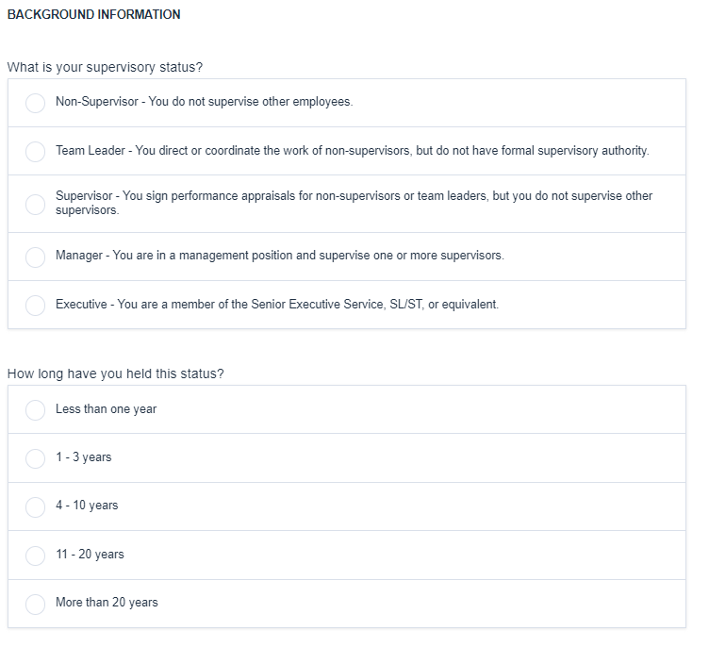

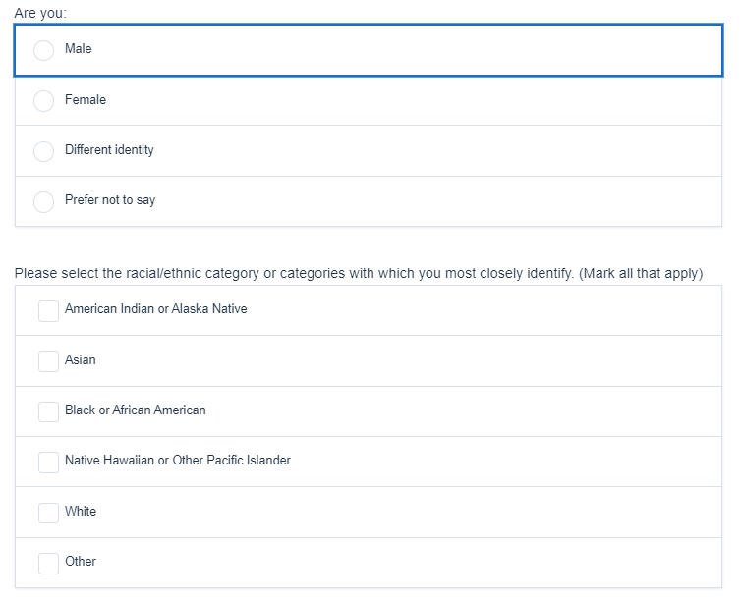

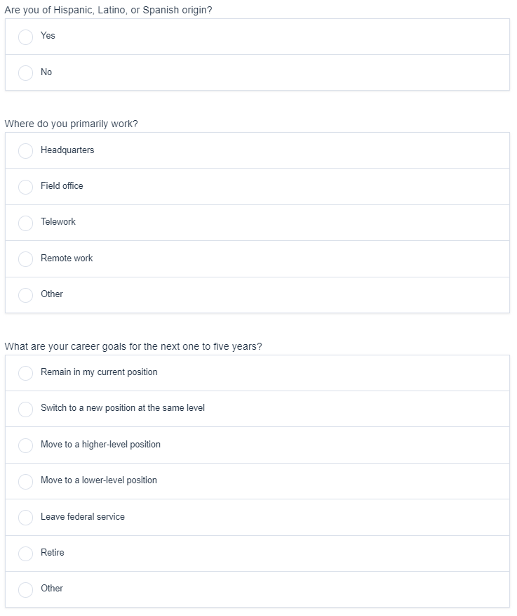

ALL PARTICIPANTS AND RATERS

**OMB approval #: 3206-0253, Expires: 12/31/2024**

