**PRS Questionnaire current screen before changes to Gender, Race , Ethnicity fields:**

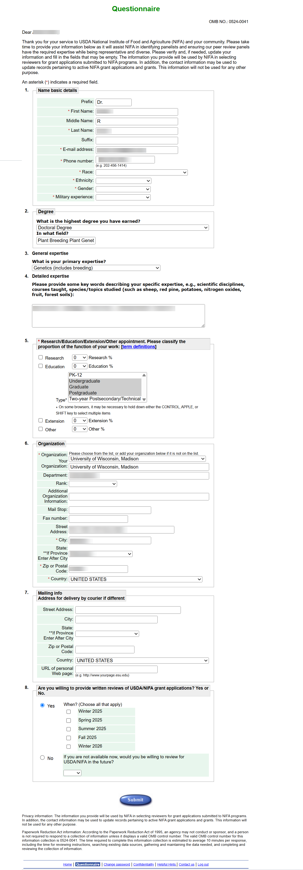

**PRS Questionnaire mock up screen with proposed Gender, Race , Ethnicity field changes:**

