
OMB Control No.: 0536-xxxx
Exp. Date: mm/dd/yyyy

<NAME>
<ADDRESS>
<CITY>, <ST> <ZIP5>-<ZIP4>

Dear [STATE] Farmer,

We need your help with a survey of farm management in [STATE]. The survey results will help government agencies better meet farmers’ needs and will help inform farm policy.

Please take a few minutes to share your thoughts. Your confidential input is essential to ensure the accuracy of the survey. We have enclosed a $5 bill as a token of our appreciation. When you complete the survey, we will send you $30 as another thank you.

The survey is being conducted over the internet. To start the survey, please type the following web address into the address bar of your web browser and then enter your personalized ID code.

Web address: <ADDRESS>

ID code: <IDCODE>

(The address bar is usually at the top of the web browser and is not the same as a web search. To access the address bar you can also press “control+L” in Windows or “command+L” on a Mac.)

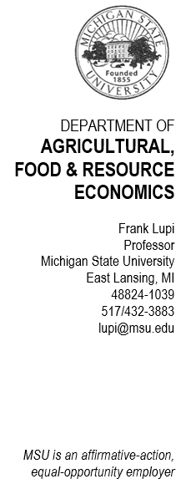
If you prefer, you may also start the survey by scanning the QR code using your phone or tablet camera.

If you have questions about this survey, please contact me at CropSurvey@usda.gov or 517-432-3883. You may also contact me by mail at 307 Morrill Hall of Agriculture, Michigan State University, East Lansing MI, 48824.
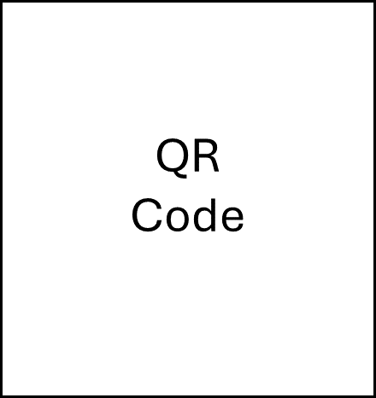
Thank you for your assistance!

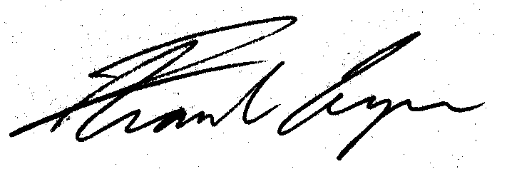
Professor Frank Lupi

PS. If you are not the person most familiar with managing field crops, please share the web address and ID code with that person.

Answers to Frequently Asked Questions

Why does this survey matter?
The information will help inform government agencies about the needs and management activities of Midwestern farmers. The survey will help USDA and Michigan State University economists improve their understanding of farmer decision-making. Survey summaries and research results will also be shared with State and local organizations to help improve programs that serve farmers.

Why do you want me to do this survey?
We need your help because you are part of a small, scientifically selected sample designed to be representative of farmers in [STATE] that grow corn or soybeans.

Who sees my answers?
Your responses are saved directly into a secure database that does not contain your name. Your answers will remain confidential. Only a small team of researchers at the USDA and Michigan State University working on this project will have access to the answers. All reports will only present results in summary form.

How is my privacy protected?
Our mailing list and data are stored on password-protected computers in locked offices. The survey ID codes are not linked to peoples’ names within the survey. Names will never be a part of the survey data. Everyone who works on the survey has completed both government and University training on protecting respondents’ data. This survey is conducted in accordance with the Confidential Information Protection and Statistical Efficiency Act of 2018, which makes your responses completely confidential.

I have entered the web address, but it does not take me to the survey web page.
Please make sure that you type the web address into the address bar of your internet browser and not the search bar. The address bar is typically located on the top of the browser. You can also press “control+L” in Windows or “command+L” on a Mac. The survey is on a secure website and cannot be found by doing a web search.

How do I get help with web survey access or other problems?
If you have trouble accessing the web survey or if you have other technical issues, you should contact me by email at CropSurvey@usda.gov and I will respond via email and/or we can set up a time to talk that is convenient for you.

